Laboratory Work 2

Course
Microcontroller Systems

Title
Clock Configuration, SysTick 10 kHz and Output Frequency Measurement

Objective
To extend Lab 1 firmware with system clock setup logic, periodic interrupt generation, and measurable output signal toggling.

Variant
Variant: 5 Required frequency by task table: 80 MHz.

Task Requirements
- Configure flash latency.
- Configure PLL source and PLL factors.
- Enable PLL and switch main clock source.
- Start SysTick timer at 10 kHz.
- Toggle GPIO pin inside SysTick handler.
- Measure output signal frequency in simulation tools.

Schematic / Simulation Setup
Runtime demonstration was assembled and executed in Wokwi.
- Scheme view:
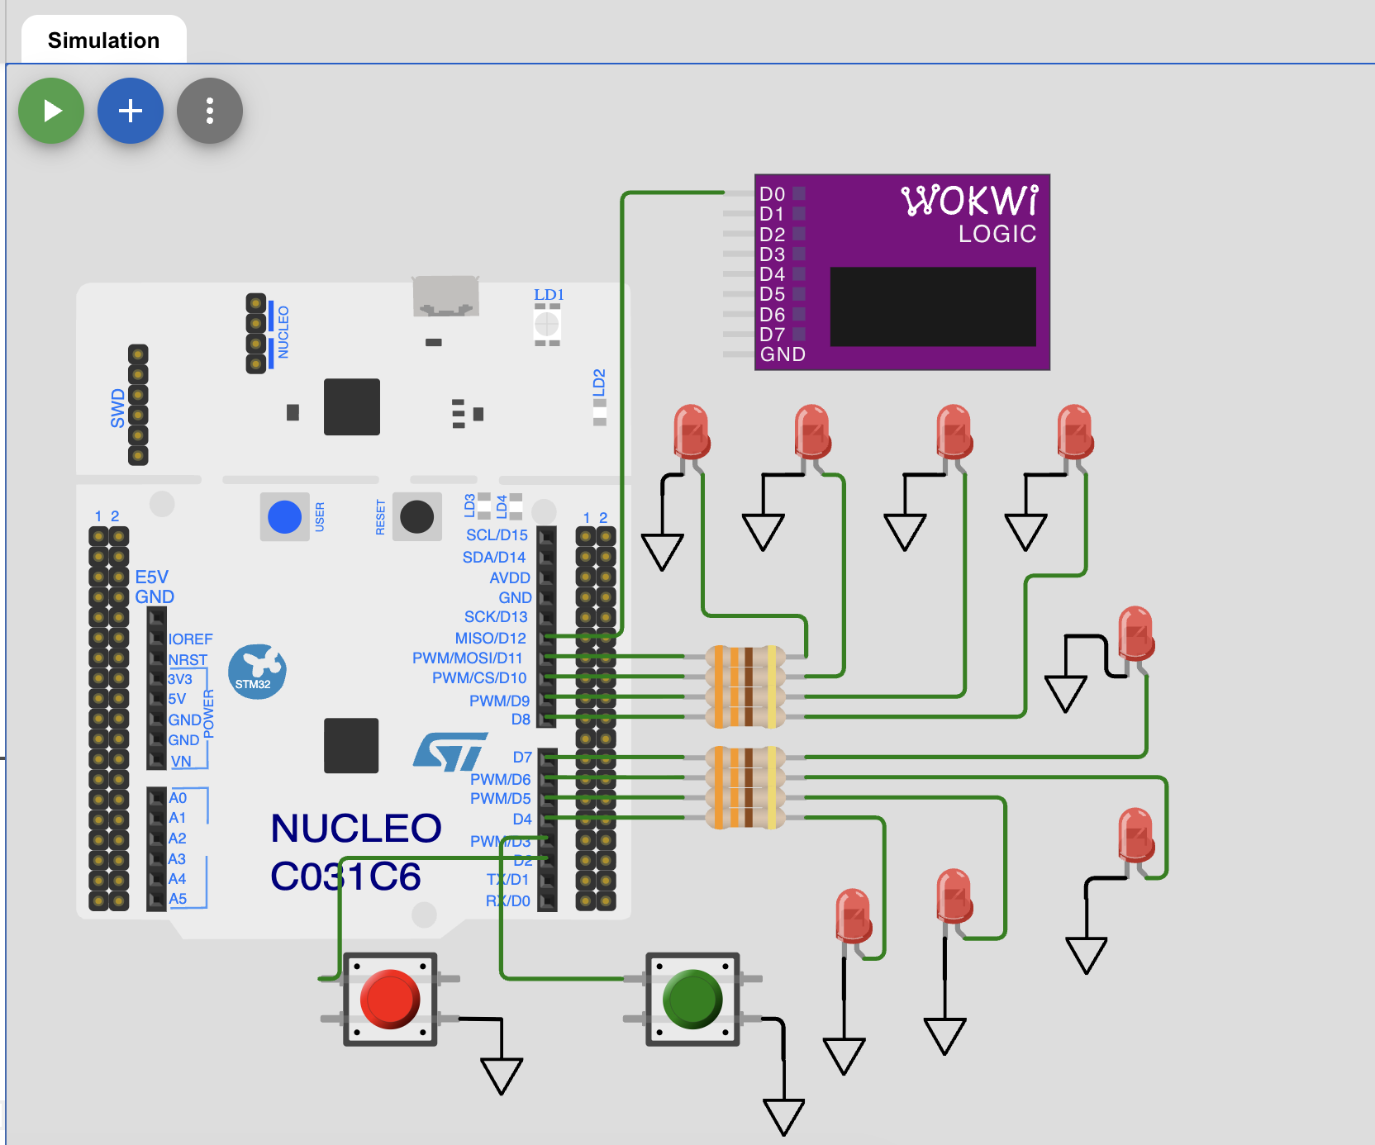
Lab 2 Wokwi scheme
- Logic analyzer running view:
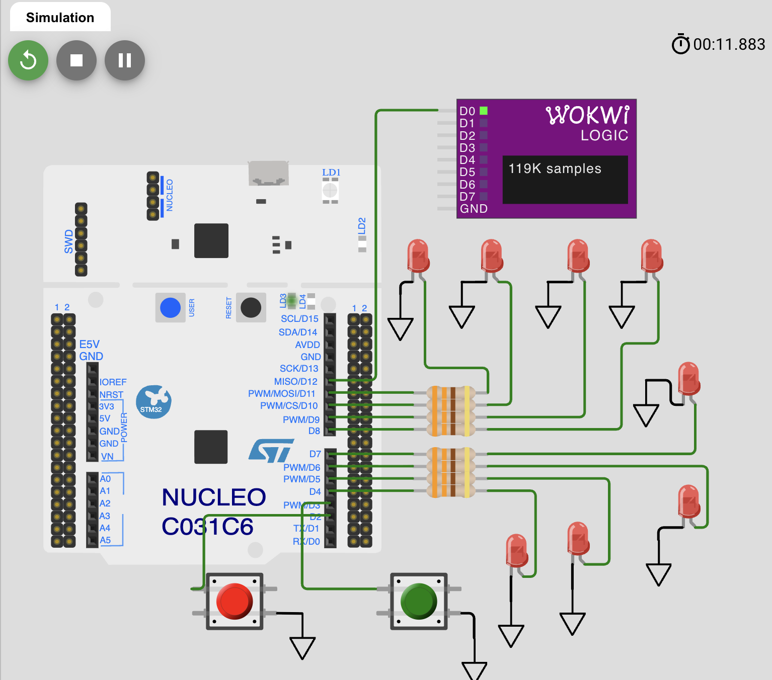
Lab 2 logic analyzer
- Frequency demonstration with active runtime state:
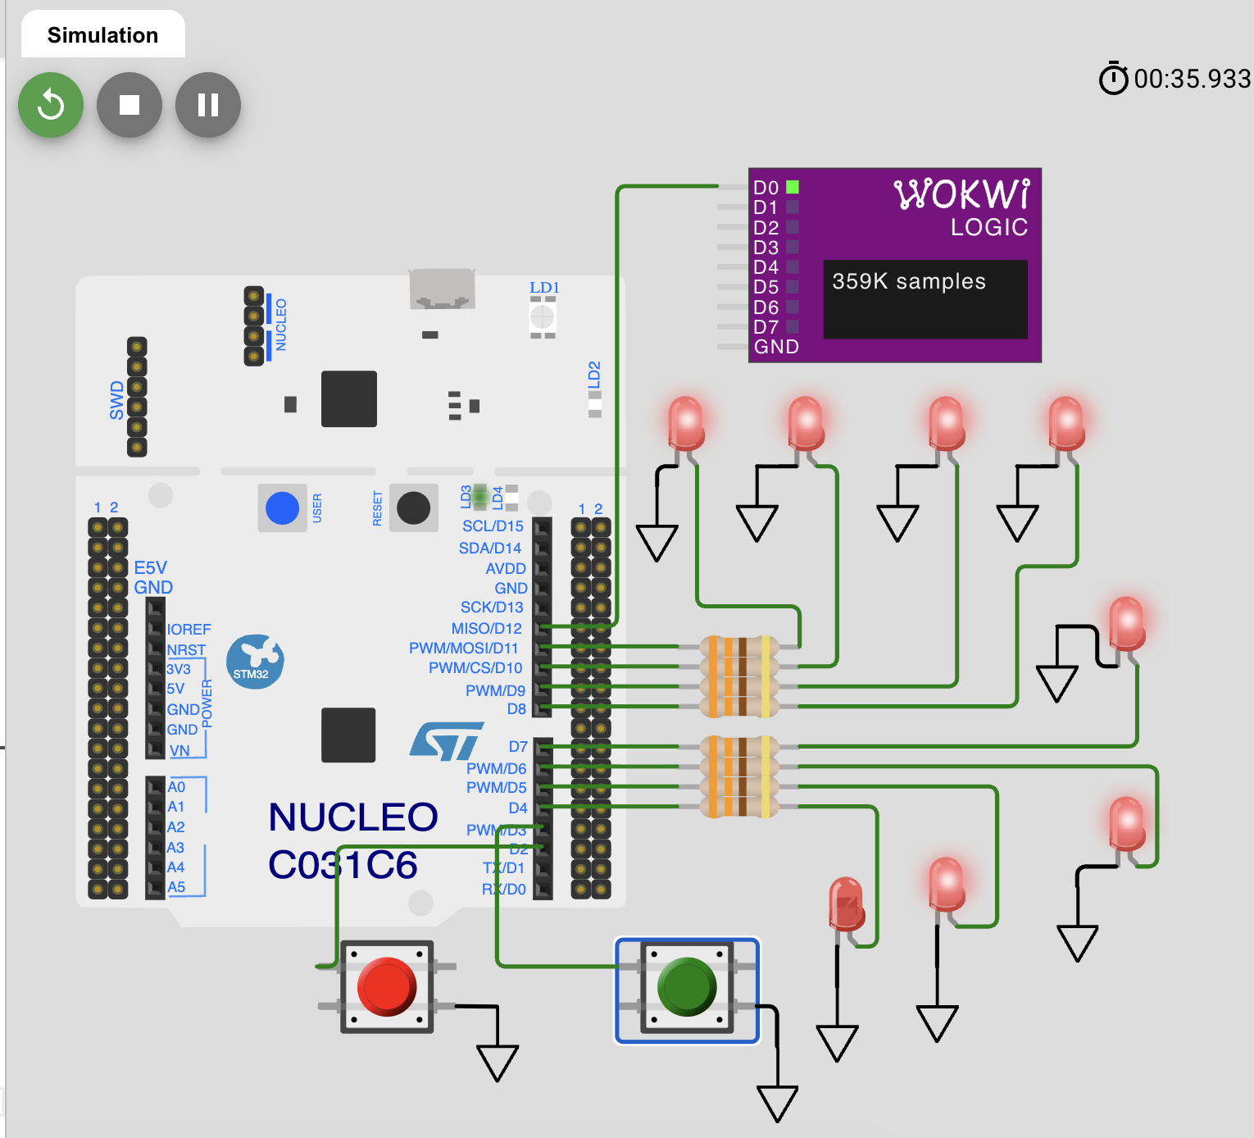
Lab 2 frequency value

Source Code
Primary STM32 implementation file: - Lab2_main.c
Wokwi runtime analogue sketch file: - Wokwi_Lab2_sketch.ino

Calculations (Variant 5)
Required target frequency from variant table: - f_SYSCLK = 80 MHz
PLL setup used in STM32 code: - HSI = 16 MHz - PLLM = 16 - PLLN = 320 - PLLP = 4
Check: 1. f_VCO_IN = 16 / 16 = 1 MHz 2. f_VCO_OUT = 1 * 320 = 320 MHz 3. f_SYSCLK = 320 / 4 = 80 MHz
SysTick setup: - required interrupt frequency: 10 kHz - reload value: LOAD = 80,000,000 / 10,000 - 1 = 7999
Output signal behavior: - output pin toggles on each tick, - expected square-wave fundamental frequency is approximately: - f_OUT ≈ 10 kHz / 2 = 5 kHz

Verification Notes
- LED/button behavior from Lab 1 remains operational.
- Output pin signal is generated continuously.
- Logic analyzer confirms periodic toggling.

Code Listing (main.c)
#include "stm32f4xx.h"
#include <stdint.h>
#ifndef LAB_VARIANT
#define LAB_VARIANT 5u
#endif
#define BTN_UP_PIN (0u) // PA0
#define BTN_DOWN_PIN (1u) // PA1
#define LED_MASK_8BIT (0xFFu) // PC0..PC7
#define FREQ_OUT_PIN (0u) // PB0 for oscilloscope
static volatile uint8_t g_counter = 0u;
static uint32_t target_freq_mhz_from_variant(uint32_t variant)
{
if (variant < 1u) {
return 84u;
}
if (variant > 41u) {
return 44u;
}
return 85u - variant;
}
static void delay_cycles(volatile uint32_t n)
{
while (n--) {
__NOP();
}
}
static uint8_t button_pressed(uint32_t pin)
{
return ((GPIOA->IDR & (1u << pin)) == 0u) ? 1u : 0u;
}
static void leds_write(uint8_t value)
{
uint32_t odr = GPIOC->ODR;
odr &= ~LED_MASK_8BIT;
odr |= value;
GPIOC->ODR = odr;
}
static void gpio_init(void)
{
RCC->AHB1ENR |= RCC_AHB1ENR_GPIOAEN | RCC_AHB1ENR_GPIOBEN | RCC_AHB1ENR_GPIOCEN;
(void)RCC->AHB1ENR;
// PC0..PC7 as LEDs.
GPIOC->MODER &= ~(0xFFFFu);
GPIOC->MODER |= (0x5555u);
GPIOC->OTYPER &= ~(LED_MASK_8BIT);
GPIOC->PUPDR &= ~(0xFFFFu);
// PA0/PA1 as button inputs with pull-up.
GPIOA->MODER &= ~((3u << (BTN_UP_PIN * 2u)) | (3u << (BTN_DOWN_PIN * 2u)));
GPIOA->PUPDR &= ~((3u << (BTN_UP_PIN * 2u)) | (3u << (BTN_DOWN_PIN * 2u)));
GPIOA->PUPDR |= ((1u << (BTN_UP_PIN * 2u)) | (1u << (BTN_DOWN_PIN * 2u)));
// PB0 as output for frequency observation.
GPIOB->MODER &= ~(3u << (FREQ_OUT_PIN * 2u));
GPIOB->MODER |= (1u << (FREQ_OUT_PIN * 2u));
GPIOB->OTYPER &= ~(1u << FREQ_OUT_PIN);
GPIOB->PUPDR &= ~(3u << (FREQ_OUT_PIN * 2u));
}
static void set_flash_latency(uint32_t sysclk_mhz)
{
uint32_t latency;
if (sysclk_mhz <= 30u) {
latency = FLASH_ACR_LATENCY_0WS;
} else if (sysclk_mhz <= 60u) {
latency = FLASH_ACR_LATENCY_1WS;
} else {
latency = FLASH_ACR_LATENCY_2WS;
}
FLASH->ACR = FLASH_ACR_ICEN | FLASH_ACR_DCEN | FLASH_ACR_PRFTEN | latency;
while ((FLASH->ACR & FLASH_ACR_LATENCY) != latency) {
}
}
static void clock_init_pll_hsi(uint32_t target_mhz)
{
uint32_t pllm = 16u;
uint32_t pllp = 4u;
uint32_t plln;
// Keep HSI on.
RCC->CR |= RCC_CR_HSION;
while ((RCC->CR & RCC_CR_HSIRDY) == 0u) {
}
// Temporarily switch SYSCLK to HSI before touching PLL.
RCC->CFGR &= ~RCC_CFGR_SW;
while ((RCC->CFGR & RCC_CFGR_SWS) != RCC_CFGR_SWS_HSI) {
}
RCC->CR &= ~RCC_CR_PLLON;
while ((RCC->CR & RCC_CR_PLLRDY) != 0u) {
}
// Choose PLLP so PLLN stays in valid range.
if ((target_mhz * 4u) >= 192u) {
pllp = 4u;
} else {
pllp = 6u;
}
plln = target_mhz * pllp;
set_flash_latency(target_mhz);
// AHB = SYSCLK; APB1 <= 42 MHz; APB2 <= 84 MHz.
RCC->CFGR &= ~(RCC_CFGR_HPRE | RCC_CFGR_PPRE1 | RCC_CFGR_PPRE2);
RCC->CFGR |= RCC_CFGR_HPRE_DIV1 | RCC_CFGR_PPRE1_DIV2 | RCC_CFGR_PPRE2_DIV1;
RCC->PLLCFGR = (pllm & RCC_PLLCFGR_PLLM)
| ((plln << RCC_PLLCFGR_PLLN_Pos) & RCC_PLLCFGR_PLLN)
| ((((pllp / 2u) - 1u) << RCC_PLLCFGR_PLLP_Pos) & RCC_PLLCFGR_PLLP)
| RCC_PLLCFGR_PLLSRC_HSI;
RCC->CR |= RCC_CR_PLLON;
while ((RCC->CR & RCC_CR_PLLRDY) == 0u) {
}
RCC->CFGR &= ~RCC_CFGR_SW;
RCC->CFGR |= RCC_CFGR_SW_PLL;
while ((RCC->CFGR & RCC_CFGR_SWS) != RCC_CFGR_SWS_PLL) {
}
}
static void systick_init_10khz(uint32_t core_clk_hz)
{
SysTick->LOAD = (core_clk_hz / 10000u) - 1u;
SysTick->VAL = 0u;
SysTick->CTRL = SysTick_CTRL_CLKSOURCE_Msk
| SysTick_CTRL_TICKINT_Msk
| SysTick_CTRL_ENABLE_Msk;
}
void SysTick_Handler(void)
{
// Toggle PB0 at each SysTick interrupt.
GPIOB->ODR ^= (1u << FREQ_OUT_PIN);
}
int main(void)
{
const uint32_t target_mhz = target_freq_mhz_from_variant(LAB_VARIANT);
uint8_t up_prev = 0u;
uint8_t down_prev = 0u;
clock_init_pll_hsi(target_mhz);
gpio_init();
leds_write(g_counter);
// Required by task: SysTick at 10 kHz.
systick_init_10khz(target_mhz * 1000000u);
for (;;) {
uint8_t up_now = button_pressed(BTN_UP_PIN);
uint8_t down_now = button_pressed(BTN_DOWN_PIN);
if ((up_now != 0u) && (up_prev == 0u)) {
g_counter++;
leds_write(g_counter);
delay_cycles(120000u);
}
if ((down_now != 0u) && (down_prev == 0u)) {
g_counter--;
leds_write(g_counter);
delay_cycles(120000u);
}
up_prev = up_now;
down_prev = down_now;
}
}

Conclusion
The second laboratory task objectives were achieved: clock-configuration logic was implemented, 10 kHz periodic timing was established, and output frequency behavior was demonstrated and captured.

