Laboratory Work 3

Course
Microcontroller Systems

Title
USART Communication with TX/RX Handling and LED Control

Objective
To extend the previous project with USART packet transmission on button press and byte reception for LED control according to variant rules.

Variant
Variant: 5
RX command mapping: - 4 -> LED OFF - 5 -> LED ON

Task Requirements and Implementation
- Send function for byte packet: implemented as sendPacketIRQStyle().
- Transmit flow with TXE-like behavior: byte-by-byte transmission is performed in software loop (functional simulation analogue).
- Button-triggered sending: pushbutton on digital pin 2 launches packet transmission.
- RX processing: received byte is checked and LED on digital pin 4 is switched ON/OFF for variant values.

Circuit / Simulation Setup
Functional simulation setup was implemented in Wokwi: - Controller board: Arduino Uno (used as simulation analogue due stable UART terminal support in Wokwi). - Pushbutton: D2 to GND (active low with internal pull-up). - LED line: D4 -> R(330 Ohm) -> LED -> GND. - UART terminal: built-in Serial Monitor (9600 baud).
Schematic screenshot:
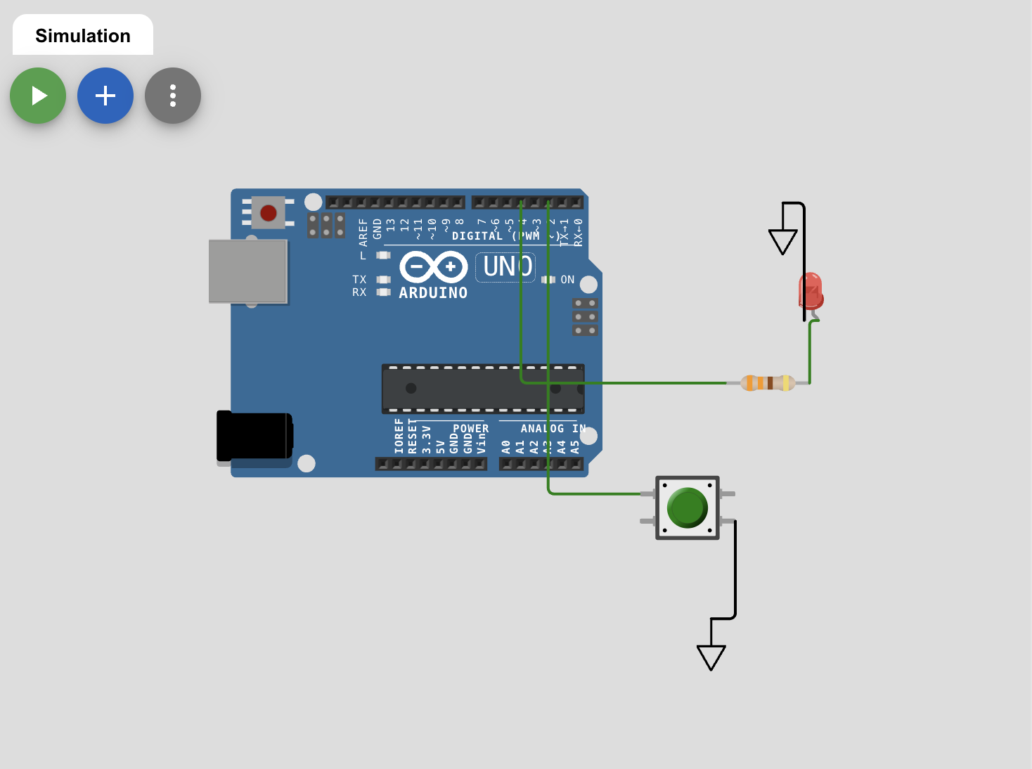
Lab 3 scheme

Runtime Verification
TX packet after button press:
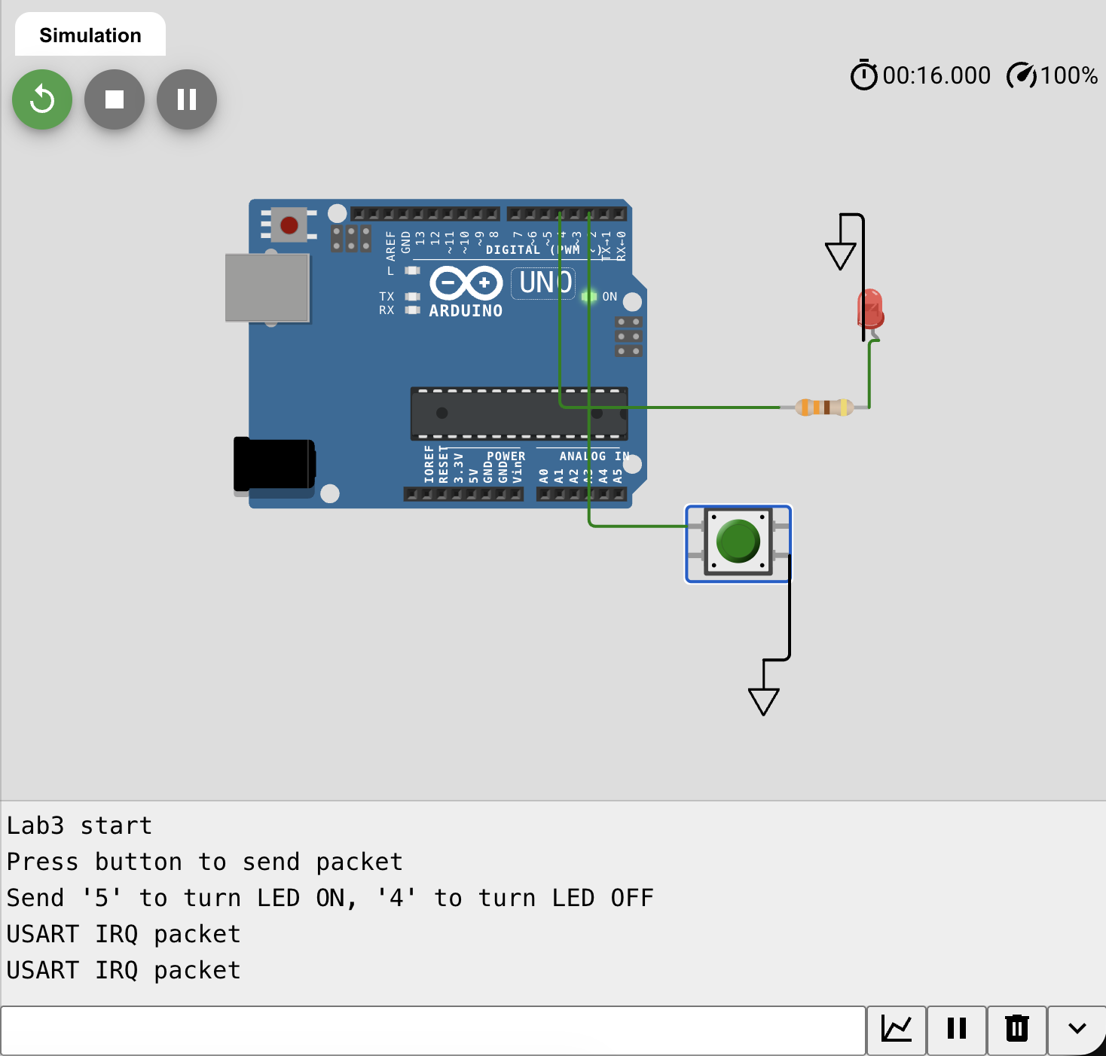
Lab 3 UART TX
RX command processing and LED control:
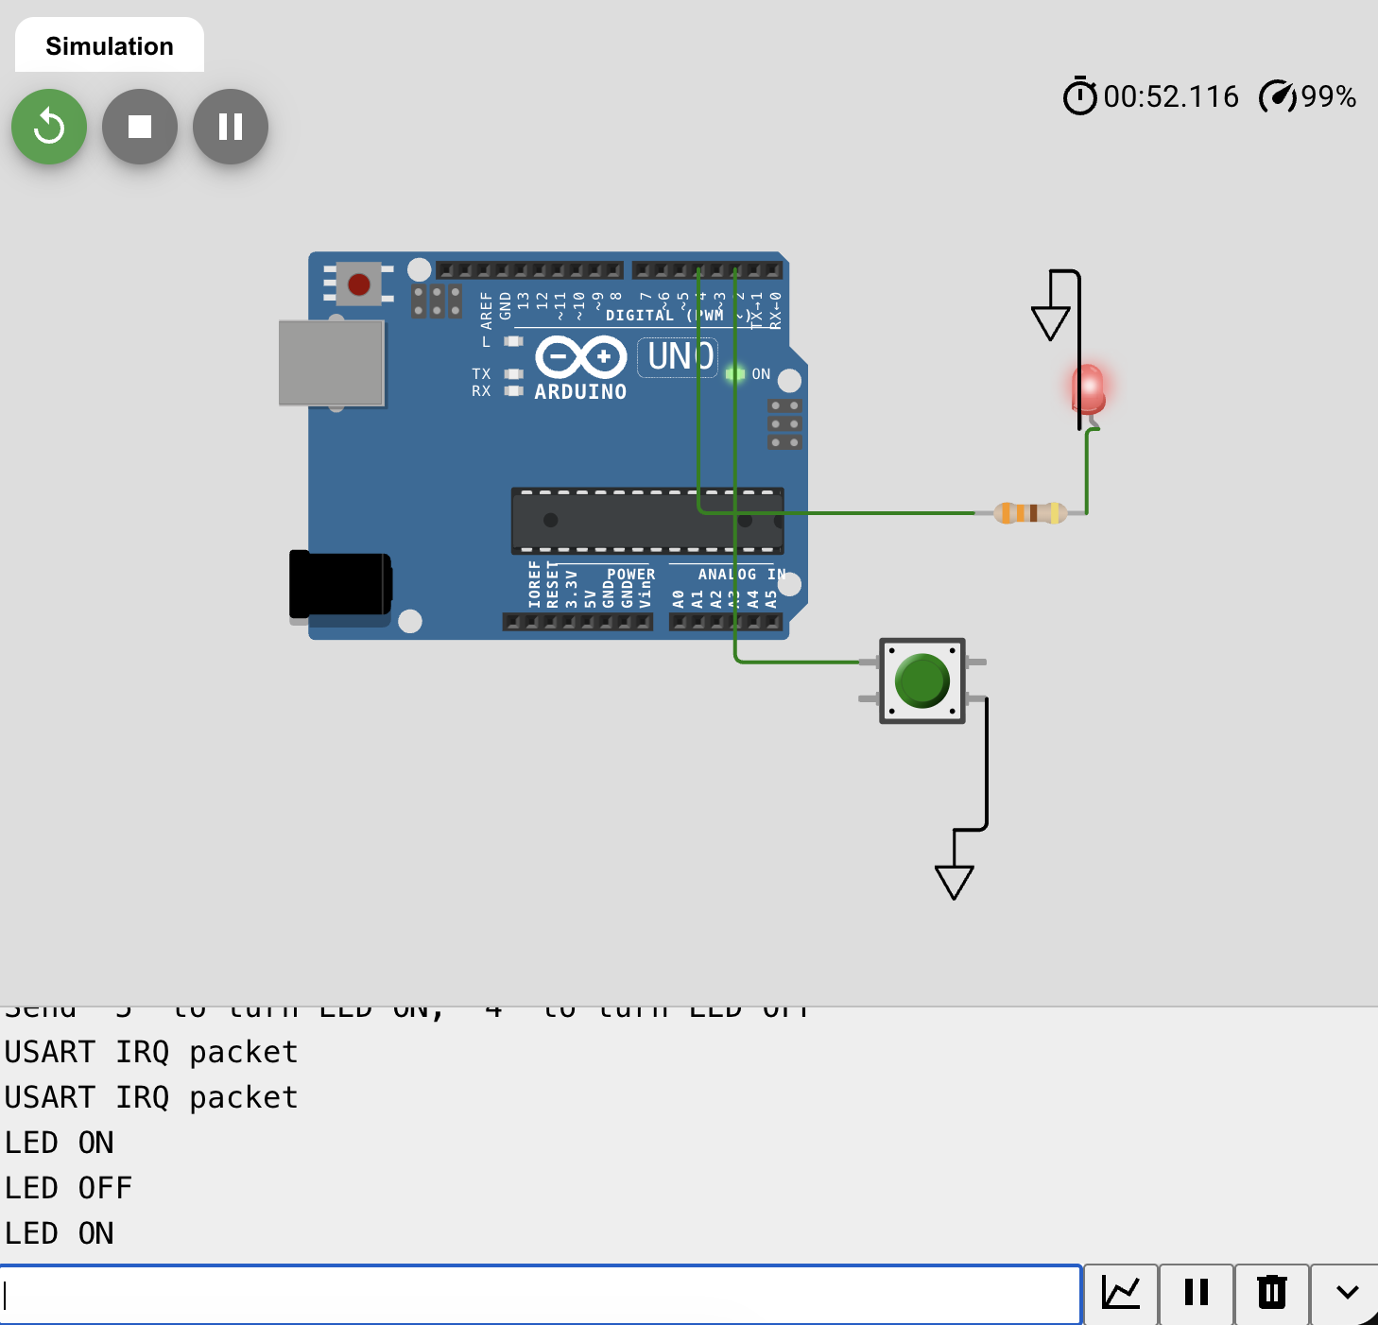
Lab 3 UART RX and LED
Observed behavior: 1. On startup, Serial terminal prints initialization text. 2. Button press sends packet USART IRQ packet. 3. Entering 5 in terminal turns LED ON. 4. Entering 4 in terminal turns LED OFF.

Calculations
USART baud in simulation: - Configured baud rate: 9600 bps. - Terminal baud rate: 9600 bps. - Baud mismatch in this setup: 0%.
Variant logic check: - Task table for variant 5: 4-off, 5-on. - Implemented mapping matches the task.

Code Listing (Wokwi_Lab3_sketch.ino)
const int BTN_SEND = 2;
const int LED_CTRL = 4;
const char CMD_OFF = '4';
const char CMD_ON = '5';
bool btnPrev = false;
void setup() {
pinMode(BTN_SEND, INPUT_PULLUP);
pinMode(LED_CTRL, OUTPUT);
digitalWrite(LED_CTRL, LOW);
Serial.begin(9600);
delay(500);
Serial.println("Lab3 start");
Serial.println("Press button to send packet");
Serial.println("Send '5' to turn LED ON, '4' to turn LED OFF");
}
void sendPacketIRQStyle(const char *s) {
while (*s) {
Serial.write(*s++);
delay(1);
}
}
void loop() {
bool btnNow = (digitalRead(BTN_SEND) == LOW);
if (btnNow && !btnPrev) {
sendPacketIRQStyle("USART IRQ packet\\r\\n");
}
btnPrev = btnNow;
while (Serial.available() > 0) {
char rx = (char)Serial.read();
if (rx == CMD_ON) {
digitalWrite(LED_CTRL, HIGH);
Serial.println("LED ON");
} else if (rx == CMD_OFF) {
digitalWrite(LED_CTRL, LOW);
Serial.println("LED OFF");
}
}
}
Additional microcontroller implementation file (STM32 source used in project structure): - Lab3_main.c

Conclusion
Laboratory work 3 was completed. Packet transmission on button press and receive-based LED control were implemented and verified. Variant 5 conditions (4/5) are fully satisfied.

