Work 2. Optimal control design with fixed endpoints in Simulink (variant 5)

Problem statement
A second-order linear plant of variant 5 with prescribed boundary conditions is considered. The goal is to design the optimal open-loop control that minimises the integral quadratic cost and drives the system from the initial state to the given final state.
${\overset{˙}{x}}_{1}=x_{2},{\overset{˙}{x}}_{2}=−6x_{1}−5x_{2}+u$
$J=\int_{0}^{4}{(x_{1}^{2}+4x_{2}^{2}+5u^{2})dt}$
$x(0)=0,x_{1}(4)=1,x_{2}(4)=0$

Simulink model
In the Simulink model the state-space block reproduces the plant dynamics, a source feeds the optimal open-loop control obtained from Pontryagin's maximum principle, and the To Workspace blocks store the state, control and accumulated cost trajectories. A screenshot of the model is shown below.
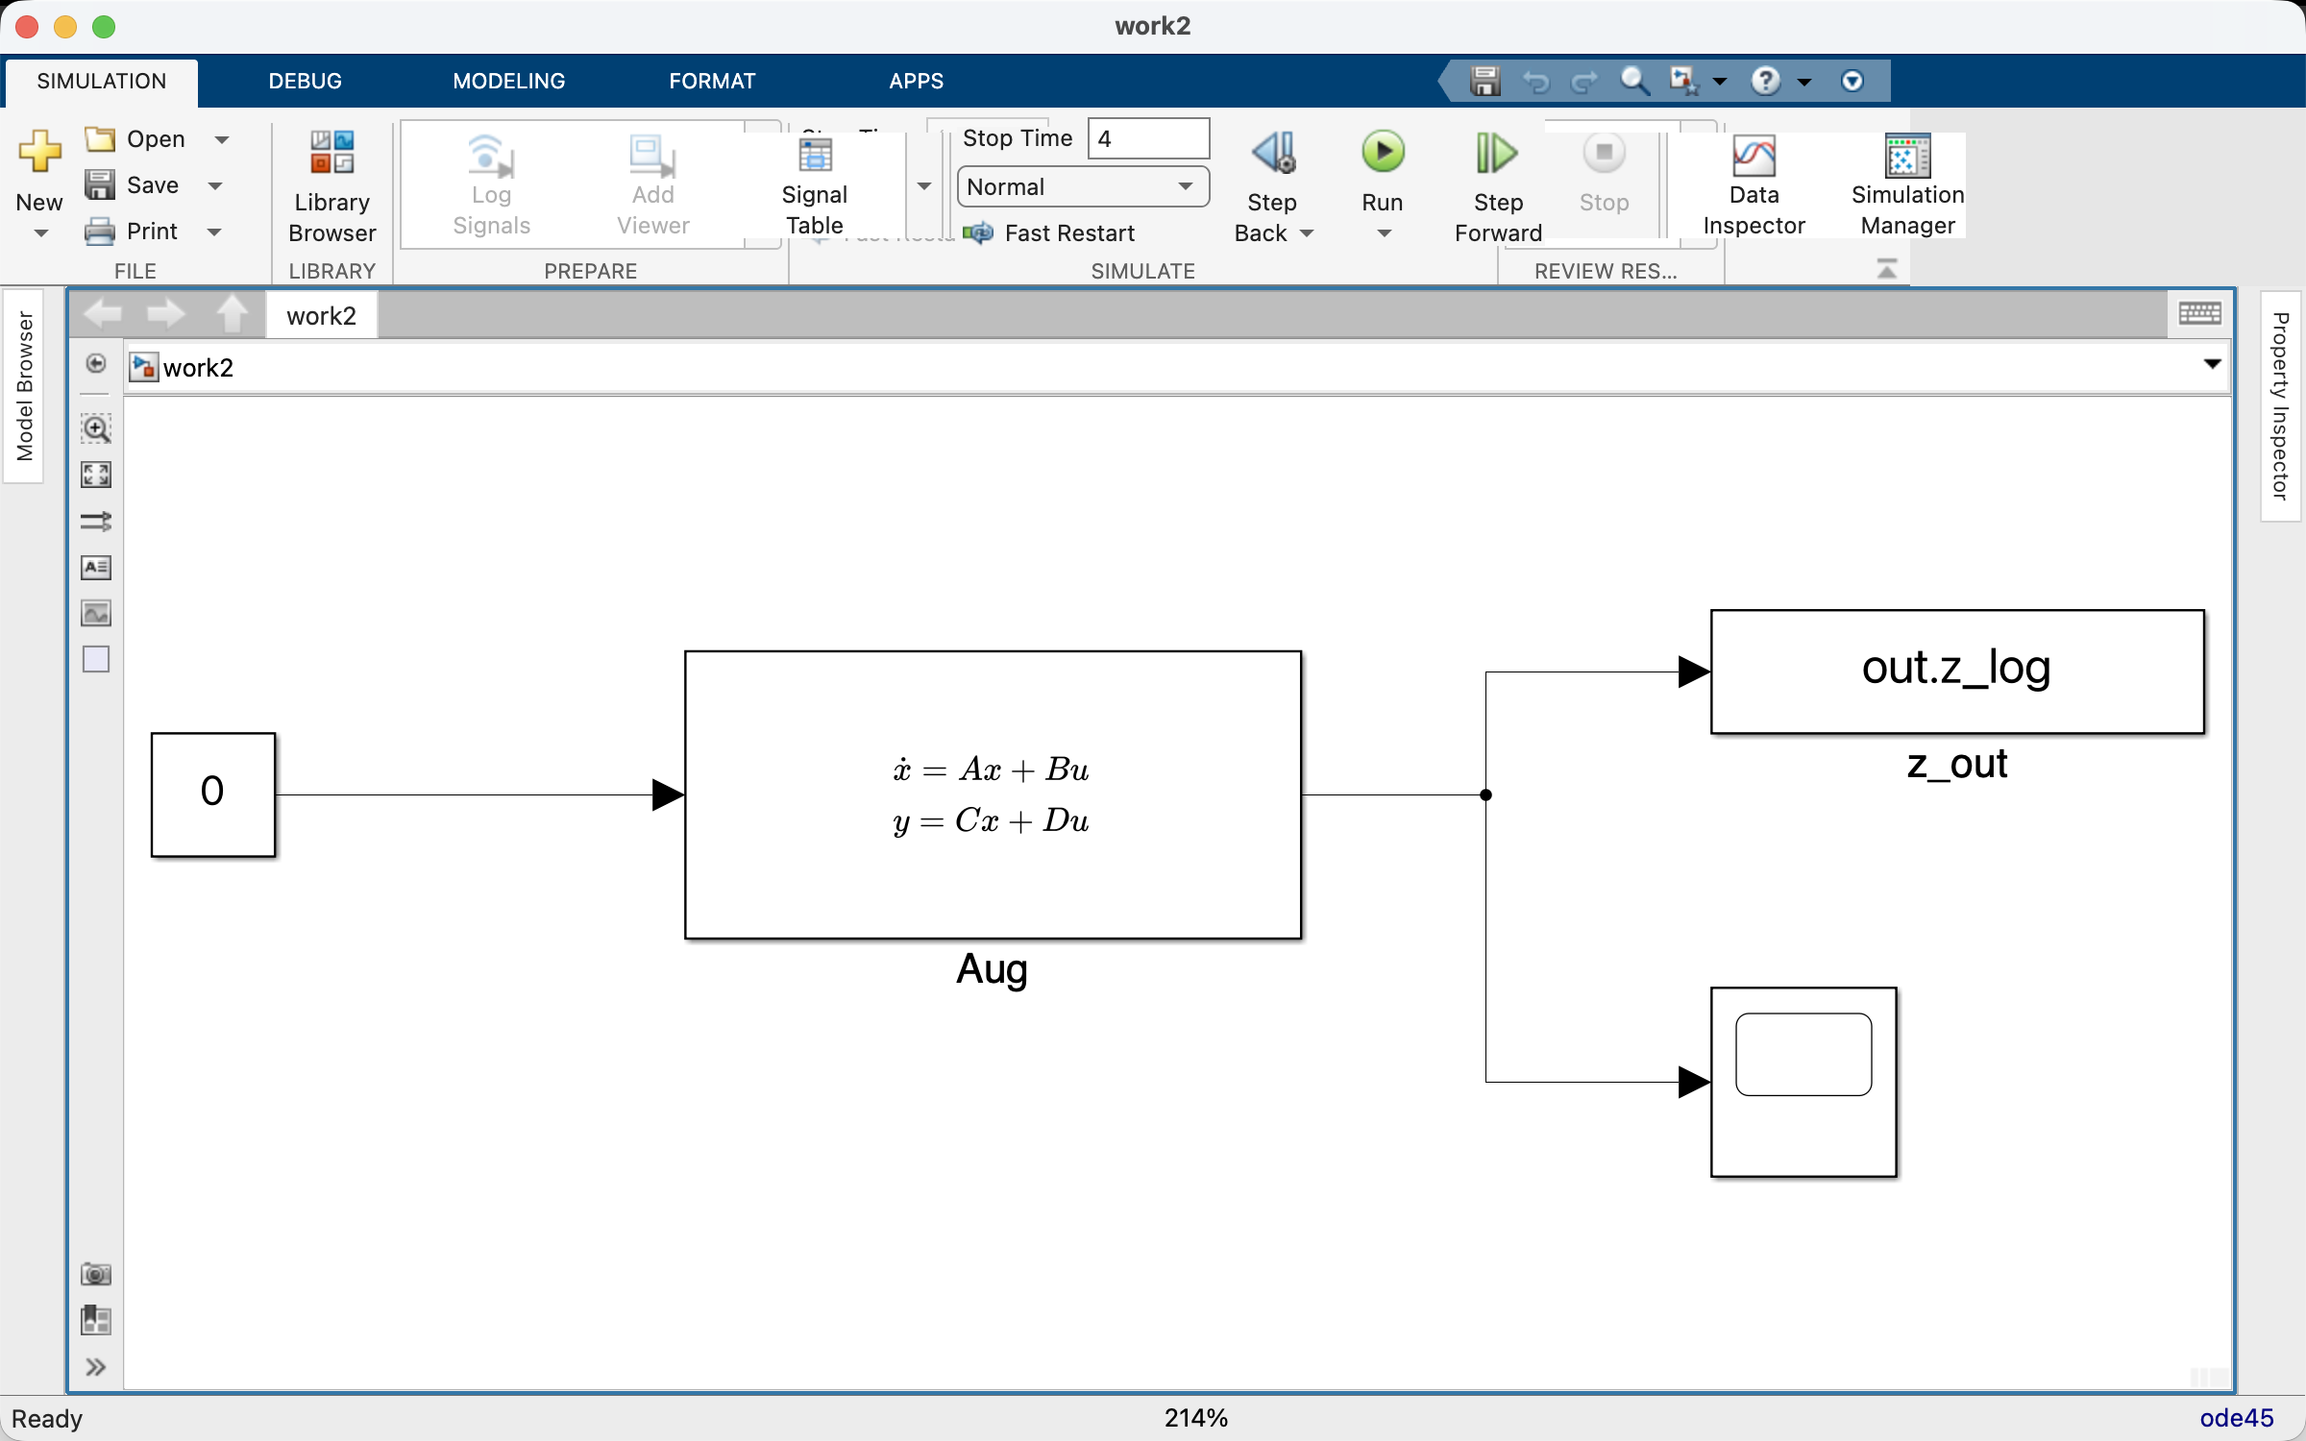

Simulation results
The integration yields the trajectories of the phase variables x1, x2, the optimal control u and the accumulated cost J. The final state practically matches the target x(4) = [1, 0], and the cost value agrees with the Python reference. The cost is evaluated from the dense solution of the boundary value problem. The dependence of the cost on the control weight r is also plotted; its minimum is attained at r = 5, which confirms the optimality of the nominal controller.
x(4) = [0.9996, -0.0015] (target [1, 0])
optimal cost J = 302.9034
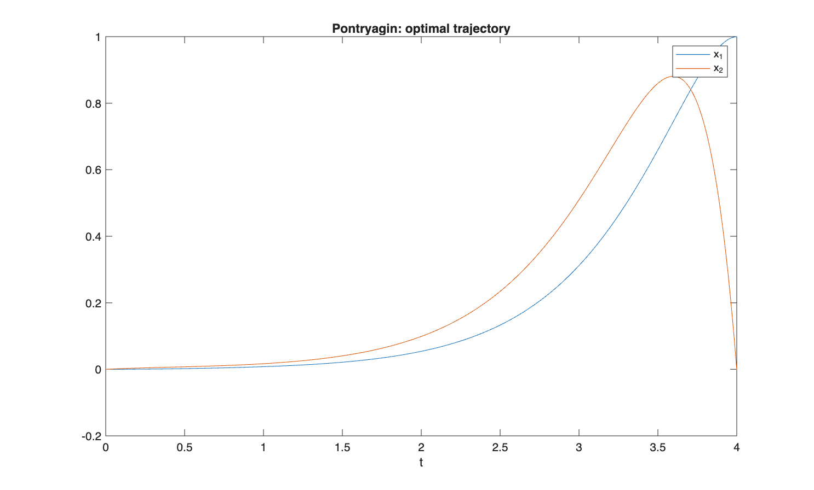
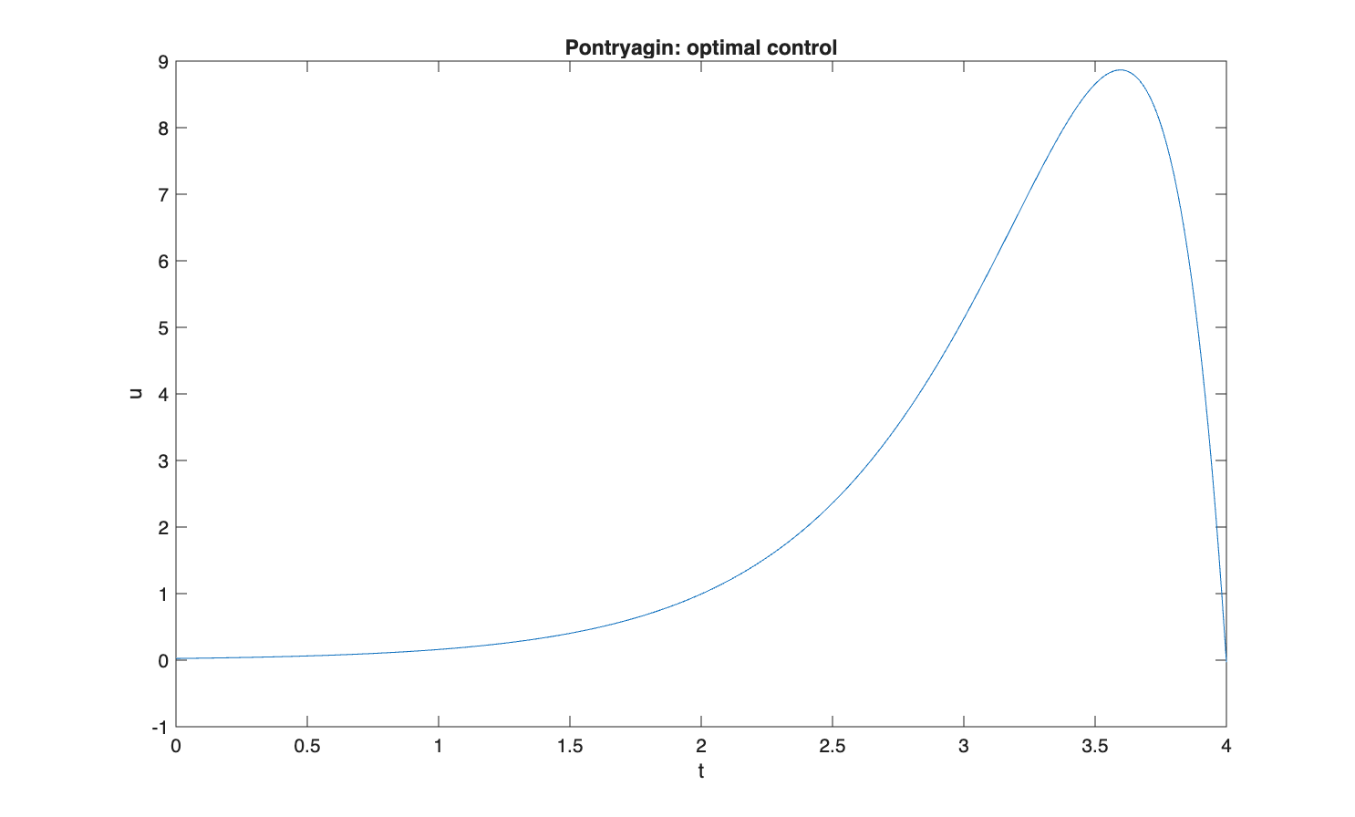
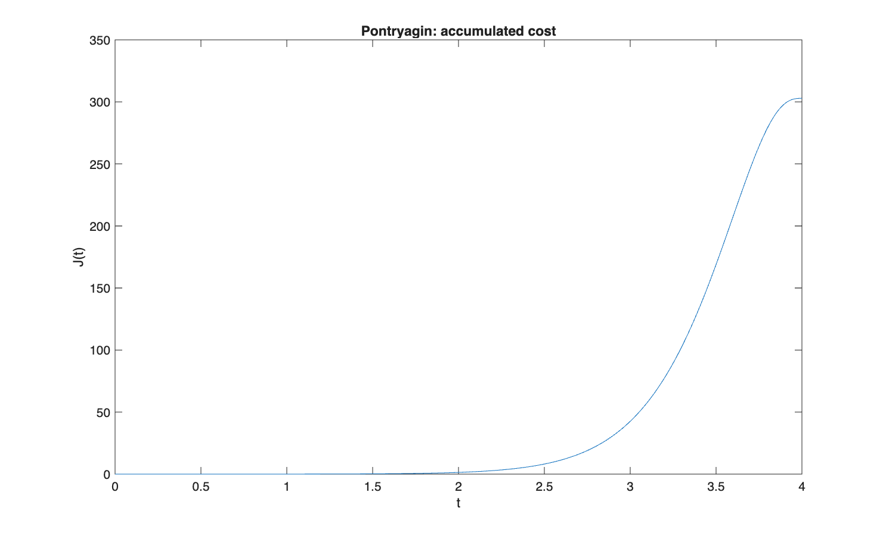
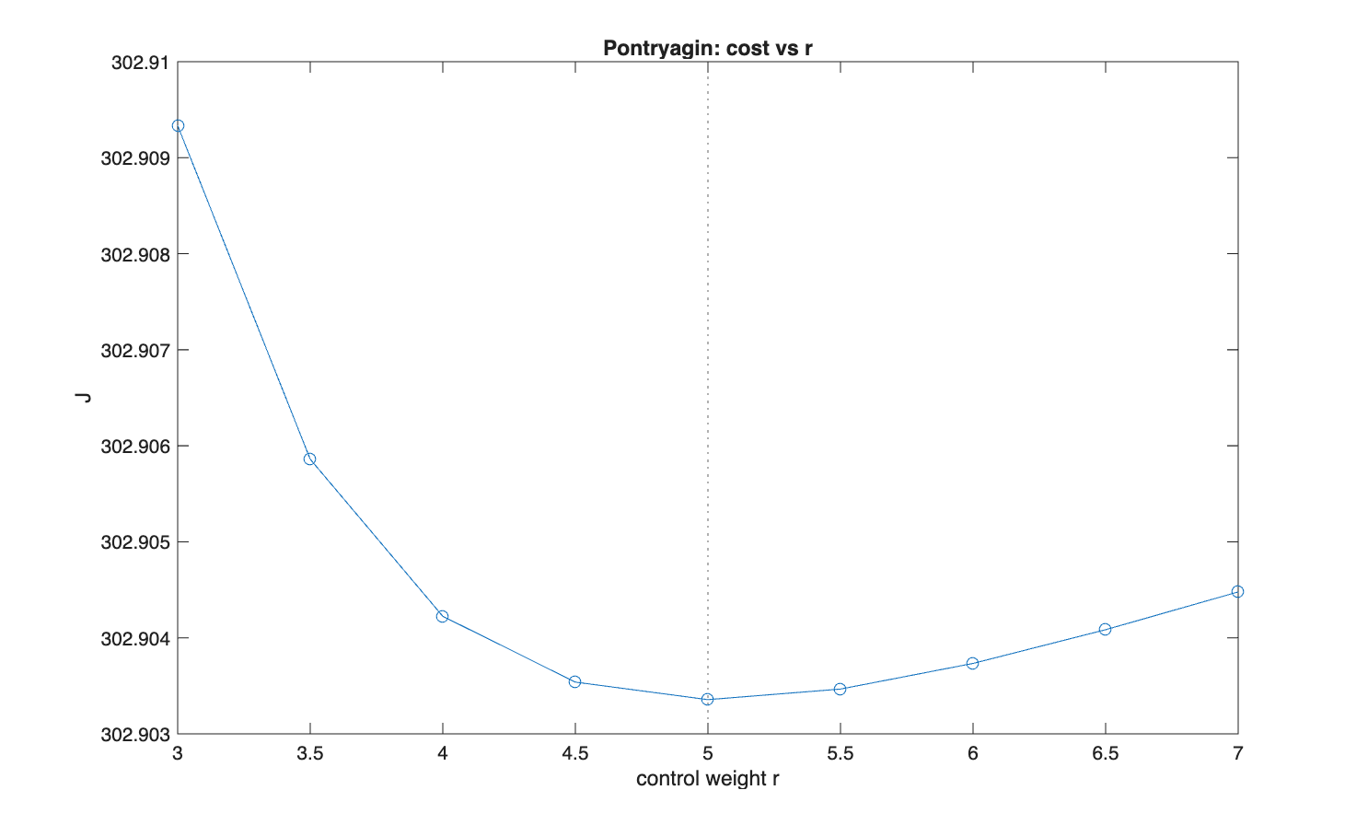

Comparison with Python / analytical reference
Numerical results of the Simulink model compared against the Python / analytical reference.
Quantity | Simulink | Python reference
x(T), component 1 | 0.9996 | 1.0000
x(T), component 2 | -0.0015 | 0.0000
Cost J_opt | 302.9034 | 302.9033

Conclusion
The Simulink model reproduces the optimal open-loop control: the final state x(T) converges to the target [1, 0], and the cost value J agrees with the Python reference (J ~ 302.90). The dependence J(r) has a minimum at r = 5, which confirms the optimality of the obtained solution.

