Work 3. LQR controller design in Simulink (variant 5)

Problem statement
For the linear time-invariant plant of variant 5 the goal is to design the optimal state-feedback controller u = -Kx that minimises the quadratic cost over an infinite horizon.
$\overset{˙}{x}=Ax+bu,u=−Kx$
$A=\left[\begin{matrix}0 & 1 \\ −2 & 5\end{matrix}\right], b=\left[\begin{matrix}0 \\ 3\end{matrix}\right], Q=\left[\begin{matrix}1 & 0 \\ 0 & 2\end{matrix}\right], r=5$
$J=\int_{0}^{∞}{(x^{T}Qx+ru^{2})dt}$

Simulink model
The plant is described in state space, the state feedback applies the gain K obtained from the algebraic Riccati equation, and the logging blocks record the states, control and accumulated cost. A screenshot of the model is shown below.
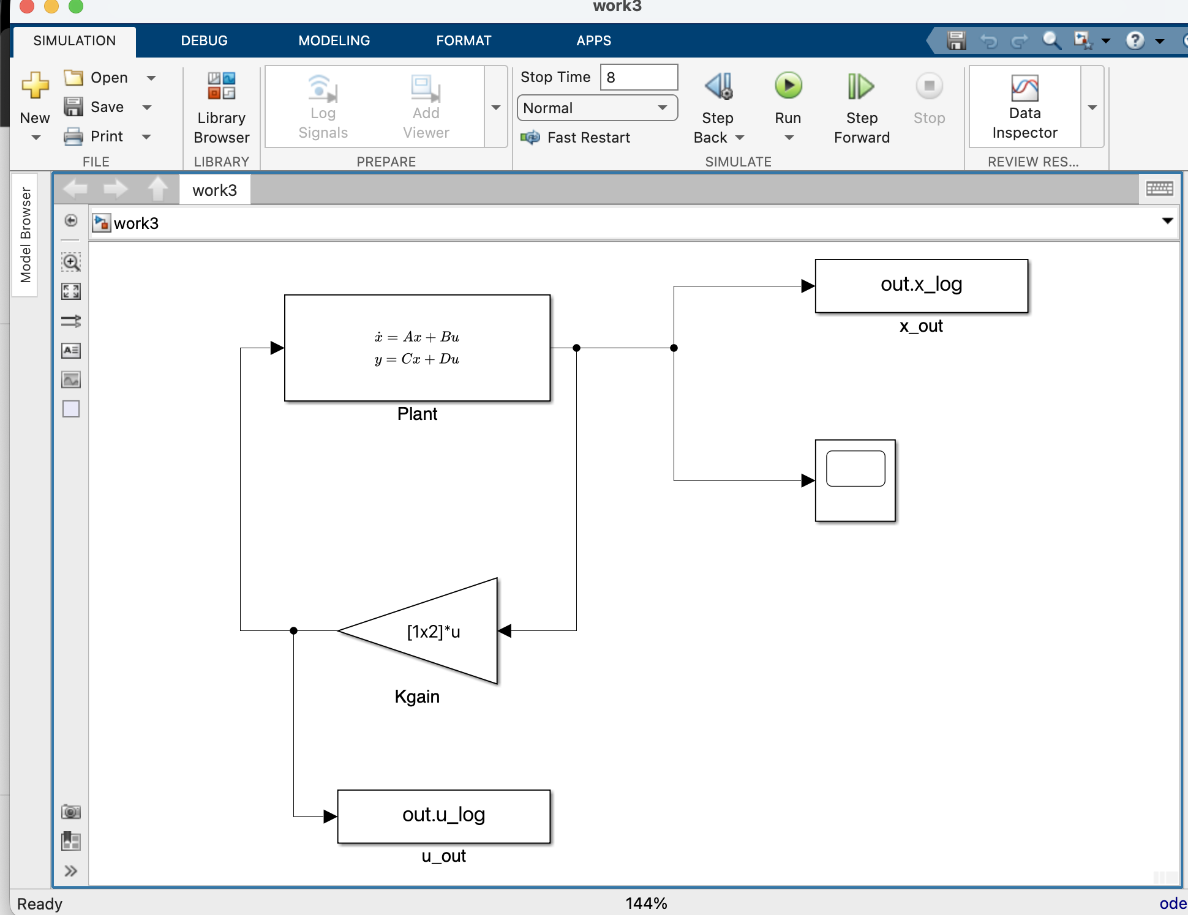

Simulation results
The trajectories of the states x1, x2, the control u and the accumulated cost J are obtained for x(0) = [1, 0]. The closed-loop matrix A - bK is Hurwitz. The effect of the control weight r and of the matrix Q on the transient is studied, as well as the response to a 5% change of the gain K while stability is preserved; for each experiment x1, x2, u and J are plotted.
K = [0.1361, 3.4746]
real parts of the eigenvalues = [-4.9358, -0.4879]
steady-state cost J = x0' P x0 = 12.8122
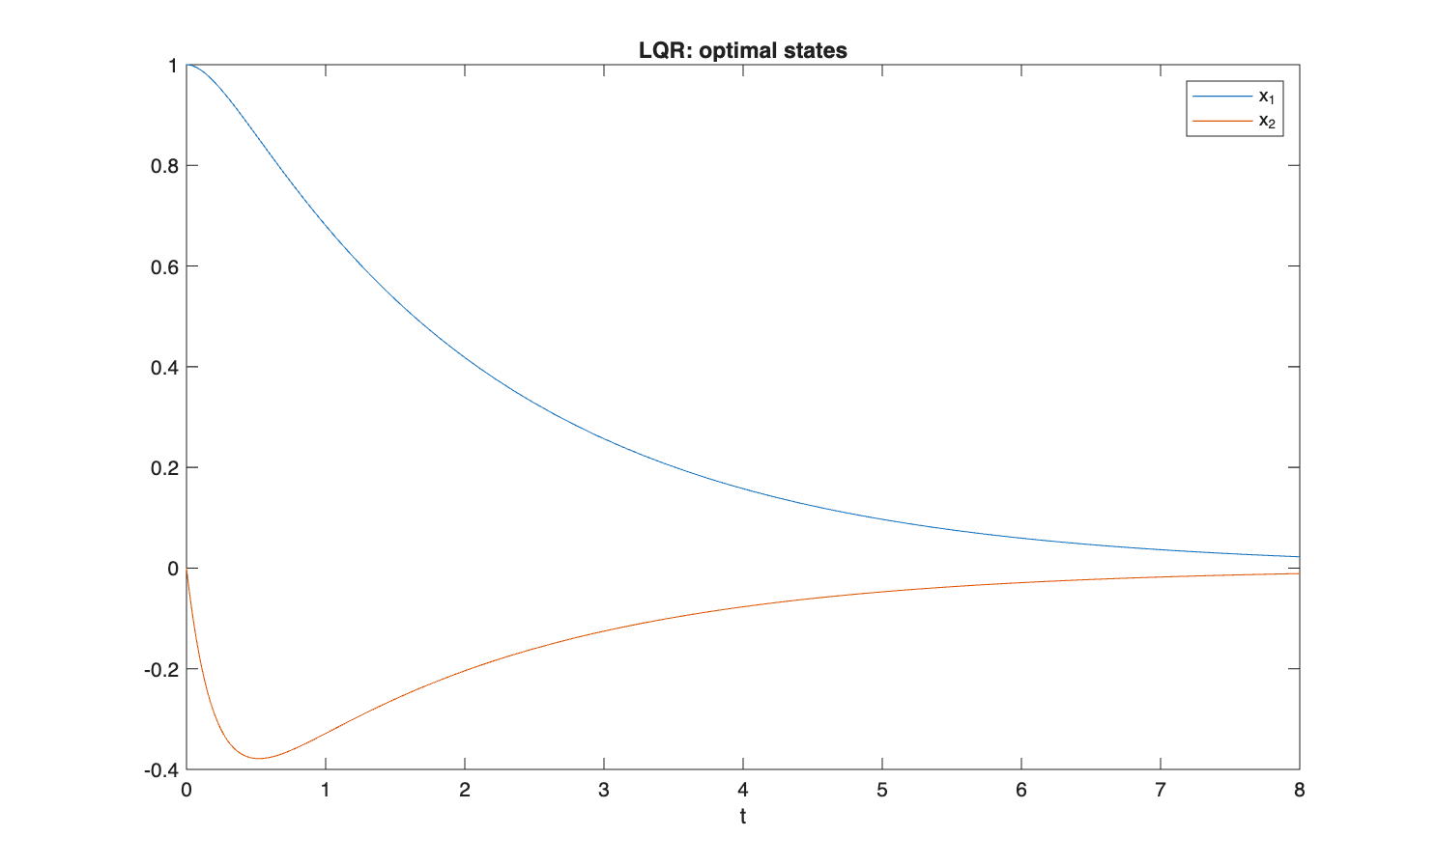
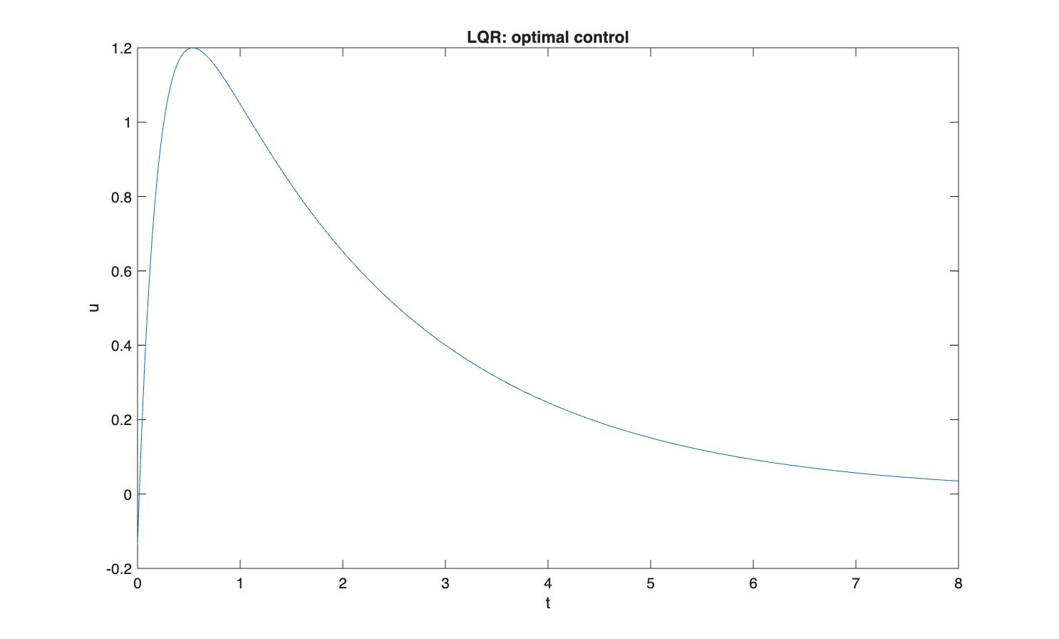
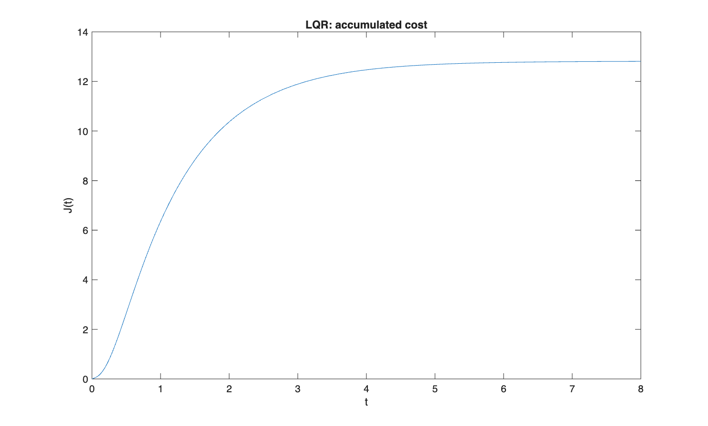
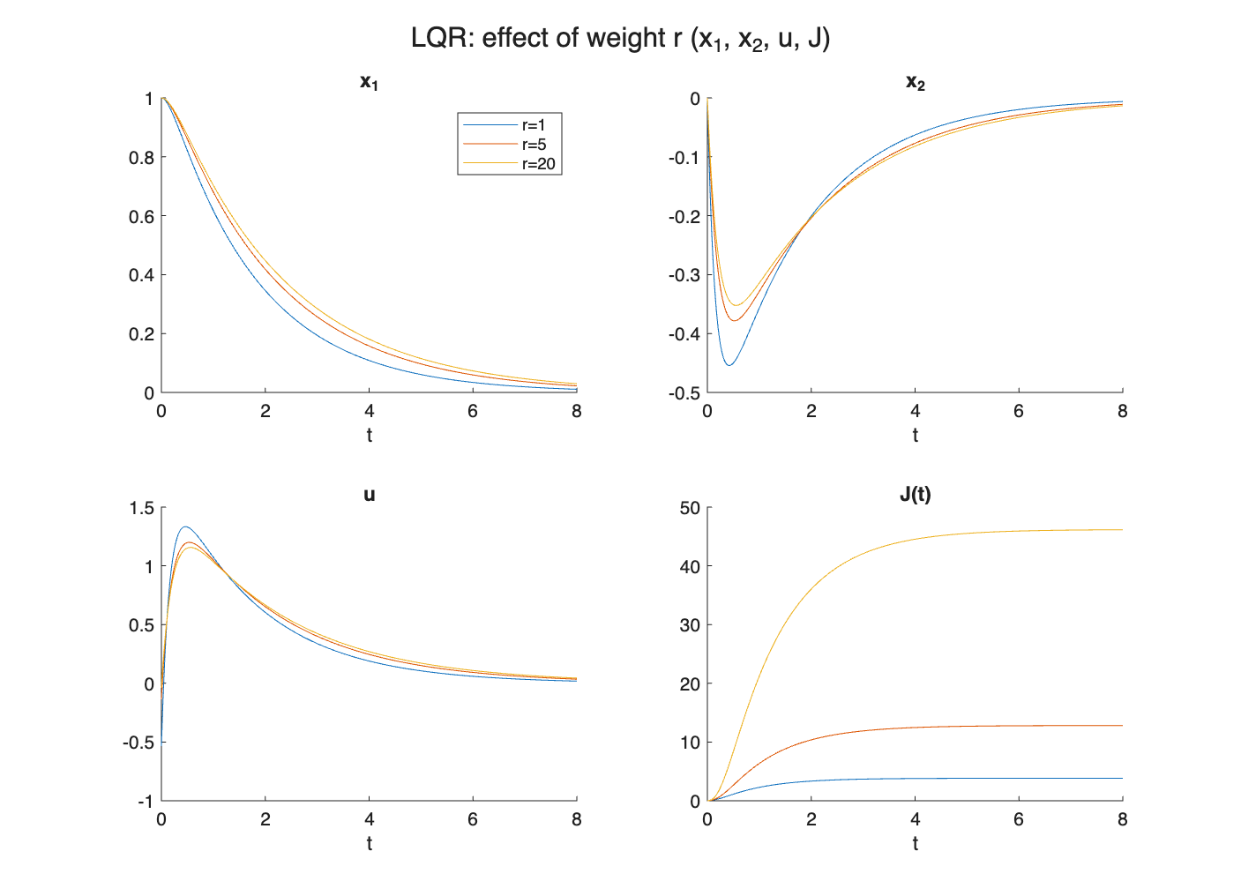
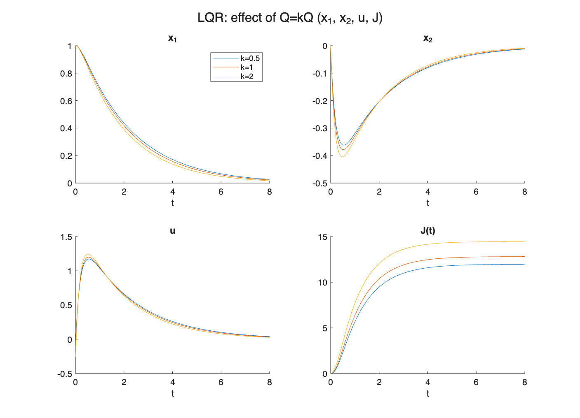
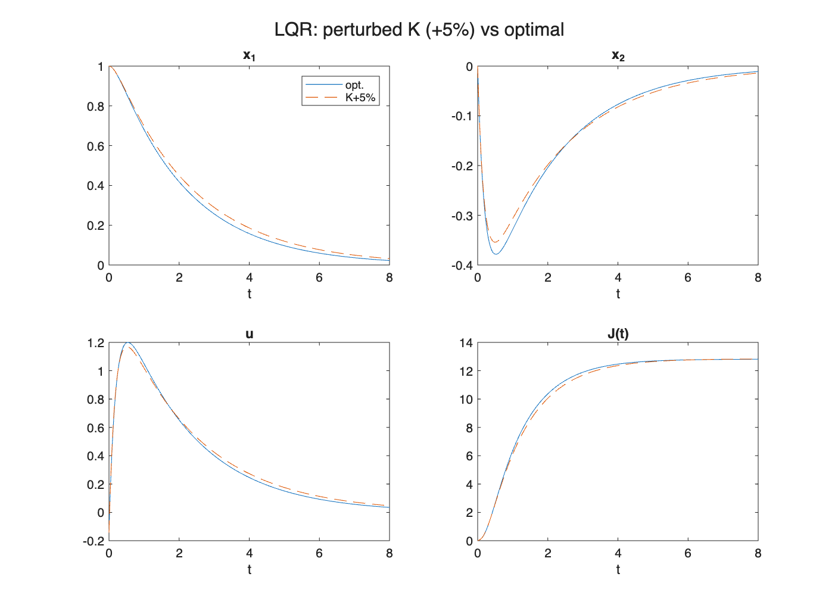

Comparison with Python / analytical reference
Numerical results of the Simulink model compared against the Python / analytical reference.
Quantity | Simulink | Python reference
K[0] | 0.1361 | 0.1361
K[1] | 3.4746 | 3.4746
J_inf | 12.8122 | 12.8122
Re(eig) [1] | -4.9358 | -4.9358
Re(eig) [2] | -0.4879 | -0.4879

Conclusion
The controller gain K, the steady-state cost J and the closed-loop eigenvalues obtained in Simulink agree with the Python reference to better than 1e-3, which confirms the correctness of the model.

