Work 4. Optimal control design by Bellman's dynamic programming in Simulink (variant 5)

Problem statement
A finite-horizon optimal control problem is considered; the matrices A, b, Q and the weight r are taken from work 2. The goal is to design the optimal control by Bellman's dynamic programming method.
$\overset{˙}{x}=Ax+bu,x(0)=[1, 0]^{T}$
$J=\int_{0}^{5}{(x^{T}Qx+ru^{2})dt}$
$A=\left[\begin{matrix}0 & 1 \\ −6 & −5\end{matrix}\right], b=\left[\begin{matrix}0 \\ 1\end{matrix}\right], Q=diag(1,4), r=5$

Simulink model
The Riccati differential equation is integrated backward in time from the terminal condition P(T) = 0, which yields the time-varying gain K(t) = r^-1 b' P(t). In the model the plant is closed by this time-varying feedback, and the logging blocks record the states, control and gain. A screenshot of the model is shown below.
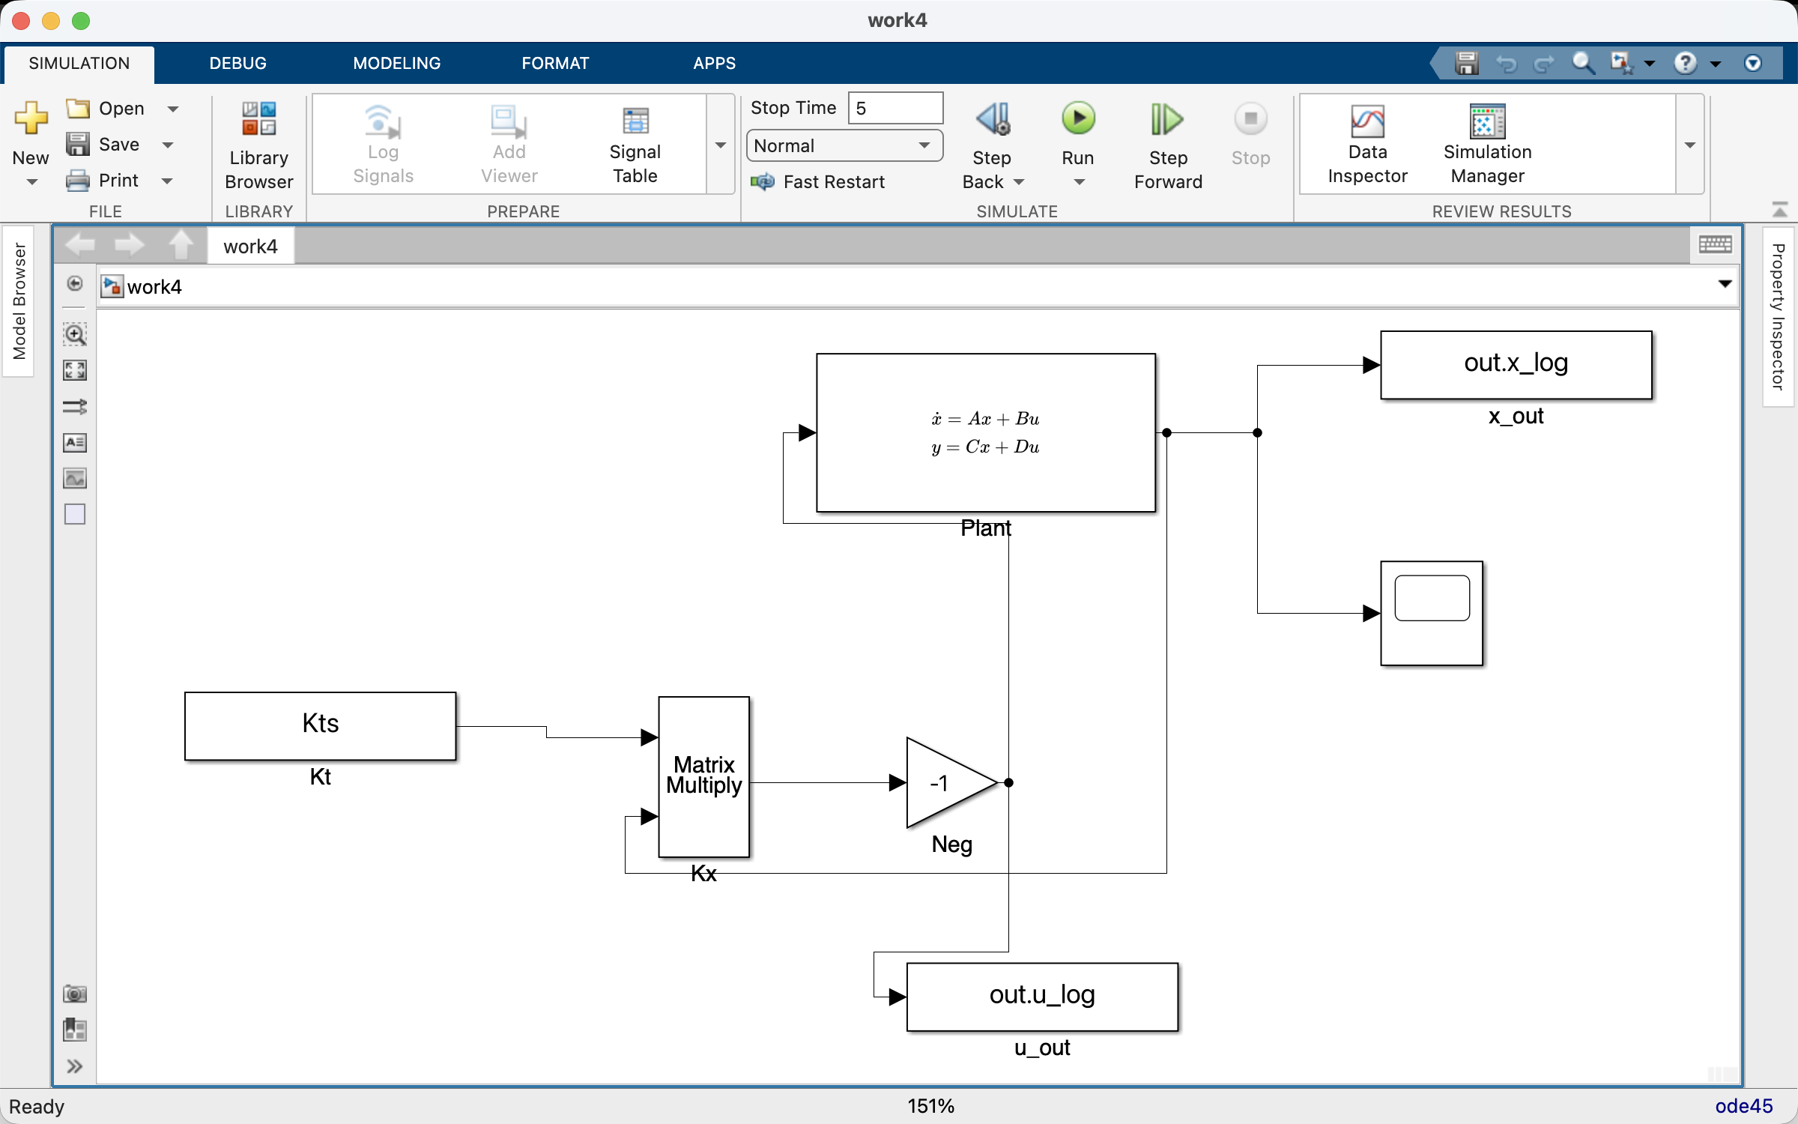

Simulation results
The trajectories of the states x1, x2, the control u, the time-varying gain K(t), the accumulated cost J(t) and the cost under deviation of the controller parameters from the optimal ones (K(t) scaled by 0.8 and 1.2) are plotted. Over most of the horizon the gain is close to its stationary value and changes sharply near the terminal time, where P(t) vanishes. The dependence of the terminal cost J(T) on the controller scale has its minimum exactly at the optimal gain (scale 1): any deviation increases the cost, which confirms the optimality of the design. The initial gain K(0) and the optimal cost agree with the Python reference.
K(0) = [0.0166, 0.0826]
optimal cost J = 2.9023
accumulated Simulink cost J(T) = 2.9026
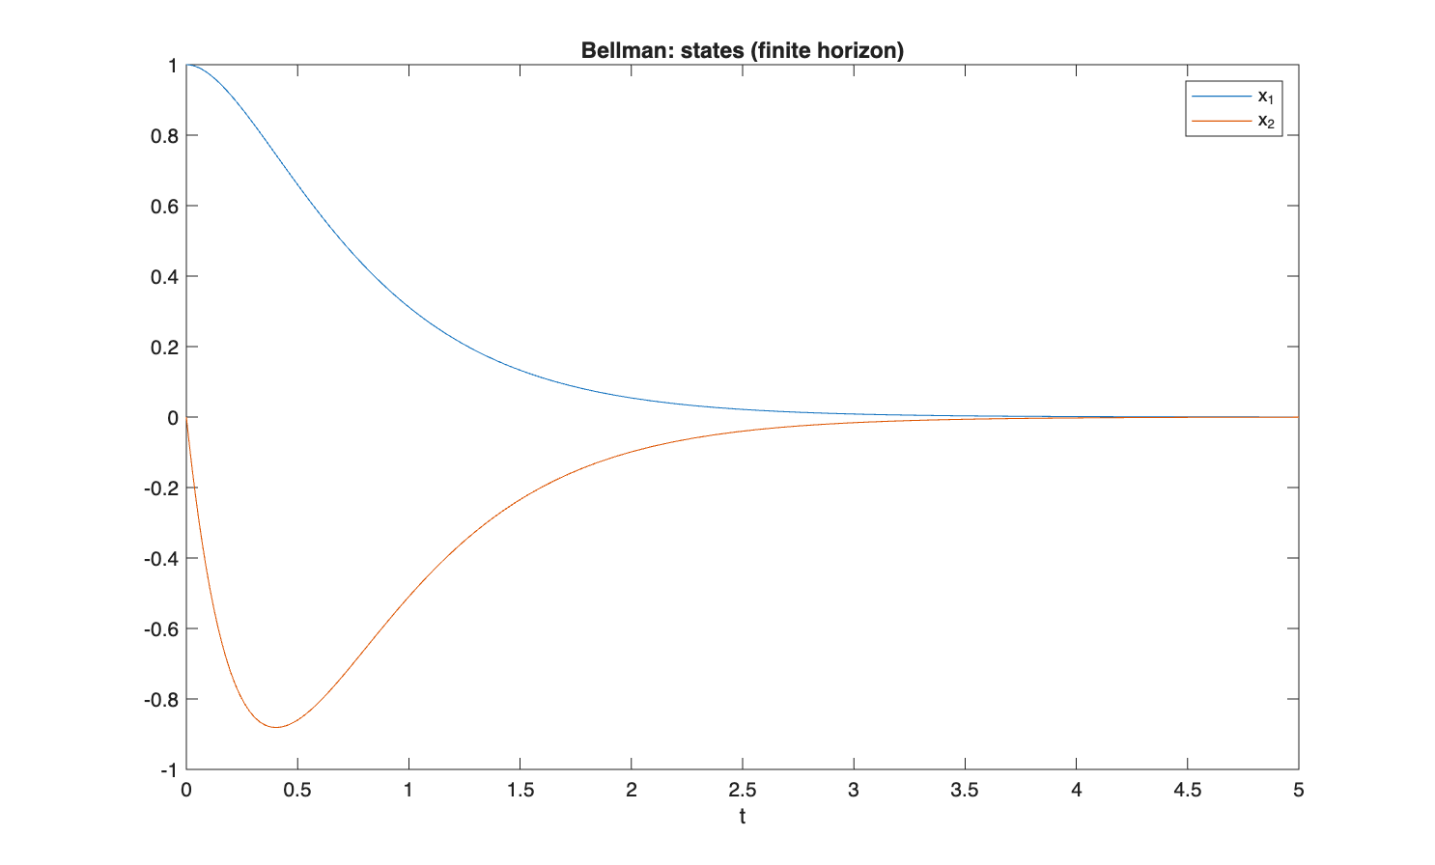
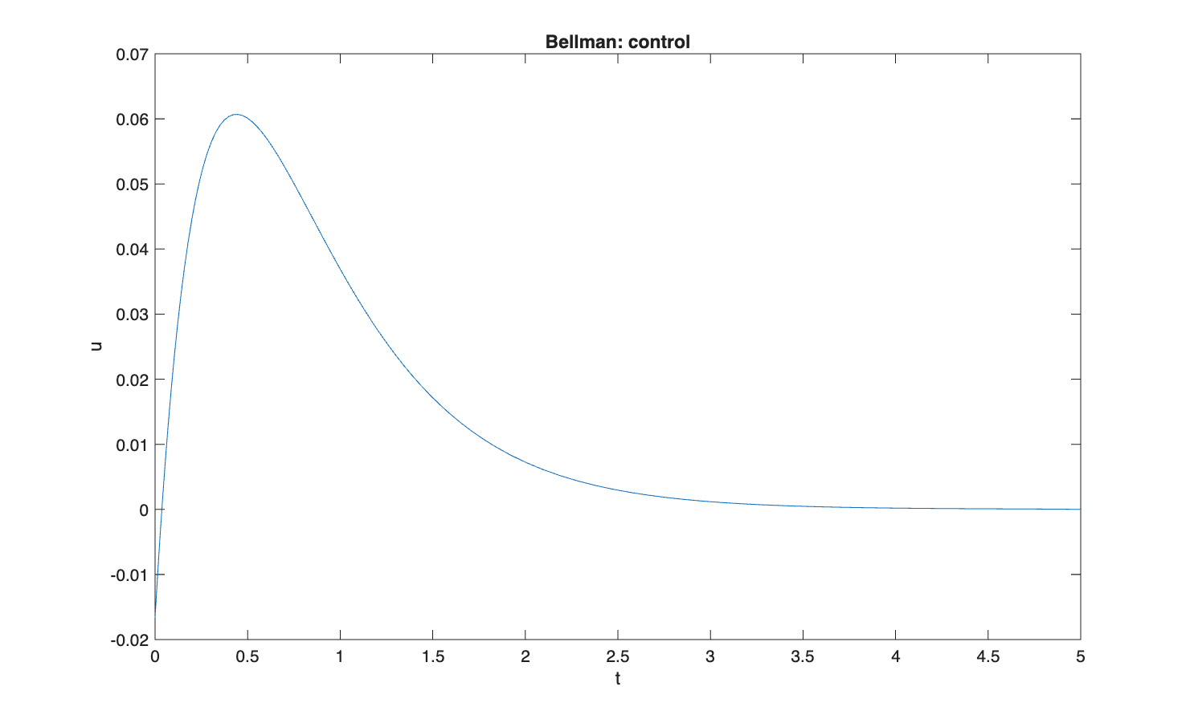
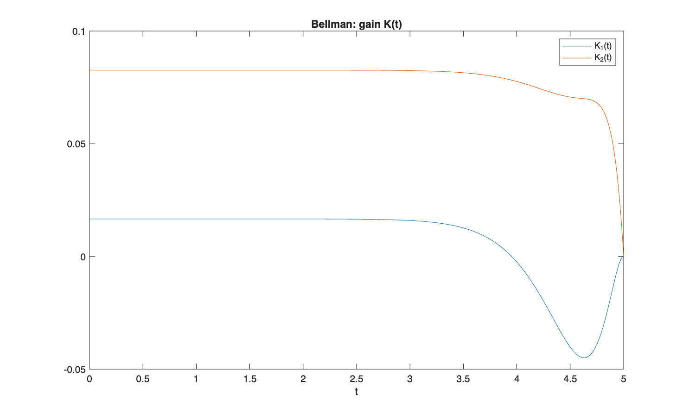
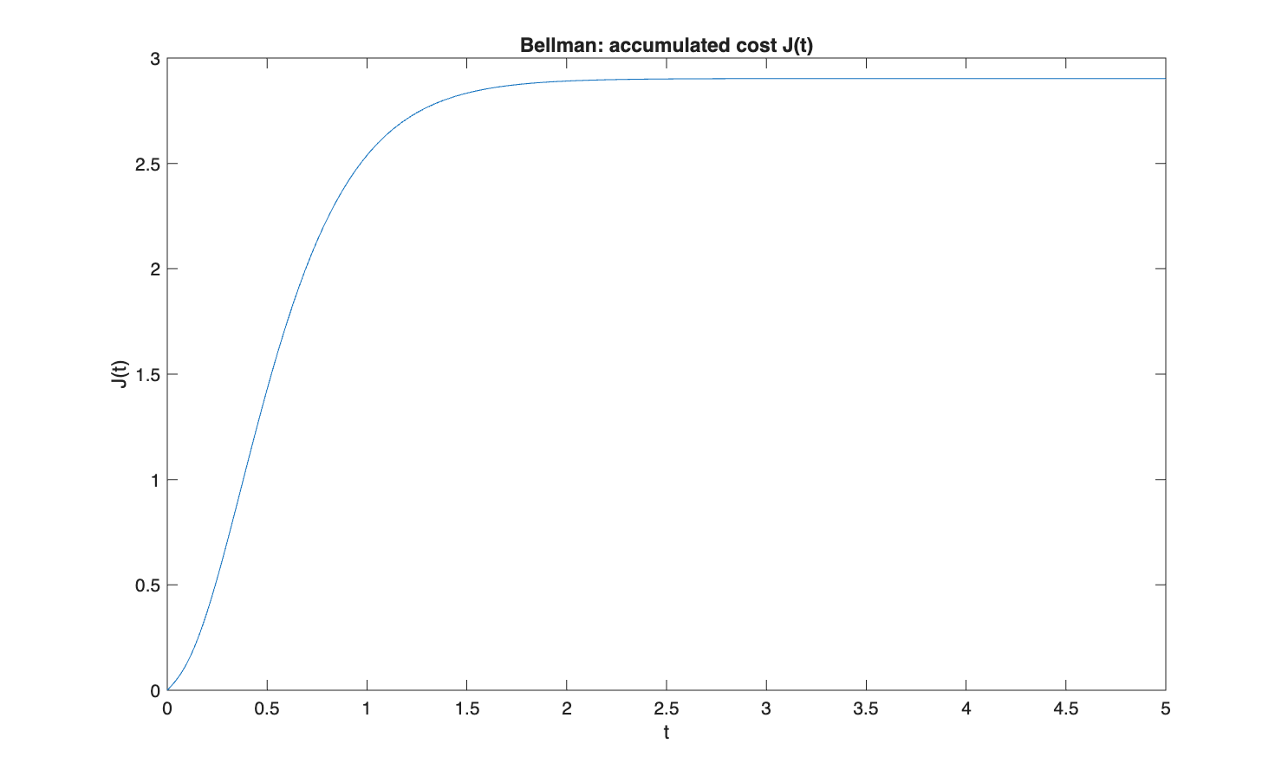
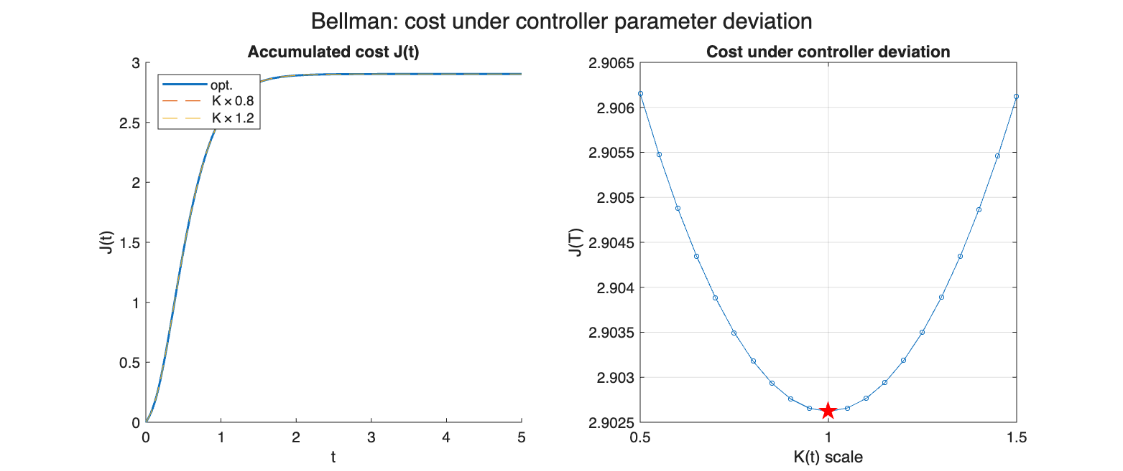

Comparison with Python / analytical reference
Numerical results of the Simulink model compared against the Python / analytical reference.
Quantity | Simulink | Python reference
K0[0] | 0.0166 | 0.0166
K0[1] | 0.0826 | 0.0826
J_opt | 2.9023 | 2.9023

Conclusion
The initial gain K(0) and the optimal cost J obtained in Simulink agree with the Python reference to better than 1e-3, which confirms the correctness of the dynamic-programming implementation.

