Work 5. Optimal observer (Kalman filter) and LQG controller in Simulink (variant 5)

Problem statement
A linear plant of variant 5 with process noise and measurement noise is considered. The goal is to design the optimal observer (Kalman filter) and, based on it, the LQG controller.
$\overset{˙}{x}=Ax+bu+Gw,y=Cx+v$
$A=\left[\begin{matrix}0 & −4 \\ 1 & −4\end{matrix}\right], b=\left[\begin{matrix}8 \\ 7\end{matrix}\right], C=[1 0], G=I$
$W=\left[\begin{matrix}4 & 3.5 \\ 3.5 & 5\end{matrix}\right], V=5$

Simulink model
The plant is driven by process noise, the measurement is noisy, and the observer reconstructs the state with the Kalman gain L = P C' V^-1. The LQG controller forms the control u = -K x_hat from the state estimate. The logging blocks record the estimates, the estimation errors and the control. A screenshot of the model is shown below.
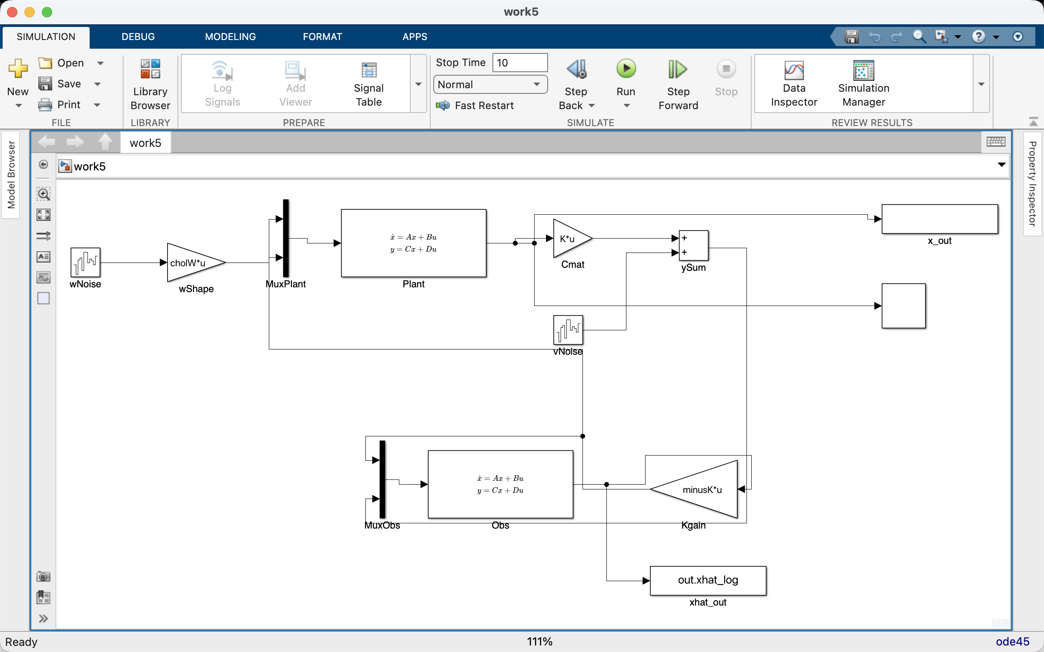

Simulation results
The trajectories of the state estimates, the estimation errors and the LQG controller signals are obtained. The process noise is formed as cholW*(unit white noise), so that the spectral density of the process noise equals the prescribed matrix W; the measurement noise has intensity V. The Kalman filter keeps the estimation error in a small neighbourhood of zero of order sqrt(tr P). The observer optimality cost J = M[e_H' e_H] (the expected squared estimation error) is computed; in steady state E[e e'] = P, hence J = tr(P). The error dynamics e' = (A-LC)e + Gw - Lv do not depend on the control, so J is the same for u = sin t and for the LQG feedback. The effect of a non-optimal gain L and of changing the noise intensities W and V on the estimation quality is studied. The gains L, K and the closed-loop LQG eigenvalues agree with the Python reference.
L = [0.2738, 0.0906]
K = [0.2046, 0.4465]
estimation-error cost J = tr(P) = 2.1024
real parts of the LQG eigenvalues = [-7.6683, -1.0942]
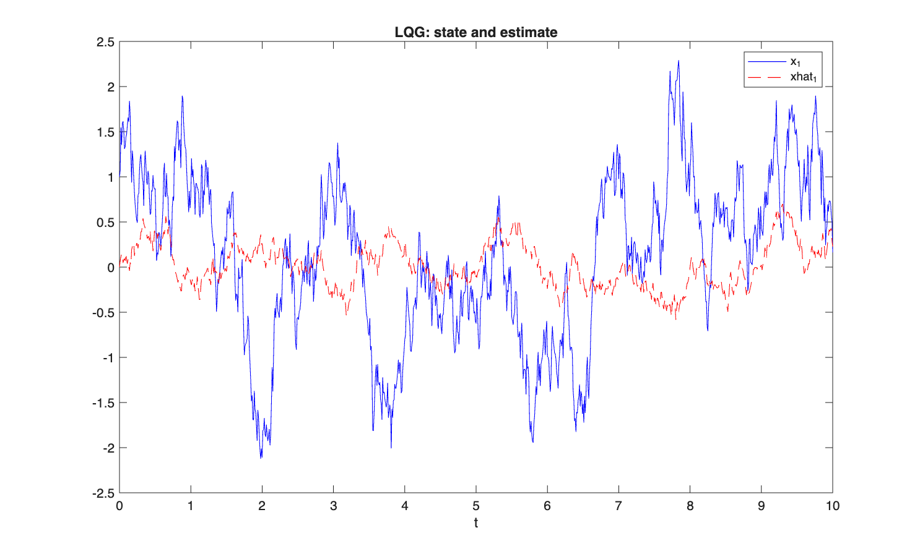
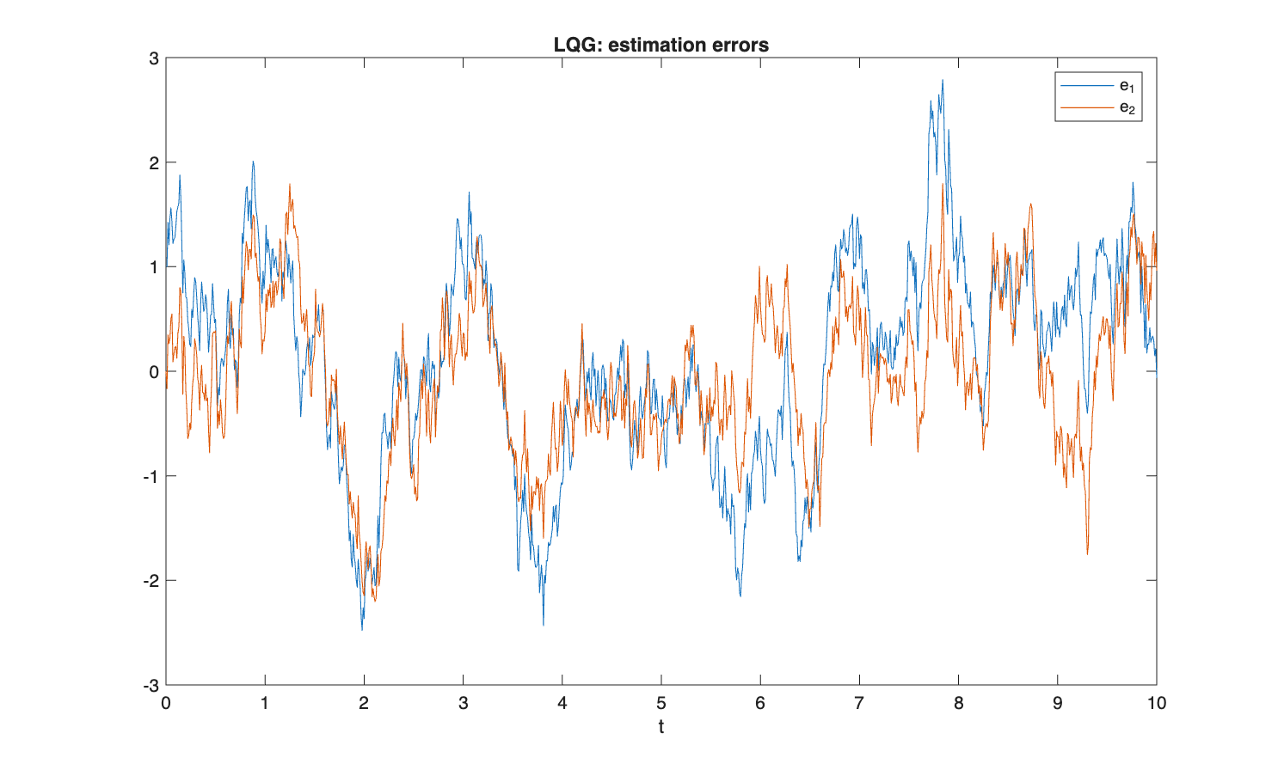
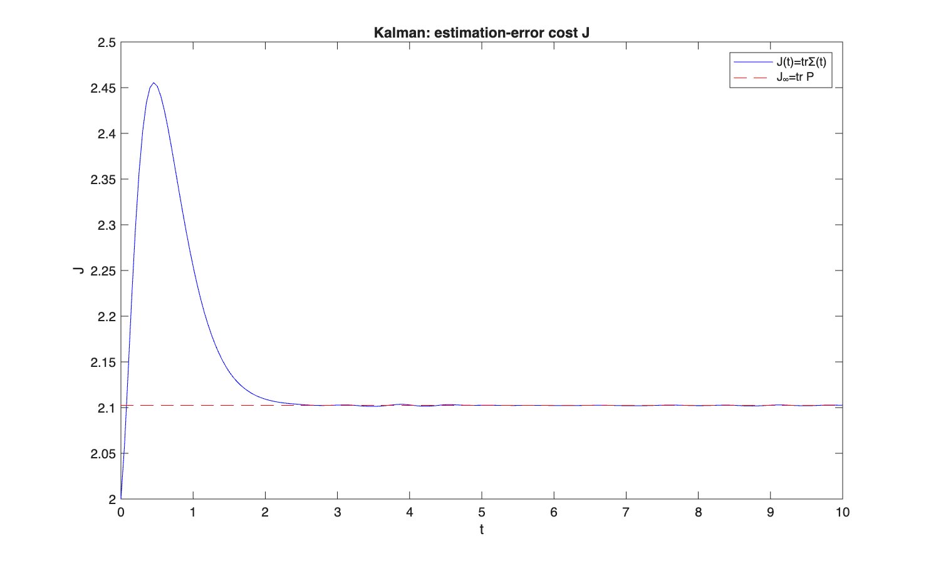
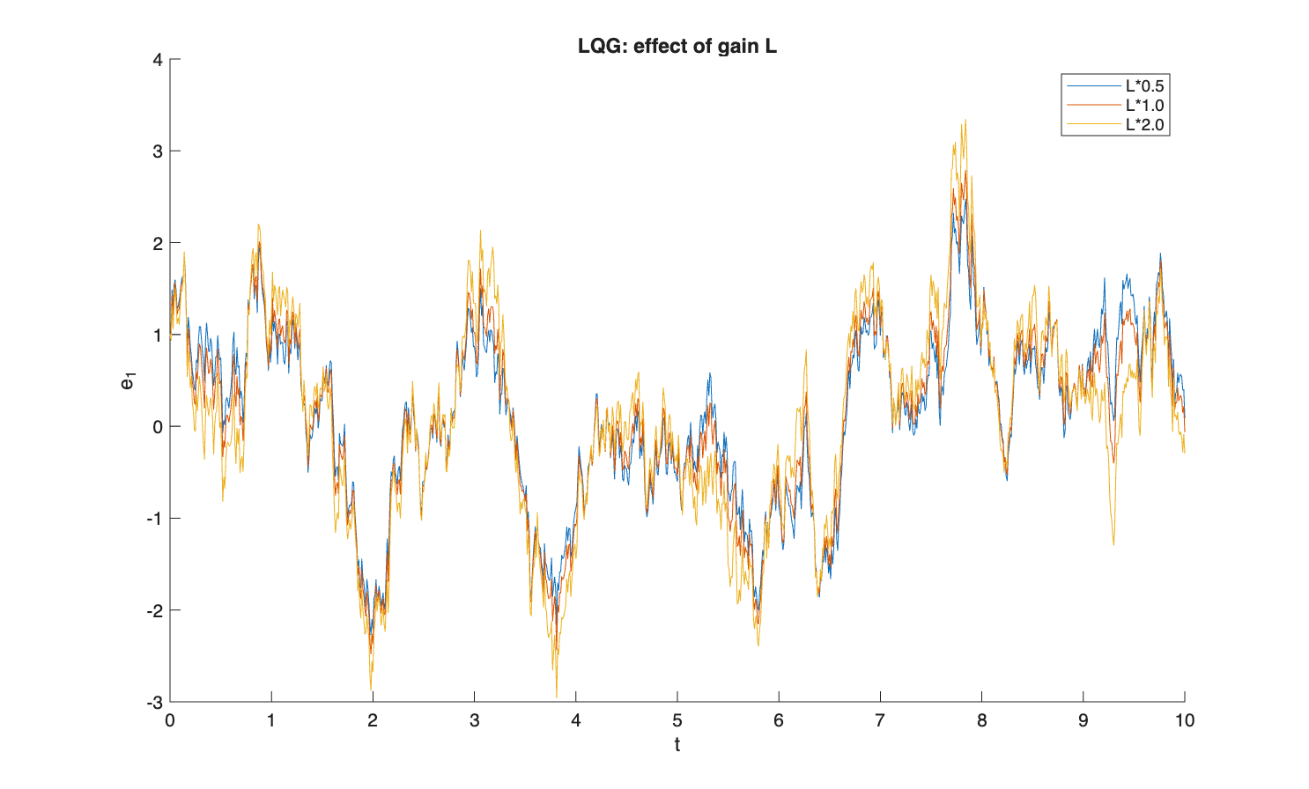
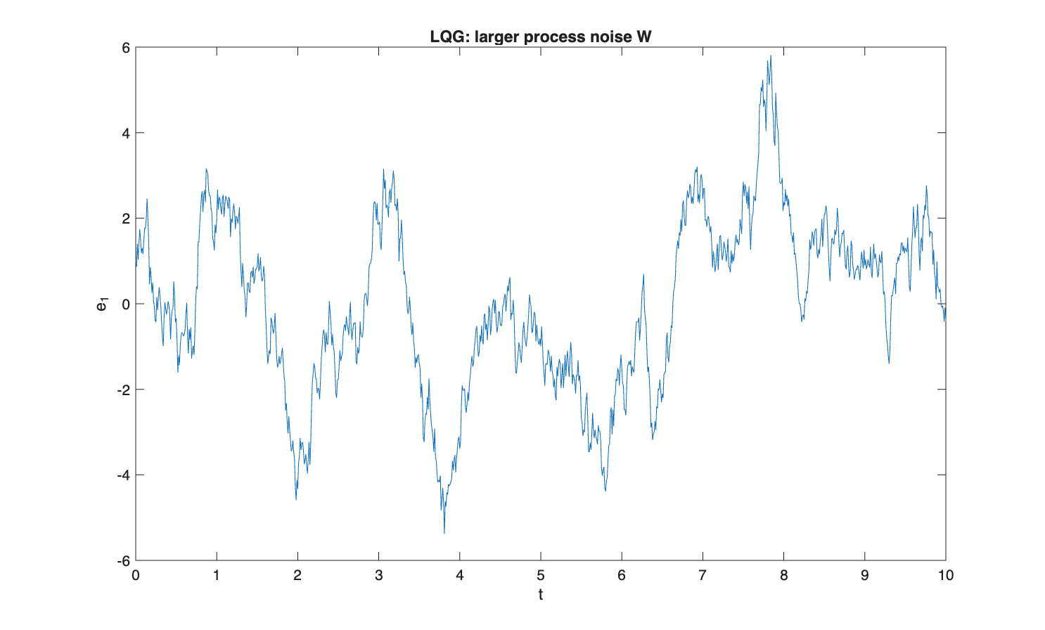
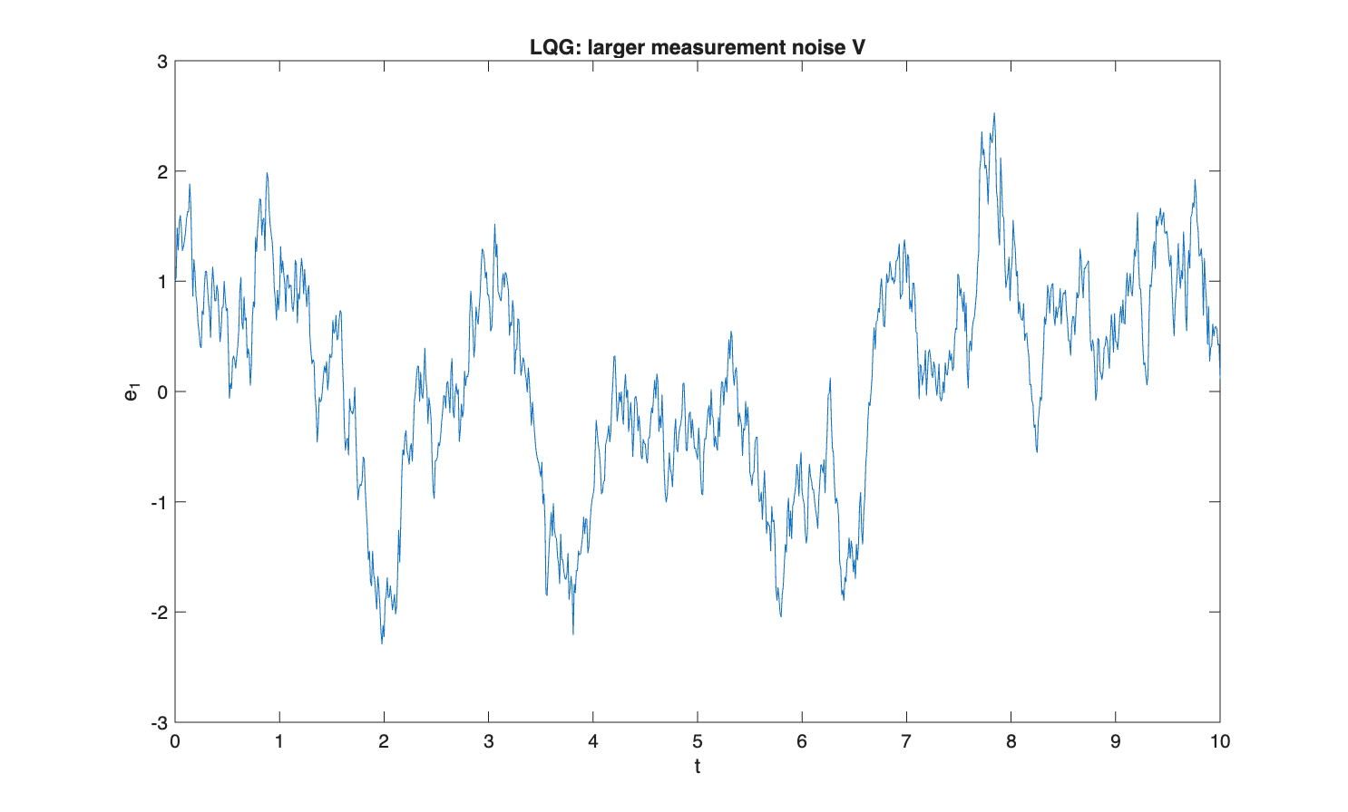

Comparison with Python / analytical reference
Numerical results of the Simulink model compared against the Python / analytical reference.
Quantity | Simulink | Python reference
L[0] | 0.2738 | 0.2738
L[1] | 0.0906 | 0.0906
K[0] | 0.2046 | 0.2046
K[1] | 0.4465 | 0.4465
Re(eig LQG) [1] | -7.6683 | -7.6683
Re(eig LQG) [2] | -1.0942 | -1.0942

Conclusion
The random noise realisation in Simulink is not reproduced sample-by-sample with Python; the deterministic quantities L, K and the LQG eigenvalues are compared instead. These quantities agree with the Python reference to better than 1e-3, which confirms the correctness of the observer and LQG controller design.

