Work 6. H-infinity optimal control design in Simulink (variant 5)

Problem statement
A linear plant of variant 5 subject to a deterministic disturbance is considered. The goal is to design the H-infinity optimal controller that minimises the influence of the disturbance on the closed-loop output.
$\overset{˙}{x}=Ax+Bu+B_{f}f,x(0)=[1, 0]^{T}$
$A=\left[\begin{matrix}6 & 2 \\ −3 & 0\end{matrix}\right], B=\left[\begin{matrix}0 \\ 3\end{matrix}\right], B_{f}=\left[\begin{matrix}4 \\ 1\end{matrix}\right], Q=diag(2,7)$
$f=10sin6t+5cos2t+4cos3t+3cos8t$

Simulink model
The H-infinity Riccati equation is solved while gamma is decreased to the boundary of existence of a stabilising solution, which yields gamma_min; the controller u = Kx with K = -B'P is designed at a slightly suboptimal gamma. The plant is excited by the prescribed disturbance f(t), and the logging blocks record the states and the control. A screenshot of the model is shown below.
$A^{T}P+PA+Q−PBB^{T}P+γ^{−2}PB_{f}B_{f}^{T}P=0$
$K=−B^{T}P$
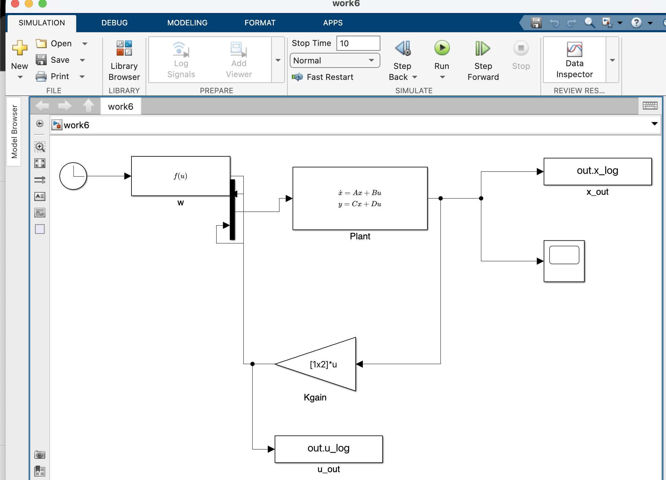

Simulation results
The trajectories of the states and the control under the disturbance are obtained, as well as the frequency responses of all three transfer functions from the disturbance to the output: the channel C_1, the channel C_2 and the full transfer (largest singular value). The H-infinity norms of the transfer functions are computed from the frequency sweep. The minimum value of gamma, the controller gain K, the closed-loop eigenvalues and the norms agree with the Python reference.
gamma_min = 9.4549
K = [-1407.24, -208.33]
real parts of the eigenvalues = [-611.29, -7.69]
||C1||_inf = 0.5324, ||C2||_inf = 3.5971, ||full||_inf = 3.6363
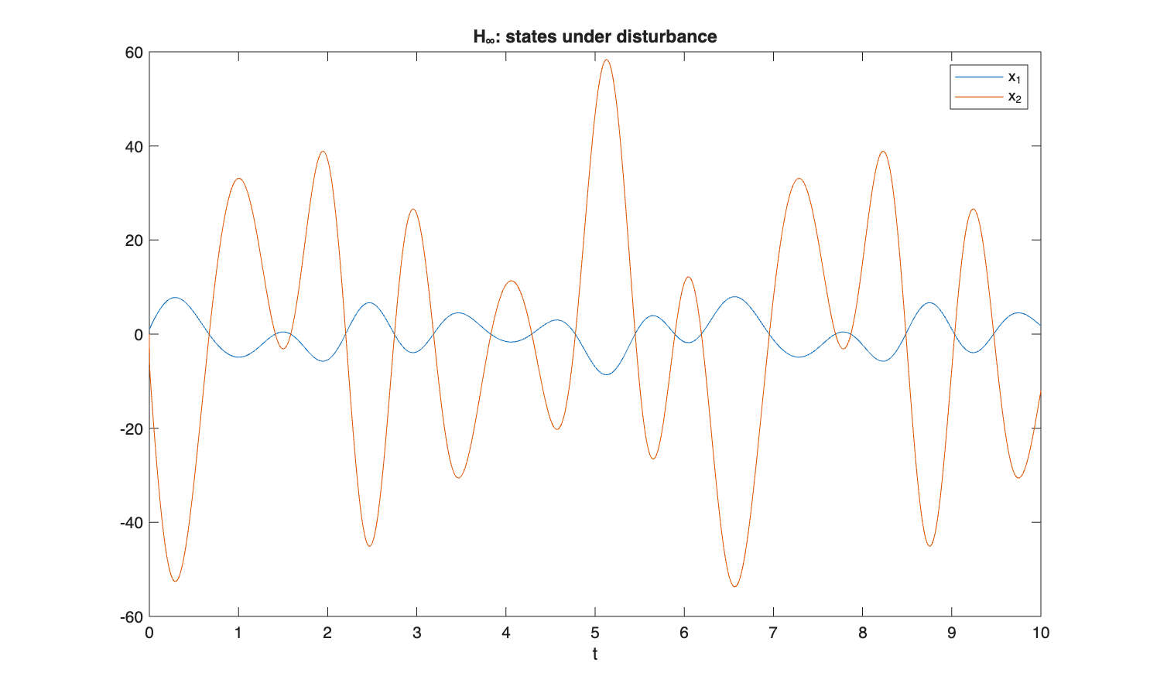
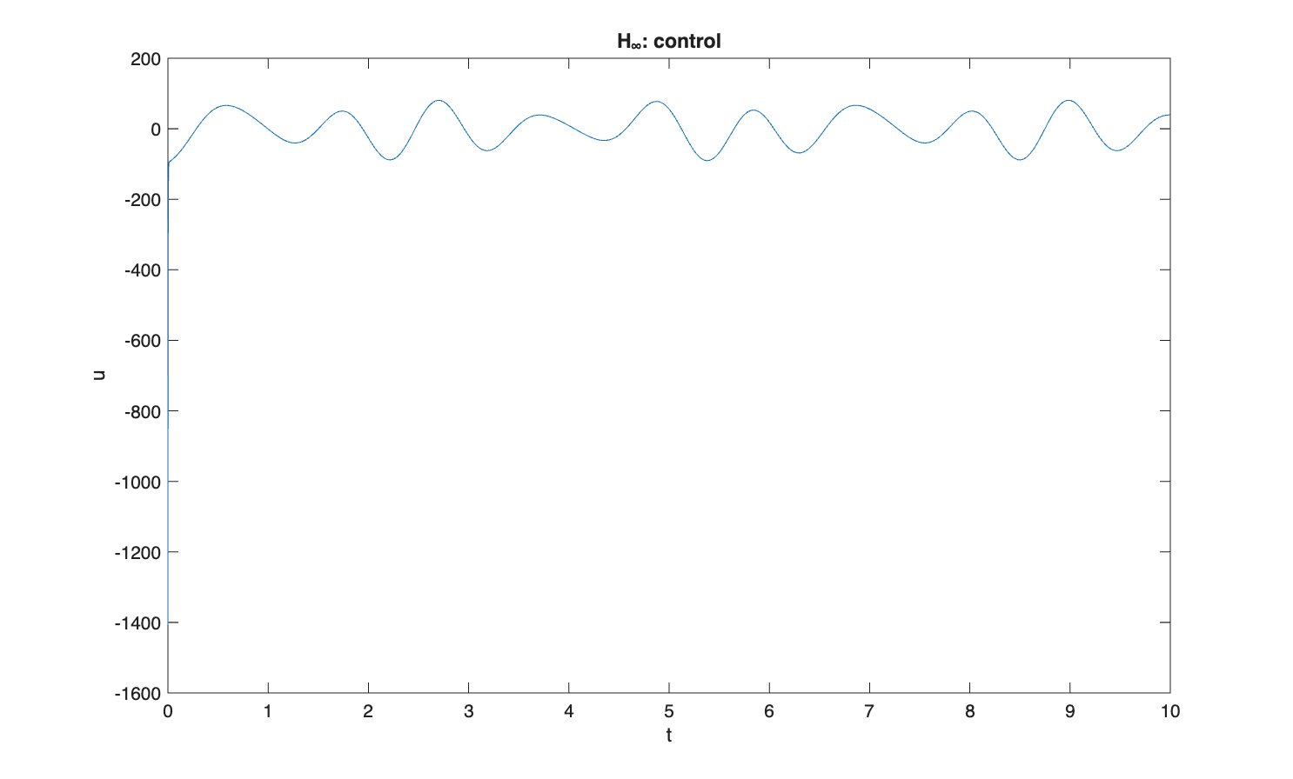
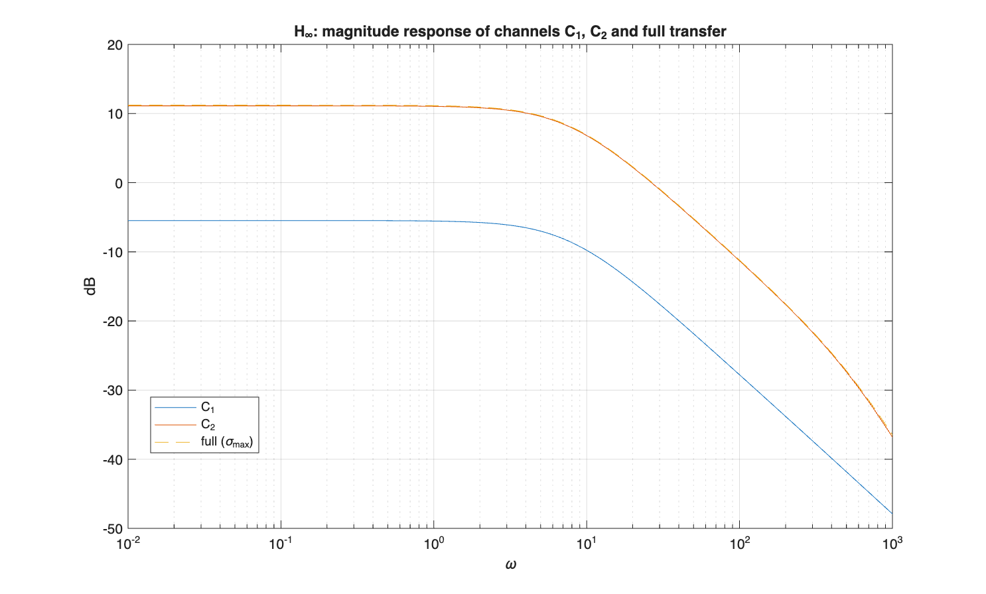

Comparison with Python / analytical reference
Numerical results of the Simulink model compared against the Python / analytical reference.
Quantity | Simulink | Python reference
gamma_min | 9.4549 | 9.4549
K[0] | -1407.24 | -1407.24
K[1] | -208.33 | -208.33
Re(eig) [1] | -611.29 | -611.29
Re(eig) [2] | -7.69 | -7.69
hinf_C1 | 0.5324 | 0.5324
hinf_C2 | 3.5971 | 3.5971
hinf_full | 3.6363 | 3.6363

Conclusion
The minimum gamma, the controller gain K, the closed-loop eigenvalues and the H-infinity norms obtained in Simulink agree with the Python reference within numerical accuracy, which confirms the correctness of the design.

