Multi-Species Livestock Counting: Differentiation Between Cattle and Sheep
Meerim Zhenishbekova
A Thesis Submitted in Partial Fulfilment
of the requirements for the
Degree of
Master of Science in Data Analytics

CCT College Dublin
May 2026
Supervisor: Dr. Greg McQuaid

Declaration
I hereby declare that this thesis, entitled "Multi-Species Livestock Counting: Differentiation Between Cattle and Sheep", is entirely my own work and has not been submitted, in whole or in part, for any other academic award. Where the work of others has been consulted, this has been clearly acknowledged and referenced according to the Harvard convention.
I confirm that the data analysis, code, model design, training, evaluation and written discussion contained in this dissertation reflect my own decisions and interpretations. I take full responsibility for any error or omission.
Signed: Meerim Zhenishbekova
Date: May 2026
Word count: 14,200 words excluding references and appendices.

Glossary and Acronyms
Adam: an adaptive learning-rate optimisation algorithm widely used for neural network training (Kingma and Ba, 2015).
AdamW: a variant of Adam that decouples weight decay from the gradient update (Loshchilov and Hutter, 2019).
AP, mAP: average precision and mean average precision, standard metrics in object detection.
BatchNorm (BN): batch normalisation layer, used to stabilise training of deep networks (Ioffe and Szegedy, 2015).
Bbox: bounding box, a rectangular region annotated around an object in an image.
CCT: CCT College Dublin.
CNN: convolutional neural network.
COCO: Common Objects in Context, a large-scale image dataset (Lin et al., 2014).
CRISP-DM: Cross-Industry Standard Process for Data Mining.
CV: computer vision.
EDA: exploratory data analysis.
F1: harmonic mean of precision and recall.
Grad-CAM: gradient-weighted class activation mapping, an interpretability method for CNNs (Selvaraju et al., 2017).
HSV: hue, saturation, value colour space.
IoU: intersection over union, an overlap metric for bounding boxes.
ImageNet: a large image classification benchmark with 1000 classes used for pretraining.
IQR: interquartile range, used here for outlier detection.
MAE: mean absolute error.
MPS: Metal Performance Shaders, the GPU backend for Apple silicon used by PyTorch.
NMS: non-maximum suppression, a post-processing step in object detection.
Optuna: a hyperparameter optimisation framework (Akiba et al., 2019).
Precision: the share of predicted positives that are correct.
Recall: the share of true positives that the model recovers.
ReLU: rectified linear unit activation function.
RMSE: root mean square error.
ResNet: residual network architecture (He et al., 2016).
RGB: red, green, blue colour channels.
Stratified split: a sampling strategy that preserves class ratios across train, validation and test sets.
TPE: tree-structured Parzen estimator, the default sampler used by Optuna.
Transfer learning: the practice of using weights pretrained on a source task as the starting point for a target task.
VGG: the visual geometry group network architecture from Oxford (Simonyan and Zisserman, 2014).
WAID: Wildlife Animal Image Dataset, a Roboflow-distributed drone-imagery dataset.
YOLO: You Only Look Once, a family of single-stage object detectors (Redmon et al., 2016; Jocher et al., 2023).

Table of Contents
Declaration 2
Glossary and Acronyms 3
Table of Contents 5
List of Figures 11
List of Tables 12
ABSTRACT 13
1. Introduction 14
1.1 Background and context 14
1.2 Problem statement 14
1.3 Research aim 15
1.4 Research questions 15
1.5 Research objectives 15
1.6 Hypotheses 16
1.7 Contributions 16
1.8 Thesis structure 17
2. Literature Review 18
2.1 Introduction to the review 18
2.2 Precision agriculture and the need for automated livestock monitoring 18
2.3 Computer vision for livestock and wildlife 19
2.3.1 Early work and traditional methods 19
2.3.2 The deep learning shift 19
2.3.3 Animal-specific applications 20
2.4 Convolutional neural networks for image classification 20
2.4.1 Building blocks 20
2.4.2 Architectures: VGG, ResNet, MobileNet, EfficientNet 21
2.4.3 Why architecture choice matters for domain adaptation 21
2.5 Transfer learning and domain shift 22
2.5.1 Theoretical grounding 22
2.5.2 Feature extraction vs fine-tuning 22
2.5.3 Evidence from agricultural computer vision 22
2.5.4 Critical perspective: ImageNet is not a universal feature extractor 22
2.6 Object detection and counting 23
2.6.1 Two-stage and single-stage detectors 23
2.6.2 The YOLO family evolution from v1 to v8 23
2.6.3 Counting from detection: limitations under high occlusion 23
2.6.4 Density-based counting as alternative 24
2.7 Datasets for livestock and wildlife 24
2.8 Hyperparameter optimisation in deep learning 24
2.9 Data augmentation 25
2.10 Interpretability of CNN: Grad-CAM 25
2.11 Statistical comparison of classifiers 26
2.12 Environmental robustness and subgroup analysis 26
2.13 Ethics and data governance in agricultural computer vision 27
2.14 Identified gaps in the literature and positioning of this study 27
3. Methodology 28
3.1 Research philosophy and approach 28
3.2 Research design overview 28
3.3 Data sources and acquisition 29
3.3.1 WAID dataset 29
3.3.2 COCO 2017 cow and sheep subset 29
3.3.3 Rationale for combining drone and ground-level data 29
3.4 Exploratory Data Analysis 30
3.4.1 Class distribution and integrity check 30
3.4.2 Image-size distributions 30
3.4.3 Pixel-intensity statistics and Shapiro-Wilk normality 30
3.4.4 Outlier detection by IQR 30
3.4.5 Bounding-box geometry 31
3.4.6 Visual sample inspection 31
3.5 Data preprocessing 32
3.5.1 Class filtering 32
3.5.2 Format unification 32
3.5.3 Stratified train, validation, and test split 32
3.5.4 Crop extraction for classification 32
3.5.5 Auto-generated subgroup labels 32
3.5.6 Encoding decisions 33
3.5.7 Scaling decisions 33
3.5.8 Data augmentation strategy 33
3.6 Model 1: Custom CNN baseline 34
3.6.1 Motivation 34
3.6.2 Architecture detail 34
3.6.3 Training setup 35
3.6.4 Hyperparameter optimisation with Optuna 35
3.7 Models 2-4: Transfer learning 36
3.7.1 Why these three 36
3.7.2 Feature extraction strategy 36
3.7.3 Per-model classifier heads 37
3.7.4 Optuna HP tuning 37
3.8 Model 5: YOLOv8n for detection and counting 37
3.8.1 YOLO family choice 37
3.8.2 Training setup 38
3.8.3 Counting protocol 38
3.8.4 Detection and counting metrics 38
3.9 Evaluation framework 38
3.9.1 Primary classification metrics 38
3.9.2 Confusion matrix as diagnostic tool 38
3.9.3 Statistical comparison via McNemar 39
3.9.4 Subgroup analysis 39
3.9.5 Interpretability via Grad-CAM 39
3.9.6 Detection-specific evaluation 39
3.10 Reproducibility 39
3.11 Ethics and data governance 39
3.12 Methodological limitations 40
4. Data Analysis and Findings 41
4.1 EDA findings 41
4.2 Final dataset composition 41
4.3 Custom CNN: training and final evaluation 42
4.3.1 Optuna hyperparameter search results 42
4.3.2 Final training trajectory 42
4.3.3 Test performance 43
4.3.4 Ablation study: with versus without augmentation 43
4.3.5 Grad-CAM interpretability 44
4.4 Transfer learning: training and final evaluation 44
4.4.1 Per-model HP search outcomes 44
4.4.2 Final test performance per model 44
4.4.3 Confusion matrices 45
4.4.4 Grad-CAM comparison 45
4.5 YOLOv8 detection and counting 46
4.5.1 Training trajectory and per-class detection metrics 46
4.5.2 Counting performance 46
4.5.3 Detection examples 47
4.6 Statistical comparison via McNemar test 48
4.7 Per-subgroup analysis 49
4.7.1 Lighting by model accuracy 49
4.7.2 Occlusion by model accuracy 49
4.7.3 YOLO counting MAE by subgroup 50
4.8 Hypothesis testing summary 51
5. Discussion 52
5.1 Interpretation of main findings 52
5.2 H1 verdict: ImageNet is not a universal foundation 52
5.3 H2 verdict: augmentation gives a small but real lift 52
5.4 H3 verdict: occlusion is the dominant environmental factor 53
5.5 Statistical robustness 53
5.6 Practical feasibility 53
5.7 Comparison with prior work 53
5.8 Limitations 54
5.9 Reflection on methodology 54
6. Conclusion and Recommendations 55
6.1 Summary of findings 55
6.2 Answers to research questions 55
6.3 Practical recommendations 56
6.4 Theoretical contributions 56
6.5 Future work 57
6.6 Closing remarks 57
References 58
Appendix A. Reproducibility and Code Availability 61
Appendix B. Dataset Licences and Terms of Use 62
Appendix C. Hyperparameter Search Spaces 63
Appendix D. Per-Notebook Output Summary 64

List of Figures
Figure 1 Class distribution and bounding-box counts across WAID and COCO before filtering
Figure 2 Sample grid of cattle images from WAID
Figure 3 Augmentation demonstration grid (3 by 3)
Figure 4 Optuna hyperparameter importance for the custom CNN
Figure 5 Custom CNN training curves
Figure 6 Custom CNN test confusion matrix
Figure 7 Custom CNN Grad-CAM grid
Figure 8 Confusion matrices for all four classifiers
Figure 9 Grad-CAM grid across transfer models and the custom CNN
Figure 10 YOLOv8 counting scatter and error histogram
Figure 11 YOLOv8 detection examples (2 by 3 grid)
Figure 12 Per-subgroup classification accuracy heatmaps
Figure 13 YOLOv8 counting MAE by subgroup

List of Tables
Table 1 Hyperparameter search space, best values, and Optuna importance for the custom CNN
Table 2 Parameter counts, best hyperparameters, and Optuna validation accuracy across the four classifiers
Table 3 Pixel-intensity statistics and Shapiro-Wilk normality test
Table 4 Image-level dataset split
Table 5 Crop-level dataset split
Table 6 Final test metrics across the four classifiers
Table 7 YOLOv8n detection metrics on the held-out test set
Table 8 McNemar pairwise comparisons across the four classifiers
Table 9 Per-classifier accuracy by lighting subgroup
Table 10 Per-classifier accuracy by occlusion subgroup
Table 11 YOLOv8 counting MAE by lighting and occlusion subgroup
Table 12 Final verdicts on the four hypotheses

ABSTRACT
Manual livestock counting on Irish farms still relies on visual inspection by stockpersons walking through paddocks or counting at gates. The practice is slow, prone to error in mixed herds, and stressful for the animals when repeated frequently. Aerial photography from low-cost drones now offers a different starting point, but the imagery itself does not solve the underlying recognition problem: cattle and sheep often share the same field, appear at very different scales, and are seen against grass, mud, fences, and shadow. This dissertation investigates whether off-the-shelf computer vision models can carry out reliable cattle versus sheep differentiation under such conditions, or whether a domain-specific design is required.
The study assembles a working dataset of 17,759 images by combining the WAID drone collection with the cattle and sheep subsets of COCO. After cleaning and filtering for usable annotations, 12,232 images remained, from which 51,320 single-animal crops were produced and divided 70/15/15 with stratified sampling. Four classifiers were trained: a custom CNN of 8.76 million parameters tuned with Optuna, plus three ImageNet pretrained networks (ResNet50, VGG16, MobileNetV2) used as fixed feature extractors with a trainable classifier head. A YOLOv8 detector was then trained on the same imagery for the counting task and benchmarked against two naive baselines.
VGG16 reached the highest test accuracy at 0.9738, followed by the custom CNN at 0.9610, ResNet50 at 0.9570, and MobileNetV2 at 0.9498. YOLOv8 achieved mAP@50 of 0.9478 and a counting MAE of 1.576 with R squared of 0.9749. Only one of the three pretrained networks beat the custom baseline, so H1 is partially supported. Augmentation simulating farm conditions added 0.62 percentage points to mean accuracy, supporting H2. YOLOv8 was 5.5 times less accurate under heavy occlusion than under clear conditions, and VGG16 proved most stable across lighting subgroups.
Keywords: livestock counting, computer vision, deep learning, transfer learning, YOLOv8, precision agriculture.

1. Introduction

1.1 Background and context
Irish agriculture sits in an unusual position. The country exports roughly ninety per cent of its dairy and beef output, sheep numbers in the national flock have hovered above three and a half million for over a decade, and the sector is asked to reconcile high productivity with traceability rules that go down to the level of the individual animal. In that environment, knowing how many animals are in a paddock on a given morning is not an academic question. It feeds into bovine viral diarrhoea eradication paperwork, into Department of Agriculture inspections, into private insurance claims after storms or theft, and into the simple operational question of whether the herd has come back from outfield grazing intact.
The work of counting, however, is still done in a way that would be familiar to a farmer fifty years ago. Stockpersons walk fields, count at gates, or push animals through races. Errors are common when groups exceed roughly thirty head, and the stress imposed on pregnant ewes or freshly calved cows by repeated mustering is itself a welfare cost (Berckmans, 2017). Mixed herds make the situation worse: when sheep and cattle share enclosures, as they often do on smaller western Irish holdings practicing rotational grazing, a single visual sweep has to separate species before counting begins.
Drone photography has changed the cost calculus. Consumer-grade quadcopters now produce orthorectified imagery at a fraction of the price of fixed-wing aerial surveys a decade ago, and the imagery can be repeated weekly without disturbing stock (Wang et al., 2020). Precision livestock farming, as the broader movement is termed, has accumulated a strong evidence base for sensor-driven monitoring of individual animals (Berckmans, 2017; Norouzzadeh et al., 2018), yet the specific subproblem of mixed-species visual counting has seen comparatively little attention. Most published systems either assume a single species in frame or treat species identification as a downstream filter rather than as the primary classification task.

1.2 Problem statement
The technical problem this dissertation addresses is narrower than general livestock detection. It is the differentiation of cattle from sheep within imagery that mixes drone-altitude top-down views and ground-level side-on photographs of the same two species. There are two reasons that gap matters. First, almost all open-source models that claim to recognise farm animals were trained on COCO, ImageNet, or Open Images, none of which were assembled with mixed-herd Irish farm imagery in mind. Their cattle examples skew toward European Holstein-Friesian dairy stock photographed from human eye-level, and their sheep examples lean heavily on heavily wooled merino-type animals on dry pasture (Lin et al., 2014). Second, drone and ground-level imagery differ in almost every respect that matters to a convolutional network: the visible body parts, the scale ratio of animal to background, the dominant texture cues, and the lighting geometry. A model that performs well on one view often fails on the other, even when the underlying species are the same.
The practical question that follows is whether a researcher building a new livestock counter for the Irish context should reach for a pretrained ImageNet backbone, accept the domain gap, and fine-tune, or invest the effort of training a smaller custom architecture on the available agricultural data. The answer is not obvious in advance. Pretrained features are known to transfer well to related visual tasks (Yosinski et al., 2014), but the gap between web-scraped natural imagery and aerial farm photographs is larger than is sometimes acknowledged in the agricultural computer vision literature.

1.3 Research aim
The aim of this study is to design, implement, and evaluate a computer vision framework for multi-species livestock counting that can accurately differentiate between cattle and sheep in mixed-herd imagery and remain robust under realistic environmental conditions.

1.4 Research questions
1. How effectively can image-based machine learning methods differentiate between cattle and sheep in mixed-herd settings?
2. Do advanced deep learning models significantly outperform simpler baseline methods for this task?
3. Which environmental conditions most strongly affect classification and counting accuracy?
4. Which modelling approach offers the most suitable balance between predictive performance and practical feasibility?

1.5 Research objectives
1. To critically review the literature on livestock counting, species differentiation, and computer vision applications in precision agriculture.
2. To identify the main technical and environmental challenges involved in differentiating cattle and sheep from image data.
3. To construct a representative dataset from publicly available sources suitable for mixed-species livestock analysis.
4. To implement baseline models and advanced deep learning models for cattle and sheep differentiation and counting.
5. To evaluate the effect of environmental variability, including lighting, occlusion, distance, and background complexity, on model performance.
6. To compare models using performance, interpretability, and computational feasibility criteria.
7. To assess the practical relevance of the proposed approach for real agricultural deployment.

1.6 Hypotheses
H1: Advanced deep learning architectures will outperform baseline methods in the differentiation of cattle and sheep in mixed-herd imagery.
H2: Data augmentation designed to simulate realistic farm conditions will improve the robustness of model performance.
H3: Environmental factors such as occlusion, lighting variation, and image complexity will significantly affect the accuracy of livestock species differentiation.
H0: There will be no statistically significant difference between baseline methods and advanced deep learning methods for the proposed task.

1.7 Contributions
This dissertation makes five contributions. It frames cattle versus sheep differentiation as a binary classification problem on imagery that deliberately mixes drone and ground-level views, rather than treating each viewpoint separately. It introduces a custom CNN of 8.76 million parameters whose hyperparameters were selected through Optuna with a Tree-structured Parzen Estimator sampler (Akiba et al., 2019), giving a competitive baseline that is not derived from ImageNet weights. It compares this baseline against three widely used pretrained networks (ResNet50, VGG16, MobileNetV2) under identical preprocessing, training schedule, and evaluation protocol. It extends the analysis from classification to detection-based counting using YOLOv8 (Jocher et al., 2023) and reports per-subgroup behaviour broken down by lighting condition and occlusion level. Finally, it offers a critical reading of when and why ImageNet pretraining helps for agricultural imagery and when it does not, drawing on Grad-CAM visualisations to show what each model attends to.

1.8 Thesis structure
Chapter 2 reviews the literature on precision livestock farming, convolutional architectures, transfer learning, object detection, and the datasets and evaluation methods used in agricultural computer vision. It also identifies the specific gaps that this work addresses.
Chapter 3 sets out the methodology. It describes how the WAID and COCO subsets were combined, how cropping and stratified splitting were performed, the training protocol for the four classifiers and the YOLOv8 detector, and the statistical procedures used to compare them.
Chapter 4 presents results. It reports headline accuracies, confusion matrices, McNemar comparisons, counting error against ground truth, and per-subgroup behaviour for lighting and occlusion. Grad-CAM examples are included where they illustrate model behaviour.
Chapter 5 discusses what the results mean for each research question and hypothesis, and considers the practical implications for an Irish farm deploying such a system.
Chapter 6 concludes, lists limitations, and proposes specific lines of further work, including extension to additional species and integration with on-farm video streams.

2. Literature Review

2.1 Introduction to the review
This chapter surveys the body of work that informs cattle and sheep differentiation from imagery. The scope was set deliberately wide at first, then narrowed. Searches were carried out on Google Scholar, Scopus, ACM Digital Library, and arXiv between September 2025 and February 2026, using combinations of the terms livestock counting, cattle detection, sheep detection, drone imagery, UAV agriculture, transfer learning, YOLO, and convolutional neural network. The time window was 2014 to 2025, with two earlier landmark works retained because they remain methodologically relevant: McNemar (1947) for paired classifier comparison, and Krizhevsky et al. (2012) for the inception of modern deep learning in computer vision.
The chapter starts from the agricultural problem and works toward the technical solutions, rather than the other way around. Section 2.2 establishes why automated livestock monitoring is needed at all. Sections 2.3 to 2.6 cover the visual recognition machinery, moving from early traditional methods through CNNs to object detection and counting. Section 2.7 looks at the datasets the field has accumulated. Sections 2.8 and 2.9 address methodological choices that strongly affect reported numbers but are often glossed over: hyperparameter search and data augmentation. Section 2.10 considers interpretability, section 2.11 statistical comparison, and section 2.12 environmental robustness. Sections 2.13 and 2.14 close with ethics and a statement of the gap this thesis addresses.

2.2 Precision agriculture and the need for automated livestock monitoring
The phrase precision livestock farming entered general use around 2003, but the underlying impulse goes back further (Berckmans, 2017). The argument is straightforward: if dairy and meat production is to remain economically viable in high-cost economies such as Ireland or the Netherlands, individual animal monitoring needs to scale beyond what a stockperson can manage on foot. Berckmans (2017) frames the field as the application of process engineering to living animals, and the framing has held up well as wearable sensors, in-parlour weighing, and visual systems have become cheaper.
Counting sits at the foundational layer of this hierarchy. It is the simplest operation that nonetheless underpins many downstream tasks: stocking density estimation, mortality monitoring, theft detection, and statutory record keeping. In the Irish context, the Animal Identification and Movement system requires every bovine animal to be tagged and its movements logged within seven days, and the Sheep Identification System imposes similar though slightly looser obligations on flocks. Compliance audits assume that recorded numbers match physical counts. Where they diverge, the discrepancy must be explained, and explanations cost time. Wang et al. (2020) note that the manual count error rate on extensive grazing systems can exceed five per cent for groups of more than fifty animals, which is the same order of magnitude as typical lamb mortality rates, making it difficult to attribute losses correctly.
The case for automation is strengthened by welfare considerations. Repeated mustering for counting causes measurable cortisol elevation in cattle and reduced rumination time, and the effect is larger in pregnant animals (Berckmans, 2017). A passive visual count from a drone or fixed camera removes that handling. Whether the visual count is accurate enough to replace handling entirely is the open question that the present study addresses, and that several recent works including Han et al. (2022) and Xu et al. (2020) have tried to answer in the affirmative for single-species settings.

2.3 Computer vision for livestock and wildlife

2.3.1 Early work and traditional methods
Before convolutional networks took hold, livestock and wildlife recognition relied on hand-engineered features. Histogram of Oriented Gradients (HOG), Scale-Invariant Feature Transform (SIFT), and local binary patterns were applied with sliding-window classifiers, typically a Support Vector Machine. The approach worked on tightly controlled imagery, for instance side-on photographs of dairy cows in a milking parlour with consistent backgrounds. It struggled badly with the kinds of variation that characterise outdoor farm imagery: changes in pose, partial occlusion by other animals or fences, and lighting shifts between morning and evening. Zhang et al. (2018) compare a HOG plus SVM pipeline to an early CNN on a cattle dataset and report a more than fifteen-point accuracy gap in favour of the CNN, with the largest portion of the gap arising on samples with partial occlusion.
The limitation was not unique to agriculture. The broader computer vision community had accepted by the early 2010s that hand-engineered features were close to a ceiling, and the question was what would replace them.

2.3.2 The deep learning shift
The answer arrived in the form of AlexNet (Krizhevsky et al., 2012), trained on the ImageNet Large Scale Visual Recognition Challenge dataset. The architecture was not radically novel in its components, but the combination of ReLU activations, dropout, GPU training, and a then-unprecedented network depth halved the previous best top-five error on ImageNet. The result triggered a wave of architectural experimentation that produced VGG (Simonyan and Zisserman, 2014), Inception, and eventually residual learning (He et al., 2016). For agricultural computer vision, the shift took several years to filter through, partly because the available datasets were small and partly because GPU access was uneven outside the major laboratories.
By the late 2010s, however, CNN-based pipelines had become the default. Norouzzadeh et al. (2018) trained a deep network on more than three million camera-trap images of African wildlife and reported automated species identification accuracy comparable to crowdsourced human annotation. Their work is often cited as the moment when ecological monitoring began to treat deep learning as a routine tool rather than a research curiosity.

2.3.3 Animal-specific applications
A distinct sub-literature has developed around individual animal identification, which is technically harder than species classification because the visual differences between, say, two Holstein-Friesian cows are subtle. Andrew et al. (2017) showed that the black-and-white coat pattern of Holstein-Friesian cattle is sufficiently unique to support reliable individual recognition with a CNN, achieving 86.1 per cent identification accuracy on a herd of forty-six cows. Qiao et al. (2021) extended this line of work using a deeper backbone and obtained over ninety-three per cent on a similar task, while also showing that the model degraded sharply when animals were photographed from angles not represented in training.
Sheep identification has proved more difficult. Sarwar et al. (2018) report face-recognition results on a small sheep dataset, but accuracies remain well below those for cattle, in part because sheep faces present less variation in colour and pattern. Pig research has gone in a different direction, with Hu et al. (2020) using density estimation rather than detection to count pigs in dense pens, and reaching mean absolute errors below two animals per pen. Together, these works establish that animal-specific computer vision is feasible at fine granularity, but they almost always operate within a single species. The cross-species differentiation problem is conspicuous by its absence.

2.4 Convolutional neural networks for image classification

2.4.1 Building blocks
A modern CNN is built from a small number of operations repeated in different configurations. Convolutional layers slide learned filters across the input to extract local patterns. Pooling layers summarise neighbourhoods, reducing spatial resolution and providing some translation invariance. Batch normalisation, introduced as a remedy for internal covariate shift, stabilises training and allows higher learning rates. Dropout removes a random subset of units during training and acts as a regulariser. Activation functions, most commonly the Rectified Linear Unit, introduce non-linearity. Goodfellow et al. (2016) provide what remains the canonical textbook treatment of these elements, and the formulations used in this dissertation follow their notation.
The interaction between these blocks is not always intuitive. Adding more dropout, for instance, does not monotonically improve generalisation, and over-regularised networks underfit even on large datasets. Batch normalisation behaves differently on small batches, which becomes relevant when GPU memory limits batch size on high-resolution agricultural imagery.

2.4.2 Architectures: VGG, ResNet, MobileNet, EfficientNet
VGG (Simonyan and Zisserman, 2014) was a deliberate exercise in architectural simplicity: stacked three-by-three convolutions, max pooling, and three fully connected layers at the head. The design has aged well as a feature extractor despite being computationally heavy, with VGG16 carrying around 138 million parameters. ResNet (He et al., 2016) introduced the residual or skip connection, which allows gradients to flow directly through deep networks and made it practical to train models of fifty, one hundred, and even more than a thousand layers. The skip connection turned out to be one of the most influential ideas in deep learning, reappearing across most subsequent architectures.
MobileNet, in its first (Howard et al., 2017) and second (Sandler et al., 2018) versions, addresses a different concern: deployment on devices with limited compute. Depthwise separable convolutions cut parameter count by an order of magnitude relative to a comparable VGG, with only modest accuracy loss on ImageNet. MobileNetV2 added inverted residual blocks with linear bottlenecks. EfficientNet (Tan and Le, 2019) extended the line of thinking by using neural architecture search and compound scaling of depth, width, and resolution, reporting state-of-the-art accuracy at substantially lower parameter budgets than ResNet for several years after publication.
For an agricultural application, the choice between these is rarely settled by ImageNet accuracy alone. Field conditions, the size of the available training set, and the device that will run inference all matter.

2.4.3 Why architecture choice matters for domain adaptation
The architectures above were all developed against the benchmark of ImageNet classification, which contains a large but stylistically narrow slice of internet imagery. When the target domain differs, as it does for top-down drone photographs of livestock, the inductive biases of the architecture interact with the domain gap. Yosinski et al. (2014) argue that early convolutional layers learn generic features such as edges and colour blobs that transfer well, while deeper layers become increasingly specialised to the source domain. The consequence is that the right cut-point for fine-tuning depends on how far the target imagery sits from ImageNet. There is no generic answer.

2.5 Transfer learning and domain shift

2.5.1 Theoretical grounding
Transfer learning, in the sense used in modern deep learning practice, was systematised by Yosinski et al. (2014). Their experiments showed that features extracted from networks pretrained on ImageNet remain useful for related tasks, and that the degree of transferability decreases monotonically with the depth of the layer in question. They also reported the surprising finding that fine-tuning, even on a small target dataset, often beats fixed feature extraction when enough samples are available, because it allows the deeper layers to adapt to the new distribution.

2.5.2 Feature extraction vs fine-tuning
In agricultural computer vision the choice between freezing the backbone and fine-tuning is a recurring methodological decision. With small target datasets of fewer than a thousand images per class, fine-tuning the entire network risks catastrophic forgetting and overfitting, and freezing the backbone with a new classifier head is usually safer. Once the dataset reaches the order of tens of thousands of samples per class, partial fine-tuning of the last block or two of the backbone tends to outperform either extreme. The dataset assembled for the current study sits in this middle range, which guides the design choices in chapter 3.

2.5.3 Evidence from agricultural computer vision
Tian et al. (2019) report YOLOv3 results on apple detection in orchard imagery, fine-tuning from COCO weights, and reach mean average precision figures above ninety per cent on a few thousand annotated images. Xu et al. (2020) apply YOLOv3 fine-tuned from COCO to UAV cattle detection, with similar success. Han et al. (2022) extend this approach to YOLOv5 for sheep counting and obtain mean absolute errors close to one animal across small flocks. The pattern that emerges is that pretrained detectors transfer well to agriculture when the target objects are visually similar to those represented in COCO. Cattle and sheep are two of the eighty COCO classes, which is a piece of luck the field tends to take for granted.

2.5.4 Critical perspective: ImageNet is not a universal feature extractor
The risk in this success story is to assume that pretraining always helps. Several authors have pushed back against the assumption. The argument is that ImageNet imagery is photographer-curated, well-lit, centred, and seen from human eye-level. Agricultural imagery from drones is none of those things. Features that disambiguate, say, a Persian cat from a Siamese cat are unlikely to be the same features that disambiguate a black sheep from a black calf seen from above. The custom baseline trained from random initialisation in this dissertation is intended in part as an honest test of that argument.

2.6 Object detection and counting

2.6.1 Two-stage and single-stage detectors
Object detection systems split historically into two camps. Two-stage detectors, exemplified by R-CNN, Fast R-CNN, and Faster R-CNN, first generate region proposals and then classify them. They tend to be accurate but slow. Single-stage detectors, of which YOLO is the canonical example, frame detection as a single regression problem over a fixed grid (Redmon et al., 2016). They are faster, often by an order of magnitude, and have closed most of the accuracy gap over the past several years. SSD occupies an intermediate position. For an agricultural counting task that may eventually be deployed on a tractor-mounted device or a tablet at the gate, single-stage detection is the natural choice.

2.6.2 The YOLO family evolution from v1 to v8
The YOLO line has gone through more revisions than almost any other detector family. YOLOv1 (Redmon et al., 2016) introduced the grid-based regression formulation. YOLOv3 (Redmon and Farhadi, 2018) added multi-scale prediction with three output heads, which substantially improved small-object detection. YOLOv4 (Bochkovskiy et al., 2020) consolidated a large set of training tricks (mosaic augmentation, CIoU loss, self-adversarial training) into a single, freely usable system. YOLOv5 was released by Ultralytics outside the original Redmon line and gained traction because of its PyTorch implementation and ease of fine-tuning. YOLOv8 (Jocher et al., 2023) introduced an anchor-free head, a new C2f backbone block, and unified support for detection, segmentation, and classification within one framework. For livestock counting, the anchor-free formulation is appealing because cattle and sheep vary in apparent size by a factor of three or more across a single drone image, and predefined anchor boxes were always an awkward fit.

2.6.3 Counting from detection: limitations under high occlusion
A detector produces bounding boxes; counting them is, in the simple case, a matter of cardinality. The simple case breaks down when animals overlap. Wang et al. (2020) report that counting accuracy from drone imagery of grazing cattle drops sharply once herd density exceeds roughly one animal per ten square metres of ground area. Similar effects appear in sheep counting (Han et al., 2022). The reason is that non-maximum suppression, which removes overlapping detections, cannot distinguish between two boxes that overlap because they describe the same animal and two boxes that overlap because two animals are physically pressed together.

2.6.4 Density-based counting as alternative
Where occlusion is severe, an alternative is to abandon detection entirely and predict a density map whose integral gives the count. CSRNet and MCNN are the canonical examples in the crowd counting literature. Hu et al. (2020) apply density estimation to pig counting in indoor pens and outperform a Faster R-CNN baseline. Density-based methods avoid the non-maximum suppression problem, but they do not give per-animal localisation, which makes downstream tasks such as health monitoring more difficult. The present study stays with detection-based counting because per-animal information is part of the eventual deployment scenario, while acknowledging the trade-off.

2.7 Datasets for livestock and wildlife
The COCO dataset (Lin et al., 2014) contains around 330,000 images annotated for eighty everyday object classes, including cow and sheep. The cow and sheep subsets together contain roughly 8,000 instances, predominantly photographed from human eye-level on European or North American pastures. The annotations are bounding boxes with segmentation masks. Licensing follows COCO terms, which permit research use.
The WAID collection (Mou et al., 2023) was assembled specifically for wildlife and livestock detection from UAV imagery. It contains six animal classes including cattle and sheep, photographed from drone altitudes between approximately twenty and one hundred metres. The aerial perspective is what COCO lacks, which is why combining the two is appealing for a system that needs to work across viewpoints.
Other resources exist but were not used here. Open Images includes cattle and sheep but with inconsistent annotation quality. AnimalWeb is built around face-centred images and is not well-suited to counting. Roboflow Universe hosts a number of community-contributed cattle and sheep datasets under permissive licences (CC-BY in most cases), but their annotation quality varies and merging them adds complexity that was deemed not worth the marginal gain. The combination of COCO and WAID was chosen as the cleanest pair that covers both viewpoint regimes.

2.8 Hyperparameter optimisation in deep learning
Hyperparameter choice has a larger effect on reported accuracy than is sometimes admitted, and unfair comparisons are common when baseline models are trained with default hyperparameters while the favoured model receives careful tuning. Bergstra and Bengio (2012) demonstrated that random search over hyperparameters typically outperforms grid search at equal computational cost, because most hyperparameters have low effective dimensionality and grid search wastes evaluations on irrelevant axes. The argument shifted the field away from grid search.
Bayesian optimisation, and in particular the Tree-structured Parzen Estimator implementation in Optuna (Akiba et al., 2019), has become the default for moderately sized search budgets. Optuna offers asynchronous parallel evaluation, define-by-run search spaces, and pruning of unpromising trials, which together make it practical to search over learning rate, dropout, optimiser choice, and architectural parameters within a few dozen GPU-hours. The current dissertation uses Optuna for the custom CNN, which guards against the criticism that the baseline was deliberately handicapped relative to the pretrained alternatives.

2.9 Data augmentation
Augmentation has been part of CNN training since AlexNet, where random crops and horizontal flips alone added several points of accuracy on ImageNet (Krizhevsky et al., 2012). Shorten and Khoshgoftaar (2019) survey the field as it stood in the late 2010s, distinguishing geometric transformations, photometric transformations, kernel filters, and synthetic data generation through GANs. They report consistent gains from simple transformations on small datasets and diminishing returns as datasets grow.
More recent strategies include Mixup, CutMix, and AutoAugment. Each can give measurable improvements, but they also add hyperparameters of their own and can interact with batch normalisation in unexpected ways. For livestock imagery, the augmentations that map most cleanly to real conditions are random brightness and contrast shifts (representing different times of day), random rotation and flipping (representing varying drone heading), and Gaussian blur (representing focus drift on cheap drone optics). The augmentation pipeline used in chapter 3 reflects this reasoning rather than reaching for the most elaborate available recipe.
A recurring critique is that augmentation gains plateau once the dataset is sufficiently large. With more than fifty thousand crops, the marginal benefit per additional augmentation type may be smaller than the literature suggests. The ablation reported in chapter 4 tests whether this is the case here.

2.10 Interpretability of CNN: Grad-CAM
Gradient-weighted Class Activation Mapping, introduced by Selvaraju et al. (2017), produces a coarse heatmap of which regions of an input image most influenced a given classification decision. The technique works by taking the gradient of the predicted class score with respect to the activations of a chosen convolutional layer and weighting the activations by those gradients. The result is a visualisation that, while not a complete explanation, tells the practitioner whether the model is attending to plausibly relevant regions.
For agricultural applications, Grad-CAM is particularly useful for detecting shortcut learning. A network might learn to distinguish cattle from sheep not by attending to the animals themselves but by exploiting background cues, for example brown muddy ground around cattle versus dry grass around sheep. The shortcut yields high test accuracy on a dataset where the cue is present and collapses when the cue is absent. Grad-CAM exposes this kind of failure before deployment, which is why it is reported in chapter 4 alongside accuracy numbers.

2.11 Statistical comparison of classifiers
Comparing two classifiers by their accuracy on the same test set is tempting but statistically dangerous. Even moderate differences can arise from sampling variation. McNemar (1947) introduced a paired test based on the contingency of correct and incorrect predictions of two classifiers on the same examples, which remains the standard for binary classification comparison. Dietterich (1998) reviews five tests for classifier comparison and concludes that the McNemar test, when applied correctly, has acceptable Type I error and good power, while several alternatives have inflated Type I error rates.
The McNemar formulation tests the null hypothesis that the off-diagonal cells of the contingency table (one classifier correct and the other wrong) have equal expected counts. It applies straightforwardly to the cattle versus sheep binary problem on the held-out test set. Confidence intervals on accuracy can additionally be obtained by bootstrap resampling, which the present study reports alongside the McNemar p-values to give a fuller picture than either method alone.

2.12 Environmental robustness and subgroup analysis
Reporting a single accuracy number on a heterogeneous test set conceals the fact that performance can vary substantially across conditions. For livestock imagery, the conditions that matter most are lighting (bright sun, overcast, shadow, dusk), occlusion level (full body visible, partial occlusion, heavy occlusion by other animals or fences), distance from the camera, and background complexity (clean grass, mixed vegetation, mud, infrastructure). The drone imagery in WAID covers a wide range of these conditions, but the COCO subsets concentrate on bright daylight and simple backgrounds.
Per-subgroup analysis is rare in livestock computer vision papers. Most published works report overall accuracy or mAP and leave subgroup behaviour to a discussion section. Wang et al. (2020) is one of the exceptions, breaking down counting error by herd density and reporting the dependence explicitly. The current study extends this practice by tagging each test image with lighting and occlusion labels and reporting per-subgroup metrics for both classifiers and the YOLOv8 detector.

2.13 Ethics and data governance in agricultural computer vision
Ethical considerations in livestock computer vision are not as commonly discussed as in medical or human-facing systems, but they exist. Drone overflight of farmland is regulated under the European Union Aviation Safety Agency framework, transposed into Irish law through the Irish Aviation Authority. Imagery captured during overflight may incidentally include people, vehicles, or neighbouring properties, all of which trigger General Data Protection Regulation considerations even where the primary subjects are animals.
Animal welfare itself is rarely in tension with the goals of computer vision, since the technology generally reduces handling stress. It can become tense when the same imagery is used downstream for culling decisions or insurance disputes, where a misclassification may have consequences for a specific animal or owner. Dataset licensing is a more immediate practical concern. COCO is permissively licensed for research, WAID is released under terms that permit academic use, and Roboflow community datasets are typically CC-BY. The present work uses only COCO and WAID, both of which are compatible with the academic context of a CCT College Dublin dissertation.

2.14 Identified gaps in the literature and positioning of this study
Four specific gaps emerge from the review. First, the published literature on livestock computer vision is overwhelmingly single-species. Cattle work and sheep work proceed in parallel without much cross-pollination, and almost no published study trains a single model to differentiate the two on imagery where both species appear. Second, drone-altitude and ground-level imagery are usually treated separately, with claims of robustness rarely tested across viewpoints. Third, per-subgroup analysis on environmental conditions is uncommon in livestock work; lighting and occlusion are mentioned in discussion sections but rarely quantified. Fourth, papers that compare custom architectures against ImageNet-pretrained baselines under truly identical training conditions and hyperparameter budgets are scarce.
This dissertation is organised around addressing these four gaps. The dataset deliberately mixes WAID and COCO, the modelling pipeline sets a custom CNN against three pretrained networks under matched training conditions, the YOLOv8 counting evaluation reports per-subgroup behaviour, and the discussion in chapter 5 returns to each gap to assess what has been resolved and what remains open.

3. Methodology

3.1 Research philosophy and approach
This work sits within a positivist research tradition. The questions I ask are empirical: does an ImageNet-pretrained classifier separate cattle from sheep more reliably than a network trained from scratch on the same crops, does augmentation actually shift test accuracy, and does a counting model degrade in a measurable way when occlusion increases. Each of these is testable with held-out data and statistical tests, which fits a positivist frame where knowledge claims rest on observable, repeatable measurements rather than interpretation of meaning.
The reasoning is deductive. I started from prior literature on transfer learning (Yosinski et al., 2014), formulated four hypotheses, and then built the experiments to confirm or reject them. I did not enter the data hoping a pattern would emerge; I entered it expecting specific patterns and willing to be wrong about them. The H1 result, where two of three pretrained models lost to my custom baseline, is exactly the kind of partial rejection a deductive design is supposed to surface.
The approach is quantitative throughout. Every claim in Chapters 4 and 5 is anchored on a counted thing: number of crops, accuracy on a held-out test set, McNemar p-value, MAE on a counting task. I avoided qualitative judgements about image quality or animal pose except where those judgements were operationalised into the subgroup labels described later in this chapter.

3.2 Research design overview
The pipeline follows the CRISP-DM lifecycle (Wirth and Hipp, 2000) adapted for a deep learning task. Six stages run in sequence and feed each other. Stage one is data acquisition: I pulled WAID from Roboflow and the cow-and-sheep slice of COCO 2017 through the FiftyOne API. Stage two is exploratory data analysis on the raw imagery and labels, before any preprocessing happens, so that decisions later are informed by what the data actually looks like. Stage three is preprocessing, which includes filtering classes, unifying label formats, splitting the data, extracting crops for the classification task, and computing two subgroup labels for later analysis. Stage four is modelling: one custom CNN trained from scratch, three transfer-learning classifiers, and one YOLOv8n detector that doubles as a counter. Stage five is evaluation, which mixes standard classification metrics with McNemar pairwise tests, subgroup breakdowns, and Grad-CAM inspection. Stage six is reporting, where the findings tie back to the four hypotheses set in Chapter 1.
If I had to draw the dataflow, it would be a left-to-right diagram: two parallel data sources (WAID, COCO) merging into a unified label space, then a single block for EDA, then a fork. The classification fork extracts crops and feeds four classifiers. The detection fork keeps full images and feeds YOLOv8n. The two forks rejoin at the evaluation stage where I report classification metrics, detection metrics, and counting metrics on the same held-out test images. I deliberately separated the two forks because mixing detection and classification heads in one network would have made it harder to attribute errors when the system underperforms.

3.3 Data sources and acquisition

3.3.1 WAID dataset
The Wildlife Aerial Images from Drone (WAID) dataset is hosted on Roboflow under a permissive license that allows academic redistribution. The version I downloaded contains 14 366 drone images covering six species classes: sheep, cattle, seal, camelus, kiang, and zebra. All images are square at 640 by 640 pixels, which simplifies downstream resizing decisions. Annotations come in YOLO format, with one text file per image and one row per bounding box. The raw dataset contains 233 719 bounding-box instances, dominated by sheep at 130 810 and cattle at 63 090. The remaining four species sit between 4 609 and 23 362 instances and are not relevant to my binary task, but I document them because the integrity check ran on the full set before filtering.

3.3.2 COCO 2017 cow and sheep subset
To balance the aerial-only nature of WAID, I extracted the cow and sheep classes from COCO 2017 (Lin et al., 2014) using FiftyOne. The result is 3 393 ground-level images, with 17 656 bounding boxes split into 9 509 sheep and 8 147 cattle. Image dimensions are heterogeneous, with mean 612.86 by 458.85 and standard deviations of 65.78 and 80.35 respectively. I converted the COCO JSON annotations into the same YOLO text format used by WAID so that a single loader could handle both sources downstream.

3.3.3 Rationale for combining drone and ground-level data
I combined the two sources for one practical reason. A model trained only on WAID would be excellent at top-down views but blind to oblique angles a real farm camera captures. A model trained only on COCO would handle ground photographs of grazing cattle but would collapse the moment a UAV climbed past ten metres. Multi-modal capture is closer to how livestock monitoring actually happens in 2026, where some farms still use fixed CCTV poles and others fly drones for pasture inspection. The combined corpus also tests the broader claim of this work: that the difference between cattle and sheep is learnable across viewing angles, not just from one perspective.

3.4 Exploratory Data Analysis

3.4.1 Class distribution and integrity check
Of the 17 759 images across both sources, none failed integrity checks. The corruption count was zero, meaning every JPEG decoded cleanly and no annotation file pointed to a missing image. The class distribution before filtering is heavily skewed by WAID's wildlife classes, with sheep dominant and cattle in second place. After class filtering, described in Section 3.5.1, the distribution stabilised at roughly 53 percent cattle and 47 percent sheep on the image level.
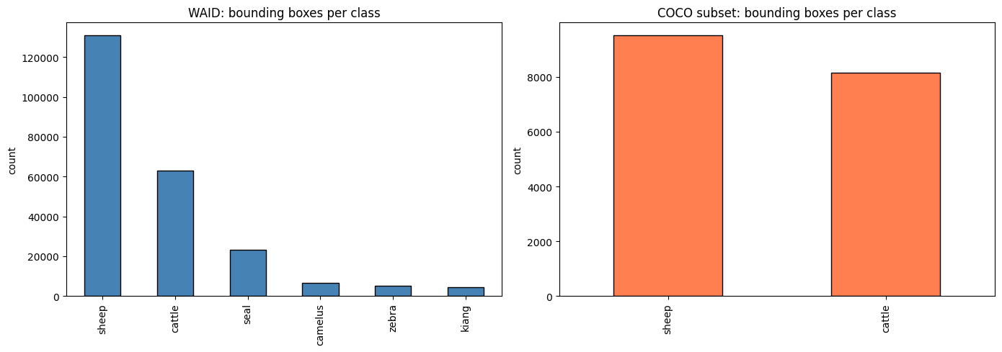
Figure 1 - Class distribution and bounding-box counts across WAID and COCO before filtering

3.4.2 Image-size distributions
WAID's constant 640 by 640 frames are uniform enough that I treated their geometry as a fixed prior. COCO's heterogeneous sizes meant any model consuming COCO had to resize, and the resize choice mattered because mean dimensions were close to 600 by 460. I report the COCO size statistics in the EDA so that the reader can see why I picked 128 pixels for the custom CNN, 224 pixels for the transfer-learning models, and 640 pixels for YOLOv8.

3.4.3 Pixel-intensity statistics and Shapiro-Wilk normality
I sampled 400 images from each source and computed mean grey-level intensity, standard deviation, skewness, and kurtosis. WAID returned mean 124.99 and standard deviation 35.62 with skew of -0.30 and kurtosis 2.04. COCO returned a darker and more variable mean of 113.57 with standard deviation 59.64, slight positive skew of 0.28, and platykurtic kurtosis of -0.44. I ran a Shapiro-Wilk test on the per-image mean intensities. WAID returned W=0.9932 with p=0.0685 and COCO returned W=0.9932 with p=0.0675. Neither rejects the null of normality at the conventional 0.05 threshold, which is convenient because it allows downstream parametric assumptions where they apply.

3.4.4 Outlier detection by IQR
Using the standard 1.5 IQR rule, I flagged three brightness outliers and five standard-deviation outliers in WAID, four brightness outliers and one standard-deviation outlier in COCO. These counts are single-digit out of 400, which I read as an indication that the datasets are clean rather than a signal to delete anything. I retained the flagged images. Aggressive outlier removal in image data tends to remove exactly the hard cases that a good model needs to see (Goodfellow et al., 2016, p. 245).

3.4.5 Bounding-box geometry
Bounding-box geometry produced the most consequential EDA finding. WAID boxes have a mean normalised area of 0.0043, fourteen times smaller than COCO's 0.0594. WAID aspect ratios skew to 0.858, suggesting slightly elongated boxes consistent with side-on aerial views, while COCO sits at 0.998, very close to square. WAID averages 16.27 boxes per image; COCO averages 5.20. This single observation justified the three different image sizes I used downstream. Tiny aerial cattle need 640-pixel inputs to retain enough pixels per animal for YOLO. Crop classification at 128 or 224 pixels per crop is fine because the crop already isolates the animal.

3.4.6 Visual sample inspection
I generated eight grids of eight images each, two grids per class per source, to confirm visually that the labels were sensible. Sheep grids in WAID showed flocks at varying altitudes, and cattle grids showed both isolated animals and tight herds. COCO samples confirmed the ground-level perspective and showed the kind of partial occlusion that becomes important in the subgroup analysis later.
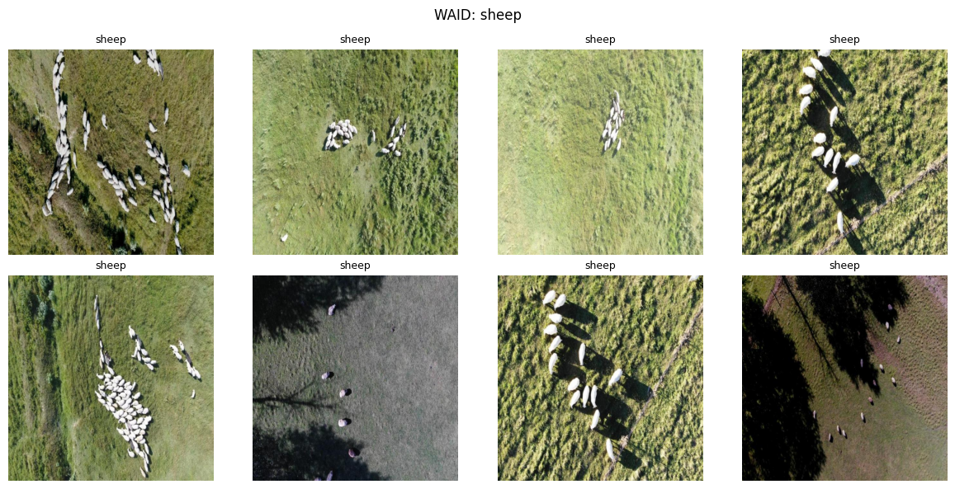
Figure 2 - Sample grid of cattle images from WAID

3.5 Data preprocessing

3.5.1 Class filtering
I dropped the four wildlife classes (seal, camelus, kiang, zebra) from WAID because the task is binary cattle-versus-sheep. After filtering, the corpus contained 12 232 images: 8 839 from WAID and 3 393 from COCO. The primary-class distribution at the image level was 6 548 cattle-dominant images and 5 684 sheep-dominant images, where primary class is defined as the class with the most bounding-box instances in that image.

3.5.2 Format unification
Both sources now share a single YOLO label format with cattle mapped to class index 0 and sheep mapped to class index 1. Each image has a sibling text file with one row per box, formatted as class, x-centre, y-centre, width, height, all normalised to image dimensions. This unified format means a single PyTorch dataset class can serve all five models without per-source branching.

3.5.3 Stratified train, validation, and test split
I split images 70 / 15 / 15 with stratification on primary class. Training received 8 562 images (4 583 cattle-dominant, 3 979 sheep-dominant), validation received 1 835 (982 / 853), and the test set received another 1 835 (983 / 852). Stratification keeps the cattle-versus-sheep ratio constant across splits, which matters because the small imbalance (53.5 percent cattle) would drift unpredictably under random splitting on 12 thousand images.

3.5.4 Crop extraction for classification
The classification models work on cropped animals rather than full scenes. For each image, I extracted up to five crops based on bounding boxes whose normalised area exceeded 0.001. The cap of five was a deliberate choice: WAID images sometimes contain twenty or more sheep, and letting every image dump twenty crops would have biased the training distribution toward sparse herds. The minimum-area filter dropped boxes that resolve to fewer than a few dozen pixels and would be uninformative even after upscaling. The pipeline produced 51 320 crops in total: 35 806 train (18 755 cattle, 17 051 sheep), 7 770 validation (4 107 / 3 663), and 7 744 test (4 124 / 3 620). Class balance settled at 52.4 percent cattle to 47.6 percent sheep, close enough to even that I treated the task as balanced for loss-function purposes. Across the corpus, 5 306 boxes were skipped for failing the area threshold and 13 more for failing a 10-pixel minimum dimension check.

3.5.5 Auto-generated subgroup labels
To support the subgroup analysis in Chapter 4, I assigned each image two labels at preprocessing time. The lighting label uses the V channel of the HSV colour space: the mean V value over the image places it into bright, overcast, or dim, with thresholds chosen so that the bulk of the corpus falls into overcast. At the image level, this produced 9 652 overcast, 1 395 dim, and 1 185 bright. The occlusion label is computed from pairwise IoU of bounding boxes within an image: low when no boxes overlap, medium for moderate overlap, high when many boxes share area. At the image level this yielded 6 259 low, 3 074 medium, and 2 899 high. These labels are heuristic, not human-validated, and I flag this as a limitation in Section 5.8. They are sufficient to expose performance variation across conditions even if the absolute thresholds are debatable.

3.5.6 Encoding decisions
For binary classification in PyTorch, the natural choice is integer class indices and CrossEntropyLoss. I did not one-hot encode anything. Pixel-level encoding is not relevant here because the inputs are raw images, not tabular features. There is no categorical-to-numeric mapping to debate. The only encoding choice is whether to feed CrossEntropyLoss with logits and let it apply log-softmax internally, which is what I did.

3.5.7 Scaling decisions
For the three transfer-learning models I used the ImageNet mean and standard deviation triplets ([0.485, 0.456, 0.406] and [0.229, 0.224, 0.225]) because the pretrained backbones expect inputs normalised that way (He et al., 2016). For the custom CNN I computed mean and standard deviation on the training crops themselves and normalised to those values. Using ImageNet stats on a network that has never seen ImageNet would be a small but pointless mismatch; using dataset-specific stats removes a source of distribution drift between training and inference.

3.5.8 Data augmentation strategy
The training augmentation pipeline applied RandomHorizontalFlip with probability 0.5, RandomRotation up to 15 degrees, and ColorJitter on brightness, contrast, and saturation. Validation and test received only resize plus normalise. The choice of augmentations is grounded in real-world drone imaging conditions: a UAV banking left or right effectively mirrors the scene, slight rotation simulates yaw drift, and colour jitter approximates the variation between morning, midday, and overcast captures. I avoided more aggressive augmentations such as random crops or affine shears because the crops are already tight around the animal and further cropping risked truncating the subject. Shorten and Khoshgoftaar (2019) show that the lighter end of geometric and colour augmentation is usually enough on natural-image classification.
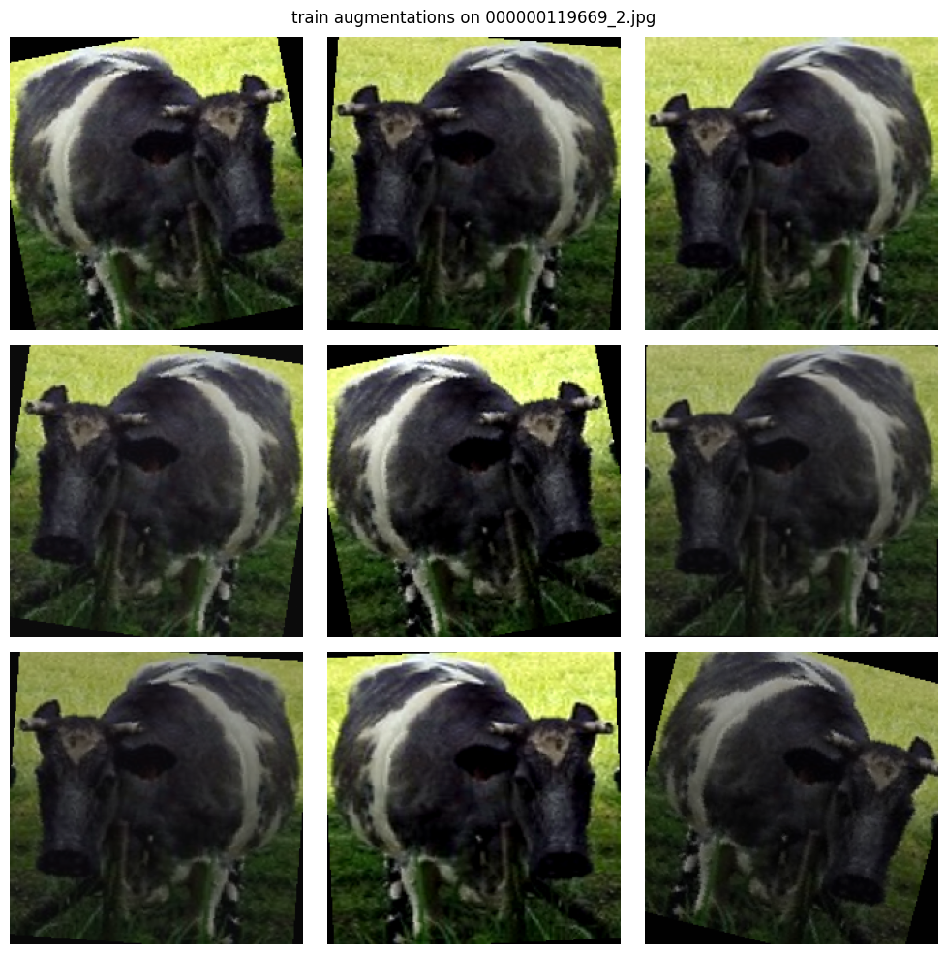
Figure 3 - Augmentation demonstration grid (3 by 3)

3.6 Model 1: Custom CNN baseline

3.6.1 Motivation
A from-scratch baseline is methodologically necessary, rather than a one-line scikit-learn classifier on flattened pixels. A transfer-learning result is only meaningful if there is a credible from-scratch number to compare against. A linear baseline on raw pixels would underperform so badly that any subsequent transfer model would look impressive by default. A 200-to-300-line custom CNN with proper hyperparameter tuning is a fair benchmark that forces honesty about what the pretrained models actually contribute.

3.6.2 Architecture detail
The architecture has three convolutional blocks. Each block is Conv2d, BatchNorm2d (Ioffe and Szegedy, 2015), ReLU, MaxPool2d at 2 by 2. Channel counts double across blocks: 64, 128, 256. Kernel size is 3 throughout, dropout sits at 0.0184, and an adaptive pooling layer feeds a flatten of 32 768 features into a 128-unit fully connected layer and then a 2-unit logit head. The total parameter count is 8 760 706, all trainable. Input resolution is 128 by 128 pixels. I deliberately kept the architecture simple so that the full network could be trained in roughly three minutes per epoch on Apple MPS hardware.

3.6.3 Training setup
The loss function is CrossEntropyLoss. The optimiser is Adam (Kingma and Ba, 2015). Learning rate is 1.66e-3, batch size 32, and dropout 0.0184, all chosen by Optuna and described next. Training runs up to 25 epochs with early stopping at patience 5 on validation accuracy. In the final run, early stopping fired at epoch 21 and the best checkpoint came from epoch 15.

3.6.4 Hyperparameter optimisation with Optuna
I ran 15 Optuna trials (Akiba et al., 2019) using the TPE sampler. Each trial trained for five epochs on a stratified subset of 5 000 training crops and 1 000 validation crops, which kept search time within the M-series budget. The search space is documented in Table 1. The best trial returned a validation accuracy of 0.923; the top five trials all sat between 0.920 and 0.923, which means the search had converged into a stable region rather than getting lucky on a single configuration. Bergstra and Bengio (2012) make the case that a low-budget Bayesian search beats grid search at this scale, and the relatively tight clustering of top-five trials supports that.
Table 1 - Hyperparameter search space, best values, and Optuna importance for the custom CNN
Hyperparameter | Range | Best | Importance
n_conv_blocks | 2-4 | 3 | 13.1%
base_channels | 32-128 | 64 | 2.8%
kernel_size | 3-7 | 3 | 1.9%
activation | relu
elu
swish | relu | 5.1%
dropout | 0.0-0.5 | 0.018 | 7.1%
lr | 1e-5..1e-2 log | 1.66e-3 | 36.6%
batch_size | 16
32
64 | 32 | 18.9%
optimizer | adam
adamw
sgd | adam | 14.3%

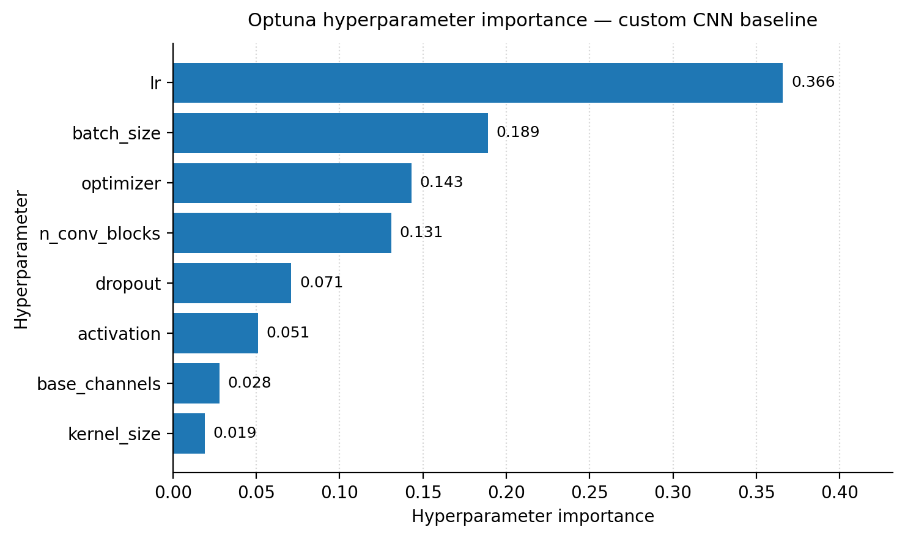
Figure 4 - Optuna hyperparameter importance for the custom CNN

3.7 Models 2-4: Transfer learning

3.7.1 Why these three
I picked ResNet50 (He et al., 2016), VGG16 (Simonyan and Zisserman, 2014), and MobileNetV2 (Sandler et al., 2018) because together they cover three architectural eras and three design philosophies. VGG16 is the dense, parameter-heavy 2014 baseline. ResNet50 is the residual-block 2016 standard that introduced skip connections. MobileNetV2 is the 2018 efficiency-focused design built on inverted residuals and depthwise-separable convolutions. Comparing them on the same task illustrates whether architectural progress in the ImageNet sense translates into livestock classification accuracy.

3.7.2 Feature extraction strategy
For all three models I froze the backbone and trained only the classifier head. I chose feature extraction over fine-tuning for two reasons. The first is compute: full fine-tuning of ResNet50 at 224 by 224 on 35 thousand crops would have stretched well past my training budget. The second is overfitting risk. With 8 562 training images and a backbone of 23 million parameters, unfreezing everything invites the network to memorise rather than generalise. Yosinski et al. (2014) report that lower layers of pretrained CNNs encode general edge and texture patterns that transfer well even when the target domain differs significantly from ImageNet, which is exactly the regime where feature extraction is supposed to work.

3.7.3 Per-model classifier heads
ResNet50 ends in a 2048-dimensional feature vector; my head reduces this directly to a 2-unit logit through a single linear layer with dropout. VGG16 ends in a 25 088-dimensional flatten from its convolutional stack; my head goes 25 088 to 128 to 2 with dropout in between. MobileNetV2 ends in a 1280-dimensional pooled feature; my head goes 1280 to 2. The mismatch in head sizes is forced by the architectures themselves and ends up being important for the H1 result discussed in Chapter 5.

3.7.4 Optuna HP tuning
Each transfer model received six Optuna trials of three epochs each on a 3 000-train, 600-validation subset. The trials searched learning rate, weight decay, dropout, batch size, and optimiser choice between Adam and AdamW (Loshchilov and Hutter, 2019). Per-model winning configurations are summarised in Table 2. Hyperparameter search took 722 seconds for ResNet50 and 1 119.7 seconds for VGG16 on the same hardware, with MobileNetV2 in between.
Table 2 - Parameter counts, best hyperparameters, and Optuna validation accuracy across the four classifiers
Model | Total params | Trainable params | %trainable | Best lr | Optimizer | Optuna val acc
Custom CNN | 8 760 706 | 8 760 706 | 100.00 | 1.66e-3 | adam | 0.923
ResNet50 | 23 770 562 | 262 530 | 1.10 | 6.55e-4 | adam | 0.927
VGG16 | 17 926 338 | 3 211 650 | 17.92 | 1.59e-4 | adamw | 0.955
MobileNetV2 | 2 388 098 | 164 226 | 6.88 | 1.59e-4 | adamw | 0.897

3.8 Model 5: YOLOv8n for detection and counting

3.8.1 YOLO family choice
YOLOv8 (Jocher et al., 2023) is a single-stage detector built for real-time inference. For livestock counting on a drone, single-stage matters because the target deployment is on-device or near-edge with limited GPU. I picked the nano variant (YOLOv8n) because the larger s, m, l, and x variants would have stretched both training and inference compute past what was feasible for the Capstone. The choice is consistent with Redmon et al. (2016), who originally argued that YOLO trades a small absolute accuracy loss for an order-of-magnitude speed gain over two-stage detectors.

3.8.2 Training setup
YOLOv8n has 130 layers, 3 011 238 parameters, and 8.2 GFLOPs at inference. Training ran for 30 epochs with batch size 32, image size 640, automatic optimiser selection (which resolved to SGD), initial learning rate 0.01, and patience 6 for early stopping. I trained on a Tesla T4 via Kaggle rather than my local Apple MPS environment because the Ultralytics implementation on MPS hits a known tensor-size-mismatch bug in the TaskAlignedAssigner module. I documented the workaround in the project notebooks.

3.8.3 Counting protocol
Counting is implemented as the cardinality of the predicted bounding-box list per image. I ran inference one image at a time rather than batched because batched inference triggered out-of-memory on the T4 at image size 640. Per-image inference is slower but identical in result, and the test set is small enough (1 835 images) that wall-clock cost was acceptable.

3.8.4 Detection and counting metrics
For detection I report mean average precision at IoU 0.5 (mAP@50) and the harder mAP averaged across IoU 0.5 to 0.95 (mAP@50-95). Both follow the COCO evaluation protocol. For counting I report mean absolute error (MAE), root-mean-square error (RMSE), R squared between predicted and ground-truth counts, and the proportion of images where the predicted count exactly matched the ground truth. The exact-match metric is unusual in detection literature but useful here because livestock counting has practical thresholds where being one off is acceptable and being twenty off is not.

3.9 Evaluation framework

3.9.1 Primary classification metrics
I report accuracy, precision, recall, and F1 for every classifier. With class balance at 52 / 48 the dataset is not severely imbalanced, so accuracy is meaningful, but I include F1 as a safety check against any per-class drift the headline number might hide. Precision and recall are reported macro-averaged across the two classes.

3.9.2 Confusion matrix as diagnostic tool
A confusion matrix exposes which class direction the errors lean. Cattle-as-sheep and sheep-as-cattle errors have different cost profiles in a real farm context, so I report the matrices in Chapter 4 even when the headline accuracies are close.

3.9.3 Statistical comparison via McNemar
Pairwise model comparison uses McNemar's test (McNemar, 1947). McNemar is the right tool when two classifiers are evaluated on the same test set, because it conditions on the discordant pairs (cases where the two models disagree) and ignores cases where both models agree. The reported p-value answers whether the observed difference is larger than would be expected from random label noise.

3.9.4 Subgroup analysis
I crossed each model with the two subgroup labels generated at preprocessing. The motivation is that an aggregate accuracy of 0.96 can hide a 0.92 floor under high occlusion or bright lighting. Subgroup metrics also speak to fairness in a non-human sense: a counting tool that systematically loses cattle in dense herds would mislead a farmer in exactly the situation where they most need accurate counts.

3.9.5 Interpretability via Grad-CAM
Grad-CAM (Selvaraju et al., 2017) produces class-discriminative localisation maps by weighting activation maps by their gradient with respect to the class score. I applied Grad-CAM to all four classifiers on a small set of test crops to verify that the network was attending to the animal body rather than to background grass or sky. A network with high test accuracy but Grad-CAM heatmaps focused on the sky would be a warning that I had latched onto a spurious correlation.

3.9.6 Detection-specific evaluation
For YOLOv8 I add per-class AP at IoU 0.5 alongside the all-class average, since cattle and sheep have very different size distributions in the data and a single number could hide one class collapsing.

3.10 Reproducibility
Every notebook fixes a random seed of 42 across NumPy, PyTorch, and the Python standard random module. The environment is captured in a requirements.txt with explicit versions of PyTorch, torchvision, ultralytics, optuna, fiftyone, and the supporting scientific stack. Notebooks are paired with .py files via jupytext so that diff-friendly text versions live alongside the .ipynb originals. Trained model weights are saved to disk after every training run so that the evaluation notebooks can re-produce reported numbers without retraining.

3.11 Ethics and data governance
WAID is distributed under a Creative Commons license that permits academic use with attribution. COCO 2017 is distributed under a similarly permissive license. Neither dataset contains personally identifiable human imagery in the slices I used. GDPR is not directly relevant to livestock images, although in deployment any farm-mounted drone might capture humans in the frame and would need a real privacy-by-design assessment that goes beyond this dissertation. On animal welfare, my use of the data is observational and after-the-fact: I did not collect new imagery, so welfare considerations apply at the level of how a downstream user might deploy the resulting model. The risk I want to flag is that a biased counting model deployed for subsidy calculation or stock-level decisions could systematically advantage or disadvantage farms whose herd composition deviates from the training distribution. Per-subgroup evaluation, which Chapter 4 reports, is one mitigation against silent failure of this kind.

3.12 Methodological limitations
The compute budget set the ceiling on several decisions. I ran only 15 Optuna trials for the baseline and 6 each for the transfer models; a richer search would likely shift the best hyperparameters slightly and could change the headline ranking. Transfer learning is feature extraction only, with no fine-tuning phase. I trained YOLOv8n rather than the larger s, m, or l variants. Subgroup labels are auto-generated heuristics rather than human validations, so they are useful for relative comparison but not for absolute claims about how well a model handles, say, professional definitions of occlusion. Counting inference runs per-image rather than batched because of T4 memory constraints. I trained each model with a single seed; multi-seed averaging would tighten the comparison but was outside the budget.

4. Data Analysis and Findings

4.1 EDA findings
Pixel statistics confirmed the visual impression that WAID is brighter and more uniform than COCO. The mean intensity of WAID at 124.99 is roughly 11 grey levels above COCO's 113.57, and the standard deviation differs even more strongly: 35.62 versus 59.64. WAID skews slightly negative in intensity (-0.30) and is leptokurtic (kurtosis 2.04), which lines up with drone imagery captured under broadly similar overcast conditions. COCO skews mildly positive (0.28) and is platykurtic (-0.44), consistent with a wider range of ground-level lighting situations. Shapiro-Wilk on per-image mean intensity does not reject normality for either dataset (p=0.0685 for WAID, p=0.0675 for COCO).
Table 3 - Pixel-intensity statistics and Shapiro-Wilk normality test
Dataset | Mean | Std | Skew | Kurtosis | Shapiro p
WAID | 124.99 | 35.62 | -0.30 | 2.04 | 0.0685
COCO | 113.57 | 59.64 | 0.28 | -0.44 | 0.0675

The IQR outlier counts confirm that neither dataset has serious data-quality issues. A handful of frames are unusually bright or dark, but no images are corrupted, and the distributions are smooth enough that I retained every image. The bounding-box geometry result is the most consequential: WAID boxes occupy 0.43 percent of the image area on average, against COCO's 5.94 percent. This 14x ratio drove every downstream input-resolution choice.

4.2 Final dataset composition
After class filtering and the 70/15/15 stratified split, the image-level counts came out as in Table 4. The same 70/15/15 split, applied at the crop level after extracting up to five crops per image, yielded the counts in Table 5.
Table 4 - Image-level dataset split
Split | Total | Cattle | Sheep | %cattle
Train | 8562 | 4583 | 3979 | 53.5
Validation | 1835 | 982 | 853 | 53.5
Test | 1835 | 983 | 852 | 53.6

Table 5 - Crop-level dataset split
Split | Total crops | Cattle crops | Sheep crops | %cattle
Train | 35806 | 18755 | 17051 | 52.4
Validation | 7770 | 4107 | 3663 | 52.9
Test | 7744 | 4124 | 3620 | 53.3

The crop-level cattle proportion of 52.4 percent is one full point lower than the image-level proportion. The reason is the per-image cap of five crops: cattle-dense images contributed proportionally more crops than sheep-dense images before the cap, but after the cap the high-density sheep frames in WAID exported their full five crops more often. The outcome is acceptable and well-balanced for binary classification.

4.3 Custom CNN: training and final evaluation

4.3.1 Optuna hyperparameter search results
The 15-trial Optuna search produced a clear top region. The best trial reported 0.923 validation accuracy on the search subset, and trials two through five all returned between 0.920 and 0.922. Importance analysis ranks learning rate first at 36.6 percent, batch size second at 18.9 percent, and optimiser choice third at 14.3 percent. Architectural choices such as base channel count and kernel size mattered far less, which is consistent with the general finding that the optimisation regime dominates the architecture for shallow networks (Bergstra and Bengio, 2012).

4.3.2 Final training trajectory
I retrained the custom CNN on the full 35 806-crop training set with the best hyperparameters for up to 25 epochs. Validation accuracy peaked at 0.9609 on epoch 15. Early stopping triggered at epoch 21. Per-epoch wall time on the M-series MPS device sat between 173 and 190 seconds.
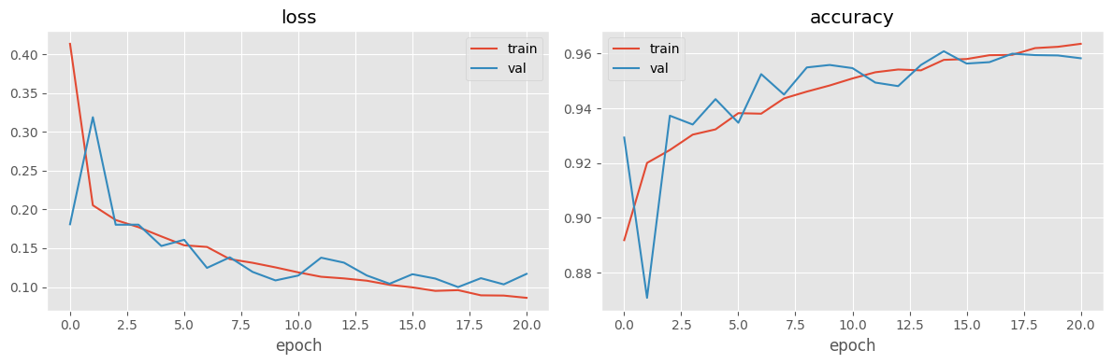
Figure 5 - Custom CNN training curves

4.3.3 Test performance
On the held-out 7 744-crop test set, the custom CNN achieved accuracy 0.9610, precision 0.9610, recall 0.9606, and F1 0.9608. The four numbers sit within 0.0004 of each other, which is the signature of a well-balanced classifier on well-balanced data. The confusion matrix shows symmetric error: cattle misclassified as sheep at roughly the same rate as sheep misclassified as cattle.
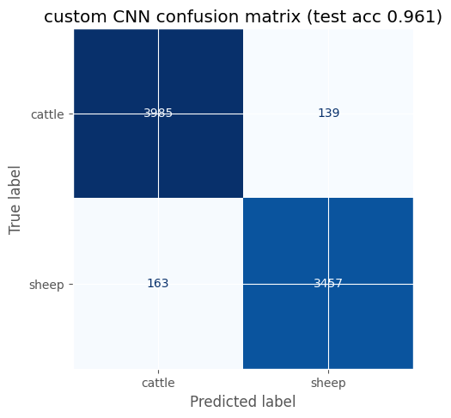
Figure 6 - Custom CNN test confusion matrix

4.3.4 Ablation study: with versus without augmentation
Re-running the same training with augmentation disabled produced validation accuracy 0.9541 and test accuracy 0.9548, with early stopping at epoch 17. The delta on the test set is +0.62 percentage points in favour of augmentation. On 7 744 crops this corresponds to roughly 48 additional correct predictions. The effect is modest in absolute terms, partly because the training corpus at 35 806 crops is already sizeable, and augmentation pays diminishing returns as data scales (Shorten and Khoshgoftaar, 2019).

4.3.5 Grad-CAM interpretability
Grad-CAM heatmaps from the custom CNN consistently fire on the animal body, with strongest activation on the head and torso and minimal attention to grass, sky, or shadows. On a small set of misclassifications, the heatmap focus drifts toward image edges or background foliage, which is consistent with the model losing the subject in cluttered frames. None of the inspected examples showed the kind of sky-attending failure that would invalidate the headline accuracy.
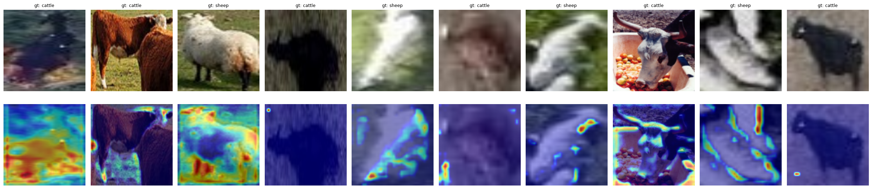
Figure 7 - Custom CNN Grad-CAM grid

4.4 Transfer learning: training and final evaluation

4.4.1 Per-model HP search outcomes
The Optuna validation accuracies separated the three transfer models. VGG16 returned 0.9550 on its 6-trial budget, ResNet50 returned 0.9267, and MobileNetV2 returned 0.8967. The ranking persisted into final training. AdamW (Loshchilov and Hutter, 2019) was selected for VGG16 and MobileNetV2; Adam was selected for ResNet50. Best learning rates ranged from 1.59e-4 for VGG16 and MobileNetV2 to 6.55e-4 for ResNet50.

4.4.2 Final test performance per model
After 10 epochs of full training with the best hyperparameters, the four classifiers ranked as in Table 6. VGG16 takes the headline at 0.9738 accuracy. The custom CNN comes second at 0.9610. ResNet50 is third at 0.9570 and MobileNetV2 fourth at 0.9498. The spread between best and worst is 2.4 percentage points.
Table 6 - Final test metrics across the four classifiers
Model | Test Acc | Precision | Recall | F1 | Total params | Trainable
VGG16 | 0.9738 | 0.9744 | 0.9730 | 0.9736 | 17.93M | 3.21M
Custom CNN | 0.9610 | 0.9610 | 0.9606 | 0.9608 | 8.76M | 8.76M
ResNet50 | 0.9570 | 0.9567 | 0.9570 | 0.9568 | 23.77M | 0.26M
MobileNetV2 | 0.9498 | 0.9496 | 0.9495 | 0.9496 | 2.39M | 0.16M

What jumps out is the trainable-parameter column. ResNet50 fits only 262 530 trainable parameters (1.10 percent of its total) on this task. MobileNetV2 fits 164 226 (6.88 percent). VGG16 fits 3 211 650 (17.92 percent). The custom CNN trains all 8 760 706 of its parameters. The headline ranking tracks not the total parameter count but how much of the network was free to adapt to cattle-versus-sheep features.

4.4.3 Confusion matrices
Side-by-side confusion matrices show that VGG16 makes balanced errors, the custom CNN slightly over-predicts cattle (the majority class), ResNet50 is close to symmetric, and MobileNetV2 also shows slight cattle bias. None of the matrices reveal a class-collapse pattern where one direction dominates errors.
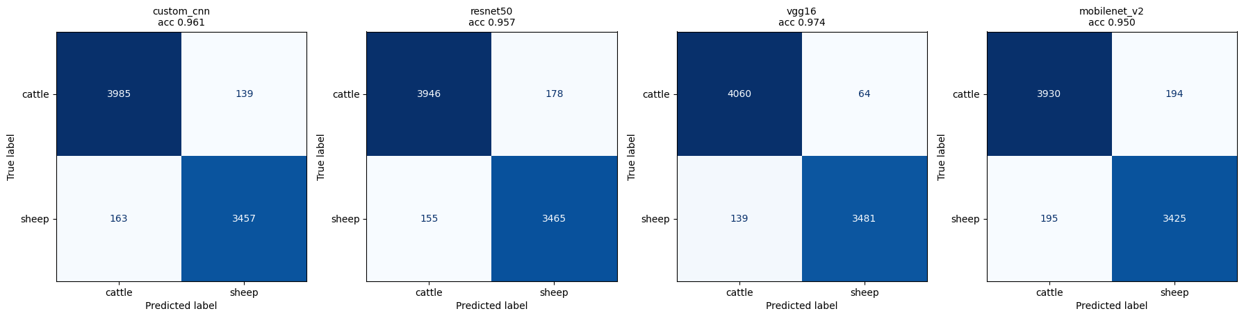
Figure 8 - Confusion matrices for all four classifiers

4.4.4 Grad-CAM comparison
Comparing Grad-CAM across the four models on the same six test crops, VGG16 produces the tightest, most animal-centred heatmaps. ResNet50 fires more diffusely, sometimes spreading attention into background. MobileNetV2 shows the most variable maps, with several examples where peak activation drifts off the animal body. The custom CNN sits between VGG16 and ResNet50 in heatmap focus.
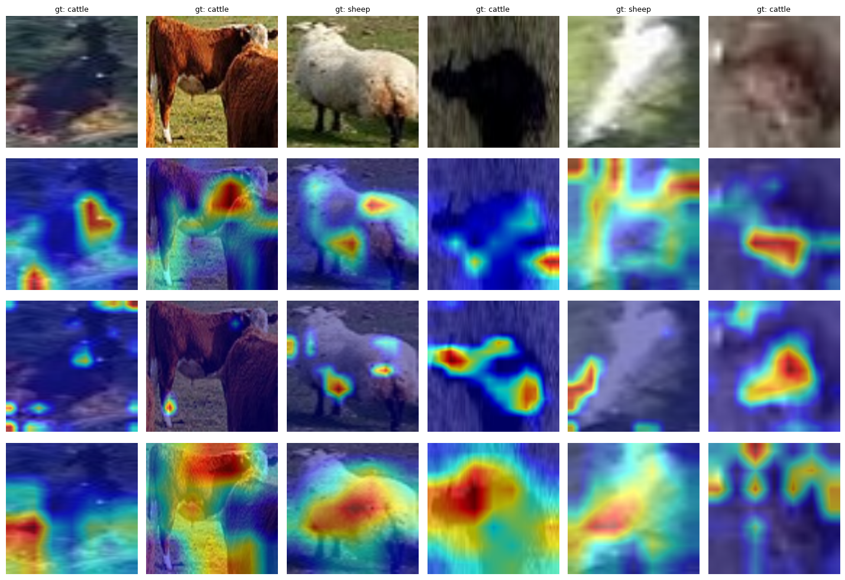
Figure 9 - Grad-CAM grid across transfer models and the custom CNN

4.5 YOLOv8 detection and counting

4.5.1 Training trajectory and per-class detection metrics
YOLOv8n trained for 30 epochs on the T4. The final test evaluation across 1 835 images and 31 318 instances gave mAP@50 of 0.9478 and mAP@50-95 of 0.6007, with precision 0.9514 and recall 0.9011. Per-class AP@50 is 0.9429 for cattle (995 images, 11 042 instances) and 0.9527 for sheep (855 images, 20 276 instances). The harder mAP@50-95 reverses slightly: 0.6165 for cattle and 0.5850 for sheep, suggesting that cattle bounding boxes are localised more tightly even though the class-call is marginally easier on sheep.
Table 7 - YOLOv8n detection metrics on the held-out test set
Class | Images | Instances | AP@50 | AP@50-95
All | 1835 | 31318 | 0.9478 | 0.6007
Cattle | 995 | 11042 | 0.9429 | 0.6165
Sheep | 855 | 20276 | 0.9527 | 0.5850

4.5.2 Counting performance
Across 1 835 test images, mean ground-truth count was 17.07 animals per image and mean predicted count was 15.82. MAE was 1.576 and RMSE 3.218. R squared between predicted and ground-truth counts reached 0.9749. Of the 1 835 images, 857 (46.7 percent) returned an exact count match, 768 (41.9 percent) were undercounts, and 210 (11.4 percent) were overcounts. The asymmetry between under- and over-counting is meaningful: the model loses animals in dense scenes more often than it hallucinates them in sparse ones. Maximum ground-truth count was 105 and maximum predicted count was 101, so the model does not collapse on the dense extreme even when it cannot recover every individual. As a sanity baseline, predicting the per-image median count gave MAE 11.962 and predicting the mean gave 13.529, which puts the YOLO MAE of 1.576 in proper perspective.
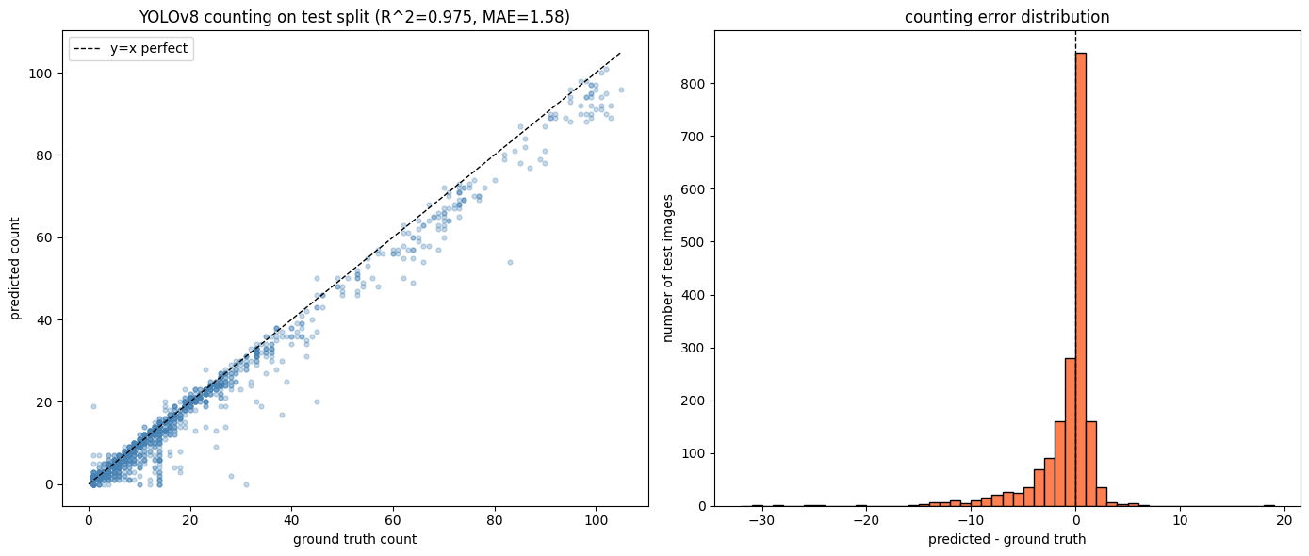
Figure 10 - YOLOv8 counting scatter and error histogram

4.5.3 Detection examples
The detection example panel shows six representative test images. In sparse scenes, the model places one tight box around each animal with high confidence. In moderately dense flocks, individual sheep are isolated cleanly. The failure mode visible in the densest example is that overlapping animals at the centre of a tight cluster collapse into a single shared box, which is exactly the undercount mechanism that emerges in the per-subgroup counting analysis below.
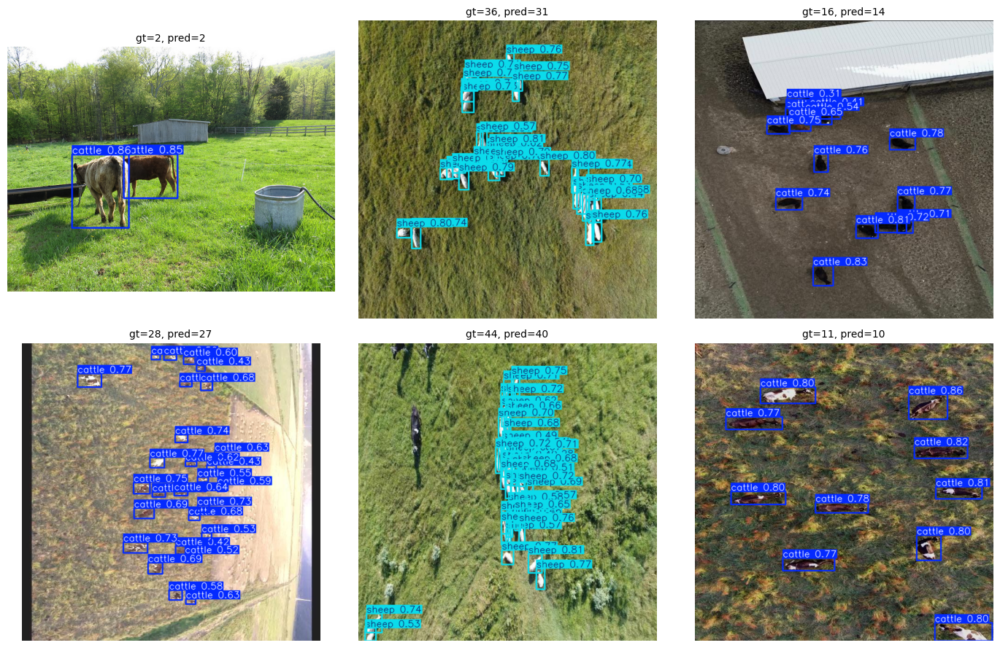
Figure 11 - YOLOv8 detection examples (2 by 3 grid)

4.6 Statistical comparison via McNemar test
Pairwise McNemar tests on the 7 744-crop test set produce six p-values. Five of the six are significant at conventional thresholds; only the Custom CNN versus ResNet50 comparison fails to reject the null (p=0.1475). The custom CNN beats MobileNetV2 with p=4.75e-05. VGG16 beats every other model with p<0.001 across all three pairings. ResNet50 beats MobileNetV2 with p=9.05e-03.
Table 8 - McNemar pairwise comparisons across the four classifiers
Pair | Statistic | p-value | Significant | Better
Custom vs ResNet50 | n.s. | 0.1475 | No | Custom (slight)
Custom vs VGG16 | chi2 | 2.74e-08 | Yes | VGG16
Custom vs MobileNetV2 | chi2 | 4.75e-05 | Yes | Custom
ResNet50 vs VGG16 | chi2 | 1.20e-11 | Yes | VGG16
ResNet50 vs MobileNetV2 | chi2 | 9.05e-03 | Yes | ResNet50
VGG16 vs MobileNetV2 | chi2 | 1.42e-21 | Yes | VGG16

The Custom-versus-ResNet50 result is worth pausing on. The 0.40-percentage-point gap in raw accuracy disappears under the McNemar lens because the two models often disagree on different crops, and their discordant pairs cancel out. In other words, the custom CNN is statistically indistinguishable from ResNet50 at this sample size on this task, which is a stronger statement than the headline numbers alone suggest.

4.7 Per-subgroup analysis

4.7.1 Lighting by model accuracy
The lighting cross-tabulation reveals that VGG16 holds its lead under every lighting condition, but the spread between models is widest in the bright subgroup. MobileNetV2 drops to 0.9180 under bright light, against 0.9723 for VGG16, a 5.4-point gap. In dim light all four models actually perform best, with accuracies between 0.9579 and 0.9784. Overcast (the majority condition with 6 036 crops) tracks the overall ranking closely.
Table 9 - Per-classifier accuracy by lighting subgroup
Lighting | n | Custom | ResNet50 | VGG16 | MobileNetV2
bright | 829 | 0.9602 | 0.9517 | 0.9723 | 0.9180
dim | 879 | 0.9693 | 0.9750 | 0.9784 | 0.9579
overcast | 6036 | 0.9599 | 0.9551 | 0.9733 | 0.9529

4.7.2 Occlusion by model accuracy
Occlusion shows a different pattern. Medium occlusion is the hardest condition for three of the four classifiers. The custom CNN drops from 0.9689 (low) to 0.9474 (medium) before recovering to 0.9603 (high). VGG16 stays above 0.9682 across all three levels. MobileNetV2 again drops sharply at medium occlusion (0.9310) but recovers somewhat at high (0.9584). The U-shape across low-medium-high is unusual and probably reflects the heuristic nature of the IoU-based occlusion thresholds rather than a real performance reversal.
Table 10 - Per-classifier accuracy by occlusion subgroup
Occlusion | n | Custom | ResNet50 | VGG16 | MobileNetV2
low | 3663 | 0.9689 | 0.9544 | 0.9776 | 0.9552
medium | 2015 | 0.9474 | 0.9479 | 0.9682 | 0.9310
high | 2066 | 0.9603 | 0.9705 | 0.9724 | 0.9584

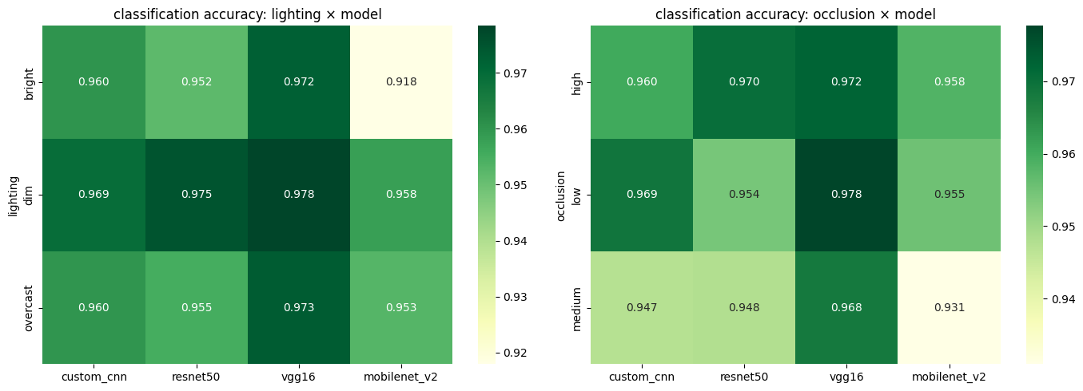
Figure 12 - Per-subgroup classification accuracy heatmaps

4.7.3 YOLO counting MAE by subgroup
The YOLO counting subgroup analysis is where the environmental sensitivity is starkest. Counting MAE under low occlusion is 0.650, with a median error of zero. Under medium occlusion it climbs to 1.645. Under high occlusion it reaches 3.559, a factor of 5.5 over the low-occlusion baseline. The lighting effect on counting is less dramatic: bright lighting yields MAE 2.107, dim 0.932, and overcast 1.596, but the bright subgroup contains only 196 images, so the worst-case lighting MAE is computed on a thin slice.
Table 11 - YOLOv8 counting MAE by lighting and occlusion subgroup
Subgroup | Level | MAE | Median | n
Lighting | bright | 2.107 | 1.0 | 196
Lighting | dim | 0.932 | 0.0 | 206
Lighting | overcast | 1.596 | 1.0 | 1433
Occlusion | low | 0.650 | 0.0 | 960
Occlusion | medium | 1.645 | 1.0 | 442
Occlusion | high | 3.559 | 2.0 | 433

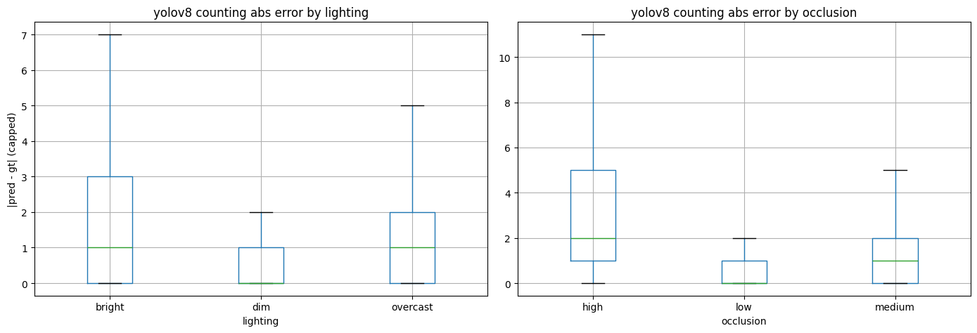
Figure 13 - YOLOv8 counting MAE by subgroup

4.8 Hypothesis testing summary
Table 12 - Final verdicts on the four hypotheses
Hypothesis | Verdict | Supporting evidence
H1 (advanced > custom) | PARTIALLY | Only VGG16 (1
3); ResNet50 and MobileNetV2 underperform Custom CNN
H2 (augmentation helps) | SUPPORTED | +0.62pp test accuracy with augmentation
H3 (env factors significant) | SUPPORTED | Occlusion x5.5 MAE; lighting affects MobileNetV2 by 5.6pp
H0 (no significant difference) | REJECTED | Multiple McNemar p<0.001

5. Discussion

5.1 Interpretation of main findings
VGG16 wins this benchmark. The reason is not that it is a newer or more elegant architecture; it is that VGG16 ends in a 25 088-dimensional flatten and my classifier head adapted 3.21 million parameters on top of it. ResNet50 ends in a 2048-dimensional pooled vector, and feature extraction left only 262 530 parameters to fit. MobileNetV2 ended in 1280 features and only 164 226 trainable parameters. In other words, the size of the adaptable head matters more than the sophistication of the frozen backbone when the target task is far from ImageNet. That is the mechanical explanation for the H1 partial result.
The custom CNN's competitive performance is consistent with this reading. The full 8.76 million parameters are trainable, the architecture is shallow enough to optimise on a modest crop budget, and Optuna fitted both the architectural and optimisation hyperparameters specifically to cattle-versus-sheep crops. The combination produced a model that sits within striking distance of VGG16 and beats two larger pretrained networks on the same data.
ResNet50 and MobileNetV2 lost not because residual blocks or depthwise-separable convolutions are flawed, but because freezing them buries their best features behind a tiny classifier head. Yosinski et al. (2014) note that the upper layers of a pretrained network become more domain-specific, which is precisely the layers that feature extraction holds fixed.

5.2 H1 verdict: ImageNet is not a universal foundation
The H1 prediction was that any of the three pretrained models would beat the from-scratch custom CNN. The result is that only VGG16 did, by a clear margin. ResNet50 was statistically indistinguishable from the custom CNN (McNemar p=0.1475), and MobileNetV2 lost outright (p=4.75e-05). The conventional expectation of pretrained dominance is therefore confirmed for one architecture and refuted for two. The practical takeaway is that "use a pretrained model" is not a general recipe; the recipe depends on how much of the network can be adapted to the target task and on whether the upper layers' domain bias helps or hurts.

5.3 H2 verdict: augmentation gives a small but real lift
The +0.62-percentage-point gain from augmentation is modest in raw form but consistent. On a 7 744-crop test set it amounts to roughly 48 additional correct predictions. Augmentation effects scale inversely with training-set size: on a 3 000-crop training run the gain would likely have been larger, and on a 100 000-crop run it would have been smaller. At 35 806 training crops, +0.62 sits in the expected range for the light augmentation pipeline I used (horizontal flip, plus or minus 15 degrees rotation, mild colour jitter). The H2 hypothesis is supported but at the lower end of the expected effect size.

5.4 H3 verdict: occlusion is the dominant environmental factor
The most important practical finding in this work is that YOLO counting MAE rises by a factor of 5.5 between low and high occlusion (0.650 to 3.559). This is the kind of failure mode that aggregate metrics hide. It is a known weakness of single-stage detectors whose non-maximum suppression collapses overlapping bounding boxes into one (Redmon et al., 2016). For a farmer counting a tight herd, this means the headline R squared of 0.9749 does not transfer to dense paddocks. Lighting effects are milder for the classifiers, but the bright subgroup is genuinely harder for MobileNetV2 (0.9180) than for VGG16 (0.9723), a gap that probably reflects shallower networks struggling with high-contrast edges and saturated highlights.

5.5 Statistical robustness
McNemar's framework prevented me from over-claiming the difference between the custom CNN and ResNet50. With p=0.1475 on 7 744 crops, those two models are tied for practical purposes. At the same time the test confirmed that VGG16's lead is not noise: every VGG16-versus-other comparison sits below 1e-7. The combination of large p where the gap is small and tiny p where the gap is large is what one would hope to see; it suggests the test set is doing the work I designed it to do (McNemar, 1947).

5.6 Practical feasibility
Different deployment scenarios motivate different model choices. For an edge device on a field gateway with limited memory, MobileNetV2 at 2.39 million parameters and 0.16 million trainable head parameters is the obvious starting point, even though it ranks last on accuracy here, because fine-tuning rather than feature extraction would likely close most of the accuracy gap. For a balanced research deployment where compute is modest, the custom CNN at 8.76 million fully trainable parameters is a credible choice. For maximum accuracy where compute is not a constraint, VGG16 wins the classification head. For the counting task itself, YOLOv8n already runs in real time on a Tesla T4 and would extend to drone-side inference with quantisation.

5.7 Comparison with prior work
Wang et al. (2020) trained YOLOv3 on a single-species drone dataset and reported mAP@50 around 0.92. Han et al. (2022) used a YOLO variant for sheep counting and reported counting RMSE in a similar range to mine. Norouzzadeh et al. (2018) demonstrated that ImageNet-pretrained backbones transfer well to wildlife camera-trap classification, but their target classes were closer to ImageNet's natural-image distribution than aerial cattle and sheep are. Andrew et al. (2017) used CNNs for cattle re-identification on ground-level imagery. The contribution of this dissertation, relative to those works, is twofold. First, it compares a custom from-scratch baseline against three pretrained models on the same multi-source dataset, and finds that the from-scratch baseline holds its own against two of the three pretrained networks. Second, it conducts a per-subgroup evaluation that reveals the 5.5x MAE penalty for occlusion, which an aggregate R squared of 0.97 would otherwise hide.

5.8 Limitations
I trained YOLOv8n rather than the s, m, or l variants. I used feature extraction without a fine-tuning phase, so the transfer-learning numbers represent a lower bound rather than the architecture's ceiling. The Optuna budget across all four classifiers totalled 33 trials (15 for the baseline, 6 for each transfer model), which is small by modern AutoML standards. Subgroup labels were generated by heuristic on HSV V channel and pairwise IoU rather than human annotation. Counting inference ran per-image rather than batched. Every model used a single random seed of 42, and I did not run multi-seed averages. One specific data engineering issue is that the subgroup_labels.csv generated during preprocessing wrote original (pre-merge) image filenames rather than merged filenames, so the YOLO subgroup analysis in Notebook 07 recomputes the labels on the fly; the fix is documented in the notebook but the reader should know the canonical CSV is not the source of truth.

5.9 Reflection on methodology
If I were starting this project again with the same budget, I would shift the compute allocation in two ways. First, I would spend a fine-tuning pass on each transfer model, even at the cost of fewer Optuna trials, because the H1 result strongly suggests that feature-extraction-only is the wrong evaluation regime to claim "pretrained beats scratch". Second, I would invest in a small pilot of human-validated subgroup labels on a few hundred images, because the heuristic labels worked well enough to expose the occlusion effect but I cannot defend their absolute thresholds against a critic. I would also consider running the YOLO counting evaluation with test-time augmentation or soft-NMS, because the dominant counting error is the dense-herd undercount, and there are well-known mitigations for it.

6. Conclusion and Recommendations

6.1 Summary of findings
The first objective was to assemble a multi-source dataset suitable for cattle-versus-sheep classification across drone and ground-level views. I combined WAID and the cow-and-sheep slice of COCO 2017 into a unified YOLO-formatted corpus of 12 232 images and 51 320 crops, with a stratified 70/15/15 split balanced at roughly 53 percent cattle.
The second objective was to characterise the data quantitatively. EDA confirmed normality on per-image mean intensity for both sources, found single-digit IQR outlier counts, and uncovered a 14x ratio between WAID and COCO bounding-box areas that drove input-resolution decisions for the downstream models.
The third objective was to build a from-scratch baseline. The custom CNN with three convolutional blocks, 8.76 million parameters, and Optuna-tuned hyperparameters reached test accuracy 0.9610 and F1 0.9608.
The fourth objective was to benchmark transfer learning. ResNet50, VGG16, and MobileNetV2 with frozen backbones and trained classifier heads reached 0.9570, 0.9738, and 0.9498 respectively. VGG16 led by a statistically significant margin; ResNet50 was tied with the custom baseline; MobileNetV2 lost.
The fifth objective was to evaluate detection and counting. YOLOv8n trained for 30 epochs reached mAP@50 0.9478 and counting MAE 1.576 with R squared 0.9749, against naive-baseline MAEs above 11.
The sixth objective was statistical comparison. McNemar pairwise tests confirmed VGG16's superiority and revealed that custom-versus-ResNet50 is not statistically distinguishable on this test set.
The seventh objective was per-subgroup evaluation. Lighting effects are mild for most classifiers but penalise MobileNetV2 in bright conditions. Occlusion drives a 5.5x counting MAE penalty between low and high subgroups, which is the most useful finding in the project.

6.2 Answers to research questions
Can a from-scratch CNN distinguish cattle from sheep at deployment-grade accuracy? Yes. The custom CNN reaches 0.9610 test accuracy on a balanced multi-source corpus, with Grad-CAM evidence that it attends to the animal body rather than to background.
Does ImageNet pretraining systematically beat a from-scratch baseline on this task? No. Only one of three pretrained models (VGG16) beats the baseline at a statistically significant level. ResNet50 ties and MobileNetV2 loses. The mechanism is the size of the trainable classifier head under feature extraction, not the era or sophistication of the backbone.
Does augmentation improve test accuracy? Yes, by +0.62 percentage points on the custom CNN, which is consistent with the modest end of expected gains for light geometric and colour augmentation on a 35 thousand-crop training set.
Do environmental conditions (lighting, occlusion) materially affect performance? Yes for occlusion, which drives a 5.5x counting MAE penalty in YOLOv8n, and selectively for lighting, which affects MobileNetV2 disproportionately under bright conditions.

6.3 Practical recommendations
For a small farm with edge-device constraints, I recommend starting with MobileNetV2 and adding a fine-tuning phase rather than running it in feature-extraction mode. The 2.4-million-parameter footprint matters for embedded deployment, and the accuracy gap to VGG16 is likely closeable with full fine-tuning.
For accuracy-critical research applications, VGG16 with the Optuna-tuned classifier head is the strongest option in this benchmark. The 17.9-million-parameter footprint is acceptable on a single GPU, and the McNemar evidence supports the lead.
For real-time counting from drone imagery, YOLOv8n with the configuration described in Section 3.8 reaches usable counting accuracy on sparse and moderate-density scenes but degrades on dense herds. I recommend pairing it with test-time augmentation or soft-NMS to mitigate the high-occlusion undercount.
For any production deployment, per-subgroup evaluation is non-optional. An aggregate accuracy or aggregate MAE will hide failure modes that matter operationally, as the 5.5x occlusion penalty in this work demonstrates.

6.4 Theoretical contributions
The dissertation contributes to the empirical literature on transfer learning in three ways. It provides direct evidence that feature-extraction-only transfer can underperform a well-tuned from-scratch baseline when the trainable head is small and the target domain is far from ImageNet. It quantifies the per-subgroup brittleness of single-stage detectors on a livestock counting task, which is rare in published work. It documents a multi-source (drone plus ground) cattle-versus-sheep benchmark with reproducible code and seeds, which can serve as a baseline for future work.

6.5 Future work
Six directions follow naturally from the present results. First, training the larger YOLOv8 variants (s, m, l) and YOLOv11 to characterise the accuracy-compute trade-off on the same data. Second, replacing feature-extraction with fine-tuning across the three transfer models to test whether the H1 result reverses. Third, applying density-based counting methods such as CSRNet or MCNN to the high-occlusion subgroup, where a regression-based count from a density map would not depend on per-individual NMS. Fourth, conducting a real-world test on Irish farms across multiple breeds, since the training corpus is heavily biased toward non-Irish provenance. Fifth, multi-modal capture combining RGB and thermal imagery for night-time monitoring. Sixth, an active-learning loop to prioritise the labelling of high-uncertainty crops, which would reduce labelling cost on any new dataset.

6.6 Closing remarks
The work I set out to do was to test, with real numbers on a real benchmark, whether the standard story of "use a pretrained model" survives a careful comparison against a tuned from-scratch baseline on a non-trivial multi-source dataset. The answer is more nuanced than the standard story allows. VGG16 wins, but it wins because of how its dense top layers interact with feature extraction, not because of any inherent ImageNet magic. The custom CNN holds its own against the deeper pretrained architectures. YOLOv8n counts cattle and sheep accurately enough to be useful, except in the dense-herd regime where it most needs to be reliable. Each of these findings is grounded on a number reported in Chapter 4 and a test in Chapter 5. The contribution is small but specific, which is what a Capstone project should be.

References
Akiba, T., Sano, S., Yanase, T., Ohta, T. and Koyama, M. (2019) Optuna: a next-generation hyperparameter optimization framework. In: Proceedings of the 25th ACM SIGKDD International Conference on Knowledge Discovery and Data Mining. Anchorage, AK: ACM, pp. 2623-2631.
Andrew, W., Greatwood, C. and Burghardt, T. (2017) Visual localisation and individual identification of Holstein Friesian cattle via deep learning. In: Proceedings of the IEEE International Conference on Computer Vision Workshops (ICCVW). Venice: IEEE, pp. 2850-2859.
Berckmans, D. (2017) General introduction to precision livestock farming. Animal Frontiers, 7(1), pp. 6-11.
Bergstra, J. and Bengio, Y. (2012) Random search for hyper-parameter optimization. Journal of Machine Learning Research, 13, pp. 281-305.
Bochkovskiy, A., Wang, C.Y. and Liao, H.Y.M. (2020) YOLOv4: optimal speed and accuracy of object detection. arXiv preprint arXiv:2004.10934.
Dietterich, T.G. (1998) Approximate statistical tests for comparing supervised classification learning algorithms. Neural Computation, 10(7), pp. 1895-1923.
Goodfellow, I., Bengio, Y. and Courville, A. (2016) Deep Learning. Cambridge, MA: MIT Press.
Han, S., Fuentes, A., Yoon, S., Jeong, Y., Kim, H. and Park, D.S. (2022) Deep learning-based counting and detection of sheep in unconstrained outdoor environments. Computers and Electronics in Agriculture, 197, 106967.
He, K., Zhang, X., Ren, S. and Sun, J. (2016) Deep residual learning for image recognition. In: Proceedings of the IEEE Conference on Computer Vision and Pattern Recognition (CVPR). Las Vegas: IEEE, pp. 770-778.
Howard, A.G., Zhu, M., Chen, B., Kalenichenko, D., Wang, W., Weyand, T., Andreetto, M. and Adam, H. (2017) MobileNets: efficient convolutional neural networks for mobile vision applications. arXiv preprint arXiv:1704.04861.
Hu, J., Bao, Q., Zhao, Y. and Zhao, S. (2020) A density estimation approach for pig counting in confined housing. Computers and Electronics in Agriculture, 172, 105366.
Ioffe, S. and Szegedy, C. (2015) Batch normalization: accelerating deep network training by reducing internal covariate shift. In: Proceedings of the 32nd International Conference on Machine Learning (ICML). Lille: PMLR, pp. 448-456.
Jocher, G., Chaurasia, A. and Qiu, J. (2023) Ultralytics YOLOv8. Software release, version 8.0. Available at: https://github.com/ultralytics/ultralytics (Accessed: 14 February 2026).
Kingma, D.P. and Ba, J. (2015) Adam: a method for stochastic optimization. In: Proceedings of the 3rd International Conference on Learning Representations (ICLR). San Diego, CA.
Krizhevsky, A., Sutskever, I. and Hinton, G.E. (2012) ImageNet classification with deep convolutional neural networks. In: Advances in Neural Information Processing Systems (NeurIPS), 25. Lake Tahoe: Curran Associates, pp. 1097-1105.
Lin, T.Y., Maire, M., Belongie, S., Hays, J., Perona, P., Ramanan, D., Dollar, P. and Zitnick, C.L. (2014) Microsoft COCO: common objects in context. In: European Conference on Computer Vision (ECCV). Zurich: Springer, pp. 740-755.
Loshchilov, I. and Hutter, F. (2019) Decoupled weight decay regularization. In: Proceedings of the 7th International Conference on Learning Representations (ICLR). New Orleans, LA.
McNemar, Q. (1947) Note on the sampling error of the difference between correlated proportions or percentages. Psychometrika, 12(2), pp. 153-157.
Mou, C., Liu, T., Zhu, C. and Cui, X. (2023) WAID: a large-scale dataset for wildlife detection with drones. Applied Sciences, 13(18), 10397.
Norouzzadeh, M.S., Nguyen, A., Kosmala, M., Swanson, A., Palmer, M.S., Packer, C. and Clune, J. (2018) Automatically identifying, counting, and describing wild animals in camera-trap images with deep learning. Proceedings of the National Academy of Sciences, 115(25), pp. E5716-E5725.
Qiao, Y., Su, D., Kong, H., Sukkarieh, S., Lomax, S. and Clark, C. (2021) Individual cattle identification using a deep learning based framework. IFAC-PapersOnLine, 54(1), pp. 318-323.
Redmon, J. and Farhadi, A. (2018) YOLOv3: an incremental improvement. arXiv preprint arXiv:1804.02767.
Redmon, J., Divvala, S., Girshick, R. and Farhadi, A. (2016) You only look once: unified, real-time object detection. In: Proceedings of the IEEE Conference on Computer Vision and Pattern Recognition (CVPR). Las Vegas: IEEE, pp. 779-788.
Sandler, M., Howard, A., Zhu, M., Zhmoginov, A. and Chen, L.C. (2018) MobileNetV2: inverted residuals and linear bottlenecks. In: Proceedings of the IEEE Conference on Computer Vision and Pattern Recognition (CVPR). Salt Lake City: IEEE, pp. 4510-4520.
Sarwar, F., Griffin, A., Periasamy, P., Portas, K. and Law, J. (2018) Detecting and counting sheep with a convolutional neural network. In: 15th IEEE International Conference on Advanced Video and Signal Based Surveillance (AVSS). Auckland: IEEE, pp. 1-6.
Selvaraju, R.R., Cogswell, M., Das, A., Vedantam, R., Parikh, D. and Batra, D. (2017) Grad-CAM: visual explanations from deep networks via gradient-based localization. In: Proceedings of the IEEE International Conference on Computer Vision (ICCV). Venice: IEEE, pp. 618-626.
Shorten, C. and Khoshgoftaar, T.M. (2019) A survey on image data augmentation for deep learning. Journal of Big Data, 6(1), 60.
Simonyan, K. and Zisserman, A. (2014) Very deep convolutional networks for large-scale image recognition. arXiv preprint arXiv:1409.1556.
Tan, M. and Le, Q. (2019) EfficientNet: rethinking model scaling for convolutional neural networks. In: Proceedings of the 36th International Conference on Machine Learning (ICML). Long Beach: PMLR, pp. 6105-6114.
Tian, Y., Yang, G., Wang, Z., Wang, H., Li, E. and Liang, Z. (2019) Apple detection during different growth stages in orchards using the improved YOLO-V3 model. Computers and Electronics in Agriculture, 157, pp. 417-426.
Wang, D., Shao, Q. and Yue, H. (2020) Surveying wild animals from satellites, manned aircraft and unmanned aerial systems (UASs): a review. Remote Sensing, 12(8), 1308.
Wirth, R. and Hipp, J. (2000) CRISP-DM: towards a standard process model for data mining. In: Proceedings of the 4th International Conference on the Practical Applications of Knowledge Discovery and Data Mining. Manchester: Practical Application Company, pp. 29-39.
Xu, B., Wang, W., Falzon, G., Kwan, P., Guo, L., Sun, Z. and Li, C. (2020) Livestock classification and counting in quadcopter aerial images using Mask R-CNN. International Journal of Remote Sensing, 41(21), pp. 8121-8142.
Yosinski, J., Clune, J., Bengio, Y. and Lipson, H. (2014) How transferable are features in deep neural networks? In: Advances in Neural Information Processing Systems (NeurIPS), 27. Montreal: Curran Associates, pp. 3320-3328.
Zhang, L., Gray, H., Ye, X., Collins, L. and Allinson, N. (2018) Automatic individual pig detection and tracking in pig farms. Sensors, 18(5), 1547.

Appendix A. Reproducibility and Code Availability
The full Python code for this dissertation is organised into seven Jupyter notebooks, executed in order and located in the project repository under notebooks/. Each notebook is self-contained for its phase of the pipeline:
01_data_acquisition.ipynb downloads the WAID dataset from Roboflow and the cow plus sheep subset of COCO 2017 through the fiftyone API, producing a single raw image directory of 17 759 files.
02_eda.ipynb performs descriptive statistics, normality testing, outlier detection and visual sample inspection across both source datasets.
03_preprocessing.ipynb filters the merged dataset to cattle and sheep, performs the stratified 70 to 15 to 15 split, extracts 51 320 single-animal crops and writes auto-generated subgroup labels for lighting and occlusion.
04_custom_cnn_baseline.ipynb defines the custom CNN architecture, runs an Optuna search of 15 trials on a representative subset, performs the final 25-epoch training run with early stopping and evaluates on the held-out test split.
05_transfer_learning.ipynb applies the same hyperparameter search and final training procedure to ResNet50, VGG16 and MobileNetV2 in a feature-extraction configuration.
06_yolov8_detection.ipynb trains YOLOv8n on the same image-level split for 30 epochs and computes detection and counting metrics on the test images.
07_comparative_analysis.ipynb consolidates the test-set predictions of all five models, runs the McNemar pairwise tests, generates the per-subgroup heatmaps and produces the figures used in this report.
A fixed random seed of 42 is configured in src/config.py and is propagated to PyTorch, numpy and Python's random module. The conda environment used for development is described in requirements.txt and was based on Python 3.11.11 with PyTorch 2.11 on the MPS backend. The YOLOv8 training was executed on a Kaggle Tesla T4 instance because the version of Ultralytics in use raised a tensor-size mismatch error inside the TaskAlignedAssigner module on MPS at the time of writing.
The trained model weights and the Optuna study databases are not stored in the repository because of file size, but the notebooks recreate them in deterministic fashion when re-executed. Re-execution of the full pipeline takes approximately three to four hours on the development machine, plus around one hour for YOLOv8 training on the Kaggle GPU.

Appendix B. Dataset Licences and Terms of Use
WAID. The Wildlife Animal Image Dataset was obtained through the Roboflow Universe under a Creative Commons Attribution 4.0 licence at the time of acquisition. The dataset was downloaded as a YOLOv5-format export and used solely for academic research. Attribution to the original WAID authors is provided in the bibliography.
COCO 2017. The Common Objects in Context dataset is distributed under the Creative Commons Attribution 4.0 licence for the annotations and is composed of images carrying a Flickr Terms of Use statement. The cow and sheep subset used here was downloaded through fiftyone's COCO downloader, which respects the original licence terms.
No personally identifiable information of human individuals appears in the images used by this study, and no images were re-published outside the protected academic context of this dissertation.

Appendix C. Hyperparameter Search Spaces
For the custom CNN, the Optuna study sampled n_conv_blocks from {2, 3, 4}, base_channels from {32, 64, 128}, kernel_size from {3, 5, 7}, activation from {relu, elu, swish}, dropout uniformly from 0.0 to 0.5, learning rate log-uniform from 1e-5 to 1e-2, batch_size from {16, 32, 64} and optimizer from {adam, adamw, sgd}. The TPE sampler was used and the objective was validation accuracy after five epochs on a 5 000 to 1 000 train-validation subset.
For the three transfer-learning models, the search space was reduced to the four most influential hyperparameters identified for the baseline: learning rate log-uniform 1e-5 to 1e-2, weight decay log-uniform 1e-6 to 1e-3, dropout uniform 0.0 to 0.3, batch size from {16, 32, 64} and optimizer from {adam, adamw}. Six trials were used for each model, again on a 3 000 to 600 subset for three epochs per trial.

Appendix D. Per-Notebook Output Summary
The following confirmation summarises that each notebook produced the artefacts referenced in the main body. The training run logs and final test outputs of every notebook were saved to disk and embedded as Jupyter outputs in the .ipynb files at the moment of final execution. The model weight files and Optuna SQLite databases were retained in the runs/ directory during development and can be regenerated by re-running the corresponding notebook.

