Big Data Solution Architecture
GROUP PROJECT
SENG8081 - Case Studies
Netflix Movies and TV shows till 2025

Submitted to:
Prof. David Marsh

Prepared by:

Veera Rani (8995178)
Isha Patel (8966332)
Yesha Panchal (8976484)
Nandhakumar Balaji (9053765)

Submitted on: 31-July-2025




Git Hub Repository
https://github.com/SENG8081/SENG8081-S25-Team2

Abstract

Managing and analyzing content data is essential for understanding viewer preferences and content trends in the fast-growing world of online streaming. This project presents a Python-based approach to organizing and analyzing Netflix’s movie and TV show catalog using data sourced from TMDb (The Movie Database) and Kaggle.

The system collects detailed information, including titles, genres, release dates, ratings, and content descriptions. The data is cleaned, formatted, and stored in a structured database for smooth querying and trend analysis. The backend uses Python to connect to TMDb's API and retrieve the latest content details, ensuring the dataset remains current and relevant.
Key features of the system include genre-based categorization, rating distribution tracking, and content release timeline analysis. This dataset and system can be used to build recommendation engines, explore content trends over time, and support content-based marketing strategies.
By combining historical and live content data, this project delivers a strong base for deep insights into Netflix’s evolving media library and enhances the potential for personalized recommendations and media analytics.
Table of Contents

- Introduction ................................................................................................................... 5
- System Overview .......................................................................................................... 6
- Data Research and Integration
• Types of Data
• Data Sources ............................................................................................................... 7
- Data Collection ............................................................................................................. 10
- Database Connection and Data Insertion Process ........................................................ 16
- Data Storage and Maintenance

• SQL Server (Sales Analysis)
• Data Loading
• Storage Needs
• Storage Solutions
• Data Retention Policies
• Data Backup and Disaster Recovery ........................................................................ 20
7. Data Quality ................................................................................................................... 30
8. Data Documentation and Metadata Management .......................................................... 32
9. Data Dictionary .............................................................................................................. 32
10. Data Analysis and Visualization .................................................................................. 33
11. Project Timeline ........................................................................................................... 41

12. Extension…………………………………………………………………………………….... 42

13. Future Work ………………………………………………………………………….. 42

14. Conclusion …………………………………………………………………………… 43

15. References …………………………………………………………………………… 44

Introduction

In today’s digital streaming era, platforms like Netflix generate vast amounts of data related to movies, TV shows, viewer preferences, and global content trends. To make sense of this data, businesses need automated systems that can collect, clean, and analyze content from both historical records and real-time sources.

This project aims to conduct a detailed analysis of Netflix's content library, focusing on historical and current data related to movies and TV shows. It explores patterns in content genres, release trends, viewer ratings, and other metadata to understand how Netflix's catalog has evolved. The main objective is to uncover insights into content popularity, genre distribution, and viewer engagement that can support data-driven decisions and recommendations. The project uses a clean and processed dataset from Kaggle, integrates real-time updates from the TMDb API, and builds visualizations and models to highlight key trends.

System Overview for Netflix Movies & TV Shows Project

This project was developed to analyze Netflix’s movies and TV shows using both historical and real-time data. The system is designed to collect, clean, store, and visualize Netflix content information in a structured and automated way. The core components work together to provide up-to-date insights into content trends, viewer preferences, and platform growth.

Key components:
- Python Backend: Used for collecting data from files and APIs, cleaning data, and preparing it for storage.
- Real-Time API: Fetches the latest movie and TV show details to keep the dataset updated.
- Historical Dataset: Contains movie and TV show data collected earlier from Kaggle and other sources.
- Database: Microsoft SQL Server stores all cleaned and detailed Netflix movies and TV shows data.
- Dashboard/Visualization: Tools like Tableau can be used to show reports and charts from the stored data.
The system helps in understanding Netflix’s evolving content library, supporting future AI-based recommendations or business insights.

Data Research and Integration

Data Sources:

TMDb API – Real-Time Content Data: The TMDb (The Movie Database) API is used to fetch real-time information on Netflix content. This includes newly added movies and TV shows, updated ratings, genre tags, and detailed descriptions. Access to this API allows the system to stay up to date with Netflix’s ever-changing library, supporting accurate content tracking and personalized recommendation features.

API Link: https://api.themoviedb.org/3

Key Steps for Utilizing the TMDb API:

- Register on TMDb to get an API key for access.
- Use Python libraries such as requests or official SDKs to connect and fetch data.
- Schedule periodic data synchronization to keep your content database updated in real time.
- Store new and updated records into the existing database following the same format used for historical records.

1. Kaggle Netflix Dataset – Historical Content Data:
This Kaggle dataset includes Netflix’s complete catalog of movies and TV shows up to 2025. It includes content titles, genres, release dates, durations, content types (movie/show), and ratings. This dataset serves as the historical foundation for analyzing past trends, tracking the growth of Netflix’s library, and studying genre popularity over time.

Kaggle Dataset Link: https://www.kaggle.com/datasets/bhargavchirumamilla/netflix-movies- and-tv-shows-till-2025

- Key Steps for Utilizing the Kaggle Dataset:

- Download the dataset and load it into your Python environment using a library like pandas.
- Design a database table structure that matches the dataset’s columns (title, type, release year, genre, etc.).
- Insert the historical records into the database for analysis and future comparison with real-time updates.

2. Data Management and Integration:

Once data from both sources (Kaggle and TMDb API) is available, they are integrated into a single system:

Database Schema: A unified database schema is created to handle both historical and real-time Netflix content data. Tables are organized to store content titles, genres, release dates, ratings, descriptions, and types (movie or TV show). This structure ensures clean, consistent data ready for analysis or application use.

Synchronization: The system performs scheduled synchronization with the TMDb API to update records and fetch new entries regularly. Depending on how frequently Netflix updates its content, this synchronization can be scheduled daily or weekly. During this process, the system checks for changes in ratings, newly added shows, or updated descriptions, and then updates the database accordingly.

In summary, this project combines a historical dataset with real-time content updates from TMDb. The integration ensures the system always has the latest and most complete Netflix content data. This supports accurate trend analysis, improves recommendations, and allows for better understanding of viewer preferences over time.

Type of data:

Data Type | Description | Purpose
Title Metadata | Movie/TV show title, type (Movie/Series), release year, duration | Analyze content catalog growth, identify trends by content type and release period
Genre Data | Includes customer ID, location (country), and potentially segmentation information | Understand geographic distribution, loyalty, and churn rate.
Cast & Crew Data | Actor, director information | Evaluate star impact and frequent collaborations
Country Data | Country of origin and availability | Track regional content and localization
Rating Data | IMDb/TMDb ratings and votes | Measure popularity and content quality
Top 10 Data | Weekly most-watched rankings | Identify high-performing content

Data Collection

Python file for Data Collection from different sources and data cleaning

1. Data Cleaning Process:

Cleaning the raw Netflix datasets was essential for making them reliable, consistent, and analysis ready. The process was applied to both TV Shows and Movies datasets using Python (primarily pandas, numpy, and re).

2. Missing Values Handling
Purpose:
Missing values, especially in key columns like cast, director, and genres, can lead to incomplete or biased insights.
Actions Taken:
- Columns like cast, director, genres, and description were filled with "Unknown" to maintain dataset completeness.
- Rows with too many missing values (i.e., fewer than 5 non-null entries) were entirely removed to preserve data quality.
Why it matters:
Prevents analysis tools from crashing or giving misleading results when encountering NaN.
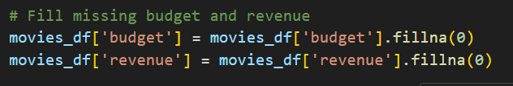

3. Data Conversion
Purpose:
Dates must be in a proper format for any time-based analysis (e.g., trend over years or seasons).
Actions Taken:
- The column date_added was converted to a datetime format using:
- Invalid date entries were automatically turned into NaT (Not a Time), which can be filtered later.
Why it matters:
Allows for filtering, grouping, or visualizing content based on release date (e.g., annual release trends).
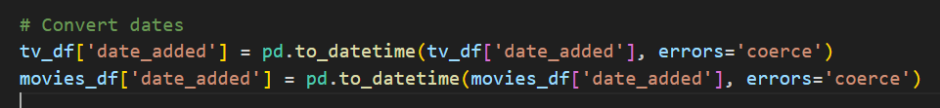

4. Duplicate Removal
Purpose:
Duplicate records inflate counts and distort metrics like total titles, revenue, or profit.
Actions Taken:
- Used drop_duplicates() to remove any fully duplicated rows from the datasets.
Why it matters:
Guarantees that each movie/TV show record is counted only once in analyses like genre distribution or budget sums.
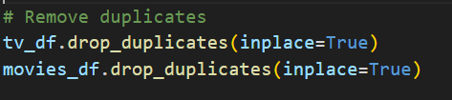
5. String Standardization
Purpose:
Inconsistent casing, spacing, or formatting in string fields leads to fragmented groupings during analysis.
Actions Taken:
- Standardized title fields:
Removes extra spaces and capitalizes titles (e.g., " breaking bad " → "Breaking Bad")
- Lowercased the language field:
Ensures "English", "ENGLISH", and "english" are treated the same
Why it matters:
Improves grouping accuracy in reports (e.g., grouping by language or title-based sorting).
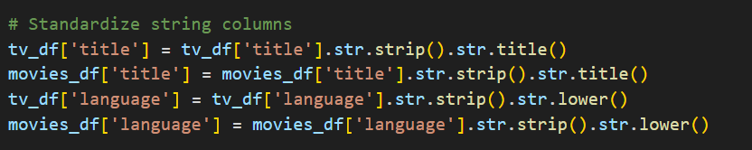

6. Numeric Imputation & Profit Calculation
Purpose:
Revenue and budget values are essential for calculating profitability and content investment patterns.
Actions Taken:
- Filled missing values in budget and revenue with 0, assuming no data implies zero (conservatively).
python
- Created a new column, profit:
Why it matters:
Profitability is a key metric for evaluating content performance, especially in cost-benefit analysis.
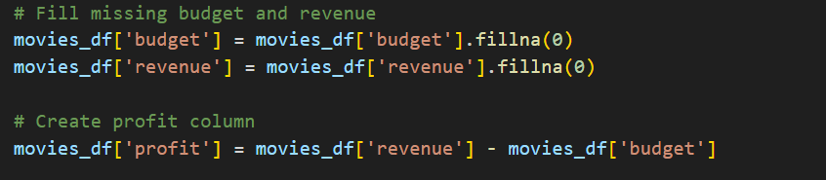

7. Emoji and Symbol Removal
Purpose:
Emojis and non-standard Unicode characters (e.g., ©, ™, emojis) can break visualizations or crash pipelines.
Actions Taken:
- Defined a regex pattern to detect:
  - Emojis
  - Foreign or special characters
- Applied it across each row to filter out affected entries.
Result:
Removed rows that contained emojis or abnormal characters in any field.
Why it matters:
Ensures clean, consistent textual data for visual tools like Tableau or Power BI, which may not handle these characters gracefully.
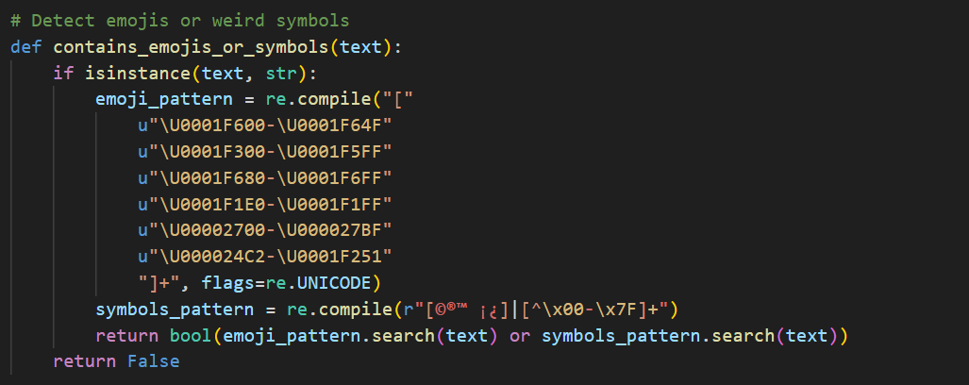

8. Final Outcome of Cleaning
- TV Shows: 16,000 records removed
- Movies: 16,000 records removed
(primarily due to emojis, duplicates, and missing critical data)
Cleaned files:
- netflix_tv_shows_final_clean.csv
- netflix_movies_final_clean.csv

9. Data Export
Final cleaned datasets were saved to:
- netflix_tv_shows_final_clean.csv
- netflix_movies_final_clean.csv
These files are now free from duplicates, missing critical fields, and non-standard Unicode artifacts, making them suitable for:
- Genre analysis
- Profitability trends
- Language-based content segmentation
- Release pattern trends over the years
10. Tools Used
- Python Libraries: pandas, NumPy, requests, pandas, pyodbc, openpyxl
- Storage: Local CSV output (can be extended to SQL Server or cloud DB)
- Regex Logic: Used for detecting emojis and special symbols

- System Diagram

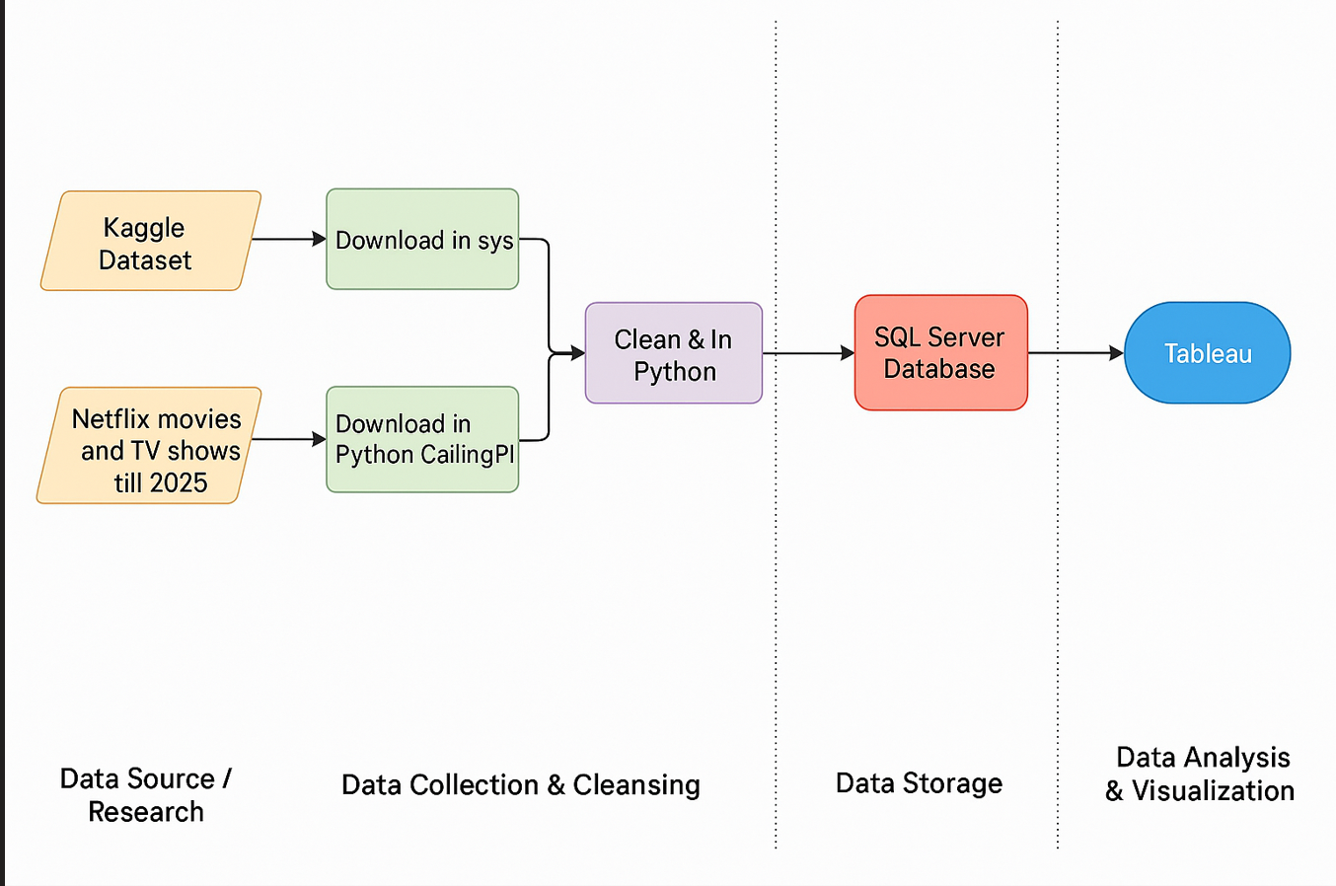

Database Connection and Data Insertion Process

Connecting Python to SQL Server
To connect Python to SQL Server, the project used the pyodbc library — a powerful and widely-used tool for ODBC (Open Database Connectivity) connections.
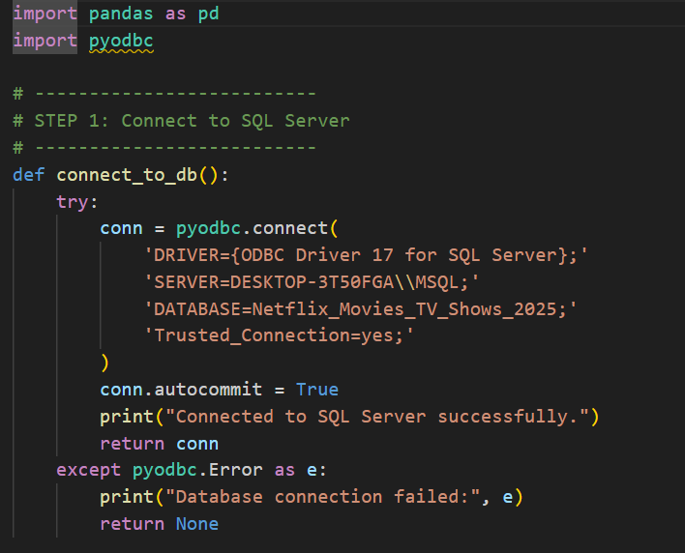
Explanation:
- DRIVER: Specifies the ODBC driver installed on your system.
- SERVER: Name of your SQL Server instance (e.g., YourMachineName\\SQLEXPRESS).
- DATABASE: The SQL database you want to use (NetflixDB).
- Trusted_Connection=yes: Uses Windows authentication (no need to enter SQL username/password).
Loading Cleaned Data from CSV:
Before inserting into SQL Server, cleaned data is loaded from saved .csv files using pandas:
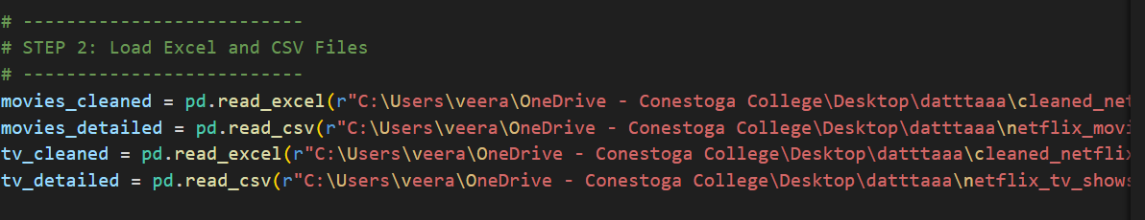

Inserting Data into SQL Server
General Approach:
- Connect to the database.
- Create a cursor object to execute SQL commands.
- Loop through each row of the DataFrame.
- Insert records using cursor.execute().
- Commit the transaction to save changes.

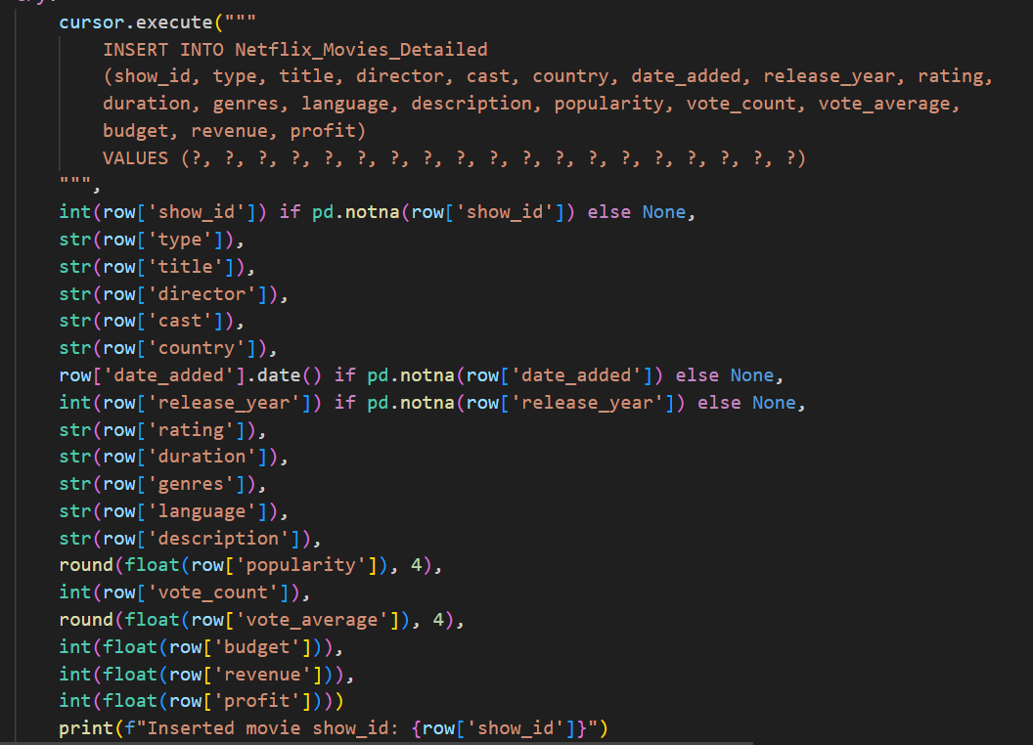

Finalizing the Process
After all insertions:
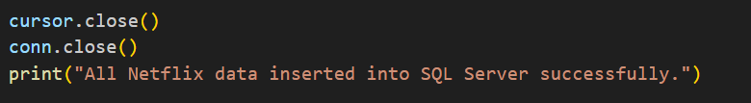

Database Schema Used
Example Tables:
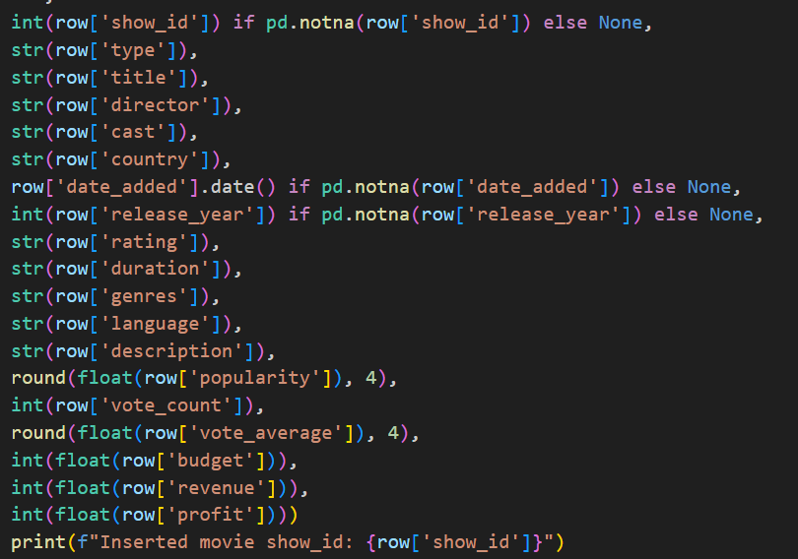

Data Storage and Maintenance

Effective data storage and maintenance are critical to the success of this Netflix content analytics system. This component ensures that cleaned, enriched, and real-time updated data is securely stored, easily retrievable, and reliably maintained for accurate long-term insights and system sustainability.

1. Database: SQL Server (Sales_Analysis)
All cleaned and integrated datasets are stored in Microsoft SQL Server. This platform offers robust relational database capabilities, transactional consistency, indexing for performance, and compatibility with Python via ODBC (using pyodbc).
Key Tables Created:
- Cleaned_Netflix_Movies_Data
- Netflix_Movies_Detailed
- Cleaned_Netflix_TV_Shows
- Netflix_TV_Shows_Detailed
Each table captures essential fields such as titles, genres, release dates, popularity, ratings, language, budget, revenue, and calculated profit—providing a rich base for querying and visual analysis.

Tables Created using the below SQL script:

- Cleaned_Netflix_Movies_Data (id, title, original_language, release_date, popularity, vote_average, vote_count, overview)
- Netflix_Movies_Detailed (show_id, type, title, director, cast, country, date_added, release_year, rating, duration, genres, language, description, popularity, vote_count, vote_average, budget, revenue, profit)
- Cleaned_Netflix_TV_Shows (id, name, original_language, first_air_date, popularity, vote_average, vote_count)
- Netflix_TV_Shows_Detailed (show_id, type, title, director, cast, country, date_added, release_year, rating, duration, genres, language, description, popularity, vote_count, vote_average, num_seasons)

-- Table 1: Cleaned Netflix Movies
CREATE TABLE Cleaned_Netflix_Movies_Data (
id INT,
title NVARCHAR(500),
original_language VARCHAR(10),
release_date DATE,
popularity FLOAT,
vote_average FLOAT,
vote_count INT,
overview NVARCHAR(MAX)
);

-- Table 2: Detailed Movies
CREATE TABLE Netflix_Movies_Detailed (
show_id INT,
type VARCHAR(50),
title NVARCHAR(500),
director NVARCHAR(500),
cast NVARCHAR(MAX),
country NVARCHAR(255),
date_added DATE,
release_year INT,
rating VARCHAR(50),
duration VARCHAR(50),
genres NVARCHAR(500),
language VARCHAR(50),
description NVARCHAR(MAX),
popularity FLOAT,
vote_count INT,
vote_average FLOAT,
budget BIGINT,
revenue BIGINT,
profit BIGINT
);

-- Table 3: Cleaned TV Shows
CREATE TABLE Cleaned_Netflix_TV_Shows (
id INT,
name NVARCHAR(500),
original_language VARCHAR(10),
first_air_date DATE,
popularity FLOAT,
vote_average FLOAT,
vote_count INT
);

-- Table 4: Detailed TV Shows
CREATE TABLE Netflix_TV_Shows_Detailed (
show_id INT,
type VARCHAR(50),
title NVARCHAR(500),
director NVARCHAR(500),
cast NVARCHAR(MAX),
country NVARCHAR(255),
date_added DATE,
release_year INT,
rating VARCHAR(50),
duration VARCHAR(50),
genres NVARCHAR(500),
language VARCHAR(50),
description NVARCHAR(MAX),
popularity FLOAT,
vote_count INT,
vote_average FLOAT,
num_seasons INT
);

2. Data Loading and Integration
The system utilizes Python-based scripts to efficiently load cleaned datasets into a Microsoft SQL Server database. This ensures a structured, consistent, and high-integrity data storage process as part of the ETL pipeline.
Key Steps in the Data Loading Process
- CSV File Handling: Cleaned .csv files (e.g., netflix_movies_final_clean.csv) are read using pandas for further transformation and preparation.
- Database Connection: A secure connection to the SQL Server is established using the pyodbc library, enabling execution of SQL commands directly from the Python environment.
- Row-wise Insertion: The script loops through each row of the DataFrame and inserts data using parameterized SQL queries, reducing the risk of SQL injection and ensuring data type consistency.
- Error Handling: The script includes comprehensive exception handling to manage:
  - Missing brand references
  - Type mismatches or conversions
  - Duplicate entries violating unique constraints
Integrity and Constraints
- Primary and foreign key constraints in the SQL schema are preserved during insertion.
- Transactions are committed only after all rows are validated, ensuring that no partial or corrupt records enter the database.

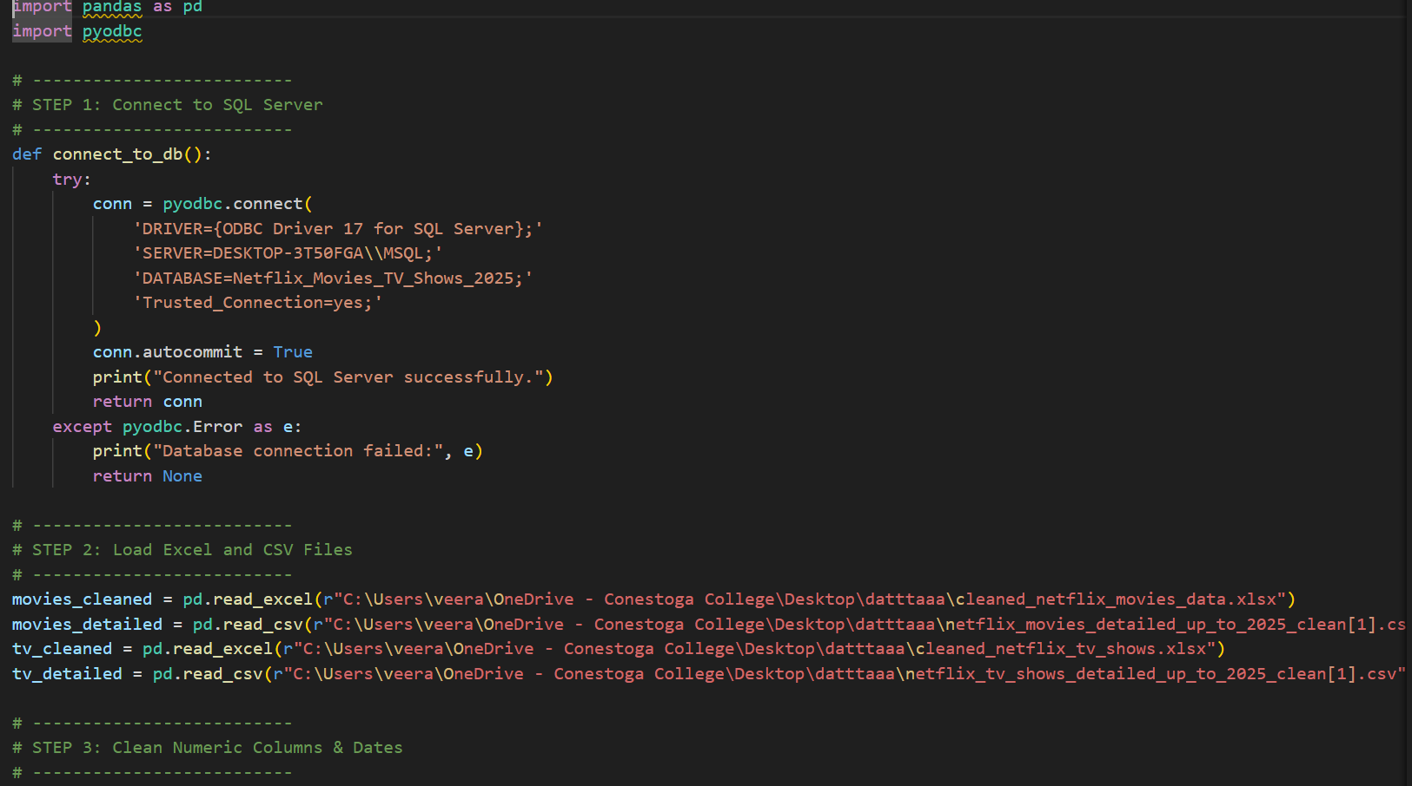
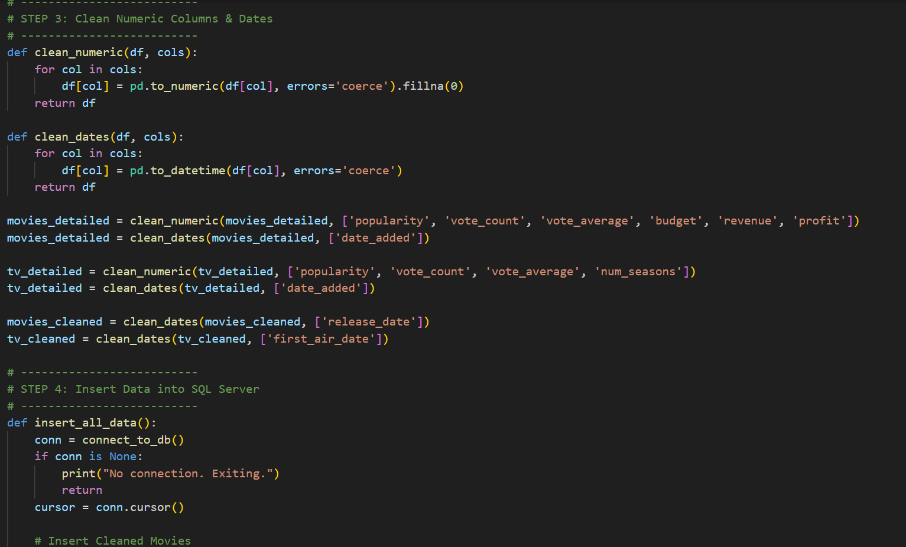
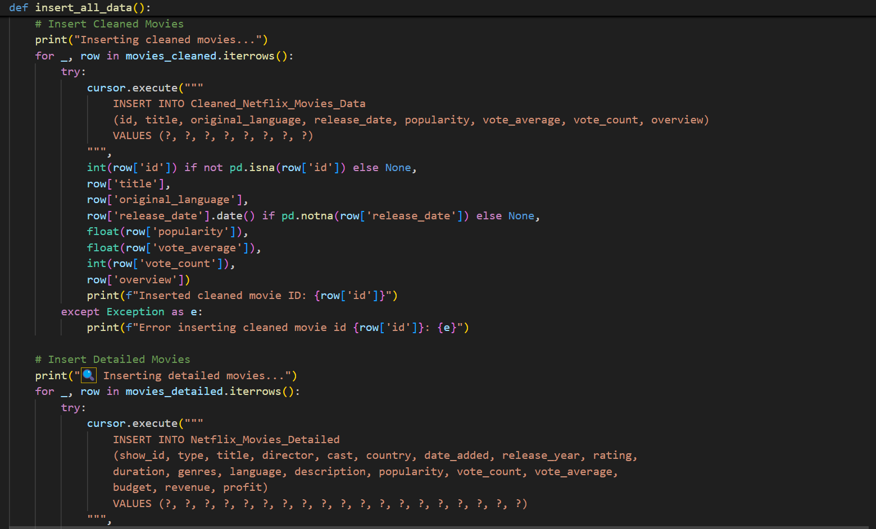
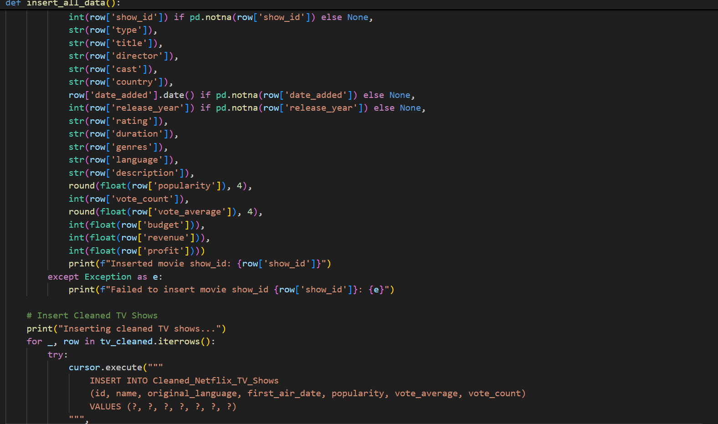
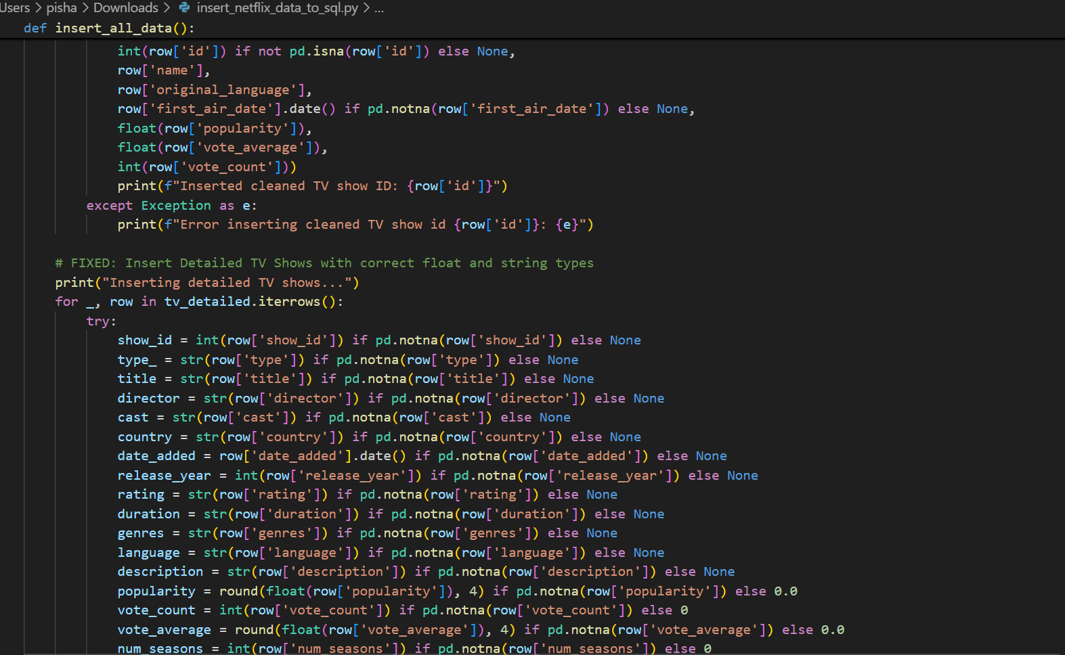
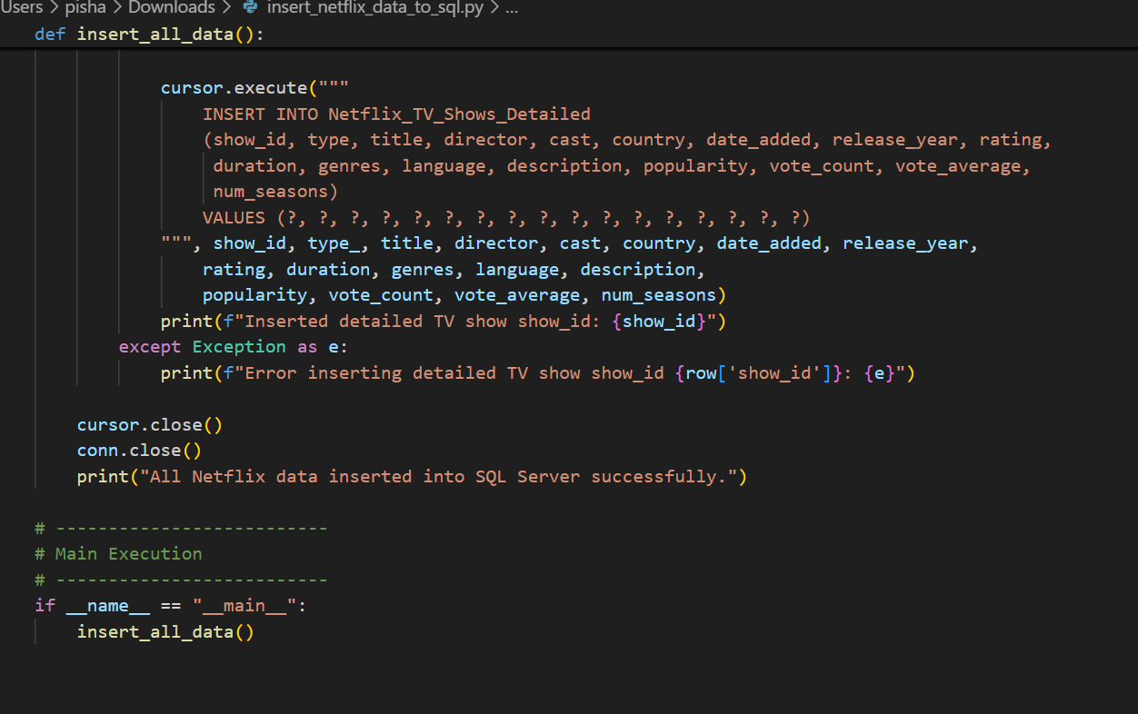

3. Storage Needs

Netflix content analysis involves handling:
- High-volume textual metadata (descriptions, cast, genres).
- Time-based data (release years, addition dates).
- Enriched metadata from TMDb API (ratings, popularity, language).
To meet these needs:
- Tables are normalized (e.g., separating core content from genre or region).
- Foreign keys and indexes are used for performance and consistency.
- Data types (e.g., DATE, FLOAT, NVARCHAR) are chosen for compatibility and space efficiency.

4. Storage Solutions
- Structured Storage: SQL Server relational model ensures structured, indexed, and validated data.
- Pre-Processing: Data cleaning (e.g., emoji removal, type standardization) happens before storage, minimizing the risk of pipeline failures.
- Scalability: Designed to support thousands of titles and regular TMDb updates, the system can scale with additional data using partitioning or archiving strategies.

5. Data Retention Policies

Data Type | Retention Period | Reason
Core content metadata | Indefinite | For long-term catalog analysis
Viewer ratings & Votes | 5 years | Popularity trend analysis
API-Fetched Metadata | 1 year + Monthly Snapshot | Compliance and freshness tracking

6. Data Backup and Disaster Recovery

- A daily or real-time backup system is essential to protect business-critical retail data from:
- System crashes
- Ransomware or malicious attacks
- Human errors or accidental deletion
- A disaster recovery plan must be in place to:
  - Restore SQL Server databases from backups
  - Re-deploy customer-facing systems like dashboards and APIs
  - Notify internal teams and mitigate impact on ongoing sales
- Regular system maintenance should ensure:
  - Database indexes are optimized
  - Storage drives are not nearing full capacity
  - Latest security patches and updates are applied to both the database and the hosting infrastructure.

Data Quality

Good data quality is very important when analyzing any dataset. We cleaned and explored the Netflix dataset to make sure it was accurate, complete, and ready for analysis.

1. Data Quality (Netflix Dataset)
Issues Identified:
Data Quality Category | Examples in the Netflix Dataset
Missing Values | Some fields like director, cast, country, and date_added were empty
Duplicates | Some shows or movies had the same show_id more than once
Inconsistencies | Country names were written differently (e.g., "USA" vs. "United States")
Outliers | Some entries had strange years (like before 1920 or after 2025)
Data Redundancy | The same genre was listed multiple times for one show
Invalid Types | Dates were stored as text instead of proper date format

2. Handling Missing Values
Method | What It Means | When to Used It
Deletion | Remove rows or columns with too many missing values | If many nulls and not critical to the analysis
Imputation (Filling) | Replace nulls with estimated values (mean, mode, forward fill, etc.) | If data is important and the missing rate is manageable
Placeholder values | Replace with "Unknown" or "Not Available" | For categorical fields like director, country

3. Data Transformation

We made the data more consistent by changing how it’s written (e.g., standard date format).

We converted text categories (like genres or ratings) into numbers so they could be used in analysis or machine learning.

4. Data Accuracy Assurance

Error Detection
- Use data profiling techniques, column analysis, pattern analysis, and descriptive statistics to detect errors or anomalies in the dataset.
- Look for patterns of inconsistency or unusual values that may indicate data quality issues.

5. Data Cleaning Tools
- Pandas: A Python library for handling missing data, duplicates, and formatting.
- OpenRefine: A tool to clean text in large datasets.
- Pyjanitor or Dataprep: Python libraries that make it easier to clean data using reusable steps.

Data Documentation and Metadata Management

Metadata Creation
- Data documentation involves recording detailed information about a dataset—its structure, meaning, source, and any cleaning or transformation steps. Metadata management ensures that each data field is clearly defined and traceable.
- It helps maintain data quality, improves transparency, and ensures consistent use across teams or projects. Well-documented metadata includes variable names, data types, permissible values, and data lineage.

Data Dictionary

Variable Name | Definition | Data Type | Permissible Values
show_id | Unique identifier for each show or movie | String | Alphanumeric, non-null (e.g., "s1", "s2", ...)
type | Type of content | String | "Movie", "TV Show"
title | Title of the movie or TV show | String | Text, non-null
director | Name(s) of the director(s) | String | Text may be null or "Not Available"
cast | Main cast members | String | Text may be null or "Not Available"
duration | Runtime or number of seasons | String | e.g., "90 min", "1 Season", "4 Seasons"
description | Summary or synopsis of the | String | Text, non-null
Data Analysis and Visualization

1st visualizations: Top 10 Most Popular Movies
API: cleaned_netflix_movies_data.xlsx
Bar chart

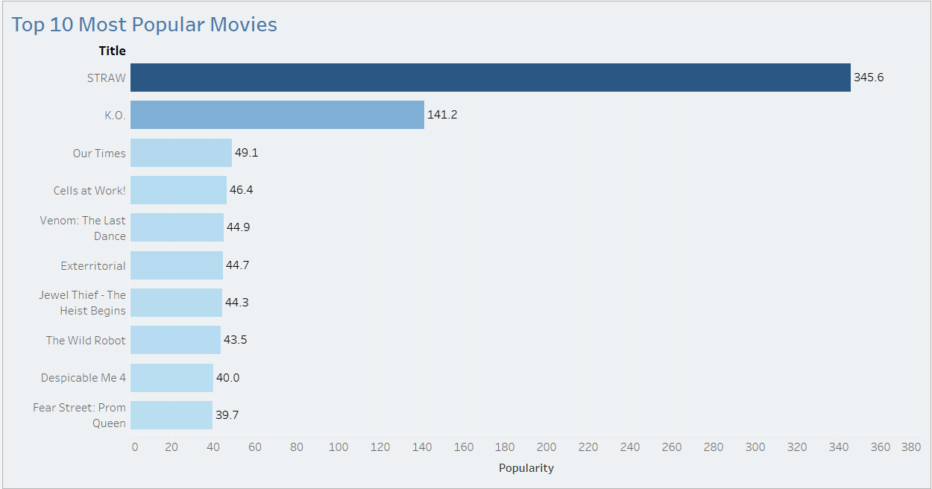

Analysis: The chart shows the frequency of each genre among Netflix movies based on API data. Drama and Comedy may lead, revealing Netflix’s dominant storytelling styles.
Purpose: Using the API data, this graphic analyzes the genres that are most represented in Netflix's movie library. It identifies the most popular content categories based on volume.
Logic: For category data, such as genres, a bar chart works well. It displays popularity trends by counting the number of films in each category.
Usefulness: This facilitates decision-making for the creation or licensing of new content and helps detect Netflix's production or acquisition patterns across genres.

2nd Visualization: Top Genres by Movie Count
Kaggle file: netflix_movies_detailed_up_to_2025_clean
Bar chart

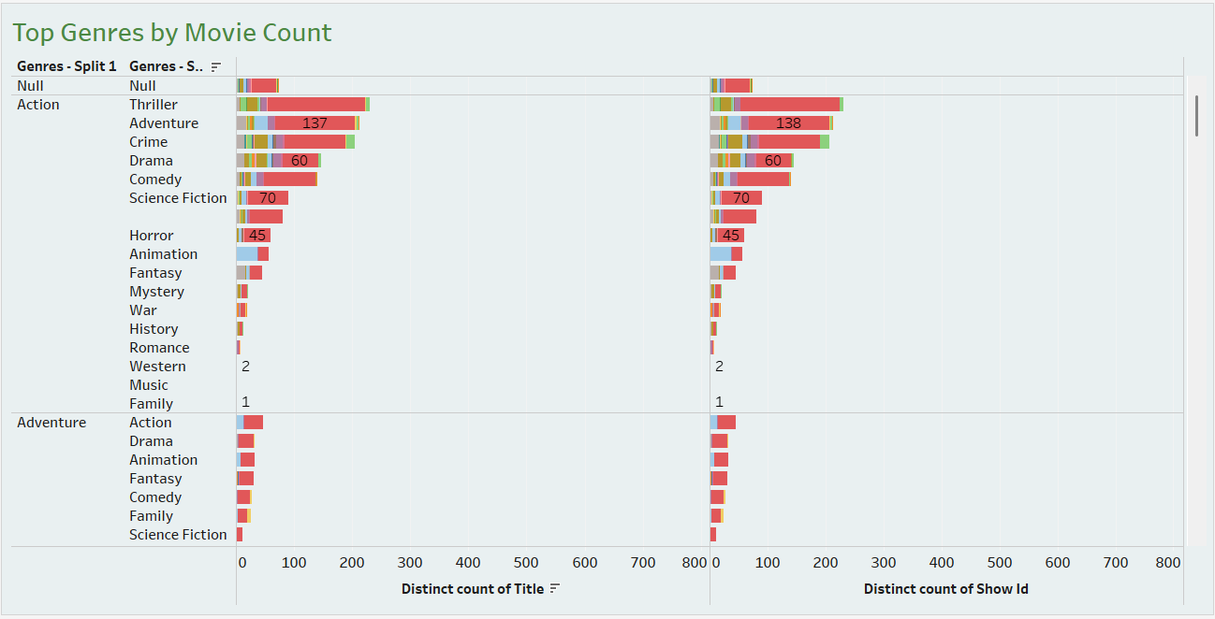

Analysis: The Kaggle version confirms genre distribution and allows cross-checking with publicly sourced metadata.
Purpose: To visually examine the distribution of genres in the Netflix movie dataset based on Kaggle and compare it with API output.
Logic: The bar chart counts unique titles per genre using the genre labels found in the Kaggle dataset and displays them as bars for comparison.
Usefulness: Good for evaluating how public data sources (like Kaggle) depict Netflix's content distribution and validating or contrasting with API insights.

3rd visualization: Movies by Country
API: cleaned_netflix_movies_data.xlsx
Map chart

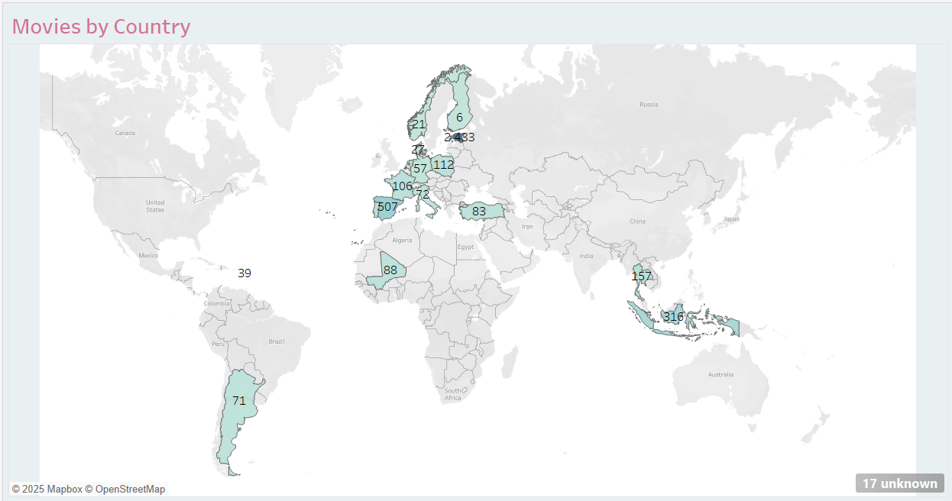

Analysis: Due to missing country data, original_language is used as a proxy to simulate geographic insight.
Purpose: As a stand-in visualization for real country data when it is unavailable. The original language is transformed into a geographic role to mimic regional analysis.
Logic: Even in cases where precise nation data are absent, some spatial inference is possible by mapping native languages to geographic regions.
Usefulness: Using existing metadata, it supports simple geographic analysis to estimate Netflix's global reach.

4th visualization: Movies by Country
Kaggle: netflix_movies_detailed_up_to_2025_clean
Map chart

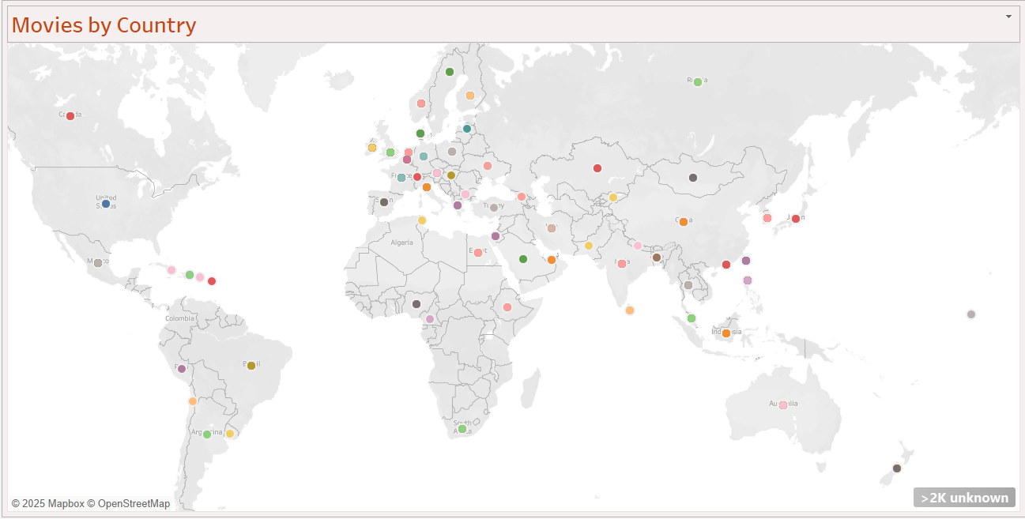

Analysis: Uses actual country data to accurately map movie distribution.
Purpose: Uses the dataset's actual `country` field to provide a more accurate worldwide map of Netflix movie distribution.
Logic: The popularity of the countries where movies are produced is directly counted or averaged and then filled maps or symbol maps are used to visualize the results.
Usefulness: Provides precise insights into spatial distribution and aids strategists in determining the most popular locations for content creation and consumption.

5th visualization: Average Rating Over Time
API: cleaned_netflix_tv_shows.xlsx
Line chart

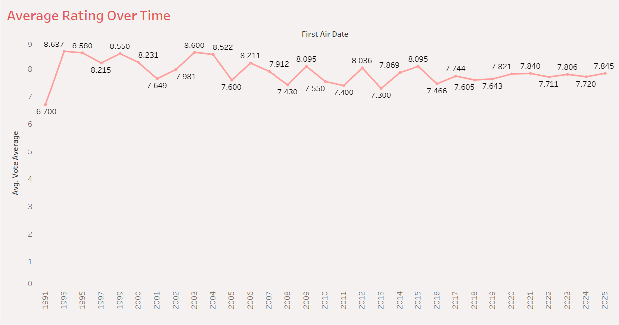

Analysis: Tracks how the average quality (based on votes) of Netflix TV shows changes over time.
Purpose: Uses average vote scores annually obtained from `first_air_date` to analyze user sentiment over time.
Logic: A time-series view of content quality is obtained by extracting the year from the date and adding up the votes.
Usefulness: Indicates whether the perceived quality of Netflix TV series is rising, falling, or staying the same over time.

6th visualization: Average Vote Score by Year
Kaggle: netflix_tv_shows_detailed_up_to_2025_clean
Line chart

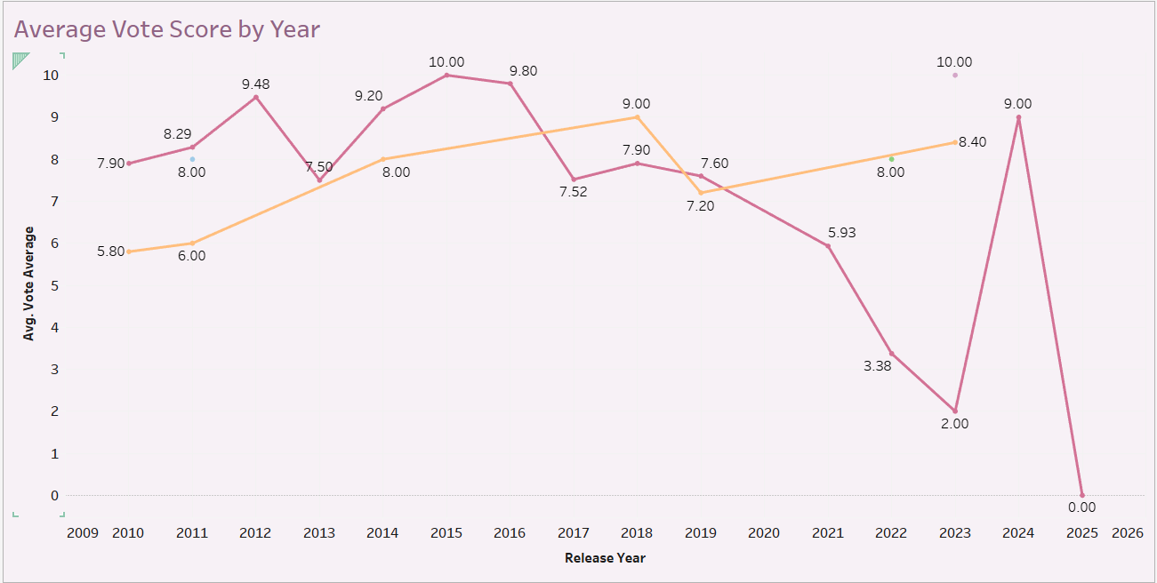

Analysis: Provides a similar trend using publicly available rating and year data.
Purpose: Uses the Kaggle TV series dataset to offer comparable insights. utilized to confirm trends found in API data.
Logic: Utilizes vote averages to follow the same trend analysis by year.
Utility: Serves as a statistic for comparing or measuring Netflix quality trends sourced from public and private APIs.

7th visualization: Popularity by Year and Genre
API: cleaned_netflix_tv_shows.xlsx
Tree Map

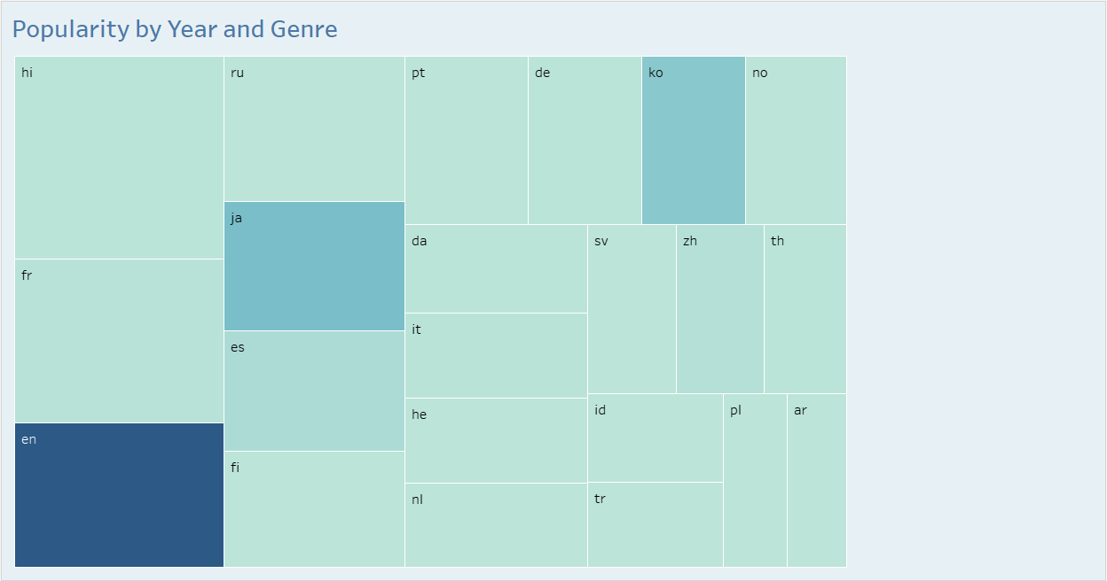

Analysis: Shows which languages dominate Netflix’s TV catalog.
Goal: Using the API dataset, illustrate the variety of Netflix TV show selections by original language.
Logic: Tree maps indicate the number of shows in each language using rectangular parts measured by volume.
Usefulness: Assists decision-makers in identifying gaps in inclusion or regional focus and in observing language representation.

8th visualization: Popularity by Year and Genre
Kaggle: netflix_tv_shows_detailed_up_to_2025_clean
Tree Map

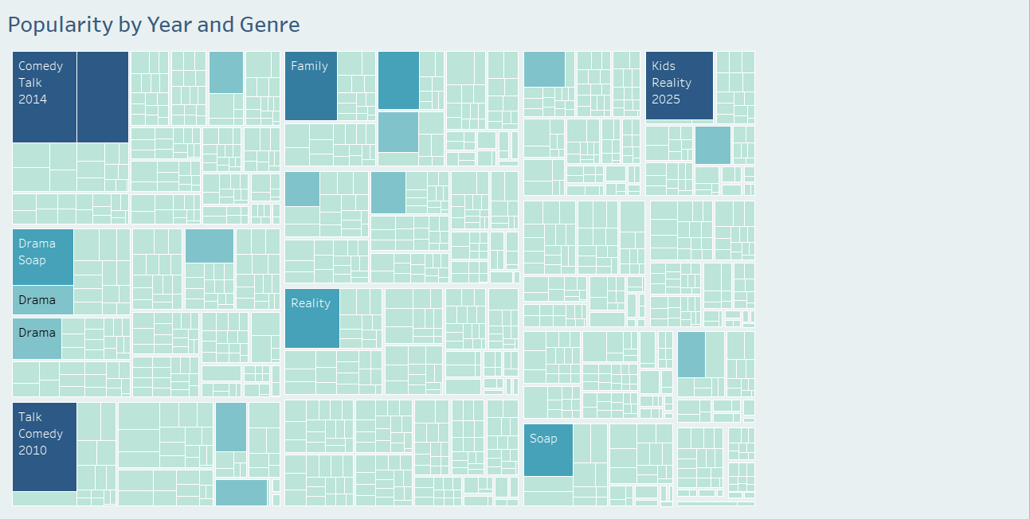

Analysis: Tree map shows the share of languages using publicly sourced TV show data.
Goal: A comparable tree map constructed from the Kaggle dataset enables comparison with distributions supplied from APIs.
Logic: Quantifies and visualizes the share of total content using the same original_language field.
Usefulness: Uses publicly accessible data to cross-validate Netflix's global content breadth.

Project Timeline

Date | Deliverable | Responsible
May 29 | Resource finding (API and dataset) | Veera, Yesha, Isha, Nandhakumar
Jun 06 | Collected data from the API and planned to clean | Veera, Nandhakumar
Jun 20 | Stored data in the database | Yesha, Isha, Veera
Jun 22 | Midterm report | Isha, Yesha, Veera, Nandhakumar
Jul 05 | Further cleaning of data | Nandhakumar, Veera
Jul 20 | Testing and solving errors | Nandhakumar, Veera, Isha, Yesha
Jul 22 | System Diagram | Nandhakumar, Veera, Yesha, Isha
Jul 27 | Analysis & visualization | Nandhakumar, Veera
Jul 31 | Final Report | Isha, Yesha, Veera, Nandhakumar

Extension

We intend to make the following improvements to our project in order to increase its impact and scope:
- Machine learning models that forecast the popularity of content in the future based on vote scores, language, genre, and runtime. What kinds of material Netflix might prioritize in creation can be determined by this predictive layer.
- A recommendation system that improves user experience simulation by simulating individualized Netflix recommendations through collaborative filtering.
- Sentiment analysis to better prepare content by understanding audience perception through social media data and public evaluations.
- Dashboard automation with APIs to guarantee real-time data refreshes in Tableau dashboards.
- Fairness Review and Ethical AI to evaluate representation and spot biases in languages, nations, and genres.

Future Enhancement:

Our future goals are to:
- Include richer metadata by integrating IMDb or other third-party platforms.
- When modeling recommendations, including user interaction behavior.
- To forecast future release volume or ratings, use time-series forecasting.
- Extend the project to include backend integration and a full-stack dashboard.

Conclusion

Through this study, we were able to use both live API data and Kaggle datasets to investigate and contrast Netflix films and TV series. We gained important knowledge on genre trends, linguistic variety, regional content output, and content quality over time by using Tableau visualizations and Python for data preparation.
We were able to confirm results and point out variations in data quality by comparing API and Kaggle data side by side.
Our visualizations provided a data-driven perspective on Netflix's library by showcasing the evolution of language diversity, viewer ratings, and content popularity. This initiative, in our opinion, has established a strong basis for more sophisticated analytics in entertainment data.

Reference

- Bhargavchirumamilla. (2025, March 4). Netflix Movies and TV Shows till 2025 [Dataset]. Kaggle.
https://www.kaggle.com/datasets/bhargavchirumamilla/netflix-movies-and-tv-shows-till-2025
- The Movie Database (TMDb). (n.d.). TMDb API – Real-Time Content Data. https://api.themoviedb.org/3
- Pandas Development Team. (n.d.). pandas documentation – pandas 2.3.0. https://pandas.pydata.org/docs
- Kleehammer, M. (2024, October 16). pyodbc [Python package]. PyPI. https://pypi.org/project/pyodbc/
- Python Software Foundation. (n.d.). Python 3 documentation.
https://docs.python.org/3/

