C3- S7 PRACTICE

Ex 1: Can I go to PNC?

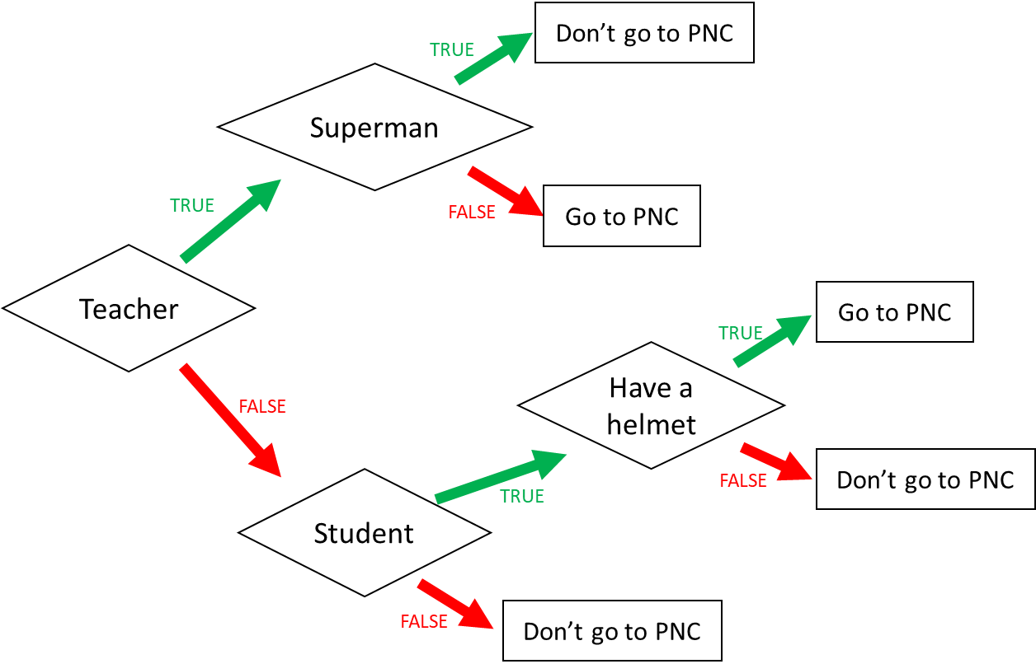

1. I am a teacher and I am superman, can I go to PNC? Don’t go to the PNC

1. I am not a teacher and not a student, can I go to PNC? Don’t go to the PNC

1. When can I go to PNC? (Express the condition using a Boolean expression)

I go to PNC if:

|  |
| --- |
| I am a Teacher and not the superman Or I’m not a teachr and student andhave a helmet. |

Ex 2: What do I eat?

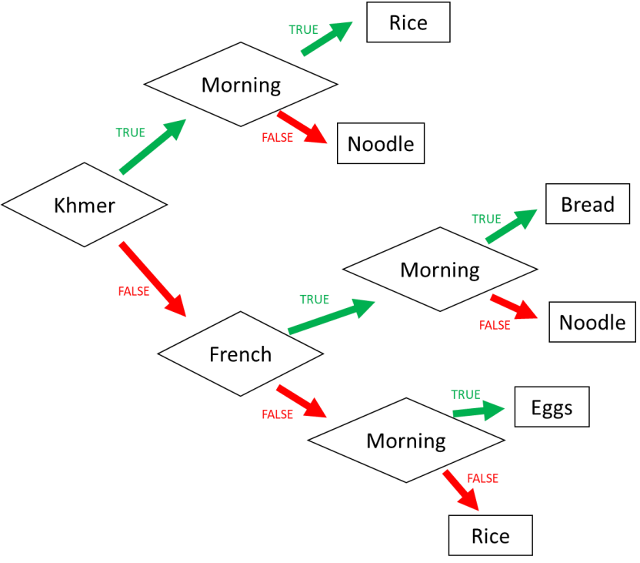

1. I am Khmer and it is the evening. What do I eat? Noodle

1. I am French and it is the morning. What do I eat? Bread

1. I am American and it is the morning. What do I eat? Eggs

1. When do I eat rice? (Express the condition using a Boolean expression)

I eat rice if:

|  |
| --- |
| Khmer and moring Or not khmer and not french and not morning. |

Ex 3: Do I go to the pool?

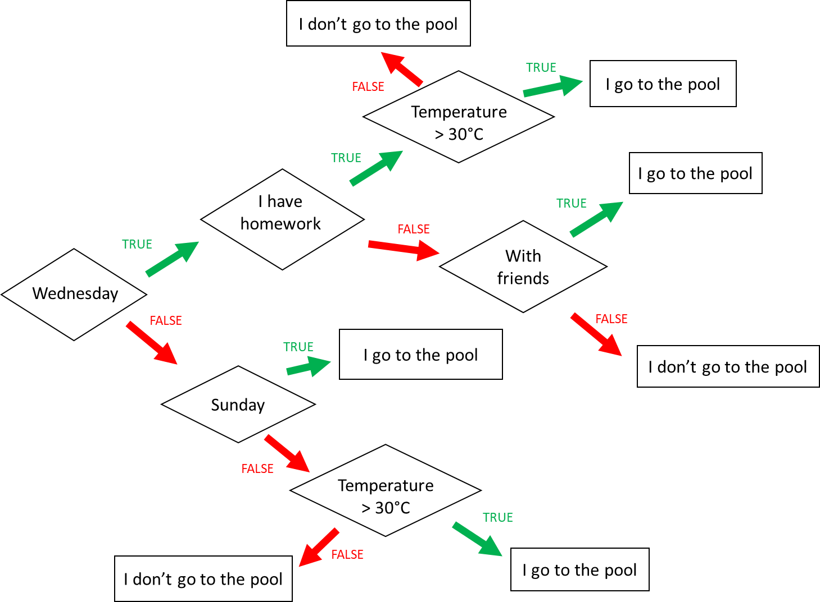

**Input 1 :**

* Wednesday
* Temperature = 31°C
* No homework

→ Do I go to the pool ? I go to the pool

**Input 2 :**

* Monday
* Temperature = 35°C
* I have no friend → Do I go to the pool ? I go to the pool

**Input 3 :**

* Wednesday
* I have homework
* I’m with friends • Temperature = 28°C → Do I go to the pool ? I don’t go to the pool.

When do I go to the pool ? (Express the condition using a Boolean expression)

I go to the pool if :

|  |
| --- |
| Wednedday and have homework and Temperture >30 or Wednesday and no homework and with friend Or not Wednesday and Sunday Or Not Wednesday and not Sunday and Temperature >30. |

Ex4: Do I create a Facebook account?

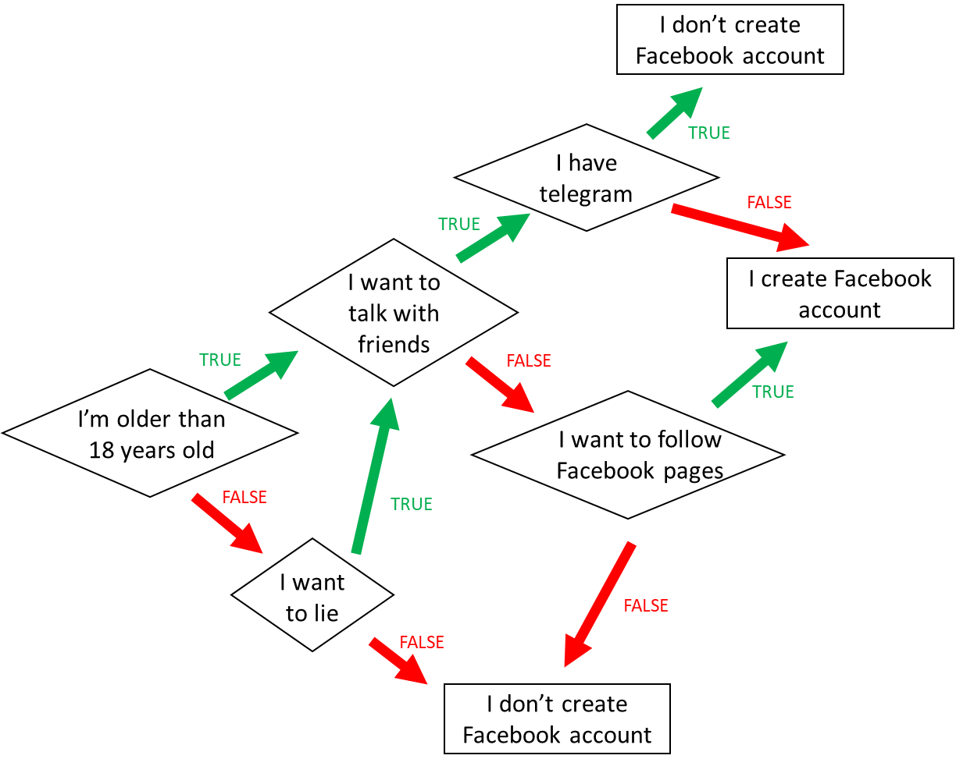

1. When do I create a Facebook account? (*Express the condition using a Boolean expression)*

*I’m older than 18 years old and I want to talk with friends and I not have telegram Or I’m older than 18 years old and I don’t want to talk with friend and I want to follow facebook pages Or I’m not older than 18 years old I want to lie and I want to talk with friend and i have telegram .....*

1. When **don’t I** create a Facebook account? *(Express the condition using a Boolean expression)*

Ex5: Create the chart flow

**Q1** Complete the char flow to follow those rules:

* If I am a girl and it is sunny, I wear a skirt
* If I am a girl and it is not sunny, I wear jeans
* If I am a boy and it is sunny, I wear a short
* If I am a boy and it is not sunny, I wear jeans

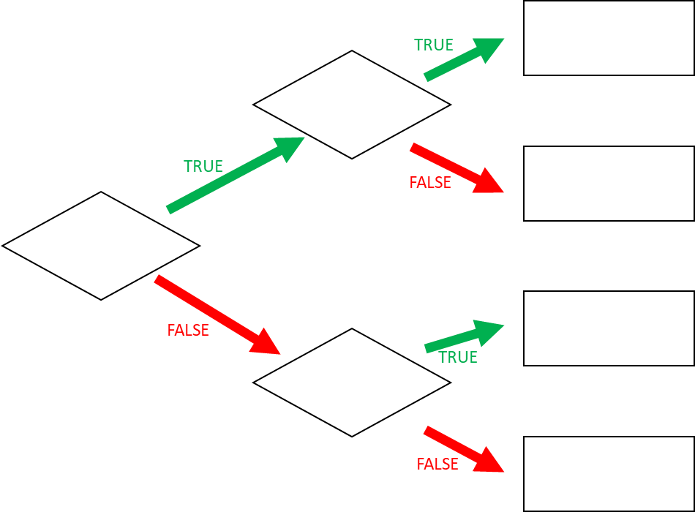

**Q1** When do I wear jeans? *(Express the condition using a Boolean expression)*

Ex6: Create you chart flow

**Q1** Complete the char flow to follow those rules:

* If I am a girl and it is sunny, I wear a skirt