FINE FOOD FINDER PRESENTATION

Who’s presenting: Christine and Justin

Introduction:
- In today’s market, there is an abundance of applications that catalogue food spots and eateries, and now, there’s 19 more.
- So we took into consideration the bloated nature of today’s food-finding apps, and we’ve decided focus on simplicity and convenient functionality
- At the moment, to find a restaurant that you want to try you have to sift through dozens of restaurant pages
  - but even then, it is not guaranteed that the restaurant can facilitate your party and caters to your dietary requirements or the restaurant ambience that you prefer, etc
  - Say for example, you came to a restaurant wanting a quiet night, only to find a rowdy crowd with obnoxious music playing.
  - So we created an application that curates a personalised list of restaurants the user would likely be interested in, according to the needs of the user
- Our food-finder’s target market are people who do not want to waste that precious time researching a place to eat, when they could already be there.
- We hope to find a particularly good usage in the tourist industry, where our users do not know the range of options available to them and wish to explore a new area.
- How it was implemented
  - QT Designer to design the UI
  - PyQT4 used as a GUI Framework
  - Python 3.5
- Which parts verified
  - Sorting and search functions verified

Scenarios/scripts to present:
- Ronald and his wife wish to celebrate their 42nd wedding anniversary while they are in travelling in Sydney! They wish to make it a special event by having the best seafood there is right near Maroubra beach. As it is their first time in Sydney, they have no idea what options are out there and can turn to our Food Finder app.
MAKE RESTAURANTS WITH THE FOLLOWING CATEGORIES (I guess you can just copy paste into your new restaurant file?):
Dining Party: Solo, Couple, Large-Group
Cuisine: Seafood
Style: Fine-Dining, Modern
Dietary: Vegetarian-Friendly
Extras: Wheelchair-Accessible, Bookings-Accepted, Bar, Outdoor-Area, View-Waterfront, View-Beachfront, View-Scenic


- Thomas and his friends have just flew over from the US and are staying at a backpacker’s lodge in Kingsford. They wish to find a nearby place for a quick eat that is dirt cheap so they don’t blow their budget on the first day. They would prefer a lively place that gets them excited for the rest of their stay ! – lively atmosphere, cheap, large-group
MAKE RESTAURANTS WITH THE FOLLOWING CATEGORIES (I guess you can just copy paste into your new restaurant file? Can add more for variety):
Price range: LESS THAN $20

Dining Party: Large-Group, Solo, Couple, Pet-Friendly, Takeaway
Cuisine: – this is not specified in the scenario
Dietary: – this is not specified in the scenario
Style: – this is not specified in the scenario
Extras: – this is not specified in the scenario

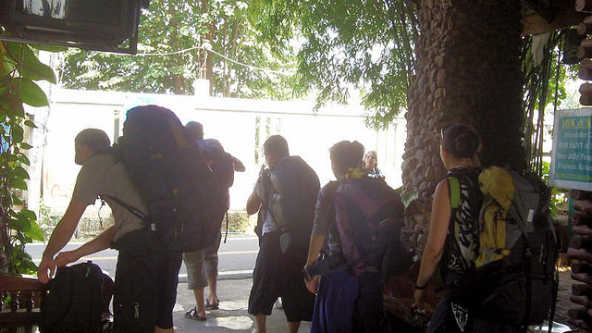

- Susie and her mum are strict vegans. They previously used our application to find a well-rated vegan friendly restaurant but upon visiting the venie, saw the same utensils being used to prepare meat for their vegan dishes. Unhappy with their dining experience, they would like to warn others.
MAKE RESTAURANTS WITH THE FOLLOWING CATEGORIES (I guess you can just copy paste into your new restaurant file? Can add more for variety):

Dining Party: Solo, Couple,
Cuisine: – this is not specified in the scenario
Dietary: – Vegan-Friendly
Style: – this is not specified in the scenario
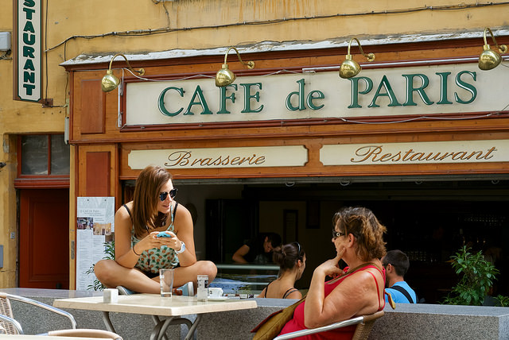
Extras: – this is not specified in the scenario

4. Renee wants a burger. But being the poor university student she is, doesn’t require the fanciest burger. Just a burger. So she uses the app to find the cheapest burger joint in Kingsford

Price range: LESS THAN $20

Dining Party: Large-Group, Solo, Couple, Pet-Friendly, Takeaway
Cuisine: – this is not specified in the scenario
Dietary: – this is not specified in the scenario
Style: – this is not specified in the scenario
Extras: – this is not specified in the scenario

