**CMPS-4131: SOFTWARE ENGINEERING - REPORT #1**

**Group/Project**

**1 Customer Statement of Requirement (9 pts)** a Problem Statement

b Glossary of Terms

**2 Systems Requirement (6 pts)**

a Enumerated Funcational Requirements

b Enumerated Non-Funcational Requirements c On-Screen Appearance Requirements

**3 Functional Requirement Specifications (30 pts)** a Stakeholders

b Actors and Goals

c **Use Cases**

i. Casual Description

ii. User Case Diagram

iii. Traceability Matrix

iv. Fully-Dressed Use Case Description

d System Sequence Diagrams

**4 User Interface Specifications (15 pts)**

a Preliminary Designs

b User Effort Estimation

**5 System Architecture (15 pts)**

a Identifying Subsystems

b Architecture Styles

c Mapping Subsystems to Hardware

d Connectors and Network Protocols

e Global Control Flow

f Hardware Requirements

**6 Plan of Work (5pts)**

a Plan Description

**7 Project Mangement (10 pts)**

a How Project was managed by group

| 4 |
| --- |
| s  y  S  h  c  S  n  a  L  P  h  t  r  e  B    ‐    4  R  G |

| 5.00 | 5.00 |
| --- | --- |
| 4.00 | 4.00 |

| 2.00 | 0.00 |
| --- | --- |
| 2.00 | 1.00 |
| 2.00 | 2.00 |

| 3.00 | 3.00 |
| --- | --- |
| 3.00 | 3.00 |

| 3.00 | 3.00 |
| --- | --- |
| 6.00 | 1.00 |
| 3.00 | 1.00 |
| 6.00 | 3.00 |
| 6.00 | 3.00 |

| 10.00 | 8.00 |
| --- | --- |
| 5.00 | 5.00 |

| 3.00 | 0.00 |
| --- | --- |
| 3.00 | 3.00 |
| 3.00 | 3.00 |
| 2.00 | 2.00 |
| 2.00 | 2.00 |
| 2.00 | 2.00 |

| 5.00 | 5.00 |
| --- | --- |

| 10.00 | 9.00 |
| --- | --- |

**PENALTY FOR LATE SUBMISSION (-5) PENALTY FOR NO REFERENCE (-5)** Total Value/ Points 90.00

|  |
| --- |
|  |

68.00

**REPORT#1: VALUE/ GRADE**

| **10.00** | **7.56** |
| --- | --- |

**76%**

**Report #1**

Berthing Plan/Scheduling Application

Team Members: 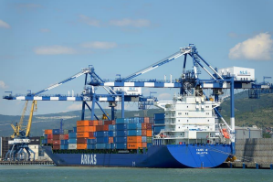

● Osborn Collins

● Mark A. Pascual

● Kevin Godoy

● Daniel Garcia

● Driane Perez

● Justin Chuc

CMPS3141 Software Engineering

Submitted to Mr. Manuel Medina

Submission Date: 27th February, 2022

Distribution of Work

| ***Signature Block*** | |
| --- | --- |
| **Statement** | *I did my share of the work, and have a general understanding of the contents of the assignment.* |
| **Team Member** | **Contribution Signature Date** |
| Osborn Collins | O.C. 27th February, 2022  **●** Customer  Statement of  Requirements  ● System  Requirements  ● UC 8  ● Small part of  Stakeholders  ● Small part of  actors and goals  ● Glossary  ● Domain Model  ● Part of UI  Development |
| Driane Perez | 27th February, 2022  ● 93% of the  Casual  Description  ● 100% of the  Traceability  Matrix  ● 95 % of the  Use Case  Diagram  ● 100% of the  work plan  ● Fully - Dressed  Description  review and  added about  5% |
| Daniel Garcia | 27th February, 2022  ● System  architecture  ● Architecture  Styles  ● Mapping  Subsystems to  Hardware  ● Connectors and  Network |

1

|  | ● Protocols  ● Global Control  Flow  ● Hardvver  requirments |
| --- | --- |
| Justin Chuc | J. Chuc27th February, 2022c  ● Connectors and  xq  Network  ● Use Case  ● Use Case  Diagram  Dressed/ Fully Dressed |
| Kevin Godoy  Mark Pascual | Kevin Godoy 27th February, 2022  ● Mapping  subsystems to  hardware  ● Client  Requirements  ● Preliminary  Designs  ● User  Estimation  ● Website  27th February, 2022  ● Plan of work  ● References  ● Some editing  ● 2 Fully Dressed  Use Case  ● Actors and  Goals  ● Some Casual  Description |
|  |  |

2

Distribution of work

| Note: See point allocations in the table below. | | Team Member Name | | |
| --- | --- | --- | --- | --- |
| R  e  s  p  o  n  s  i  b  i  l  i  t  y  Lev  el | See point allocations in the table below. | Osborn  Mark  Daniel  Collins  Pascual  Garcia | Kevin  Justin  Godoy  Chuc | Driane Perez |
| Project management (10 points) | 10% 90% |  |  |
| Sec.1: Customer Statement of Requirements (9 points) | 100% |  |  |
| Sec.2: System Requirements (6 points)  Sec.3: Functional  Requirements Specification (30 points) | 100%  10% 40% |  | 40% |
| Sec.4: User Interface Specs (15 points) |  | 100% |  |
| Sec.5: System Architecture (15 points)  Domain Model | 100%  100% |  |  |
| Sec.6: Plan of Work (5  points) |  |  | 100% |

3

**Table of contents**

Customer Requirement …………………………………………………………....…………………Page 4 Glossary …………………………………………………………………………...…………………Page 7 System Requirements……………………………………………………………………...…………Page 8

● Functional Requirements

● Enumerated Non-Functional Requirement

● On-screen appearance Requirements

Stakeholders………………………………………………………………………..……...…..…….Page 11 Actors and Goals……………………………………………………………….……………………Page 11 Casual Description……………………………………………………………………….……....… Page 16 Use Case Diagrams……………………………………….………………….……………..……… Page 21 Traceability Matrix…………………………………….………………….………….……………..Page 22 Fully Dressed Descriptions of Use Cases…………………………..……………………….………Page 26 System Sequence Diagrams…………………………………………………………..……...……...Page 29 Domain Model………………………………………………………………………………………Page 36 User Effort Estimation…………………………………………………………………………...….Page 36 System Architecture……………………………………………………………………………..….Page 40 ● Identifying Subsystem

● Architecture Styles

● Mapping Subsystems to Hardware

● Connectors and Network Protocols

● Global Control Flow

● Hardware Requirements

● Client Requirements

● Mobile

● Server

Project Management and Plan of Work……………………………………………………………. Page 43 1. Merging contributions from individual team members

2. Project Coordination and progress report

3. Plan of work (gantt chart)

4. Break down of responsibilities

References………………………………………………………………………………………….. Page 45 4

**Customer Statement Requirement**

Ports are incredibly complex industries that thrive on efficient operations and supply chains. By ensuring that there is no lag between the vessel entering the port, having its cargo loaded or unloaded, refueled and inspected, cleared to depart, and finally pushed out of the berth, these ports allow countries all around the world to bring in vital trade and commerce to the region.

Most ports these days have the latest technology in order to reduce this turnaround time. For instance, the Port of Rotterdam which is the largest port in Europe and 11th worldwide is renowned for the immense importance it has placed on technological advancements. This port is supported by world class machinery such as specialized truck trailers, automated loading system and advanced loading crane. These improvements are a handful of common features implemented throughout a port. However, this technology can only speed up the process once the ship enters the port.

How do ports efficiently process ships waiting to enter or leave the port? This is where the concept of a berthing plan is introduced. Berthing Plans are detailed documents drawn up regarding the complete resource allocation for a port and surrounding facilities. It implements a supply chain and operation plan for all vessels that will dock or berth at the port at least a month before and may go up to 6 months. They are integral in the allocation of a port’s resources for both incoming and outgoing vessels by planning ahead.

We have been using an excel sheet to basically plan for our berth. Due to limitations with this option, we are interested in sourcing a more modernized system that will phase out this tedious manual process. The system should help to optimize the Port operations for arriving and departing vessels. This system will be used by a wide variety of employees, for example, employees from the operations department right down to the persons from the mechanical department and as a result it will need to be very user friendly and easy to learn. Due to the fact we will have a wide range of employees using the application, we just want to emphasize that we don’t need a system with a ton of features and complexity that will make the learning curve be so high that it’s a burden to be use by an employee, while they are doing the jobs, they were tasked with doing.

5

First, we have been operating by just sending out a weekly ship schedule in PDF format, which basically only shows the estimated arrival and departure time of a vessel. This gets the job done, but it causes different delays because we are only planning one week at a time when we could be planning up to 6 months in advance. Managing vessels’ arrival and departure time is very important because vessels cannot be scheduled to dock simultaneously at our berth because we only have one berth and we wouldn’t have the adequate facilities for it. The schedule should be staggered so that ships are able to minimize their waiting times. This by default improves efficiency and reduces strains on the port resources. The main thing we are trying to avoid is a bottleneck.

Secondly, the ship schedules in our current process aren’t dynamic. Another important objective of the port is a reduction in the unexpected arrival or departure of a ship. This throws the entire system into disarray, as it may further delay other ships. For instance, if a ship arrives earlier than expected, it will have a large idling and waiting time that reduces its efficiency. On the other hand, if a ship arrives late, it will also depart late, which creates a propagating delay that spreads to other ships in the port. So, since the schedule is fixed and is not being updated in real time, there is really no way to minimize early or delayed arrival and departure of a vessel.

Thirdly, since the schedule is a PDF, the only notification we can send is an email and it makes it very difficult to notify people who aren’t around a computer regularly. For example, employees working in a crane or a stacker won’t be able to be notified about any changes made in the schedule until they come out of the machinery and go around their computer, or phone and by that time there will be delays already. So, it's important that everyone working a vessel is notified immediately of any changes made to the schedule.

With these issues in mind, we are requesting for your organization to provide some feedback and present some solutions VIA a system that would help to solve these issues we have described. We would like to be assigned a project manager to help convert this manual archaic process to a more automated system. The ship schedule should be the main dashboard and the starting point for all operations. This basically means that the ship schedule will need to be dynamic and

6

showing any changes made in real-time, for example, by changing the estimated arrival time of one vessel all other vessels following will be adjusted by either moving up to an earlier time or down to a later time. With this in place this will help to have all resources used in an optimized way.

We expect the system to provide us notification of any changes made in the system, for example if a supervisor, boat-man, foreman and stevedore is scheduled to work on a vessel, they will be sent a notification of when the ship should arrive and what time work needs to begin. If the vessel's time was adjusted and it is showing that it will reach later or earlier, they will get a notification.

One last thing we didn’t mention initially but we would like you to keep in mind, is that the system should have some level of intelligence where it should track different delays happening in real time and send notification so that everyone knows what's happening and to ensure delay is at a minimum. From that point all data should be compiled into a report. The main objective of working a vessel is to unload and load a vessel as quickly as possible. Therefore, tracking delays would help to show where it went wrong and how to improve for the next vessel.

At the end of the day, the overall objective of the berthing plan app is to efficiently create a timetable of ship arrival and departure, and a list of facilities and services that will have to be provided to a berthed vessel. By optimizing this timetable, the port can achieve the most efficient turnaround time for each vessel.

7

**Glossary**

| Terms | Definition |
| --- | --- |
| Berth | A ship's allotted place at a wharf or dock |
| Vessel | A ship or large boat. |
| Anchorage | An area that is suitable for a ship to anchor in. |
| Stacker/Crane | A machine that stacks containers in a Port Yard Space. |
| Port | A town or city with a harbor where ships load or unload, especially one where customs officers are stationed. |
|  |  |

8

**System Requirements**

Ranking Scheme: From 1 -4 with 1 having the most priority and 4 having the least priority.

**Functional Requirements**

| ID | Priority | Requirements |
| --- | --- | --- |
| Req1 | 1 | The system shall provide digital instances of all vessels that will berth for up to 6 months. |
| Req2 | 1 | The system shall have all ships in a queue for up to 6 months. |
| Req3 | 1 | The system should allow the ship schedule to be dynamic and easy to update. |
| Req4  Req5 | 3  2 | The system will allow user management.  The system shall notify designated users of any changes. |
| Req6 | 2 | The system should allocate all persons, and equipment for working the vessel. |
| Req7 | 2 | The system will keep track of operations, and always ensure that operations are working as optimized as possible. |
| Req8 | 3 | System should keep as much data as possible to analyze trends and for reporting. |
| Req9 | 4 | System should track and show the different status a vessel that is at the port is currently in. |
| Req10 | 3 | System should be able to be manipulated through the graphical portion and through a manual back end screen. |

9

**Enumerated Nonfunctional Requirements**

| ID | Priority | Requirements |
| --- | --- | --- |
| Req11 | 3 | Only authenticated users will be able to access the system. |
| Req12 | 3 | The user access will be determined by the user roles and permissions associated with the role. |
| Req13 | 1 | The system should have some level of intelligence where it is able to track information and report data accurately. |
| Req14 | 3 | The system will allow user management. |
| Req15 | 1 | Must be easy to learn and user friendly. |
| Req16 | 1 | System should not allow any clashing of vessels berthing at the same time. |
| Req17 | 2 | System should have an auto schedule feature. |
| Req18 | 2 | Movement in the system should be very easy to follow |

10

**On-Screen Appearance Requirements**

| ID | Priority | Requirements |
| --- | --- | --- |
| Req19 | 1 | The system should be user friendly with a small margin for errors. |
| Req20 | 1 | The system should display the ship schedule as the main dashboard for the system. |
| Req21 | 2 | Each vessel listed to berth will display voyage number, vessel name, ETA, ATA, ETD, ATD, operations personnel working and stevedore gang working the vessel. |
| Req22 | 3 | Notification will be displayed as a message showing up in an inbox like tab. |
| Req23 | 4 | Vessels will be displayed in various colors to differentiate between ships in the queue. |
| Req24 | 3 | The system should display delays in minutes on the main dashboard. |
| Req25 | 3 | The system should be optimized for touching because the schedule would operate similar to a grid in excel. |

11

**Stakeholders**

1. System Administrator

2. CEO & Senior Management

3. Operations Manager

4. Operations Supervisor

5. Operations Team

6. Gang Foreman

7. Gang(Stevedore)

8. Machine Operators

9. Marine Team

10. Pilot

11. Shipping Agents

12. Technical Team ( Mechanical, Maintenance, Electrical, Welding etc)

**Actors and Goals**

| **Actors** | **Roles** | **Types Goals** |
| --- | --- | --- |
| System | ● Providing login for the various stakeholders  (System Administrator,  CEO & Senior  Management,  Operations Manager,  Operations Supervisor,  Operations Team, Gang  Foreman,  Gang(Stevedore),  Machine Operators,  Marine Team, Pilot,  Shipping Agents,  Technical Team)  ● Provide a tailored  dashboard for the  various users allowing  them to see status of  ships, report incidents  and initiate delay timer.  ● Provide a  weekly/monthly  calendar and schedules  of ships scheduled to  berth. | Participating ● Allow login of the various users to the application once  their credentials are accurate.  ● Update calendar and berthing  schedules in real time  ● Allow administrators to make  adjustments  ● Display accurate schedules. |

12

|  | ● Allowing admin to add users, update status and  modify ship schedules  ● Track delays and  inform appropriate  personnel.  ● Access will be  determined on the role  you have. Example an  agent should only see  schedules, and make  changes to the ETA and  ETD. |  |
| --- | --- | --- |
| System  Administrator  CEO, Senior  Management | ● Log into the system  ● Log of from the system ● Input relevant data  about shipping  schedules  ● Update the application ● Create user accounts  and provide access  ● Log into the system  ● Log off from the  system  ● View Ship schedule and ship details  ● Gets notification on  when a ship starts  working and when it is  completed.  ● Gets regular updates on a ship’s status(arrival,  departure, currents  status, delays) | Initiating  ● Log on to from the system  ● Log off from the system  Initiating  ● Allowed to populate the  system with relevant  Initiating  information as it pertains to  shipping schedules.  ● Allowed to update the  Initiating  application.  ● Allowed to create user  Initiating  accounts and grant access to  various levels of users.  Initiating  ● Log on to from the system  ● Log off from the system  Initiating  ● Allowed to view shipping  information on the dashboard  of the application. |

13

| Operations  Manager | ● Log delay in operation whilst off loading of  vessel  ● Log into the system  ● Log off from the  system  ● Ensure the system is  working properly  ● Update the log and  schedules of ships at  the port  ● Mark delay as resolved ● User Setup and Access ● Get notification on  when a vessel starts  working and when it  completes.  ● Gets notification of  when a delay goes over  target. | Initiating  ● Log on to from the system  ● Log off from the system  ● Report a delay in operations  ● Update the the system with  current information  Initiating  ● Keep maintenance log of the  system and perform frequent  Initiating  maintenance of the the system  Initiating  Initiating |
| --- | --- | --- |
| Operations  Supervisor | ● Log delay in operation whilst off loading of  vessel  ● Log into the system  ● Log off from the  system  ● Ensure the system is  working properly  ● Update the log and  schedules of ships at  the port  ● Mark a delay as  resolved  ● Get notifications on  which ship they are  supposed to work.  ● Get notification on  when a vessel starts | Initiating  ● Log on to from the system  ● Log off from the system  ● Report a delay in operations  ● Update the the system with  current information  Initiating  ● Keep maintenance log of the  system and perform frequent  Initiating  maintenance of the the system  Initiating  Initiating |

14

| Operations Team | working and when it  completes.  ● Gets notification of  when a delay  happening  ● Gets a notification of  when the delay time  goes over target.  ● Create, Update and  Delete working  schedule of crane  operators, stevedore  gang, Drivers, Gang  foreman, Stacker  Operators.  ● Report Delays  ● Log delay in operation whilst off loading of  vessel  ● Log into the system  ● Log off from the  system  ● Ensure the system is  working properly  ● Update the log and  schedules of ships at  the port  ● Mark a delay as  resolved  ● Get notifications on  which ship they are  supposed to work.  ● Get notification on  when a vessel starts  working and when it  completes.  ● Gets notification of  when a delay  happening  ● Gets a notification of  when the delay time  goes over target. | Initiating  ● Log on to from the system  ● Log off from the system  ● Report a delay in operations  ● Report delays  Initiating  ● Update schedules  ● Get various reports  Initiating  Initiating  Initiating  Participating  Participating  Participating  Participating |
| --- | --- | --- |
| Gang Foreman | ● Log delay in operation whilst off loading of  vessel  ● Log into the system  ● Log off from the | Initiating  ● Log on to from the system  ● Log off from the system  ● Report a delay in operations  ● Update schedules  Initiating  ● Allowed to view various |

15

|  | system  ● Get notifications on  what vessel is to be  worked  ● View working schedule of gangs for a particular | reports  Initiating  Participating  Participating |
| --- | --- | --- |
| Gang (Stevedore) | ● Log into the system  ● Log off from the  system  ● View working schedule. ● Get notification of  when they are supposed  to work | Initiating  ● Log on to from the system  ● Log off from the system  Initiating  ● Allowed to view working  schedule  Participating  Participating |
| Machine  Operators  Marine Team | ● Log on to the system  ● Log off from the  system  ● See which ship he  scheduled to work  ● Get notifications on  what vessel he is to  work.  ● Log on to the system  ● Log off from the  system  ● View schedules of  vessels  ● Make changes to ship  schedule and ship  details | Initiating  ● Log on to from the system  ● Log off from the system  Initiating  ● See schedule assigned to  working gangs  Participating  Participating  Initiating  ● Log on to from the system  ● Log off from the system  Initiating  ● See schedule assigned to  working gangs  Participating  ● Allowed to make changes to  ships’schedules and details.  Initiating |
| Pilot | ● Log on to the system  ● Log off from the  system  ● View schedules of  vessels  ● Get notification of what ship they are scheduled  to pilot and when. | Initiating  ● Log on to from the system  ● Log off from the system  Initiating  ● Track the progress of the  loading and off loading of a  Participating  vessel  Participating |
| Shipping Agents | ● Log into system  ● Log off of the system | Initiating  ● Log on and off from the  Initiating  system |

16

|  | ● See the status of the  loading and off loading  of vessels  ● Make changes to to  ETA and ETD | ● Track the progress of the  Participating  loading and off loading of a  vessel  ● Allowed to make changes to  Initiating  ETA and ETD |
| --- | --- | --- |

Technical Team ● Log into system ● Log off of the system

● Report delay

● Get notification of

individuals from

various departments

scheduled to work.

**Casual Description**

Initiating

Initiating

Initiating

Participating

● Log on and off from the system

● Report a delay

●

| Name | Description Requirements Covered |
| --- | --- |
| UC - 1 Create Account | Account that will be created depending  Req 4,Req 11, Req 12  on the type of user you are.  Different account roles will be set  depending on what type of stakeholder  you are.  The administrator for your workplace  will be able to create a different user for  the roles. |
| UC - 2 Login to system | Login to see any changes that were  Req20, Req 11  made to the table  Login to access the system |
| UC - 3 View Main Dashboard | Accessing the main dashboard to see  Req1, Req2,  any changes that were made by users  Req3,Req5,Req25,Req  23  Allowing specific users to change the  planning depending on what user you  are.  Once logged into the system a |

17

|  | notification should pop showing what  recent changes were made to the  system.  Allowing designated users to make  changes dynamically through the  dashboard while also notifying the  other users. |
| --- | --- |
| UC - 4 Add vessel | Adds a vessel to the dynamic table  Req. 3, Req. 11, Req.  14  Add the attribute and information of the  vessel |
| UC - 5 Update vessel | Allows the designated user to update all  Req. 3, Req. 11, Req.  the attribute and information of the  14  vessel |
| UC - 6 Add delay | Allows the designated user to enter a  Req 5, Req 7, Req 8,  delay on the ground whilst a vessel is  Req 22  being loaded or unloaded.  Delay added to the system to  accommodate vessels that will be  affected by the delay  Delay will be tractable to be later used  to make better decisions by the  designated user when adding delays or  loading and unloading vessels. |
| UC - 7 Verify the user | Function use case that will verify that  Req 11, Req 18, Req 19  the user is in the correct dashboard,  main page.  Also will be responsible to determine  which table will be assigned to the  different users.  Will designate specific pages that will  be only accessed by designated user. |
| UC - 8 View Schedule ( table) | Allows users to view schedules that are  Req 2,Req 1, Req  relevant to them and other individuals  11,Req 12, Req 20, Req  working along with them.  24  Allow user that should not be allow to  edit the table to view an see what was  change on a tabular form |

18

|  | Designated role will login and will be  able to see this in the main dashboard  along the changes that were made |
| --- | --- |
| UC - 9 Display Progress Status | From the moment a vessel is berthed the  Req. 4, Req. 9, Req 15,  status as it relates to loading and  Req 19, Req 21  unloading is tracked. Delay, if any, are  also displayed as part of the progress  status  The time that is left to arrive or  departure time left of the vessel.  Will display the progress for each  vessels with a friendly user pop up that  will be easily learnable and understable |
| UC - 10 Send Notification UC - 11 view Notification | Notification sent to a designated user  Req 5, Req 19  after a change is made by the user that  updated the vessel information or any  attribute of it.  A pop up specific to only see changes in  Req 5, Req 19, Req 15,  a more orderly and understandable  Req 18, Req 22  manner.  Will be a friendly user to make them  understandable to the reader. |
| UC - 12 Resource allocation | The relevant personnel and equipment  Req 5, Req 6, Req 7,  needed in the process of loading and  Req 9,  unloading a berthed vessel is allocated  in order for the process to be completed  as efficiently as possible.  Designated Users will be notify that a  vessel needs resources allocation  If vessel enter at a earlier state resources  will be allocated immediately to avoid  delays in the berth planning system |
| UC - 13 set Estimated arrival | Set the estimated time of arrival.  Req 3, Req 7, Req 9,  Req 13, Req 21  It will also be part of the attribute of a  vessel. |

19

| UC - 14 set departure time | Set an estimated departure time for a  Req 3, Req 7, Req 9,  vessel.  Req 13, Req 21 |
| --- | --- |
| UC - 15 Auto schedule | Reschedule the vessels when changes  Req 3, Req 5, Req 10,  are made to the attributes of a vessel.  Req 13, Req 16, Req 17  If the vessel will arrive late it will auto  schedule the vessels again.  Same |
| UC - 16 set vessel late  UC - 17 set vessel early | Will allow the designated user to add a  Req 3, Req 5, Req 9,  late attribute to the vessel.  Req 14, Req 16  Calculation will be made by the system  once this is changed.  It will update the others estimated times  to avoid delays in the system  Will also inform the users that a change  was made to the system to be prepared  and allocate resources.  Will allow the designated user to add a  Req 3, Req 5,Req 9,  late attribute to the vessel.  Req 14, Req 16  Calculation will be made by the system  once this is changed.  It will update the others estimated times  to avoid delays in the system  Will also inform the users that a change  was made to the system to be prepared  and allocate resources. |
| UC - 18 update estimated arrival time | updates the estimated time of arrival.  Req 3, Req 5, Req 9,  Req 16  It will also be part of the attribute of a  vessel and allow you to update it.  Will also update the notification |
| UC - 19 track delays | Tracking all delays to be later used.  Req 5, Req 7, Req 16  Tracking delays would help to show  where it went wrong.  To improve for the next vessel and  improve the system to reduce the delays |

20

|  | between vessels. |
| --- | --- |
| UC - 20 compiler into a report | Compiles a report to be used later to  Req 4, Req 8, Req 13,  better the system. |
| UC - 21 logout and verify  constantly | Logout of the system and verify that  Req 11, Req 12, Req 13  every change was reported to the  designated user.  Notify and verify that every  notification is sent, if one or more  changes was not notified by the system  during the updating or changing phase  of the system it will check the  notification table and send them once  more. |

21

**Use Case Diagram**

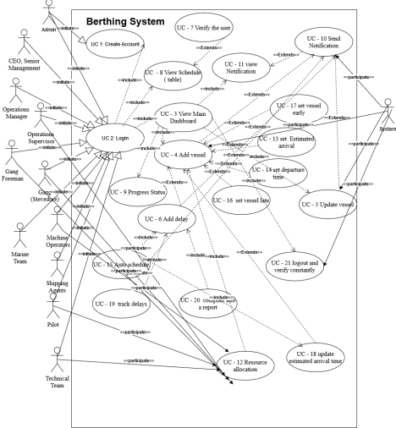22

**Traceability Matrix**

| P  W | Requirem ents | U  c  1 | U  c  2 | U  c  3 | U  c  4 | U  U  U  c  c  c  5  6  7 | U  U  Uc  c  c  -1  8  9  0 | Uc  Uc  -11  -1  2 | Uc  -1  3 | Uc  -1  4 | Uc  -1  5 | Uc  -1  6 | Uc  -1  7 | Uc  -1  8 | Uc  -1  9 | Uc  -2  0 | Uc  -2  1 |
| --- | --- | --- | --- | --- | --- | --- | --- | --- | --- | --- | --- | --- | --- | --- | --- | --- | --- |
| 1 | Req1 |  |  | X |  |  | X |  |  |  |  |  |  |  |  |  |  |
| 1 | Req2 |  |  | X |  |  | X |  |  |  |  |  |  |  |  |  |  |
| 1  3 | Req3  Req4 | X |  | X | X | X | X |  | X | X | X | X | X | X |  | X |  |
| 2 | Req5 |  |  | X |  | X | X | X X |  |  | X | X | X | X | X |  |  |
| 2 | Req6 |  |  |  |  |  |  | X |  |  |  |  |  |  |  |  |  |

23

| 2 | Req7 |  |  |  |  | X |  | X | X | X |  |  |  |  | X |  |  |
| --- | --- | --- | --- | --- | --- | --- | --- | --- | --- | --- | --- | --- | --- | --- | --- | --- | --- |
| 3 | Req8 |  |  |  |  | X |  |  |  |  |  |  |  |  |  | X |  |
| 4 | Req9 |  |  |  |  |  | X | X | X | X |  | X | X | X |  |  |  |
| 3  3  3  1  3 | Req10  Reqq11  Req12  Req13  Req14 | X  X | X |  | X  X | X X X | X  X |  | X | X | X  X | X | X |  |  | X | X  X  X |
| 1 | Reg 15 |  |  |  |  |  | X | X |  |  |  |  |  |  |  |  |  |

24

| 1 | Req16 |  |  |  |  |  |  |  |  |  | X | X | X | X | X |  |  |
| --- | --- | --- | --- | --- | --- | --- | --- | --- | --- | --- | --- | --- | --- | --- | --- | --- | --- |
| 2 | Req17 |  |  |  |  |  |  |  |  |  | X |  |  |  |  |  |  |
| 2 | Reg18 |  |  |  |  | X |  | X |  |  |  |  |  |  |  |  |  |
| 1  1  2  3  4 | Req19  Req20  Req21  Req22  Req23 |  | X | X |  | X  X | X X  X  X | X  X | X | X |  |  |  |  |  |  |  |
| 3 | Req24 |  |  |  |  |  | X |  |  |  |  |  |  |  |  |  |  |

25

| 3 | Req25 |  |  | X |  |  |  |  |  |  |  |  |  |  |  |  |  |
| --- | --- | --- | --- | --- | --- | --- | --- | --- | --- | --- | --- | --- | --- | --- | --- | --- | --- |
|  | Max  Value | 3 | 3 | 4 | 3 | 3 3 3 | 3 4 2 | 3 4 | 4 | 4 | 3 | 4 | 4 | 4 | 2 | 3 | 3 |
|  | Total  Weight | 9 | 4 | 12 7 |  | 7 10 6 | 12 11 3 | 9 10 | 10 | 10 | 10 | 11 | 11 | 8 | 5 | 7 | 7 |

26

**Fully - Dressed Description**

| USE CASE #3: View Main Dashboard | |
| --- | --- |
| **Initiating Actor:** System Administrator | |
| **Actor’s Goal:** View Dashboard | |
| **Participating Actor** System | |
| **Preconditions** The system has been initialized and the database is updated with the latest information. | |
| **Post conditions** Able to make changes and propagate throughout the system for all users. | |
| **Flow of Event for Main Success Scenario** | |
| **Step** | **Actor Action Description** |
| **=>**  **<=** | System  Clicks the login button on the screen  Administrator  System Provides login screen |
| **=>** | System  Provides credentials and clicks login.  Administrator |
| **<=** | System Confirm login credentials are accurate |
| **<=** | System Verify the type of user it is |
| **<=** | System Get the relevant data from the database for the system administrator. |
| **<=** | System Transfer the System administrator to his dashboard |

27

| USE CASE #8: View Schedule | |
| --- | --- |
| **Initiating Actor** Operations Team, Technical Team, Gang Foreman, Machine Operators, Pilot | |
| **Actor’s Goal** To view/read schedules, they can't create, update or delete. | |
| **Participating Actor** Operations Team, Technical Team, Gang Foreman, Machine Operators, Pilot, System. | |
| **Preconditions** There needs to be at least one vessel with a schedule in the system. | |
| **Post conditions** None, it's just viewing. | |
| **Flow of Event for Main Success Scenario** | |
| **Step** | **Actor Action Description** |
| => | Operations Team, Technical  Taps on screen to view  Team, Gang Foreman, Machine  dashboard  Operators, Pilot |
| <= | System Display the dashboard with the most updated/current version of  the list of vessels that will arrive  for the week. |
| => | Operations Team, Technical  Taps on “Vessel Icon” to view  Team, Gang Foreman, Machine  vessel details  Operators, Pilot |

<= system Displays the most updated/current version of the

vessel details such as ETA,

ETD, gang working, pilot

working, Supervisor on shift,

gang foreman.

28

| USE CASE #9: Display Progress Status | | |
| --- | --- | --- |
| **Initiating Actor** | | Operations Manager |
| **Actor’s Goal** | | To view the status of a berthed vessel at the sea port. |
| **Participating Actor** | | Operations Manager, system |
| **Preconditions** | | The system database is updated and a vessel is currently berthed and is being loaded or unloaded. Actor is logged in. |
| **Post conditions** | | Status of vessel reported and relay to the  relevant/interested parties. |
| **Flow of Event for Main Success Scenario** | | |
| **Step** | **Actor** | **Action Description** |
| <= | System | Operations manager is provided with his/her related dashboard. |
| => | Operations Manager | Clicks the image representing the berthed vessel |
| <= | System | Provides a status button of the user along with other options to the user. |
| =>  <= | Operations Manager  System | Clicks the status button for the berthed vessel.  Displays the latest logged information from the database as it relates to the status of the berthed vessel. |

29

**System Sequence Diagrams**

USE CASE #3: View Main Dashboard

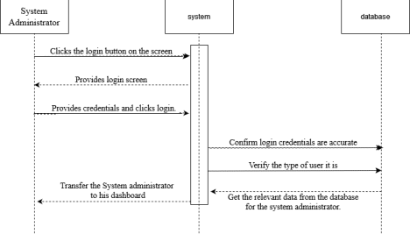30

USE CASE #8: View Schedule

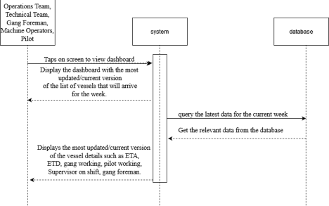USE CASE #9: Display Progress Status

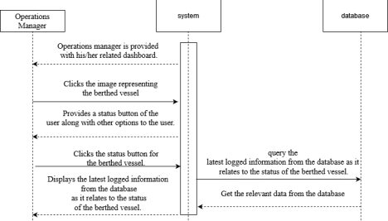31

**User Interface Specification**

**Preliminary Designs**

32

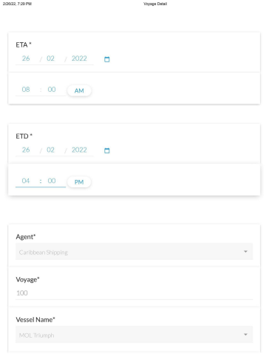33

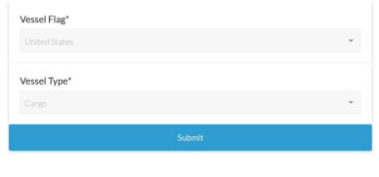Figure 1 *showing the form for the voyage information*

When the user clicks on “Voyage Information,” this form will pop up. They will be prompted to fill out several fields. The first two are the “Estimated Time of Arrival” and the “Estimated Time of Departure.” In these fields, the user will enter the date and time for the expedited arrival and departure of the vessel. Next, they will enter the number of voyages that the vessel has made to the port in the “Voyage” field. Then they will choose a company for the “Agent” field, which will specify who owns the vessel. Afterwhich, they will choose which vessel is berthing in the “Vessel Name,” field. Lastly, they will fill out the “Vessel Flag” and “Vessel Type” which represent the nationality of the ship and the type of ship that it is. In the end, they will store the file by clicking “Submit.”

34

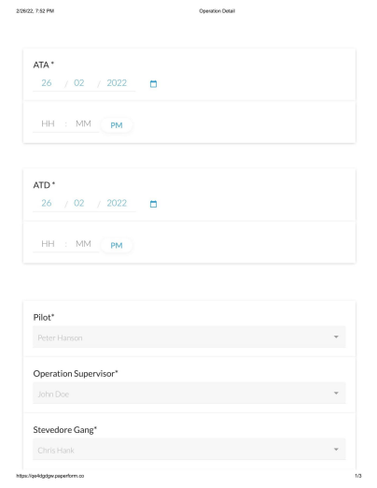35

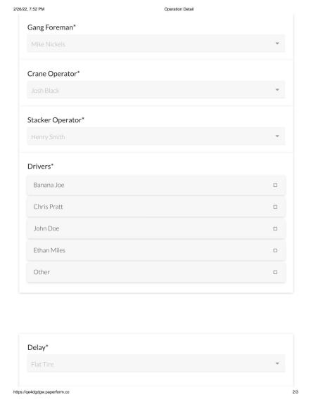36

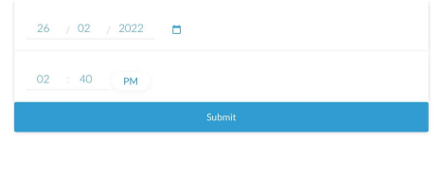Figure 2 *showing the Operation Detail Form*

When the user clicks on “Operation Detail,” they will be shown a form that goes over the crew details. They will first have to fill out the “ATA” and “ATD” which are the real time date and times that the ship arrived and left. Next they will choose who the pilot of the ship is from the list available in the “Pilot” field. After that they will choose who the team supervisor is in the “Operation Supervisor” field. After that they will choose who the “Stevedore Gang,” “Gang Foreman,” “Crane operator” and “Stacker Operator'' are by choosing who in the drop list. Furthermore, the user will choose who all will be the designated drivers for the operation in the “Drivers” field. Finally, the last field is optional but the user will choose a delay, if any, that occurs. A qualifying delay will be in the drop down list and then the user will enter the date and time of when it occurred.

37

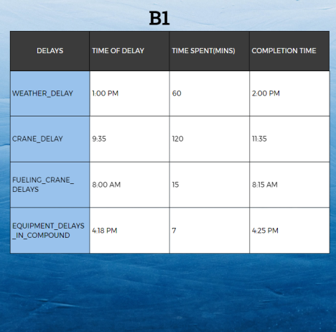Figure 3 *Showing Delay Table*

In this table, the user is shown the Delays

38

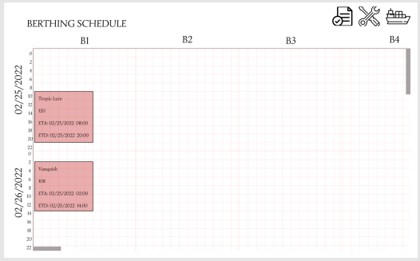Figure 4 *Showing the Berthing Schedule*

Here the user is shown a schedule that they will be able to manipulate. The user has the ability to drag the form around the table. By doing so, the timer will change depending on where the user drops the form in respect to the time axis. The forms within the schedule show the Vessel Name, the Voyage and the estimated arrival and departure times. By clicking on the ship icon in the top right, a new “Voyage Detail,” as shown in figure 1, which will become a new form on the schedule. Next, clicking on the tool icon will show the “Operations Detail” and a form will open up as shown in figure 2. By clicking on the documents, the user will be shown a screen for the delay table as shown in Figure 4. Finally, double clicking on the schedule form will also bring up the “Voyage Detail.”

39

**Domain Model**

**UC - 3 (View Main Dashboard)**

**Extracting Responsibilities**

| **Responsibilities Description Type Concept Name** |
| --- |
| RS.1 Coordinate actions of concept associated with the use  D Controller  case and delegate the work to other concepts |
| RS. 2 System displays login screen D LOGIN_SCREEN |
| RS. 3 Enters login credential and click login K USER_INFO |
| RS. 4 System Verifies credentials K LOGIN_CONFIR MATION |
| RS. 5 If logins are correct,this is a successful login and main  D DASHBOARD  dashboard is displayed |
| RS. 6 If logins are incorrect user gets a prompt that logins are  K PROMPT_MESS  incorrect and to try again  AGE |

**Extracting Association**

| **Concept Pair Association Description Association Name** |
| --- |
| Controller Login MenuController passes request to login  Login Form  form and gets login page  Request  displayed |
| Login Menu InterfaceLogin form is prepared for  UI Preparation  interface page |
| Interface ControllerLogin form is displayed Displays |
| Controller Login MenuEnters User Credentials User Input |
| Controller Login MenuSubmits the credentials in the  Login  form  Login Menu DatabaseDatabase searches for a match  Data Search  with what was inputted |

Database Login MenuLogins match one in DB Data Comparison. 

40

| Login menu Dashboard MenuLogin menu switches to  Dashboard Menu  Dashboard Menu |
| --- |
| Dashboard Menu InterfaceDashboard Menu is being  UI Preparation  prepared for interface |
| Interface ControllerDashboard is Displayed Displays |

**Extracting Attributes**

| **Concept** | **Attributes Attributes Description** |
| --- | --- |
| **GET_LOGIN_MENU** |  |
| **ENTER_LOGIN_INFO** |  |
| **VALIDATE_LOGIN** |  |
| **GET_DASHBOARD** |  |
| **DISPLAY_DASHBOARD** |  |

**User Effort Estimation**

Figure 1 - Voyage Detail

Navigation - 1 Click

Click ship icon on schedule

Data Entry - 13 Clicks 5 keystrokes

Click on “ETA” date

Keystroke date in field

Click on “ETA” time

Keystroke time in field

Click on “ETD” date

41

Keystroke date in field

Click on “ETD” time

Keystroke time in field

Click on “Agent”

Click agent name from list

Click on “Voyage”

Keystroke number of voyages

Click on “Vessel Name”

Click vessel name from list

Click on “Vessel Flag”

Click vessel flag from list

Click on “Vessel Type”

Click vessel type from list

Figure 2 - Operation Detail

Navigation - 1 Click

Click tools icon on schedule

Data Entry - 12 Clicks (Potentially 16 depending on Drivers) 6 Key Strokes Click on “ATA” date

Keystroke date in field

Click on “ATA” time

Keystroke time in field

Click on “ATD” date

Keystroke date in field

42

Click on “ATD” time

Click on “Pilot”

Click pilot name from list

Click on “Operation Supervisor”

Click Operation Supervisor name from list

Click on “Stevedore Gang”

Click Stevedore Gang name from list

Click on “Gang Foreman”

Click Gang Foreman name from list

Click on “Crane Operator”

Click Crane Operator name from list

Click on “Stacker Operator”

Click Stacker Operator name from list

Click on “Drivers”

Click (several) driver name(s) from list

Click on “Delay”

Click delay type from list

Click on Delay Date

Keystroke date in field

Click on Delay Time

Keystroke date in field

Figure 3 - Delay Table

43

Navigation - 1 Click

Click on document icon

Date entry - 1 Click 1 keystroke (Multiple clicks and keystrokes depending on how many delays) Click on blank Completion Time cell

Keystroke the time

Figure 4 - Berthing Schedule

Data Entry - 3 Clicks 1 Drag 1 double-click

Drag schedule form to change time

Double click on form to bring up the “Voyage Detail”

Click on ship icon to bring up a “Voyage Detail” form

Click on tools icon to bring up “Operation Detail” form

Click on documents icon to bring up “Delay Table”

**System architecture**

**Identifying Subsystems**

**Architecture Styles**

The architecture styles that will be used are Event-driven architecture, Database centric and client server architecture. The use of event driven is because of the way the Berthing system works that depending on an event happening it sends a notification to the users depending on what change happened to the ships arriving and departing. This will also be database centric because all data will be stored in a database so that it can be displayed in real time to the users and also sending notifications to them if an event is to change. All of this will be done with the help of the server client architecture so that all users will be connected too.

**Mapping Subsystems to Hardware**

The system will be able to function on multiple functions. Tablets, phones and computers will be able to run the application. Since the system requires an online connection, all devices must have a stable internet connection before they are able to view the updated schedules. On the user side, they will be able to drag and drop the forms within the schedule.

44

**Connectors and Network Protocols**

This system will be able to communicate between many devices and for this reason we will use HTTP so all devices can communicate to each other using a database, PHP and mysql. In order for this to work the page should refresh every 5 seconds. Javascript script will be used to refresh the parts of data on the web application.

The notifications on the mobile devices will use the **web push protocol**. This protocol works by using your server to send a push protocol to the push service then the service sends the desired notification to the mobile devices.

**Global Control Flow**

**Execution orderliness**: This will be an event driven system because every time the berthing database is updated by any of the users that have the privilege to do so. It will trigger an event depending on the user and the user case they initiated.

**Time dependency**: This system will be using both event response and real time system. For the event response it will send notifications to the users when an event is about to happen or an event is changed. This aims to facilitate the users to be aware of new updates like if a ship arrives early or if there is an puch back on the departure of a cargo. The system will be updating in real time and refreshing the data every 5 seconds so that users using the web application will always have the most updated data from the database.

**Hardware Requirements**

**Client Requirements**:

● Laptop/Desktop/Tablet/Mobile Phone - 1.8 GHz processor, RAM: 2GB **Mobile**:

● Web browser, iOS or Android operating system, stable Internet connection **Server**:

● CPU: Intel Xeon 2.4GHz, 6GB ECC ram memory, 2 TB HD storage, 30Mbps Internet connection.

45

**Project Management & Plan of Work**

**1. Merging contribution from individual team members**

Going forward from here after submitting report #1, the team will continue with the database design, implementation and testing for the application. This application will rely heavily on a robust database, hence, it is rather important to have the database rigorously tested. Kevin and Osborn have done some of the initial research and design of the user interfaces. The intent is to make other iterations of the UIs. Another key component of our application is the programming which will be the main thread tying everything together. These tasks and others will be assigned to group members who are relatively good in the various areas to get done. All members of the team are responsible to be cognizant of what is taking place as frequent meetings will take place for updates to be provided. The gantt chart below lists a time of the task we hope to accomplish by the specified dates.

**2. Project coordination and progress report**

No part of the Berthing plan system has been developed apart from the UIs. The team as is shown below have specific members leading various aspects of the Berthing plan. As was previously mentioned the leader of the section is supposed to ensure that the specified tasks get complete by the date stipulated. Regular report will be provided at our scheduled Zoom meeting. As the project progresses and enters into the final phase the various components will be all tied together and final testing will be carried out.

46

**3. Plan of work**

**4. Break Down of Responsibility**

| **Task Team members** |
| --- |
| Database Design, implementation and testing Mark Pascual and Justin Chuc |
| Programming Daniel Garcia and Driane Perez |
| User interface design and testing Kevin Godoy and Osborn Collins |
|  |

47

**References**

Menon A. (2021). What are berthing plans - Everything you need to know. Retrieved 25th February, 2022 from https://www.marineinsight.com/marine-navigation/berthing-plans/#:~:text=Introduction%20to%20Berthing %20Plans,at%20least%20a%20month%20before.

Lucidchart. (2020, May 13). *Types of UML diagrams*. Introducing Types of UML Diagrams | Lucidchart Blog. Retrieved February 24, 2022, from https://www.lucidchart.com/blog/types-of-UML-diagrams Rumbli, C. (2021, September 9). *UML diagram types: Learn about all 14 types of UML diagrams*. Creately Blog. Retrieved February 27, 2022, from https://creately.com/blog/diagrams/uml-diagram-types-examples/ Figma. (2020, December 1). *Figma for beginners: Create designs (2/4) - youtube*. Figma. Retrieved February 27, 2022, from https://www.youtube.com/watch?v=wvFd-z7jSaA

*Paperform — That’s a Wrap. (2021, December 22). YouTube. Retrieved*

*https://www.youtube.com/watch?v=WQh4ax0li5s&ab_channel=Paperform https://berthingschedule.webflow.io/*

48

49