**HOMEWORK**

LOGIC REVIEW BEFORE MIDTERM EXAM

**Exercise 1:**

The alphabet is given below to help you:

a b c d e f g h i j k l m n o p q r s t u v w x y z

**Q1** a w b s c o

Answer : s

**Q2** e e z o y o o

Answer : j

**Exercise 2:**

**Q1** An ASCII represents 245 characters. What is the size (in bits) of an ASCII? *(Justify your answer)*

* 7 bits is less than 245, 8 bits is enough
* So the answer is 8 bits.

**Q2** with 8 bytes, how many values can be represented? *(Justify your answer)* ​

* 8 bits = 28 = 1 byte,
* So 8 bytes = 28*8

The answer is 264

**Q3** How many bits to store alphabet and number in keyboard 0…9, A…Z and a…z

* From 0 to 9 has 10 numbers,a to z has 26 numbers and A to Z has 26 numbers too.
* 10+(2*26) = 62
* 5 bits is less than 62, 6 bits is enough

So 6 bits the answer

**Exercise 3:**

**Q1** What is the result of this operation with binary numbers? ​

1011 0101

- 0101 1110

________________

101 0111

**Q2** What is the result of this operation with binary numbers? ​

1111 0011

- 0111 1101

- 0011 1011

_________________

0011 1011

**Q3** What is the result of this operation with binary numbers? ​

1011 0011

- 0101 1101

- 0011 1011

- 0001 1000

________________

0000 0011

**Q4** What is the result of this operation with binary numbers? ​

1011 0101

+ 0111 1111

________________

**10011 0100**

**Q5** What is the result of this operation with binary numbers? ​

1111 0011

+ 1001 1101

+ 0111 1011

_________________

**10 0000 1011**

**Q6** What is the result of this operation with hexadecimal numbers?

D2F7

+ CF84

+ 3CDE

_____________

1DF59

**Exercise 4:**

Compute the following conversions

|  |  |
| --- | --- |
| Base 2 | Base 10 |
| 101101 | *Explanation:*  101101(2)= 1*2^5+0*2^4+1*2^3+1*2^2+0*2^1+1*2^0  = 32 + 0 + 8 + 4 + 0 + 1 = 45(10)  So : 101101(2) = 45(10) |

|  |  |
| --- | --- |
| Base 2 | Base 16 |
| 101101 | *Explanation:*  101101= 0010 1101  2 D  So : 101101(2) = 2D(16) |

|  |  |
| --- | --- |
| Base 16 | Base 8 |
| D8F | *Explanation*:  D8F(16) = 110 110 001 111(2)  6 6 1 7  So : D8F(16) = 6617(8) |

|  |  |
| --- | --- |
| Base 16 | Base 2 |
| D8F | *Explanation*:  D8F(16) = 1101 1000 1111(2)  So : D8F(16) = 1101 1000 1111(2) |

**Exercise 5:**

**Q1. Rules:**

* First 3 characters “AOU”, repeated many times (max repetition is 20)
* In the end you can have X, Y or Z, only one letter

Examples:

AOUAOUX

AOUY

AOUAOUAOUAOUX

1. Explain your encoding
2. Give examples
3. Explain the size

Answer

a).Explain encoding:

* AOU : 0 : 00
* AOUAOU : 01
* AOUAOUAOU : 10

_ _ _ _

_ _ _ _

* (AOU)20 : 10011
* X : 00
* Y : 01
* Z : 10

b). Give examples:

* AOUX : 00 0
* AOUAOUY : 01 01
* (AOUAOUAOU....AOU)20Z= 10011 10

c). Explain the size:

AOUX,AOUAOUY,AOUAOUAOUZ,.....( AOU)20Z = 00 0, 01 01,10 10,......10011 10

**Q2. Rules:**

* 3 signs: @, #, %
* The sign is any order
* Each sign is repeated the same number of times, maximum of repetition is 5
* In the end you can have A, B or C, only one letter

Examples:

@@###A

%%@@@@@#B

1. Explain your encoding, give the example and your explanation
2. For this example, **%%%%%**C, what is the littlest size possible with your encoding?
3. Explain the size

Answer

a). Explain your encoding, give the example and your explanation :

* **: 00**
* **@ % : 01**
* **# : 10**
* **@@ : 11**
* **%% : 100**
* **## : 101**
* **@@@@@ : 110**
* **%%%%% : 111**
* **##### : 1000**
* **A : 00**
* **B : 01**
* **C : 10**

**EX : @#%C**

* **@ : 00**
* **# : 10**
* **% : 01**
* **C : 10**

**So : @#%C : 00 10 01 10**

b). For this example, **%%%%%**C, what is the littlest size possible with your encoding?

* **%%%%% : 111, C : 10**
* **So :** the littlest size possible with my encoding is **%%%%%C : 111 10**

**c).** Explain the size :

@#%A,@@##%%B,.....,@@@@@#####%%%%%C = 00 10 01 00, 11 101 100 01,.........,110 1000 111 10

**EXERCICE 6: Encoding problem**

**Rules:**

* 4 letters: A, B, C, D
* Any order
* Maximum of repetition is 14

Examples:

ABCD

DBCAA

ADABCAA

1. Explain your encoding
2. Give examples
3. Explain the size

Answer

1. Explain your encoding

* A : 00
* B : 01
* C : 10
* D : 11
* (AAA...)14 = 100
* (BBB...)14 = 101
* (CCC...)14 = 110
* (DDD...)14 = 111

b) Give examples : **CBABDB**

* A : 00
* B : 01
* C : 10
* D : 11

So : **CBABDB** =10 01 00 01 11 01

c) Explain the size

CBAD, BABDC,.......,(AA..)14(CC..)14(DD..)14(BB..)14 = 10 01 00 11, 01 00 01 11 10,..., 100 110 111 101

**EXERCICE 7: Encoding problem**

**Rules**:

* First 2 characters “AB”, repeated many times (max repetition is 5)
* Then 1 character “*”, repeated many times (max repetition is 5)
* Then 1 number (0-9)

Examples:

ABABAB***8

AB*****7

ABABAB*****3

1. Explain your encoding
2. Give examples
3. Explain the size

Answer

a) Explain encoding

* AB : 00

_ _ _

_ _ _

* ABABABABAB : 100
* * : 00
* _ _ _
* _ _ _
* ***** : 100
* 0 : 0
* _ _ _
* _ _ _
* 9 : 1001

b) Give examples : **AB*****9**

AB : 00, ***** : 100, 9 : 1001

So : AB*****9 = 00 100 1001

c) Explain the size :

AB*1, ABAB**2, ABAB***8,.........,ABABABABAB*****9 = 00 00 01, 01 01 10, 01 10 1000,...., 100 100 1001

**EXERCICE 8: Encoding problem**

**Rules:**

* 4 letters: A, E, O, U
* Each letter is repeated minimum 0 time and maximum 7 times.
* The letters are always in the alphabetic order: A then E then O then U

Examples:

AAAAEEEOOU

EEEUUUUUUU

AAEEOOUU

1. Find an encoding of maximum **12 bits**. Explain the method, explain the size and give examples.
2. Is your encoding lossless or losely?

Answer

1. Find an encoding of maximum **12 bits**. Explain the method, explain the size and give examples.

* No A : 00
* A : 01
* _ _ _
* _ _ _
* AAAAAAA : 111
* No E : 00
* E : 01
* _ _ _
* _ _ _
* EEEEEEE : 111
* No O : 00
* O : 01
* _ _ _
* _ _ _
* OOOOOOO : 111
* No U : 00
* U : 01
* _ _ _
* _ _ _
* UUUUUUU : 111
* The encoding of maximum **12 bits** is: “AAAAAAAEEEEEEEOOOOOOOUUUUUU”,Because the maximum of each letter is **3 bits (**AAAAAAA : 111 = 3 bits).So all 4 letters is **12 bits.**
* AEOU,AAEEOO,AAAEEEUUU,.....,AAAAAAAEEEEEEEOOOOOOOUUUUUUU

=01 01 01 01, 10 10 10 00, 11 11 00 11, ......,111 111 111 111

* EX : EEEOOU
* EEE : 11
* OO : 10
* U : 01
* So : EEEOOU = 11 10 01

b) My encoding lossless,Because we can take information that we represented.

**EXERCICE 9: Encoding problem**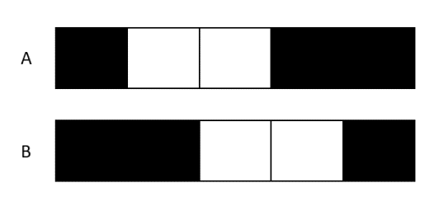

**Rules:**

* The image has only 2 options A & B

Question - Find an encoding

|  |  |  |
| --- | --- | --- |
| Meaning | Encoding decimal | Encoding binary |
| Color of pixel | Black : 0  White : 1 | 0  1 |

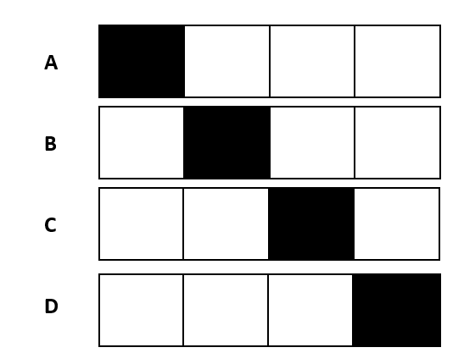

**EXERCICE 10: Encoding problem**

**Rules:**

* The image has only 4 options A, B, C, D

Question - Find an encoding

|  |  |  |
| --- | --- | --- |
| Meaning | Encoding decimal | Encoding binary |
| Color of pixel | Black : 0  White : 1 | 0  1 |
| Position of black pixel | Position 1 : 0  Position 2 : 1  Position 3 : 2  Position 4 : 3 | 00  01  10  11 |

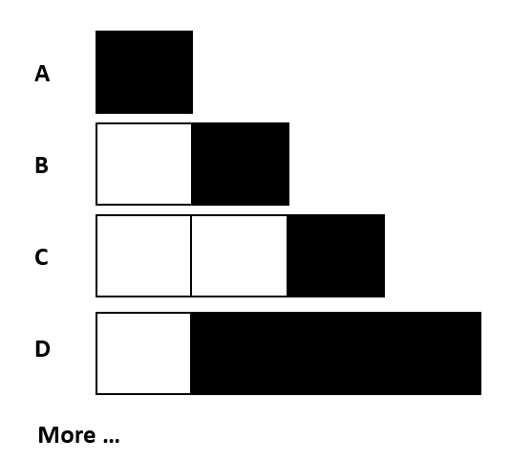

**EXERCICE 10: Encoding problem**

**Rules:**

* The image has 1 to 4 pixels
* 1 to 3 black pixels
* The black pixels shall be together

Question - Find an encoding

|  |  |  |
| --- | --- | --- |
| Meaning | Encoding decimal | Encoding binary |
| Number of all pixel | 1 pixel : 0  2 pixel : 1  3 pixel : 2  4 pixel : 3 | 00  01  10  11 |
| Number of black pixel | 1 black : 0  2 black : 1  3 black : 2 | 00  01  10 |

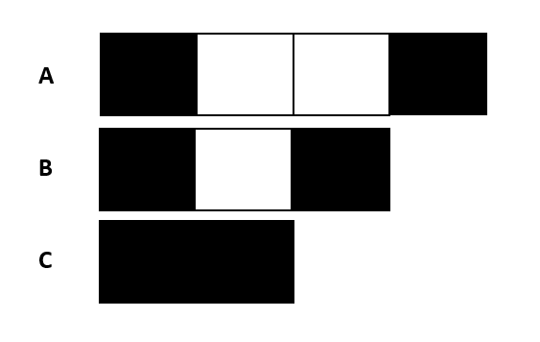

**EXERCICE 11: Encoding problem**

**Rules:**

* The white pixels have 0 to 2
* Black pixel always first and last cells

Question - Find an encoding

|  |  |  |
| --- | --- | --- |
| Meaning | Encoding decimal | Encoding binary |
| Number of all pixel | 2 pixel : 0  3 pixel : 1  4 pixel : 2 | 00  01  10 |
| Number of white pixel | 0 white : 0  1 white : 1  2 white : 2 | 00  01  10 |
| Position of black pixel | First : 0  Last : 1 | 00  01 |