HOMEWORK

1. Draw the shape corresponding to the Boolean expression

a, (x > 2 and x < 4) or (y < 2) 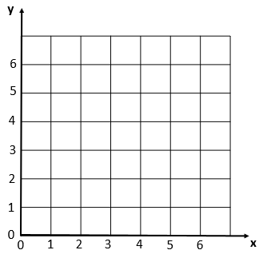

b, (x>2 and x<6) and (y>2 and y<6) and not(x>4)



2, Write the boolean condition for this grid

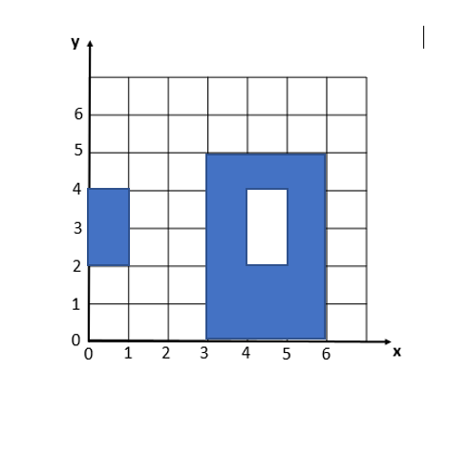

Expression:

(x>0 and x<1) and (y>2 and y<4) or  
(x>3 and x<6) and (y>0 and y<5) and

Not[(x>4 and x<5) and (y>2 and y<4)]

2. Demonstrate these equalities using the 9 simplification rules you have learnt:

* !(C and D) and (!C or D) and (C or !D) = !C

!(C and D) and (!C or D) and (C or !D) = !C or !D and (!C or D) and (C or !D)

= (!C or !D) and (!C or D) and (C or !D)

= !C or (!D and D) and (C or !D)

= !C or False and (C or !D)

= !C or (False and C) or (False and !D)

= !C or False or False

= !C

* ! ( !C and (!B or !C) ) = C
* (A and B) or (A and !B) = A

3.. What is the output of flowchart? If x=6 and y = 5 and z = 1

f x=6 and y = 5 and z = 1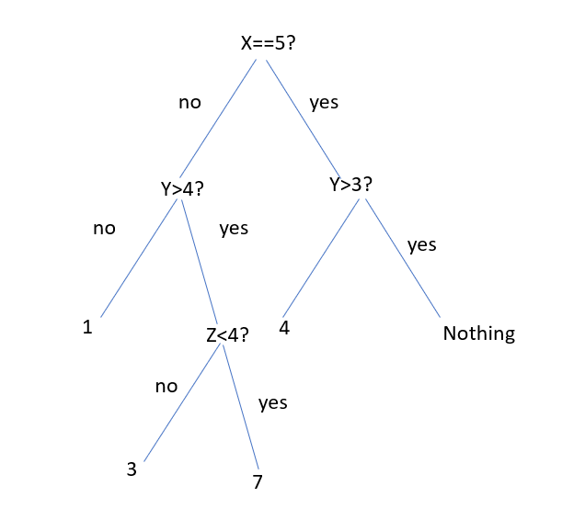

=7

1. Draw the tree of conditions

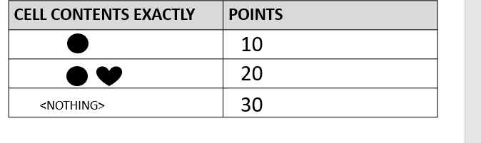

no

yes

30

10

20

yes

no

1. Draw the tree of conditions

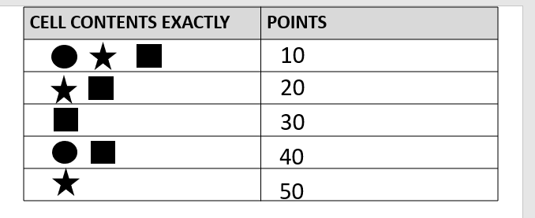

yes

no

30

50

20

10

40

1. Draw the tree of conditions

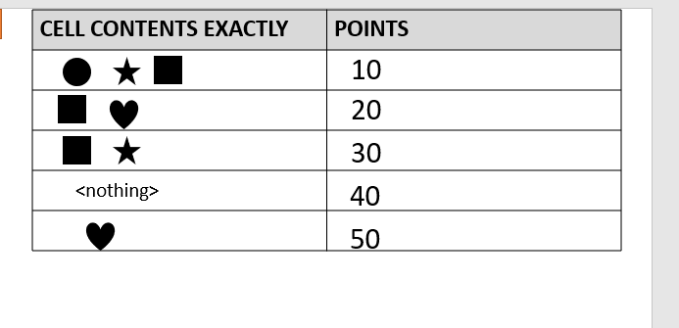

10

30

40

50

20

yes

no

7.

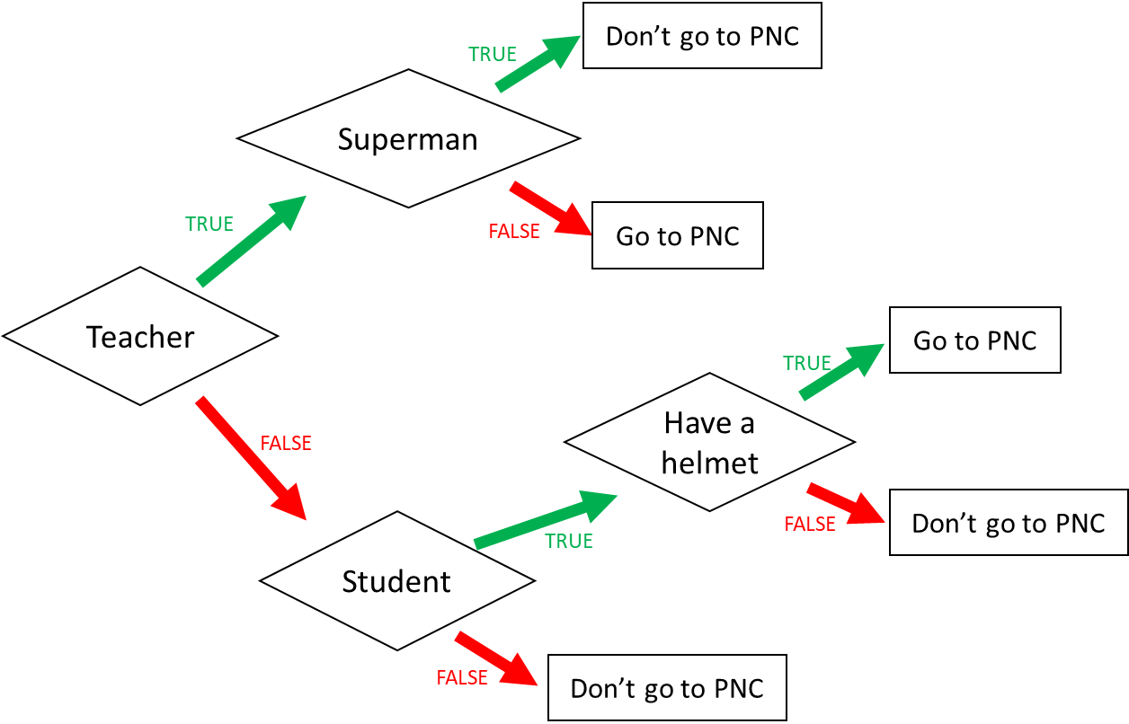

1. I am a teacher and I am superman, can I go to PNC?

No

1. I am not a teacher and not a student, can I go to PNC?

No

1. When can I go to PNC? (Express the condition using a Boolean expression)

I go to PNC if: I am a teacher and I’m not a supermen or i’m not teacher and i’m a student and I have a helmet

8

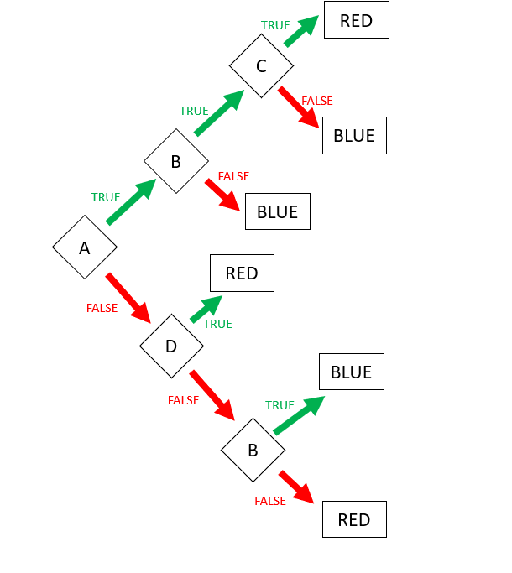

Expression: **RED** = ABC or !AD or !A!D!B

Expression: **BLUE** (FALSE) = A!B or AB!C

9. Encoding

* First 3 characters “MIX”, repeated many times (max repetition is 5)
* Then 1 character “!”, repeated many times (max repetition is 5)
* Then 1 number (0-3)

Examples:

MIXMIXMIX!1

MIX!!!!!3

MIXMIXMIX!!!2

**Q1**. Propose an **encoding** **structure** to encode this image.

|  |  |
| --- | --- |
| Encoding parts | Encoding values (in binary) |
| The repetition of text “MIX”: 1…5 | 001…101 |
| The repetition of character “!”: 1…5 | 001…101 |
| The number of the end: 0..3 | 00…11 |
|  |  |

**Q2**. What is the total **size** of your encoding? Give explanations.

Encoding size:8bits

*Explanation:*

Part1: 101 that mean text of MIX repeated 5 times

Part2: 101 that mean character if ! reqpeated 5 times  
Part3: 11 that mean the number at the end is 3.

We want to encode **a text** following those rules:

* 3 letters: A, B, C
* The letters are always in the alphabetic order
* Letters are repeated from 1 to 10 times
  + Each letter is repeated the same number of times
* The last character must be either: X, Y, or Z

*Examples:*

|  |  |
| --- | --- |
| ABCZ | Good |
| AAAABBBBCCCCX | Good |
| AABBCCY | Good |
| AAABBBCCCX | Good |
| AABBBBCCX | Bad: letter A is repeated 2 times but letter B 3 times |

**Q1**. Propose an **encoding** **structure** to encode this image. (20pts)

|  |  |
| --- | --- |
| Encoding parts | Encoding values (in binary) |
| A,B,C:1...........10 | 0001.......1010 |
| 1.x  2.y  3.z | 01  10  11 |
|  |  |
|  |  |

**Q2**. What is the total **size** of your encoding? Give explanations.

Encoding size:(4pts)

*Explanation:(6pts)*