Signal Generator Demo Instructions
- Hardware checklist
  - IGX Power cable
  - Ethernet cable
  - 2 100G cables
  - Keyboard & mouse
- Turn on IGX and wait for it to boot up – to login to the IGX, password is same as the username.
- Open a terminal (the following commands should be run inside the terminal)
- altera@altera-NVIDIA-IGX-Orin-Development-Kit:~
- cd hololink
- altera@altera-NVIDIA-IGX-Orin-Development-Kit:~/hololink
- xhost +
- access control disabled, clients can connect from any host
- ./docker/demo.sh
- root@altera-NVIDIA-IGX-Orin-Development-Kit:/home/altera/hololink#
- ./examples/signal_generator.sh
- The GUI will be launched, and the console will be filled with logs.
- Before continuing, please wait for the log to finish and the GUI to be complete
Optional: Running GNU Radio configuration to visualize time and frequency domain graphs
- Open a new terminal and run the following command in it:
- gnuradio-companion &

- This will open a new empty canvas:
  - note here: there is a bug in GNU Radio so sometimes it opens and immediately close. If this happens, try a couple of times until the it no longer closes.
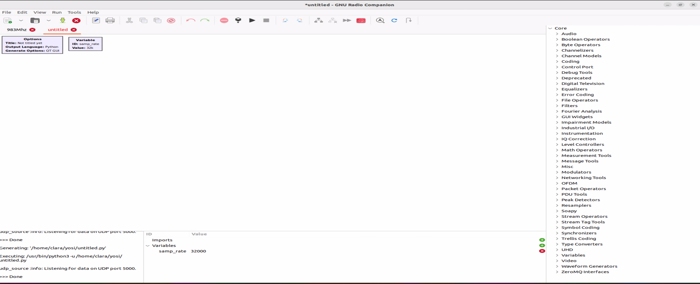
- Use the ‘file’ menu and open the signal_generator_client.grc flow configuration file that is found on your home directory. You should see the following screenshot:
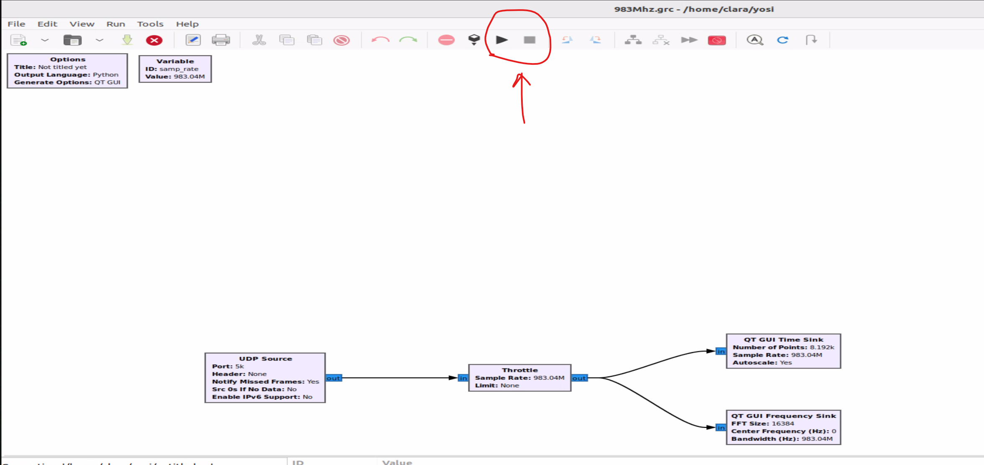

- To run/stop the flow – use the buttons ‘play/stop’ buttons marked in the red circle above. Once you the run the flow, a 2-graph window should open:
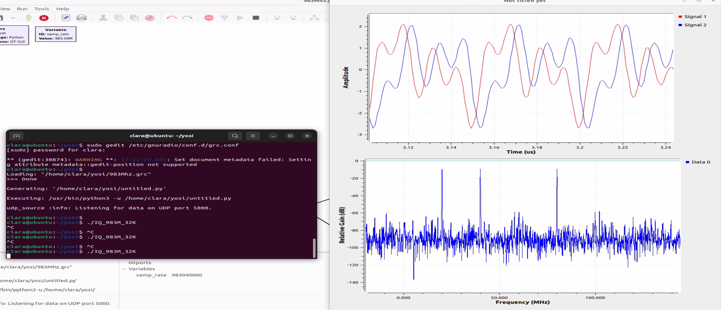

Signal Generator User Interface
The Signal Generator user interface is made of two sections:
- Signal Generator
- Signal Viewer
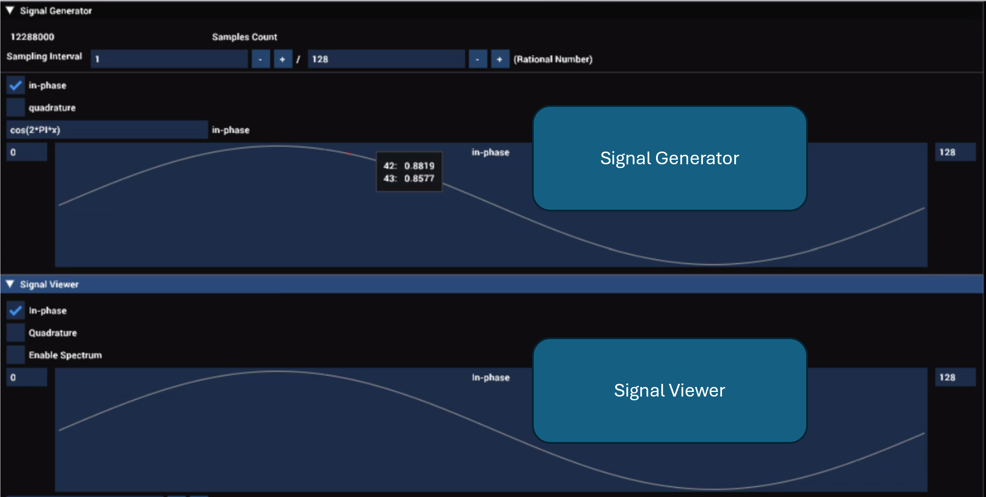
The Signal Generator:
The number of samples that the signal generator generates is shown in the Samples Count field. This value cannot be changed in runtime.
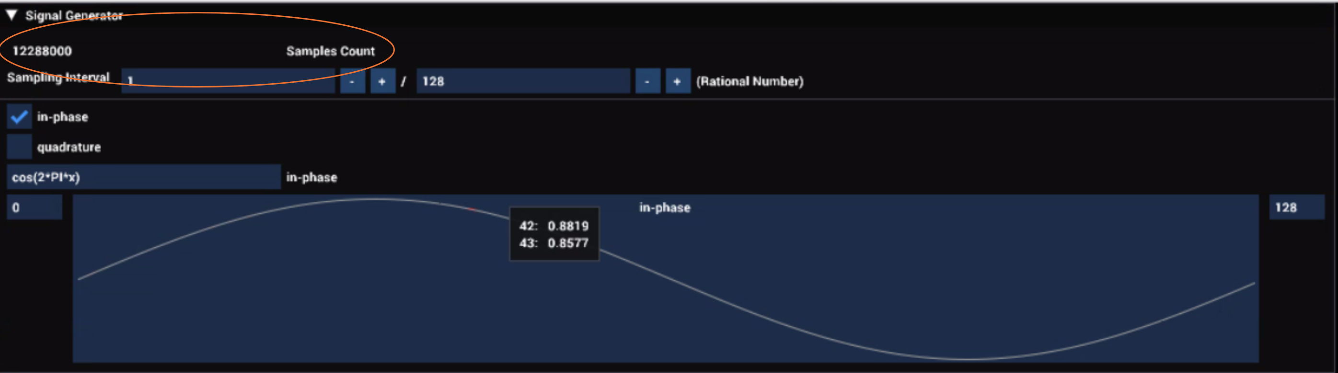

The Sampling Interval defines the values of the x variable when the signal expressions are evaluated. It is a rational number and both the numerator, and the denominator can be set.
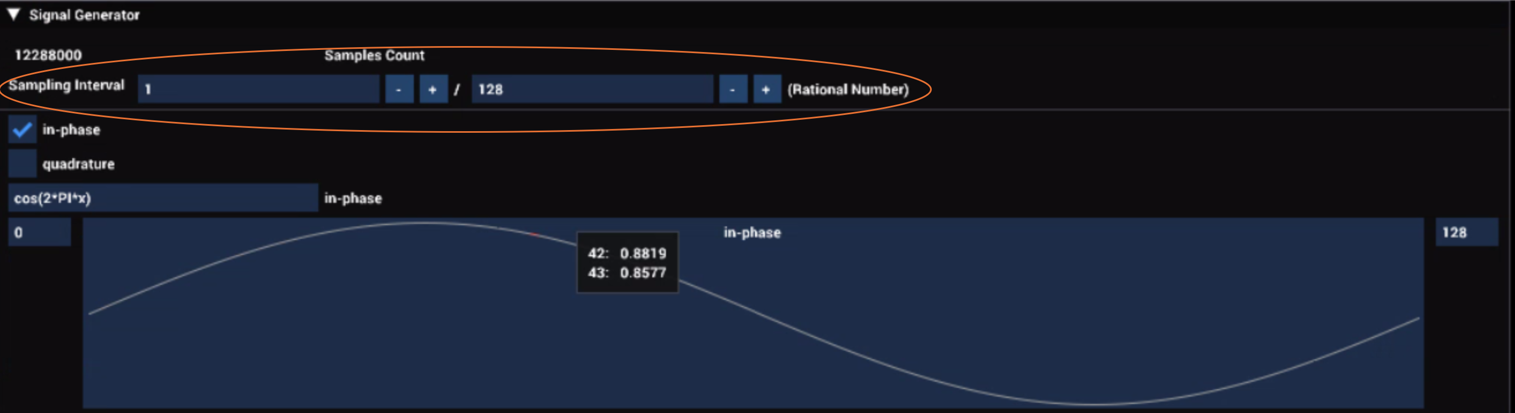

In the in-phase and quadrature fields, the user can define the signal in-phase and quadrature component expressions respectively.
The expression supports the 4 basic mathematical operations (+, -, *, /) including the plus and minus unary operations and parentheses (round brackets).
One variable - x (lower case x) - is supported. The value it will be given during the evaluation processes is determined by the Sampling Interval field.
The constant PI can be used as well as some common math functions like cos and sin.
When defining the in-phase and quadrature expressions, it is advised that the two expressions will match each other.
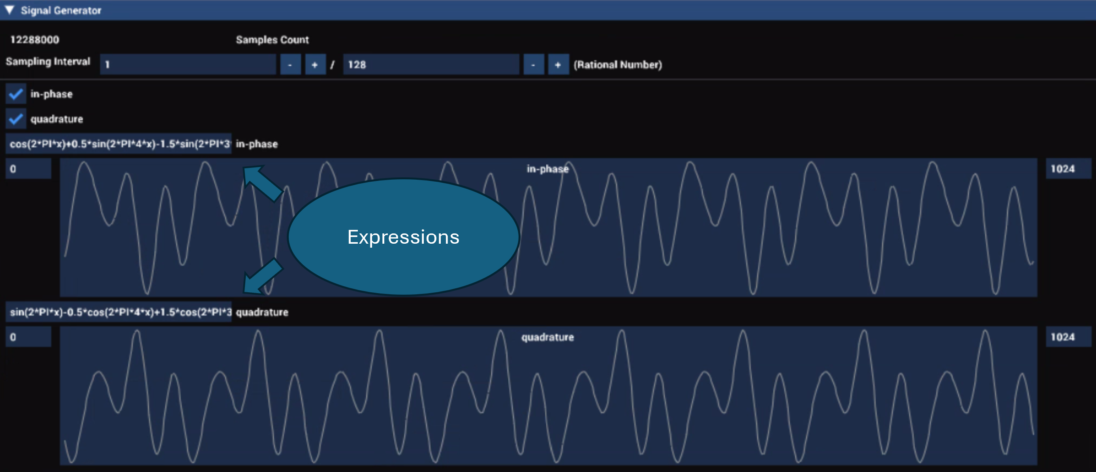

Example:
in-phase: cos(2*PI*x)+0.5*sin(2*PI*4*x)-1.5*sin(2*PI*3*x)
quadrature: sin(2*PI*x)-0.5*cos(2*PI*4*x)+1.5*cos(2*PI*3*x)
A visualization of the generated signal is presented under each component expression.
The user can set the range of samples to be viewed in the time domain by changing the values on the sides of the plot window.
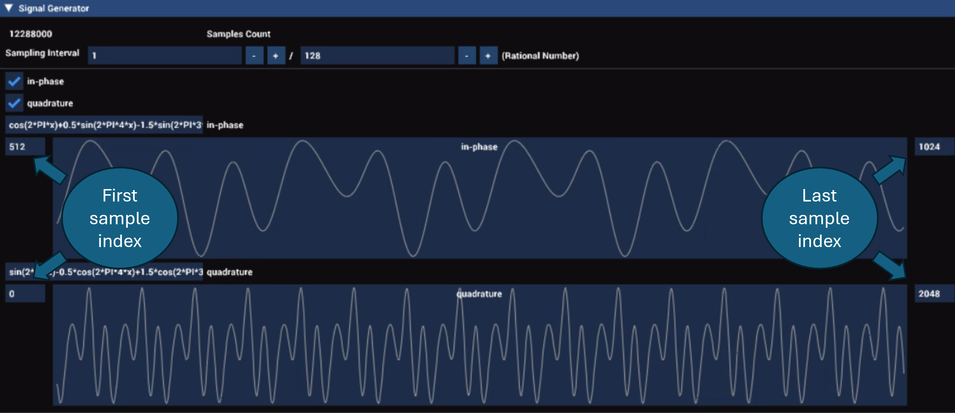

The Signal Viewer:
In this section, the user can view the signal as it was returned from the FPGA.
Both the time domain (in-phase and quadrature) and the frequency domain (spectrum) can be viewed.
The number of samples that are returned is the same as the number of samples that are sent (Samples Count).
The user can set the range of samples to be viewed in the time domain by changing the values on the sides of the plot window.
In the Spectrum Size, the user the set the number of samples that will be used to calculate the spectrum. The user can set the range of frequencies to be viewed in the spectrum view by changing the values on the sides of the plot window.
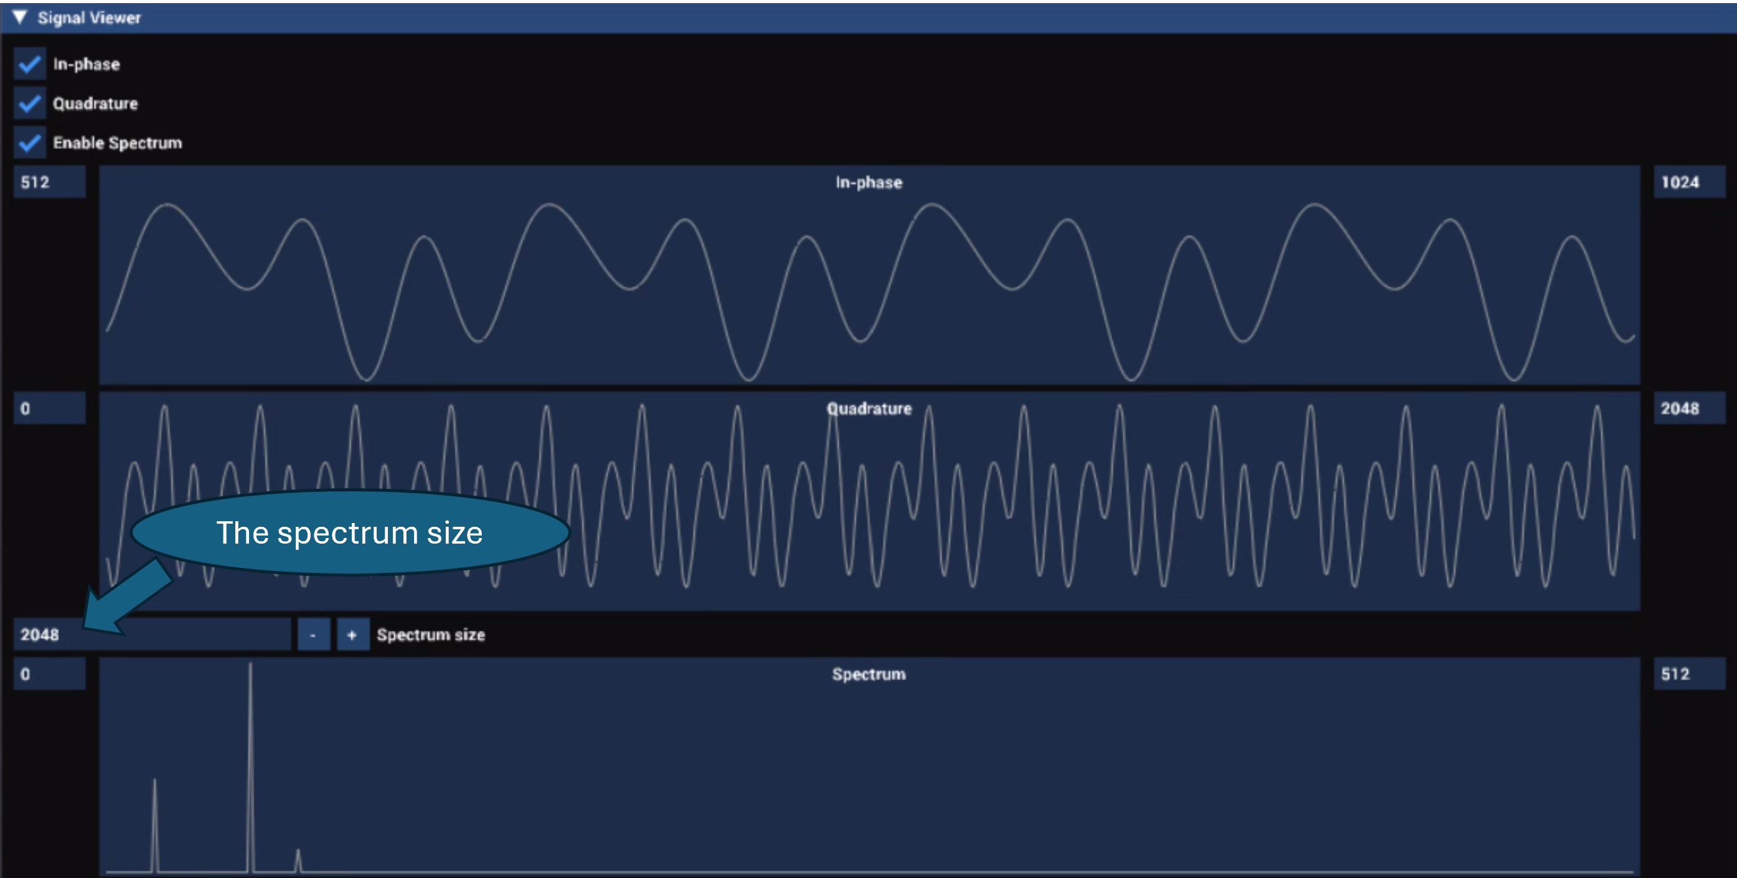

Troubleshooting:
- Unable to connect to the FPGA
- Check/replace the DAC/Optic cables.
- Make sure the MTU for the 100Gbps ports is set to 9000.
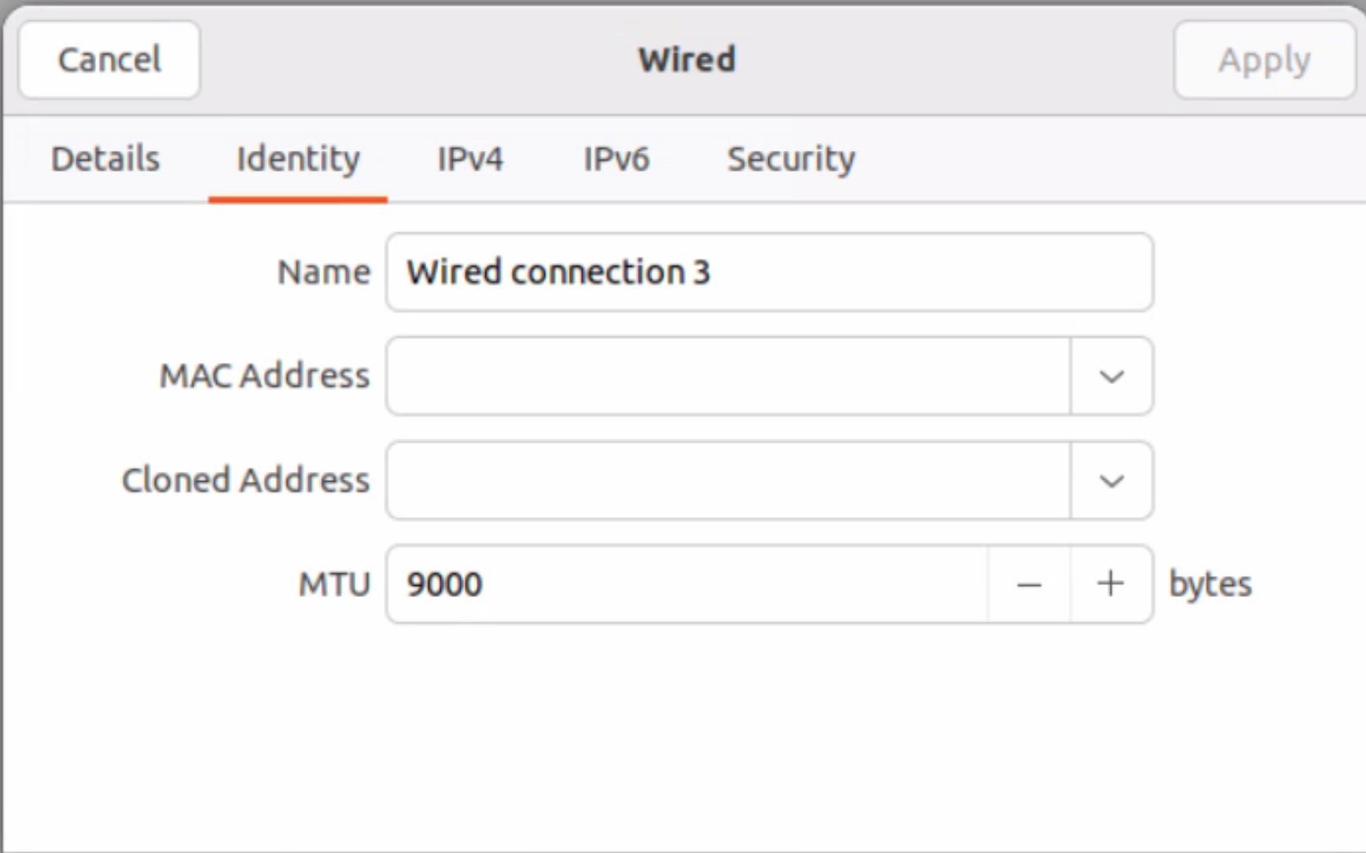
- Resize the GPU BAR1 Address Range on IGX ( See instructions in the IGX installation guide).
Please Note that for the purposes of the Altera demo, the Nvidia team have already taken care of all these configurations, so no further configuration is required.

