기술조사 강사님 안내
- 기술조사 : 해당 도메인 / 적용된 인공지능 기술 / 공개된 architecture
- 7월 20일 조별 시장조사 발표 /
- 여러개의 딥러닝 모델이 서로 데이터 주고받으며 상호작용하는 architecture로 구성
- 모델링 / 어떻게 전처리 했는지/ 전처리 파이프라인 구성
- 웹서비스/ 클라우드 서비스 이용할 예정

참고) 이준하 대표 강의내용
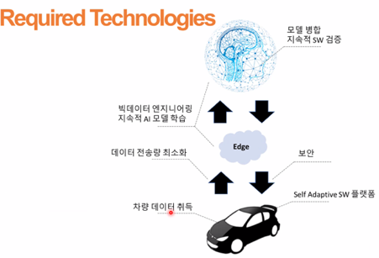​​

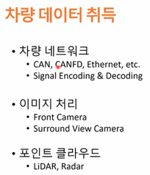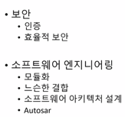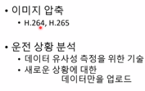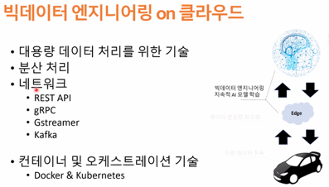
Vision data : Surround view camera 6 + front 2 -> 보통 8개 카메라, 잘 handling할 수 있어야 해
OpenCV, openGL 등 이용, 이미지 압축 중요
차량 -> pc 100개 정도가 함께 돌아가는 시스템. 서로 메세지를 주고 받는 분산시스템.
Vehicle component 간에 정보 주고받아
(vehicle signal) / Camera / ultra sonic 주차 환경을 위해/

1.Background

[1] autonomous driving

Current challenges in autonomous driving
reference : Barabas (2017) Current challenges in autonomous driving
https://iopscience.iop.org/article/10.1088/1757-899X/252/1/012096

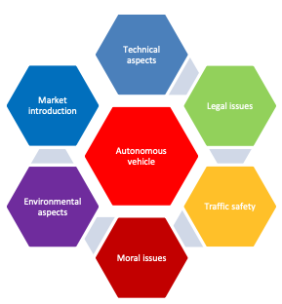
“자동차 기술만으로 자율주행 레벨4 실현 어려워...C-ITS 구축 전제돼야”
:http://www.aitimes.com/news/articleView.html?idxno=139059

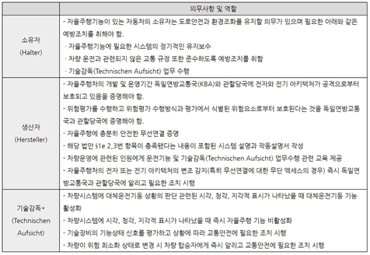
독일 레벨 4 자율주행 차량 정부안 대상자별 의무사항(표=KOTRA 뮌헨무역관)
- Expected Autonomous cars market
- Global Autonomous Cars (Semi & Fully) Market Report 2021: Market is Expected to Reach $1,383.89 Billion in 2025 - Forecast to 2030
reference https://www.prnewswire.com/news-releases/global-autonomous-cars-semi--fully-market-report-2021-market-is-expected-to-reach-1-383-89-billion-in-2025---forecast-to-2030--301292821.html
- Projected size of the global autonomous car market from 2019 to 2023
https://www.statista.com/statistics/428692/projected-size-of-global-autonomous-vehicle-market-by-vehicle-type/
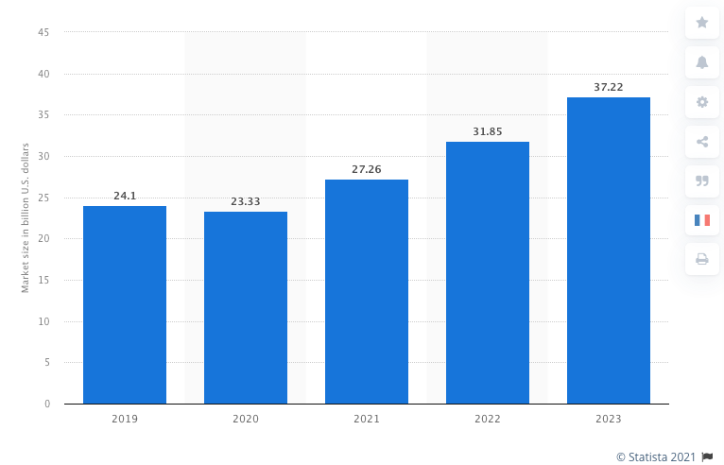
- market overview
https://www.mordorintelligence.com/industry-reports/autonomous-driverless-cars-market-potential-estimation

- Levels of driving automation
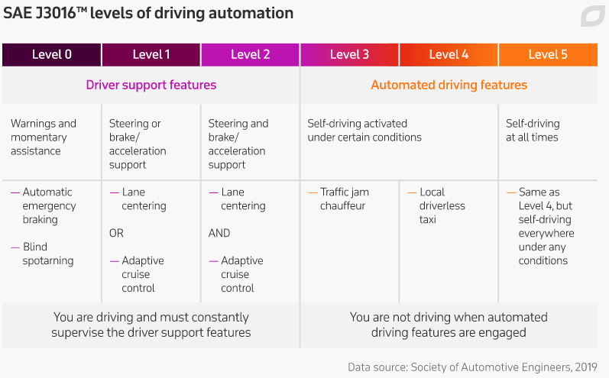
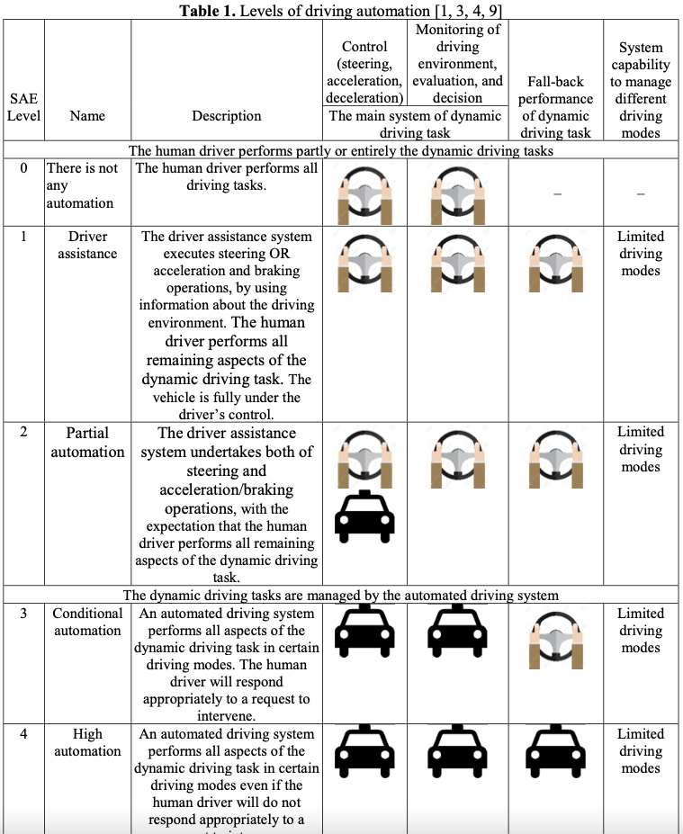
- 사용 데이터
reference: https://www.itransition.com/blog/autonomous-vehicle-sensors
https://www.epnc.co.kr/news/articleView.html?idxno=82099
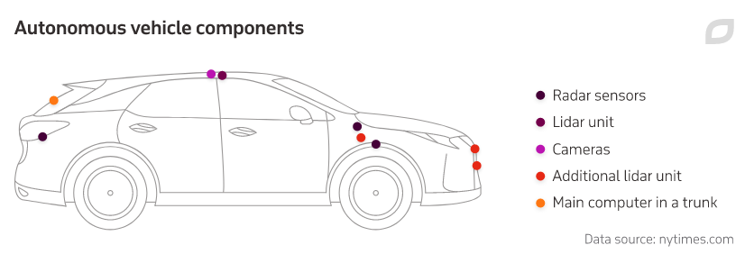
Camera sensors
How they work
Autonomous cars often have video cameras and sensors in order to see and interpret the objects in the road just like human drivers do with their eyes. By equipping cars with these cameras at every angle, the vehicles are capable of maintaining a 360° view of their external environment, thereby providing a broader picture of the traffic conditions around them.

Today, 3D cameras are available and utilized for displaying highly detailed and realistic images. These image sensors automatically detect objects, classify them, and determine the distances between them and the vehicle. For example, the cameras can easily identify other cars, pedestrians, cyclists, traffic signs and signals, road markings, bridges, and guardrails.

Areas for improvement
Unfortunately, these camera sensors are still far from perfect. Poor weather conditions such as rain, fog, or snow can prevent cameras from clearly seeing the obstacles in the roadway, which can increase the likelihood of accidents. Additionally, there are often situations where the images from the cameras simply aren’t good enough for a computer to make a good decision about what the car should do. For example, in situations where the colors of objects are very similar to the background or the contrast between them is low, the driving algorithms can fail.

Radar sensors
How they work
Radar (Radio Detection and Ranging) sensors make up a crucial contribution to the overall function of autonomous driving: they send out radio waves that detect objects and gauge their distance and speed in relation to the vehicle in real time.

Both short- and long-range radar sensors are usually deployed all around the car and each one has their different functions. While short range (24 GHz) radar applications enable blind spot monitoring, the ideal lane-keeping assistance, and parking aids, the roles of the long range (77 GHz) radar sensors include automatic distance control and brake assistance. Unlike camera sensors, radar systems typically have no trouble at all when identifying objects during fog or rain.

Areas for improvement
The pedestrian recognition algorithm definitely needs a lot of improvement, seeing as the automotive radar sensors used in today’s vehicles only correctly identify between 90% and 95% of pedestrians, which is hardly enough to ensure safety on the road. As well, the still widely-used 2D radars are not able to determine accurately an object’s height, as the sensors only scan horizontally, which can cause a variety of problems when driving under bridges or road signs. A wider variety of 3D radar sensors are currently being developed in order to solve these issues.

Lidar sensors
How they work
Lidar (Light Detection and Ranging) sensors work similar to radar systems, with the only difference being that they use lasers instead of radio waves. Apart from measuring the distances to various objects on the road, lidar allows creating 3D images of the detected objects and mapping the surroundings. Moreover, lidar can be configured to create a full 360-degree map around the vehicle rather than relying on a narrow field of view. These two advantages make autonomous vehicle manufacturers such as Google, Uber, and Toyota choose lidar systems.

Moreover, lidar can be configured to create a full 360° map around the vehicle rather than simply relying on a narrow field of view. These two advantages have led autonomous vehicle manufacturers such as Google, Uber, and Toyota to choose lidar systems for their vehicles.

Areas for improvement
Since rare earth metals are needed in order to produce adequate lidar sensors, these sensors are much more expensive than radar sensors used in autonomous vehicles. The systems required for autonomous driving can cost well beyond $10,000, while the top sensor being used by Google and Uber costs up to $80,000. Yet another problem is that snow or fog can sometimes block lidar sensors and negatively affect their ability to detect objects in the road.

현재 자율주행 사용기술:
Advanced driver assistance systems (ADAS).
- Lane-keep-assist (LKA).
- Traffic-jam-assist (TJA).
현재 가장 고급 옵션 중 하나는 Audi A8입니다. TJA 시스템 덕분에 업계에서 많은 사람들에게 레벨 3 자율주행차라고 불렸습니다. 그러나 합법성, 보험 및 도로 표지판 변형에 대한 질문 이 북미 시장에서 TJA 시스템을 차단 했기 때문에 레벨 3 상태에 대해 논의 하고 있습니다.
운전자 없이 작동하려면 레벨 5 자율주행차가 주변을 보고, 장애물을 인식하고, 최종적으로 인식에 따라 안전하게 행동해야 합니다.
인간과 동등하거나 그 이상인 보고, 인식하고, 행동하는 것은 레벨 5 자율주행 차량의 구현에 세 가지 큰 장애물입니다.

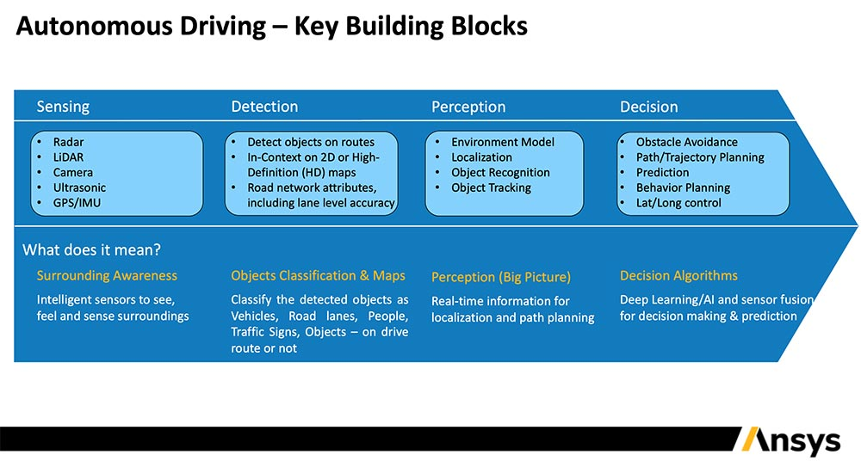

[2] Color blindness
- Using AI to Solve Colorblindness and More
https://medium.com/vectors-angel/the-company-using-ai-to-solve-colorblindness-and-more-6a93f726071c
Fashion and Regular Sunglasses
Global Market Size: $14.5B (all of these refer to global market size in 2018.) With a 2.3% projected global CAGR through 2025, this sector is growing alongside increasing disposable income and rising preference for luxury goods. Two major players in this industry include the Luxottica Group and the Safilo Group.
Prescription Eyewear
Global Market Size: $5B. The 4.3% global CAGR through 2028 corresponds with a rise in elderly populations and life expectancy. According to the Vision Council of America, 76.2% of Americans already used some kind of vision correction in 2015. A US Census Report further estimates that the population older than 65 will jump from 8.5% (617 million) worldwide in 2015 to 17% by 2050 (1.6 billion), bolstering the global demand for prescription eyewear. Some major players include the Luxottica Group, Carl Zeiss, Seiko Optical Products, and Hoya Vision.
Contact Lenses
Global Market Size: $11.9B. With a 5.6% projected global CAGR through 2025, medical complications that occur with age such as myopia and presbyopia paired with rising populations drive much of this growth. Some major players include Essilor-Luxottica, Alcon Vision, CooperVision, Bausch + Lomb, and ZEISS International.
Medical Cataract Surgeries
Global Market SizeL $5.4B. With a projected 5.2% CAGR through 2025, this sector is expecting to reach $9.8B in only five years. Again, much of this growth is propelled by the increasing elderly population. Some major players include Alcon Vision, Hoya Vision, Carl Zeiss, and Johnson & Johnson.

color blindness 해결해주는 어플리케이션: https://colorblindpal.com/
2. color blindness charts 학습 예시 (validation 용으로 사용 가능?)
https://towardsdatascience.com/reading-color-blindness-charts-deep-learning-and-computer-vision-a8c824dd71cd 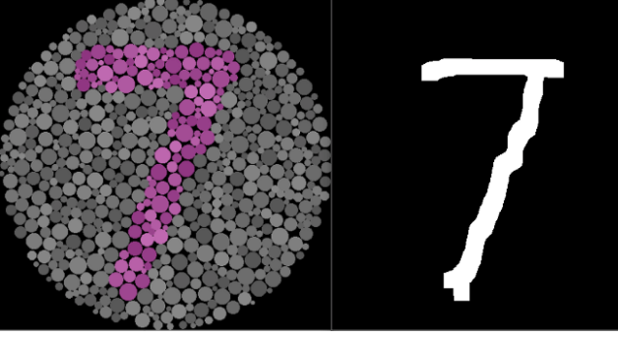
색각이상의 이해

색의 인식.
색의 인식은 망막 내의 시세포 중 하나인 원뿔세포(Cone cell)를 통해 이루어집니다.
이 원뿔세포에 기능에 이상이 있을 때 색을 정확하게 인식할 수 없는 색각이상을 발생하게 됩니다.

색각이상자의 비율.
세계 인구 중 남자의 8%, 여자의 0.5%에서 색각이상이 나타나며,
국내 인구 중 남자의 5.9%, 여자의 0.4% (약 150만명)의 색각이상자 비율을 가지고 있습니다.

색각이상의 유형.
색각이상의 유형은 여러가지가 있지만 적색과 녹색을 구분하지 못하는 적녹색맹이 가장 많으며,
청색과 녹색, 또는 황색을 구분하지 못하는 청색맹, 색상을 전혀 구분하지 못하고 명암 대비로만 시각
정보를 인식하는 전색맹이 있다.
Phase1. 색각이상을 고려한 색상 사용

1. 99%의 색각이상자(적록색맹)를 위한 채도 변경
빨간색은 초록색 or 갈색과 혼동할 수 있으므로 주황 계열로 채도 변경하고,
초록색은 빨간색 or 갈색과 혼동할 수 있으므로 청록 계열로 채도 변경하는 것이 좋습니다.





2. 색각이상자가 구분하기 어려운 색상과 조합 사용을 지양
아래와 같이 구분이 어려운 색상 조합을 지양합니다.
빨간색-초록색, 초록색-갈색, 노란색-초록색, 파란색-분홍색, 짙은 파란색-보라색

3. 색각이상자가 명확히 구분할 수 있는 색상표 사용
Color Universal Design Organization (http://www.cudo.jp/e) 의 오카베 마사타카,
이토 케이의 연구 결과에 따르면 색각 이상자가 명확히 구분할 수 있는 색상표는 다음과 같습니다.
총 8개의 색상이 제시되어있으나 복수의 색상 사용 시, 최소한의 색만 사용하는 것을 권장합니다.

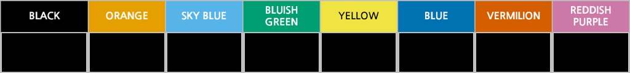
색상과 명도 보정에 관한 자료
https://www.koreascience.or.kr/article/JAKO201310837317613.pdf

3. AI Based Colour Blindness Correction App
http://socube.cuhk.edu.hk/en/fundedproject/ai-based-colour-blindness-correction-app/

2. Method
[1] 자율주행 구현 기술
참고 github)
1) https://github.com/ndrplz/self-driving-car
- traffic sign classifier, vehicle detection 등 12가지 관련 코드
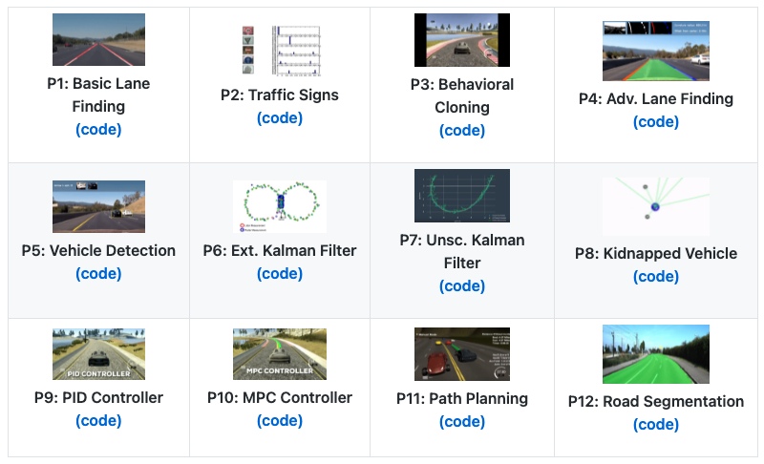
P2 - Traffic Sign Classification
Summary: Built and trained a deep neural network to classify traffic signs, using TensorFlow. Experimented with different network architectures. Performed image pre-processing and validation to guard against overfitting.
Keywords: Deep Learning, TensorFlow, Computer Vision
P3 - Behavioral Cloning
Summary: Built and trained a convolutional neural network for end-to-end driving in a simulator, using TensorFlow and Keras. Used optimization techniques such as regularization and dropout to generalize the network for driving on multiple tracks.
Keywords: Deep Learning, Keras, Convolutional Neural Networks
P5 - Vehicle Detection and Tracking
Summary: Created a vehicle detection and tracking pipeline with OpenCV, histogram of oriented gradients (HOG), and support vector machines (SVM). Implemented the same pipeline using a deep network to perform detection. Optimized and evaluated the model on video data from a automotive camera taken during highway driving.
Keywords: Computer Vision, Deep Learning, OpenCV

2) 테슬라개발DNN신경망,"레이더센서보다100배낫다"
http://www.aitimes.com/news/articleView.html?idxno=139403
[2] AI based color correction
- deep correct : Deep learning color correction for color blindness
https://ebooks.iospress.nl/volumearticle/47619
- webSignt
https://github.com/DanRuta/WebSight

