

CAPSTONE PROJECT REPORT
Report 4 – Software Design Document

– DaNang, July 2026 –

Table of Contents
I. Record of Changes
II. Software Design Document
1. System Design
1.1 System Architecture
1.1.1 System Architecture Explanation
1.1.2 System Architecture Explanation
1.1.2.1 TypeScript
1.1.2.2 React.js + Vite + Tailwind CSS
1.1.2.3 Node.js + Express / NestJS
1.1.2.4 Python + FastAPI + OpenCV (AI Service)
1.1.2.5 Google Gemini 2.5 Flash API
1.1.2.6 Redis Cache & BullMQ
1.1.2.7 MongoDB
1.1.2.8 Socket.io
1.1.2.9 PayOS / VietQR Gateway
1.1.2.10 Cloudinary / AWS S3
1.1.2.11 Docker & GitHub Actions (DevOps & CI/CD)
1.2 Package Diagram
1.2.1. Front-end Package Diagram
1.2.2. Back-end Package Diagram
1.2.3. Mobile App Package Diagram
1.2.4. AI Service Package Diagram
2. Database Design
3. Detailed Design
3.1 Authentication & Account Management
3.1.1 Class Diagram for Register Account (UC-01)
3.1.2 Sequence Diagram for Register Account (UC-01)
3.1.3 Class Diagram for Sign In (UC-02)
3.1.4 Sequence Diagram for Sign In (UC-02)
3.1.5 Class Diagram for Verify Email (UC-03)
3.1.6 Sequence Diagram for Verify Email (UC-03)
3.1.7 Class Diagram for Sign In with Google (UC-04)
3.1.8 Sequence Diagram for Sign In with Google (UC-04)
3.1.9 Class Diagram for Recover Password (UC-05)
3.1.10 Sequence Diagram for Recover Password (UC-05)
3.1.11 Class Diagram for Reset Password (UC-06)
3.1.12 Sequence Diagram for Reset Password (UC-06)
3.1.13 Class Diagram for Sign Out (UC-07)
3.1.14 Sequence Diagram for Sign Out (UC-07)
3.2 Customer Online Portal
3.2.1 Class Diagram for Search Medicines Online (UC-08)
3.2.2 Sequence Diagram for Search Medicines Online (UC-08)
3.2.3 Class Diagram for Add to Cart (UC-09)
3.2.4 Sequence Diagram for Add to Cart (UC-09)
3.2.5 Class Diagram for Manage Personal Cart (UC-10)
3.2.6 Sequence Diagram for Manage Personal Cart (UC-10)
3.2.7 Class Diagram for Confirm Online Order (UC-11)
3.2.8 Sequence Diagram for Confirm Online Order (UC-11)
3.2.9 Class Diagram for Pay Online Order (UC-12)
3.2.10 Sequence Diagram for Pay Online Order (UC-12)
3.2.11 Class Diagram for View Order History (UC-13)
3.2.12 Sequence Diagram for View Order History (UC-13)
3.2.13 Class Diagram for View Customer Profile (UC-14)
3.2.14 Sequence Diagram for View Customer Profile (UC-14)
3.2.15 Class Diagram for Consult AI via Text (UC-15)
3.2.16 Sequence Diagram for Consult AI via Text (UC-15)
3.2.17 Class Diagram for Consult AI via Voice (UC-16)
3.2.18 Sequence Diagram for Consult AI via Voice (UC-16)
3.3 Pharmacist POS Counter Terminal
3.3.1 Class Diagram for Search Retail Medicines (UC-17)
3.3.2 Sequence Diagram for Search Retail Medicines (UC-17)
3.3.3 Class Diagram for Add to Retail Cart (UC-18)
3.3.4 Sequence Diagram for Add to Retail Cart (UC-18)
3.3.5 Class Diagram for Edit Retail Cart (UC-19)
3.3.6 Sequence Diagram for Edit Retail Cart (UC-19)
3.3.7 Class Diagram for Suggest Substitute Medicine (UC-20)
3.3.8 Sequence Diagram for Suggest Substitute Medicine (UC-20)
3.3.9 Class Diagram for Apply Voucher and Points (UC-21)
3.3.10 Sequence Diagram for Apply Voucher and Points (UC-21)
3.3.11 Class Diagram for Scan Prescription with AI (UC-22)
3.3.12 Sequence Diagram for Scan Prescription with AI (UC-22)
3.3.13 Class Diagram for Check Medicine Interactions (UC-23)
3.3.14 Sequence Diagram for Check Medicine Interactions (UC-23)
3.3.15 Class Diagram for Confirm Retail Payment (UC-24)
3.3.16 Sequence Diagram for Confirm Retail Payment (UC-24)
3.3.17 Class Diagram for Send E-Invoice via Email (UC-25)
3.3.18 Sequence Diagram for Send E-Invoice via Email (UC-25)
3.3.19 Class Diagram for Create Wholesale Invoice (UC-26)
3.3.20 Sequence Diagram for Create Wholesale Invoice (UC-26)
3.3.21 Class Diagram for Search Return Invoice (UC-27)
3.3.22 Sequence Diagram for Search Return Invoice (UC-27)
3.3.23 Class Diagram for Create Return Slip (UC-28)
3.3.24 Sequence Diagram for Create Return Slip (UC-28)
3.4 Central Warehouse & FEFO Inventory Management
3.4.1 Class Diagram for View Medicine Catalog (UC-29)
3.4.2 Sequence Diagram for View Medicine Catalog (UC-29)
3.4.3 Class Diagram for View Inventory by Batch (UC-30)
3.4.4 Sequence Diagram for View Inventory by Batch (UC-30)
3.4.5 Class Diagram for Create Goods Receipt (UC-31)
3.4.6 Sequence Diagram for Create Goods Receipt (UC-31)
3.4.7 Class Diagram for Create Purchase Order (PO) (UC-32)
3.4.8 Sequence Diagram for Create Purchase Order (PO) (UC-32)
3.4.9 Class Diagram for Inspect Goods via AI (UC-33)
3.4.10 Sequence Diagram for Inspect Goods via AI (UC-33)
3.4.11 Class Diagram for Alert Expiry Dates (UC-34)
3.4.12 Sequence Diagram for Alert Expiry Dates (UC-34)
3.4.13 Class Diagram for Track Medicine Lot (UC-35)
3.4.14 Sequence Diagram for Track Medicine Lot (UC-35)
3.5 Branch Store Management
3.5.1 Class Diagram for View Branch Stock (UC-36)
3.5.2 Sequence Diagram for View Branch Stock (UC-36)
3.5.3 Class Diagram for Request Stock Requisition (UC-37)
3.5.4 Sequence Diagram for Request Stock Requisition (UC-37)
3.5.5 Class Diagram for Request Internal Transfer (UC-38)
3.5.6 Sequence Diagram for Request Internal Transfer (UC-38)
3.5.7 Class Diagram for Approve Stock Replenishment (UC-39)
3.5.8 Sequence Diagram for Approve Stock Replenishment (UC-39)
3.5.9 Class Diagram for Confirm Transfer Receipt (UC-40)
3.5.10 Sequence Diagram for Confirm Transfer Receipt (UC-40)
3.6 HQ System Governance & Staff Management
3.6.1 Class Diagram for View Staff List (UC-41)
3.6.2 Sequence Diagram for View Staff List (UC-41)
3.6.3 Class Diagram for Create Staff Account (UC-42)
3.6.4 Sequence Diagram for Create Staff Account (UC-42)
3.6.5 Class Diagram for Approve Staff Account (UC-43)
3.6.6 Sequence Diagram for Approve Staff Account (UC-43)
3.6.7 Class Diagram for Reject Staff Account (UC-44)
3.6.8 Sequence Diagram for Reject Staff Account (UC-44)
3.6.9 Class Diagram for Create Branch Manager Account (UC-45)
3.6.10 Sequence Diagram for Create Branch Manager Account (UC-45)
3.6.11 Class Diagram for Update Staff Role (UC-46)
3.6.12 Sequence Diagram for Update Staff Role (UC-46)
3.6.13 Class Diagram for Add Medicine (UC-47)
3.6.14 Sequence Diagram for Add Medicine (UC-47)
3.6.15 Class Diagram for Update Medicine (UC-48)
3.6.16 Sequence Diagram for Update Medicine (UC-48)
3.6.17 Class Diagram for View Supplier List (UC-49)
3.6.18 Sequence Diagram for View Supplier List (UC-49)
3.6.19 Class Diagram for Add Supplier (UC-50)
3.6.20 Sequence Diagram for Add Supplier (UC-50)
3.6.21 Class Diagram for Update Supplier (UC-51)
3.6.22 Sequence Diagram for Update Supplier (UC-51)
3.7 Corporate Finance, Approvals & AI Analytics
3.7.1 Class Diagram for View Revenue Dashboard (UC-52)
3.7.2 Sequence Diagram for View Revenue Dashboard (UC-52)
3.7.3 Class Diagram for Compare Branch Performance (UC-53)
3.7.4 Sequence Diagram for Compare Branch Performance (UC-53)
3.7.5 Class Diagram for Approve Purchase Order (PO) (UC-54)
3.7.6 Sequence Diagram for Approve Purchase Order (PO) (UC-54)
3.7.7 Class Diagram for Reject Purchase Order (PO) (UC-55)
3.7.8 Sequence Diagram for Reject Purchase Order (PO) (UC-55)
3.7.9 Class Diagram for Approve Goods Receipt Note (GRN) (UC-56)
3.7.10 Sequence Diagram for Approve Goods Receipt Note (GRN) (UC-56)
3.7.11 Class Diagram for Reject Goods Receipt Note (GRN) (UC-57)
3.7.12 Sequence Diagram for Reject Goods Receipt Note (GRN) (UC-57)
3.7.13 Class Diagram for Manage Promotions (UC-58)
3.7.14 Sequence Diagram for Manage Promotions (UC-58)
3.7.15 Class Diagram for Manage Cash Flow (UC-59)
3.7.16 Sequence Diagram for Manage Cash Flow (UC-59)
3.7.17 Class Diagram for Query Audit Logs (UC-60)
3.7.18 Sequence Diagram for Query Audit Logs (UC-60)
3.7.19 Class Diagram for Forecast Demand (UC-61)
3.7.20 Sequence Diagram for Forecast Demand (UC-61)
3.7.21 Class Diagram for Auto-Generate PO from AI Forecast (UC-62)
3.7.22 Sequence Diagram for Auto-Generate PO from AI Forecast (UC-62)
3.7.23 Class Diagram for Detect Inventory Anomalies with AI (UC-63)
3.7.24 Sequence Diagram for Detect Inventory Anomalies with AI (UC-63)
3.7.25 Class Diagram for Analyze Seasonal and Epidemic Trends (UC-64)
3.7.26 Sequence Diagram for Analyze Seasonal and Epidemic Trends (UC-64)
3.7.27 Class Diagram for Receive Notifications (UC-65)
3.7.28 Sequence Diagram for Receive Notifications (UC-65)

I. Record of Changes
Date | A*  M, D | In charge | Change Description
*A - Added M - Modified D - Deleted

II. Software Design Document

1. System Design

1.1 System Architecture

1.1.1 System Architecture Explanation
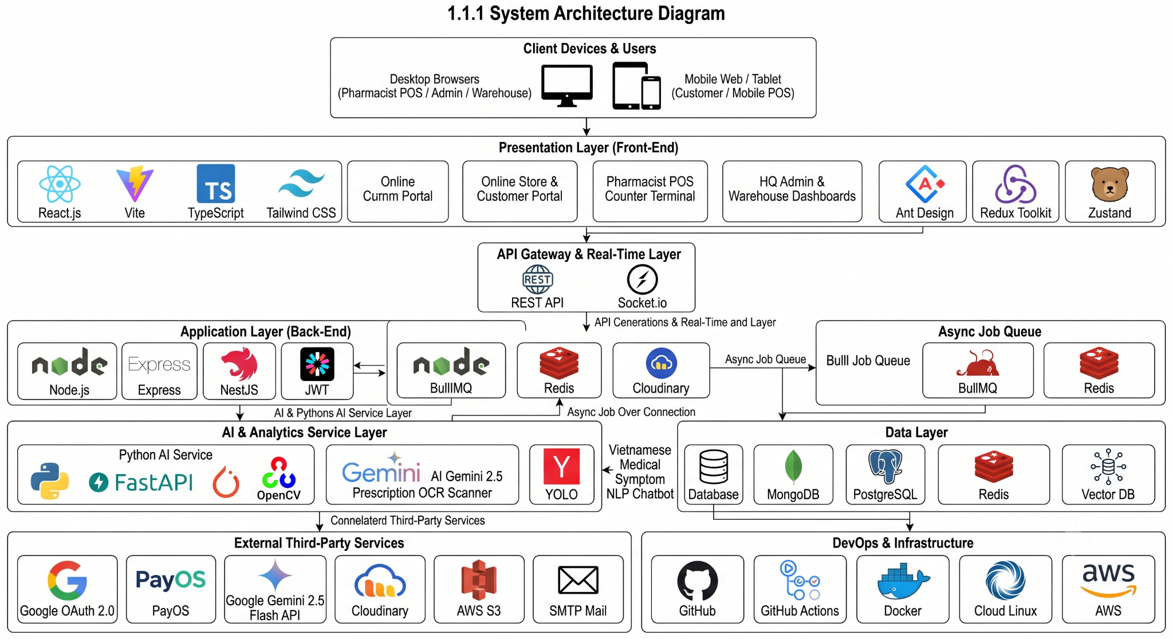

1.1.2 System Architecture Explanation

1.1.2.1 TypeScript
TypeScript is a strongly typed superset of JavaScript that compiles to plain JavaScript. It adds optional static typing, interface contracts, and generics, making it easier to write scalable, maintainable, and bug-free code across both Front-End and Back-End microservices. It integrates seamlessly with modern IDEs, catching type-mismatch errors early during development.

1.1.2.2 React.js + Vite + Tailwind CSS
React.js is a component-based Front-End library for building modern, responsive user interfaces. Combined with Vite, it provides lightning-fast Hot Module Replacement (HMR) and optimized production bundlings. Tailwind CSS is a utility-first CSS framework that enables rapid styling of responsive layouts without custom CSS overhead, ensuring a clean and consistent UI design for counter POS and admin screens.

1.1.2.3 Node.js + Express / NestJS
Node.js is an open-source, cross-platform asynchronous JavaScript runtime environment built on Chrome's V8 engine. Paired with NestJS/Express, it powers the Core Application Layer using a modular microservice architecture (api-gateway, auth-service, inventory-service, orders-service, supplier-service, user-service), delivering non-blocking I/O execution for high-throughput HTTP API requests.

1.1.2.4 Python + FastAPI + OpenCV (AI Service)
FastAPI is a high-performance Python web framework built on ASGI standards. In our system, it hosts the dedicated ai-service microservice, integrating OpenCV and PyTorch image processing libraries to execute computer vision box package counting and handle natural language medical symptom consultation queries.

1.1.2.5 Google Gemini 2.5 Flash API
Google Gemini 2.5 Flash is a multimodal generative AI model utilized for Optical Character Recognition (OCR). It analyzes doctor prescription photo layouts, extracts active ingredient names and dosage concentrations, merges duplicate entries, and matches branch database SKUs to auto-fill retail POS shopping carts.

1.1.2.6 Redis Cache & BullMQ
Redis is an open-source, in-memory data store used for high-speed caching (< 10ms response time), session token management, and executing atomic locking operations on medicine batches (batchNo) to enforce First-Expired, First-Out (FEFO) rules. BullMQ uses Redis to manage background asynchronous queues for sending OTP emails and generating PDF e-invoices.

1.1.2.7 MongoDB
The Data Layer utilizes a robust database instance storing structured domain entities including Users, Medicines, Batches, Sales Orders, Purchase Orders (PO), Goods Receipt Notes (GRN), and System Audit Logs, guaranteeing ACID transactional compliance and data durability.

1.1.2.8 Socket.io
Socket.io is a real-time event-based communication library. It maintains persistent WebSocket TCP connections between client web apps and the backend server, broadcasting live notifications for low stock alerts, near-expiry batch warnings, and urgent branch replenishment requests.

1.1.2.9 PayOS / VietQR Gateway
PayOS is a lightweight online payment gateway supporting dynamic VietQR generation. It listens for asynchronous banking webhook callbacks, verifying cryptographic digital signatures to settle online customer orders instantly without requiring manual intervention.

1.1.2.10 Cloudinary / AWS S3
Cloudinary / AWS S3 provides secure cloud object storage for prescription image uploads, shipment package inspection photos, and medicine product catalog thumbnails with automated image compression and HTTPS URL delivery.

1.1.2.11 Docker & GitHub Actions (DevOps & CI/CD)
Docker containerizes system microservices into isolated environments, ensuring consistency between development, testing, and production servers. GitHub Actions automates the Continuous Integration and Continuous Deployment (CI/CD) pipeline, executing lint checks, automated unit tests, and docker image deployments.

1.2 Package Diagram

1.2.1. Front-end Package Diagram
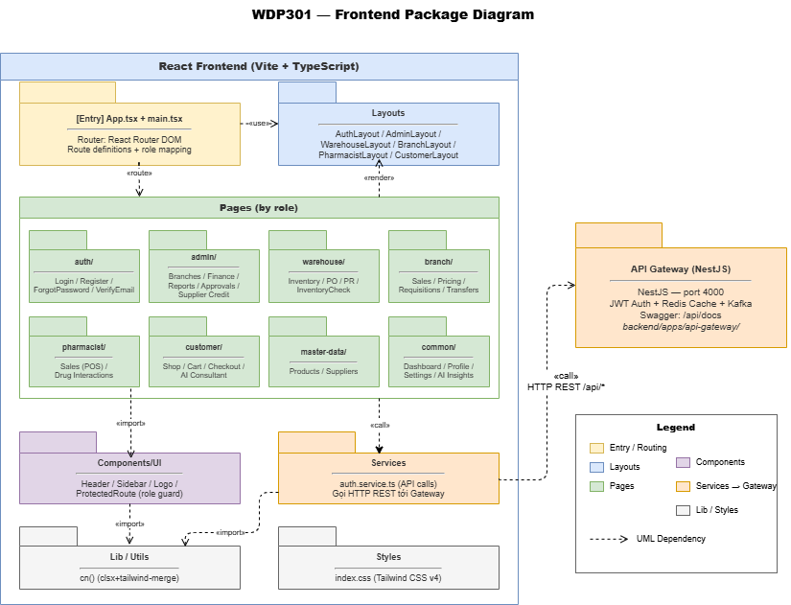
Package Descriptions
No | Package | Description
1 | routes / Entry (main.tsx, App.tsx) | Acts as the main entry point of the React application. Configures React Router DOM for client-side SPA routing, mapping application URLs to specific layouts and enforcing top-level role routing.
2 | layouts | Contains layout wrapper structures used across different portals to maintain UI consistency (AuthLayout, AdminLayout, WarehouseLayout, BranchLayout, PharmacistLayout, CustomerLayout), integrating headers, sidebars, and footers.
3 | pages (by role) | Contains the primary view screens of the application, organized into role-based subdirectories:  • auth/: Login, Register, Forgot Password, Verify Email.  • customer/: Online Store, Cart, Checkout, AI Health Consultant.  • pharmacist/: POS Sales Terminal, Counter Checkout, Drug Interaction Checker.  • branch/: Local Inventory, Pricing, Stock Requisitions (PR), Branch Transfers.  • warehouse/: Central Inventory, Goods Receipt Notes (GRN), POs, Stock Check.  • admin/: Branch Admin, Corporate Finance, Approval Center, Audit Logs.  • master-data/: Global Product SKUs, Supplier Registry.  • common/: Role Dashboards, User Profile Settings, System Analytics.
4 | components | Houses reusable UI components (Header, Sidebar, Logo, Data Tables, Modal Dialogs, Toast Notifications) and security wrappers such as ProtectedRoute for client-side Role-Based Access Control (RBAC) route guarding.
5 | services | Encapsulates the application's business API integration layer (auth.service.ts, pos.service.ts, inventory.service.ts). Handles HTTP RESTful requests, error interceptors, and data synchronization with the NestJS API Gateway.
6 | lib / utils | Contains shared utility helper functions, currency formatters (VND formatting), date/timestamp converters (UTC to GMT+7), form validation rules, and class merging helpers (cn() via clsx and tailwind-merge).
7 | styles | Stores global CSS stylesheets (index.css), configuring Tailwind CSS v4 design tokens, custom color variables, fonts, glassmorphism utilities, and print layout styles for counter receipts.

1.2.2. Back-end Package Diagram
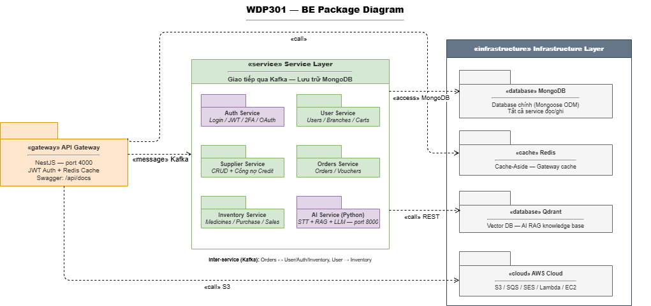

Package Descriptions
No | Package | Description
1 | API Gateway | Built with NestJS (running on port 4000). Serves as the central API Gateway and reverse proxy for all incoming client requests. Handles JWT authentication, rate limiting, Redis API caching, Swagger documentation (/api/docs), and routes requests to backend microservices via Apache Kafka.
2 | Auth Service | Microservice responsible for user authentication workflows. Manages user registration, credential login, JWT token issuance and refresh, password recovery, 2FA, and Google OAuth 2.0 social integration.
3 | User Service | Manages user profiles, staff account directories, store branch metadata, and active customer online shopping carts. Coordinates user-to-branch permission scopes.
4 | Supplier Service | Manages master pharmaceutical supplier profiles, GDP license tracking, contact registries, supplier debt tracking, and credit payment terms.
5 | Orders Service | Processes retail counter POS transactions, online e-commerce checkout orders, promotional discount voucher calculations, wholesale partner invoices, and digital e-invoice generation.
6 | Inventory Service | Core inventory and supply chain microservice. Manages master drug SKUs, FEFO (First-Expired, First-Out) batch tracking, Purchase Orders (PO), Goods Receipt Notes (GRN), inter-branch transfers, and physical stock card audit logs (Thẻ kho).
7 | AI Service (Python) | Dedicated Python microservice built with FastAPI (running on port 8000). Executes AI Gemini 2.5 Flash OCR prescription scanning, Speech-to-Text (STT) voice processing, AI health symptom NLP consultation (RAG + LLM), computer vision box counting, and AI EOQ demand forecasting.
8 | MongoDB Database | Primary persistent NoSQL database accessed via Mongoose ODM. Stores domain application data across all microservices including Users, Medicines, Batches, Orders, POs, and Audit Logs.
9 | Redis Cache | In-memory key-value database operating under the Cache-Aside pattern. Manages API Gateway response caching, atomic FEFO batch reservation locks during checkout, user session storage, and BullMQ background task queues.
10 | Qdrant Vector DB | Specialized Vector Database storing medical knowledge base embeddings to power Retrieval-Augmented Generation (RAG) for the AI symptom chatbot and semantic drug search.
11 | AWS Cloud Infrastructure | Cloud infrastructure layer utilizing AWS S3 for secure prescription photo and image object storage, AWS SES/SQS for asynchronous email queuing, and cloud server hosting.

1.2.3. Mobile App Package Diagram
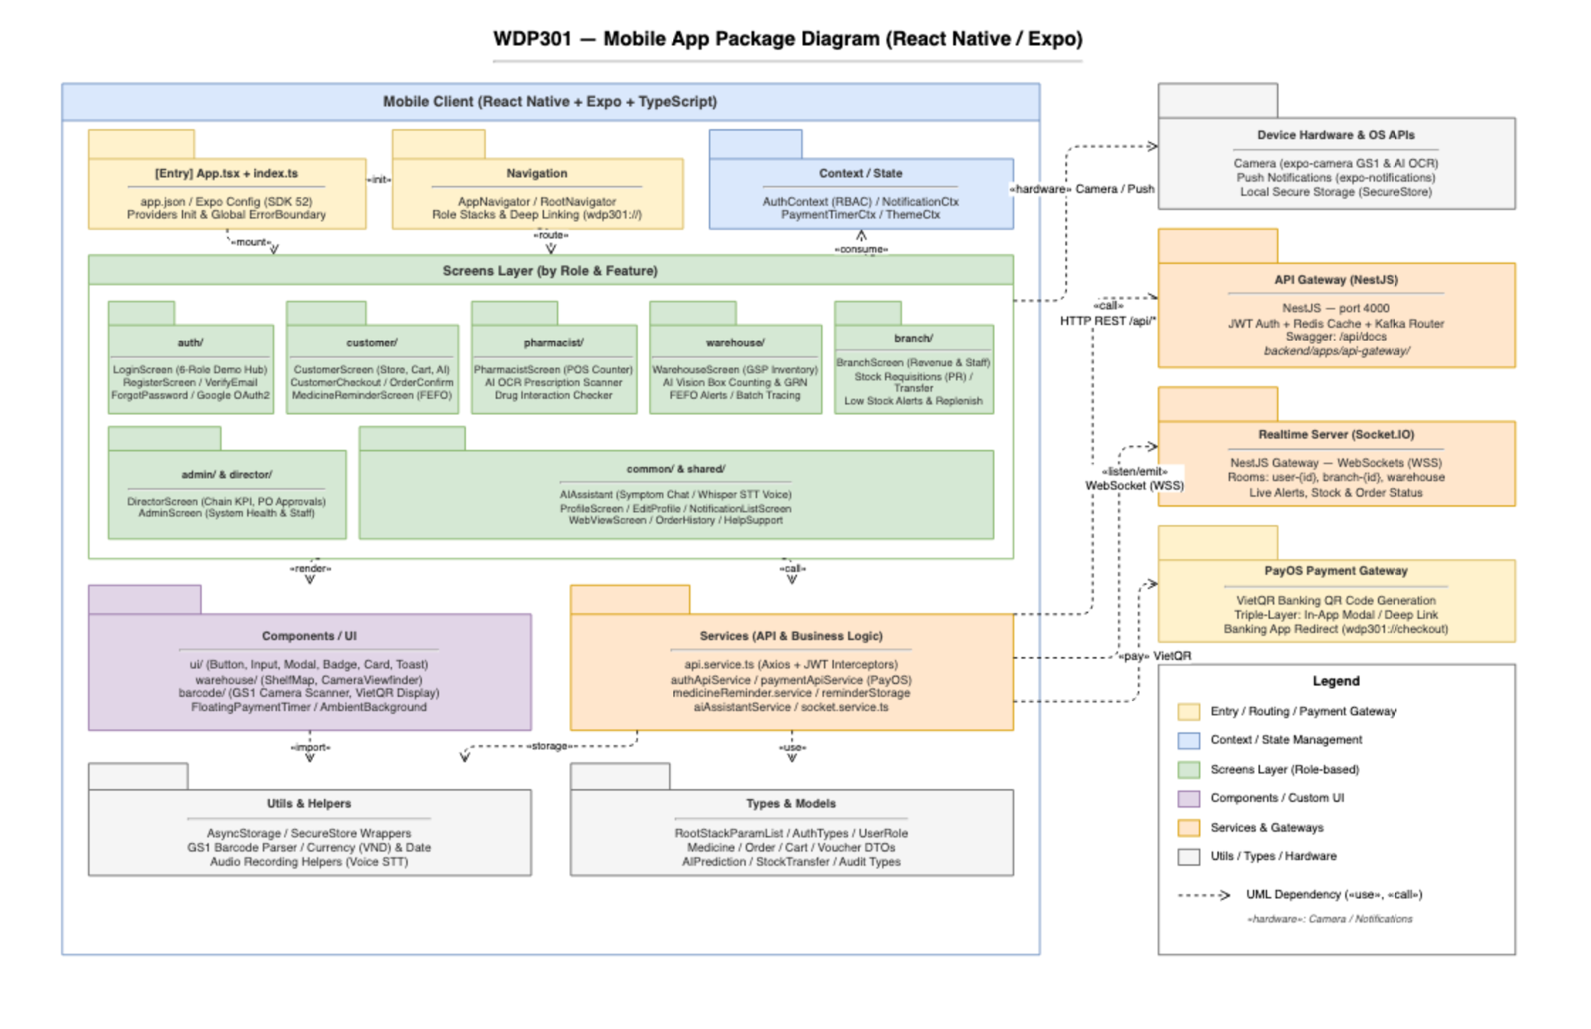

Package Descriptions
No | Package | Description
1 | [Entry] App.tsx + index.ts | Bootstrap entry point of the React Native mobile application. Initializes Expo configuration (app.json), registers root context providers (AuthContext, NotificationContext, ThemeContext), and configures global error boundary handling.
2 | Navigation | Configures client-side routing via React Navigation 6.x (AppNavigator.tsx, RootNavigator.tsx). Manages role-based navigation stacks (Customer, Pharmacist, Warehouse, Branch, Admin, Director), bottom tab navigators, and deep-linking schemes (wdp301://checkout).
3 | Context / State | Encapsulates global reactive application state: AuthContext (manages active user session, JWT tokens, RBAC roles, and 6-role quick login demo switching), NotificationContext (real-time in-app alerts), PaymentTimerContext (VietQR payment countdown), and ThemeContext.
4 | screens/auth/ | Provides authentication and account security screens (LoginScreen, RegisterScreen, ForgotPasswordScreen). Supports credential sign-in, two-step email OTP verification (verifyEmail), and secure in-app Google OAuth 2.0 authentication via WebView.
5 | screens/customer/ | Houses retail customer portal screens (CustomerScreen, CustomerCheckoutScreen, OrderConfirmation, MedicineReminderScreen). Enables searching 2,300+ pharmaceutical SKUs, managing shopping cart, AI symptom chat consultation with 1-click cart addition, VietQR checkout, and FEFO dosage reminders.
6 | screens/pharmacist/ | Delivers counter retail pharmacy capabilities (PharmacistScreen). Features retail POS sales with quick cash calculation, on-device camera AI OCR prescription scanning (POST /api/ai/prescriptions/scan), and drug-drug interaction contraindication checks.
7 | screens/warehouse/ | Manages central GSP warehouse operations (WarehouseScreen). Features GSP inventory lot tracking, AI computer vision package box counting (POST /api/ai/inspect-goods), FEFO expiration alerts (<30 days, <90 days), and end-to-end batch tracing.
8 | screens/branch/ | Supports retail store branch operations (BranchScreen). Enables branch managers to track shift revenue and on-duty staff, inspect store-level low stock alerts, and issue urgent internal stock replenishment requisitions (PR) to central warehouse.
9 | screens/admin/ & screens/director/ | Provides executive management dashboards: DirectorScreen monitors chain financial KPIs, approves/rejects supplier Purchase Orders (PO) and Goods Receipt Notes (GRN); AdminScreen provides real-time microservices health telemetry, employee accounts RBAC, and system audit logs.
10 | screens/common/ & shared/ | Universal shared utility screens: AIAssistant (multi-turn NLP symptom consultation with Groq Whisper voice STT), ProfileScreen, NotificationListScreen, WebViewScreen, OrderHistory, and HelpSupport.
11 | Components / UI | Reusable UI component library structured into: generic atomic components (ui/: Button, Input, Modal, Badge, Card, Toast), warehouse specialized widgets (warehouse/: ShelfMap, CameraViewfinder with laser overlay), and barcode scanner overlays (barcode/: GS1 Scanner, VietQR Display).
12 | Services (API & Business Logic) | Centralizes outbound network services connecting to backend microservices: api.service.ts (Axios HTTP client with Bearer JWT interceptors), authApiService, paymentApiService (PayOS VietQR generation), medicineReminder.service, and socket.service.ts.
13 | Utils & Helpers | Provides shared helper functions: AsyncStorage and SecureStore encrypted storage wrappers, GS1-128 / GS1 DataMatrix barcode parsing algorithms, VND currency formatters, date/time formatters, and audio recording streaming helpers for Groq Whisper voice STT.
14 | Types & Models | Houses strong TypeScript type definitions and Data Transfer Objects (DTOs): RootStackParamList, AuthTypes, UserRole, MedicineDTO, OrderDTO, CartDTO, VoucherDTO, GoodsReceiptDTO, StockTransferDTO, and AuditLogDTO.
15 | Device Hardware & OS APIs | Bridges React Native JavaScript thread with native hardware capabilities via Expo APIs: expo-camera for real-time barcode scanning and AI OCR photo capture, expo-notifications for background push notifications, and expo-secure-store / Biometrics for encrypted credential storage.
16 | Backend Gateways & External Integrations | Direct external communication targets: API Gateway (NestJS :4000) via HTTP REST (/api/*), Realtime Server (Socket.IO) for WebSocket live room broadcasting, and PayOS Payment Gateway for dynamic VietQR banking checkout and deep-link payment reconciliation.

1.2.4. AI Service Package Diagram
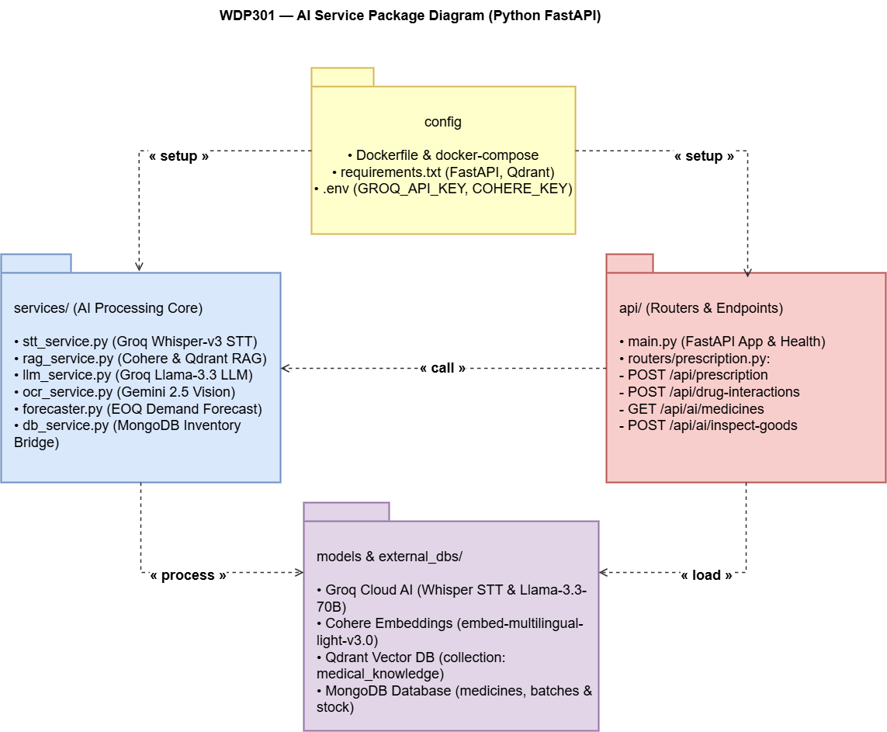

Package Descriptions
No | Package | Description
1 | config (Configuration & Containerization) | Manages application initialization, containerization, and environment variables. Contains Dockerfile & docker-compose setup, Python dependencies manifest (requirements.txt specifying FastAPI, Qdrant-client, Cohere, Groq), and .env secrets loading (GROQ_API_KEY, COHERE_KEY, database URIs).
2 | api/ (Routers & Endpoints) | Defines the FastAPI HTTP routing and request validation layer:  • main.py: Initializes the FastAPI application instance, CORS middleware, and health check endpoints.  • routers/prescription.py: Exposes core REST API endpoints:  - POST /api/prescription: Receives prescription photos for AI Gemini 2.5 OCR extraction.  - POST /api/drug-interactions: Evaluates active ingredient pairs for contraindication warnings.  - GET /api/ai/medicines: Executes semantic symptom queries via RAG vector search.  - POST /api/ai/inspect-goods: Processes warehouse package photos for computer vision box counting.
3 | services/ (AI Processing Core) | Houses the core artificial intelligence execution modules:  • stt_service.py: Uses Groq Whisper-v3 for high-speed voice Speech-to-Text transcription.  • rag_service.py: Manages Cohere multilingual embeddings and Qdrant RAG vector retrievals.  • llm_service.py: Integrates Groq Llama-3.3-70B LLM for natural language medical consultations.  • ocr_service.py: Uses Google Gemini 2.5 Vision to parse prescription layouts & extract active ingredients.  • forecaster.py: Runs predictive algorithms calculating Economic Order Quantity (EOQ) replenishment.  • db_service.py: Bridge connector executing read/write queries to the MongoDB inventory database.
4 | models & external_dbs/ (AI Models & Data Layer) | Integrates external AI inference APIs, vector databases, and primary data stores:  • Groq Cloud AI: Ultra-fast cloud inference for Whisper STT and Llama-3.3-70B LLM models.  • Cohere Embeddings: Generates vector embeddings (embed-multilingual-light-v3.0) for Vietnamese medical terms.  • Qdrant Vector DB: Vector store housing the medical_knowledge collection for RAG searches.  • MongoDB Database: Direct database connection to master medicines, batches, and stock collections.

2. Database Design

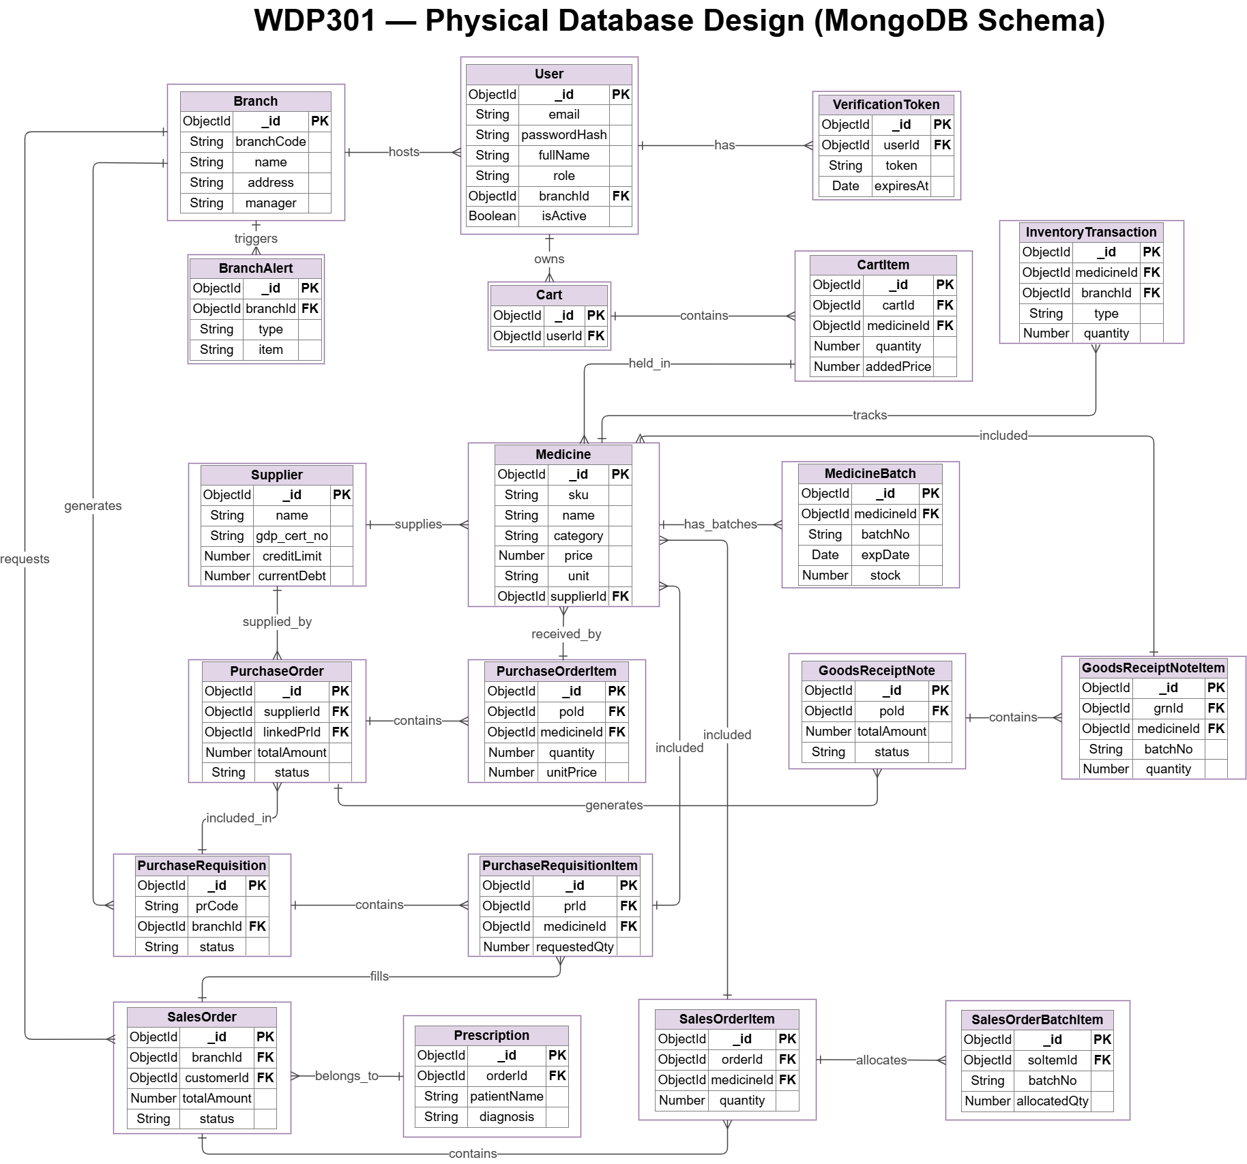
Table Descriptions
No | Table | Description
1 | User | Stores system user account details, login credentials, hashed passwords, full names, assigned RBAC roles (Admin, Branch Manager, Inventory Manager, Pharmacist, Customer), and account activation status.  • Primary key: _id  • Foreign key: branchId (references Branch._id)
2 | VerificationToken | Manages time-limited security verification tokens and 6-digit OTP codes used for user registration, password reset flows, and account activation.  • Primary key: _id  • Foreign key: userId (references User._id)
3 | Branch | Stores store branch location information, unique branch codes, store names, physical addresses, and assigned branch manager IDs.  • Primary key: _id  • Foreign key: None
4 | BranchAlert | Logs automated system warnings triggered by store branches, such as low stock safety thresholds, critical medicine deficits, or cold storage temperature alerts.  • Primary key: _id  • Foreign key: branchId (references Branch._id)
5 | Cart | Represents an active online shopping cart owned by a customer user to compile items prior to online checkout.  • Primary key: _id  • Foreign key: userId (references User._id)
6 | CartItem | Stores individual medicine SKU line items, selected packaging units, quantities, and price snapshots inside a customer's active cart.  • Primary key: _id  • Foreign keys: cartId (references Cart._id), medicineId (references Medicine._id)
7 | Medicine | Master drug catalog storing SKU codes, brand names, therapeutic categories, base retail prices, packaging units, and default supplier associations.  • Primary key: _id  • Foreign key: supplierId (references Supplier._id)
8 | MedicineBatch | Tracks physical lots/batches of a medicine SKU, storing Batch Numbers (batchNo), Expiry Dates (expDate), manufacturing dates, and available stock quantities for FEFO enforcement.  • Primary key: _id  • Foreign key: medicineId (references Medicine._id)
9 | InventoryTransaction | Audit transaction ledger logging all physical stock movements (GRN receipts, counter sales, branch transfers, stock adjustments) across store branches.  • Primary key: _id  • Foreign keys: medicineId (references Medicine._id), branchId (references Branch._id)
10 | Supplier | Stores pharmaceutical supplier profiles, company names, GDP license certificate numbers (gdp_cert_no), credit limits, and current debt liabilities.  • Primary key: _id  • Foreign key: None
11 | PurchaseRequisition | Stores internal stock replenishment requests (PR) generated by branch managers to request stock from the central warehouse.  • Primary key: _id  • Foreign key: branchId (references Branch._id)
12 | PurchaseRequisitionItem | Line item entity detailing the requested medicine SKU and quantity within a Purchase Requisition.  • Primary key: _id  • Foreign keys: prId (references PurchaseRequisition._id), medicineId (references Medicine._id)
13 | PurchaseOrder | Official procurement order (PO) issued to an external supplier after HQ Admin approval of branch requisitions, tracking total order amount and status.  • Primary key: _id  • Foreign keys: supplierId (references Supplier._id), linkedPrId (references PurchaseRequisition._id)
14 | PurchaseOrderItem | Line item entity in a PO detailing requested medicine SKU, unit purchase price, and ordered box quantity.  • Primary key: _id  • Foreign keys: poId (references PurchaseOrder._id), medicineId (references Medicine._id)
15 | GoodsReceiptNote | Inbound receiving document (GRN) generated at central warehouse when physical goods delivered by a supplier arrive based on an approved PO.  • Primary key: _id  • Foreign key: poId (references PurchaseOrder._id)
16 | GoodsReceiptNoteItem | Detail entity of the GRN capturing actual inspected received quantities, assigned batch numbers (batchNo), and expiry dates.  • Primary key: _id  • Foreign keys: grnId (references GoodsReceiptNote._id), medicineId (references Medicine._id)
17 | Prescription | Stores electronic or scanned doctor prescription details (patient name, medical diagnosis, doctor signatures) required to authorize sales of prescription-only (Rx) drugs.  • Primary key: _id  • Foreign key: orderId (references SalesOrder._id)
18 | SalesOrder | Stores completed sales transaction records from retail POS counter checkouts or online customer orders, tracking total amount and fulfillment status.  • Primary key: _id  • Foreign keys: branchId (references Branch._id), customerId (references User._id)
19 | SalesOrderItem | Line item entity under a Sales Order specifying sold medicine SKU, unit selling price, and purchased quantity.  • Primary key: _id  • Foreign keys: orderId (references SalesOrder._id), medicineId (references Medicine._id)
20 | SalesOrderBatchItem | Bridge entity linking a sales order item directly to specific physical FEFO medicine batches (batchNo) for inventory stock deduction.  • Primary key: _id  • Foreign key: soItemId (references SalesOrderItem._id)

3. Detailed Design

3.1 Authentication & Account Management

3.1.1 Class Diagram for Register Account (UC-01)
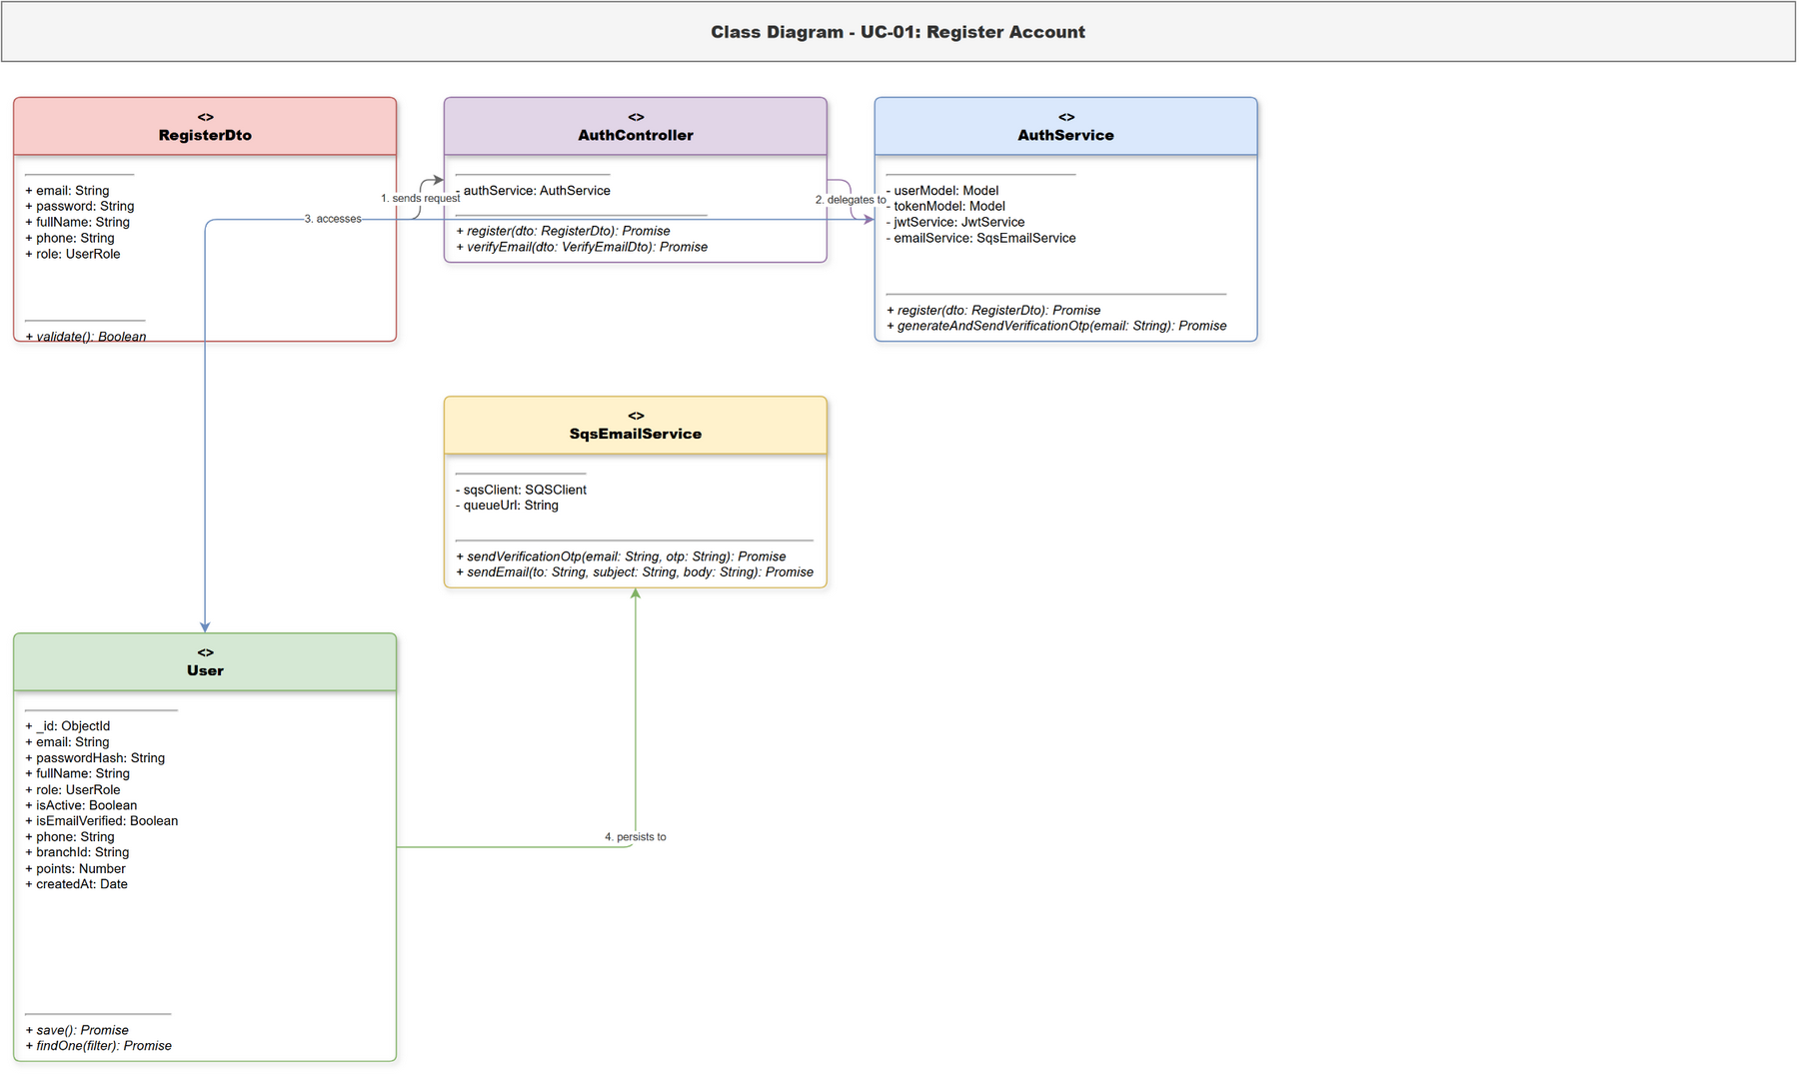
Figure 1. Class diagram for Register Account

3.1.2 Sequence Diagram for Register Account (UC-01)
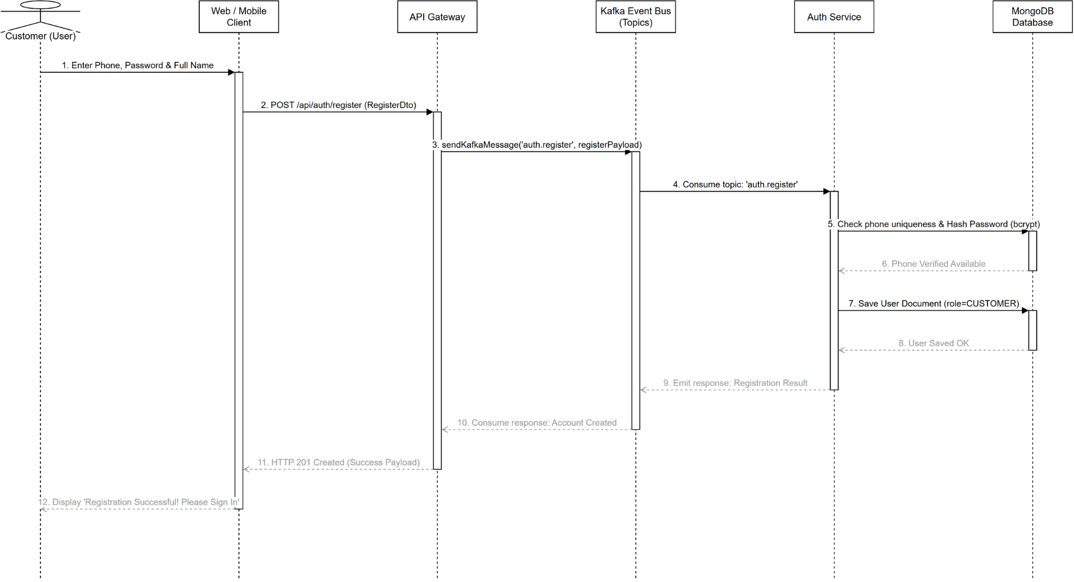
Figure 2. Sequence diagram for Register Account

3.1.3 Class Diagram for Sign In (UC-02)
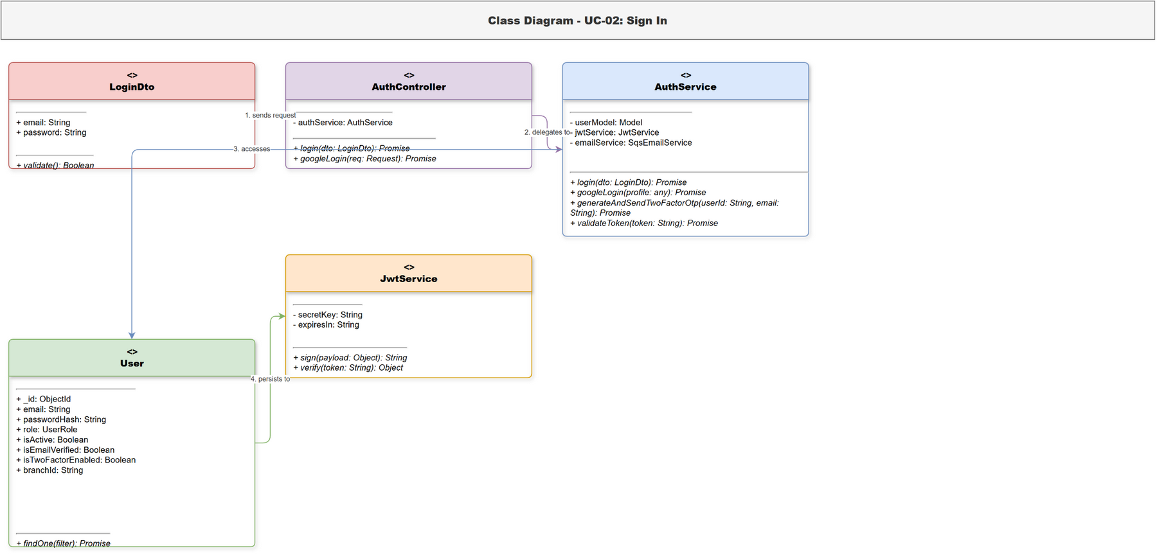
Figure 3. Class diagram for Sign In

3.1.4 Sequence Diagram for Sign In (UC-02)
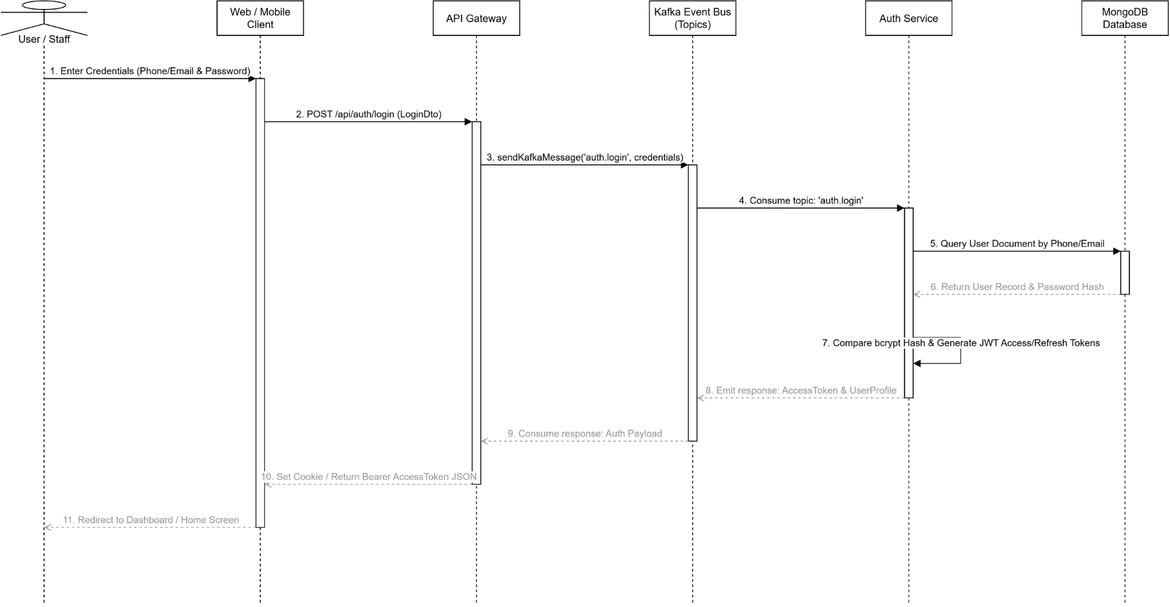
Figure 4. Sequence diagram for Sign In

3.1.5 Class Diagram for Verify Email (UC-03)
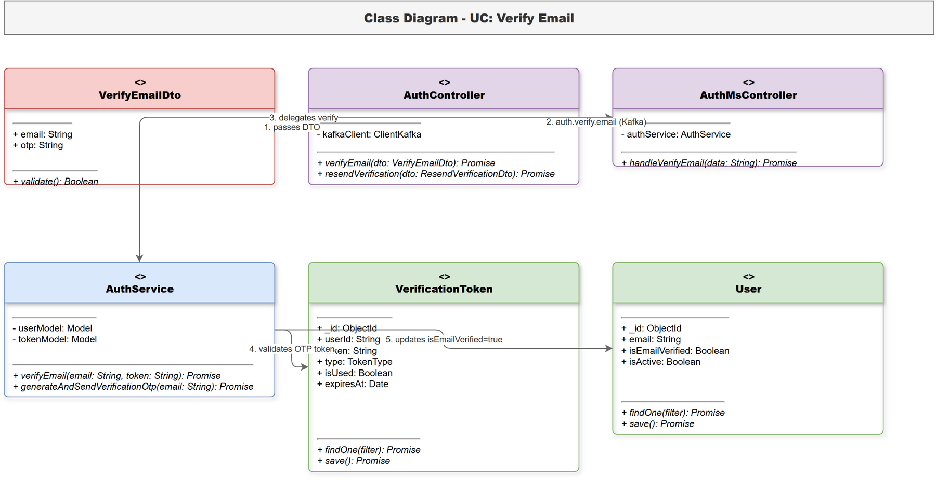
Figure 5. Class diagram for Verify Email

3.1.6 Sequence Diagram for Verify Email (UC-03)
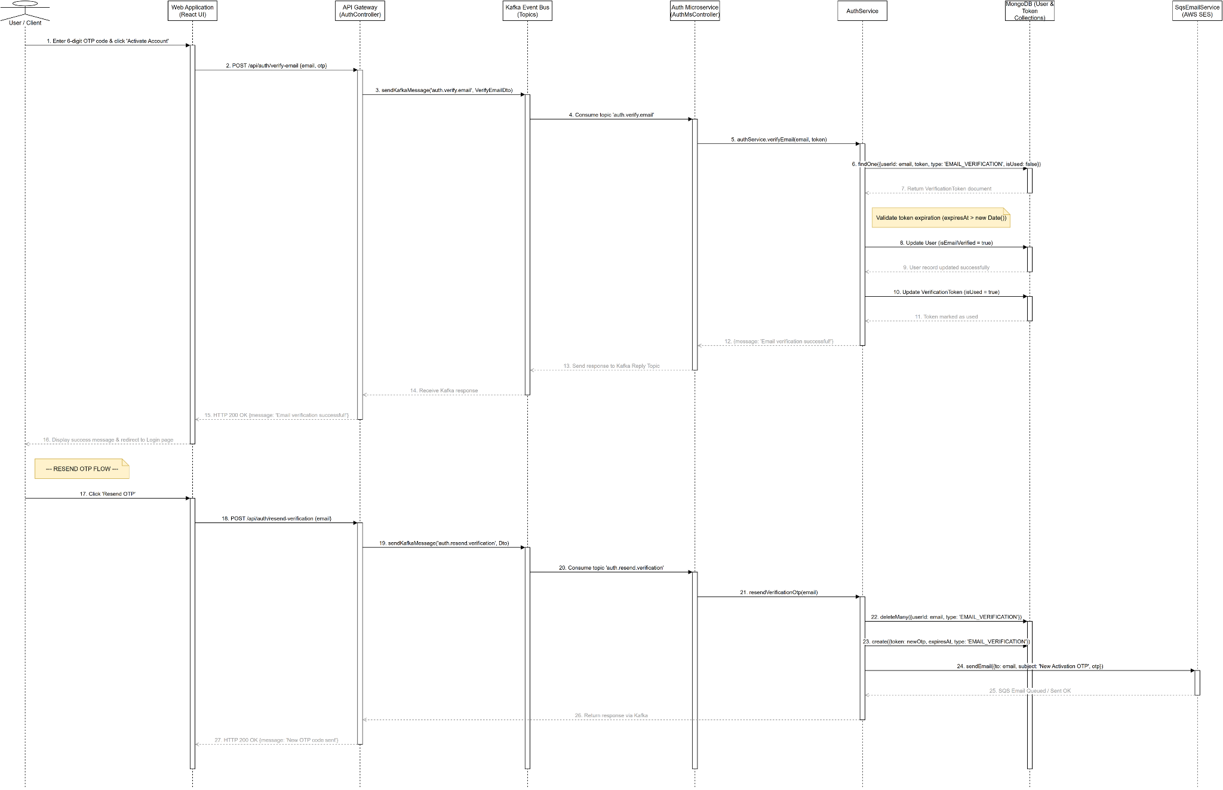
Figure 6. Sequence diagram for Verify Email

3.1.7 Class Diagram for Sign In with Google (UC-04)
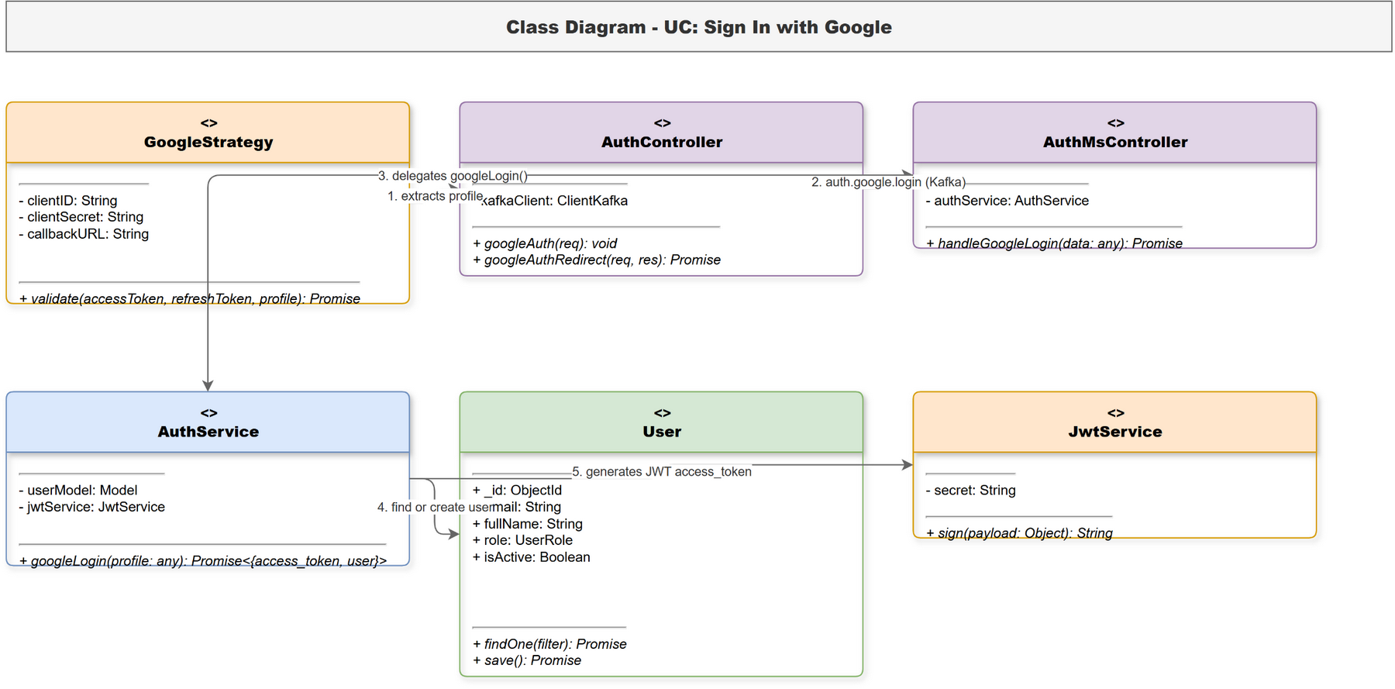
Figure 7. Class diagram for Sign In with Google

3.1.8 Sequence Diagram for Sign In with Google (UC-04)
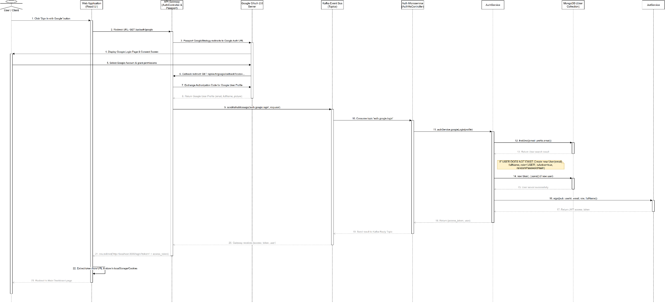
Figure 8. Sequence diagram for Sign In with Google

3.1.9 Class Diagram for Recover Password (UC-05)
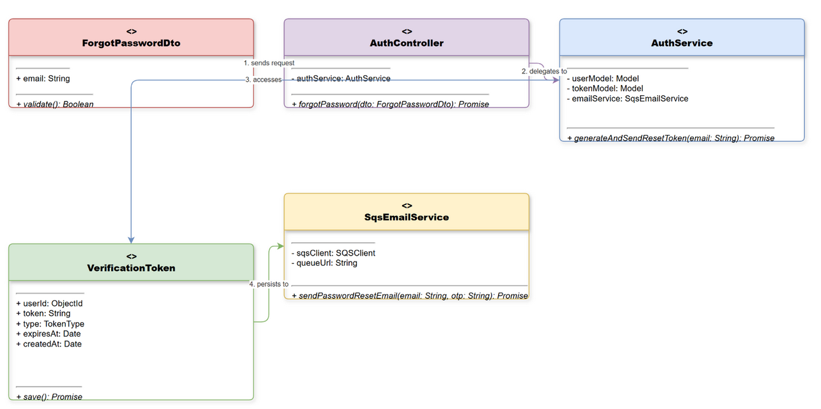
Figure 9. Class diagram for Recover Password

3.1.10 Sequence Diagram for Recover Password (UC-05)
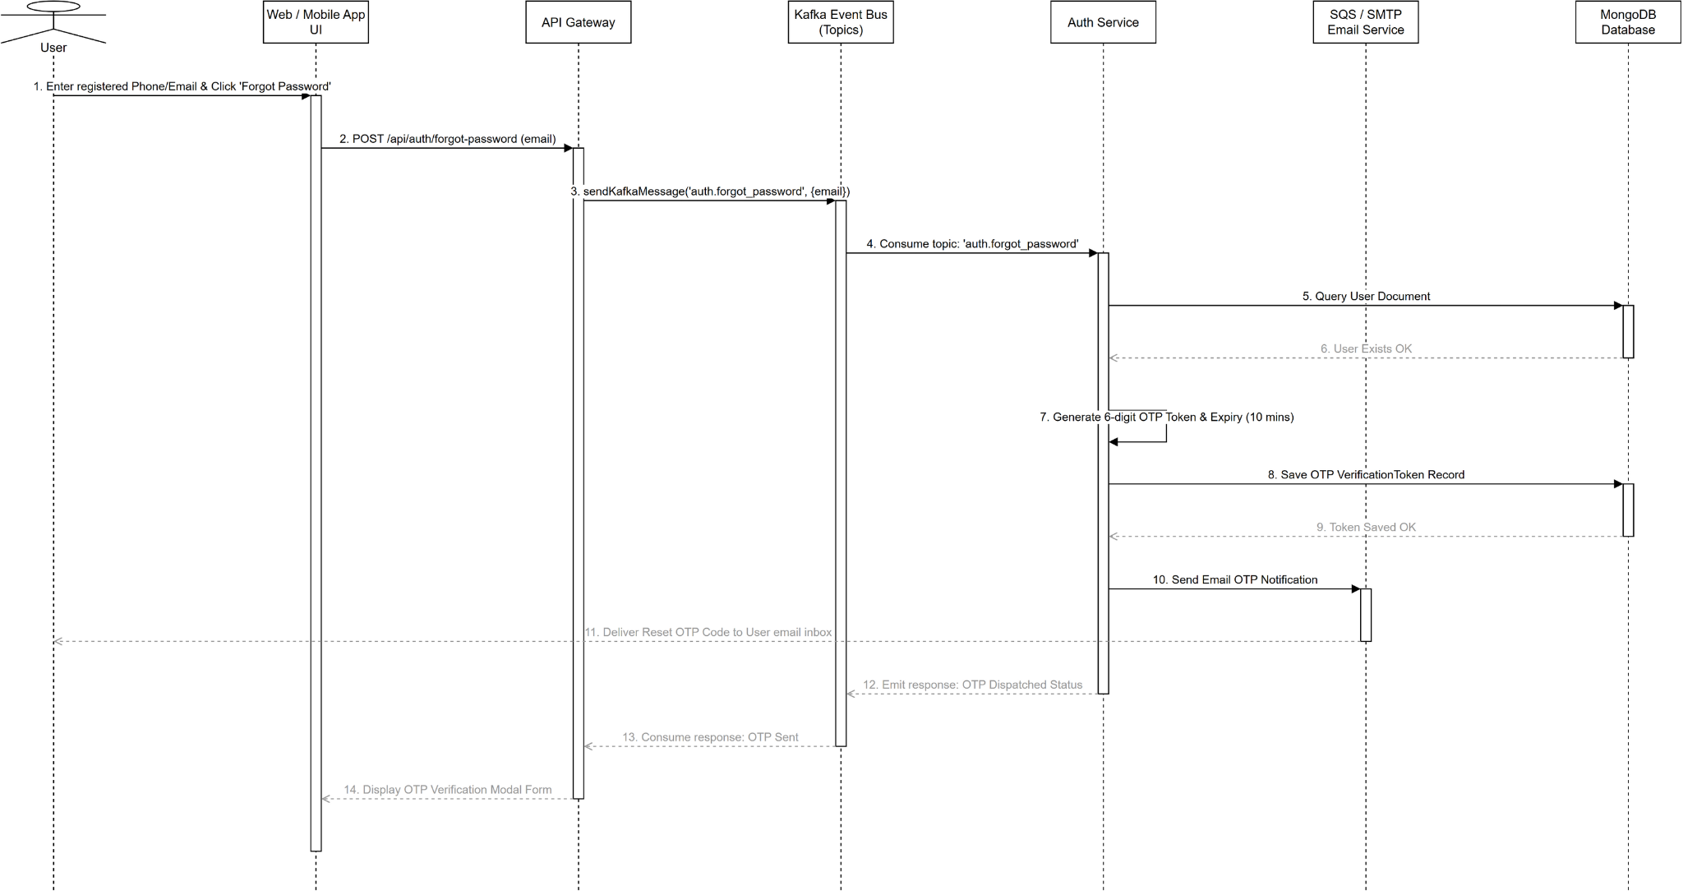
Figure 10. Sequence diagram for Recover Password

3.1.11 Class Diagram for Reset Password (UC-06)
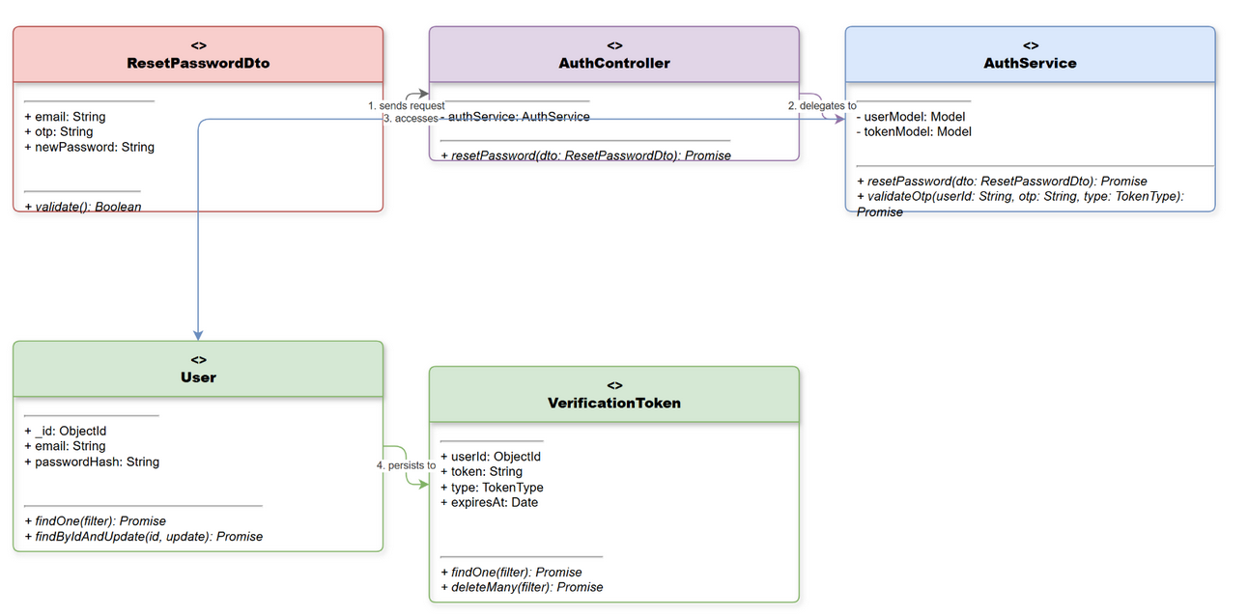
Figure 11. Class diagram for Reset Password

3.1.12 Sequence Diagram for Reset Password (UC-06)
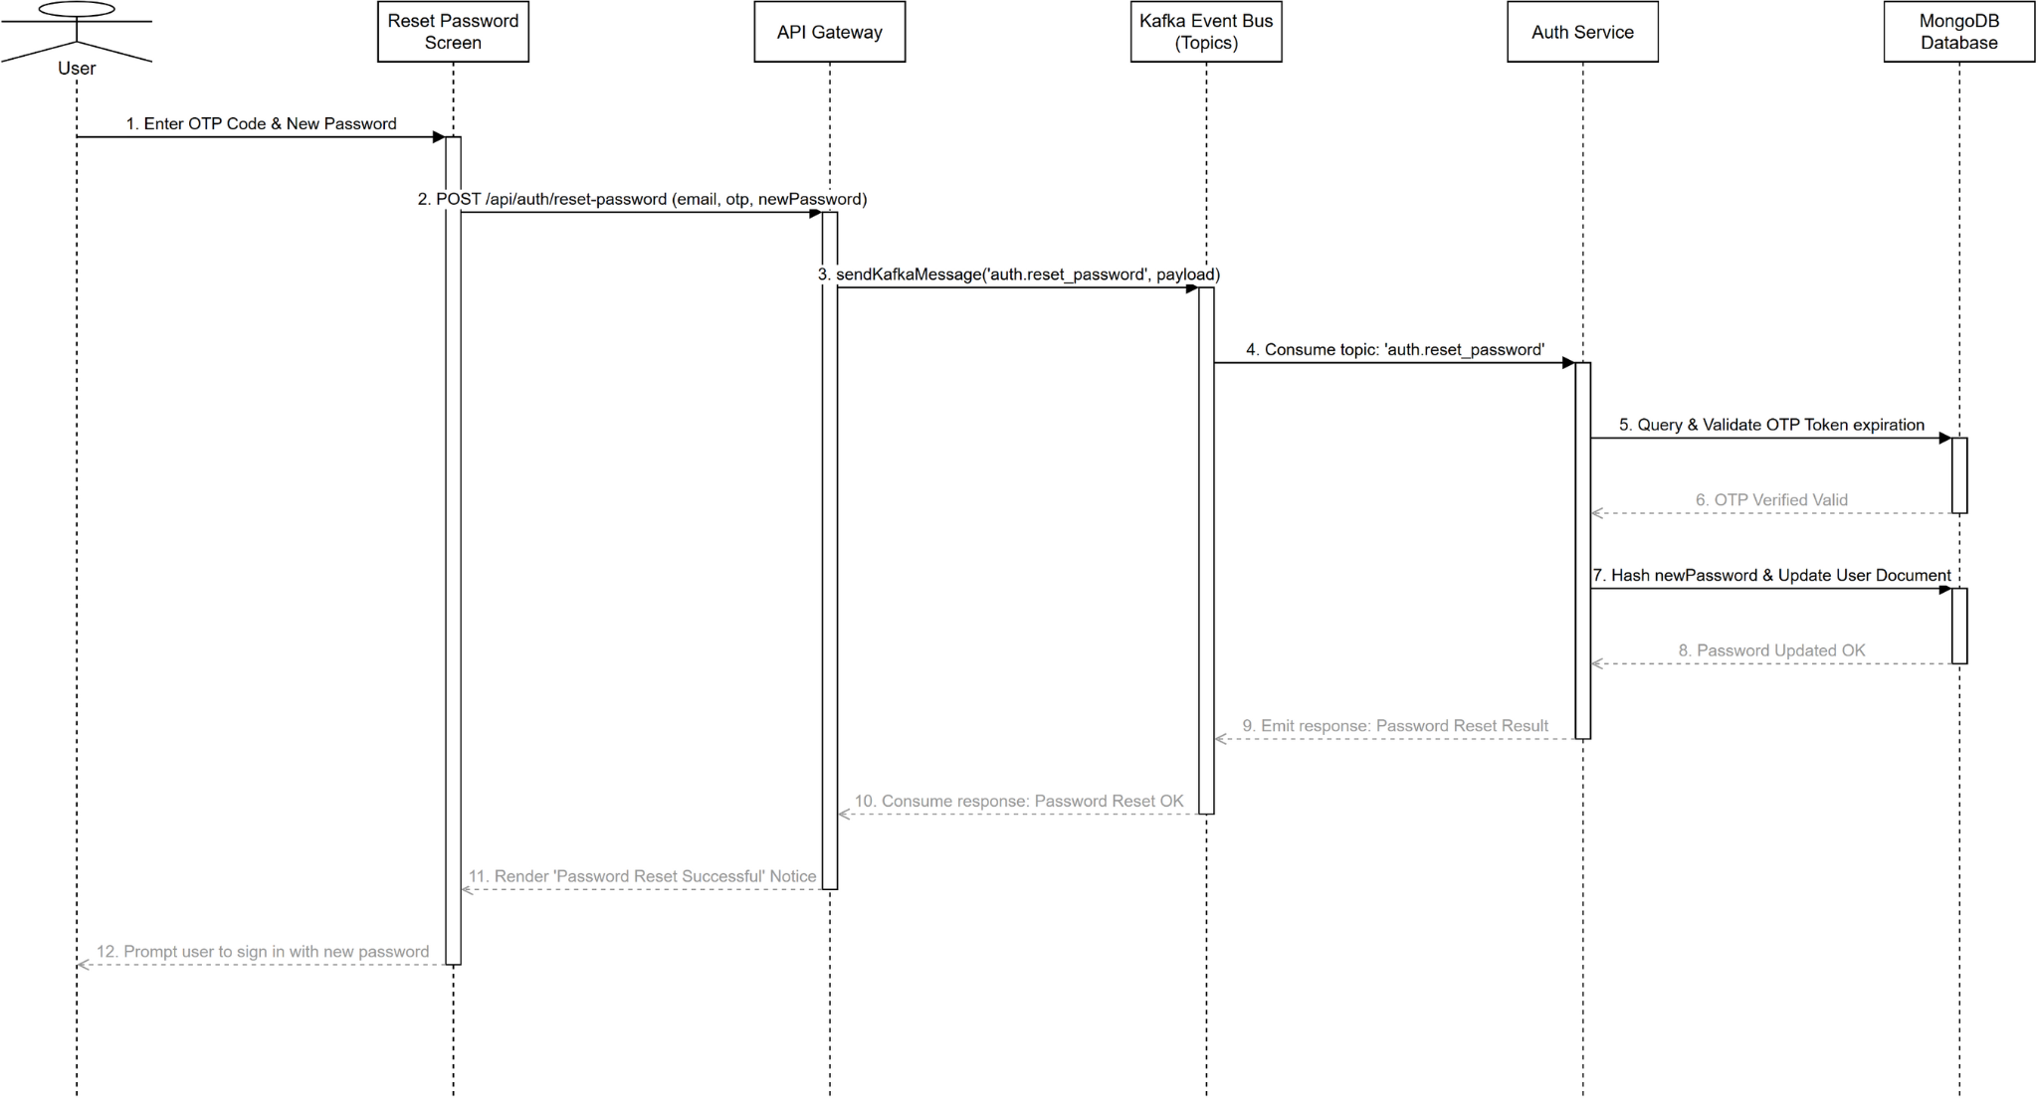
Figure 12. Sequence diagram for Reset Password

3.1.13 Class Diagram for Sign Out (UC-07)
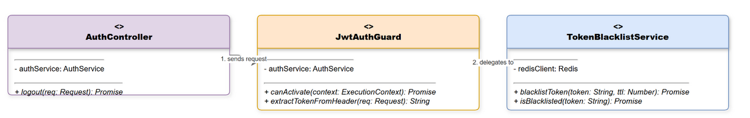
Figure 13. Class diagram for Sign Out

3.1.14 Sequence Diagram for Sign Out (UC-07)
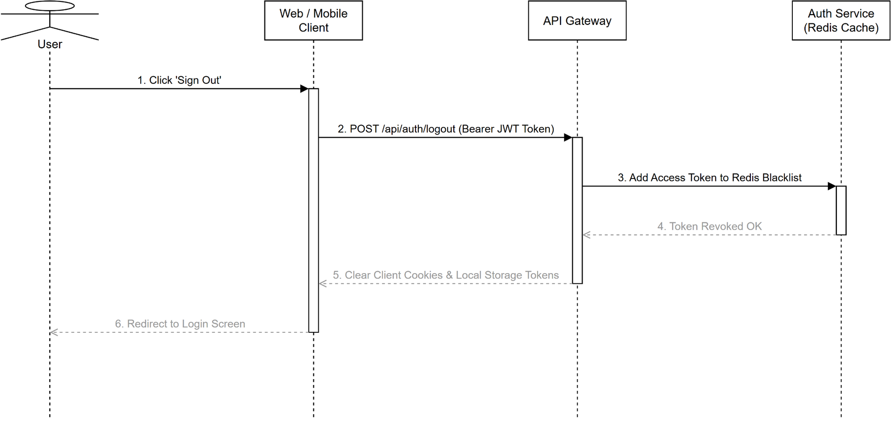
Figure 14. Sequence diagram for Sign Out

3.2 Customer Online Portal

3.2.1 Class Diagram for Search Medicines Online (UC-08)
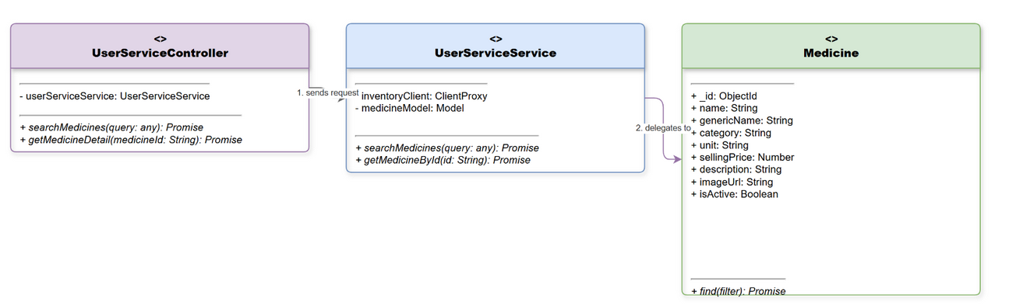
Figure 15. Class diagram for Search Medicines Online

3.2.2 Sequence Diagram for Search Medicines Online (UC-08)
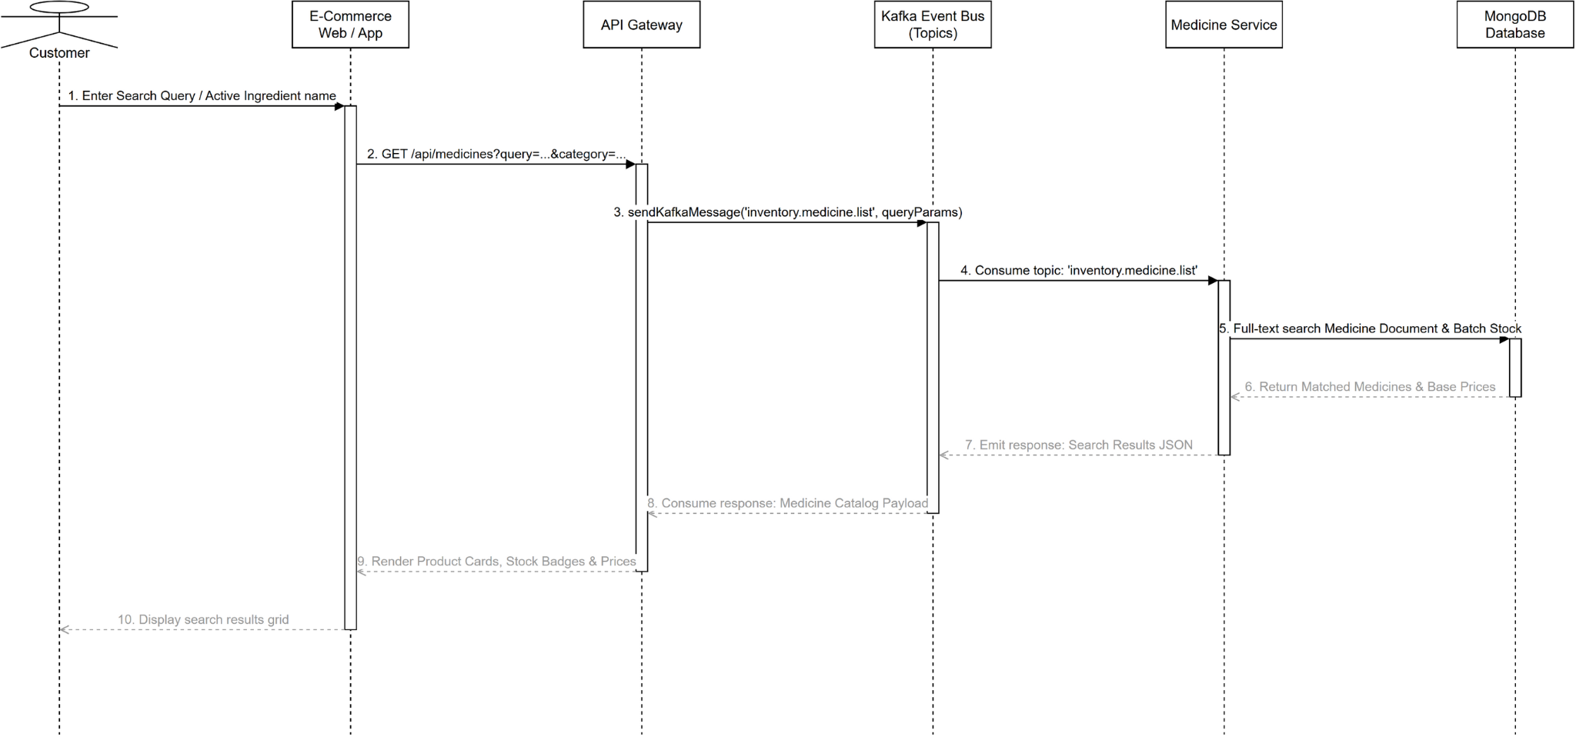
Figure 16. Sequence diagram for Search Medicines Online

3.2.3 Class Diagram for Add to Cart (UC-09)
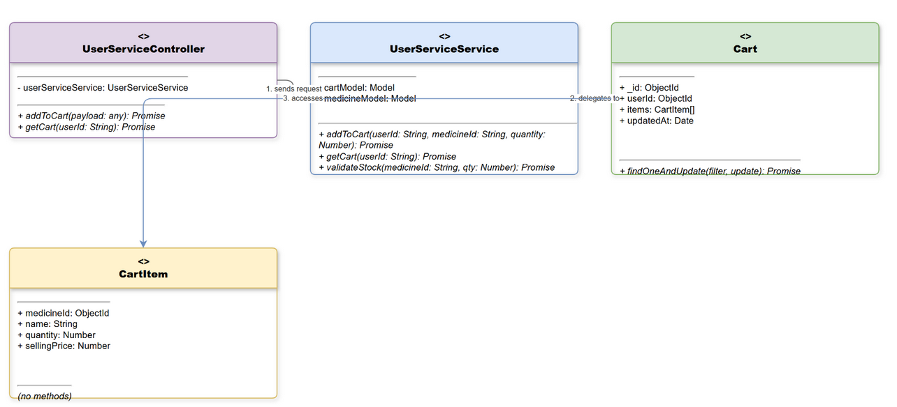
Figure 17. Class diagram for Add to Cart

3.2.4 Sequence Diagram for Add to Cart (UC-09)
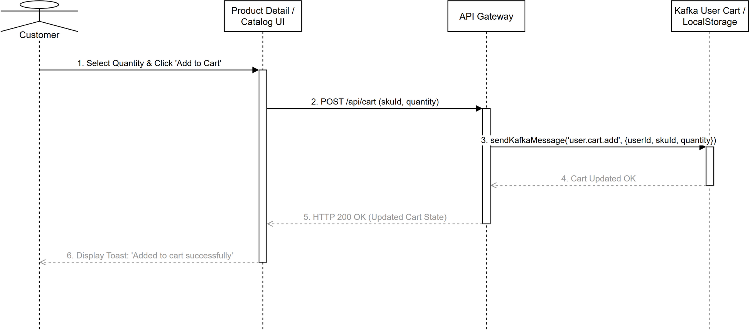
Figure 18. Sequence diagram for Add to Cart

3.2.5 Class Diagram for Manage Personal Cart (UC-10)
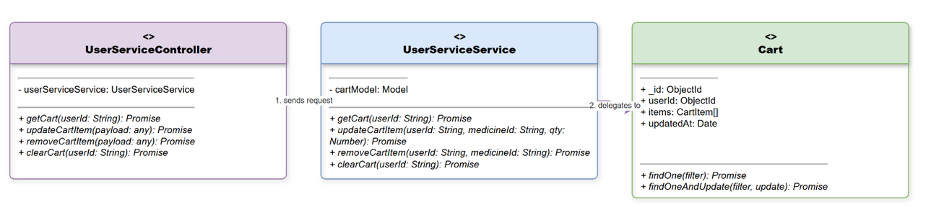
Figure 19. Class diagram for Manage Personal Cart

3.2.6 Sequence Diagram for Manage Personal Cart (UC-10)
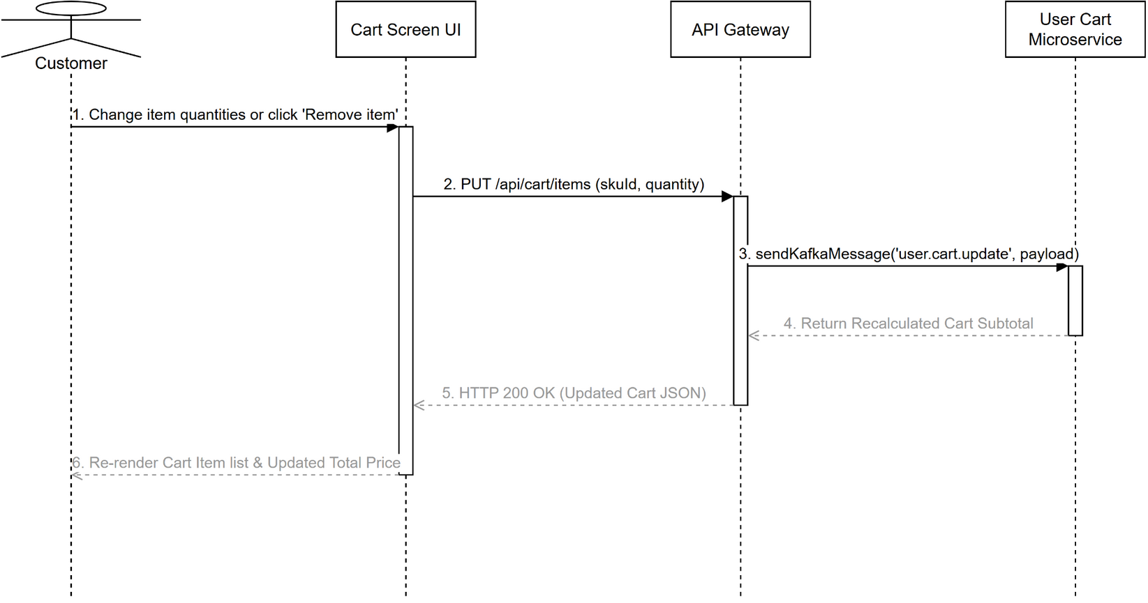
Figure 20. Sequence diagram for Manage Personal Cart

3.2.7 Class Diagram for Confirm Online Order (UC-11)
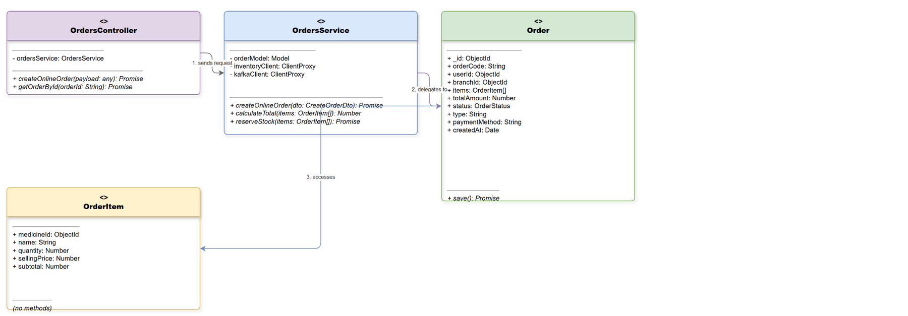
Figure 21. Class diagram for Confirm Online Order

3.2.8 Sequence Diagram for Confirm Online Order (UC-11)
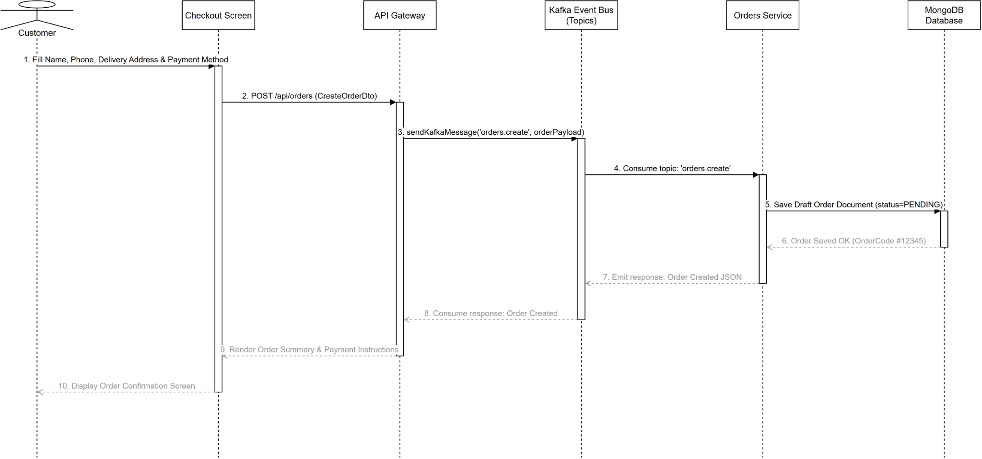
Figure 22. Sequence diagram for Confirm Online Order

3.2.9 Class Diagram for Pay Online Order (UC-12)
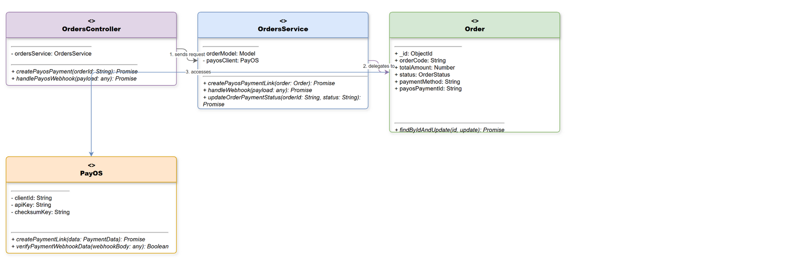
Figure 23. Class diagram for Pay Online Order

3.2.10 Sequence Diagram for Pay Online Order (UC-12)
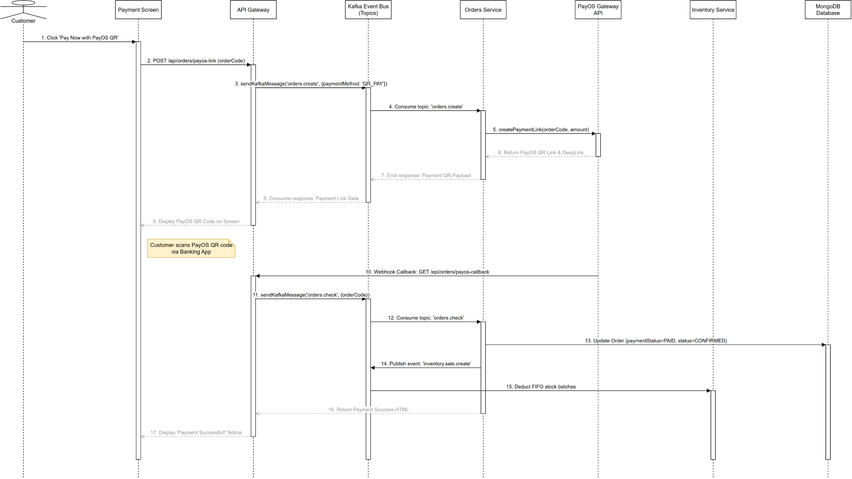
Figure 24. Sequence diagram for Pay Online Order

3.2.11 Class Diagram for View Order History (UC-13)
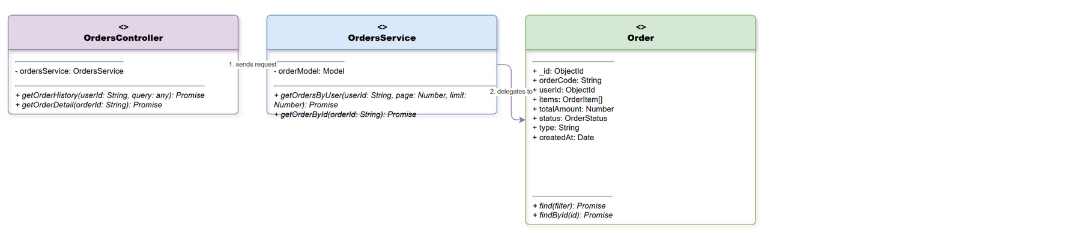
Figure 25. Class diagram for View Order History

3.2.12 Sequence Diagram for View Order History (UC-13)
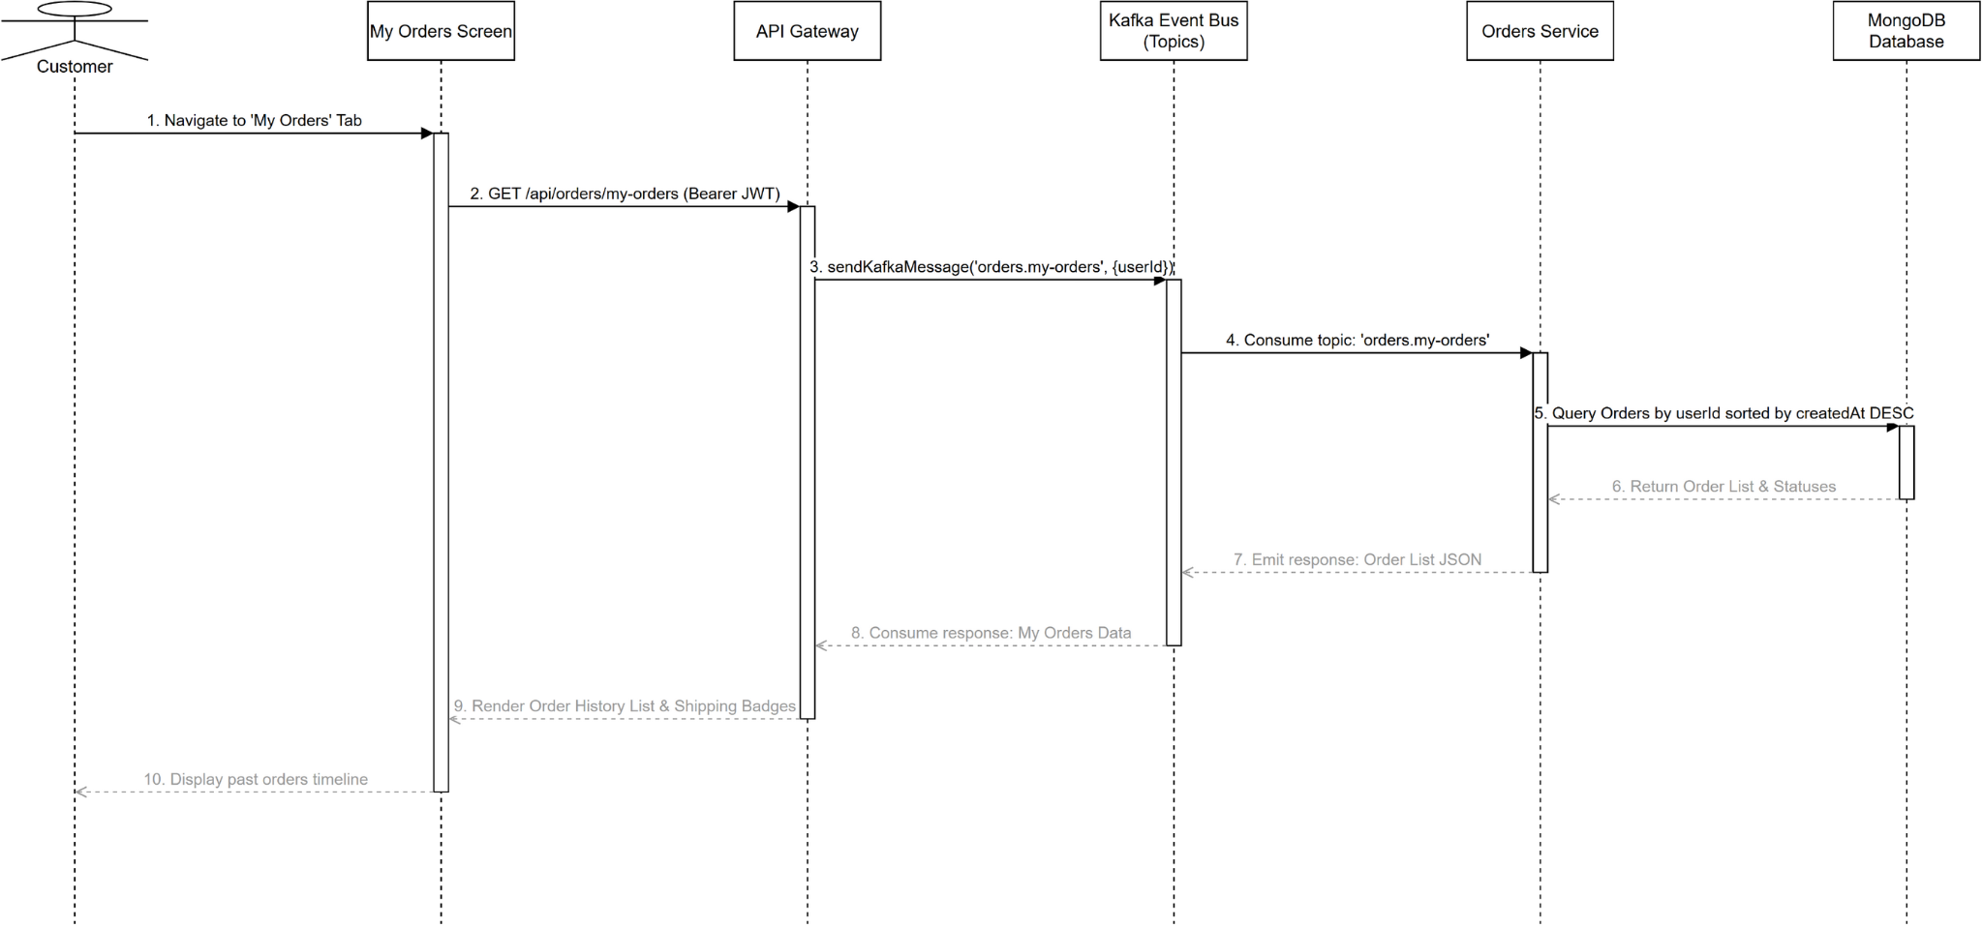
Figure 26. Sequence diagram for View Order History

3.2.13 Class Diagram for View Customer Profile (UC-14)
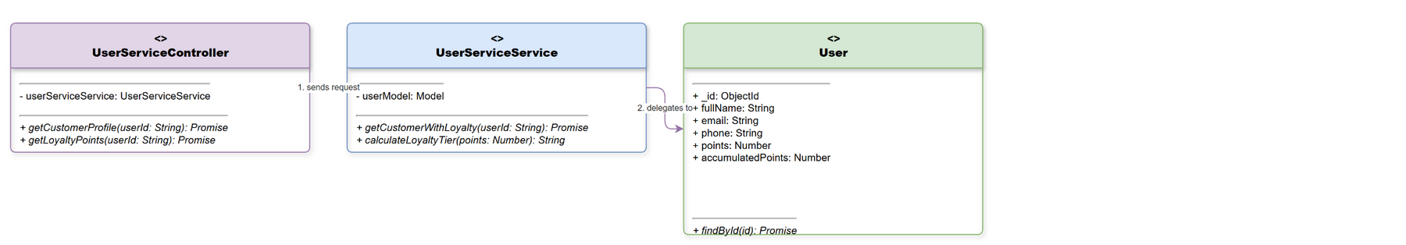
Figure 27. Class diagram for View Customer Profile

3.2.14 Sequence Diagram for View Customer Profile (UC-14)
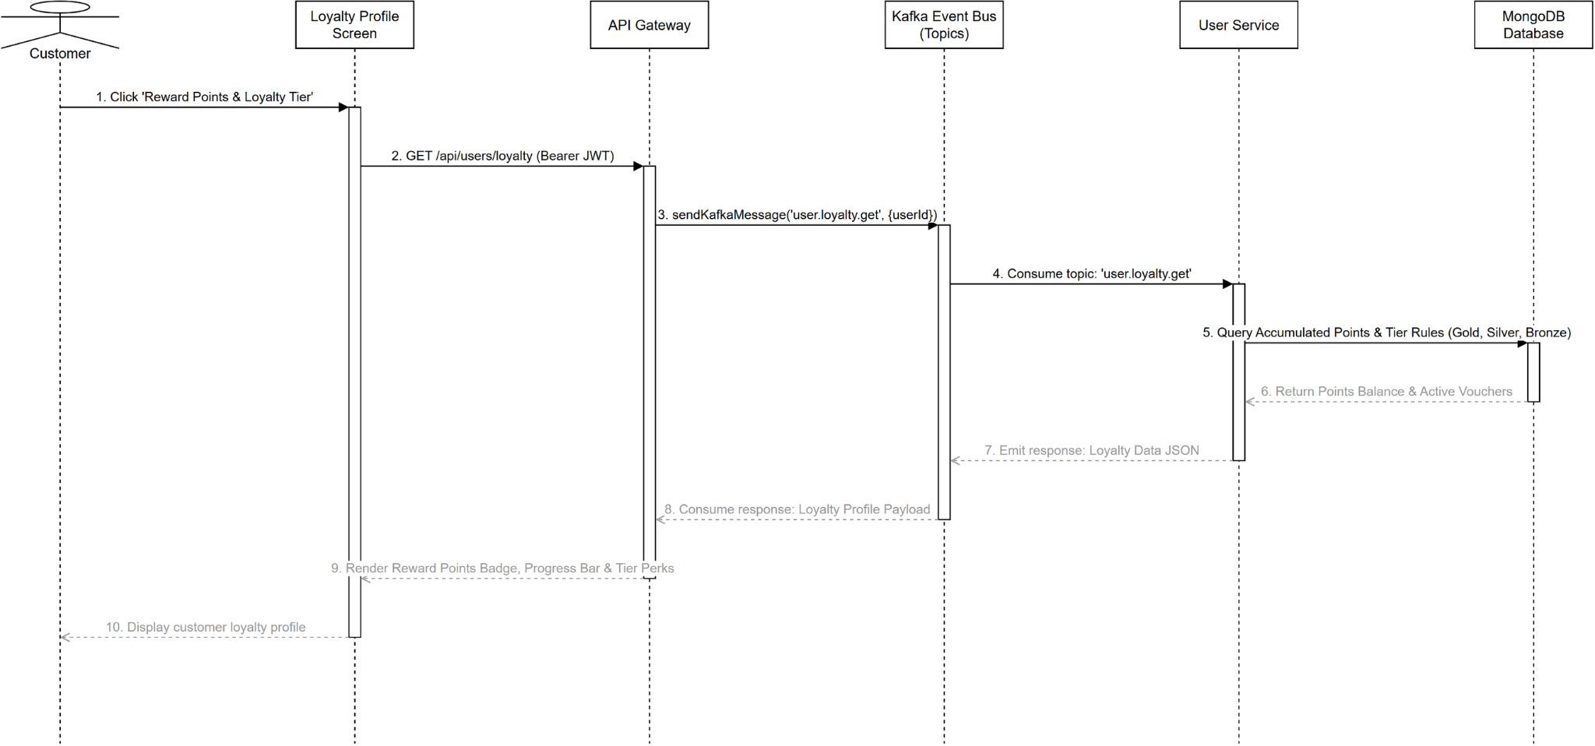
Figure 28. Sequence diagram for View Customer Profile

3.2.15 Class Diagram for Consult AI via Text (UC-15)
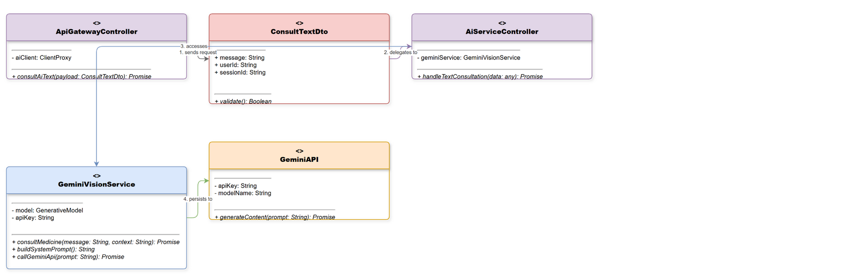
Figure 29. Class diagram for Consult AI via Text

3.2.16 Sequence Diagram for Consult AI via Text (UC-15)
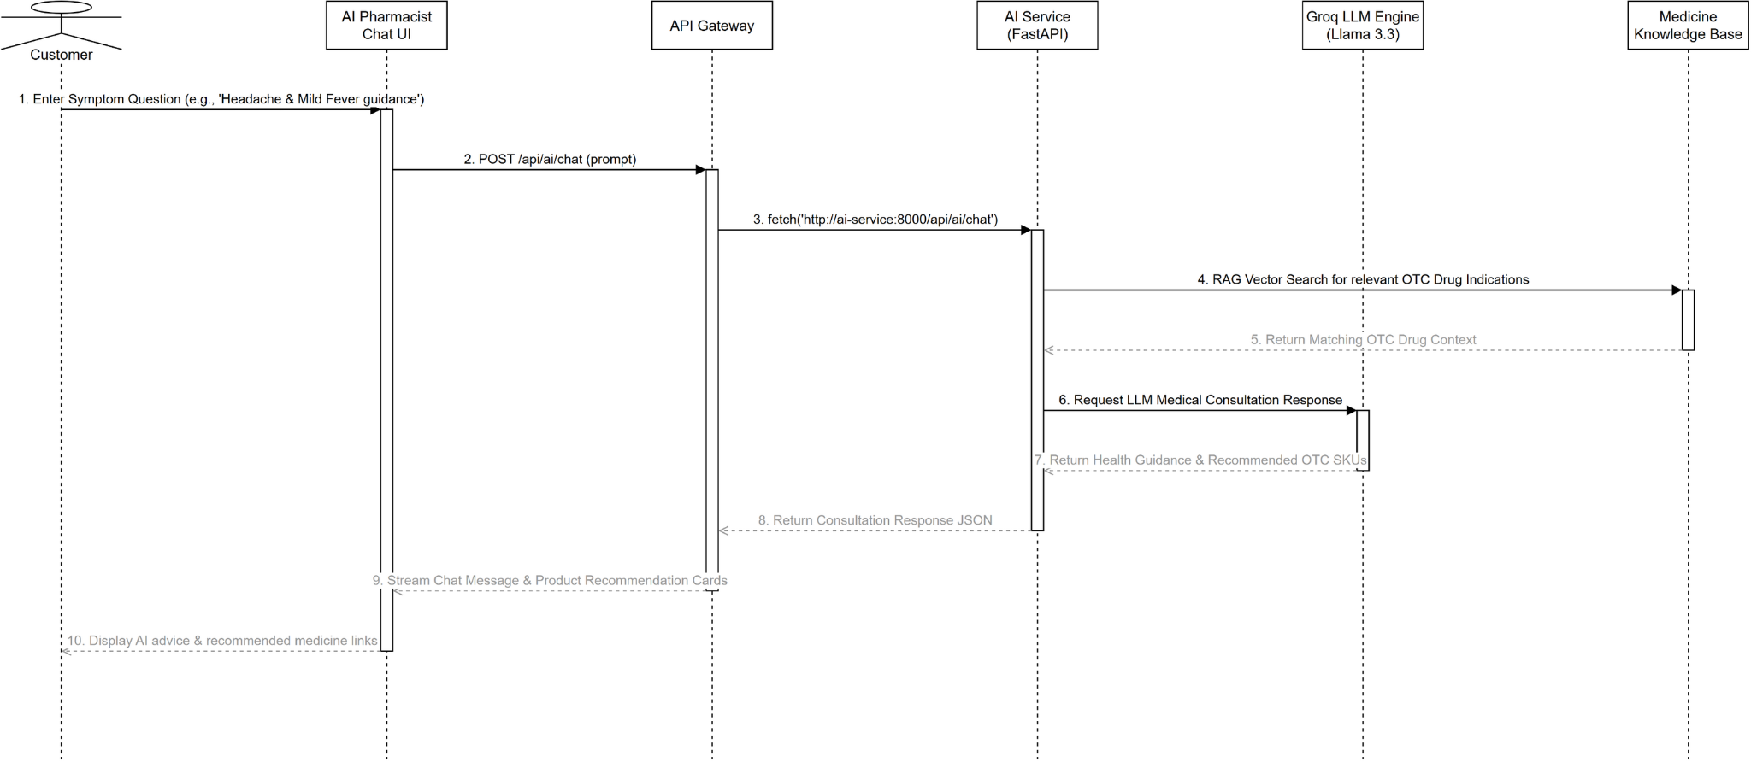
Figure 30. Sequence diagram for Consult AI via Text

3.2.17 Class Diagram for Consult AI via Voice (UC-16)
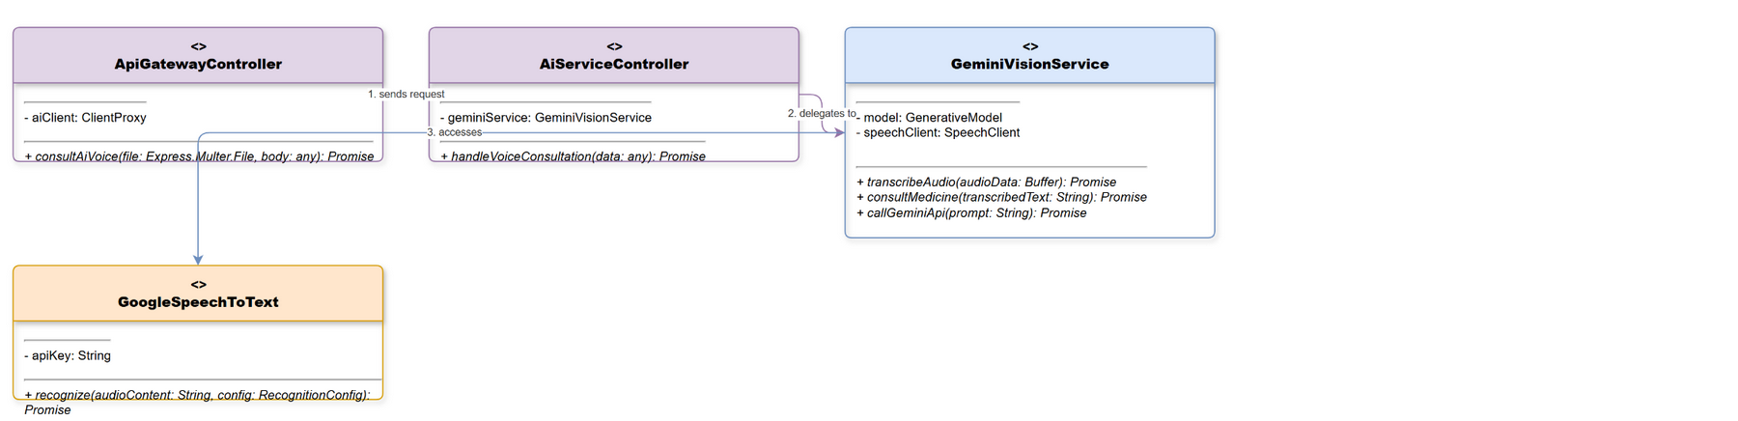
Figure 31. Class diagram for Consult AI via Voice

3.2.18 Sequence Diagram for Consult AI via Voice (UC-16)
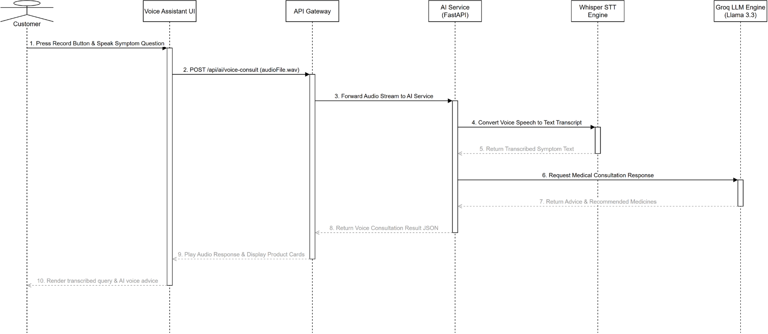
Figure 32. Sequence diagram for Consult AI via Voice

3.3 Pharmacist POS Counter Terminal

3.3.1 Class Diagram for Search Retail Medicines (UC-17)
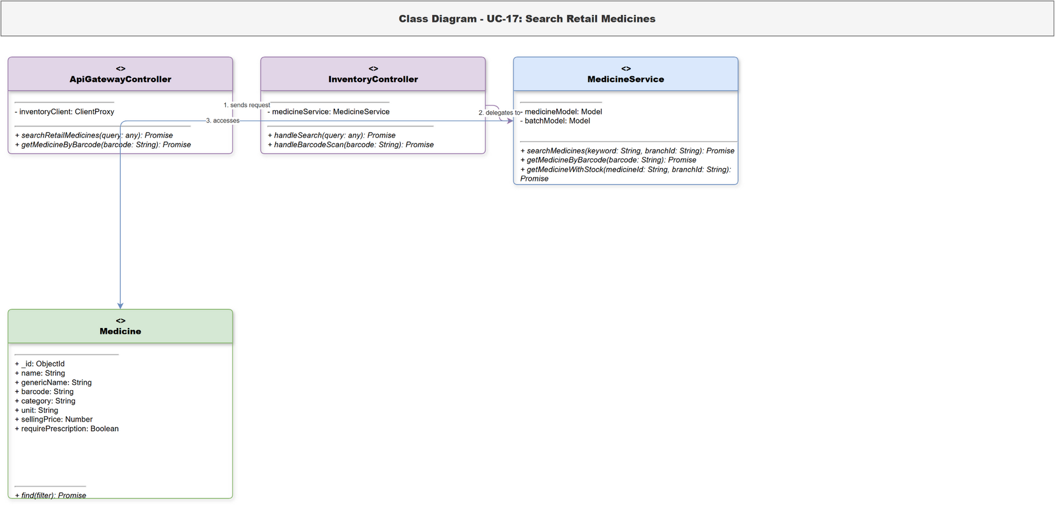
Figure 33. Class diagram for Search Retail Medicines

3.3.2 Sequence Diagram for Search Retail Medicines (UC-17)
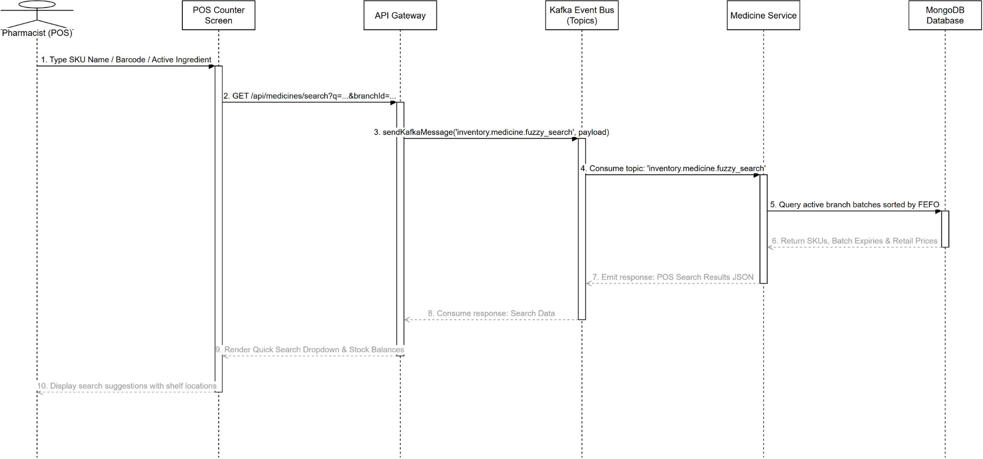
Figure 34. Sequence diagram for Search Retail Medicines

3.3.3 Class Diagram for Add to Retail Cart (UC-18)
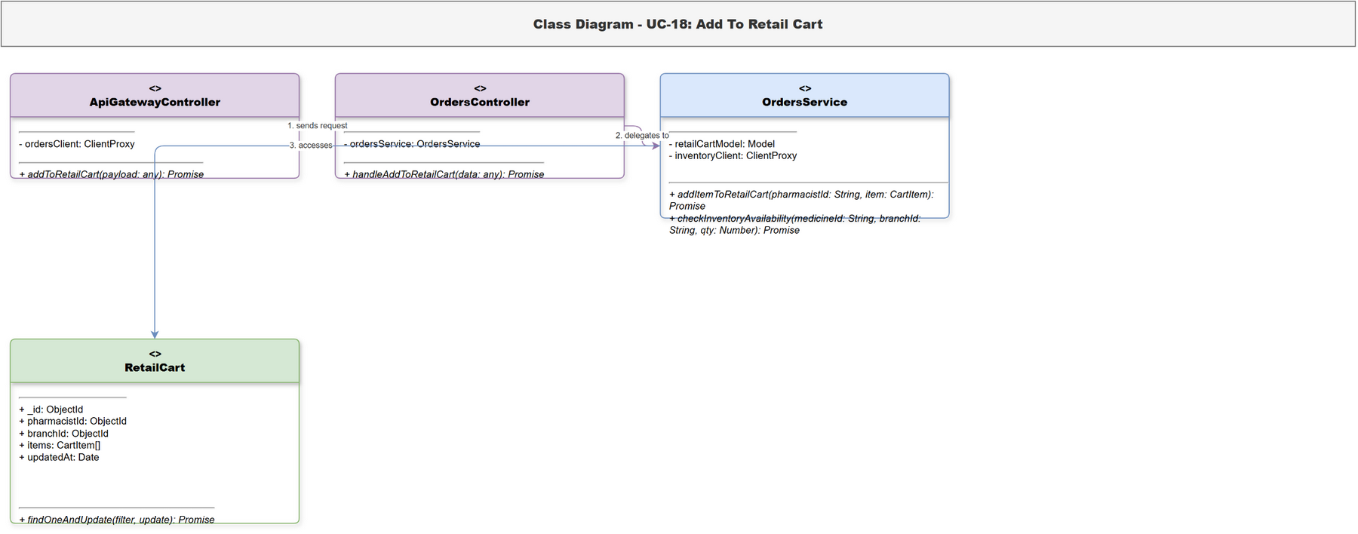
Figure 35. Class diagram for Add to Retail Cart

3.3.4 Sequence Diagram for Add to Retail Cart (UC-18)
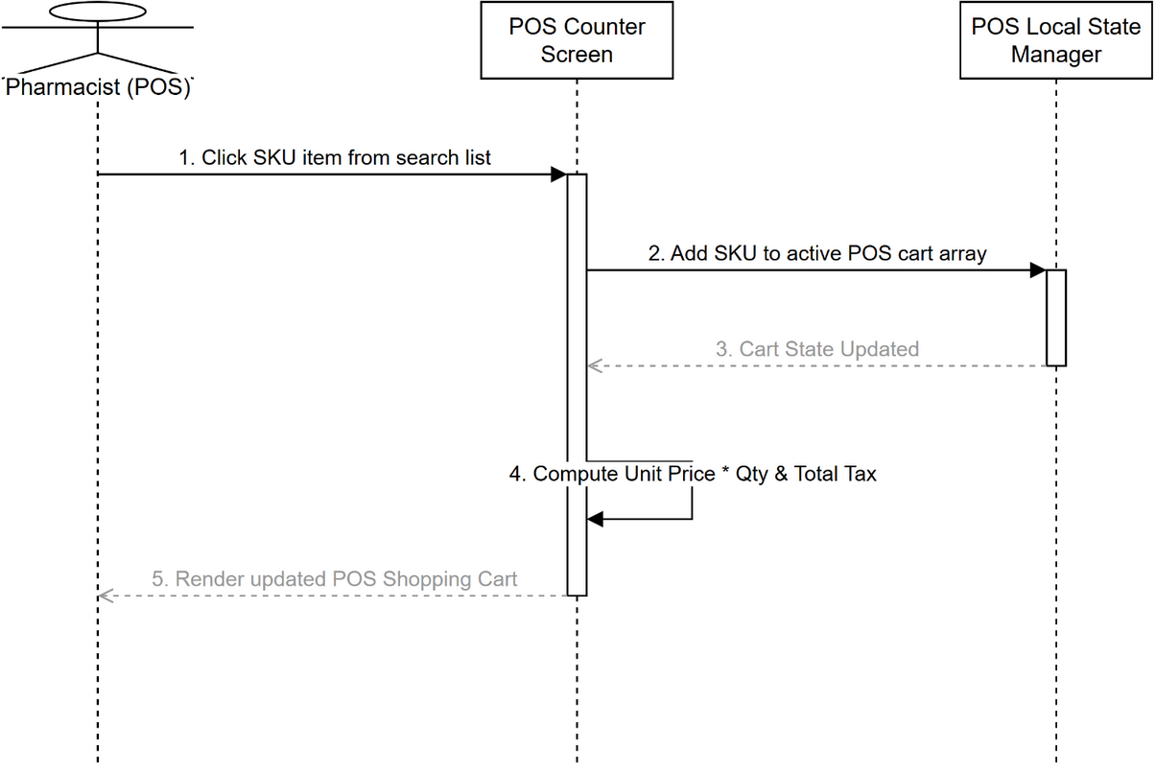
Figure 36. Sequence diagram for Add to Retail Cart

3.3.5 Class Diagram for Edit Retail Cart (UC-19)
Figure 37. Class diagram for Edit Retail Cart

3.3.6 Sequence Diagram for Edit Retail Cart (UC-19)
Figure 38. Sequence diagram for Edit Retail Cart

3.3.7 Class Diagram for Suggest Substitute Medicine (UC-20)
Figure 39. Class diagram for Suggest Substitute Medicine

3.3.8 Sequence Diagram for Suggest Substitute Medicine (UC-20)
Figure 40. Sequence diagram for Suggest Substitute Medicine

3.3.9 Class Diagram for Apply Voucher and Points (UC-21)
Figure 41. Class diagram for Apply Voucher and Points

3.3.10 Sequence Diagram for Apply Voucher and Points (UC-21)
Figure 42. Sequence diagram for Apply Voucher and Points

3.3.11 Class Diagram for Scan Prescription with AI (UC-22)
Figure 43. Class diagram for Scan Prescription with AI

3.3.12 Sequence Diagram for Scan Prescription with AI (UC-22)
Figure 44. Sequence diagram for Scan Prescription with AI

3.3.13 Class Diagram for Check Medicine Interactions (UC-23)
Figure 45. Class diagram for Check Medicine Interactions

3.3.14 Sequence Diagram for Check Medicine Interactions (UC-23)
Figure 46. Sequence diagram for Check Medicine Interactions

3.3.15 Class Diagram for Confirm Retail Payment (UC-24)
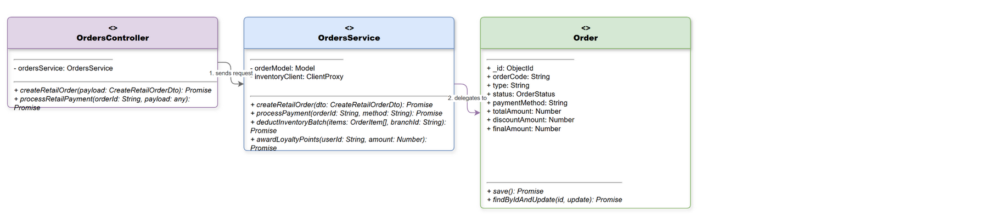
Figure 47. Class diagram for Confirm Retail Payment

3.3.16 Sequence Diagram for Confirm Retail Payment (UC-24)
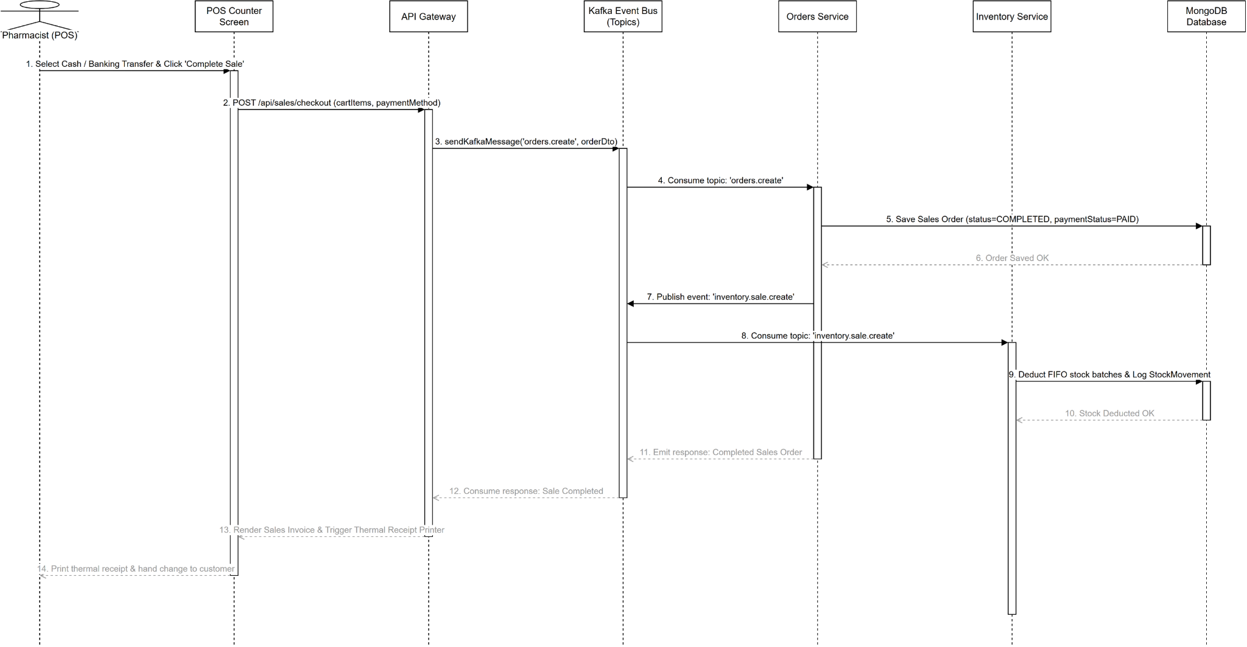
Figure 48. Sequence diagram for Confirm Retail Payment

3.3.17 Class Diagram for Send E-Invoice via Email (UC-25)
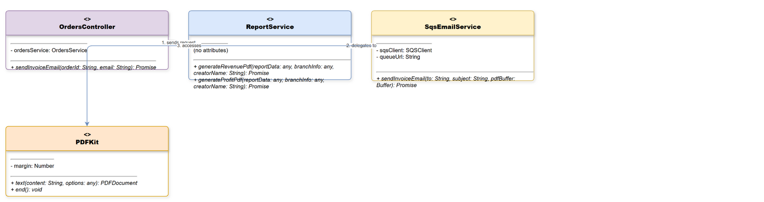
Figure 49. Class diagram for Send E-Invoice via Email

3.3.18 Sequence Diagram for Send E-Invoice via Email (UC-25)
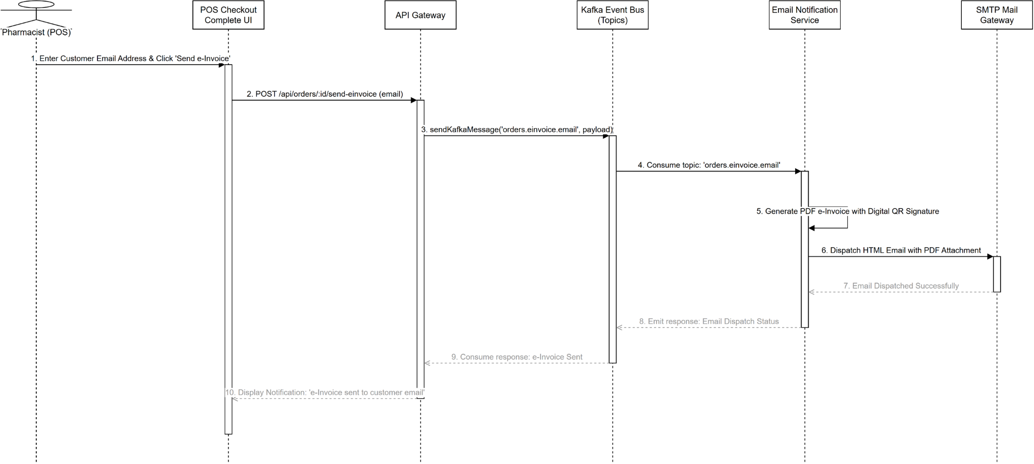
Figure 50. Sequence diagram for Send E-Invoice via Email

3.3.19 Class Diagram for Create Wholesale Invoice (UC-26)
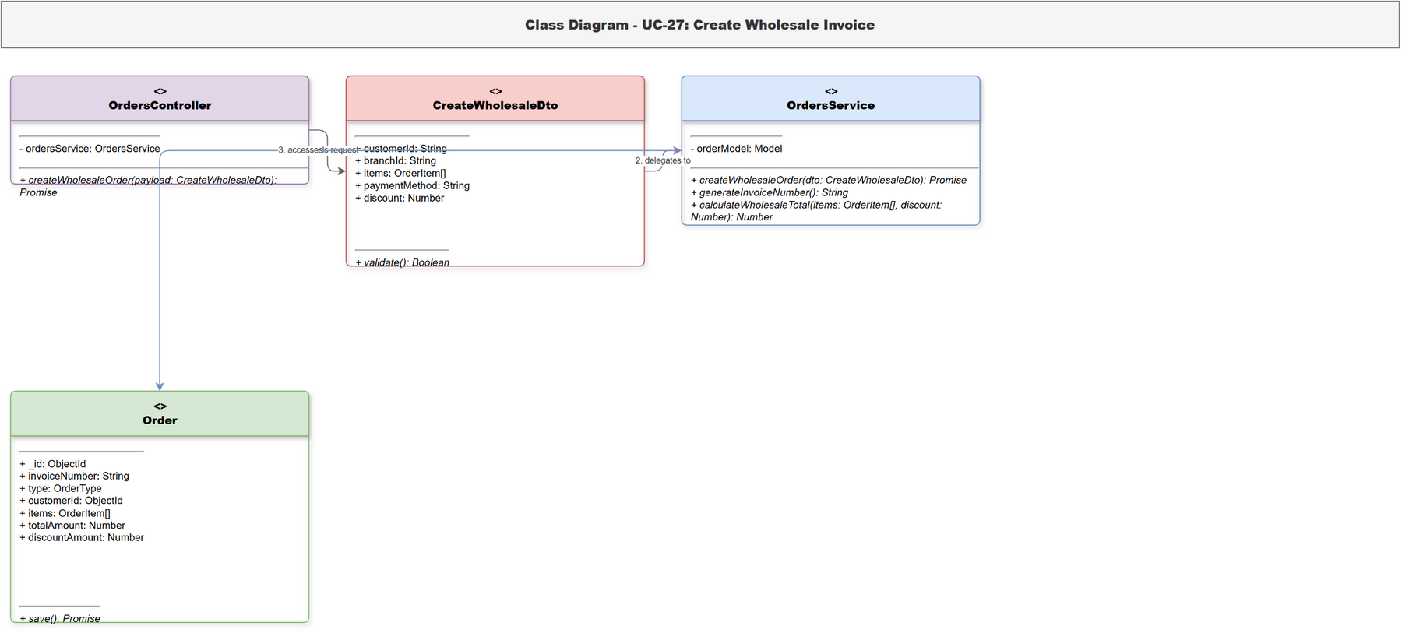
Figure 51. Class diagram for Create Wholesale Invoice

3.3.20 Sequence Diagram for Create Wholesale Invoice (UC-26)
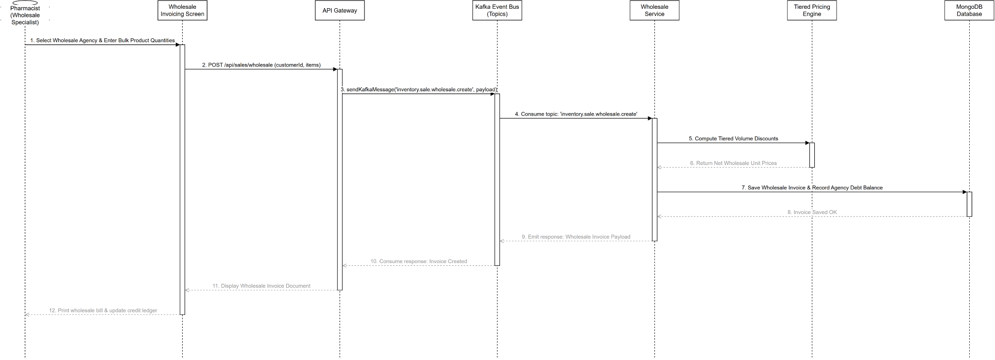
Figure 52. Sequence diagram for Create Wholesale Invoice

3.3.21 Class Diagram for Search Return Invoice (UC-27)
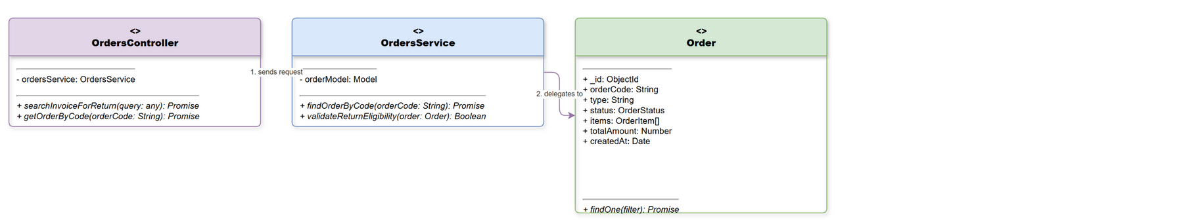
Figure 53. Class diagram for Search Return Invoice

3.3.22 Sequence Diagram for Search Return Invoice (UC-27)
Figure 54. Sequence diagram for Search Return Invoice

3.3.23 Class Diagram for Create Return Slip (UC-28)
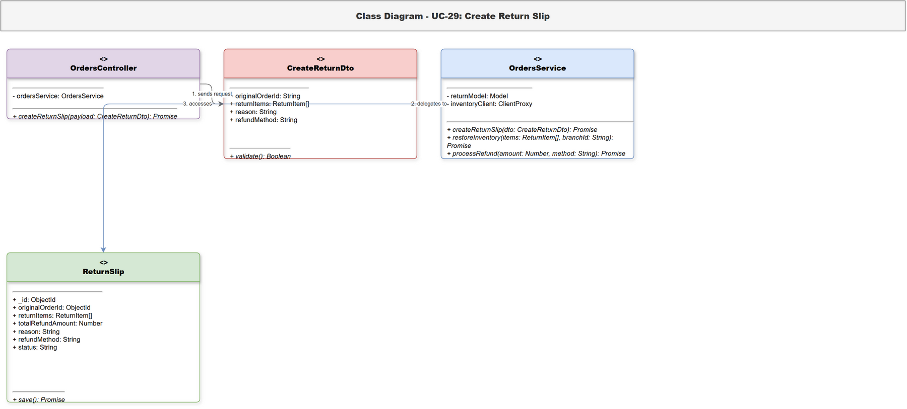
Figure 55. Class diagram for Create Return Slip

3.3.24 Sequence Diagram for Create Return Slip (UC-28)
Figure 56. Sequence diagram for Create Return Slip

3.4 Central Warehouse & FEFO Inventory Management

3.4.1 Class Diagram for View Medicine Catalog (UC-29)
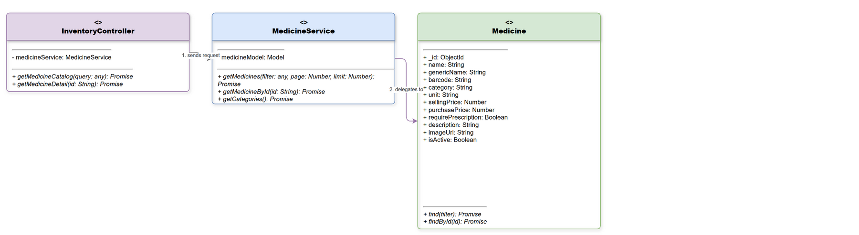
Figure 57. Class diagram for View Medicine Catalog

3.4.2 Sequence Diagram for View Medicine Catalog (UC-29)
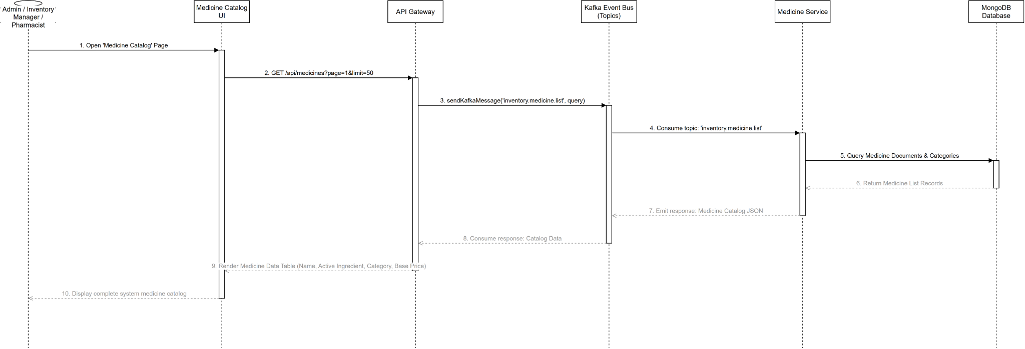
Figure 58. Sequence diagram for View Medicine Catalog

3.4.3 Class Diagram for View Inventory by Batch (UC-30)
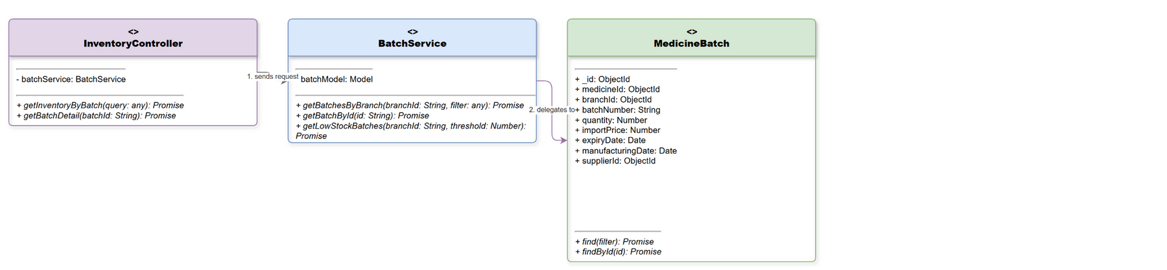
Figure 59. Class diagram for View Inventory by Batch

3.4.4 Sequence Diagram for View Inventory by Batch (UC-30)
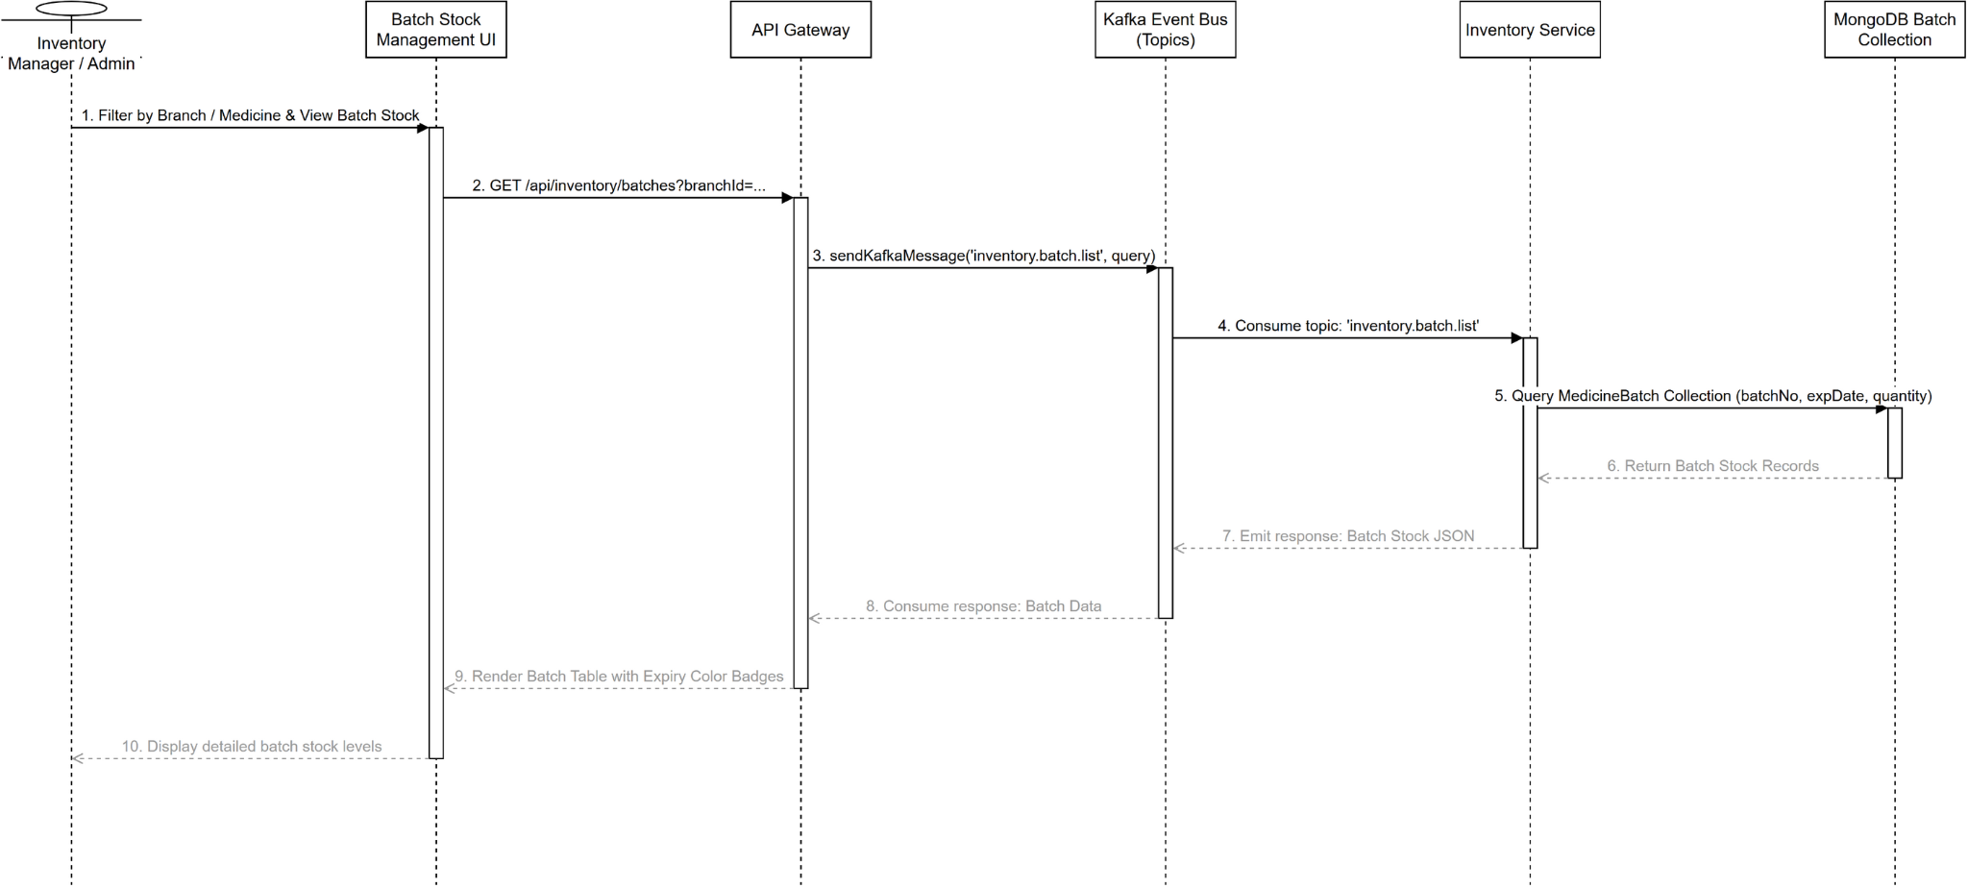
Figure 60. Sequence diagram for View Inventory by Batch

3.4.5 Class Diagram for Create Goods Receipt (UC-31)
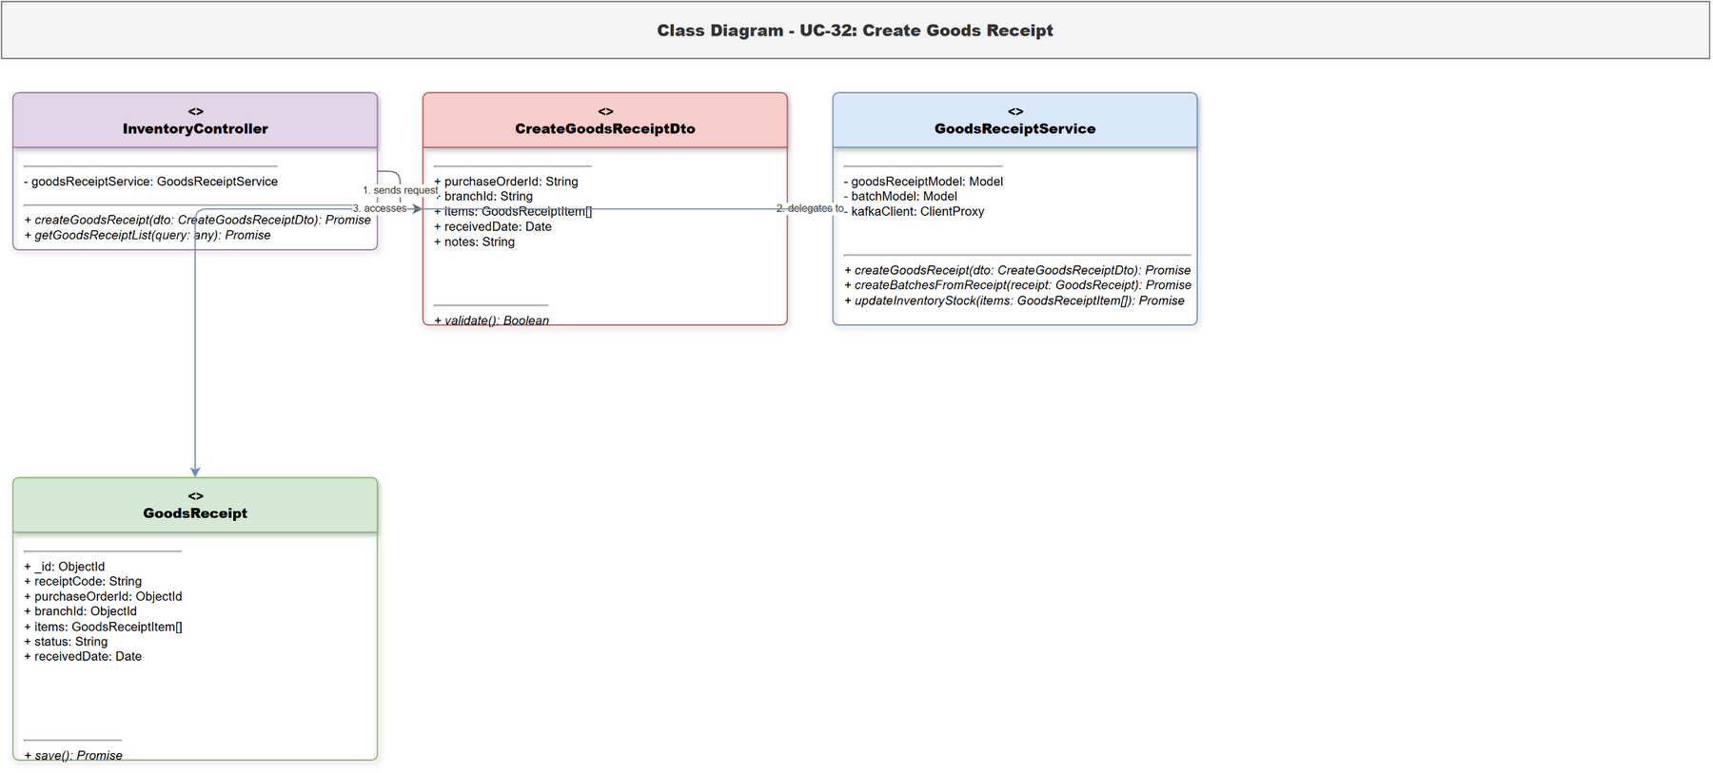
Figure 61. Class diagram for Create Goods Receipt

3.4.6 Sequence Diagram for Create Goods Receipt (UC-31)
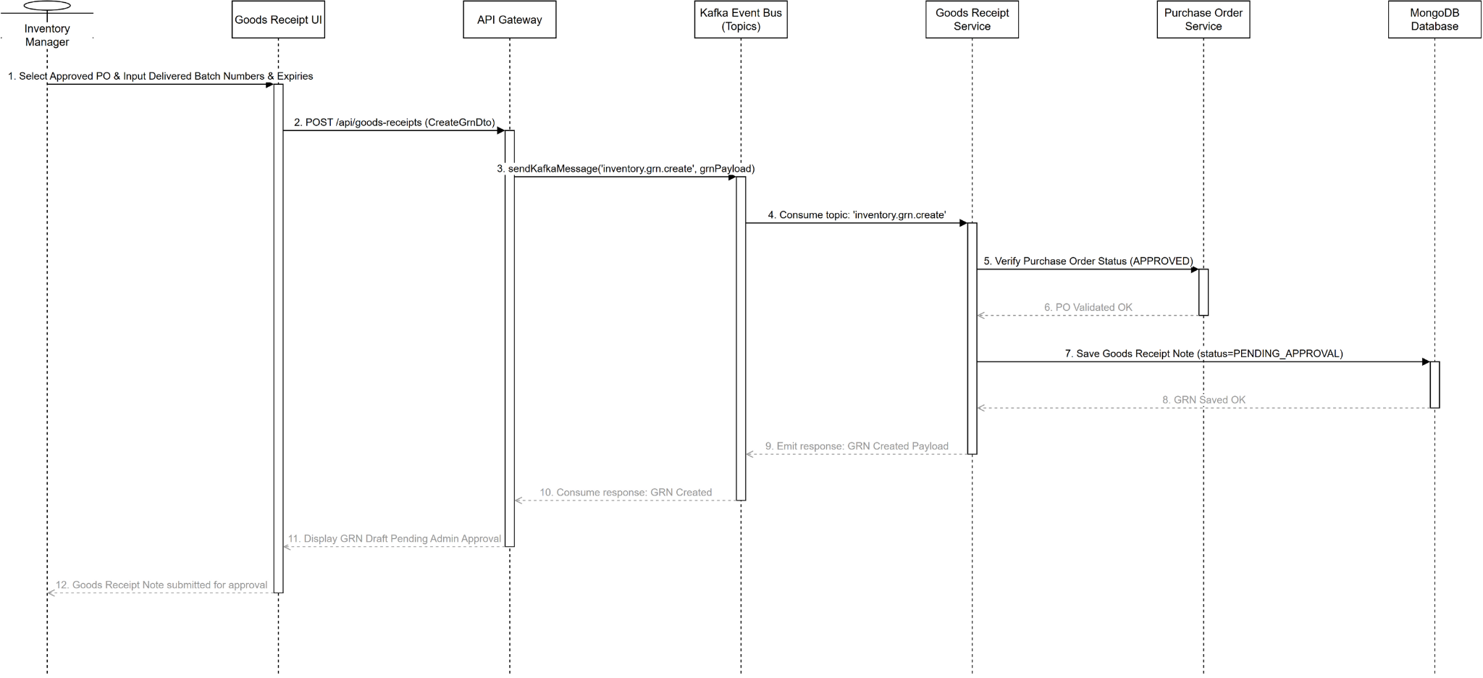
Figure 62. Sequence diagram for Create Goods Receipt

3.4.7 Class Diagram for Create Purchase Order (PO) (UC-32)
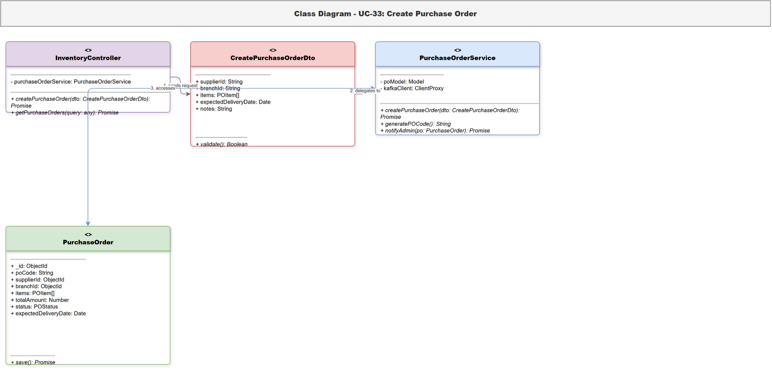
Figure 63. Class diagram for Create Purchase Order (PO)

3.4.8 Sequence Diagram for Create Purchase Order (PO) (UC-32)
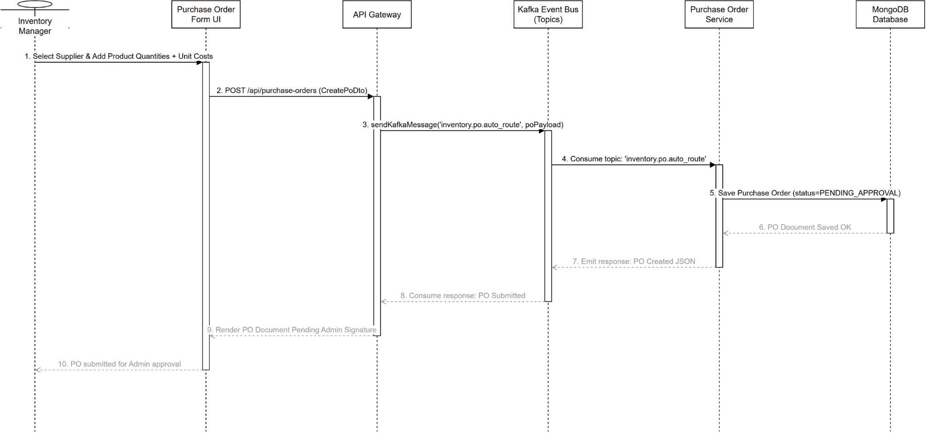
Figure 64. Sequence diagram for Create Purchase Order (PO)

3.4.9 Class Diagram for Inspect Goods via AI (UC-33)
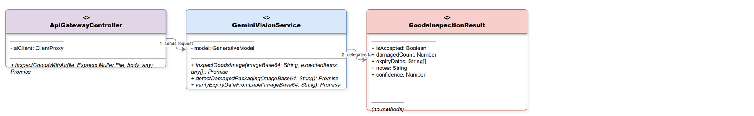
Figure 65. Class diagram for Inspect Goods via AI

3.4.10 Sequence Diagram for Inspect Goods via AI (UC-33)
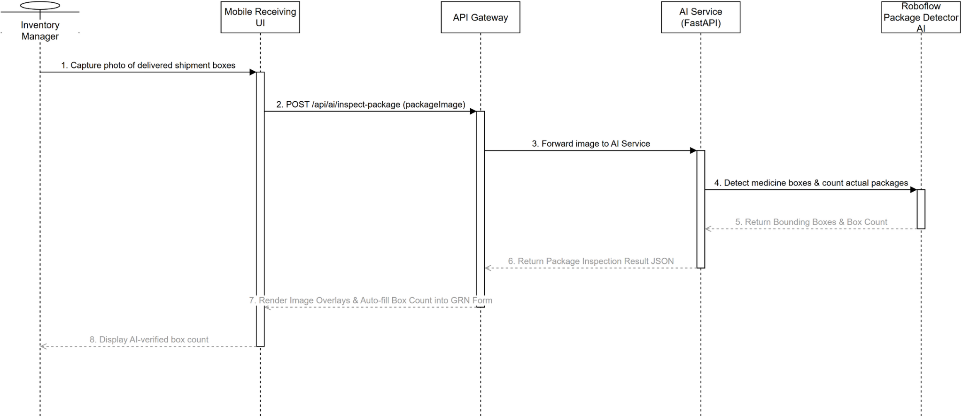
Figure 66. Sequence diagram for Inspect Goods via AI

3.4.11 Class Diagram for Alert Expiry Dates (UC-34)
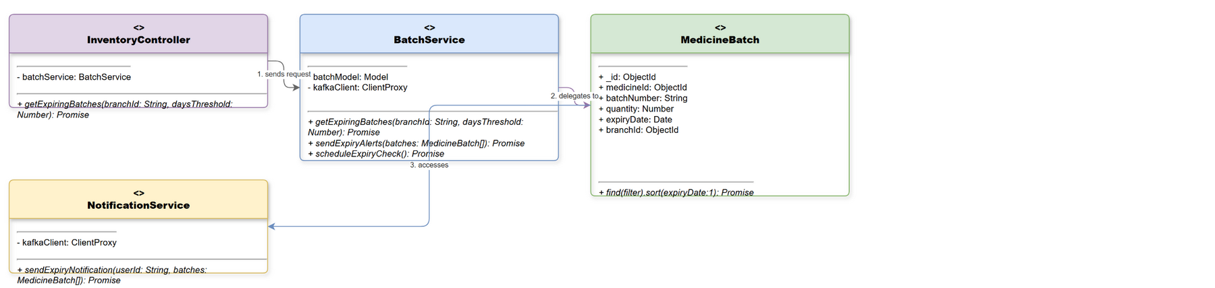
Figure 67. Class diagram for Alert Expiry Dates

3.4.12 Sequence Diagram for Alert Expiry Dates (UC-34)
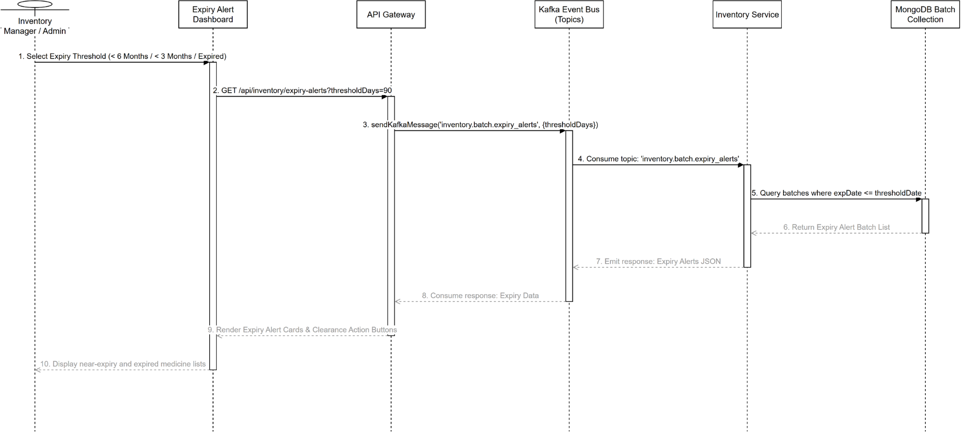
Figure 68. Sequence diagram for Alert Expiry Dates

3.4.13 Class Diagram for Track Medicine Lot (UC-35)
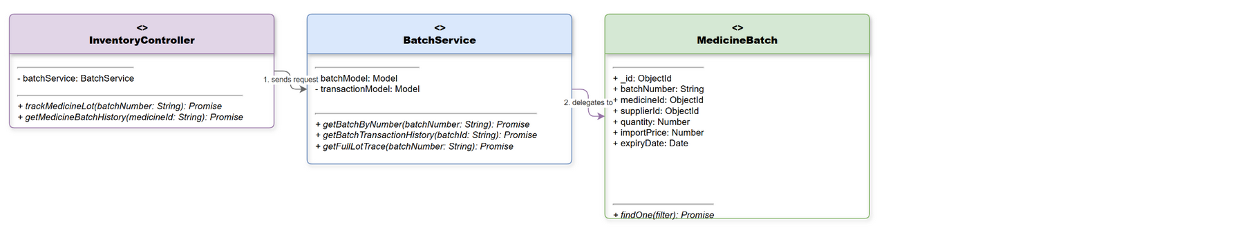
Figure 69. Class diagram for Track Medicine Lot

3.4.14 Sequence Diagram for Track Medicine Lot (UC-35)
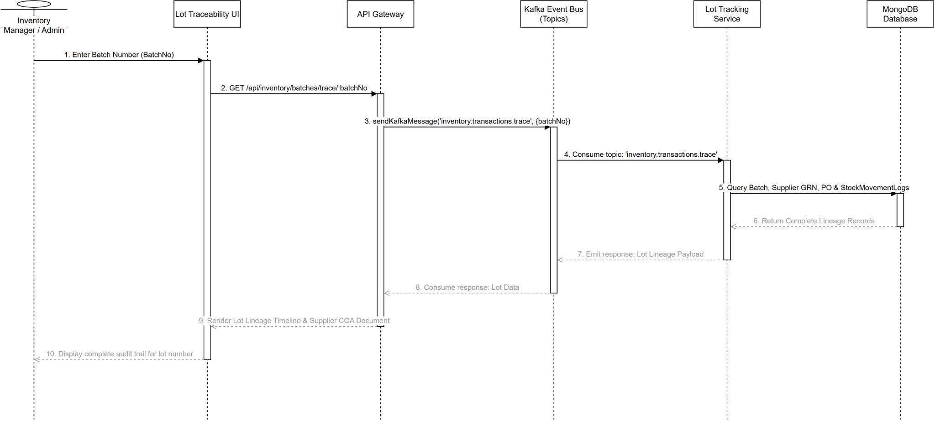
Figure 70. Sequence diagram for Track Medicine Lot

3.5 Branch Store Management

3.5.1 Class Diagram for View Branch Stock (UC-36)
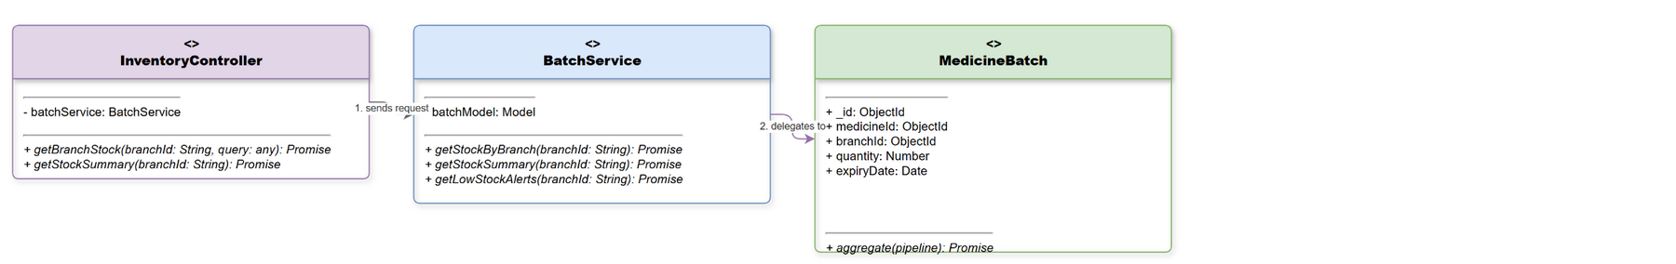
Figure 71. Class diagram for View Branch Stock

3.5.2 Sequence Diagram for View Branch Stock (UC-36)
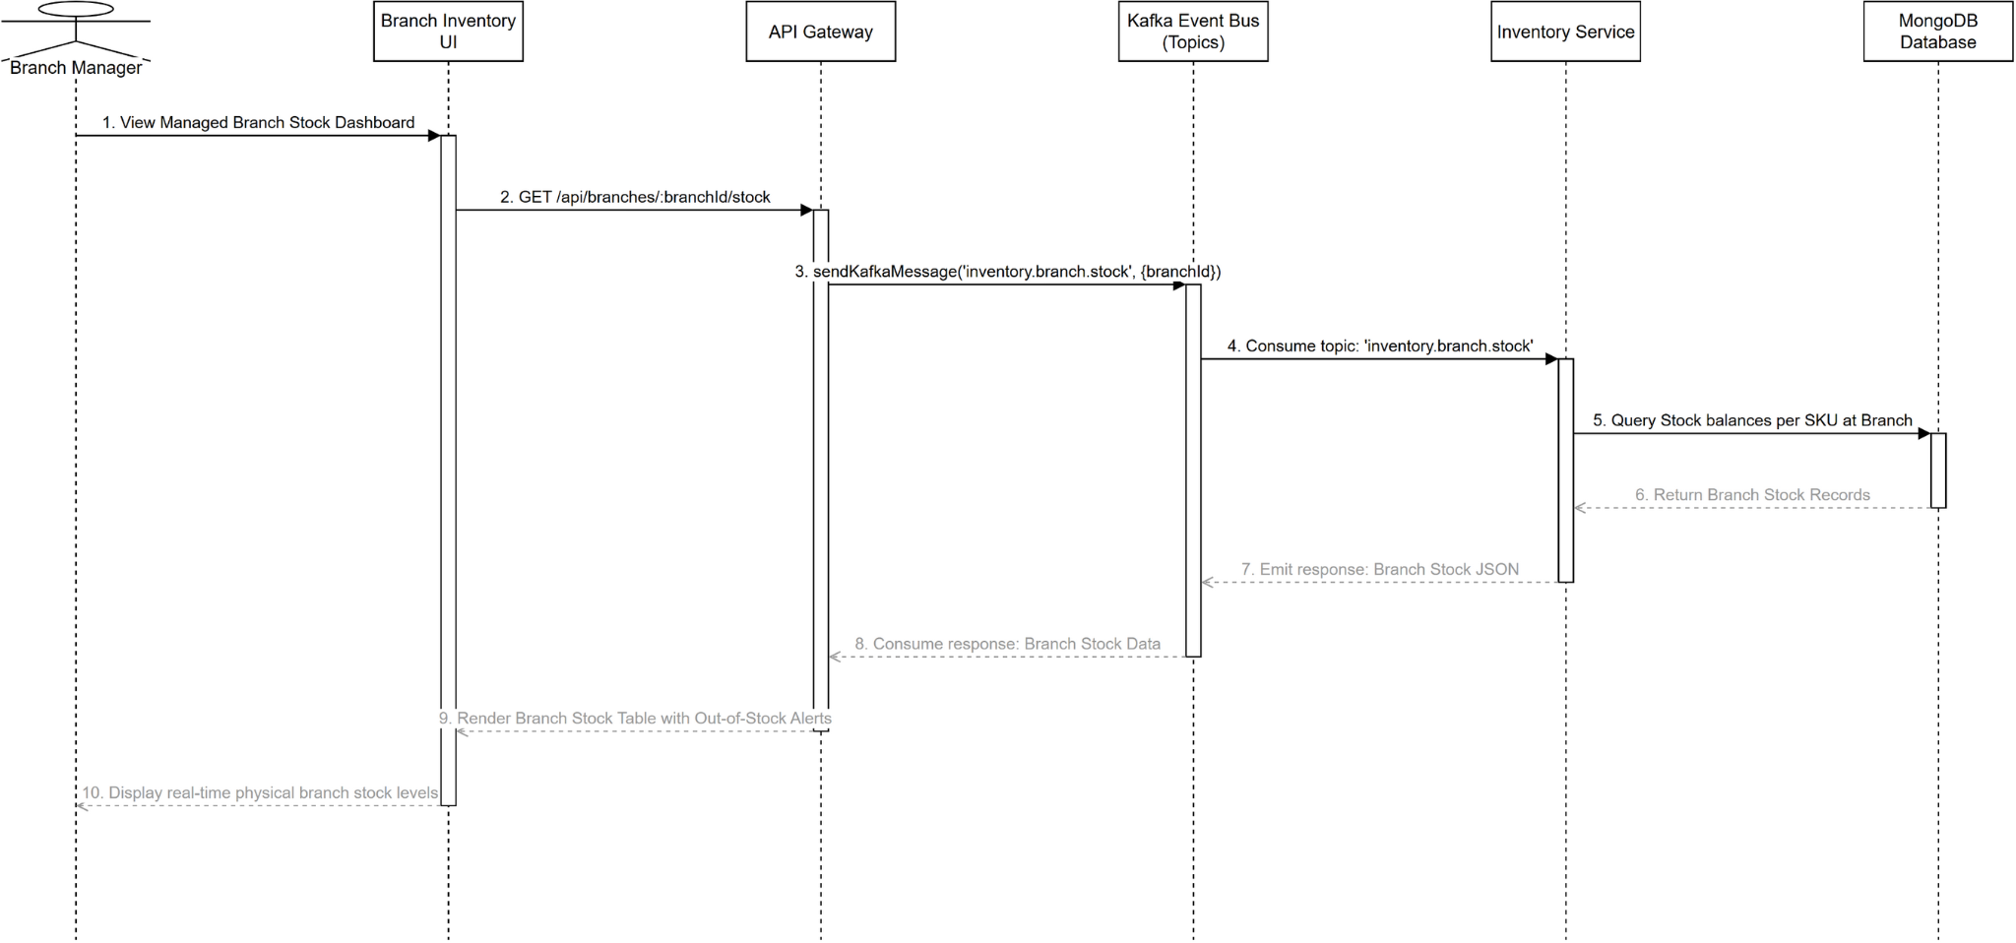
Figure 72. Sequence diagram for View Branch Stock

3.5.3 Class Diagram for Request Stock Requisition (UC-37)
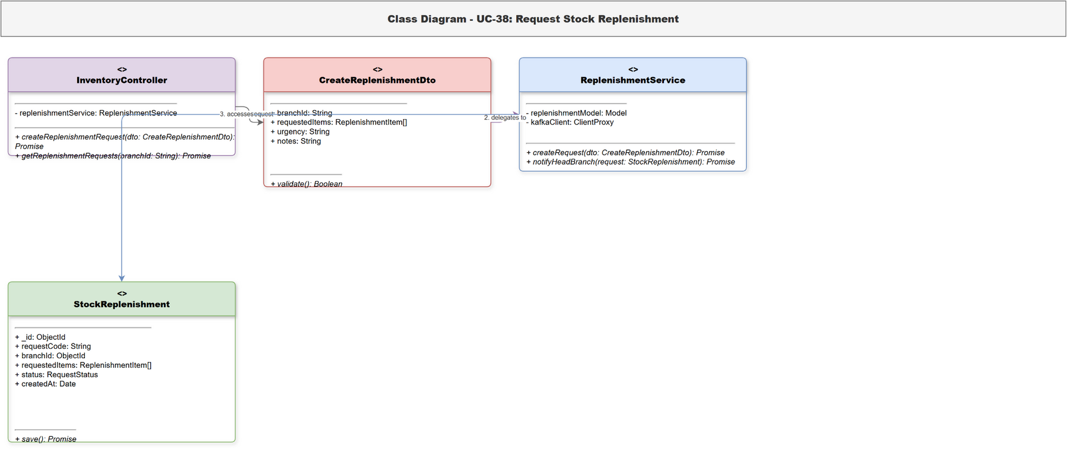
Figure 73. Class diagram for Request Stock Requisition

3.5.4 Sequence Diagram for Request Stock Requisition (UC-37)
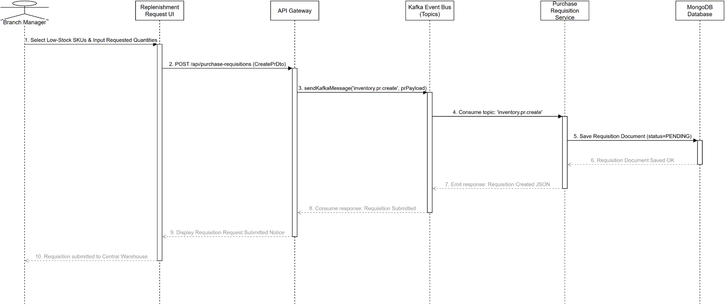
Figure 74. Sequence diagram for Request Stock Requisition

3.5.5 Class Diagram for Request Internal Transfer (UC-38)
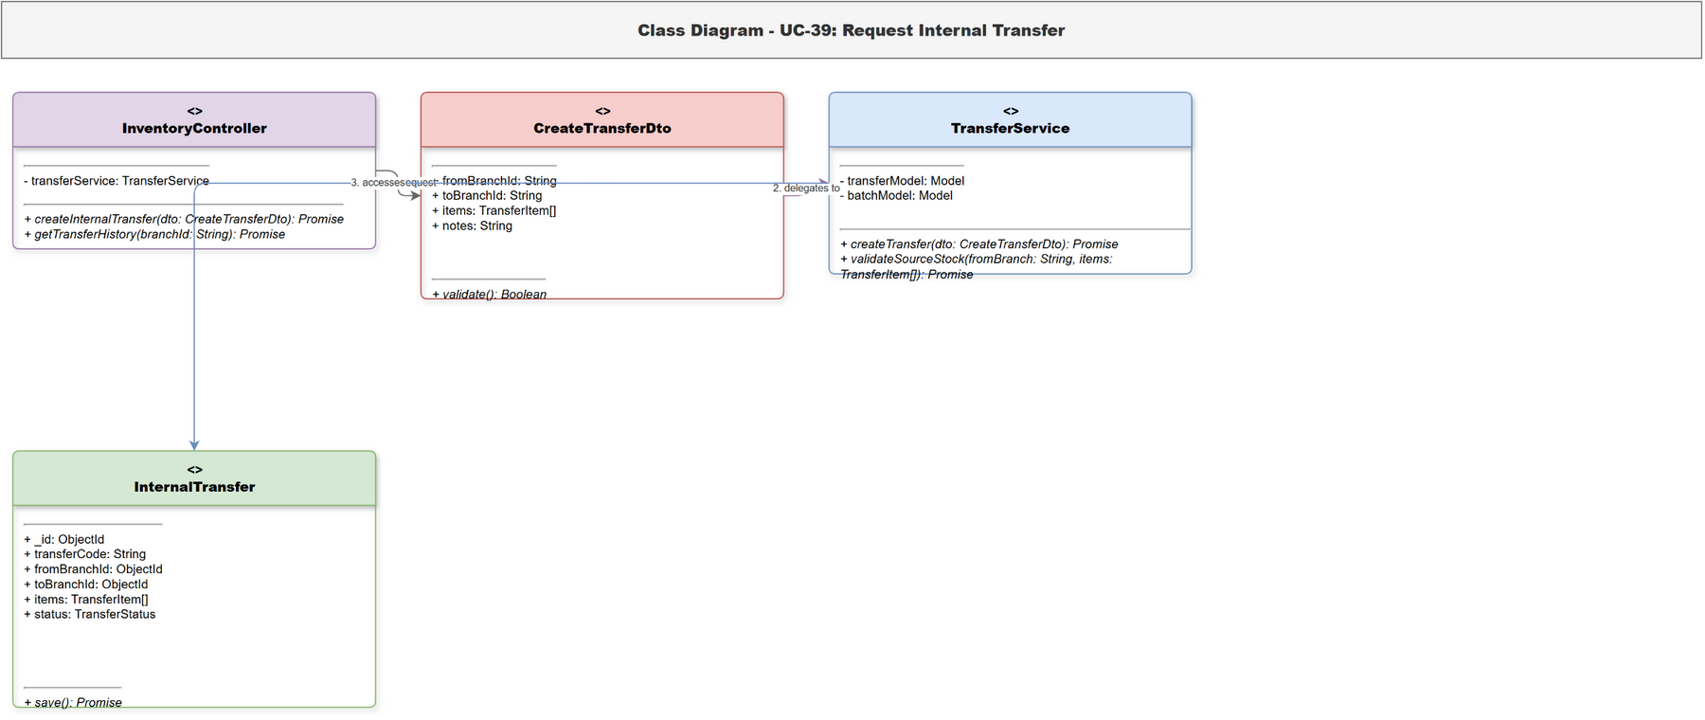
Figure 75. Class diagram for Request Internal Transfer

3.5.6 Sequence Diagram for Request Internal Transfer (UC-38)
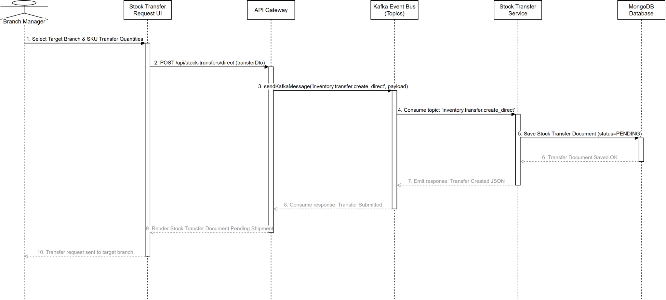
Figure 76. Sequence diagram for Request Internal Transfer

3.5.7 Class Diagram for Approve Stock Replenishment (UC-39)
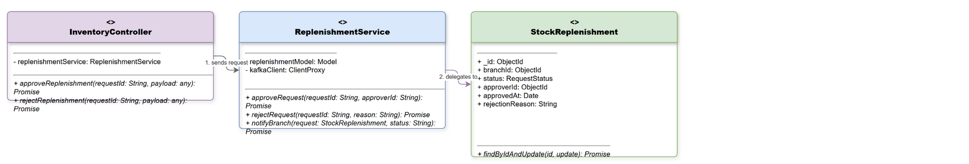
Figure 77. Class diagram for Approve Stock Replenishment

3.5.8 Sequence Diagram for Approve Stock Replenishment (UC-39)
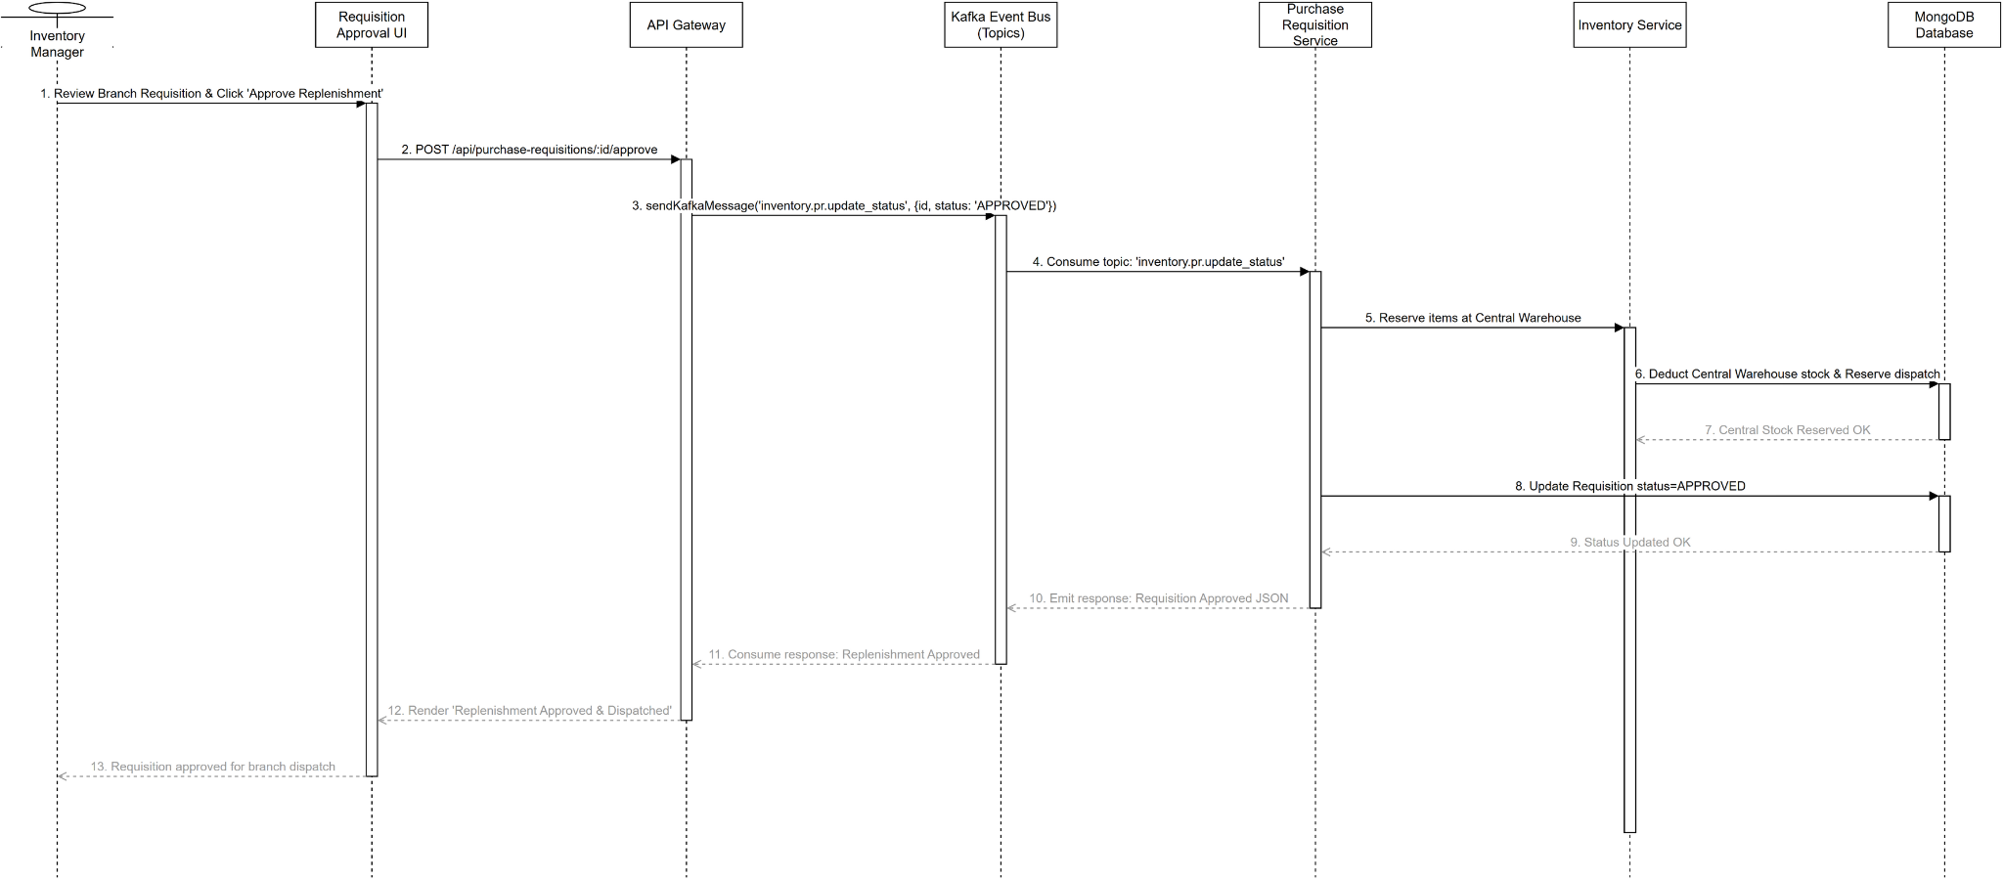
Figure 78. Sequence diagram for Approve Stock Replenishment

3.5.9 Class Diagram for Confirm Transfer Receipt (UC-40)
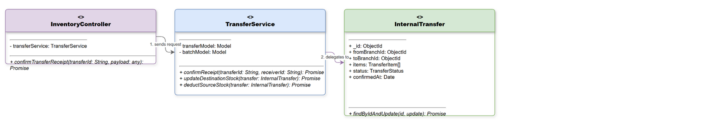
Figure 79. Class diagram for Confirm Transfer Receipt

3.5.10 Sequence Diagram for Confirm Transfer Receipt (UC-40)
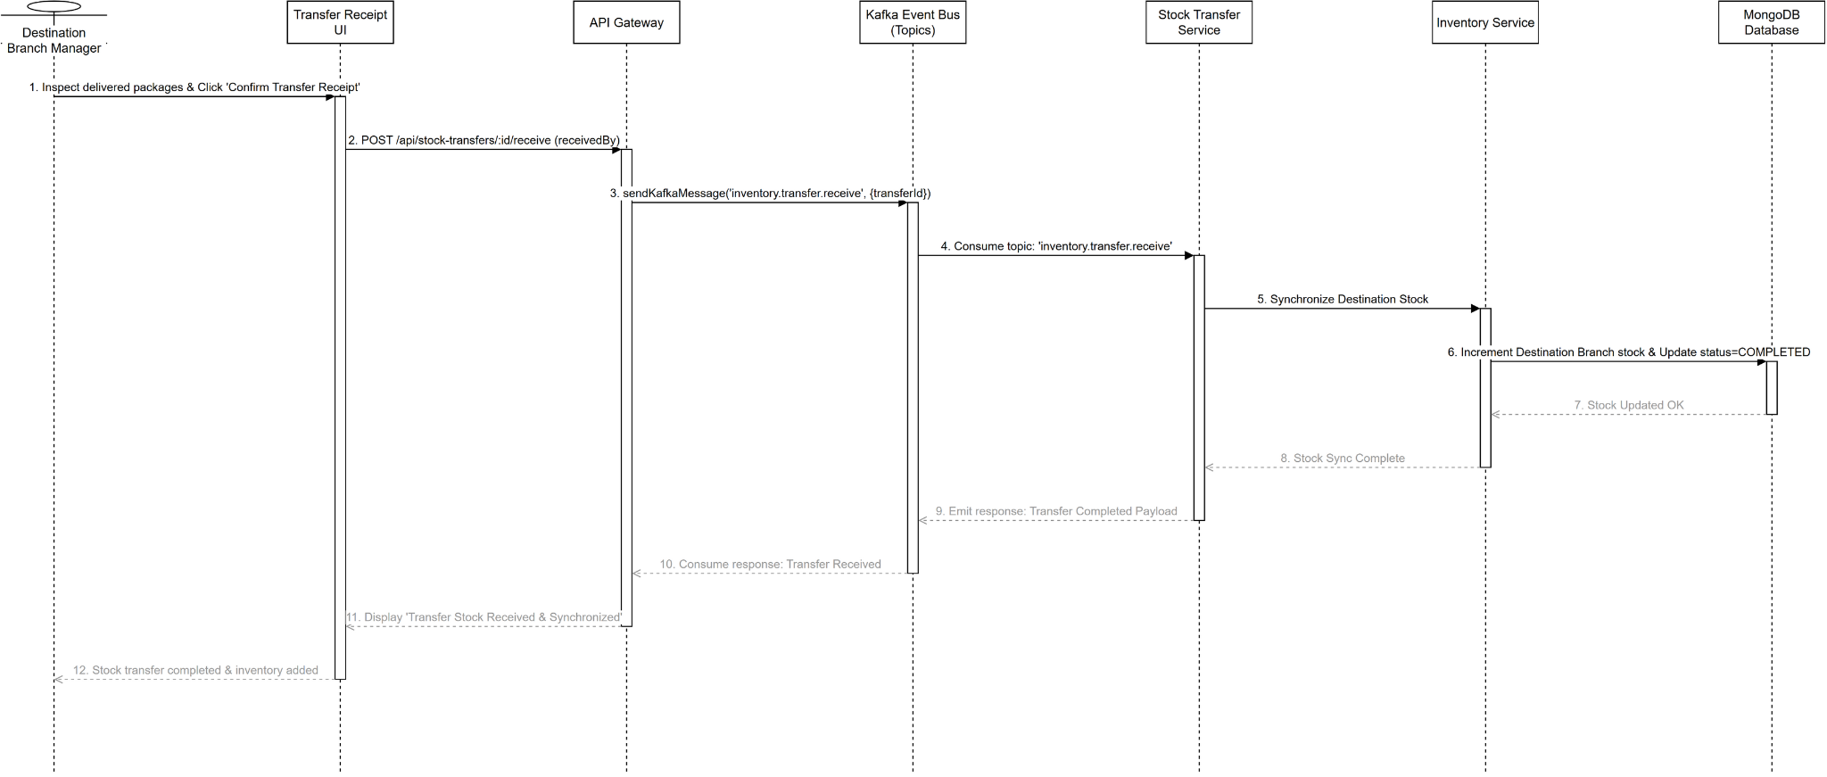
Figure 80. Sequence diagram for Confirm Transfer Receipt

3.6 HQ System Governance & Staff Management

3.6.1 Class Diagram for View Staff List (UC-41)
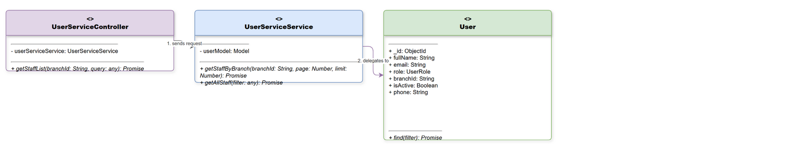
Figure 81. Class diagram for View Staff List

3.6.2 Sequence Diagram for View Staff List (UC-41)
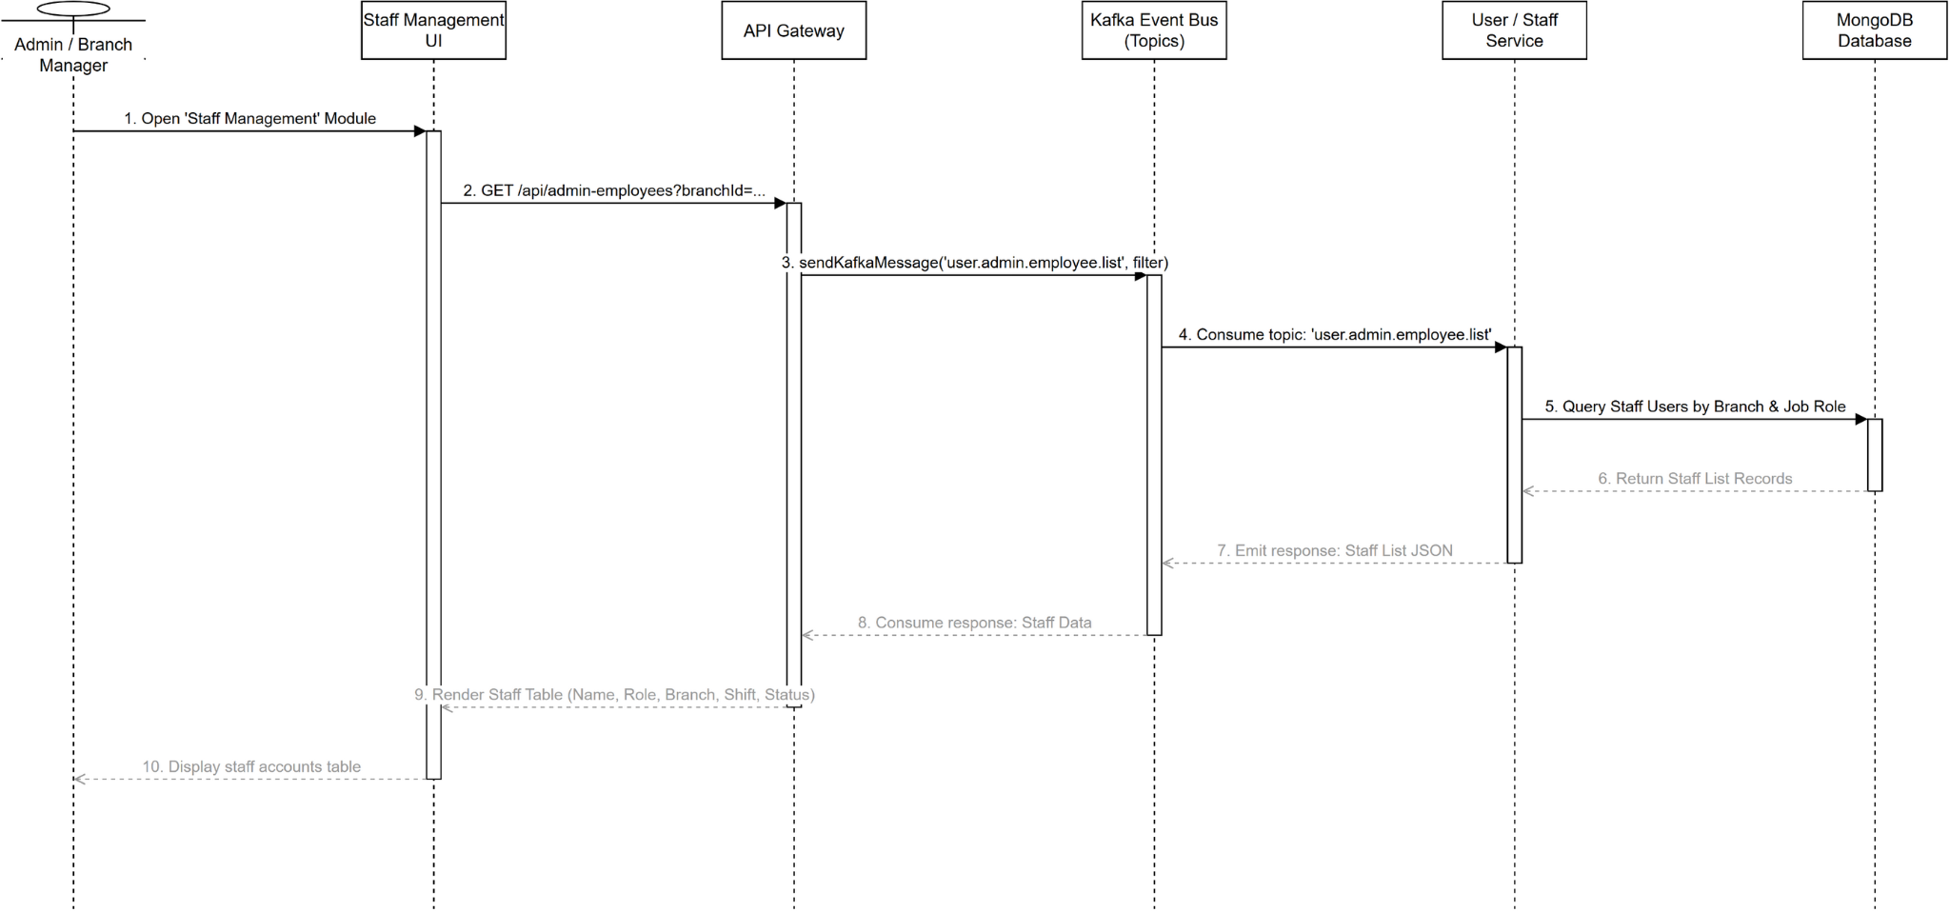
Figure 82. Sequence diagram for View Staff List

3.6.3 Class Diagram for Create Staff Account (UC-42)
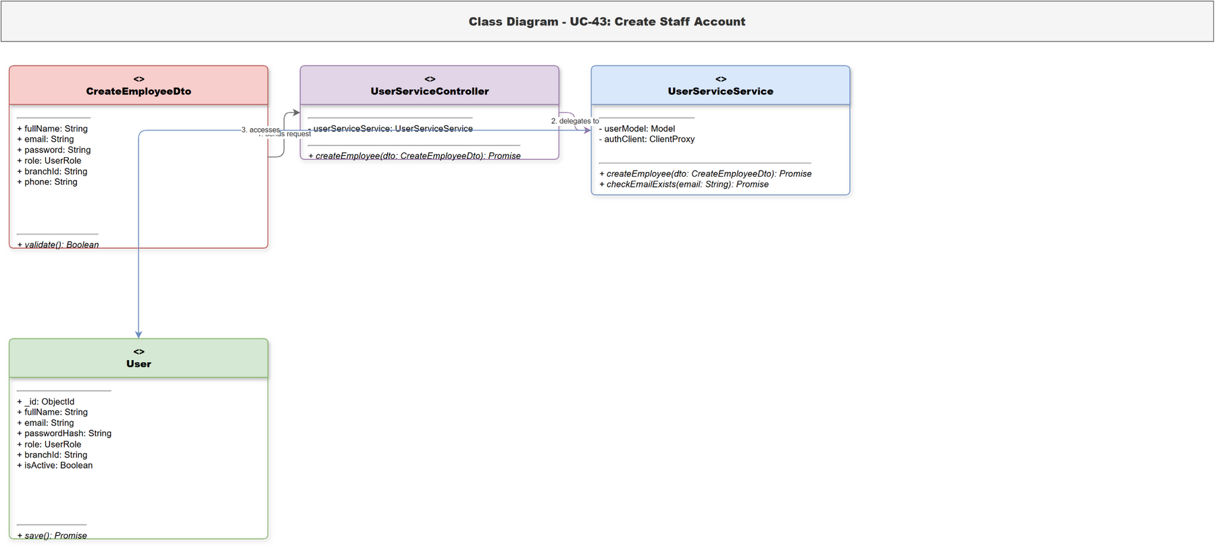
Figure 83. Class diagram for Create Staff Account

3.6.4 Sequence Diagram for Create Staff Account (UC-42)
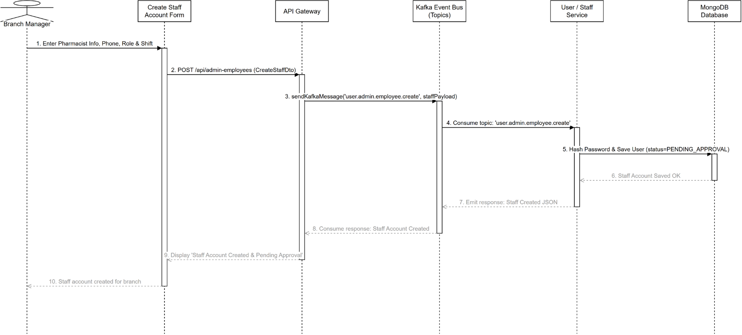
Figure 84. Sequence diagram for Create Staff Account

3.6.5 Class Diagram for Approve Staff Account (UC-43)
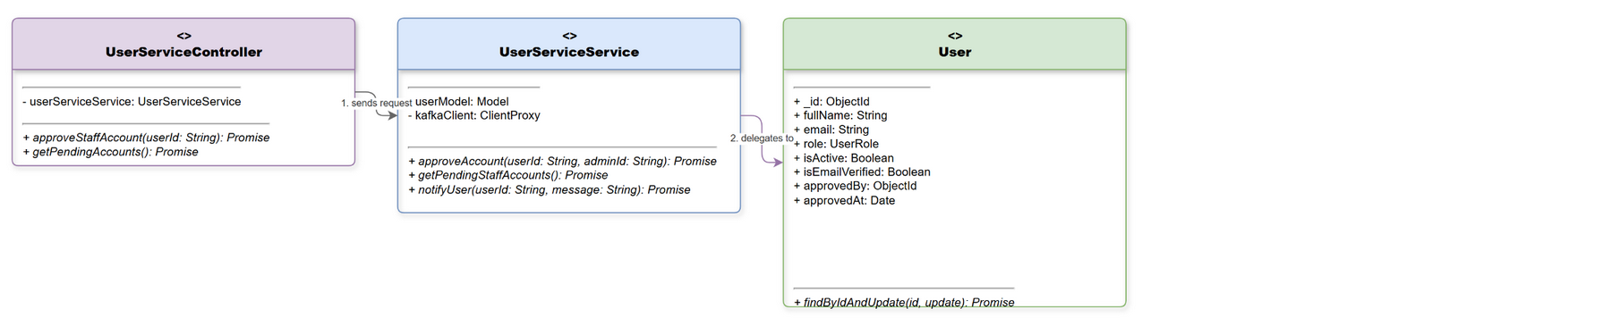
Figure 85. Class diagram for Approve Staff Account

3.6.6 Sequence Diagram for Approve Staff Account (UC-43)
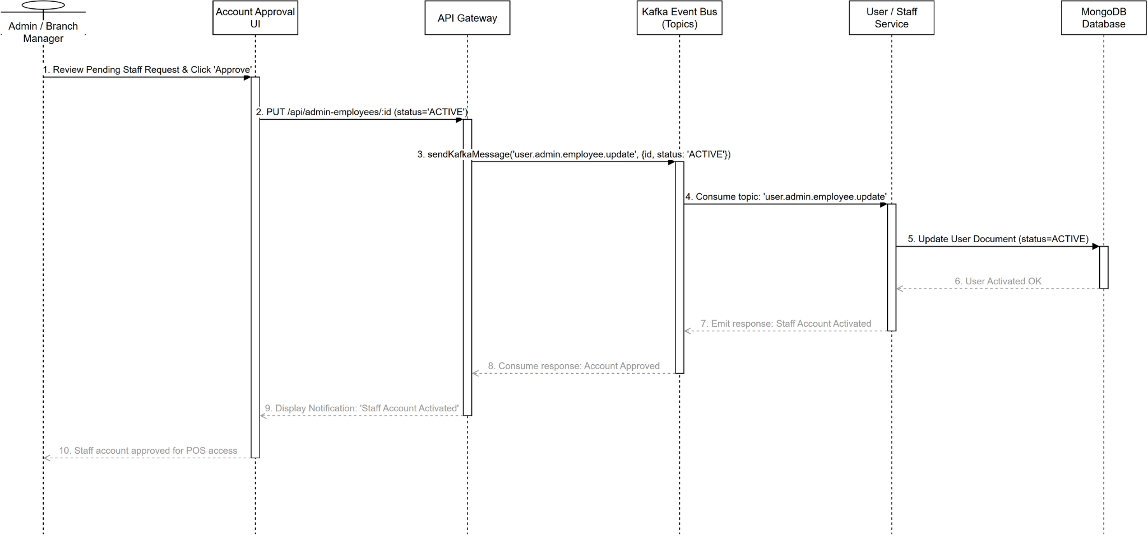
Figure 86. Sequence diagram for Approve Staff Account

3.6.7 Class Diagram for Reject Staff Account (UC-44)
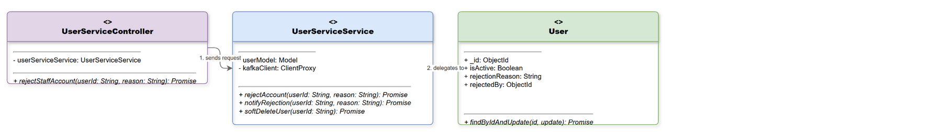
Figure 87. Class diagram for Reject Staff Account

3.6.8 Sequence Diagram for Reject Staff Account (UC-44)
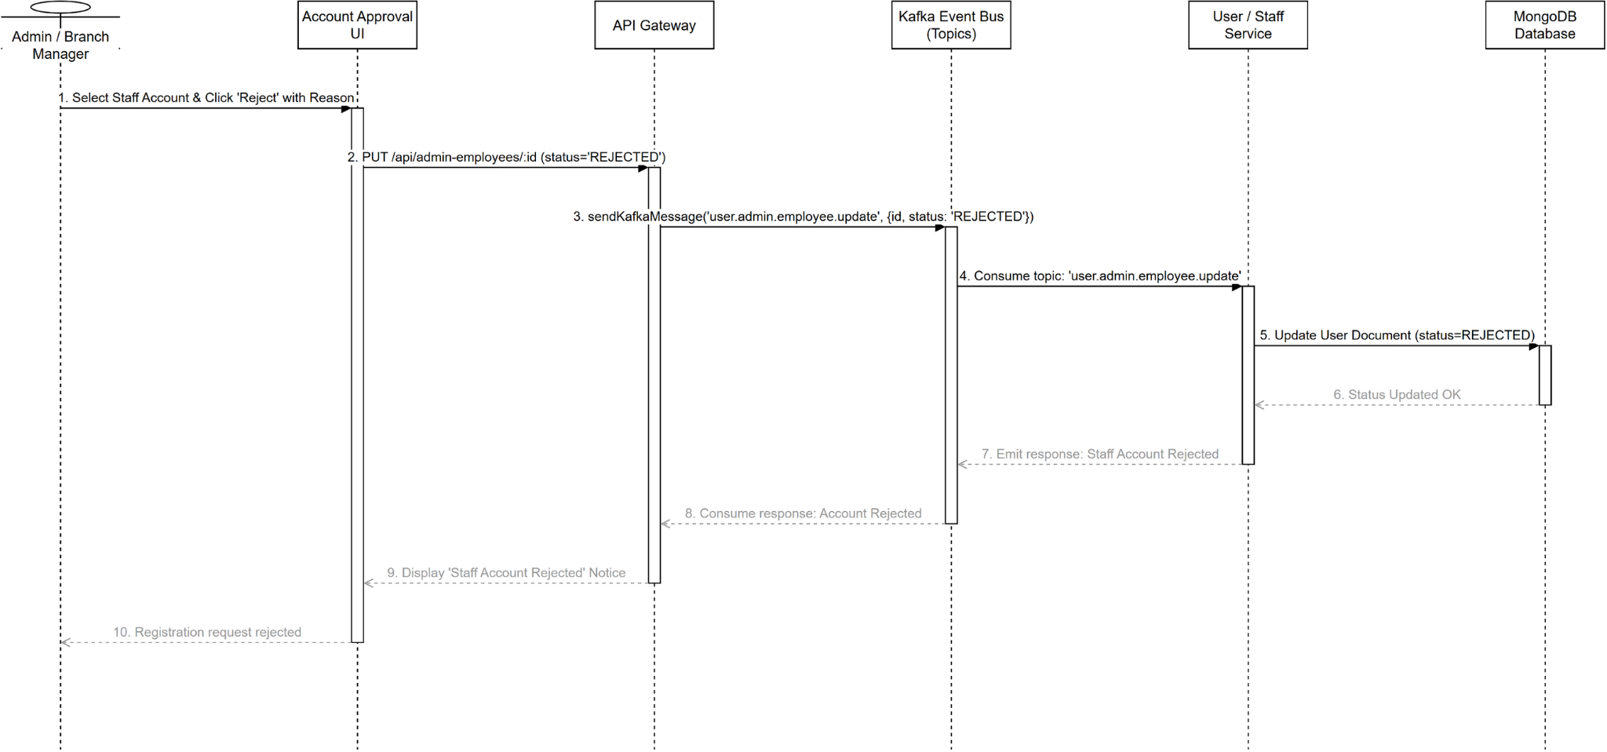
Figure 88. Sequence diagram for Reject Staff Account

3.6.9 Class Diagram for Create Branch Manager Account (UC-45)
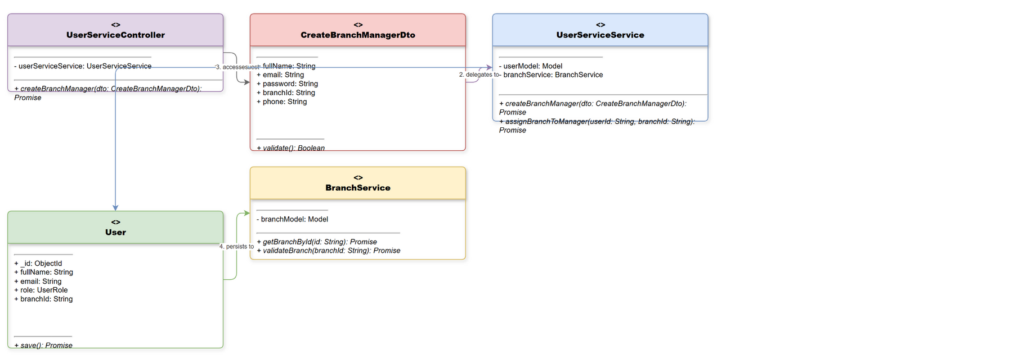
Figure 89. Class diagram for Create Branch Manager Account

3.6.10 Sequence Diagram for Create Branch Manager Account (UC-45)
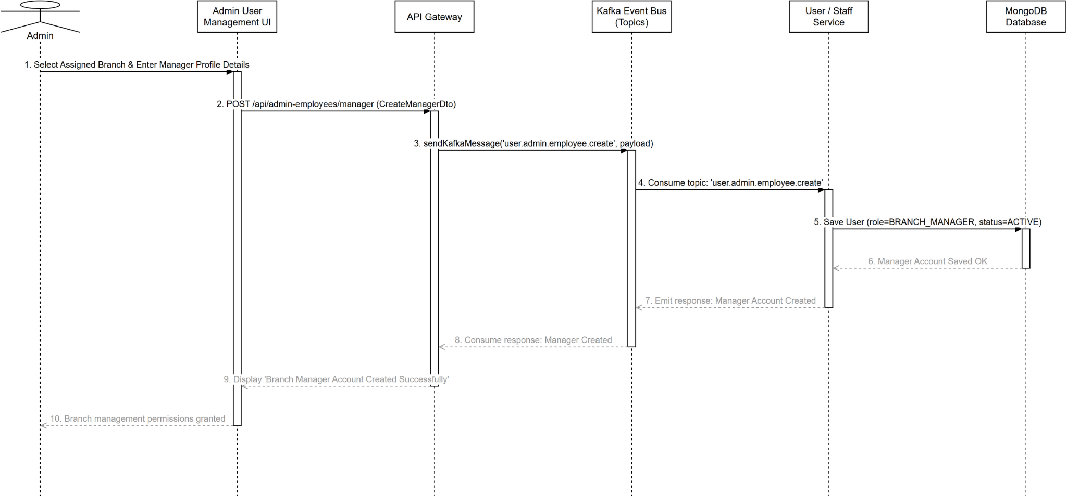
Figure 90. Sequence diagram for Create Branch Manager Account

3.6.11 Class Diagram for Update Staff Role (UC-46)
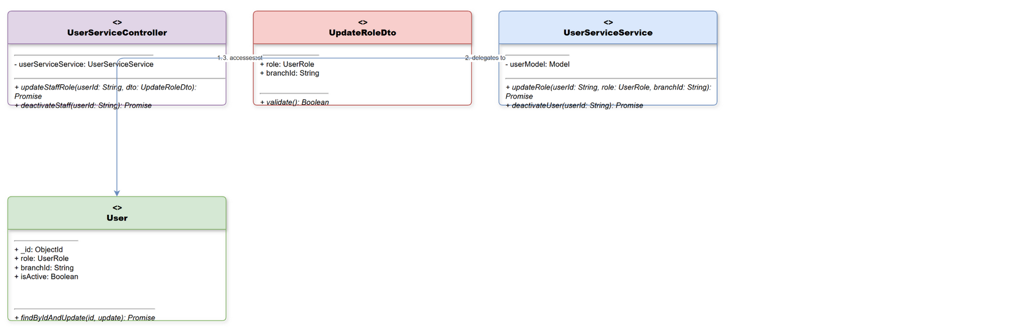
Figure 91. Class diagram for Update Staff Role

3.6.12 Sequence Diagram for Update Staff Role (UC-46)
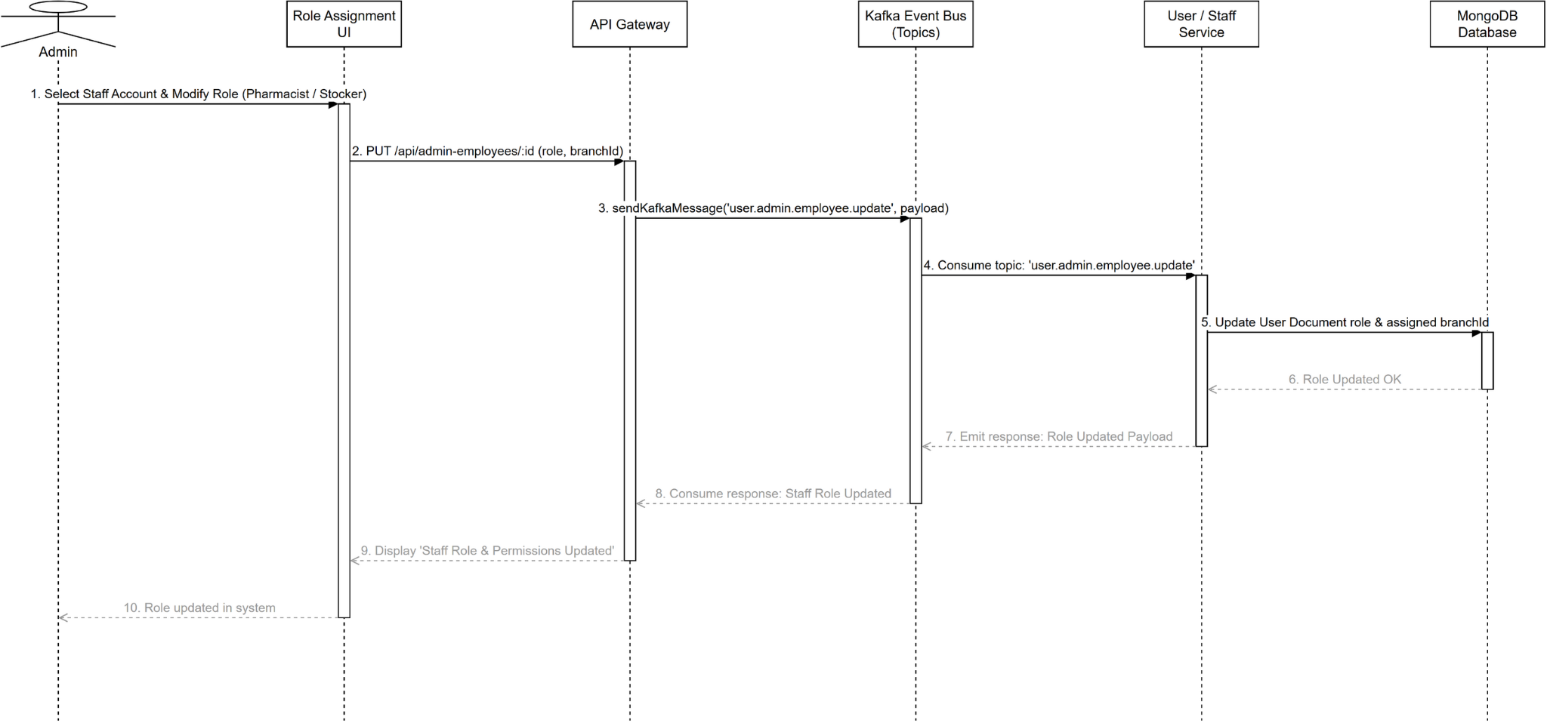
Figure 92. Sequence diagram for Update Staff Role

3.6.13 Class Diagram for Add Medicine (UC-47)
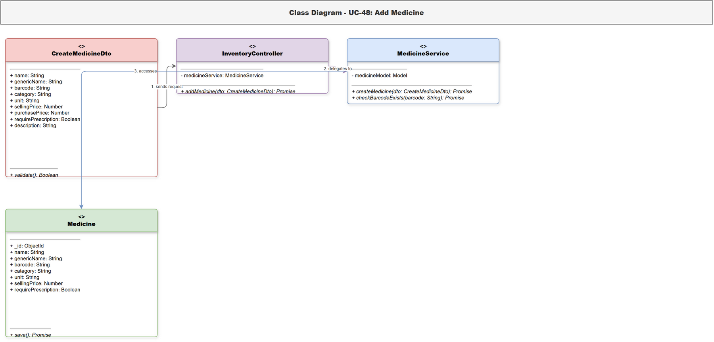
Figure 93. Class diagram for Add Medicine

3.6.14 Sequence Diagram for Add Medicine (UC-47)
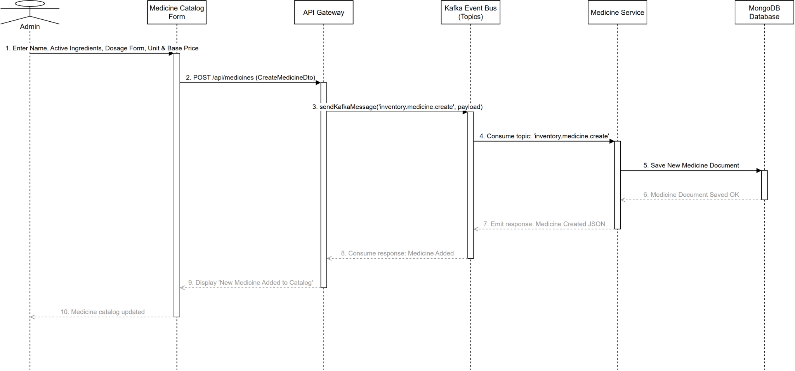
Figure 94. Sequence diagram for Add Medicine

3.6.15 Class Diagram for Update Medicine (UC-48)
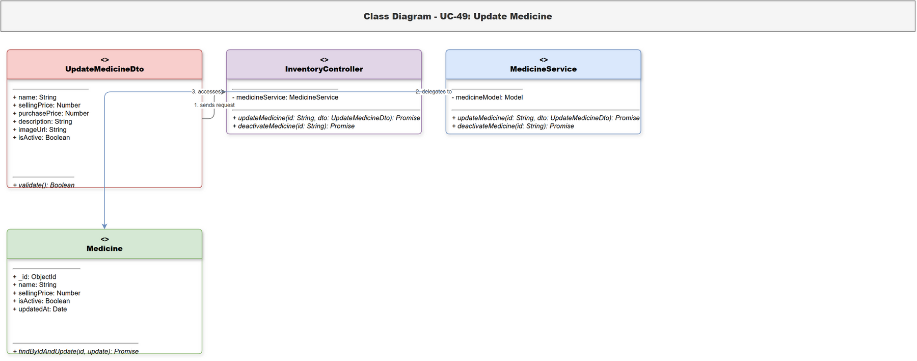
Figure 95. Class diagram for Update Medicine

3.6.16 Sequence Diagram for Update Medicine (UC-48)
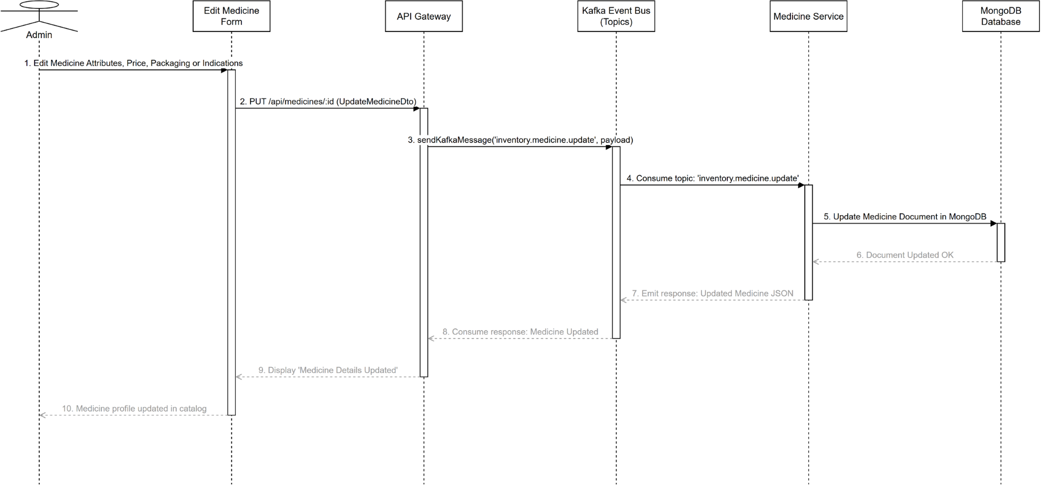
Figure 96. Sequence diagram for Update Medicine

3.6.17 Class Diagram for View Supplier List (UC-49)
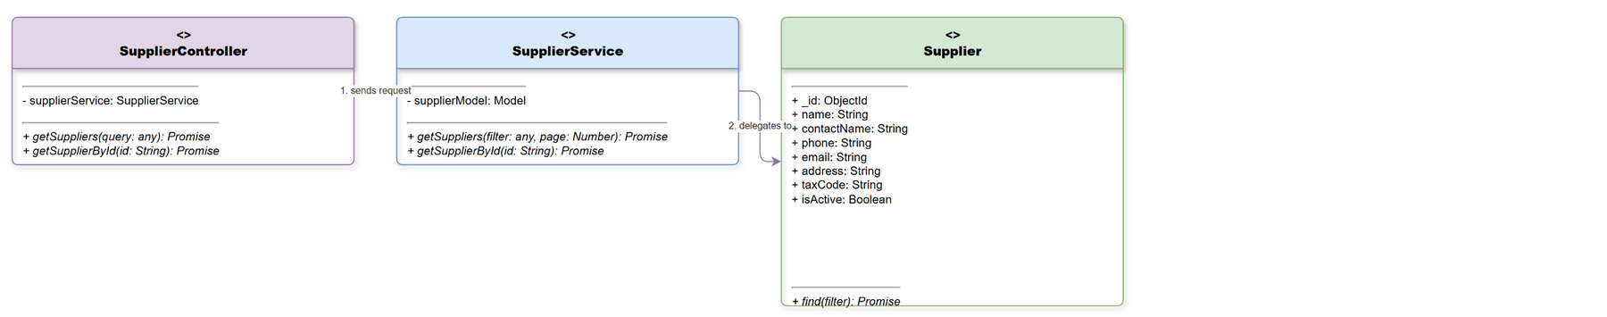
Figure 97. Class diagram for View Supplier List

3.6.18 Sequence Diagram for View Supplier List (UC-49)
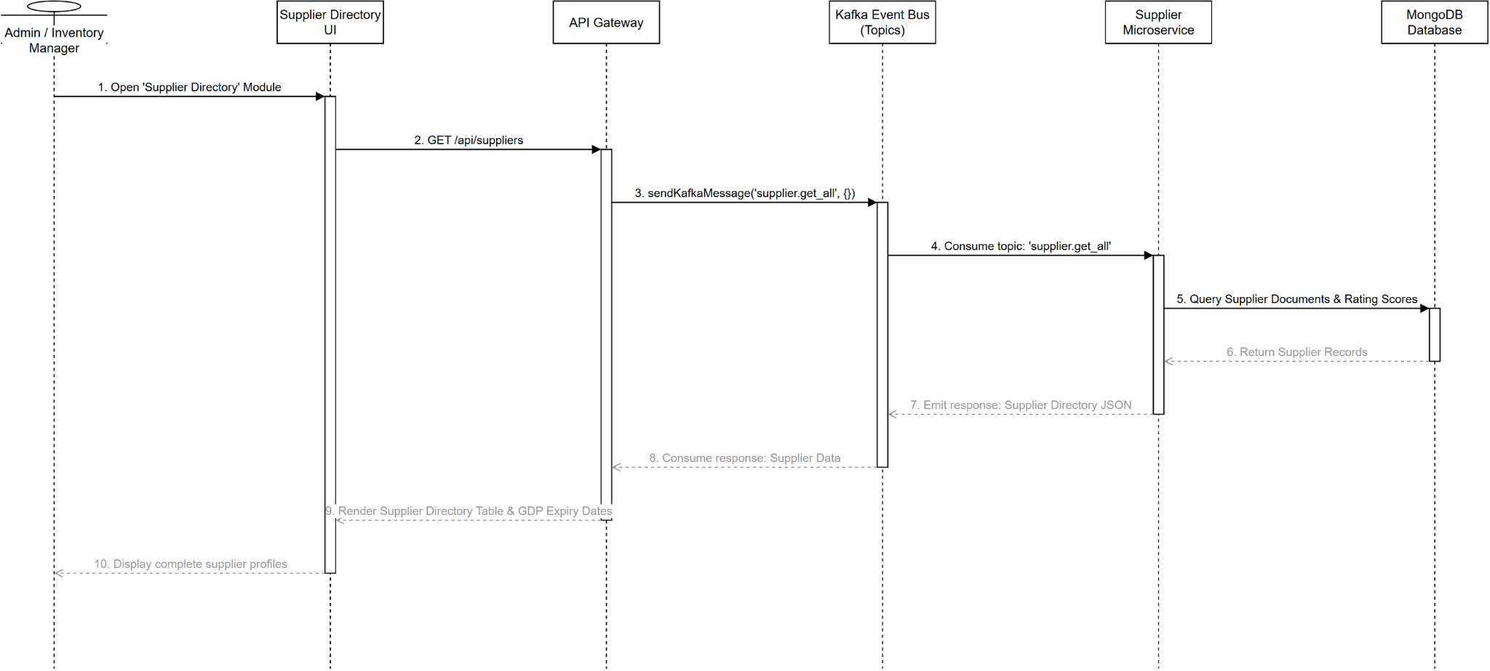
Figure 98. Sequence diagram for View Supplier List

3.6.19 Class Diagram for Add Supplier (UC-50)
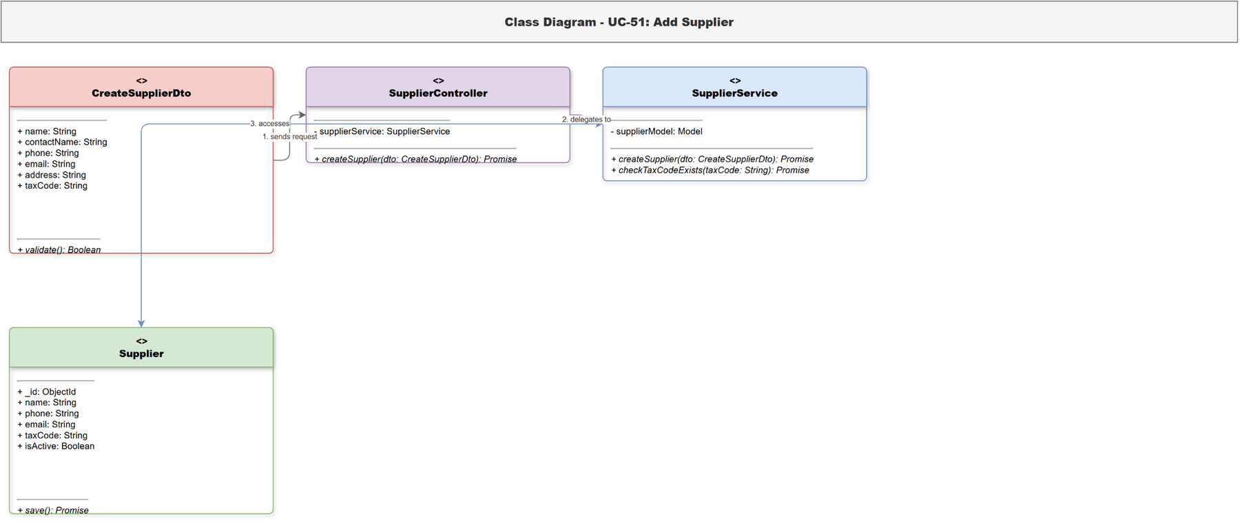
Figure 99. Class diagram for Add Supplier

3.6.20 Sequence Diagram for Add Supplier (UC-50)
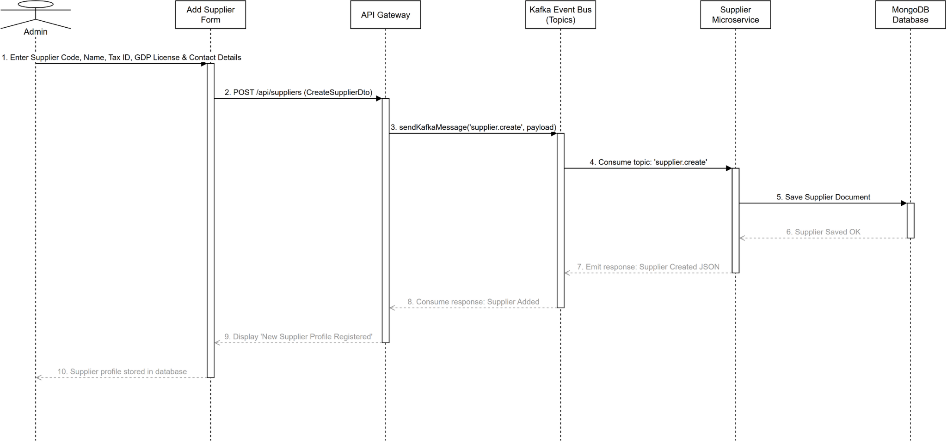
Figure 100. Sequence diagram for Add Supplier

3.6.21 Class Diagram for Update Supplier (UC-51)
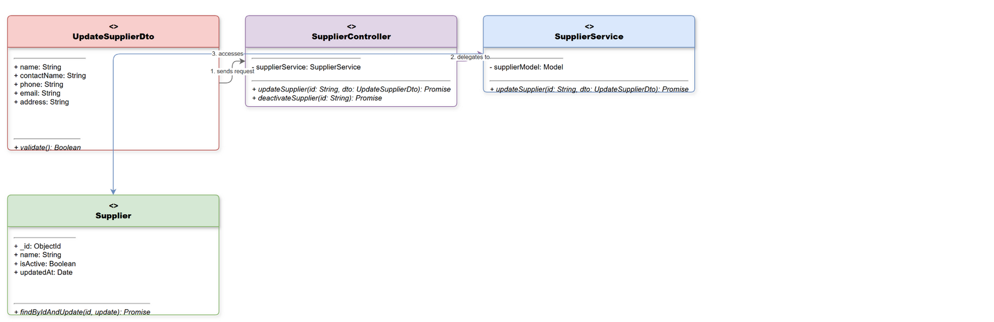
Figure 101. Class diagram for Update Supplier

3.6.22 Sequence Diagram for Update Supplier (UC-51)
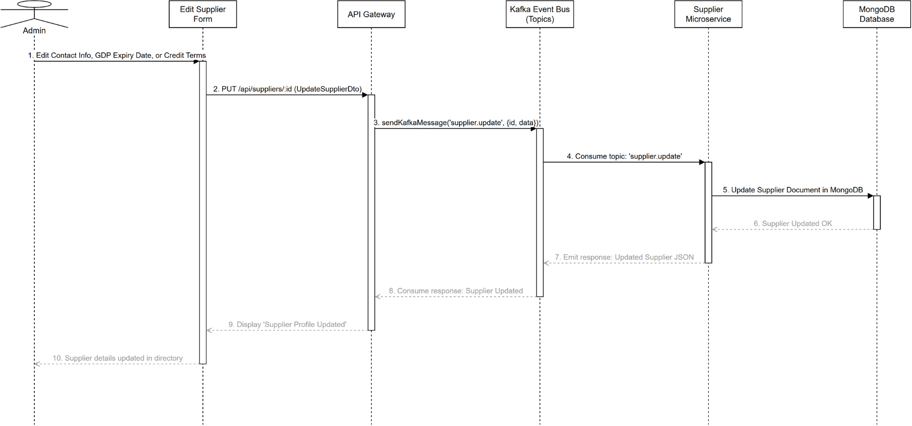
Figure 102. Sequence diagram for Update Supplier

3.7 Corporate Finance, Approvals & AI Analytics

3.7.1 Class Diagram for View Revenue Dashboard (UC-52)
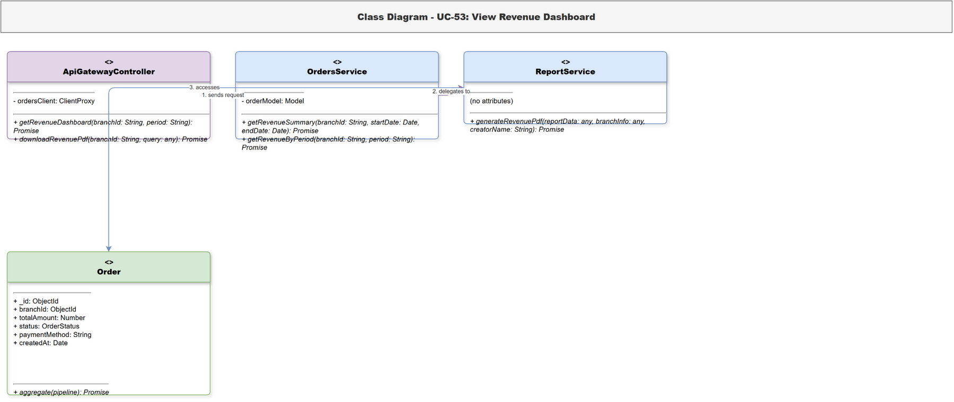
Figure 103. Class diagram for View Revenue Dashboard

3.7.2 Sequence Diagram for View Revenue Dashboard (UC-52)
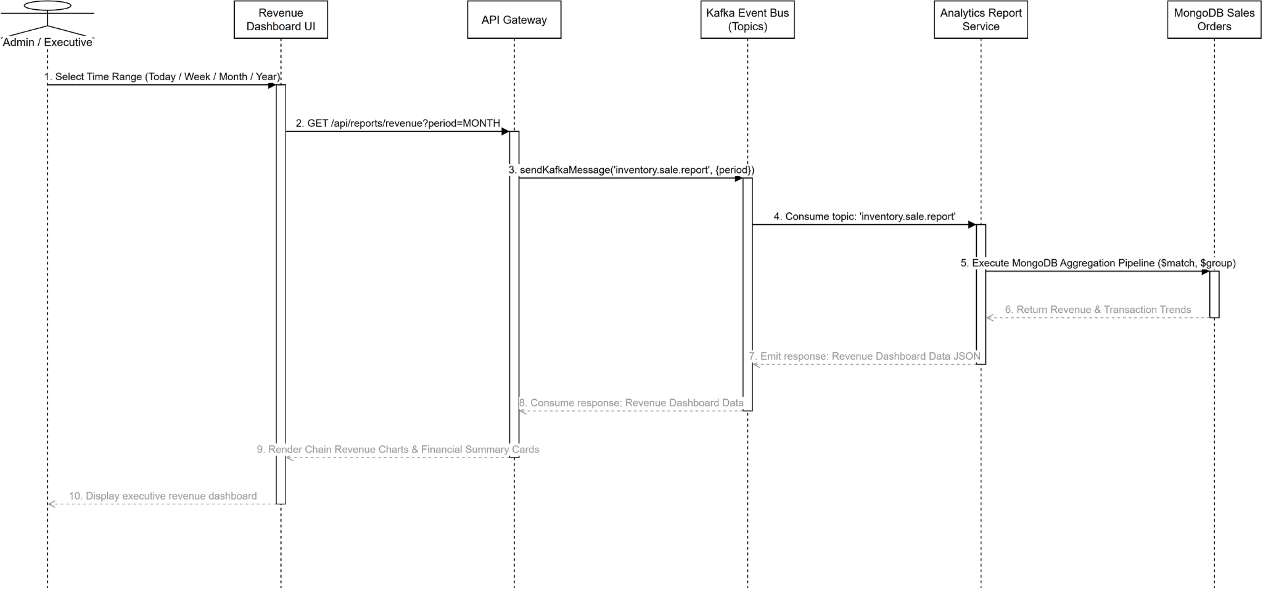
Figure 104. Sequence diagram for View Revenue Dashboard

3.7.3 Class Diagram for Compare Branch Performance (UC-53)
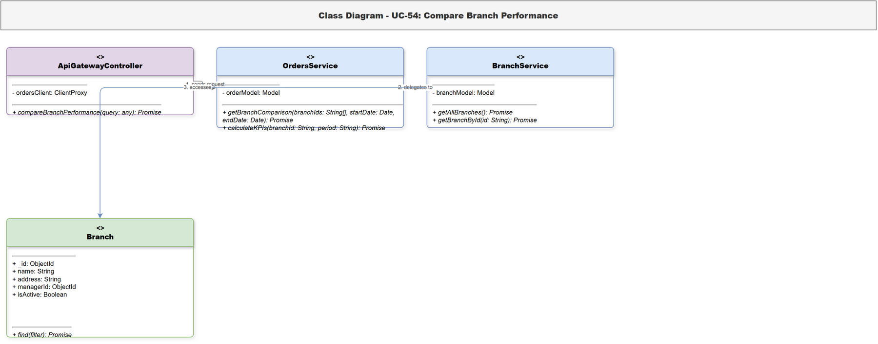
Figure 105. Class diagram for Compare Branch Performance

3.7.4 Sequence Diagram for Compare Branch Performance (UC-53)
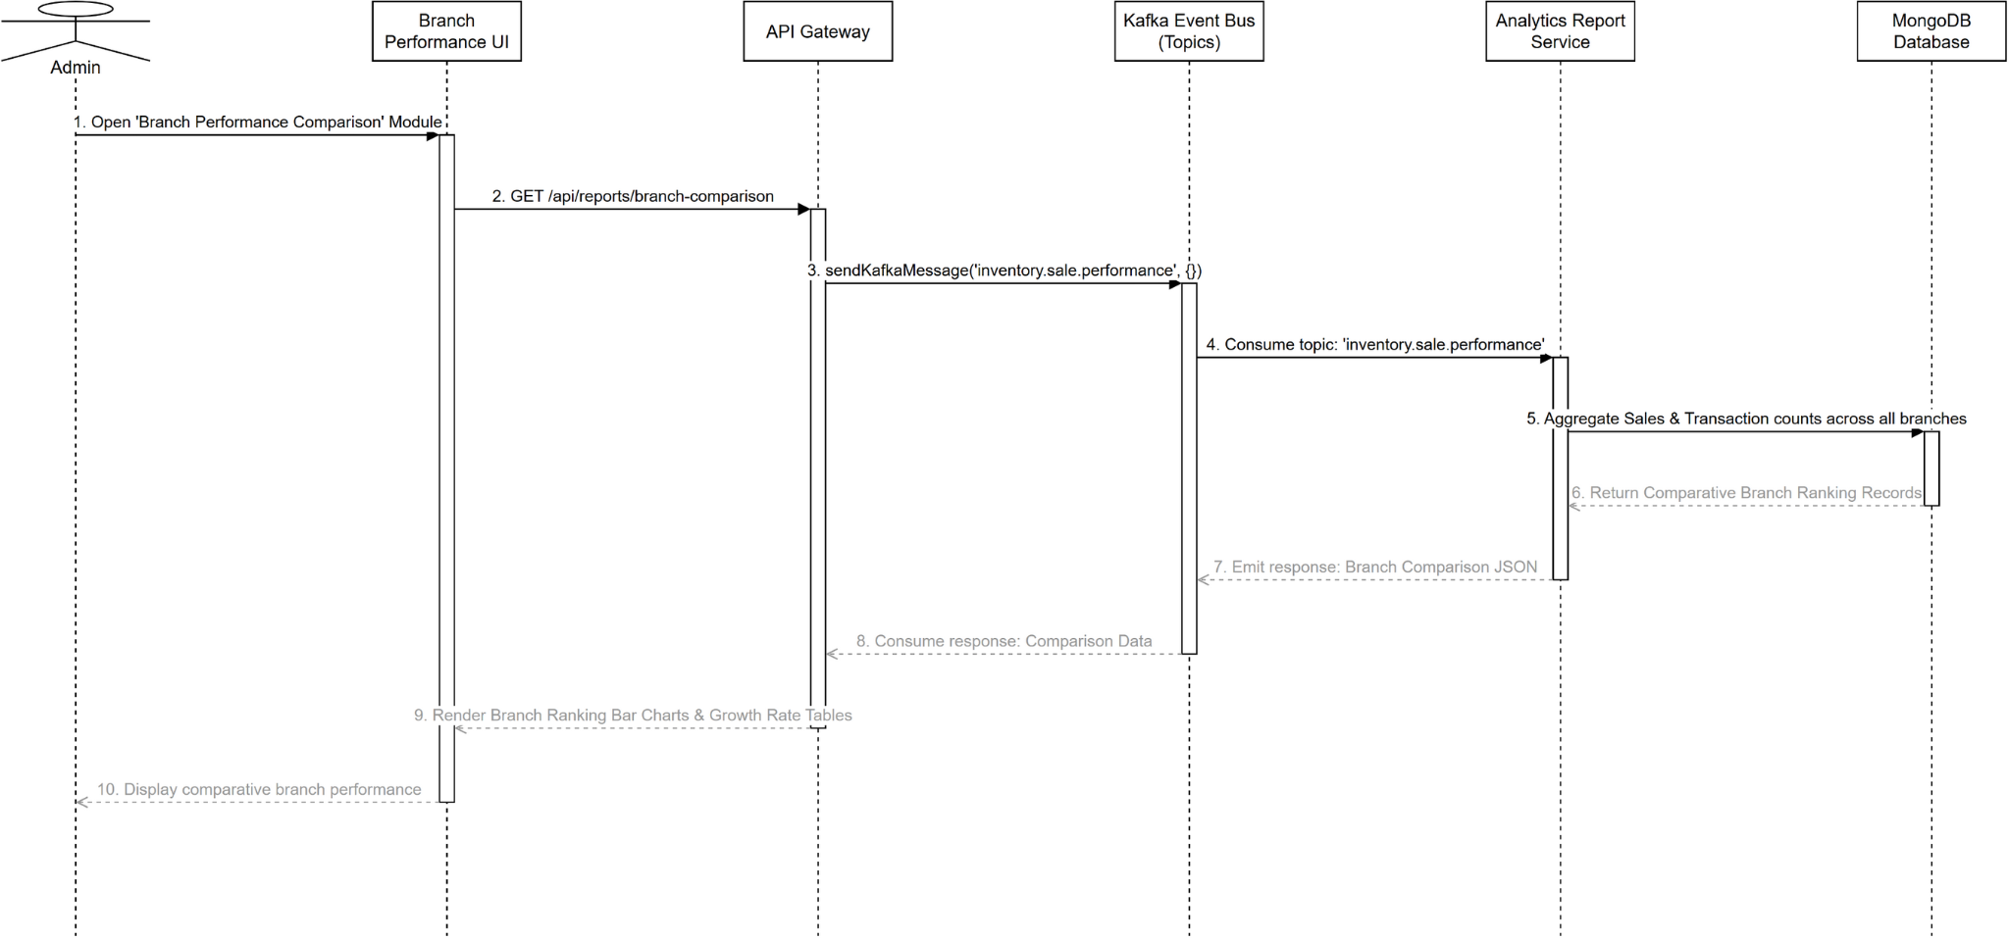
Figure 106. Sequence diagram for Compare Branch Performance

3.7.5 Class Diagram for Approve Purchase Order (PO) (UC-54)
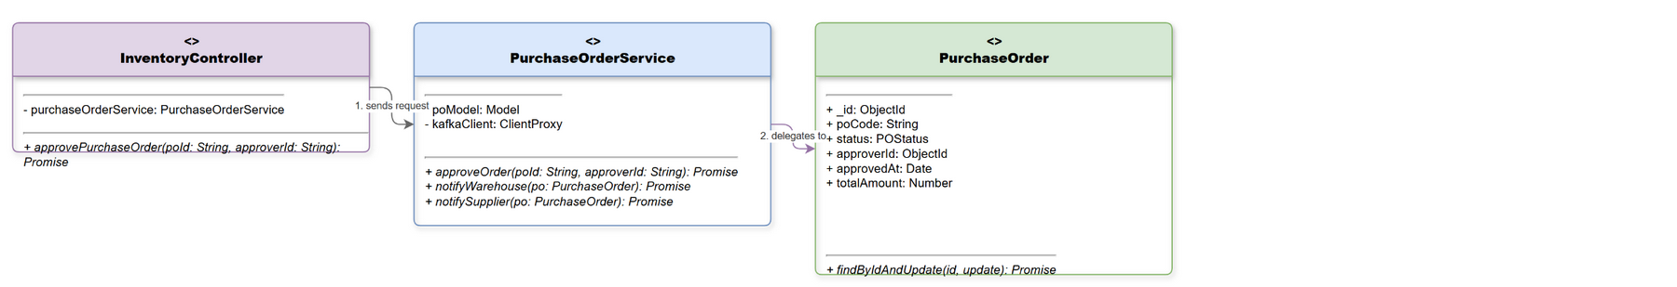
Figure 107. Class diagram for Approve Purchase Order (PO)

3.7.6 Sequence Diagram for Approve Purchase Order (PO) (UC-54)
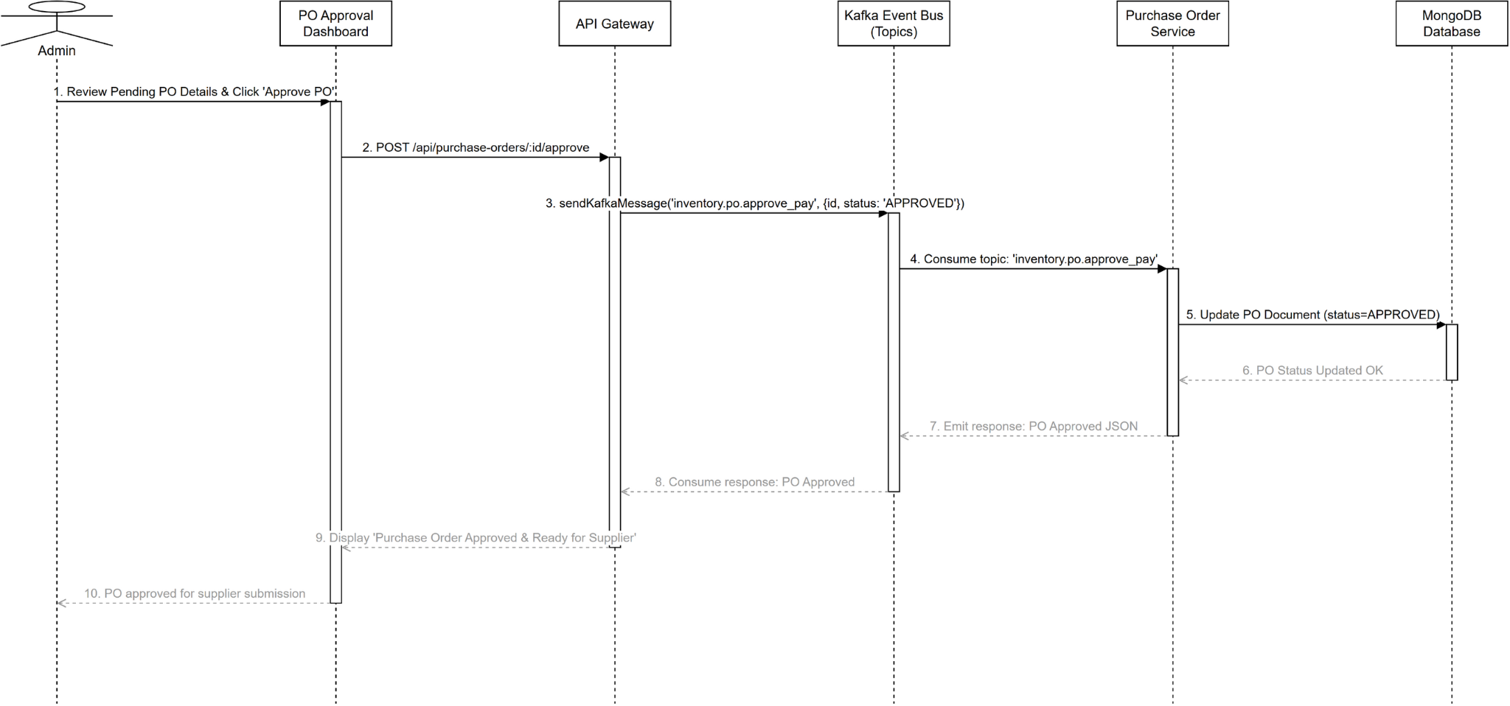
Figure 108. Sequence diagram for Approve Purchase Order (PO)

3.7.7 Class Diagram for Reject Purchase Order (PO) (UC-55)
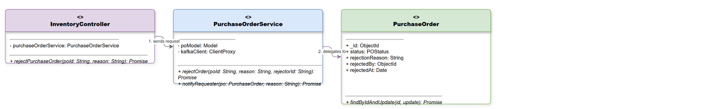
Figure 109. Class diagram for Reject Purchase Order (PO)

3.7.8 Sequence Diagram for Reject Purchase Order (PO) (UC-55)
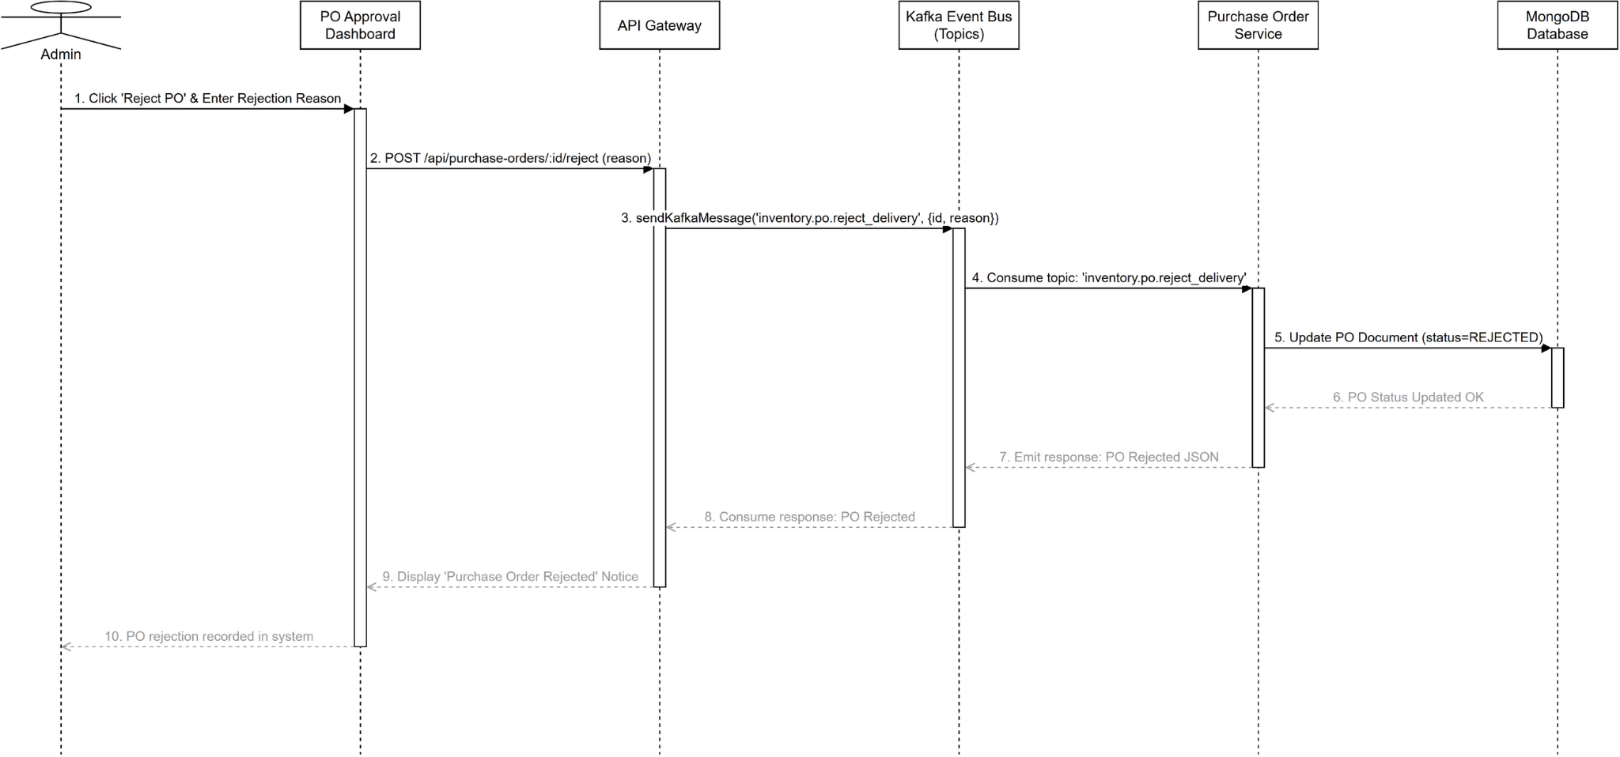
Figure 110. Sequence diagram for Reject Purchase Order (PO)

3.7.9 Class Diagram for Approve Goods Receipt Note (GRN) (UC-56)
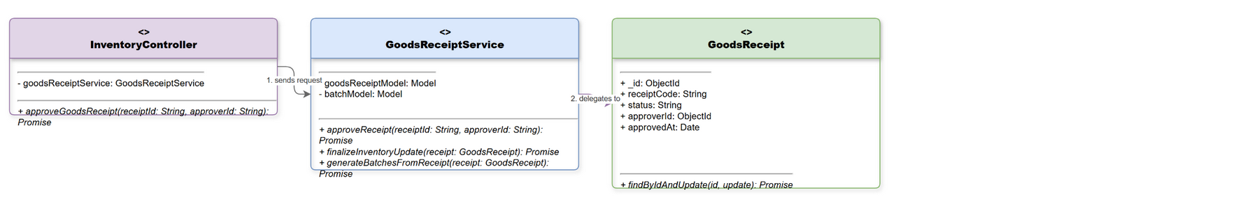
Figure 111. Class diagram for Approve Goods Receipt Note (GRN)

3.7.10 Sequence Diagram for Approve Goods Receipt Note (GRN) (UC-56)
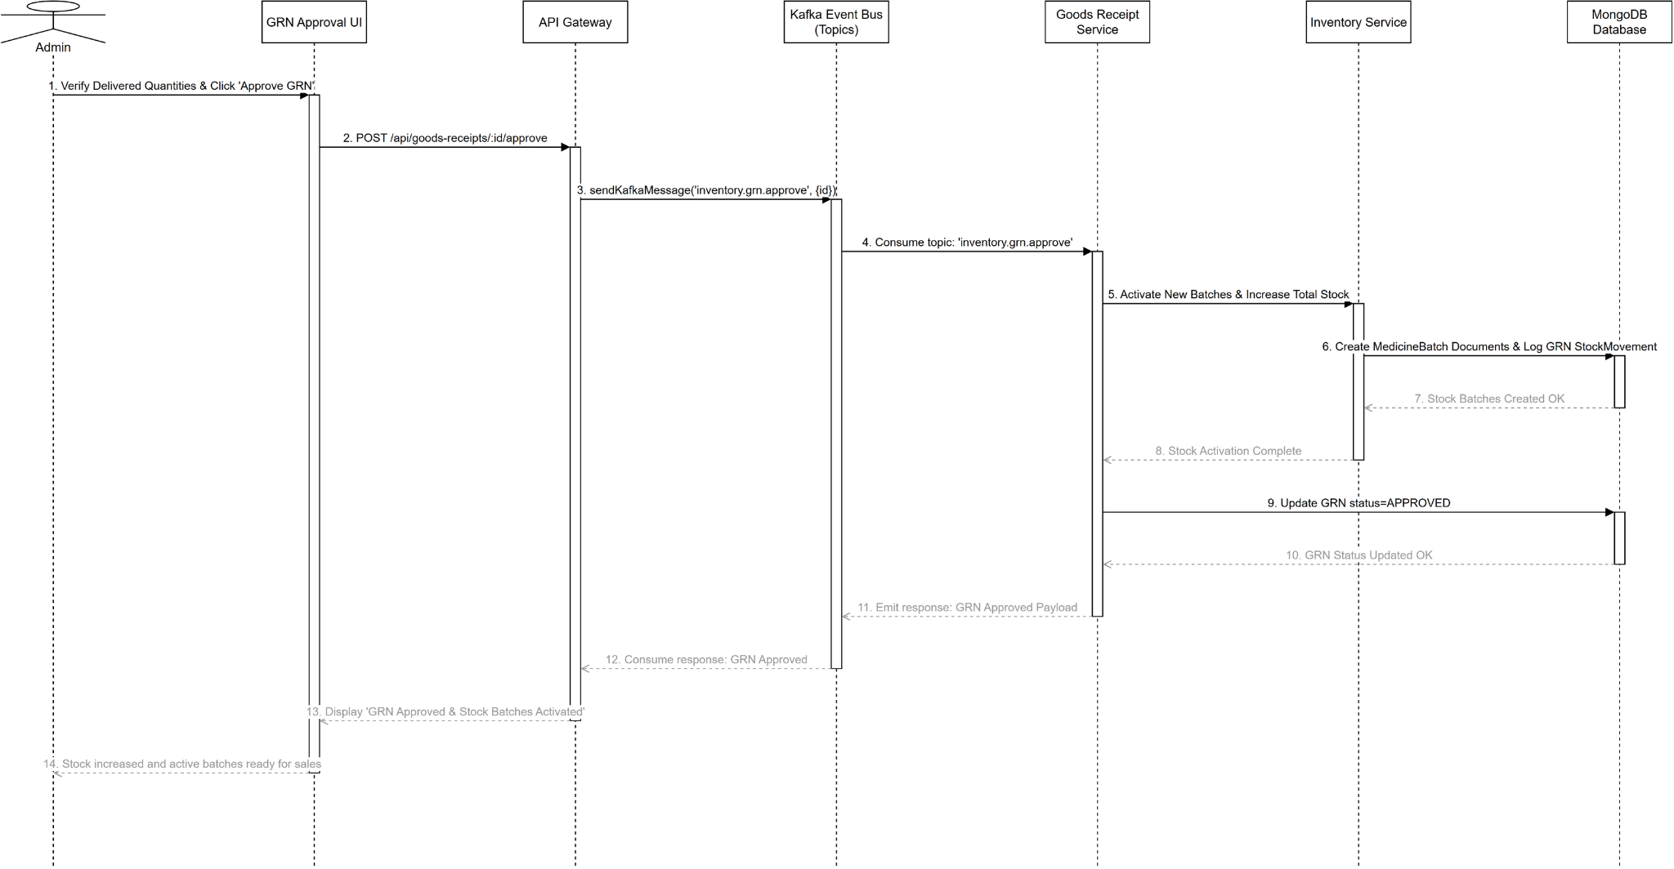
Figure 112. Sequence diagram for Approve Goods Receipt Note (GRN)

3.7.11 Class Diagram for Reject Goods Receipt Note (GRN) (UC-57)
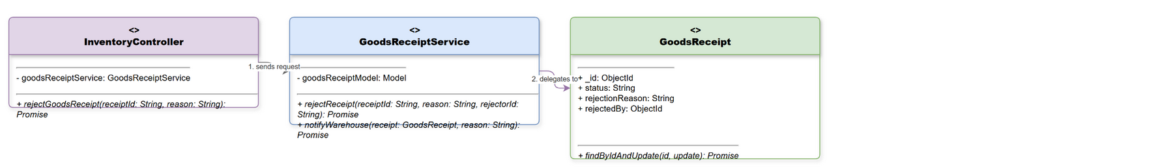
Figure 113. Class diagram for Reject Goods Receipt Note (GRN)

3.7.12 Sequence Diagram for Reject Goods Receipt Note (GRN) (UC-57)
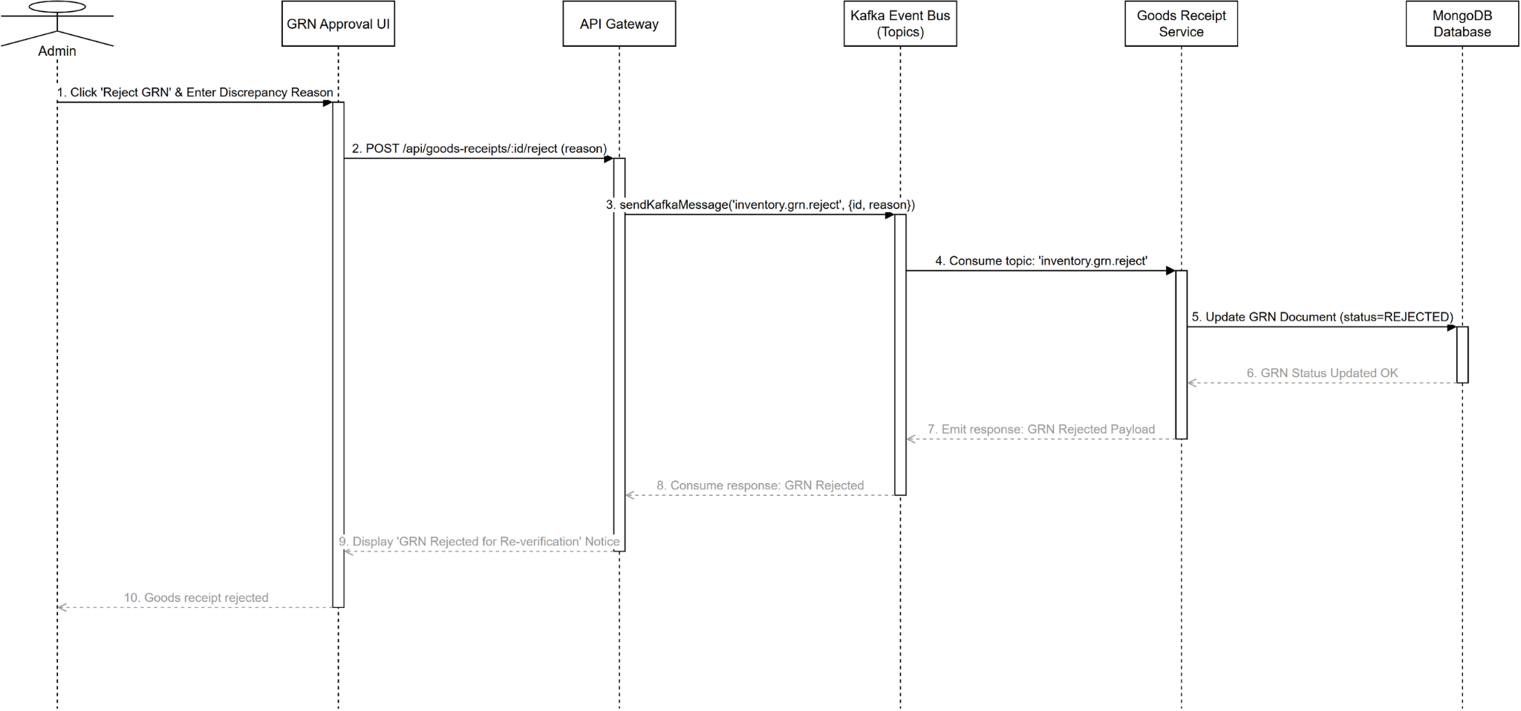
Figure 114. Sequence diagram for Reject Goods Receipt Note (GRN)

3.7.13 Class Diagram for Manage Promotions (UC-58)
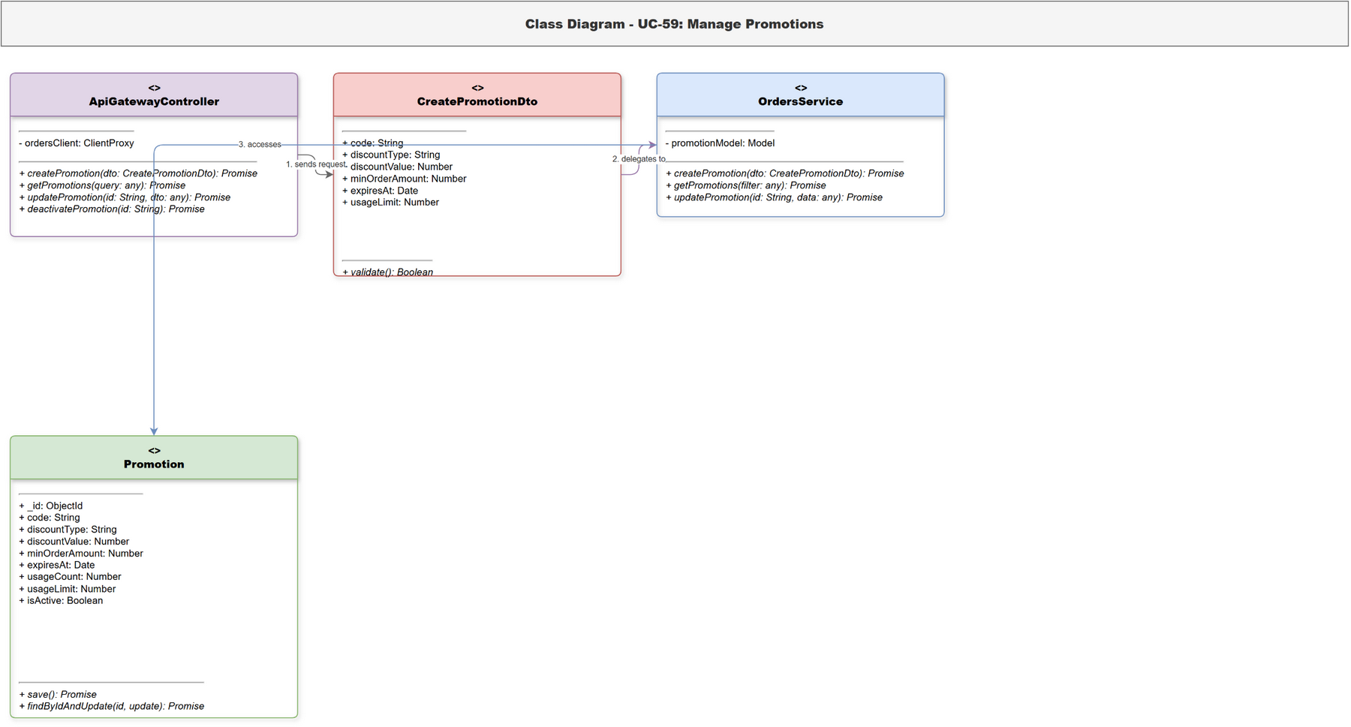
Figure 115. Class diagram for Manage Promotions

3.7.14 Sequence Diagram for Manage Promotions (UC-58)
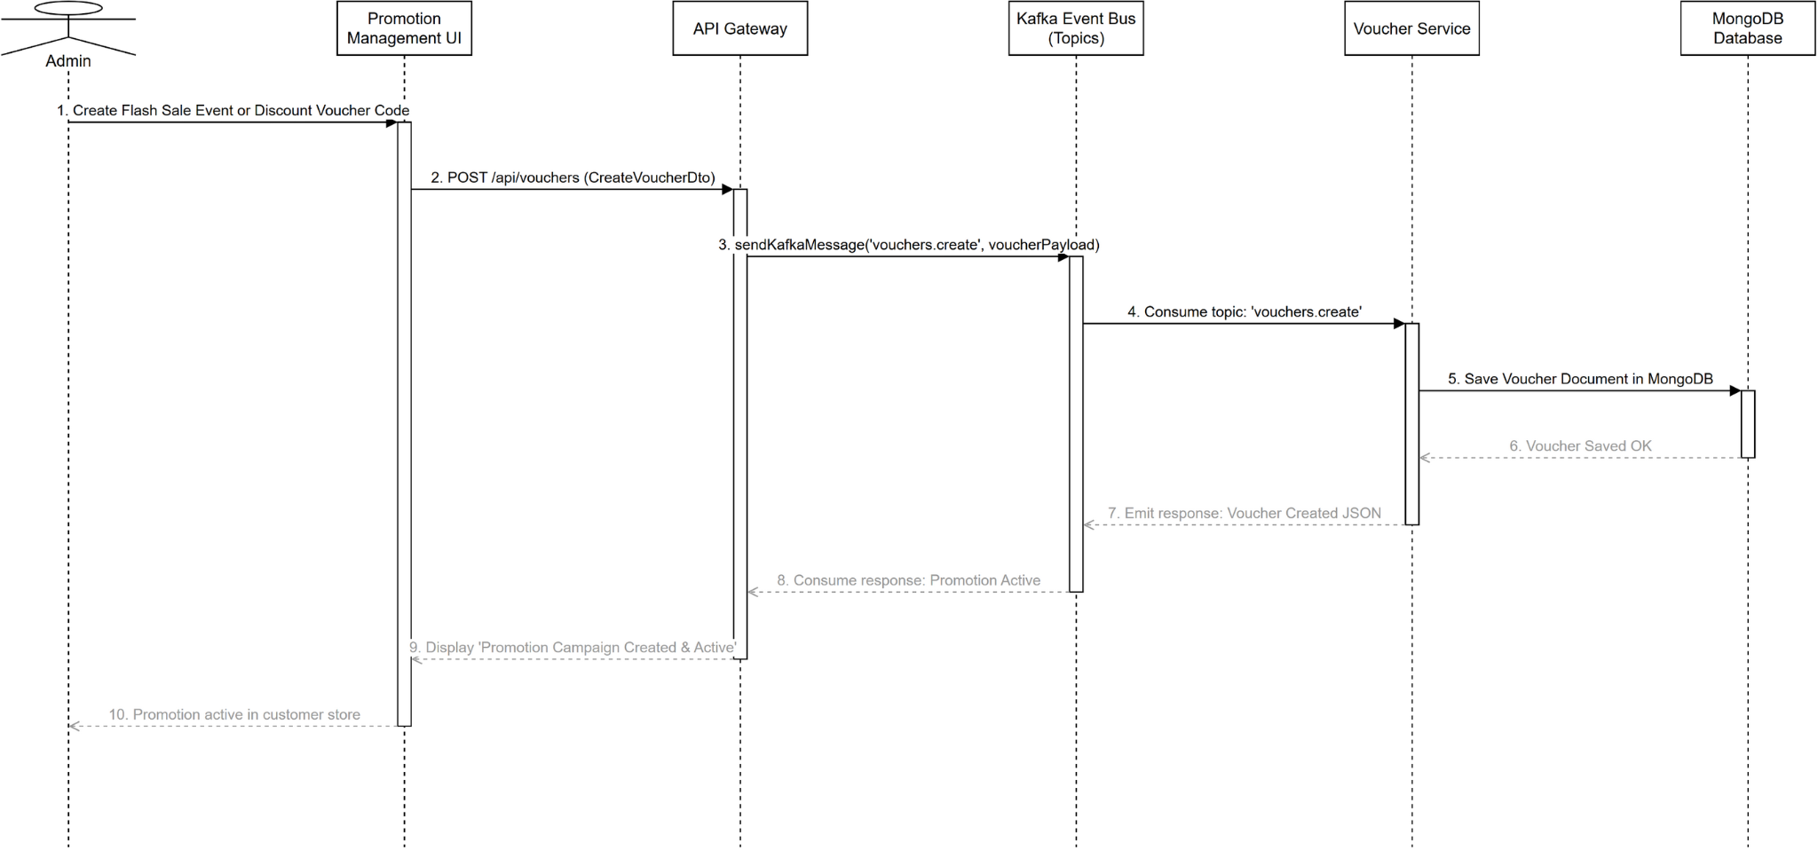
Figure 116. Sequence diagram for Manage Promotions

3.7.15 Class Diagram for Manage Cash Flow (UC-59)
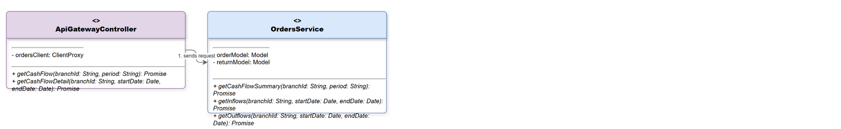
Figure 117. Class diagram for Manage Cash Flow

3.7.16 Sequence Di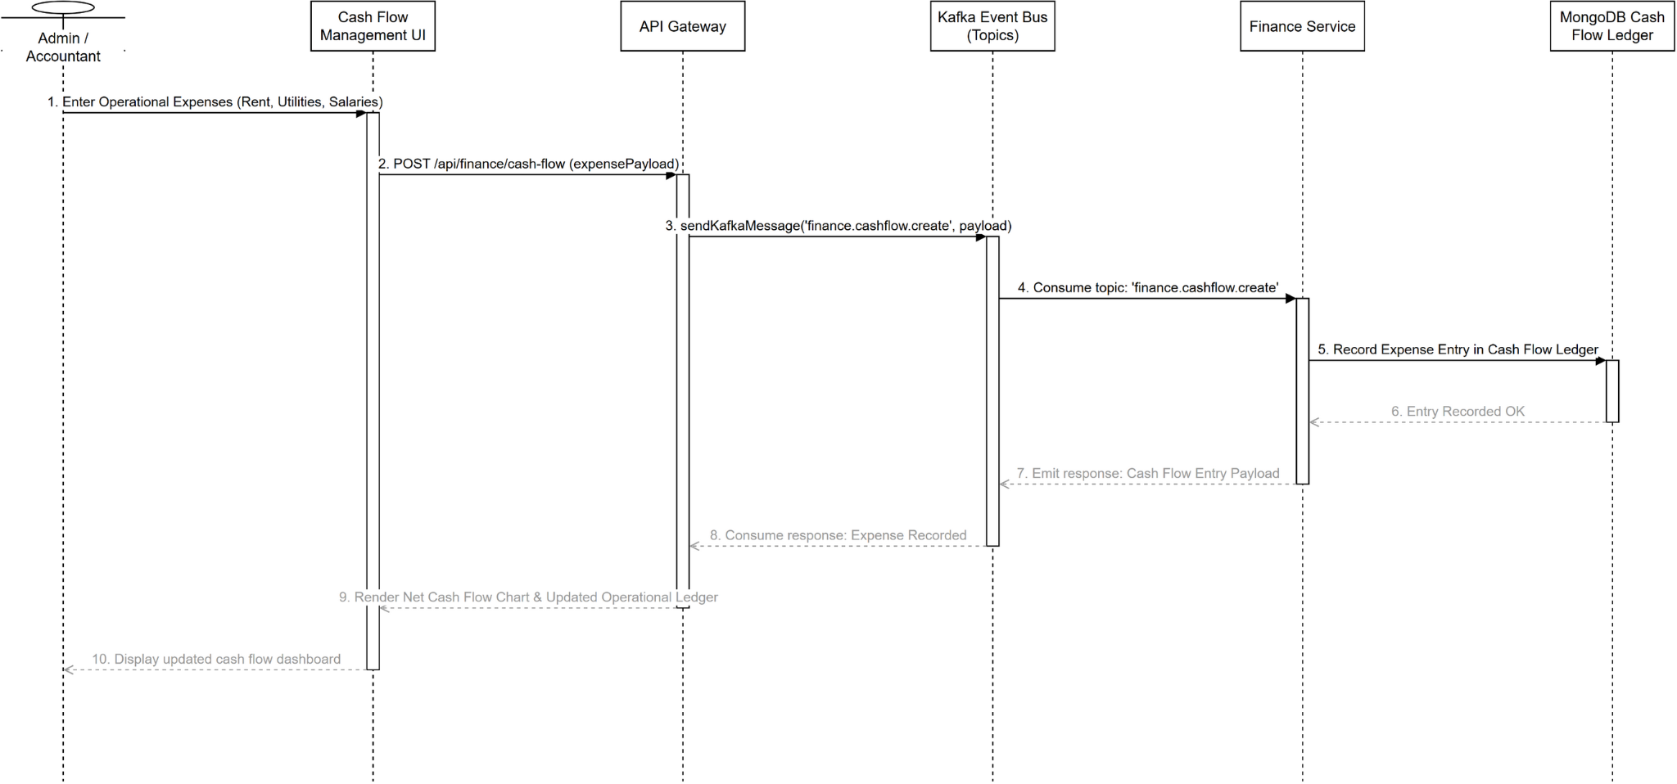agram for Manage Cash Flow (UC-59)

Figure 118. Sequence diagram for Manage Cash Flow

3.7.17 Class Diagram for Query Audit Logs (UC-60)
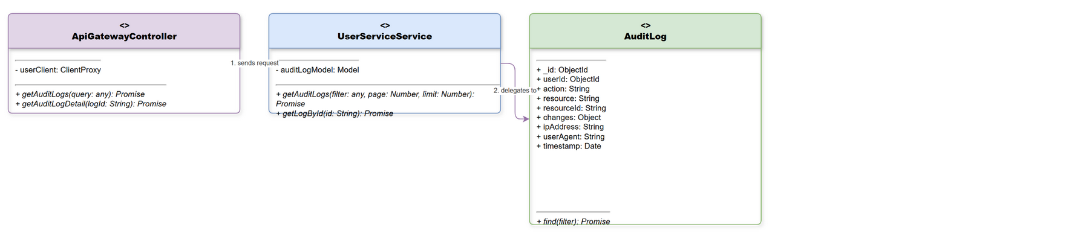
Figure 119. Class diagram for Query Audit Logs

3.7.18 Sequence Diagram for Query Audit Logs (UC-60)
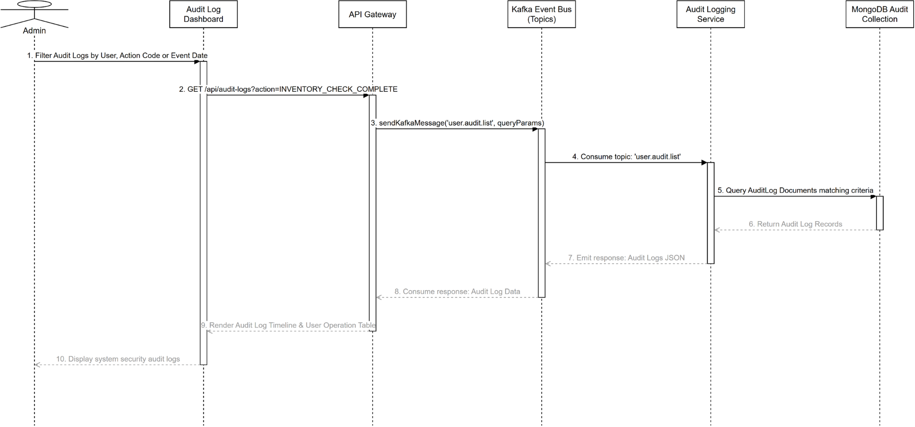
Figure 120. Sequence diagram for Query Audit Logs

3.7.19 Class Diagram for Forecast Demand (UC-61)
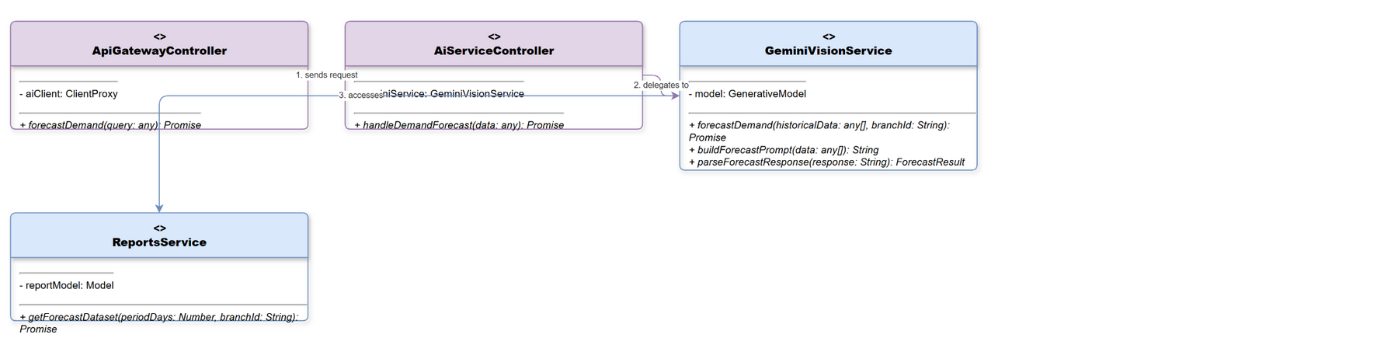
Figure 121. Class diagram for Forecast Demand

3.7.20 Sequence Diagram for Forecast Demand (UC-61)
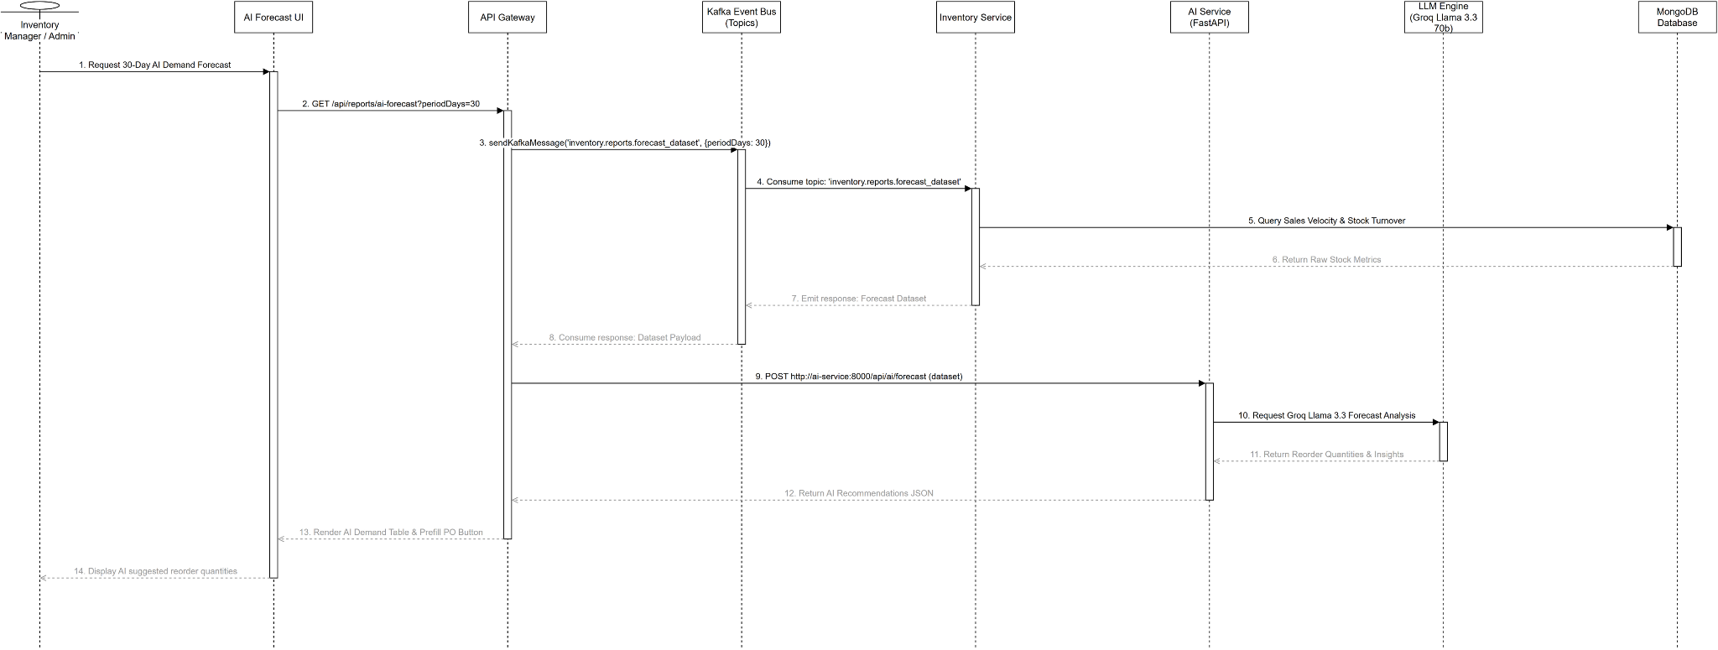
Figure 122. Sequence diagram for Forecast Demand

3.7.21 Class Diagram for Auto-Generate PO from AI Forecast (UC-62)
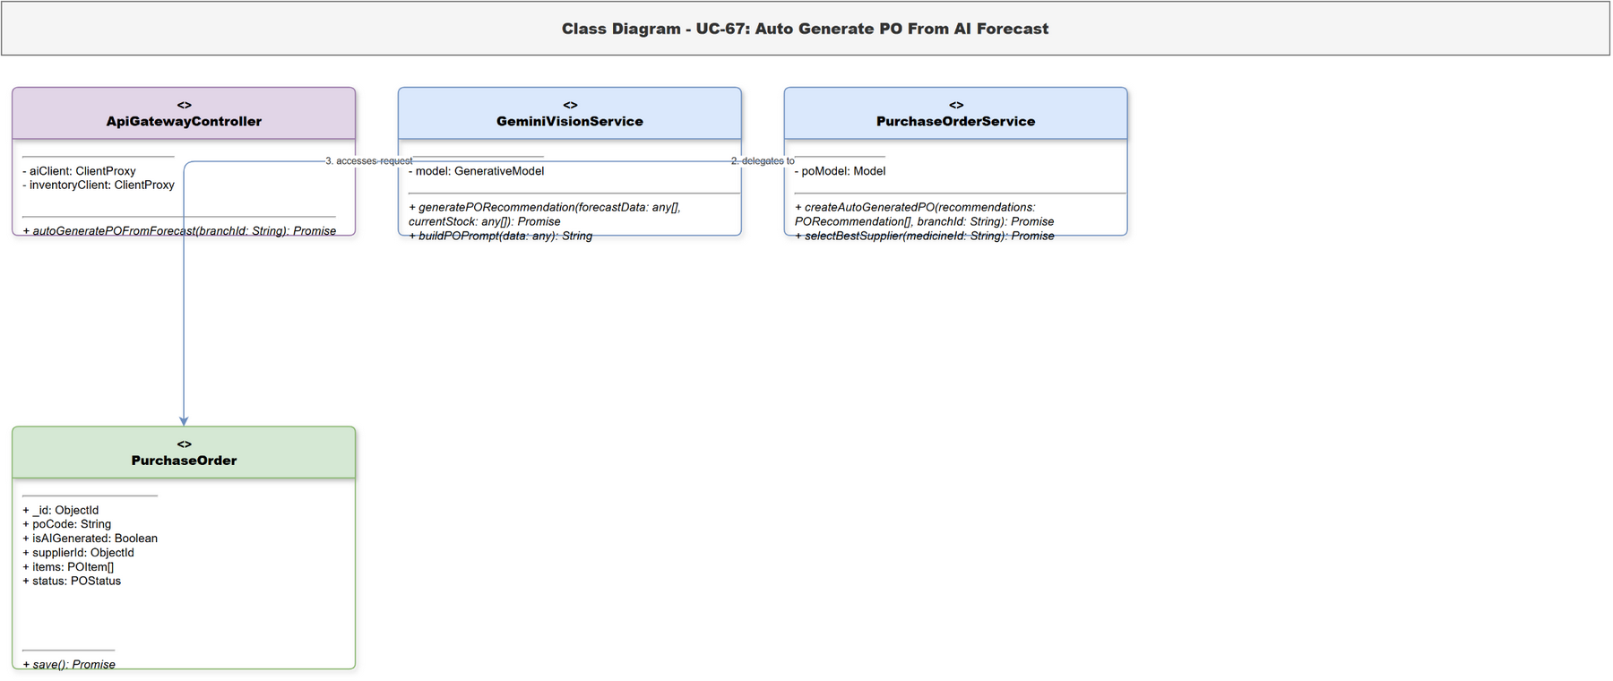
Figure 123. Class diagram for Auto-Generate PO from AI Forecast

3.7.22 Sequence Diagram for Auto-Generate PO from AI Forecast (UC-62)
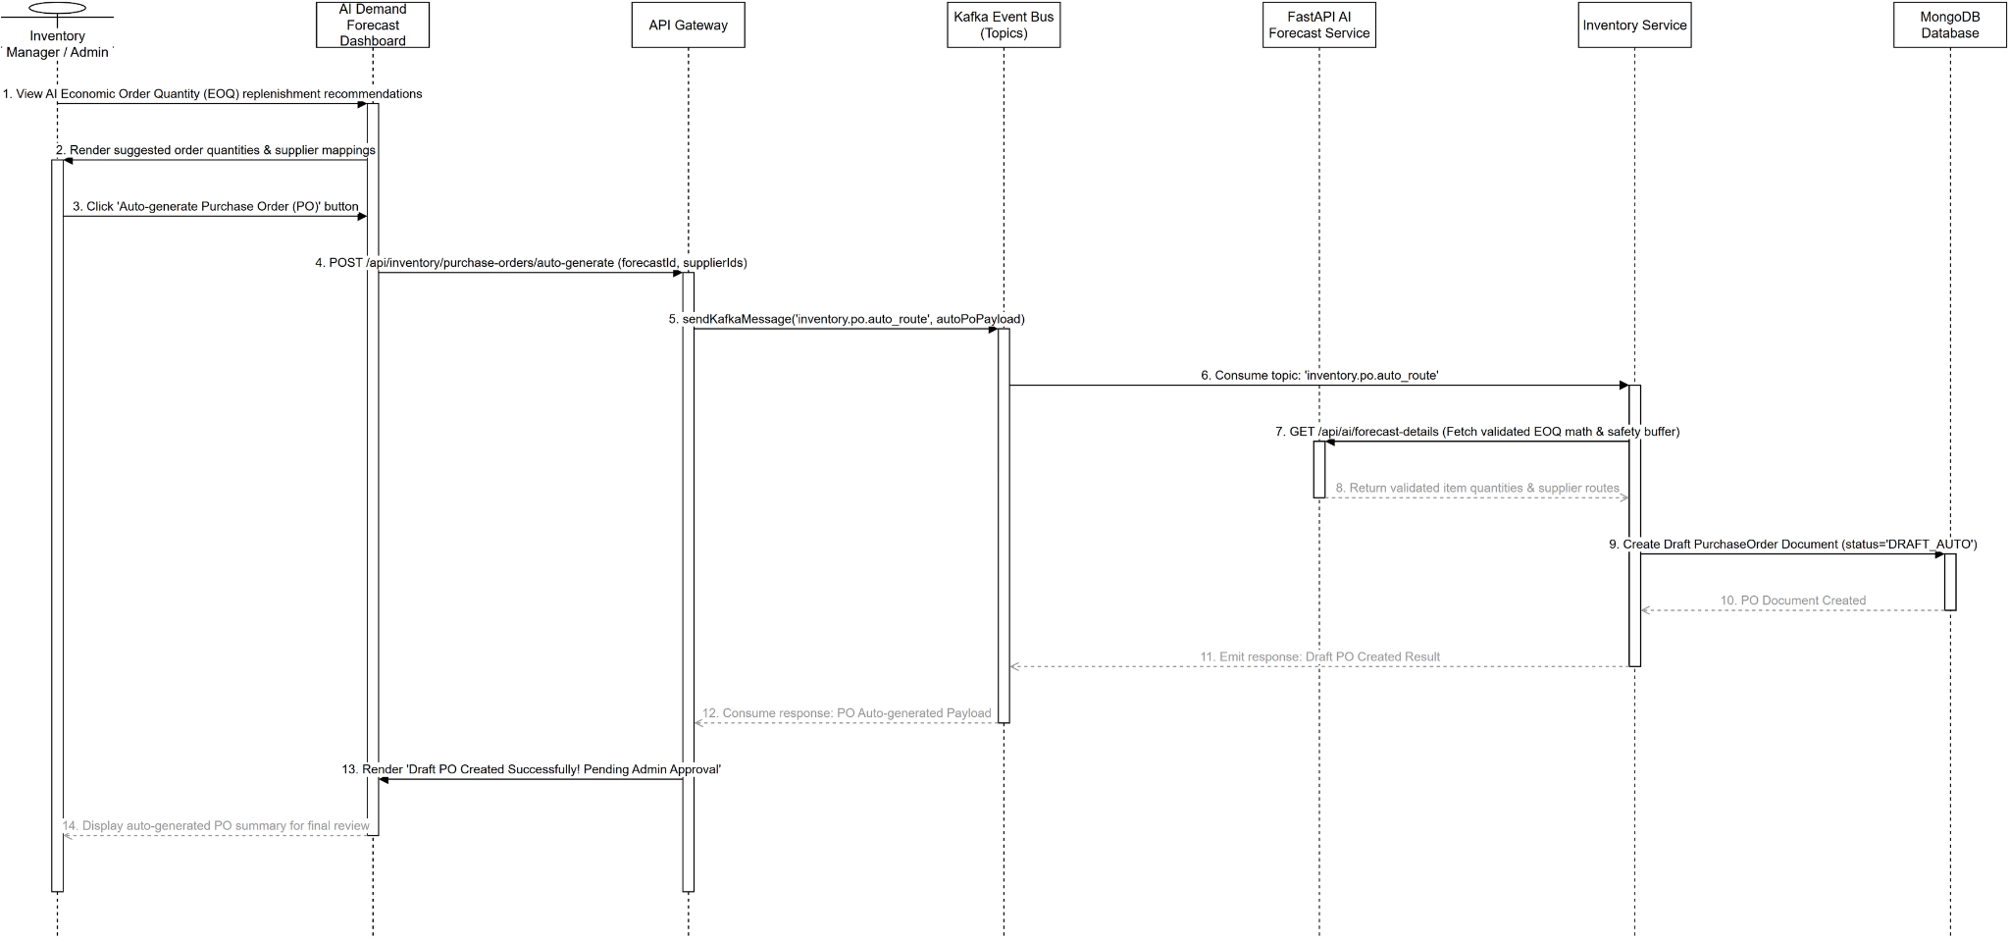
Figure 124. Sequence diagram for Auto-Generate PO from AI Forecast

3.7.23 Class Diagram for Detect Inventory Anomalies with AI (UC-63)
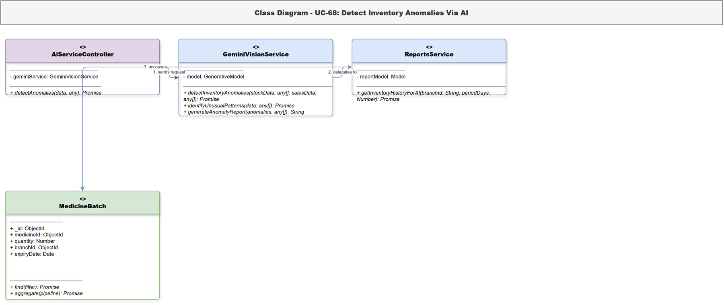
Figure 125. Class diagram for Detect Inventory Anomalies with AI

3.7.24 Sequence Diagram for Detect Inventory Anomalies with AI (UC-63)
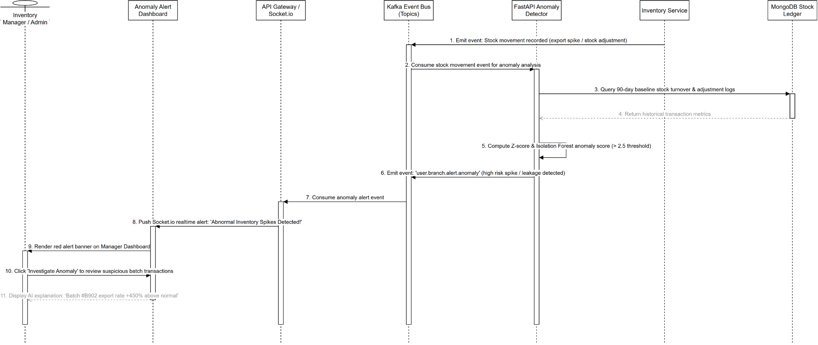
Figure 126. Sequence diagram for Detect Inventory Anomalies with AI

3.7.25 Class Diagram for Analyze Seasonal and Epidemic Trends (UC-64)
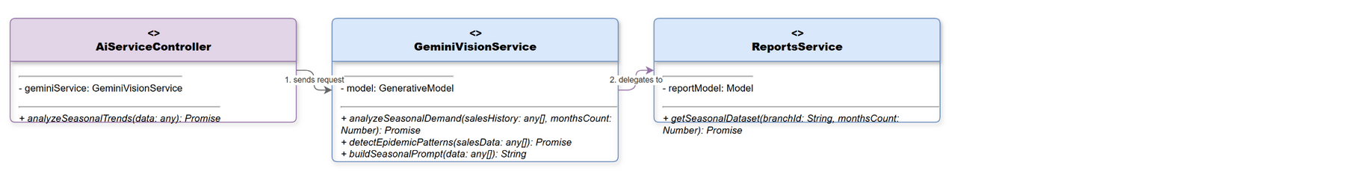
Figure 127. Class diagram for Analyze Seasonal and Epidemic Trends

3.7.26 Sequence Diagram for Analyze Seasonal and Epidemic Trends (UC-64)
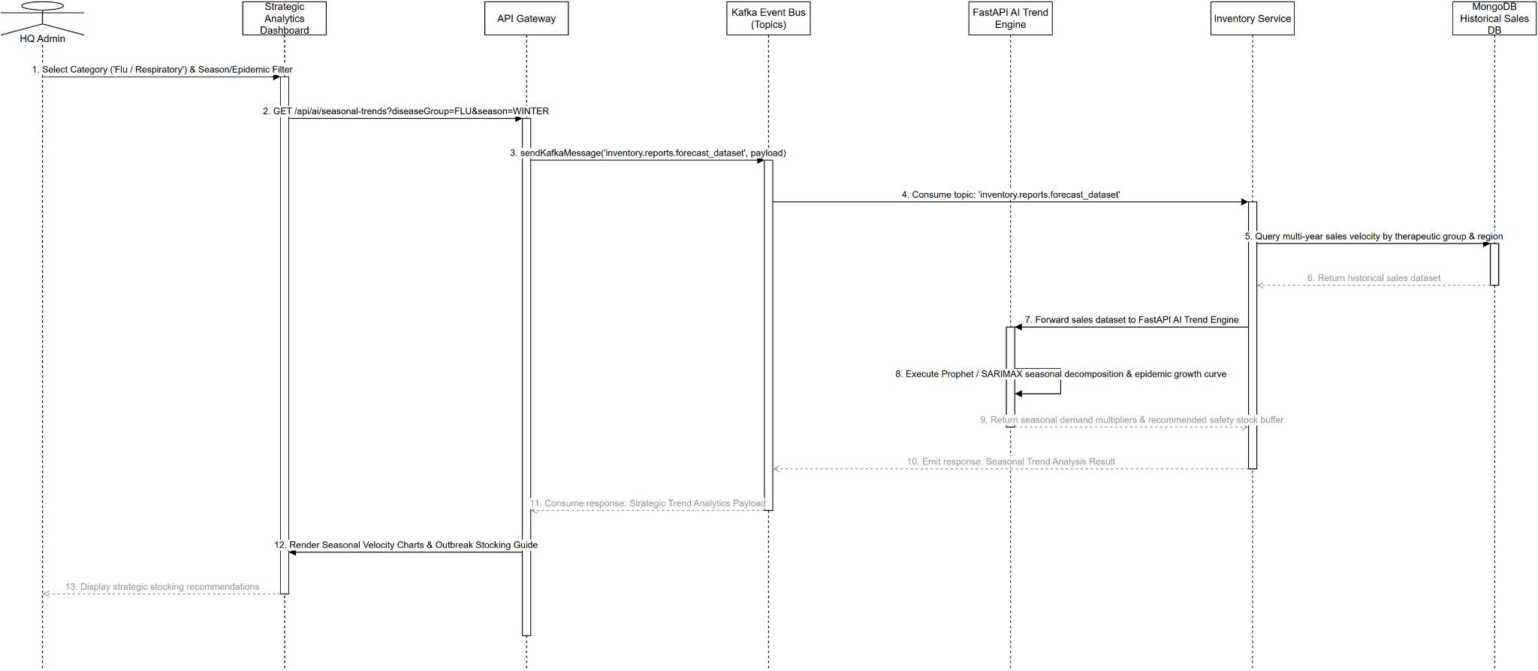
Figure 128. Sequence diagram for Analyze Seasonal and Epidemic Trends

3.7.27 Class Diagram for Receive Notifications (UC-65)
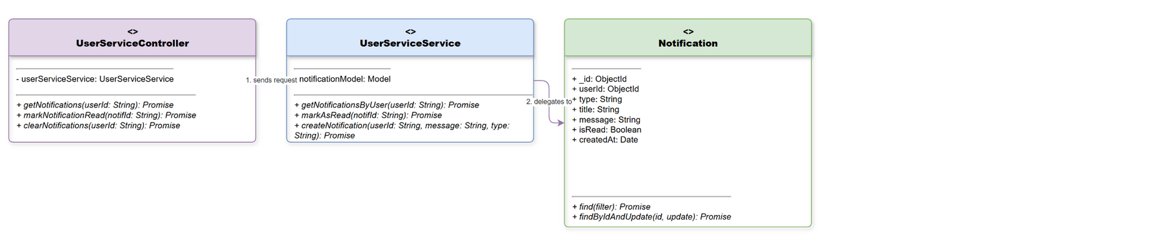
Figure 129. Class diagram for Receive Notifications

3.7.28 Sequence Diagram for Receive Notifications (UC-65)
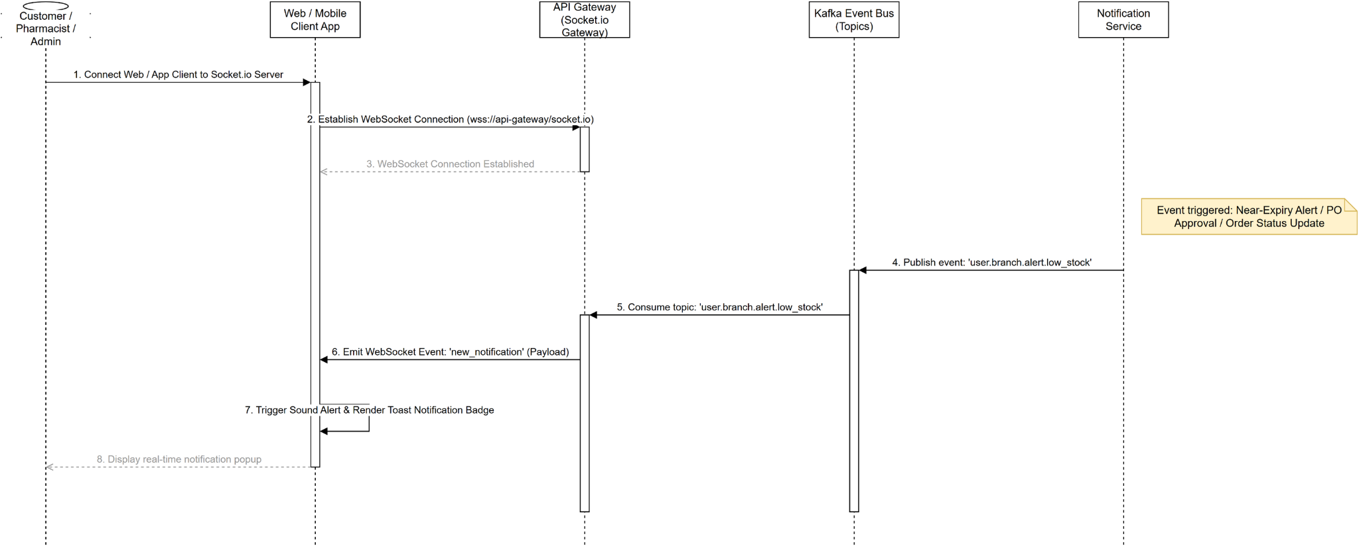
Figure 130. Sequence diagram for Receive Notifications

3.8 Sprint 5: Customer Care, Loyalty & Operational Governance

3.8.1 Class Diagram for Customer Complaint Handling (UC-61)
Figure 131. Class diagram for Customer Complaint Handling

3.8.2 Sequence Diagram for Customer Complaint Handling (UC-61)
Figure 132. Sequence diagram for Customer Complaint Handling

3.8.3 Class Diagram for Loyalty Tier & Member Benefits (UC-62)
Figure 133. Class diagram for Loyalty Tier & Member Benefits

3.8.4 Sequence Diagram for Loyalty Tier & Member Benefits (UC-62)
Figure 134. Sequence diagram for Loyalty Tier & Member Benefits

3.8.5 Class Diagram for Payment Webhook Reconciliation (UC-63)
Figure 135. Class diagram for Payment Webhook Reconciliation

3.8.6 Sequence Diagram for Payment Webhook Reconciliation (UC-63)
Figure 136. Sequence diagram for Payment Webhook Reconciliation

3.8.7 Class Diagram for Central Warehouse 2D Layout & Shelf Mapping (UC-65)
Figure 137. Class diagram for Warehouse 2D Layout Mapping

3.8.8 Sequence Diagram for Central Warehouse 2D Layout & Shelf Mapping (UC-65)
Figure 138. Sequence diagram for Warehouse 2D Layout Mapping

3.8.9 Class Diagram for RFM Customer Segmentation & Churn Analytics (UC-66)
Figure 139. Class diagram for RFM Customer Segmentation

3.8.10 Sequence Diagram for RFM Customer Segmentation & Churn Analytics (UC-66)
Figure 140. Sequence diagram for RFM Customer Segmentation

3.8.11 Class Diagram for Branch Cash Drawer Management (UC-67)
Figure 141. Class diagram for Branch Cash Drawer Management

3.8.12 Sequence Diagram for Branch Cash Drawer Management (UC-67)
Figure 142. Sequence diagram for Branch Cash Drawer Management

3.8.13 Class Diagram for Pharmacist OCR Prescription Verification (UC-68)
Figure 143. Class diagram for Pharmacist OCR Verification

3.8.14 Sequence Diagram for Pharmacist OCR Prescription Verification (UC-68)
Figure 144. Sequence diagram for Pharmacist OCR Verification

3.8.15 Class Diagram for Prescription OCR Audit History (UC-69)
Figure 145. Class diagram for Prescription OCR Audit History

3.8.16 Sequence Diagram for Prescription OCR Audit History (UC-69)
Figure 146. Sequence diagram for Prescription OCR Audit History

3.8.17 Class Diagram for Pharmacist Consultation Voice Recording History (UC-70)
Figure 147. Class diagram for Voice Recording History

3.8.18 Sequence Diagram for Pharmacist Consultation Voice Recording History (UC-70)
Figure 148. Sequence diagram for Voice Recording History

3.8.19 Class Diagram for Branch & Chain Cash Flow Analysis (UC-72)
Figure 149. Class diagram for Branch & Chain Cash Flow

3.8.20 Sequence Diagram for Branch & Chain Cash Flow Analysis (UC-72)
Figure 150. Sequence diagram for Branch & Chain Cash Flow

3.9 Sprint 6: Marketing Campaigns, AI Consultation & Warehouse IoT

3.9.1 Class Diagram for Time-limited Flash Sale Management (UC-74)
Figure 151. Class diagram for Flash Sale Management

3.9.2 Sequence Diagram for Time-limited Flash Sale Management (UC-74)
Figure 152. Sequence diagram for Flash Sale Management

3.9.3 Class Diagram for Advanced Promotional Voucher & Combo (UC-75)
Figure 153. Class diagram for Promotional Voucher & Combo

3.9.4 Sequence Diagram for Advanced Promotional Voucher & Combo (UC-75)
Figure 154. Sequence diagram for Promotional Voucher & Combo

3.9.5 Class Diagram for Automated Marketing Email Campaigns (UC-76)
Figure 155. Class diagram for Marketing Email Campaigns

3.9.6 Sequence Diagram for Automated Marketing Email Campaigns (UC-76)
Figure 156. Sequence diagram for Marketing Email Campaigns

3.9.7 Class Diagram for Customer Product Review & Rating (UC-77)
Figure 157. Class diagram for Product Review & Rating

3.9.8 Sequence Diagram for Customer Product Review & Rating (UC-77)
Figure 158. Sequence diagram for Product Review & Rating

3.9.9 Class Diagram for Import Medicine Auxiliary Label & Barcode Printing (UC-78)
Figure 159. Class diagram for Auxiliary Label & Barcode Printing

3.9.10 Sequence Diagram for Import Medicine Auxiliary Label & Barcode Printing (UC-78)
Figure 160. Sequence diagram for Auxiliary Label & Barcode Printing

3.9.11 Class Diagram for Multi-Supplier Bulk RFQ Quotation (UC-79)
Figure 161. Class diagram for Bulk RFQ Quotation

3.9.12 Sequence Diagram for Multi-Supplier Bulk RFQ Quotation (UC-79)
Figure 162. Sequence diagram for Bulk RFQ Quotation

3.9.13 Class Diagram for AI Symptom Consultation Chatbot (UC-80)
Figure 163. Class diagram for AI Symptom Consultation Chatbot

3.9.14 Sequence Diagram for AI Symptom Consultation Chatbot (UC-80)
Figure 164. Sequence diagram for AI Symptom Consultation Chatbot

3.9.15 Class Diagram for AI Voice Medicine Search (UC-81)
Figure 165. Class diagram for AI Voice Medicine Search

3.9.16 Sequence Diagram for AI Voice Medicine Search (UC-81)
Figure 166. Sequence diagram for AI Voice Medicine Search

3.9.17 Class Diagram for IoT Central Warehouse Telemetry & Alerts (UC-82)
Figure 167. Class diagram for IoT Warehouse Telemetry

3.9.18 Sequence Diagram for IoT Central Warehouse Telemetry & Alerts (UC-82)
Figure 168. Sequence diagram for IoT Warehouse Telemetry

3.9.19 Class Diagram for Marketing Campaign ROI Analytics (UC-83)
Figure 169. Class diagram for Marketing Campaign ROI

3.9.20 Sequence Diagram for Marketing Campaign ROI Analytics (UC-83)
Figure 170. Sequence diagram for Marketing Campaign ROI

3.10 Sprint 7: POS Advanced Operations, Barcode & GSP Inventory

3.10.1 Class Diagram for Shift Handover & Cash Balancing (UC-84)
Figure 171. Class diagram for Shift Handover & Cash Balancing

3.10.2 Sequence Diagram for Shift Handover & Cash Balancing (UC-84)
Figure 172. Sequence diagram for Shift Handover & Cash Balancing

3.10.3 Class Diagram for Order & Transaction Cancellation (UC-85)
Figure 173. Class diagram for Order Cancellation

3.10.4 Sequence Diagram for Order & Transaction Cancellation (UC-85)
Figure 174. Sequence diagram for Order Cancellation

3.10.5 Class Diagram for Distance-based Delivery Fee Calculation (UC-86)
Figure 175. Class diagram for Delivery Fee Calculation

3.10.6 Sequence Diagram for Distance-based Delivery Fee Calculation (UC-86)
Figure 176. Sequence diagram for Delivery Fee Calculation

3.10.7 Class Diagram for Barcode Scanning Goods Receipt (UC-87)
Figure 177. Class diagram for Barcode Scanning Goods Receipt

3.10.8 Sequence Diagram for Barcode Scanning Goods Receipt (UC-87)
Figure 178. Sequence diagram for Barcode Scanning Goods Receipt

3.10.9 Class Diagram for Barcode Scanning Stock Dispatch (UC-88)
Figure 179. Class diagram for Barcode Stock Dispatch

3.10.10 Sequence Diagram for Barcode Scanning Stock Dispatch (UC-88)
Figure 180. Sequence diagram for Barcode Stock Dispatch

3.10.11 Class Diagram for Barcode Scanner Inventory Audit (UC-89)
Figure 181. Class diagram for Barcode Scanner Inventory Audit

3.10.12 Sequence Diagram for Barcode Scanner Inventory Audit (UC-89)
Figure 182. Sequence diagram for Barcode Scanner Inventory Audit

3.10.13 Class Diagram for GSP Bin & Rack Warehouse Location Management (UC-90)
Figure 183. Class diagram for GSP Bin & Rack Location Management

3.10.14 Sequence Diagram for GSP Bin & Rack Warehouse Location Management (UC-90)
Figure 184. Sequence diagram for GSP Bin & Rack Location Management

3.10.15 Class Diagram for SKU Code Generation & GS1 Barcode Generator (UC-91)
Figure 185. Class diagram for SKU Code & GS1 Barcode Generator

3.10.16 Sequence Diagram for SKU Code Generation & GS1 Barcode Generator (UC-91)
Figure 186. Sequence diagram for SKU Code & GS1 Barcode Generator

3.10.17 Class Diagram for Multi-Unit of Measure Conversion (UC-92)
Figure 187. Class diagram for Unit of Measure Conversion

3.10.18 Sequence Diagram for Multi-Unit of Measure Conversion (UC-92)
Figure 188. Sequence diagram for Unit of Measure Conversion

3.10.19 Class Diagram for Branch-specific Pricing Policy (UC-93)
Figure 189. Class diagram for Branch-specific Pricing Policy

3.10.20 Sequence Diagram for Branch-specific Pricing Policy (UC-93)
Figure 190. Sequence diagram for Branch-specific Pricing Policy

3.10.21 Class Diagram for Negative & Discrepancy Stock Alert (UC-94)
Figure 191. Class diagram for Negative Stock Alert

3.10.22 Sequence Diagram for Negative & Discrepancy Stock Alert (UC-94)
Figure 192. Sequence diagram for Negative Stock Alert

3.10.23 Class Diagram for AI Cross-sell & Bundled Medicine Recommendation (UC-95)
Figure 193. Class diagram for AI Cross-sell Recommendation

3.10.24 Sequence Diagram for AI Cross-sell & Bundled Medicine Recommendation (UC-95)
Figure 194. Sequence diagram for AI Cross-sell Recommendation

3.11 Sprint 8: Omnichannel, Advanced AI Diagnostics & Enterprise Governance

3.11.1 Class Diagram for Customer Wishlist & Stock Back In Notification (UC-96)
Figure 195. Class diagram for Customer Wishlist & Back In Stock

3.11.2 Sequence Diagram for Customer Wishlist & Stock Back In Notification (UC-96)
Figure 196. Sequence diagram for Customer Wishlist & Back In Stock

3.11.3 Class Diagram for Rare Medicine Pre-Order Booking (UC-97)
Figure 197. Class diagram for Rare Medicine Pre-Order

3.11.4 Sequence Diagram for Rare Medicine Pre-Order Booking (UC-97)
Figure 198. Sequence diagram for Rare Medicine Pre-Order

3.11.5 Class Diagram for Post-Purchase CSAT Feedback Survey (UC-98)
Figure 199. Class diagram for CSAT Feedback Survey

3.11.6 Sequence Diagram for Post-Purchase CSAT Feedback Survey (UC-98)
Figure 200. Sequence diagram for CSAT Feedback Survey

3.11.7 Class Diagram for Health Quiz Gamification & Point Rewards (UC-99)
Figure 201. Class diagram for Health Gamification & Rewards

3.11.8 Sequence Diagram for Health Quiz Gamification & Point Rewards (UC-99)
Figure 202. Sequence diagram for Health Gamification & Rewards

3.11.9 Class Diagram for Delivery Proof & Shipper QR Scanner (UC-100)
Figure 203. Class diagram for Delivery Proof & Shipper QR

3.11.10 Sequence Diagram for Delivery Proof & Shipper QR Scanner (UC-100)
Figure 204. Sequence diagram for Delivery Proof & Shipper QR

3.11.11 Class Diagram for Social Pixel & Omnichannel Attribution Tracking (UC-101)
Figure 205. Class diagram for Social Pixel & Attribution Tracking

3.11.12 Sequence Diagram for Social Pixel & Omnichannel Attribution Tracking (UC-101)
Figure 206. Sequence diagram for Social Pixel & Attribution Tracking

3.11.13 Class Diagram for Narcotic & Restricted Medicine Compliance Log (UC-102)
Figure 207. Class diagram for Restricted Medicine Compliance Log

3.11.14 Sequence Diagram for Narcotic & Restricted Medicine Compliance Log (UC-102)
Figure 208. Sequence diagram for Restricted Medicine Compliance Log

3.11.15 Class Diagram for Supplier GDP Master Contract & Terms (UC-103)
Figure 209. Class diagram for Supplier GDP Master Contract

3.11.16 Sequence Diagram for Supplier GDP Master Contract & Terms (UC-103)
Figure 210. Sequence diagram for Supplier GDP Master Contract

3.11.17 Class Diagram for Supplier Payment Voucher Settlement (UC-104)
Figure 211. Class diagram for Supplier Payment Voucher

3.11.18 Sequence Diagram for Supplier Payment Voucher Settlement (UC-104)
Figure 212. Sequence diagram for Supplier Payment Voucher

3.11.19 Class Diagram for AI Supply Chain Disruption & Delay Risk Forecast (UC-105)
Figure 213. Class diagram for Supply Chain Risk Forecast

3.11.20 Sequence Diagram for AI Supply Chain Disruption & Delay Risk Forecast (UC-105)
Figure 214. Sequence diagram for Supply Chain Risk Forecast

3.11.21 Class Diagram for Digital Health Passport & Electronic Health Record (UC-106)
Figure 215. Class diagram for Digital Health Passport EHR

3.11.22 Sequence Diagram for Digital Health Passport & Electronic Health Record (UC-106)
Figure 216. Sequence diagram for Digital Health Passport EHR

3.11.23 Class Diagram for AI Allergy & Contraindication Cross-check (UC-107)
Figure 217. Class diagram for Allergy & Contraindication Check

3.11.24 Sequence Diagram for AI Allergy & Contraindication Cross-check (UC-107)
Figure 218. Sequence diagram for Allergy & Contraindication Check

3.11.25 Class Diagram for Prescription Adherence Tracking & Physician Report (UC-108)
Figure 219. Class diagram for Prescription Adherence Tracking

3.11.26 Sequence Diagram for Prescription Adherence Tracking & Physician Report (UC-108)
Figure 220. Sequence diagram for Prescription Adherence Tracking

3.11.27 Class Diagram for Multilingual AI Voice Commerce & Ordering (UC-109)
Figure 221. Class diagram for Multilingual AI Voice Commerce

3.11.28 Sequence Diagram for Multilingual AI Voice Commerce & Ordering (UC-109)
Figure 222. Sequence diagram for Multilingual AI Voice Commerce

3.11.29 Class Diagram for AI Best Procurement Price & Supplier Routing (UC-110)
Figure 223. Class diagram for AI Best Procurement Price Routing

3.11.30 Sequence Diagram for AI Best Procurement Price & Supplier Routing (UC-110)
Figure 224. Sequence diagram for AI Best Procurement Price Routing

3.11.31 Class Diagram for Pharmacist Sales KPI & Target Tracking (UC-111)
Figure 225. Class diagram for Pharmacist Sales KPI Tracking

3.11.32 Sequence Diagram for Pharmacist Sales KPI & Target Tracking (UC-111)
Figure 226. Sequence diagram for Pharmacist Sales KPI Tracking

3.11.33 Class Diagram for Disaster Recovery Backup & Manual Restore Log (UC-112)
Figure 227. Class diagram for Disaster Recovery Backup & Restore

3.11.34 Sequence Diagram for Disaster Recovery Backup & Manual Restore Log (UC-112)
Figure 228. Sequence diagram for Disaster Recovery Backup & Restore

3.11.35 Class Diagram for Biometric Mobile Authentication FaceID/Fingerprint (UC-113)
Figure 229. Class diagram for Biometric Mobile Authentication

3.11.36 Sequence Diagram for Biometric Mobile Authentication FaceID/Fingerprint (UC-113)
Figure 230. Sequence diagram for Biometric Mobile Authentication

3.11.37 Class Diagram for IoT Device Management & Sensor Calibration (UC-114)
Figure 231. Class diagram for IoT Device & Sensor Calibration

3.11.38 Sequence Diagram for IoT Device Management & Sensor Calibration (UC-114)
Figure 232. Sequence diagram for IoT Device & Sensor Calibration

