

CAPSTONE PROJECT REPORT
Report 2 – Project Management Plan

– Danang, August 2026 –
Table of Contents
I. Record of Changes 3
II. Project Management Plan 4
1. Overview 4
1.1 Scope & Estimation 4
1.2 Project Objectives 7
1.3 Project Risks 7
2. Management Approach 8
2.1 Project Process 8
2.2 Quality Management 10
2.3 Training Plan 11
3. Project Deliverables 11
4. Responsibility Assignments 12
5. Project Communications 12
6. Configuration Management 13
6.1 Document Management 13
6.2 Source Code Management 14
6.3 Tools & Infrastructures 15

I. Record of Changes
Date | A*  M, D | In charge | Change Description
25/08/2026 | A | PhucDA | Create initial Project Management Plan
*A - Added M - Modified D - Deleted

II. Project Management Plan

1. Overview

1.1 Scope & Estimation
Assume that all 5 team members work full-time on the capstone project (no other full-time job) and commit 8 hours per day. So, each member will commit 56 hours per week (7 man-days). For 14 weeks, the team will commit 490 man-days
# | WBS Item | Complexity | Est. Effort  (man-days)
1 | Project Initiation & Authentication, Account Management |  | 37
1.1 | Write Report 1 - Project Introduction | Simple | 2
1.2 | Write Report 2 - Project Management Plan | Medium | 4
1.3 | Write Report 3 - Software Requirement Specification | Medium | 5
1.4 | Deployment and CI/CD | Medium | 3
1.5 | Design user interface of Authentication, Account Management module | Medium | 4
1.6 | Coding register account | Medium | 3
1.7 | Coding sign in | Simple | 2
1.8 | Coding verify email | Simple | 2
1.9 | Coding sign in with Google Account | Simple | 2
1.1 | Coding recover password | Medium | 3
1.11 | Coding reset password | Simple | 2
1.12 | Coding sign out | Simple | 1
1.13 | Testing and fix bugs | Medium | 4
2 | Online Customer Portal |  | 54
2.1 | Write Report 4 - Software Design Document | Complex | 5
2.2 | Design user interface of Online Customer Portal module | Complex | 6
2.3 | Coding search medicines online | Medium | 4
2.4 | Coding add to cart | Simple | 2
2.5 | Coding manage personal cart | Simple | 2
2.6 | Coding confirm online order | Medium | 4
2.7 | Coding pay online order (VietQR/COD) | Complex | 6
2.8 | Coding view order history | Simple | 2
2.9 | Coding view customer profile | Simple | 2
2.1 | Coding consult AI via text | Complex | 6
2.11 | Coding consult AI via voice (Speech-to-Text) | Complex | 7
2.12 | Testing and fix bugs | Medium | 5
2.13 | Update report 3 | Medium | 3
3 | Pharmacist POS Counter Terminal |  | 59
3.1 | Design user interface of Pharmacist POS Counter Terminal module | Complex | 7
3.2 | Coding search retail medicines | Simple | 2
3.3 | Coding add to retail cart (Auto-FEFO) | Medium | 4
3.4 | Coding edit retail cart | Simple | 2
3.5 | Coding suggest substitute medicine | Medium | 4
3.6 | Coding apply voucher and points | Medium | 3
3.7 | Coding scan prescription with AI (OCR) | Complex | 8
3.8 | Coding check medicine interactions | Complex | 5
3.9 | Coding confirm retail payment | Medium | 4
3.1 | Coding send e-invoice via email | Simple | 2
3.11 | Coding create wholesale invoice | Medium | 3
3.12 | Coding search return invoice | Simple | 2
3.13 | Coding create return slip | Medium | 3
3.14 | Testing and fix bugs | Medium | 6
3.15 | Update report 3, 4 | Medium | 4
4 | Central Warehouse & FEFO Inventory Management |  | 41
4.1 | Design user interface of Central Warehouse & FEFO Inventory module | Complex | 6
4.2 | Coding view medicine catalog | Simple | 2
4.3 | Coding view inventory by batch (Lot Tracking) | Medium | 4
4.4 | Coding create goods receipt (GRN) | Medium | 4
4.5 | Coding create purchase order (PO) | Medium | 3
4.6 | Coding inspect goods via AI camera | Complex | 8
4.7 | Coding alert expiry dates | Medium | 3
4.8 | Coding track medicine lot timeline | Medium | 3
4.9 | Testing and fix bugs | Medium | 4
4.1 | Update report 3, 4 | Medium | 4
5 | Branch Store Management |  | 23
5.1 | Design user interface of Branch Store Management module | Medium | 4
5.2 | Coding view branch stock | Simple | 2
5.3 | Coding request stock requisition | Medium | 3
5.4 | Coding request internal transfer | Medium | 3
5.5 | Coding approve stock replenishment | Simple | 2
5.6 | Coding confirm transfer receipt | Simple | 2
5.7 | Testing and fix bugs | Simple | 3
5.8 | Update report 3, 4, 5 | Medium | 4
6 | HQ System Governance & Staff Management |  | 33
6.1 | Design user interface of HQ Governance & System Admin module | Medium | 5
6.2 | Coding view, create, approve, reject staff account | Medium | 6
6.3 | Coding create branch, update staff role | Medium | 5
6.4 | Coding add and update medicine master data | Medium | 5
6.5 | Coding view, add, update supplier | Medium | 5
6.6 | Testing and fix bugs | Medium | 4
6.7 | Update report 3, 4, 5 | Medium | 4
7 | Corporate Finance, Approvals & AI Analytics |  | 74
7.1 | Design user interface of Corporate Finance & AI Analytics module | Complex | 7
7.2 | Coding view revenue dashboard | Medium | 4
7.3 | Coding compare branch performance | Medium | 4
7.4 | Coding approve and reject purchase order (PO) | Medium | 3
7.5 | Coding approve and reject goods receipt note (GRN) | Medium | 3
7.6 | Coding manage promotions and vouchers | Medium | 4
7.7 | Coding manage cash flow and fixed expenses | Medium | 4
7.8 | Coding query audit logs | Simple | 2
7.9 | Coding forecast demand (EOQ Models) | Complex | 9
7.1 | Coding auto-generate PO from AI forecast | Complex | 5
7.11 | Coding detect inventory anomalies with AI | Complex | 7
7.12 | Coding analyze seasonal and epidemic trends | Complex | 7
7.13 | Coding receive real-time socket notifications | Medium | 5
7.14 | Testing and fix bugs | Complex | 6
7.15 | Update report 3, 4, 5 | Medium | 4
8 | Finalization & Optimization |  | 43
8.1 | Optimize code and fix bugs | Medium | 25
8.2 | Write Report 5 - Test Documentation | Medium | 4
8.3 | Write Report 6 - Software User Guide | Medium | 4
8.4 | Write Report 7 - Final Project Report | Medium | 5
8.5 | Prepare Thesis Presentation | Medium | 5
 | TOTAL ESTIMATED EFFORT |  | 364

1.2 Project Objectives

# | Testing Stage | Test Coverage | No. of Defect | % of Defect | Notes
1 | Reviewing | 100% | 15 | 5% | Leader reviews code of members before merging
2 | Unit Test | 95% | 10 | 5% | Developer creates and tests
3 | Integration Test | 95% | 10 | 5% | Tester creates and tests
4 | System Test | 95% | 5 | 5% | Tester creates and tests
5 | Acceptance Test | 95% | 5 | 5% | User verifies system

1.3 Project Risks

# | Risk Description | Impact | Possibility | Response Plans
1 | AI OCR extraction accuracy depends on prescription image quality, may misread handwritten prescriptions | High | High | Pharmacist must manually review and confirm AI-suggested items before checkout; test with diverse real prescription samples early
2 | Complex FEFO batch-locking and concurrency (ACID compliance) may cause overselling or double-deduction bugs | High | Medium | Design and unit-test the FEFO allocation logic early (Sprint 4); use database transactions and locks
3 | AI features (OCR, demand forecasting, interaction checker) depend on third-party APIs (Google Gemini), risking cost, rate limits, or downtime | Medium | Medium | Add fallback and error handling, cache repeated queries, monitor API usage
4 | Real-time Socket.io notifications must support up to 500 concurrent users, risking scaling issues | Medium | Medium | Load-test the notification service; fall back to HTTP polling as defined in the SRS (UC-65)

2. Management Approach

2.1 Project Process
For this project, our team has decided to adopt the Scrum methodology, dividing the execution phase into 8 sprints as shown in the table below:
# | Milestone | Description | % Effort
1 | Sprint 1: Project Initiation & Authentication, Account Management | Kick-off activities including creating Project Introduction, Project Plan, and SRS. Setting up the CI/CD pipeline. Implementing core authentication and account management features. | 10%
2 | Sprint 2: Online Customer Portal | Creating Software Design Document. Implement customer search, cart, order, online payment, and AI text/voice consultation features. | 15%
3 | Sprint 3: Pharmacist POS Counter Terminal | Implement retail cart, AI prescription OCR scanning, drug interaction checking, and retail/wholesale payment. Testing and updating related documents. | 16%
4 | Sprint 4: Central Warehouse & FEFO Inventory Management | Implement batch/lot tracking, goods receipt, purchase order, AI goods inspection, and expiry alerts. Testing and updating related documents. | 11%
5 | Sprint 5: Branch Store Management | Implement branch stock viewing, stock requisition, and internal transfer features. Testing and updating related documents. | 6%
6 | Sprint 6: HQ System Governance & Staff Management | Implement staff, branch, medicine, and supplier management features. Testing and updating related documents. | 9%
7 | Sprint 7: Corporate Finance, Approvals & AI Analytics | Implement revenue dashboard, PO/GRN approvals, AI demand forecasting, and real-time notification features. Testing and updating related documents. | 20%
8 | Sprint 8: Finalization & Optimization | Create final documentation (Software User Guide, Final Project Report). Focus on code optimization, refactoring, and resolving remaining bugs. Preparation of the Thesis Presentation materials. | 13%

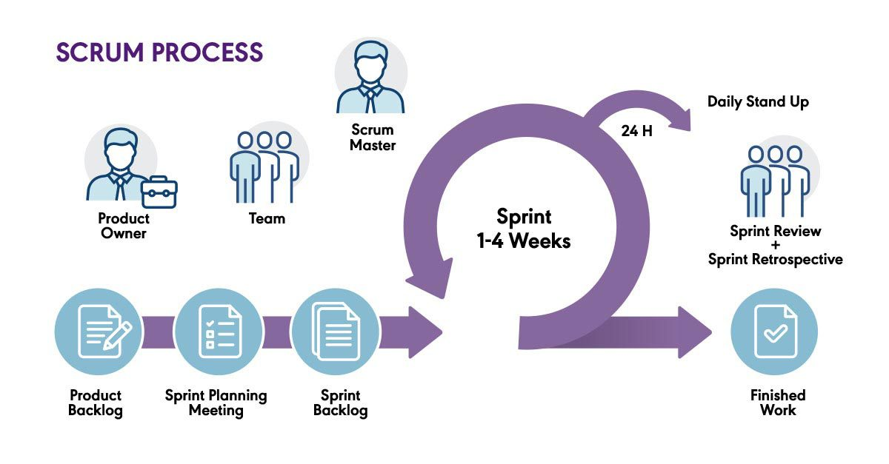Figure 1: Scrum process

2.2 Quality Management

2.2.1 Review processes
The review process we apply to the project is as follows:
Step | Action | Description
1 | Self-review | Members check their own part. Make sure this part matches defined requirements.
2 | Group review | The entire team will join discussions to evaluate and validate completed work, confirming that it aligns with project requirements.
3 | Mentor feedback | Project outputs will be inspected and approved by the mentor. If issues or deviations are found, constructive feedback will be provided, and the revised work will undergo a follow-up review.

2.2.2 Code quality management

Action | Description | Tool
Testing | Use testing types (Unit Test, Integration Test, ...) to verify code. | Jest, Playright
Code convention and formatting | Define and enforce coding standards for software development within the team. This includes naming conventions, formatting rules, and code organization guidelines. | ESLint/Prettier
Code reviews | Conduct regular code reviews where the leader inspects each member's code for adherence to coding standards, best practices, and potential issues, with the support of tools. | GitHub Pull Request review

2.3 Training Plan

Training Area | Participants | When, Duration | Waiver Criteria
Unit Testing (Jest) | All team members | Sprint 1, 4 days | Mandatory
NestJS Best Practices & Project Structure | Members working on Back-End | Sprint 1, 2 days | Waived if member already has NestJS experience
AI API Integration (Google Gemini OCR & Forecasting) | Members assigned to AI features | Sprint 1, 2 days | Mandatory for assigned members
FEFO / Pharmaceutical Domain Knowledge | All team members | Sprint 1, 1 day | Mandatory

3. Project Deliverables

# | Deliverable | Due Date | Notes
1 | Report1_Project Introduction | 26/08/2026
2 | Report2_Project Management Plan | 26/08/2026
3 | Report3_Software Requirement Specification | 27/08/2026
4 | Report4_Software Design Document | ??/??/2026
5 | Report5_Test Documentation | ??/??/2026
6 | Report5_Unit Test Case | ??/??/2026
7 | Report5_Test Report | ??/??/2026
8 | Report6_Software User Guides | ??/??/2026
9 | Report7_Final Project Report | ??/??/2026
10 | Source Code | ??/??/2026

4. Responsibility Assignments
R – Responsible ; A – Accountable ; C – Consulted ; I – Informed

Responsibility | PhuocTH | ThanhLT | DatNT | NamNV | PhucDA | LongNX
Project Planning & Tracking | A,R | I | I | R | R | C
Prepare Project Introduction Document | A,R | R | R | R | R | C
Prepare SRS Document | A,R | R | R | D | D | C
Prepare Software Design Document | R | R | R | R | A,R | C
Prepare Software Test Document | A,R | R | R | R | R | C
Prepare Unit Test Case Document | R | A, R | R | R | R | C
Prepare Test Report | A,R | R | R | R | R | C
Setup CI/CD | A | R | R | R | R | C
Coding FE | A,R | R | R | R | R | C
Coding BE | A,R | R | R | R | R | C
Prepare Software User Guiders | I | A,R | R | R | R | C
Prepare Final Project Report | R | A,R | R | R | R | C
Prepare Defense Thesis | A | R | R | R | R | C

5. Project Communications
Communication Item | Who/ Target | Purpose | When, Frequency | Type, Tool, Method(s)
Daily Report | All members | Share daily progress  made on project tasks. | Everyday | Discord
Weekly Meeting | All members and mentors | Report progress.  Question and answer.  Discuss problems.  Review document. | 21h00,  Monday | Discord

6. Configuration Management

6.1 Document Management

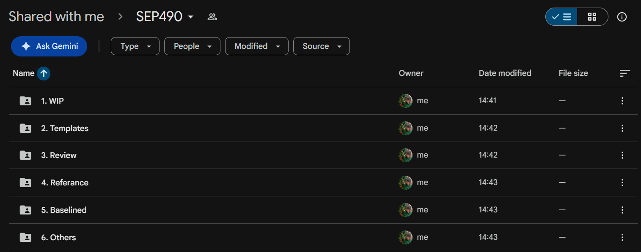
Figure 2. Folder structure

Folder Name | Description
1. WIP | (Work in Progress) store file is in progress
2. Templates | Templates of basic operations and sample data provided by FPT  University Danang Examination Department.
3. Review | Documents completed by members are waiting to be reviewed by  the mentor and project owner.
4. Reference | Reference documents include graduation projects of previous  semesters, coding conventions, and project rules,...
5. Baselined | Documents have been reviewed by mentor and comments fixed by  members. Official document of the project
6. Others | documents

6.2 Source Code Management
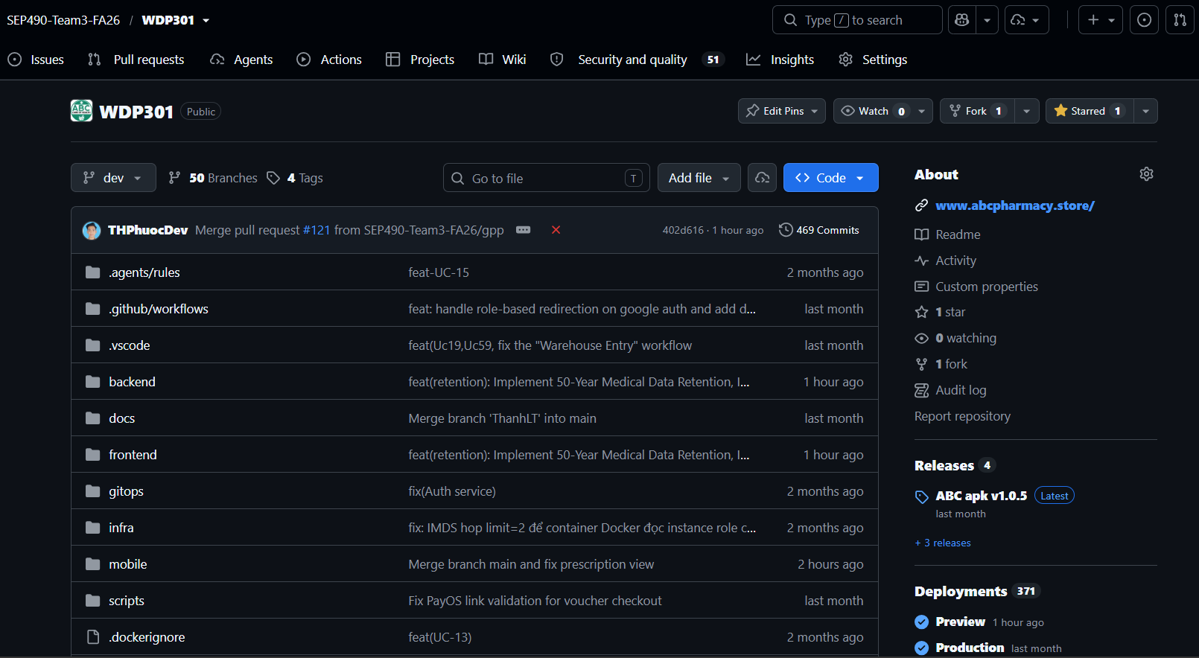

Figure 3: Source code in Github
The team manages source code using a monorepo hosted on GitHub at:
https://github.com/SEP490-Team3-FA26/WDP301
The repository is organized as follows:
Folder | Purpose
backend/ | NestJS Back-End source code
frontend/ | ReactJS Front-End source code
mobile/ | Flutter mobile application source code
Branching strategy:
- dev – main development branch, where all features are integrated after review.
- feature/feature-name – each new feature is developed on a separate branch created from dev.
- Once a feature is complete, a Pull Request is opened to merge into dev. The PR must be reviewed and approved by the leader (or an assigned reviewer) before merging.
- main – production branch. Once a sprint/release is stable on dev, it is merged into main, which triggers the CI/CD pipeline to deploy to the production environment.

CI/CD: the repository includes .github/workflows (GitHub Actions) for automated build/test/deploy, along with Docker (docker-compose.yml, docker-compose.prod.yml, docker-compose.ci.yml) and Kubernetes/Helm (gitops/) for containerized deployment.

6.3 Tools & Infrastructures
Category | Tools / Infrastructure
Technology | ReactJS (Front-End), NestJS/Node.js (Back-End), Flutter (Mobile). Redis + BullMQ, Kafka, Socket.io, OpenAPI/Swagger
Database | MongoDB (with multi-document ACID transactions)
Containerization | Docker
Orchestration | Kubernetes (Minikube for dev, Helm charts for deployment)
Version Control | GitHub (SEP490-Team3-FA26/WDP301) — branches: dev (development), main (production)
CI/CD | GitHub Actions
Deployment | GitOps (Helm) → www.abcpharmacy.store
Project management | Jira (Tasks Management, Bug) + Discord (Meeting, Daily report)

