

CAPSTONE PROJECT REPORT
Report 3 – Software Requirement Specification

– DaNang, July 2026 –
Table of Contents
I. Record of Changes 3
II. Software Requirement Specification 4
1. Product Overview 4
2. User Requirements 5
2.1 Actors 5
2.2 Use Cases 6
2.2.1 Diagram(s) 6
2.2.2 Descriptions 14
3. Functional Requirements 19
3.1 System Functional Overview 19
3.1.1 Screens Flow 19
3.1.2 Screen Descriptions 21
3.1.3 Screen Authorization 25
3.1.4 Non-Screen Functions 28
3.1.5 Entity Relationship Diagram 30
3.2 Authentication & User Account Management 32
3.2.1 Register Account (UC-01) 32
3.2.2 Sign In (UC-02) 33
3.2.3 Verify Email (UC-03) 34
3.2.4 Sign In with Google (UC-04) 35
3.2.5 Recover Password (UC-05) 36
3.2.6 Reset Password (UC-06) 37
3.2.7 Sign Out (UC-07) 38
3.3 Online Customer Portal 39
3.3.1 Search Medicines Online (UC-08) 39
3.3.2 Add to Cart (UC-09) 40
3.3.3 Manage Personal Cart (UC-10) 41
3.3.4 Confirm Online Order (UC-11) 42
3.3.5 Pay Online Order (UC-12) 43
3.3.6 View Order History (UC-13) 44
3.3.7 View Customer Profile (UC-14) 45
3.3.8 Consult AI via Text (UC-15) 46
3.3.9 Consult AI via Voice (UC-16) 47
3.4 Pharmacist POS Counter Terminal 48
3.4.1 Search Retail Medicines (UC-17) 48
3.4.2 Add to Retail Cart (UC-18) 49
3.4.3 Edit Retail Cart (UC-19) 50
3.4.4 Suggest Substitute Medicine (UC-20) 51
3.4.5 Apply Voucher and Points (UC-21) 52
3.4.6 Scan Prescription with AI (UC-22) 53
3.4.7 Check Medicine Interactions (UC-23) 54
3.4.8 Confirm Retail Payment (UC-24) 55
3.4.9 Send E-Invoice via Email (UC-25) 56
3.4.10 Create Wholesale Invoice (UC-26) 56
3.4.11 Search Return Invoice (UC-27) 57
3.4.12 Create Return Slip (UC-28) 58
3.5 Central Warehouse & FEFO Inventory Management 59
3.5.1 View Medicine Catalog (UC-29) 59
3.5.2 View Inventory by Batch (UC-30) 60
3.5.3 Create Goods Receipt (UC-31) 61
3.5.4 Create Purchase Order (PO) (UC-32) 62
3.5.5 Inspect Goods via AI (UC-33) 63
3.5.6 Alert Expiry Dates (UC-34) 64
3.5.7 Track Medicine Lot (UC-35) 65
3.6 Branch Store Management 66
3.6.1 View Branch Stock (UC-36) 66
3.6.2 Request Stock Requisition (UC-37) 67
3.6.3 Request Internal Transfer (UC-38) 68
3.6.4 Approve Stock Replenishment (UC-39) 69
3.6.5 Confirm Transfer Receipt (UC-40) 70
3.7 HQ System Governance & Staff Management 71
3.7.1 View Staff List (UC-41) 71
3.7.2 Create Staff Account (UC-42) 72
3.7.3 Approve Staff Account (UC-43) 73
3.7.4 Reject Staff Account (UC-44) 73
3.7.5 Create Branch (UC-45) 74
3.7.6 Update Staff Role (UC-46) 75
3.7.7 Add Medicine (UC-47) 76
3.7.8 Update Medicine (UC-48) 77
3.7.9 View Supplier List (UC-49) 78
3.7.10 Add Supplier (UC-50) 79
3.7.11 Update Supplier (UC-51) 81
3.8 Corporate Finance, Approvals & AI Analytics 82
3.8.1 View Revenue Dashboard (UC-52) 82
3.8.2 Compare Branch Performance (UC-53) 83
3.8.3 Approve Purchase Order (PO) (UC-54) 84
3.8.4 Reject Purchase Order (PO) (UC-55) 85
3.8.5 Approve Goods Receipt Note (GRN) (UC-56) 86
3.8.6 Reject Goods Receipt Note (GRN) (UC-57) 87
3.8.7 Manage Promotions (UC-58) 88
3.8.8 Manage Cash Flow (UC-59) 89
3.8.9 Query Audit Logs (UC-60) 90
3.8.10 Forecast Demand (UC-61) 91
3.8.11 Auto-Generate PO from AI Forecast (UC-62) 92
3.8.12 Detect Inventory Anomalies with AI (UC-63) 93
3.8.13 Analyze Seasonal and Epidemic Trends (UC-64) 94
3.9 Extended Module Functional Requirements 96
3.9.1 Mobile Inbound Barcode Inspection (UC-66) 99
3.9.2 SKU & Barcode Management (UC-67) 101
3.9.3 Manage Categories & Active Ingredients (UC-68) 102
3.9.4 Multi-Level Unit Conversion (UC-69) 103
3.9.5 Branch Specific Price List (UC-70) 104
3.9.6 Wholesale & Supplier Debt Control (UC-71) 105
3.9.7 Stocktake Session & Barcode Audit Count (UC-72) 107
3.9.8 Stock Adjustment & Disposal Slip (UC-73) 108
3.9.9 IoT GSP Warehouse Environment Monitoring (UC-74) 109
3.9.10 Cashier Shift Closing & Cash Balancing (UC-75) 110
3.9.11 Branch Requisition Quota Management (UC-76) 111
3.9.12 AI Inter-Branch Stock Rebalancing (UC-77) 112
3.9.13 Controlled Substances Management (UC-78) 113
3.9.14 Digital Health Passport & Reminder (UC-79) 114
3.9.15 Database Backup & Disaster Recovery (UC-80) 116
4. Non-Functional Requirements 117
4.1 Quality Attributes 117
4.1.1 Usability 117
4.1.2 Reliability 117
4.1.3 Performance 118
4.2 Security 118
4.3 Maintainability 118
5. Requirement Appendix 118
5.1 Business Rules 119
5.2 Common Requirements 119
5.3 Application Messages List 120

I. Record of Changes
Date | A*  M, D | In charge | Change Description
02/05/2026 | A,M | PhuocTH | Create initial Product Overview and User Requirements.
08/05/2026 | A,M | DatNT | Create System Architecture and Functional Requirements Overview.
15/05/2026 | A,M | NamNV | Detail Use Case Specification list (UC-01 to UC-66).
25/05/2026 | A | PhucDA | Design Database Schema, ERD, and FEFO inventory data model.
05/06/2026 | A | ThanhLT | Draw Screenflow Diagrams for all system modules.
15/06/2026 | A,M | PhuocTH | Create Screen Descriptions and 3.1.3 Screen Authorization matrix.
25/06/2026 | A | DatNT | Define 3.1.4 Non-Screen Functions (Cron Jobs, Webhooks, AI OCR Services).
02/07/2026 | A,M | NamNV | Write Business Rules (BR-01 to BR-21) and 5.2 Common Requirements.
10/07/2026 | A | PhucDA | Create 5.2 Application Messages List (Validation, Toasts, Alerts).
18/07/2026 | A,M | ThanhLT | Detail 4.2 Quality Attributes, Security, and Performance SLA metrics.
22/07/2026 | M | PhuocTH | Finalize completed Use Case list and review system documentation.
23/07/2026 | M | DatNT | Review comment fixes and baseline final specification document.
*A - Added M - Modified D - Deleted
Table 1 - Record of Changes

II. Software Requirement Specification

1. Product Overview
ABC Pharmacy in Da Nang is one of the best drug stores for foreigner visitors, specialize in providing medicines used for tourism. It’s familiar name for visitors whenever they come to Da Nang city.
The AI-Integrated Pharmacy Chain Management System is a comprehensive software platform designed to optimize operational efficiency for pharmacy chains with 2 to 20 branches in Vietnam. The system focuses on solving core challenges in the retail pharmaceutical industry, particularly the management of large inventories (up to 1,000 medication SKUs) and the integration of AI technologies to optimize stock levels and minimize expiration risks.

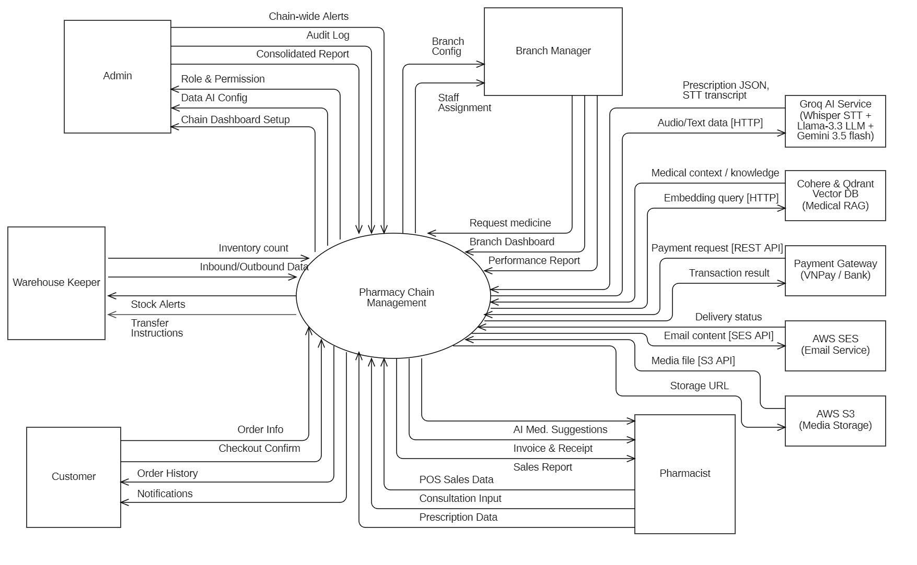
Figure 1 - System Context Diagram

2. User Requirements

2.1 Actors

# | Actor | Description
1 | Admin | The highest-level administrator at the headquarters (HQ). Responsible for managing user accounts, configuring Role-Based Access Control (RBAC), setting up system-wide parameters, and synchronizing the global product catalog (SKUs) and price lists. They monitor system audit logs, approve consolidated Purchase Requisitions (PR), and access chain-wide business intelligence dashboards and AI forecasting reports.
2 | Branch Manager | The manager responsible for the daily operations of a specific pharmacy branch. They monitor real-time local inventory levels, generate Purchase Requisitions (PR) to request stock from HQ, approve internal stock transfer proposals, and view sales, profit, and salesperson performance reports for their branch.
3 | Inventory Manager | The staff member responsible for physical inventory handling at the central warehouse or branch stores. They handle goods received by generating Goods Receipt Notes (GRN) and entering mandatory Batch Numbers and Expiration Dates. They manage order dispatching using FIFO/FEFO principles, initiate internal warehouse transfers, conduct periodic rolling stocktakes, and log stock adjustments.
4 | Pharmacist | The front-counter staff who directly interacts with customers. They search for medicine details and drug-drug interactions, process retail/wholesale transactions, scan QR codes to validate electronic prescriptions, apply discount/promotion codes, issue e-receipts, handle product returns/exchanges, and register customer loyalty points.
5 | Customer | The end-user purchasing goods from the pharmacy. Customers can look up their own transaction history, track membership loyalty points, receive digital invoices via Email/Zalo OA, and access personalized prescription information.

Table 2 - Actors

2.2 Use Cases

2.2.1 Diagram(s)

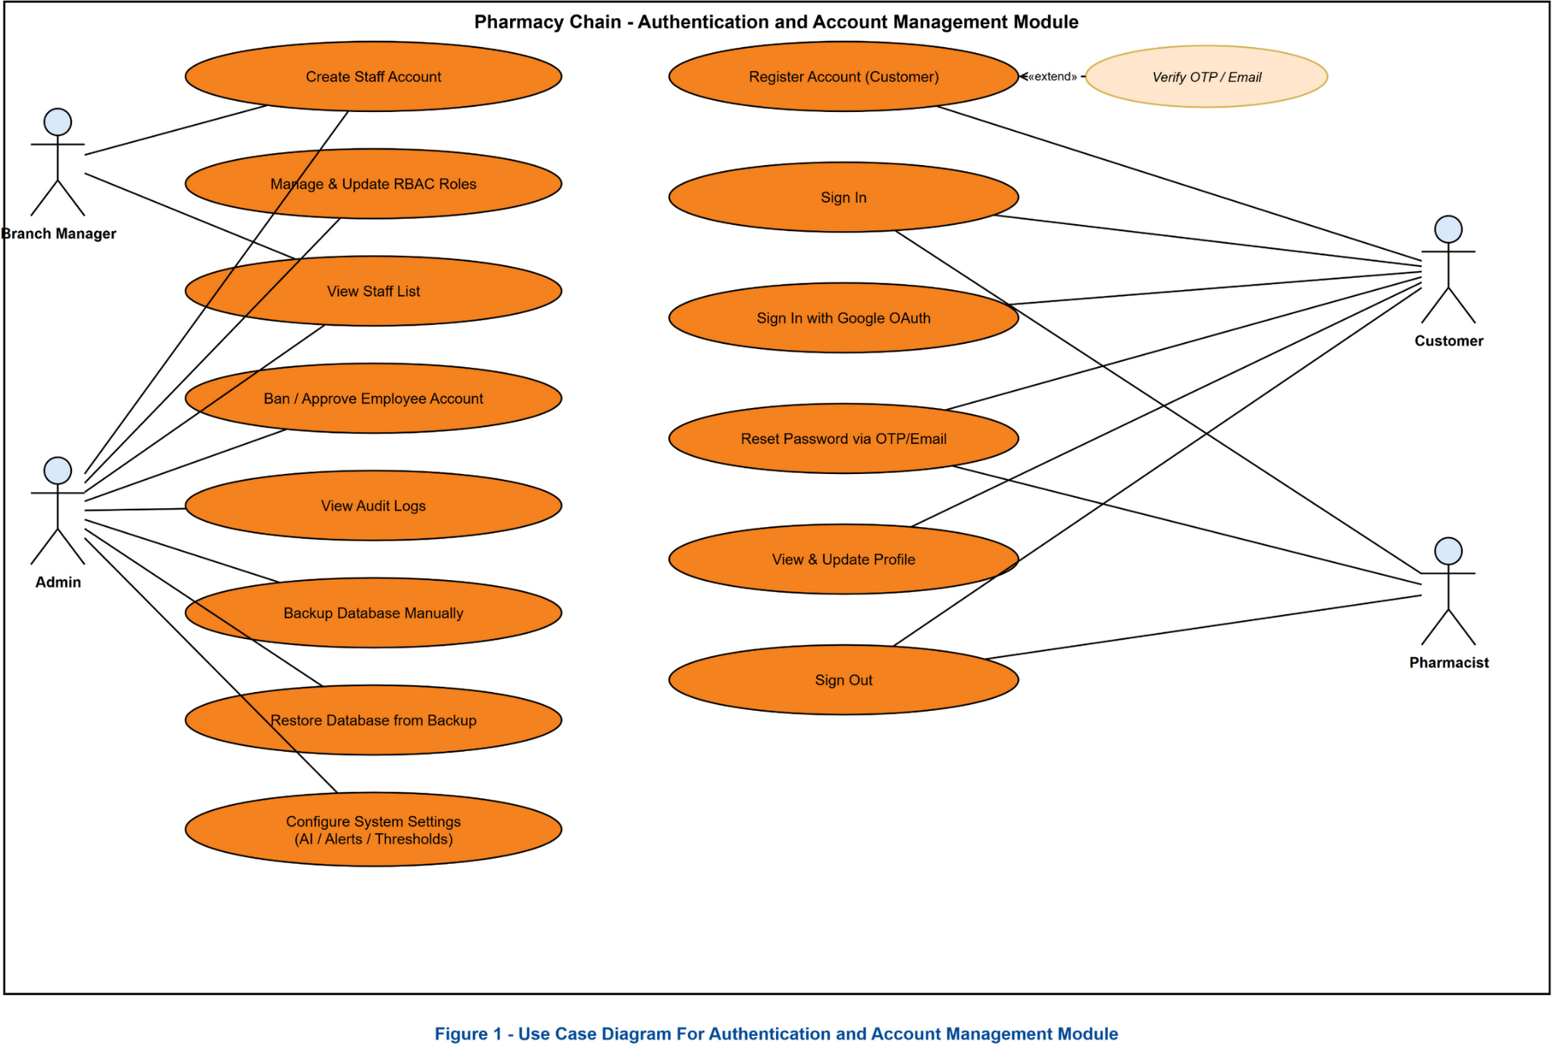
Figure 2 - Use Case Diagram For Authentication
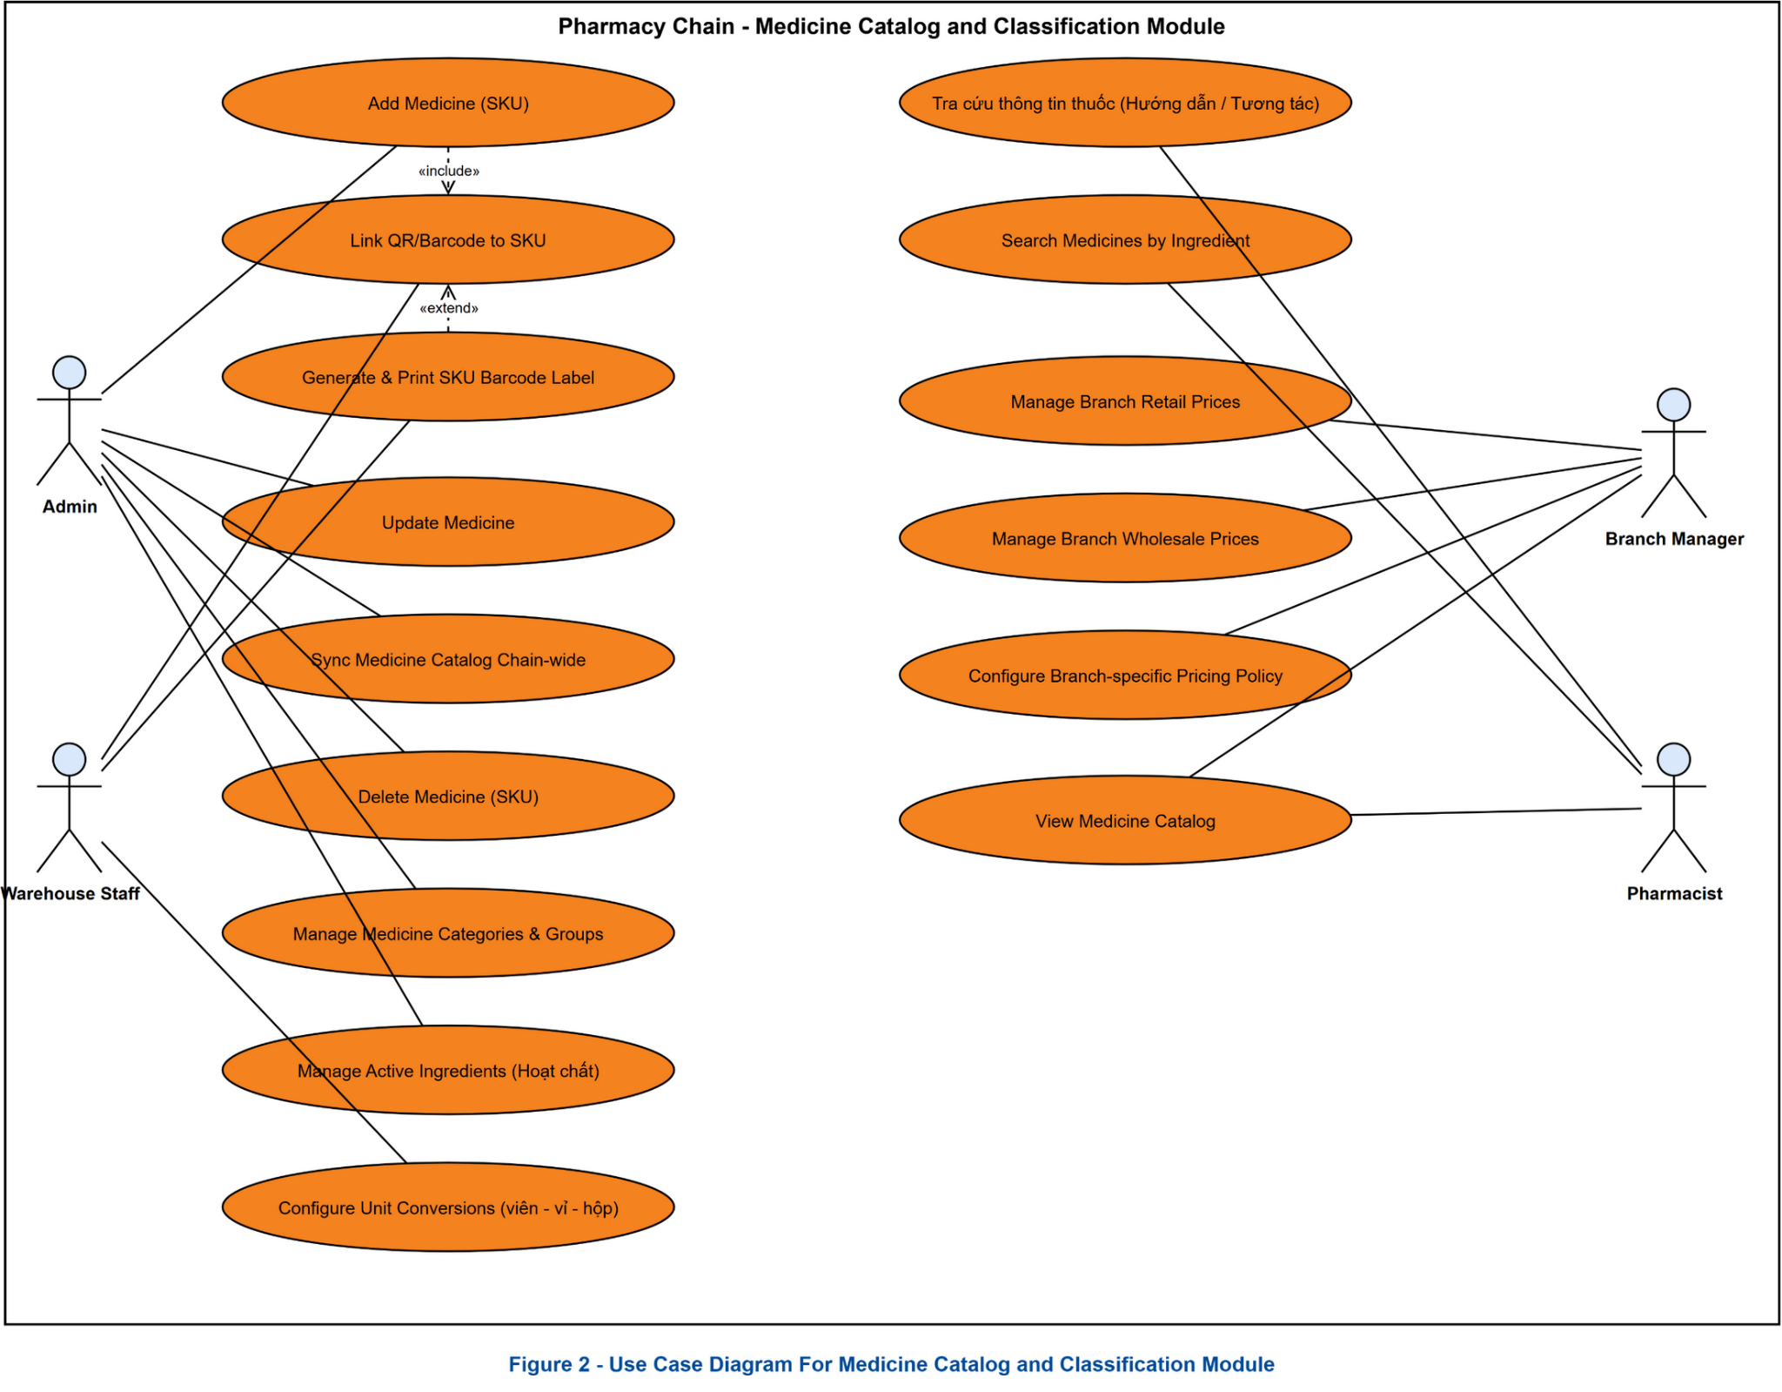
Figure 3 - Use Case Diagram For Medicine Catalog
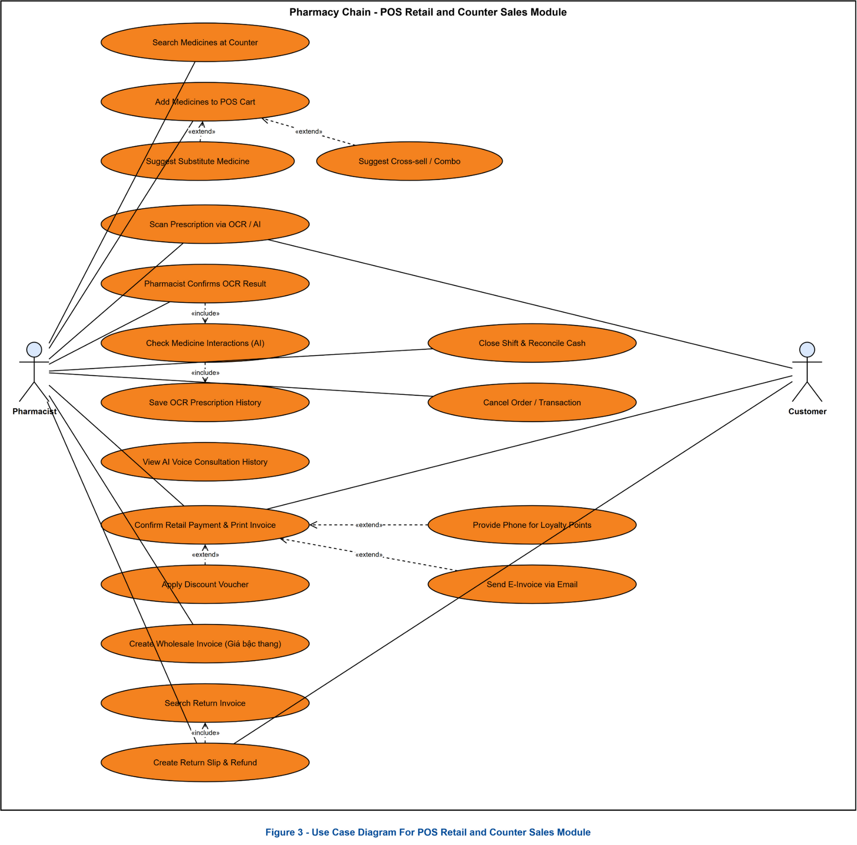
Figure 4 - Use Case Diagram For Counter Sale
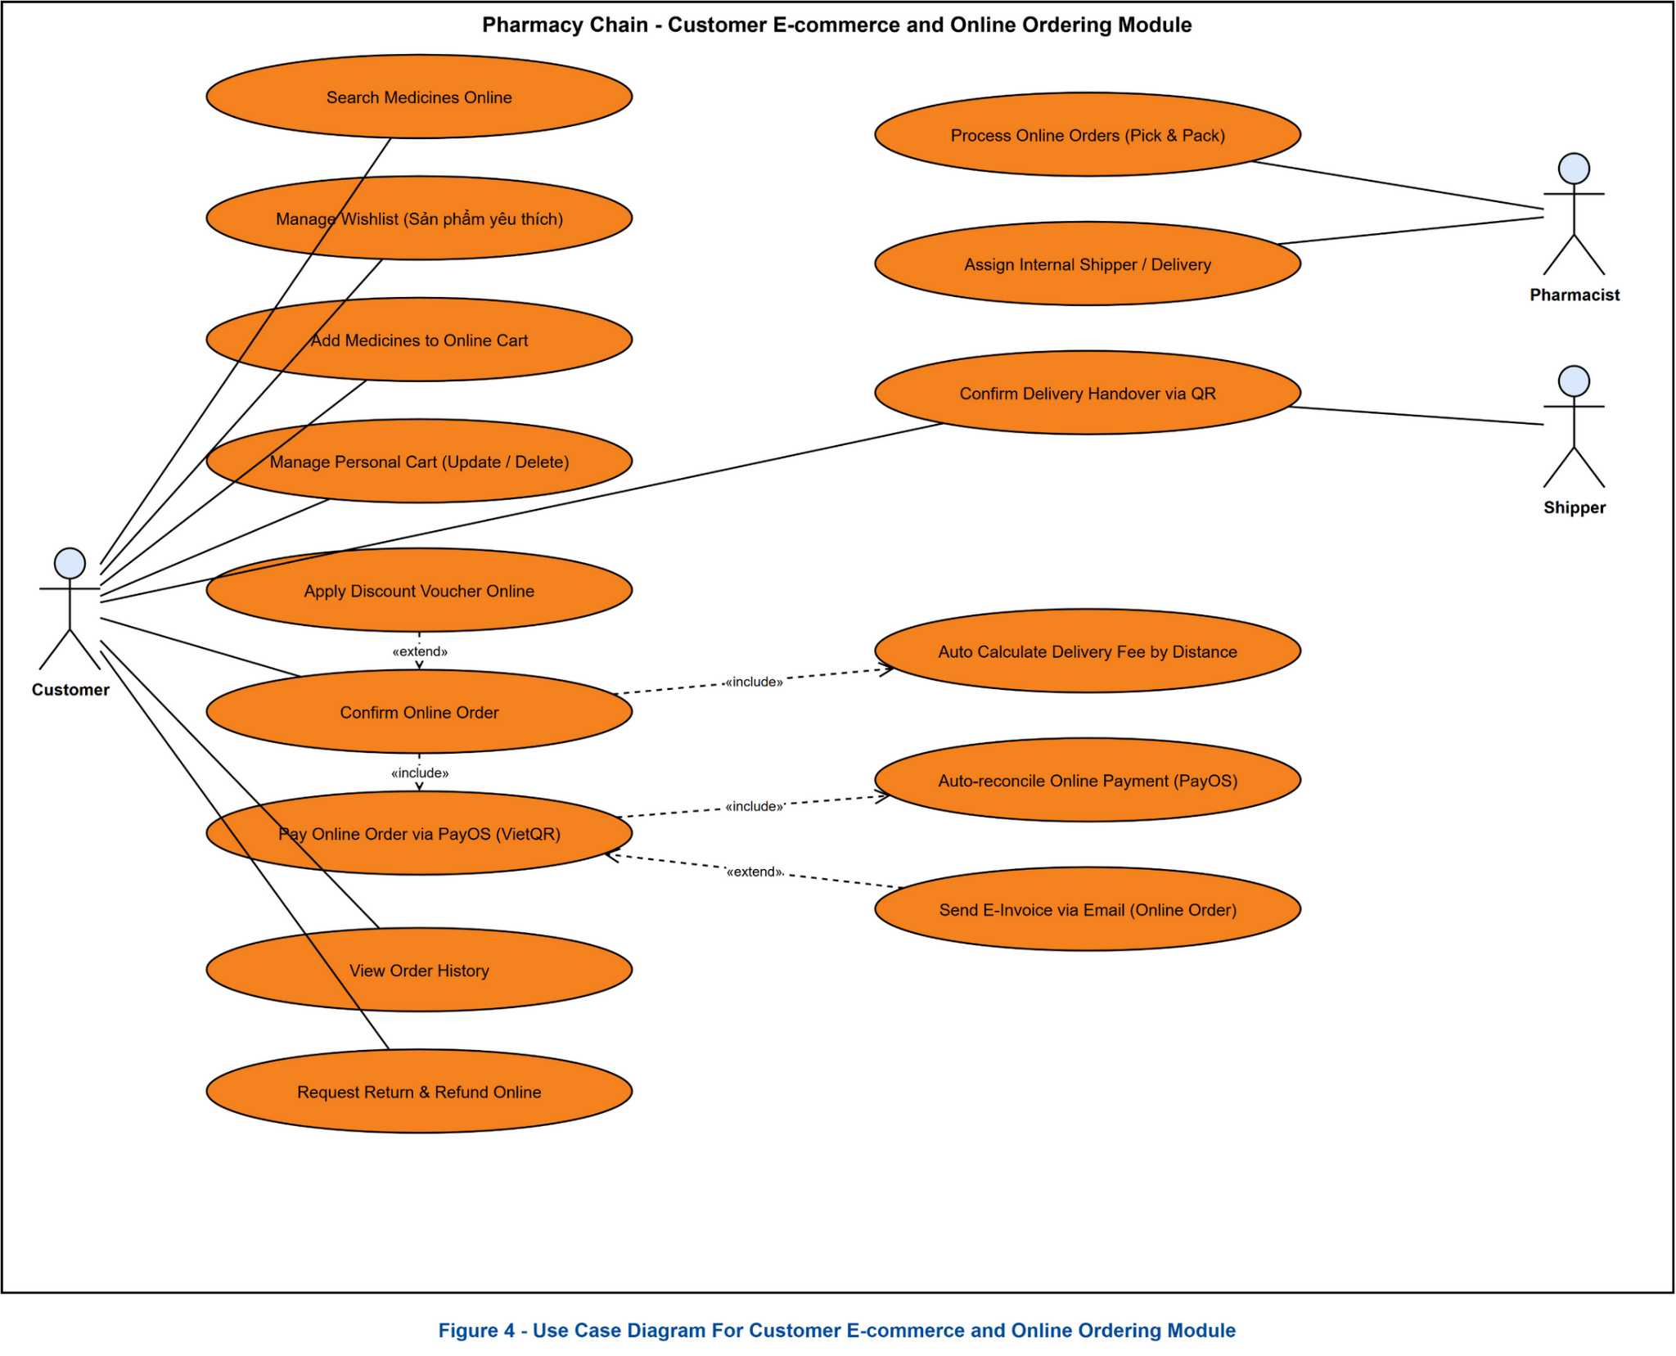
Figure 5 - Use Case Diagram For Online Sales
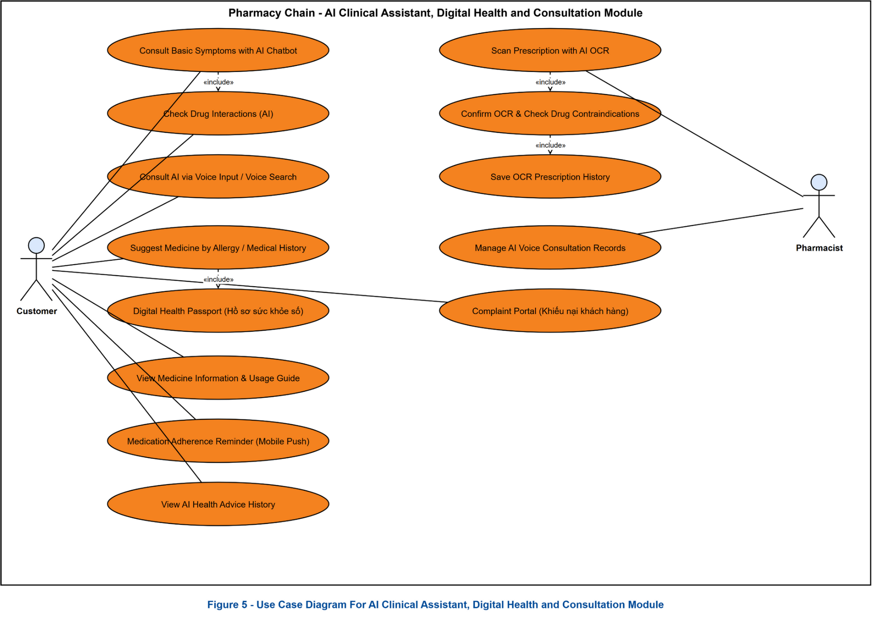
Figure 6 - Use Case Diagram For AI Clinical Assistant, Digital health and Consultation Module

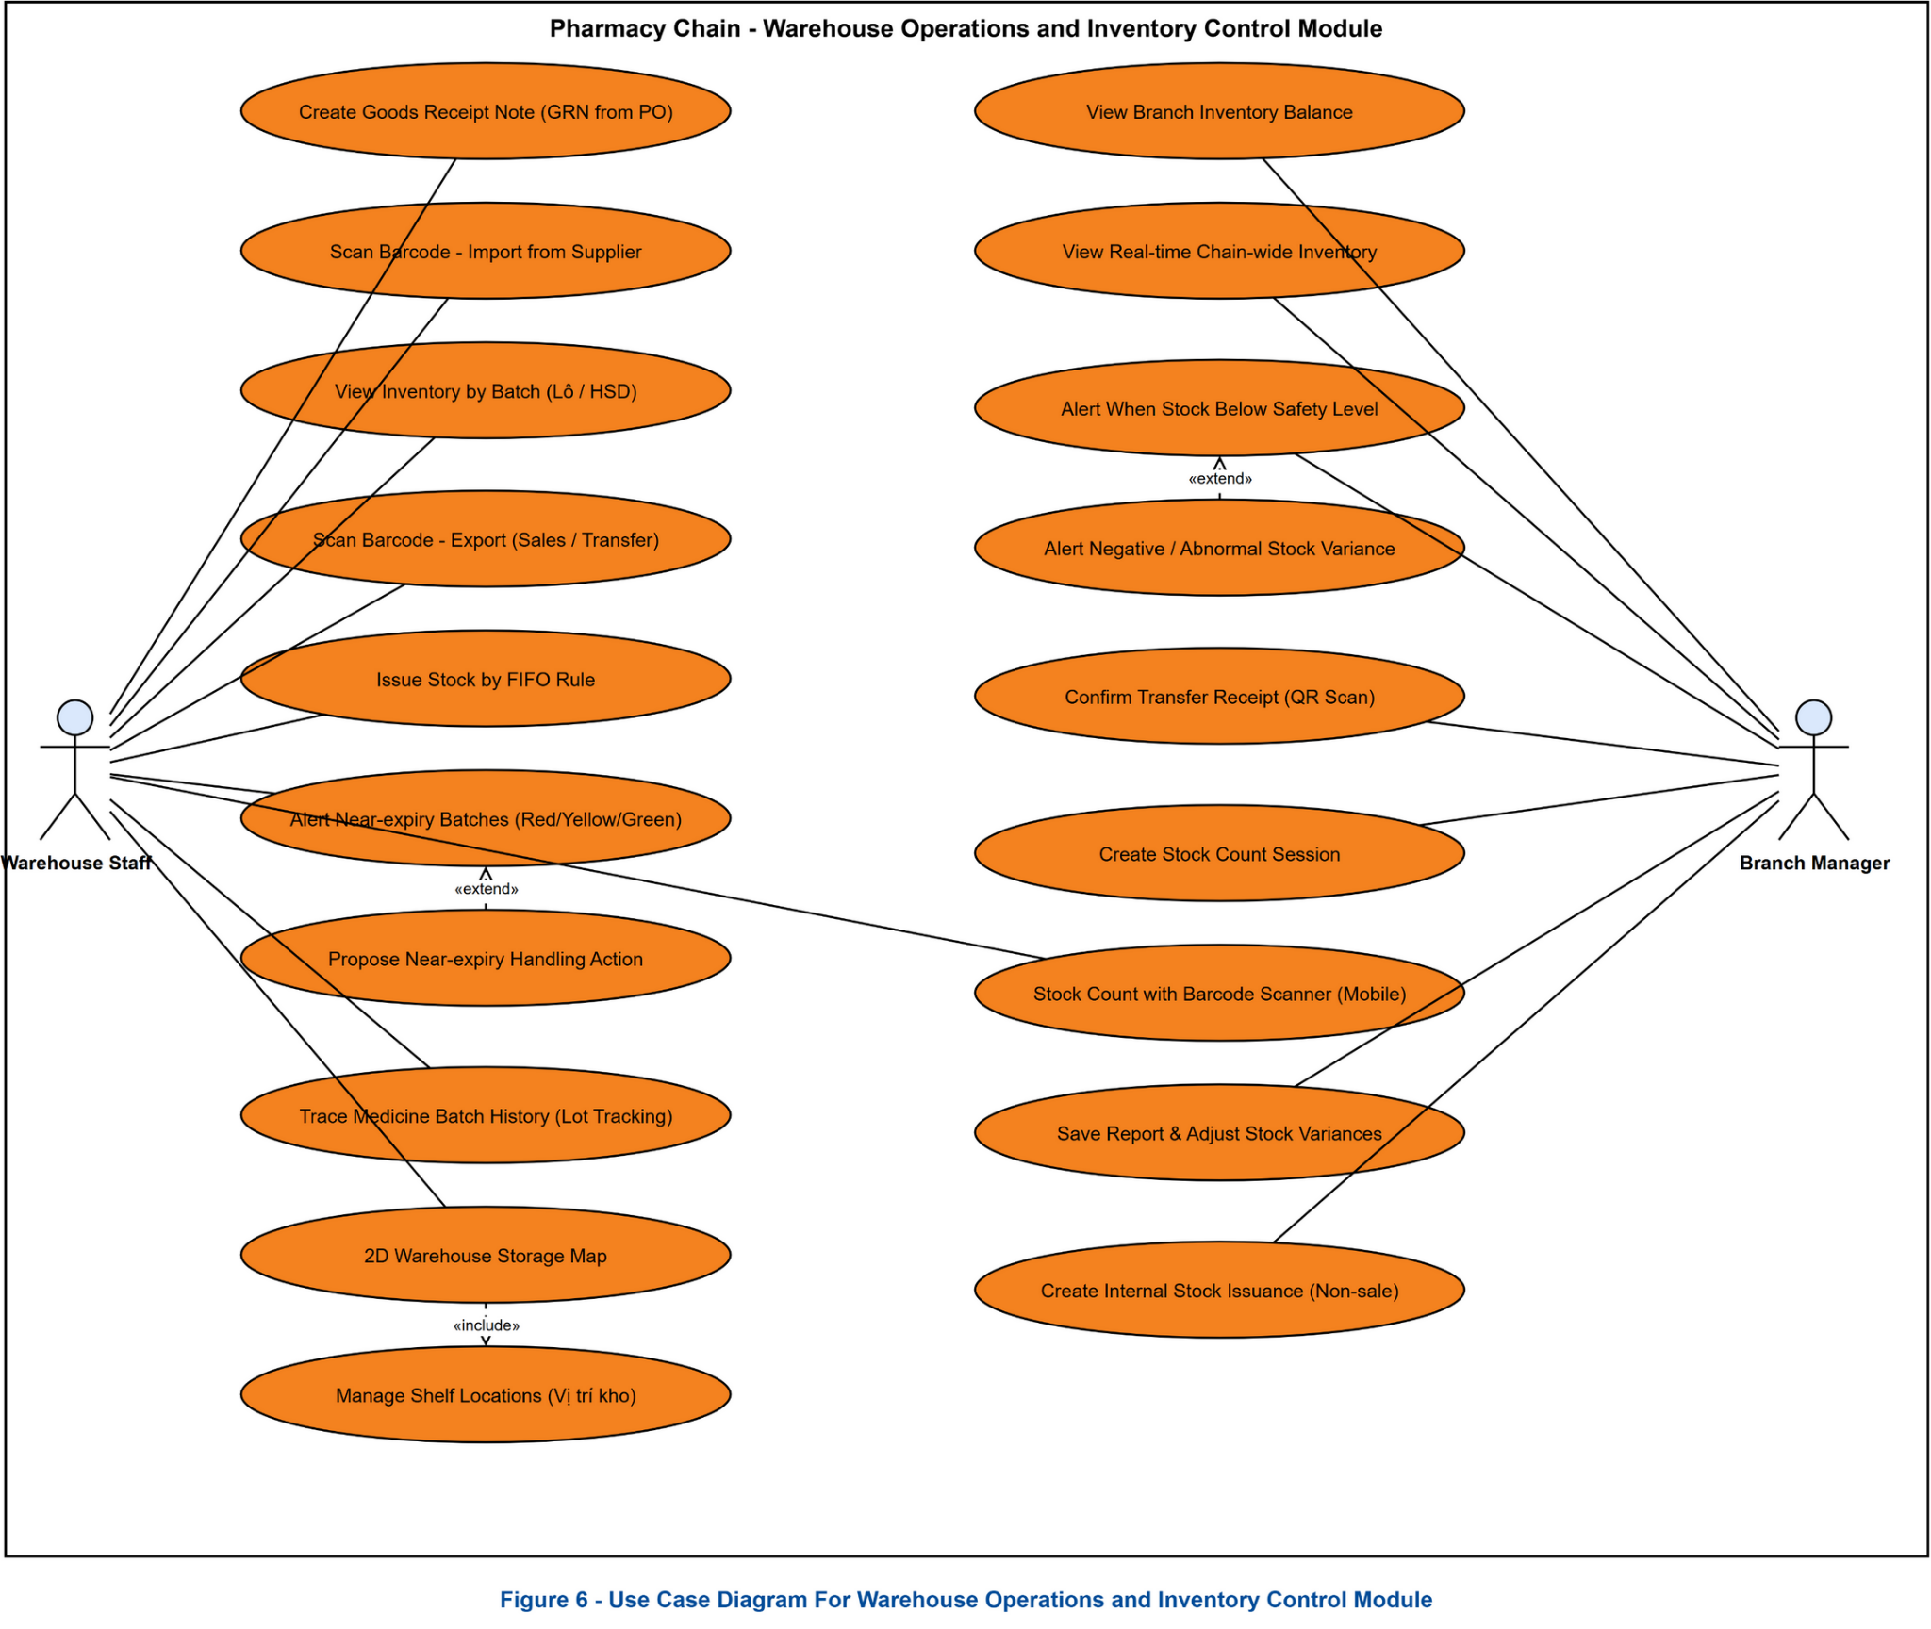
Figure 7 - Use Case Diagram For Warehouse Operation and Inventory Control
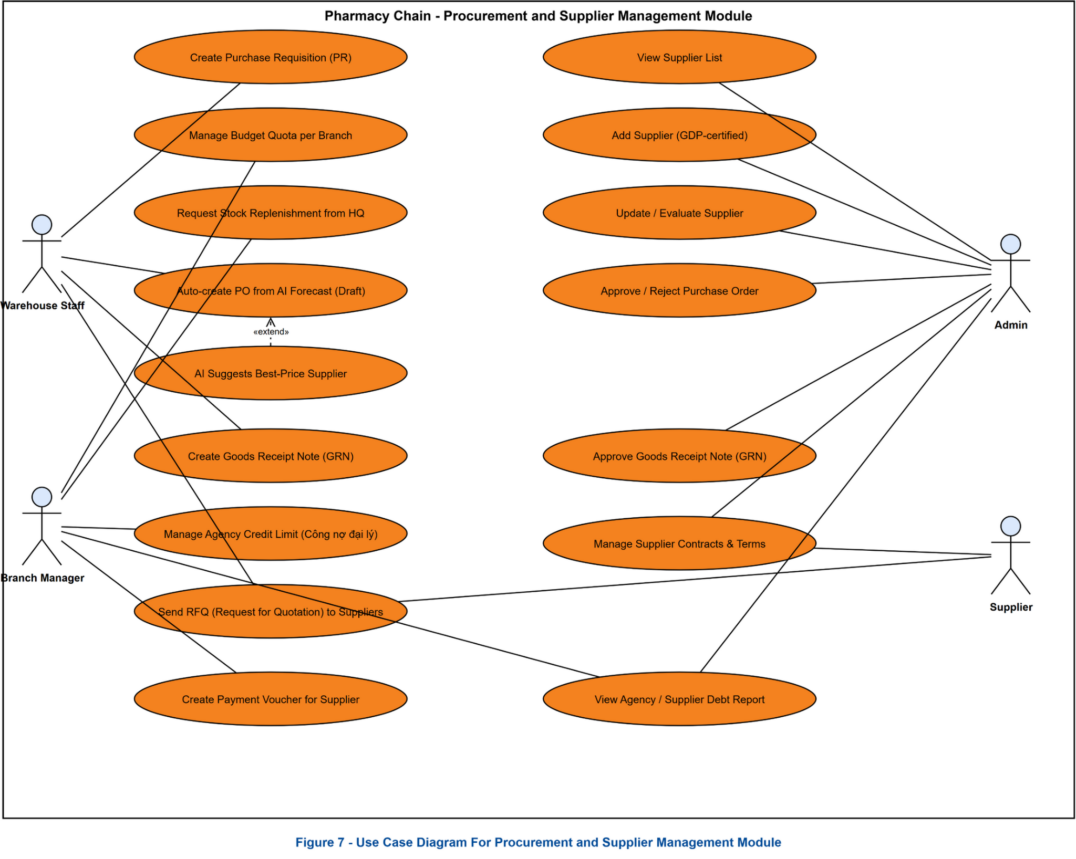
Figure 8 - Use Case Diagram For Procurement and Supplier Managerment
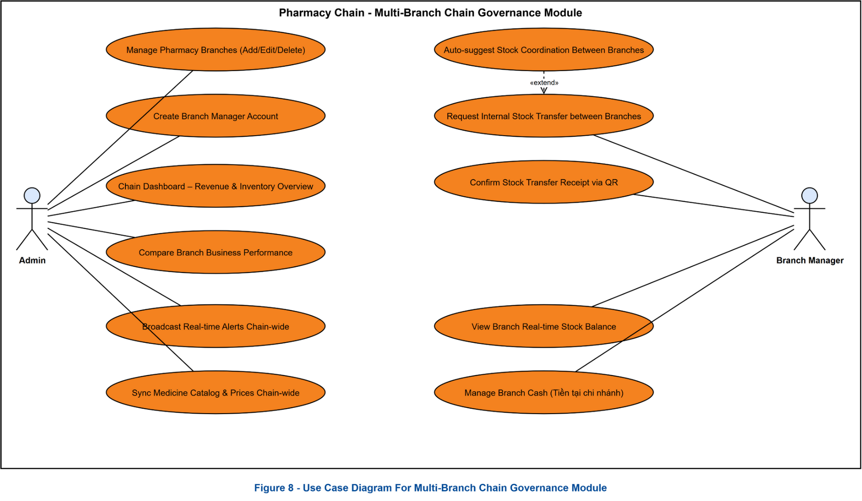
Figure 9 - Use Case Diagram For Multi-Branch Chain Governance
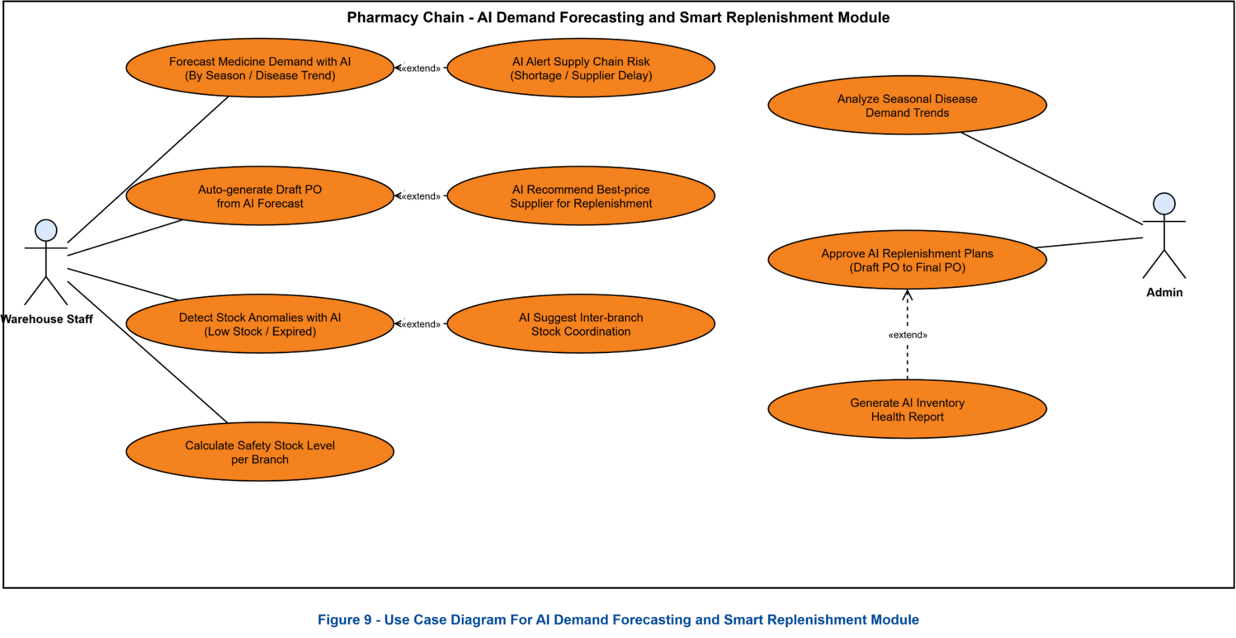
Figure 10 - Use Case Diagram For AI Demand and Smart Replenishment
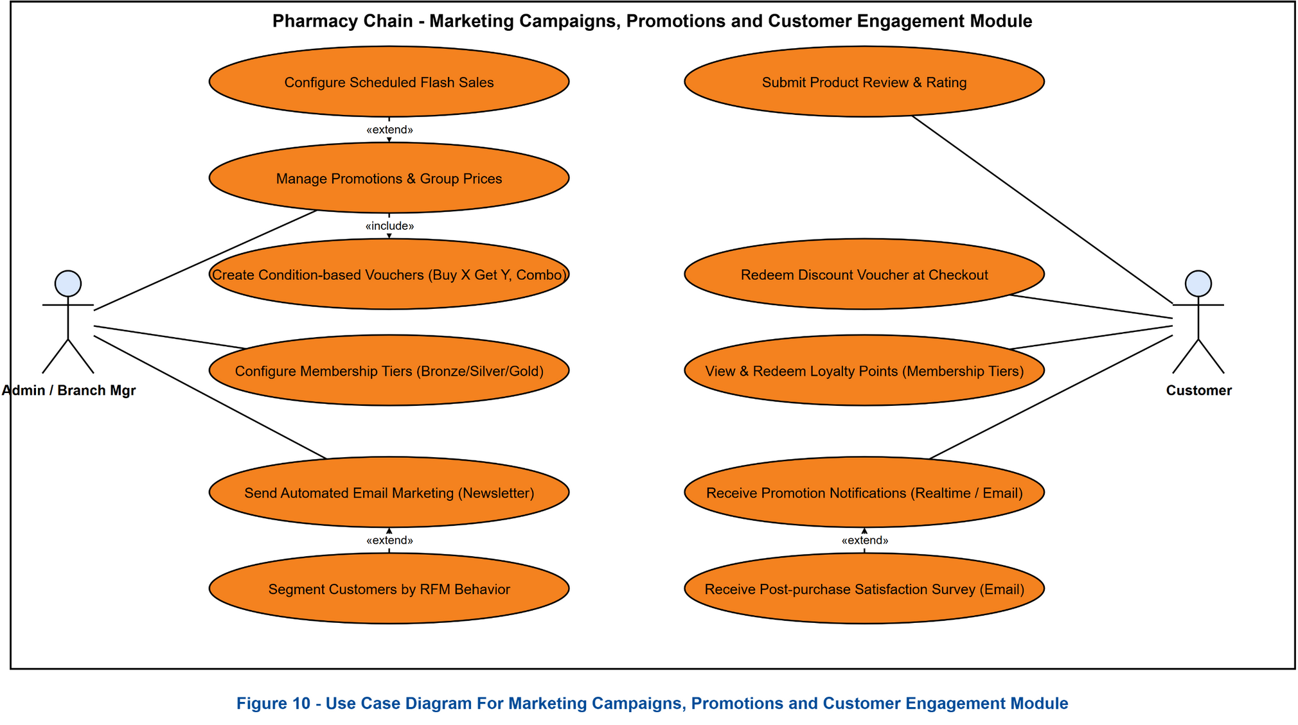
Figure 11 - Use Case Diagram For Marketing Campaigns, Promotion and Customer Engagement
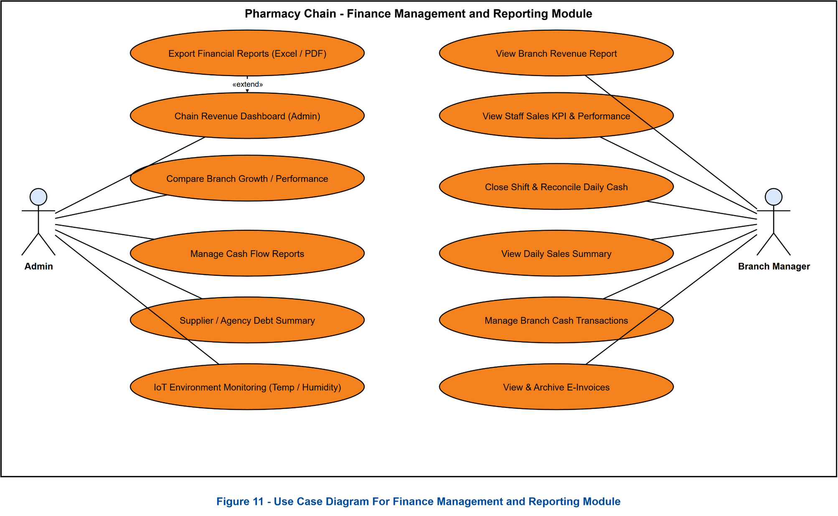
Figure 12 - Use Case Diagram For Finance Management and Reporting

2.2.2 Descriptions
ID | Use Case | Actors | Use Case Description
UC-01 | Register account | Customer | Allows customers to register a new personal account in the system using an email address and password.
UC-02 | Sign in | Customer, Pharmacist, Inventory Manager, Admin, Branch Manager | Allows users to log in to the system using their registered or assigned account credentials.
UC-03 | Verify email | Customer, Pharmacist, Branch Manager | Allows customers to confirm the activation code sent to their personal email after successful account registration.
UC-04 | Sign in with Google | Customer | Allows customers to quickly log in to the online shopping portal using their Google account.
UC-05 | Recover password | Pharmacist, Inventory Manager, Admin, Branch Manager | Allows staff to send a password recovery request via email when they forget their login credentials.
UC-06 | Reset password | Pharmacist, Inventory Manager, Admin, Branch Manager | Allows staff to set a new password via a secure link sent to their recovery email.
UC-07 | Sign out | Customer, Pharmacist, Inventory Manager, Admin, Branch Manager | Terminates the current session and safely logs out of the system account.
UC-08 | Search medicines online | Customer | Browse and search for medicines by name, active ingredient, or medical indication on the online store.
UC-09 | Add to cart | Customer | Allow customers to save desired pharmaceutical products into their personal cart for later checkout.
UC-10 | Manage personal cart | Customer | Allow customers to adjust quantities or remove products from their online cart.
UC-11 | Confirm online order | Customer | Fill in full name, phone number, shipping address, and confirm submission of online order.
UC-12 | Pay online order | Customer | Complete online payment via bank transfer using dynamic QR code or COD.
UC-13 | View order history | Customer | View list of past orders, detailed order items, and shipping status.
UC-14 | View customer profile | Customer | View personal information, accumulated points, and current tier status (Gold, Silver, Bronze...).
UC-15 | Consult AI via text | Customer | Enter symptom description questions; chatbot automatically analyzes and suggests health guidance & recommended products.
UC-16 | Consult AI via voice | Customer | Press record button to describe symptoms via voice; AI automatically recognizes speech and converts to text for consultation.
UC-17 | Search retail medicines | Pharmacist | Quickly search for medicines by name or active ingredient directly on the counter retail screen.
UC-18 | Add to retail cart | Pharmacist | Select medicines from search results and add them to the customer's active retail shopping cart.
UC-19 | Edit retail cart | Pharmacist | Change purchase quantity of each medicine or remove items from the retail cart.
UC-20 | Suggest substitute medicine | Pharmacist | System automatically suggests equivalent substitute medicines (matching active ingredient or therapeutic group) when requested item is out of stock.
UC-21 | Apply voucher and points | Pharmacist | Look up loyalty customer information by phone number to earn reward points or apply discount voucher codes directly to the invoice.
UC-22 | Scan prescription with AI | Pharmacist | Capture/upload doctor prescription photos (single/multi-page). AI Gemini 2.5 Flash analyzes layout, extracts active ingredients/dosages, merges duplicates, matches branch DB & auto-selects nearest FEFO batch to auto-fill cart.
UC-23 | Check medicine interactions | Pharmacist | Select multiple medicines in cart to trigger AI verification for interactions or harmful contraindication warnings.
UC-24 | Confirm retail payment | Pharmacist | Confirm transactions via Cash or Bank Transfer. System automatically deducts branch stock based on FIFO batches and prints invoices.
UC-25 | Send e-invoice via email | Pharmacist | Allows entering customer email at counter to send electronic invoice (e-invoice) directly upon payment completion.
UC-26 | Create wholesale invoice | Pharmacist | Issue wholesale invoices for agency partners, automatically applying tier pricing based on large volume purchases.
UC-27 | Search return invoice | Pharmacist | Search past invoices by customer phone number or invoice code to verify purchase origin prior to executing returns.
UC-28 | Create return slip | Pharmacist | Create return slips recording return reasons (defective goods, near-expiry...), execute customer refunds, and restock counter inventory.
UC-29 | View medicine catalog | Admin, Inventory Manager, Pharmacist | Displays a complete list of medicines in the system with active ingredient, medicine category, unit, and base price.
UC-30 | View inventory by batch | Inventory Manager, Admin | Display actual stock details per product including batch number (`batchNo`), expiry date (`expDate`), and available stock quantity.
UC-31 | Create goods receipt | Inventory Manager | Create a new receiving session for goods delivered by supplier based on an approved Purchase Order (PO).
UC-32 | Create purchase order (PO) | Inventory Manager | Create new purchase orders (PO) to submit to Admin for approval before submitting to suppliers.
UC-33 | Inspect goods via AI | Inventory Manager | Capture images of shipment packages using mobile device; AI automatically counts actual medicine boxes in shipment to populate receipt.
UC-34 | Alert expiry dates | Inventory Manager, Admin | Report detailed lists of near-expiry batches (under 6 months / 3 months) or expired items to plan for disposal/write-offs.
UC-35 | Track medicine lot | Inventory Manager, Admin | Enter batch number (`batchNo`) to trace full supplier history, PO, GRN, and display quantity fluctuation timeline for that batch.
UC-36 | View branch stock | Branch Manager | Quickly look up actual physical stock quantities of medicines at the managed branch.
UC-37 | Request stock requisition | Branch Manager | Create stock replenishment requests sent to central warehouse when branch counters experience shortages or out-of-stock items.
UC-38 | Request internal transfer | Branch Manager | Create stock transfer slips to ship goods to neighboring branches to resolve cross-branch stock imbalances.
UC-39 | Approve stock replenishment | Inventory Manager | Review Requisition requests submitted by branches and approve dispatch of goods from central warehouse.
UC-40 | Confirm transfer receipt | Branch Manager | Receive goods delivered from central warehouse, verify physical count, and click confirm to synchronize and update destination stock.
UC-41 | View staff list | Admin, Branch Manager | Displays a table listing all employees in the pharmacy chain with detailed information on role, work shift, branch, and activation status.
UC-42 | Create staff account | Branch Manager | Allows Branch Manager to create new accounts for pharmacists and counter staff members at their branch.
UC-43 | Approve staff account | Admin, Branch Manager | Allows Admin or Branch Manager to review and approve newly registered staff accounts.
UC-44 | Reject staff account | Admin, Branch Manager | Allows Admin or Branch Manager to reject new staff registration requests.
UC-45 | Create branch manager account | Admin | Allows HQ Admin to create new branch manager accounts and grant branch management permissions.
UC-46 | Update staff role | Admin | Allows Admin to update staff profile, assign job roles, and reassign branch locations.
UC-47 | Add medicine | Admin | Create a new medicine and fill in identification attributes, packaging specifications, and usage instructions.
UC-48 | Update medicine | Admin | Edit medicine attributes, descriptions, images, or classification categories in the system catalog.
UC-49 | View supplier list | Admin, Inventory Manager | Displays contact information, supplier code, and reliability rating of suppliers.
UC-50 | Add supplier | Admin | Register new pharmaceutical supplier information and store legal profiles in the system.
UC-51 | Update supplier | Admin | Adjust contact information, GDP license expiration date, or supplier credit terms.
UC-52 | View revenue dashboard | Admin | View revenue charts over time, transaction counts, total payables/receivables, and chain-wide operational performance.
UC-53 | Compare branch performance | Admin | Display comparative ranking tables for sales volume, transaction counts, and growth rates across all branch locations.
UC-54 | Approve purchase order (PO) | Admin | Approve Purchase Orders (PO) sent to suppliers and configure payment methods.
UC-55 | Reject purchase order (PO) | Admin | Reject approval of purchase order PO and record rejection reasons.
UC-56 | Approve goods receipt note (GRN) | Admin | Sign and approve physical inspection receipt from warehouse manager to confirm official entry, increase total stock, and activate new batches.
UC-57 | Reject goods receipt note (GRN) | Admin | Reject physical inspection receipt (GRN) from warehouse manager and record rejection reasons for re-verification.
UC-58 | Manage promotions | Admin | Create percentage/cash discount voucher codes, set up Flash Sale events for designated time slots.
UC-59 | Manage cash flow | Admin | View financial cash flow reports, enter fixed operational expenses (rent, salaries, utilities...) of branches.
UC-60 | Query audit logs | Admin | Retrieve audit log records tracking critical business operations performed by staff for security compliance.
UC-61 | Forecast demand | Inventory Manager, Admin | System automatically analyzes sales volume and actual inventory levels to suggest replenishment order quantities from suppliers.
UC-62 | Auto-generate PO from AI forecast | Inventory Manager, Admin | Allows converting AI Economic Order Quantity (EOQ) replenishment recommendations directly into an official Purchase Order (PO) with one click.
UC-63 | Detect inventory anomalies with AI | Inventory Manager, Admin | AI system automatically detects and alerts unusual inventory fluctuations such as export spikes, critically low stock, or abnormal inventory adjustments.
UC-64 | Analyze seasonal and epidemic trends | Admin | Analyzes historical sales data across seasonal shifts and disease outbreaks to forecast medicine demand and optimize strategic stocking.
UC-65 | Receive notifications | Customer, Pharmacist, Inventory Manager, Admin, Branch Manager | System pushes real-time socket notifications for near-expiry alerts, PO/GRN approval requests, or urgent branch replenishment requests.
UC-66 | Mobile inbound barcode inspection | Inventory Manager | Allows warehouse staff to scan QR/Barcodes on delivered cartons via mobile devices, auto-matching items against PO and recording batch numbers and expiry dates.
UC-67 | SKU & barcode management | Admin | Define unique SKU formatting for product packaging variations and automatically generate Code-128/EAN-13 barcodes for product labeling.
UC-68 | Manage categories & active ingredients | Admin | Classify medicines by therapeutic category and maintain master active ingredient data to support clinical interaction and contraindication checking.
UC-69 | Multi-level unit conversion | Admin | Establish unit of measure hierarchies (e.g., Box - Blister - Pill) with fixed multiplication factors for inventory accounting and POS retail dispensing.
UC-70 | Branch specific price list | Branch Manager, Admin | Allow branch managers to configure localized retail and wholesale pricing overrides for their specific store location within HQ-approved price bounds.
UC-71 | Wholesale & supplier debt control | Admin, Branch Manager | Track agency credit limits, payment grace periods, overdue receivables, and enforce automated ordering blocks when credit thresholds are breached.
UC-72 | Stocktake session & barcode audit count | Inventory Manager, Branch Manager | Initialize rolling stocktake sessions by warehouse zone or store shelf, enabling mobile barcode scanning to verify physical on-hand stock counts.
UC-73 | Stock adjustment & disposal slip | Admin, Inventory Manager | Reconcile discrepancies between physical counts and system balances, submit stock adjustment vouchers, and log formal disposal records for expired drugs.
UC-74 | IoT GSP warehouse environment monitoring | Inventory Manager, Admin | Ingest realtime telemetry from IoT temperature and humidity sensors in central warehouse storage areas, triggering instant alerts upon GSP threshold violations.
UC-75 | Cashier shift closing & cash balancing | Pharmacist, Branch Manager | Perform end-of-shift cash drawer reconciliations, tallying cash collected against PayOS digital payments and recording variance explanations.
UC-76 | Branch requisition quota management | Admin | Allocate monthly purchasing and stock requisition budget quotas per branch to manage corporate working capital and prevent overstocking.
UC-77 | AI inter-branch stock rebalancing | Admin, Branch Manager | AI algorithm identifies surplus stock in low-velocity branches and recommends automated internal transfers to stockout-risk branches.
UC-78 | Controlled substances management | Admin, Pharmacist | Comply with Ministry of Health regulations for narcotics and psychotropic drugs by enforcing strict doctor prescription validation, buyer ID logging, and GPP audit reports.
UC-79 | Digital health passport & reminder | Customer, Pharmacist | Allow customers to record allergy profiles and underlying conditions, with automated synchronization of medication reminders to mobile app after pharmacy checkout.
UC-80 | Database backup & disaster recovery | Admin | Execute manual or scheduled full/incremental database backups with encryption, and provide secure 2FA-authorized disaster recovery procedures.

3. Functional Requirements

3.1 System Functional Overview

3.1.1 Screens Flow
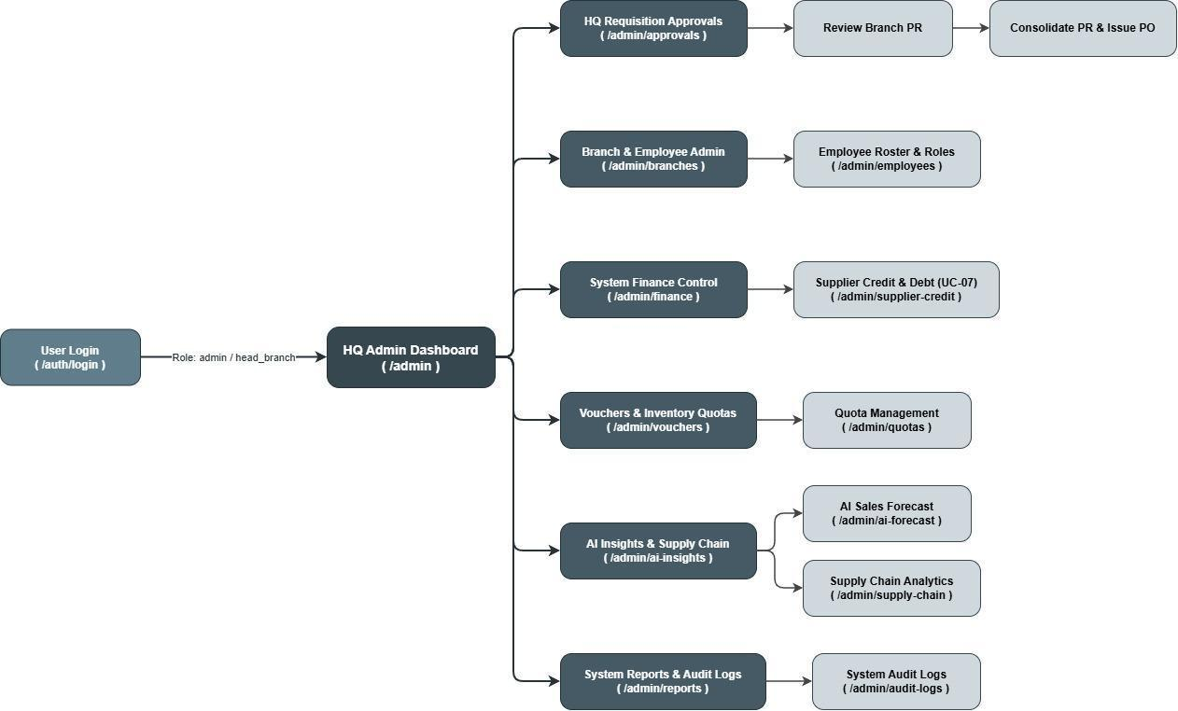
Figure 7 - Screen flow for Admin
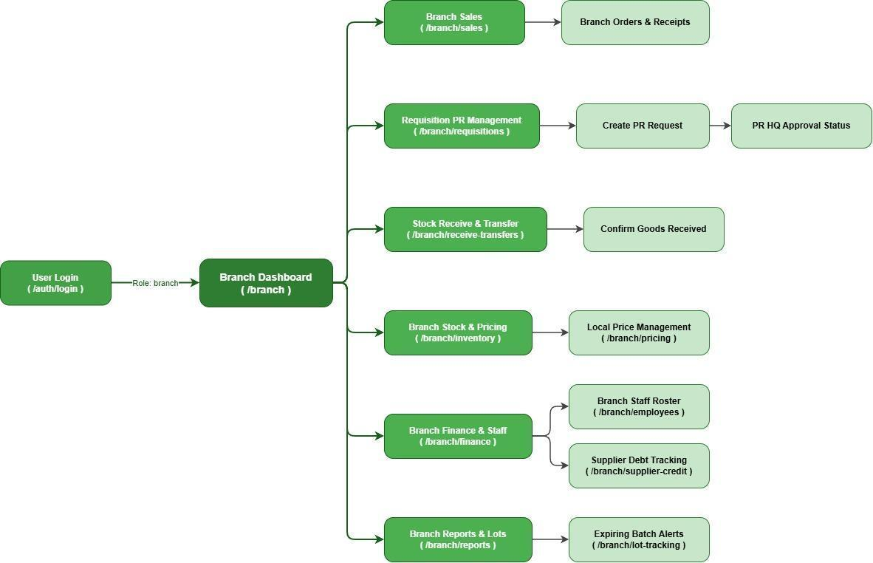
Figure 8 - Screen flow for Branch Manager

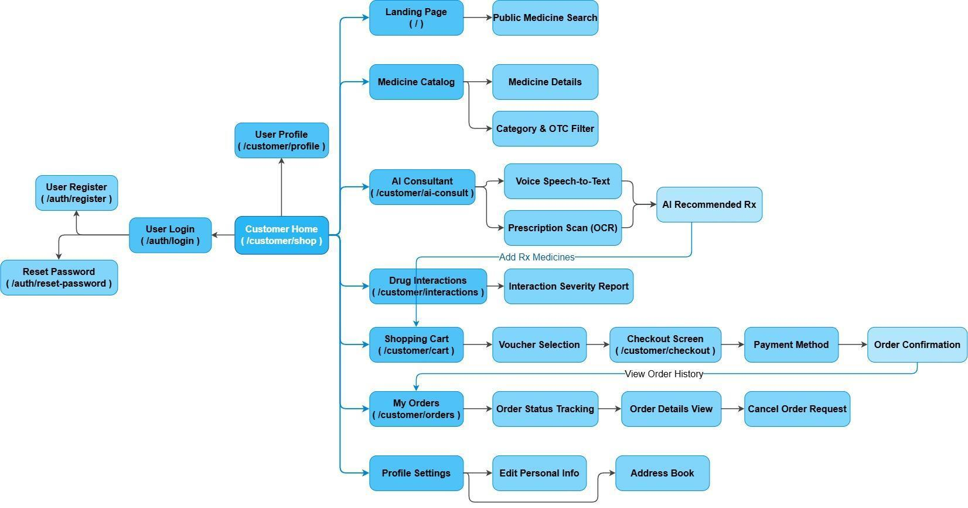

Figure 9 - Screen flow for Customer
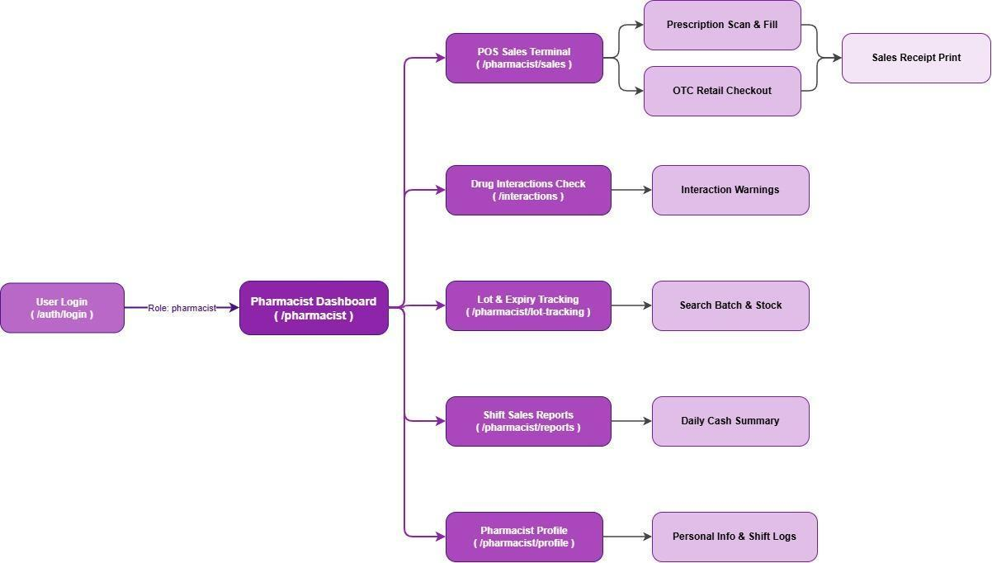
Figure 10 - Screen flow for Pharmacist
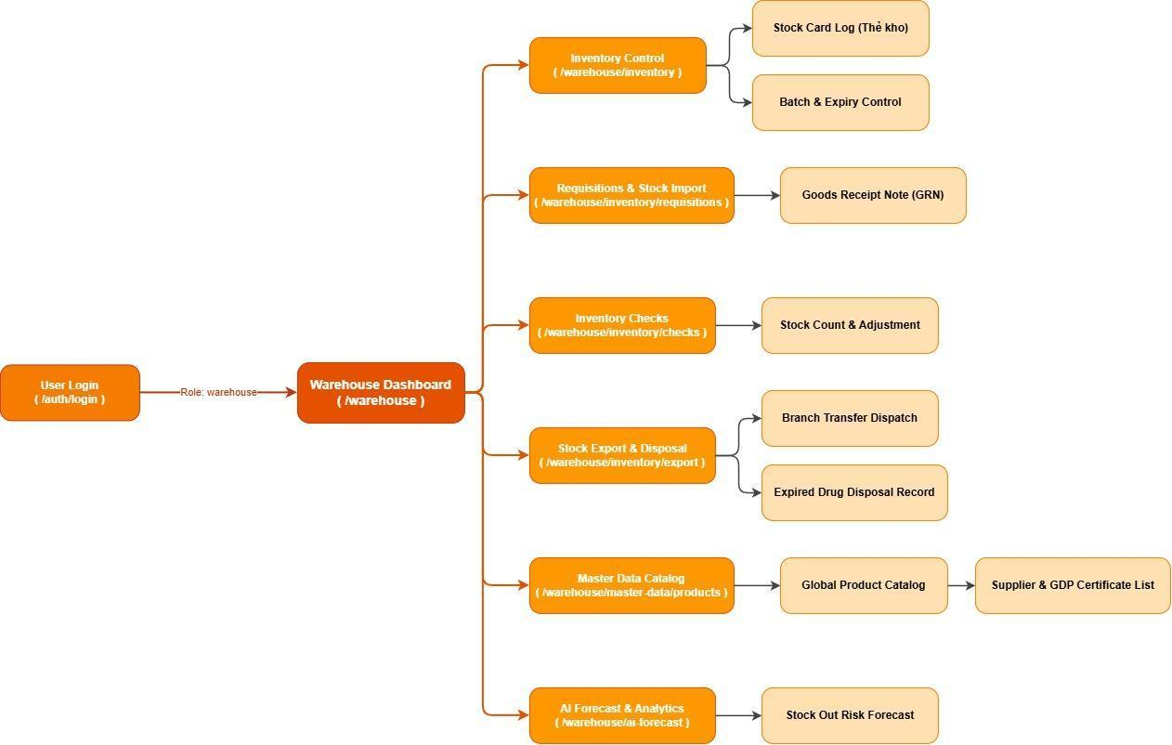
Figure 11 - Screen flow for Warehouse

3.1.2 Screen Descriptions
# | Feature | Screen | Description
1 | Access system & authentication | Login Screen / Register Screen / Reset Password Screen | Allows customers and system staff (Pharmacists, Inventory Managers, Branch Managers, Admins) to register, log in via credentials or Google OAuth, verify email, and request password recovery.
2 | Explore online pharmacy & landing page | Landing Page / Public Medicine Search Screen | Enables guest users and online customers to view featured products, popular health categories, and quickly search for medicines on the store homepage.
3 | Browse medicine catalog & detailed specifications | Medicine Catalog Screen / Medicine Details Screen / Category & OTC Filter Screen | Displays comprehensive drug information including active ingredients, dosage, indications, contraindications, side effects, price, and filter by OTC/Prescription status.
4 | AI symptom & prescription consultation | AI Consultant Screen / Speech-to-Text Action / Prescription Scan (OCR) Screen / AI Recommended Rx Screen | Allows customers to describe symptoms via text or voice speech-to-text, upload doctor prescription photos for AI OCR extraction, and receive intelligent product recommendations.
5 | Analyze drug interactions | Drug Interactions Screen / Interaction Severity Report Screen | Enables users to select multiple medications to verify chemical interactions, contraindication severity, and safety warnings.
6 | Manage online shopping cart & voucher application | Shopping Cart Screen / Voucher Selection Action | Displays selected items, checks stock availability, calculates total value, and allows customers to apply discount vouchers or redeem loyalty points.
7 | Complete online checkout & payment | Checkout Screen / Unified Payment Method Screen / Order Confirmation Screen | Integrates customer shipping address details, order summary, and payment options including Bank Transfer dynamic QR and Cash on Delivery (COD).
8 | Track personal orders & history | My Orders Screen / Order Status Tracking Screen / Order Details View Screen | Enables customers to view their purchase history, check real-time delivery status, review invoice details, or request order cancellation.
9 | Customer profile & loyalty tier management | Profile Settings Screen / Edit Personal Info Screen / Address Book Screen | Displays customer membership tier status (Bronze, Silver, Gold), accumulated reward points, saved shipping addresses, and personal profile information.
10 | Counter retail POS & prescription filling | POS Sales Terminal Screen / Prescription Scan & Fill Screen / OTC Retail Checkout Screen | Allows pharmacists to quickly search medicines, scan prescriptions via AI OCR, automatically auto-fill cart with nearest FEFO batches, and perform fast POS checkout.
11 | Print receipts & issue electronic/wholesale invoices | Sales Receipt Print Action / E-Invoice Email Action / Wholesale Invoice Screen | Generates physical receipt prints, automatically emails e-invoices to customers, and issues wholesale invoices with volume tier pricing.
12 | Counter drug interaction check & substitution | Drug Interactions Check Screen / Interaction Warnings Modal / Substitute Suggestion Action | Triggers real-time alerts for harmful drug-drug interactions and recommends equivalent active-ingredient substitute medicines when items are out of stock.
13 | Process returns & counter inventory lookup | Return Invoice Search Screen / Create Return Slip Screen / Lot & Expiry Tracking Screen | Enables pharmacists to search past counter invoices by customer phone number, process returns/refunds, and verify batch stock levels at counter.
14 | Shift sales summary & daily cash balancing | Shift Sales Reports Screen / Daily Cash Summary Screen / Pharmacist Profile Screen | Provides counter pharmacists with end-of-shift sales breakdowns, cash drawer balancing, and personal shift logs.
15 | Monitor branch sales & transaction receipts | Branch Dashboard / Branch Sales Screen / Branch Orders & Receipts Screen | Gives branch managers a real-time overview of daily store revenue, counter order volume, and transaction receipts.
16 | Manage branch stock requisitions (PR) | Requisition PR Management Screen / Create PR Request Action / PR HQ Approval Status Screen | Allows branch managers to submit stock replenishment requests (PR) to central warehouse and HQ when counter inventory reaches safety thresholds.
17 | Receive stock & handle internal transfers | Stock Receive & Transfer Screen / Confirm Goods Received Action / Internal Transfer Slip Screen | Enables branch managers to confirm incoming stock shipments from central warehouse and manage inter-branch inventory transfers to resolve stock imbalances.
18 | Manage branch inventory & local pricing | Branch Stock & Pricing Screen / Local Price Management Screen | Displays physical stock quantities per FEFO batch at the branch and allows authorized local retail price adjustments.
19 | Branch staff roster & supplier credit tracking | Branch Finance & Staff Screen / Branch Staff Roster Screen / Supplier Debt Tracking Screen | Enables branch managers to oversee employee shift schedules, create pharmacist accounts, approve staff access, and track branch expenses and supplier debt.
20 | Branch reporting & near-expiry alerts | Branch Reports & Lots Screen / Expiring Batch Alerts Screen | Generates branch financial performance reports and alerts managers about batches expiring within 3 to 6 months to trigger promotional discounts or write-offs.
21 | Central warehouse inventory & stock card tracking | Warehouse Dashboard / Inventory Control Screen / Stock Card Log Screen (Thẻ kho) | Provides warehouse managers with full visibility of central inventory, detailed batch numbers (batchNo), expiry dates (expDate), and real-time stock card logs.
22 | Process Goods Receipt Notes (GRN) & PO imports | Requisitions & Stock Import Screen / Goods Receipt Note (GRN) Screen / AI Camera Inspection Screen | Allows warehouse staff to process receiving sessions based on approved Purchase Orders (PO), count boxes manually or via AI camera, and create GRNs.
23 | Warehouse stock audits & inventory adjustments | Inventory Checks Screen / Stock Count & Adjustment Screen | Facilitates physical inventory stock counts, audit reporting, and stock balance adjustments for damaged or lost goods.
24 | Dispatch branch transfers & disposal tracking | Stock Export & Disposal Screen / Branch Transfer Dispatch Screen / Expired Disposal Record Screen | Manages outbound shipments for branch requisitions, tracks transit status, and logs official write-off records for expired pharmaceutical items.
25 | Master product catalog & supplier registry | Master Data Catalog Screen / Global Product Catalog Screen / Supplier & GDP Certificate List Screen | Maintains central medicine catalog definitions, active ingredients, dosage forms, manufacturer profiles, and supplier GDP license details.
26 | AI demand forecasting & automated PO creation | AI Forecast & Analytics Screen / Stock Out Risk Forecast Screen / Auto-Generate PO Action | Analyzes sales trends, stock-out risks, and seasonal epidemic patterns using AI models to recommend optimal replenishment and auto-generate Purchase Orders (PO).
27 | Approve purchase orders & GRN receipts | HQ Admin Dashboard / HQ Requisition Approvals Screen / Review Branch PR Screen / Consolidate PR & Issue PO Screen | Enables HQ Admin to review branch requisitions, approve or reject supplier POs and warehouse GRNs, and consolidate chain purchasing.
28 | Store network & employee account governance | Branch & Employee Admin Screen / Employee Roster & Roles Screen | Allows HQ Admin to manage branch locations, create Branch Manager accounts, approve staff registrations, and update role permissions.
29 | Corporate financial control & cash flow management | System Finance Control Screen / Supplier Credit & Debt Screen | Provides executive financial reporting, chain-wide cash flow tracking, supplier payables/receivables management, and fixed expense monitoring.
30 | Manage promotional vouchers & inventory quotas | Vouchers & Inventory Quotas Screen / Quota Management Screen | Allows Admin to create promotional voucher codes, percentage discounts, flash sales, and configure branch stock allocation quotas.
31 | Executive AI analytics & branch performance comparison | AI Insights & Supply Chain Screen / AI Sales Forecast Screen / Supply Chain Analytics Screen | Offers high-level C-suite dashboards comparing sales, growth rates, epidemic impact trends, and inventory anomaly detection across all branches.
32 | Query system audit logs & real-time notifications | System Reports & Audit Logs Screen / System Audit Logs Screen / Notification Center Popup | Tracks critical system activities for security compliance and delivers real-time notifications for low stock, expiring batches, and pending approvals.

3.1.3 Screen Authorization
Screen | Admin | Branch Manager | Inventory Manager | Pharmacist | Customer
Authentication & Public Screens
Login Screen | X | X | X | X | X
Register Account Screen |  |  |  |  | X
Reset / Forgot Password Screen | X | X | X | X | X
Landing Page / Public Home | X | X | X | X | X
Public Medicine Search Screen | X | X | X | X | X
View Detail Medicine Screen | X | X | X | X | X
Online Customer Portal
Category & OTC Filter Screen |  |  |  |  | X
AI Consultant Screen |  |  |  |  | X
Prescription Scan (OCR) Screen |  |  |  | X | X
Drug Interactions Screen |  |  |  | X | X
Add to Cart Action |  |  |  |  | X
Shopping Cart Screen |  |  |  |  | X
Unified Payment & Checkout Screen |  |  |  |  | X
Order History Self-Lookup Screen |  |  |  |  | X
Customer Profile Settings Screen |  |  |  |  | X
Pharmacist POS Counter Terminal
Pharmacist Dashboard Screen |  | X |  | X
POS Sales Terminal Screen |  | X |  | X
OTC Retail Checkout Screen |  | X |  | X
Sales Receipt Print Action |  | X |  | X
E-Invoice & Wholesale Invoice Screen |  | X |  | X
Return Invoice Search & Slip Screen |  | X |  | X
Counter Lot & Expiry Tracking Screen |  | X |  | X
Shift Sales Reports & Cash Summary Screen |  | X |  | X
Branch Management Portal
Branch Dashboard Screen | X | X
Branch Sales Overview Screen | X | X
Requisition PR Management Screen | X | X
Create PR Request Screen |  | X
Stock Receive & Transfer Screen |  | X | X
Branch Stock & Local Pricing Screen | X | X
Branch Staff Roster & Employee Admin Screen | X | X
Supplier Debt Tracking Screen | X | X
Branch Reports & Expiring Alerts Screen | X | X
Central Warehouse Management
Warehouse Dashboard Screen | X |  | X
Inventory Control Screen | X |  | X
Stock Card Log Screen | X |  | X
Goods Receipt Note (GRN) Screen | X |  | X
Camera / AI CV Stock Inspection Screen |  |  | X
Stock Count & Adjustment Screen | X |  | X
Stock Export & Disposal Screen | X |  | X
Master Product Catalog Screen | X |  | X
Supplier & GDP Certificate List Screen | X |  | X
AI Demand Forecast & Auto-PO Screen | X |  | X
HQ Admin Executive Portal
HQ Admin Dashboard Screen | X
HQ Requisition & PO Approvals Screen | X
Consolidate PR & Issue PO Screen | X
Branch Network Admin Screen | X
System Finance & Cash Flow Control Screen | X
Vouchers & Inventory Quotas Screen | X
AI Insights & Supply Chain Analytics Screen | X
System Audit Logs Screen | X

3.1.4 Non-Screen Functions
# | Feature | System Function | Description
1 | AI Analysis & Intelligence Services | Expiry Date Scanner (Cron Job) | A daily background job that scans all medicine batches (medicinebatches) to flag items nearing expiry. It ranks warnings into categories:  • Red Alert (< 3 months): Automatically blocks the batch from POS checkout, moves it to "Quarantine," and alerts warehouse staff.  • Yellow Alert (< 6 months): Pushes notifications to store managers to launch promotional discount campaigns.
 |  | AI Gemini 2.5 Prescription OCR Engine | An asynchronous API service processing uploaded multi-page doctor prescription images. It uses Google Gemini API to extract active ingredients and dosage specs, merge duplicate items, match with branch DB, and auto-select nearest FEFO batches.
 |  | AI Drug Interaction & Contraindication Analyzer | An API service that checks active ingredients of selected items in cart or POS against a clinical drug database, flagging dangerous drug-drug interactions, food contraindications, and severity warning levels.
 |  | AI Health & Symptom NLP Consultant | An asynchronous backend service processing natural language symptom queries (text or voice-to-text transcriptions) using LLM models to provide symptom analysis and recommend matching OTC products.
 |  | AI Stock Anomaly & Theft Detector | A batch background job comparing physical stocktake counts with transaction histories to detect abnormal inventory discrepancies, unrecorded wastage, or potential theft spikes.
 |  | AI EOQ Demand Forecasting Engine | A scheduled service running predictive AI models over historical sales data, seasonal shifts, and local disease history to project replenishment demands and auto-generate draft Purchase Orders (PO).
2 | Payment & Checkout Processing | Bank Transfer Dynamic QR & Webhook Handler | An asynchronous API webhook listener that receives payment status callbacks from VietQR / Bank gateways. It verifies digital signatures, automatically updates order status to "Paid", and triggers stock deduction.
 |  | Tiered Pricing & Discount Calculation Engine | Backend pricing middleware that automatically calculates customer tier discounts (Gold, Silver, Bronze), validates voucher codes, and applies wholesale volume pricing tiers during cart checkout.
3 | Inventory FEFO & Batch Allocation | Atomic FEFO Batch Lock & Allocation Worker | A database transaction manager executing atomic locks on medicine batches (batchNo) based on First-Expired, First-Out (FEFO) logic upon order placement, preventing overselling.
 |  | AI Camera Box Counting Service | A computer vision backend service analyzing shipment package photos uploaded by warehouse staff. It automatically detects and counts box quantities, attaching visual audit evidence to Goods Receipt Notes (GRN).
 |  | Inter-Branch Stock Sync Worker | A background worker synchronizing inventory balance adjustments, transfer dispatches, and receiving confirmations across multiple branch databases in real time.
4 | Real-Time Communication & Messaging | WebSocket Real-Time Event Broadcaster | A Socket.io background service maintaining persistent TCP connections with connected clients. It emits live alerts for urgent branch replenishment requests, low stock warnings, and PO/GRN approval requests.
 |  | SMTP Email & E-Invoice Queue Dispatcher | An asynchronous queue worker (BullMQ/Redis) dedicated to sending account verification OTPs, password recovery links, order confirmation emails, and PDF e-invoices via SMTP without blocking main API threads.
5 | Security, Compliance & Auditing | System Audit Logging Middleware | Middleware intercepting and asynchronously writing critical business actions (inventory manual overrides, price modifications, staff role changes, PO approvals) into immutable audit log tables for security compliance.
 |  | Role Authorization & Account Status Enforcer | Backend security middleware validating JWT tokens, verifying role permissions (Admin, Branch Manager, Inventory Manager, Pharmacist, Customer), and blocking unapproved or deactivated staff accounts.

3.1.5 Entity Relationship Diagram
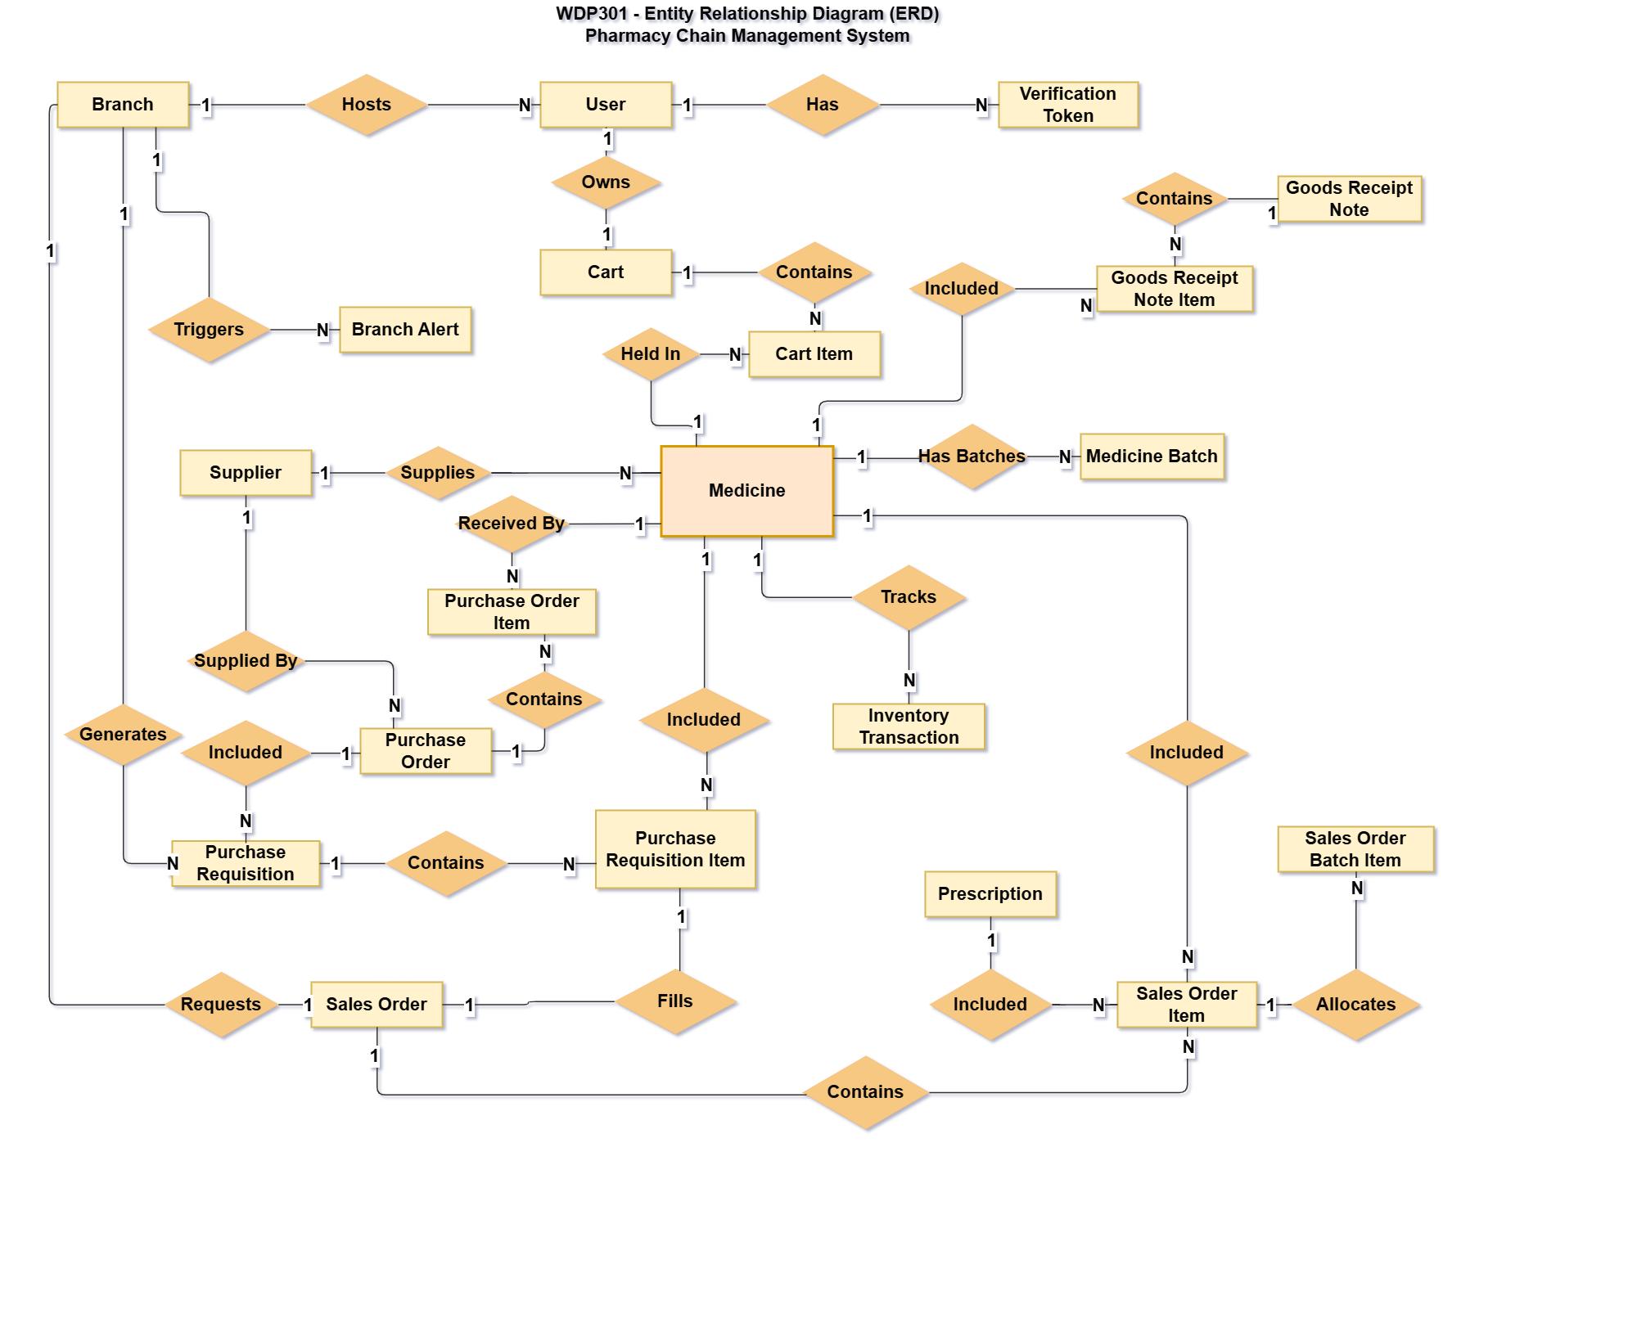
Entities Description
# | Entity | Description
1 | User | Represents any authenticated system user, including customers, counter pharmacists, warehouse staff, branch managers, and system administrators. Stores basic login credentials, hashed passwords, contact info, and assigned RBAC roles.
2 | Verification Token | Manages time-limited security tokens and 6-digit OTP codes used for user account email verification, password recovery requests, and session security validations.
3 | Branch | Represents a physical pharmacy store location within the chain. Tracks store code, physical address, contact hotline, operating hours, and isolates local inventory stock levels.
4 | Branch Alert | Stores automated system warnings triggered by store branches, such as low stock safety threshold alerts, critical medicine deficits, or cold storage temperature warnings.
5 | Cart | Represents a customer's active online shopping cart. Each customer user owns one active cart to compile selected pharmaceutical products prior to online checkout.
6 | Cart Item | A bridge entity representing a specific medicine SKU, packaging unit, and selected quantity inside a customer's active online cart.
7 | Medicine | The master catalog entity representing a unique drug/medicine SKU. Stores clinical specifications like active ingredients, dosage concentration, therapeutic category, default packaging units, OTC/Rx flags, and base retail price.
8 | Medicine Batch | Tracks physical batches (lots) of a medicine SKU. Essential for FEFO (First-Expired, First-Out) batch management, storing Batch Number (batchNo), Expiration Date (expDate), Manufacturing Date, and Unit Purchase Cost.
9 | Inventory Transaction | Ledger entity logging all physical stock movements across the system (inbound GRN receipts, counter sales deductions, inter-branch transfers, audit write-offs) for complete auditability.
10 | Supplier | Represents an external pharmaceutical manufacturer or wholesale supplier. Stores company name, tax ID, GDP license expiration date, contact details, payment credit terms, and liability tracking.
11 | Purchase Requisition | An internal stock replenishment request generated by a branch manager or automated low-stock alert to request inventory restocking from the central warehouse.
12 | Purchase Requisition Item | Line item entity detailing the specific medicine SKU and requested quantity within a Purchase Requisition.
13 | Purchase Order | An official procurement order issued to an external supplier to purchase stock, generated after HQ Admin review and approval of branch requisitions.
14 | Purchase Order Item | Line item entity detailing the medicine SKU, agreed unit purchase cost, and ordered box quantity from the supplier under a Purchase Order.
15 | Goods Receipt Note | An inbound receiving document generated at the central warehouse when physical goods delivered by a supplier arrive based on an approved Purchase Order.
16 | Goods Receipt Note Item | Detail entity of the GRN capturing actual inspected quantities received, assigned batch numbers (batchNo), and verified expiration dates (expDate).
17 | Prescription | Stores medical doctor prescription details (scanned electronic files or uploaded prescription images) required by pharmaceutical regulations to authorize the sale of prescription-only (Rx) drugs.
18 | Sales Order | Represents a completed retail transaction order, whether processed at a physical branch POS counter or placed online via the customer portal.
19 | Sales Order Item | Line item entity representing a specific medicine SKU, packaging unit, sold quantity, and active selling price under a Sales Order.
20 | Sales Order Batch Item | A bridge entity linking a sales order line item directly to specific physical FEFO medicine batches (batchNo / Expiry Date) allocated to fulfill the order, ensuring proper FEFO inventory deduction.

3.2 Authentication & User Account Management

3.2.1 Register Account (UC-01)
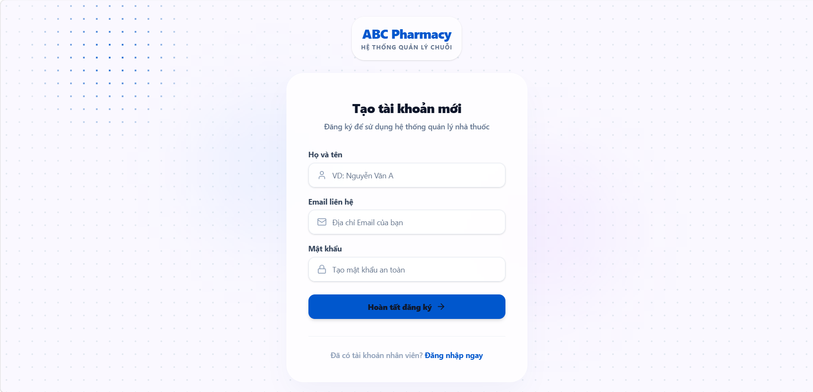
• Function Trigger:
• Navigation Path: Home > Click 'Register' > Navigated to `/auth/register`
• Trigger Event / Frequency: User clicks 'Register' button upon demand.
• Function Description:
• Actors / Roles: Customer (Guest)
• Purpose: Allows new customers to create a personal account using email and password.
• Interface Type: Full Web Page Screen
• Screen Layout: N/A
• Function Details:
• Data:
- Read-only / Output: Success confirmation message, OTP verification modal.
- Editable / Input: Full Name, Email Address, Phone Number, Password, Confirm Password.
• Validation:
- Email must follow valid RFC 5322 format (`name@domain.com`) and must not already exist in the database.
- Password must be at least 8 characters, containing uppercase, lowercase, number, and special character.
- Phone number must be a valid 10-digit Vietnamese number (`0x...`).
• Business Rule:
- BR-01: Registration requires email verification via a 6-digit OTP code before account activation.
- BR-03: Password complexity requirements enforced.
• Functionality:
- In Normal Cases: User enters valid personal details and submits. System hashes password using bcrypt, creates an inactive user record, sends a 6-digit OTP to the user's email, and redirects to the Email Verification screen with a success toast notification.
- In Abnormal Cases: If the email is already registered, system blocks submission, displays an inline red error "Email is already in use", and keeps input fields intact for correction.

3.2.2 Sign In (UC-02)
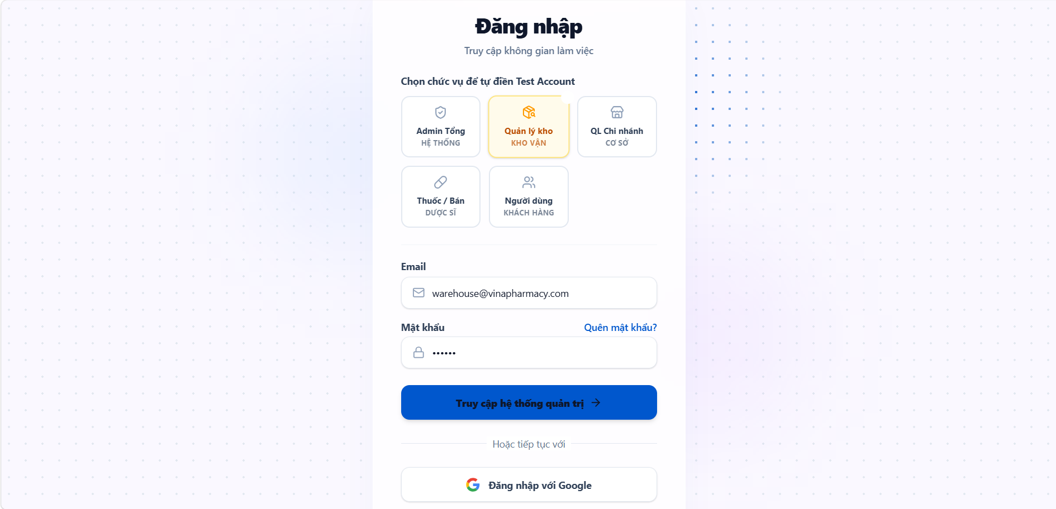
• Function Trigger:
• Navigation Path: Home / Dashboard > Click 'Login' > Navigated to `/auth/login`
• Trigger Event / Frequency: User clicks 'Sign In' button.
• Function Description:
• Actors / Roles: Customer, Pharmacist, Inventory Manager, Branch Manager, Admin
• Purpose: Authenticates registered users and generates JWT session tokens with role-based permissions.
• Interface Type: Full Web Page Screen
• Screen Layout: N/A
• Function Details:
• Data:
- Read-only / Output: User session metadata, JWT Auth Token, user role badge.
- Editable / Input: Email Address / Username, Password, Remember Me checkbox.
• Validation:
- Email and Password fields are strictly required.
• Business Rule:
- BR-02: Newly created staff accounts must be approved by Admin/Branch Manager before initial login.
• Functionality:
- In Normal Cases: User enters credentials and clicks 'Sign In'. System validates credentials against database, verifies active account status, issues JWT access and refresh tokens, stores session context, and redirects user to their role-specific dashboard (e.g., `/pharmacist/sales` for Pharmacist, `/admin` for Admin).
- In Abnormal Cases: If credentials do not match or account is deactivated/pending approval, system displays inline error MSG05 "Incorrect email or password. Please check your credentials and try again."

3.2.3 Verify Email (UC-03)
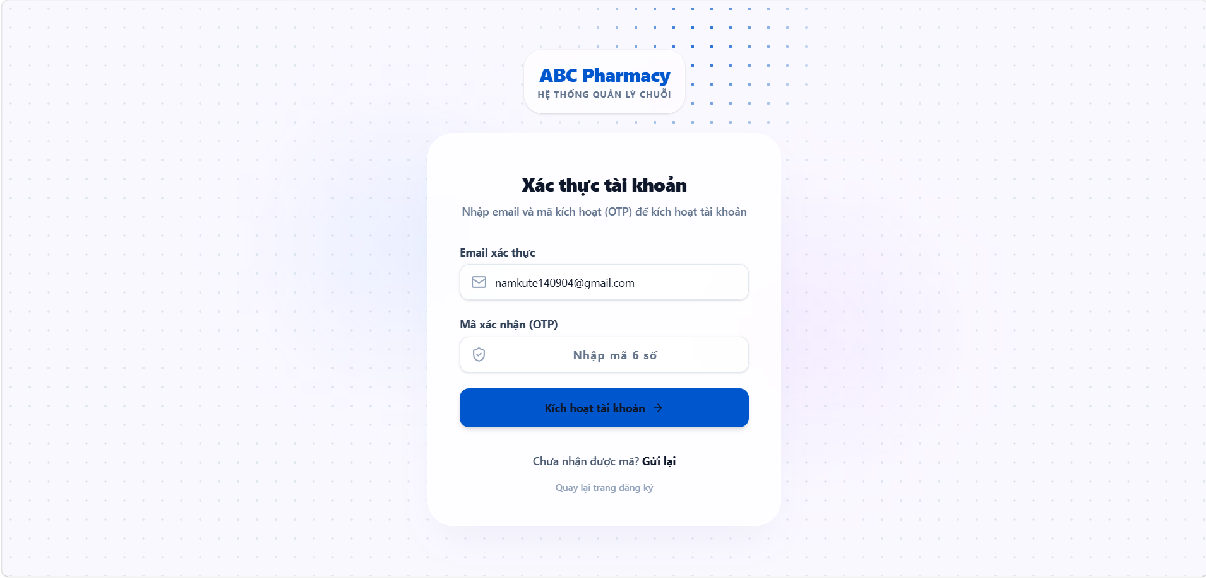
• Function Trigger:
• Navigation Path: Automatically redirected from Register Screen > `/auth/verify-email`
• Trigger Event / Frequency: User submits registration form or requests resend OTP.
• Function Description:
• Actors / Roles: Customer, Pharmacist, Branch Manager
• Purpose: Confirms customer email ownership by validating the 6-digit OTP sent via email.
• Interface Type: Modal Dialog / Screen
• Screen Layout: N/A
• Function Details:
• Data:
- Read-only / Output: Email destination label, OTP countdown timer (180s).
- Editable / Input: 6-digit OTP Code.
• Validation:
- OTP must be exactly 6 numeric digits within the valid TTL window.
• Business Rule:
- BR-01: Mandatory email verification prior to account activation.
• Functionality:
- In Normal Cases: User enters the 6-digit code received in email and clicks 'Verify'. System validates OTP code and TTL, updates user account status to `ACTIVE`, and displays success toast MSG07 "Email verified successfully. You can now log in."
- In Abnormal Cases: If code is expired or incorrect, system displays inline red error "Invalid or expired verification code", allowing the user to click 'Resend OTP'.

3.2.4 Sign In with Google (UC-04)
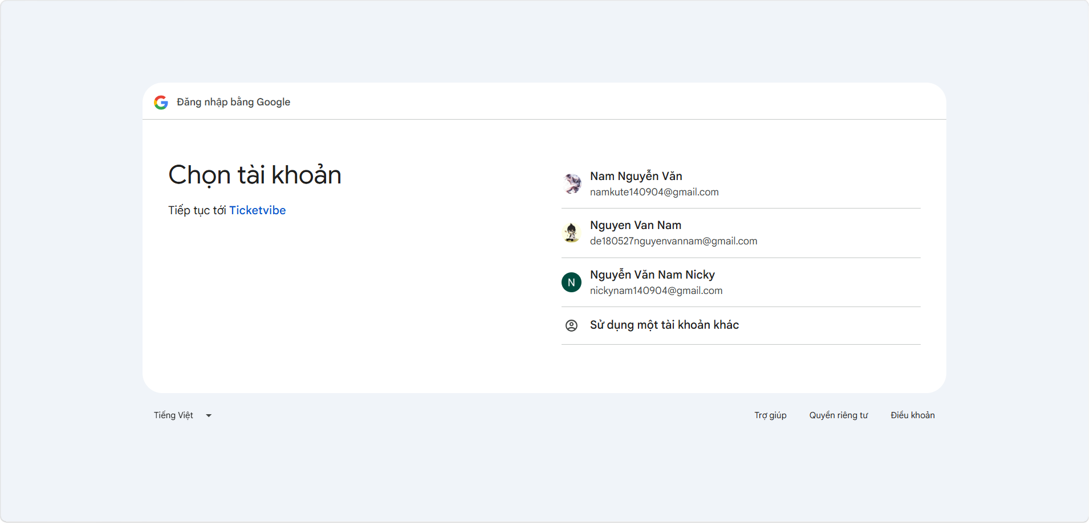
• Function Trigger:
• Navigation Path: Login Screen > Click 'Continue with Google' button
• Trigger Event / Frequency: On button click by Customer on demand.
• Function Description:
• Actors / Roles: Customer
• Purpose: Enables quick authentication for online shopping using Google OAuth 2.0.
• Interface Type: Third-party OAuth Popup / Redirect
• Screen Layout: N/A
• Function Details:
• Data:
- Read-only / Output: Google Profile Avatar, Email, Full Name.
- Editable / Input: Google OAuth Account Authorization.
• Validation:
- Google OAuth token response must be cryptographically verified by backend server.
• Business Rule:
- N/A (Standard Customer OAuth Access).
• Functionality:
- In Normal Cases: Customer clicks 'Continue with Google', completes Google consent prompt. Backend verifies token, automatically provisions a customer account if first-time login, issues JWT session, and logs user into `/customer/shop`.
- In Abnormal Cases: If user cancels Google OAuth prompt, system catches callback error and retains user on `/auth/login` with toast "Google authentication cancelled."

3.2.5 Recover Password (UC-05)
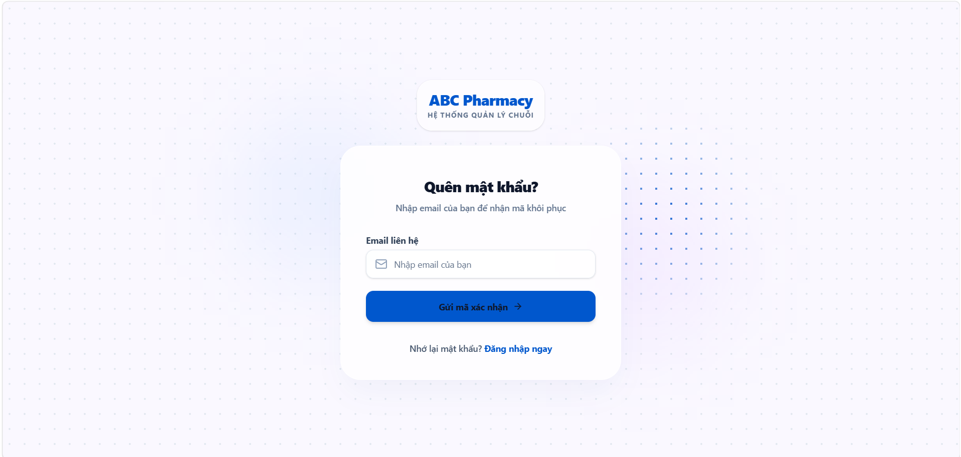
• Function Trigger:
• Navigation Path: Login Screen > Click 'Forgot Password?' > `/auth/forgot-password`
• Trigger Event / Frequency: User clicks link upon forgetting credentials.
• Function Description:
• Actors / Roles: Customer, Pharmacist, Inventory Manager, Branch Manager, Admin
• Purpose: Initiates password recovery workflow by dispatching a reset link via email.
• Interface Type: Full Web Page Screen
• Screen Layout: N/A
• Function Details:
• Data:
- Read-only / Output: Instructions banner, success confirmation notification.
- Editable / Input: Registered Email Address.
• Validation:
- Email field is required and must match valid email format.
• Business Rule:
- N/A.
• Functionality:
- In Normal Cases: User enters registered email and submits. System generates a secure time-limited password reset token (15-min TTL), enqueues email job via BullMQ/SMTP, and displays toast MSG08 "A password reset link has been sent to your email."
- In Abnormal Cases: If email is not found in database, system displays generic success message for privacy protection without disclosing account non-existence.

3.2.6 Reset Password (UC-06)
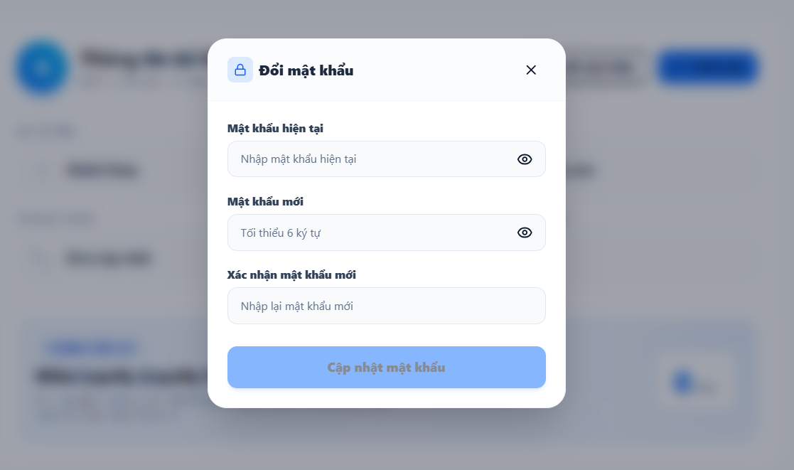
• Function Trigger:
• Navigation Path: Email link click > Navigated to `/auth/reset-password?token=...`
• Trigger Event / Frequency: User opens secure link from email inbox.
• Function Description:
• Actors / Roles: Customer, Pharmacist, Inventory Manager, Branch Manager, Admin
• Purpose: Allows users to define a new account password using the secure recovery token.
• Interface Type: Full Web Page Screen
• Screen Layout: N/A
• Function Details:
• Data:
- Read-only / Output: Account email identifier.
- Editable / Input: New Password, Confirm New Password.
• Validation:
- New Password must meet complexity requirements (BR-03) and match Confirm Password field.
• Business Rule:
- BR-03: Enforce password strength rules.
• Functionality:
- In Normal Cases: User enters valid new password, submits. System verifies token validity, hashes new password, updates DB record, invalidates recovery token, and redirects to Login screen with success toast.
- In Abnormal Cases: If recovery token is expired or tampered with, system blocks form submission and displays red error "Password reset link is invalid or expired. Please request a new one."

3.2.7 Sign Out (UC-07)
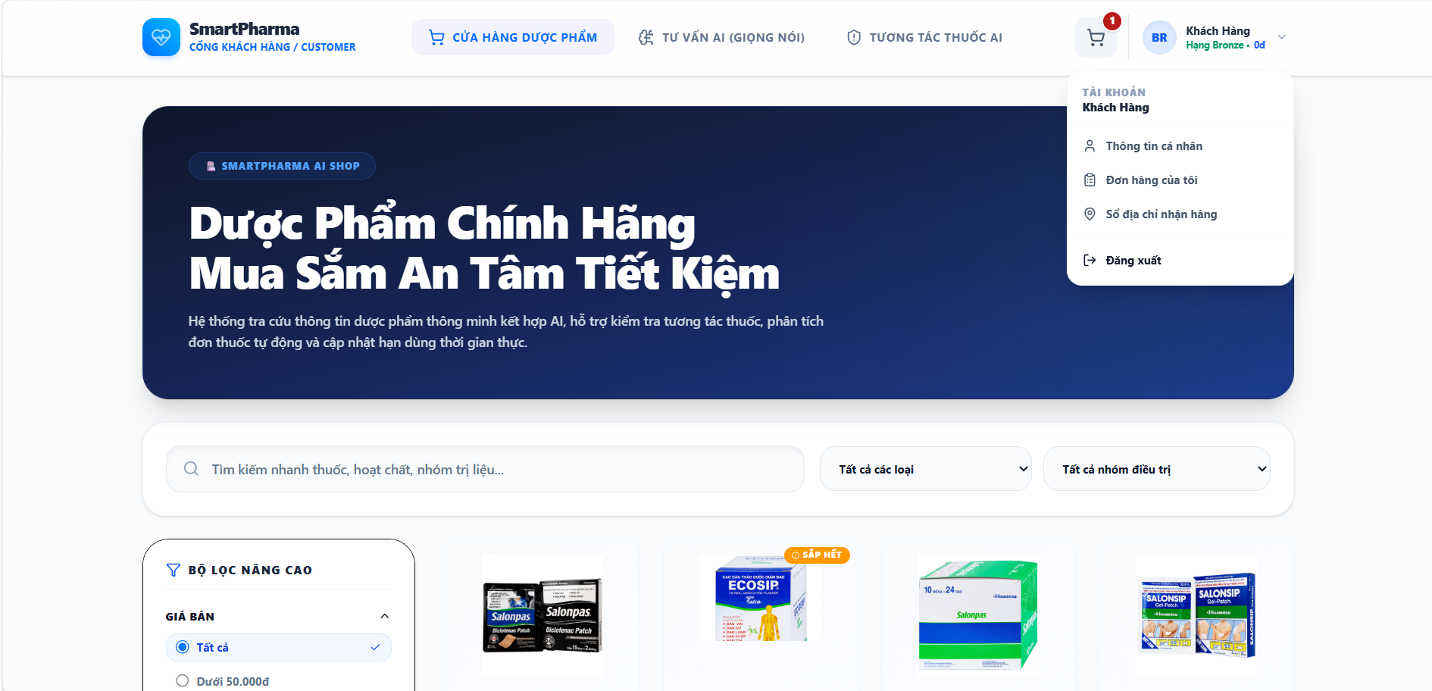
• Function Trigger:
• Navigation Path: Top Navigation Bar > Click User Avatar > Select 'Sign Out'
• Trigger Event / Frequency: User clicks 'Sign Out' button.
• Function Description:
• Actors / Roles: Customer, Pharmacist, Inventory Manager, Branch Manager, Admin
• Purpose: Safely terminates active JWT session and clears client storage.
• Interface Type: Web Action / Header Widget
• Screen Layout: N/A
• Function Details:
• Data:
- Read-only / Output: N/A.
- Editable / Input: N/A.
• Validation:
- Active session token must be present in request header.
• Business Rule:
- N/A.
• Functionality:
- In Normal Cases: User clicks 'Sign Out'. System invalidates refresh token on server, clears localStorage/cookies on client, disconnects active WebSocket rooms, and redirects to Landing Page (`/`).
- In Abnormal Cases: If client storage clearing fails, system forcibly wipes tokens and redirects to Login page.

3.3 Online Customer Portal

3.3.1 Search Medicines Online (UC-08)
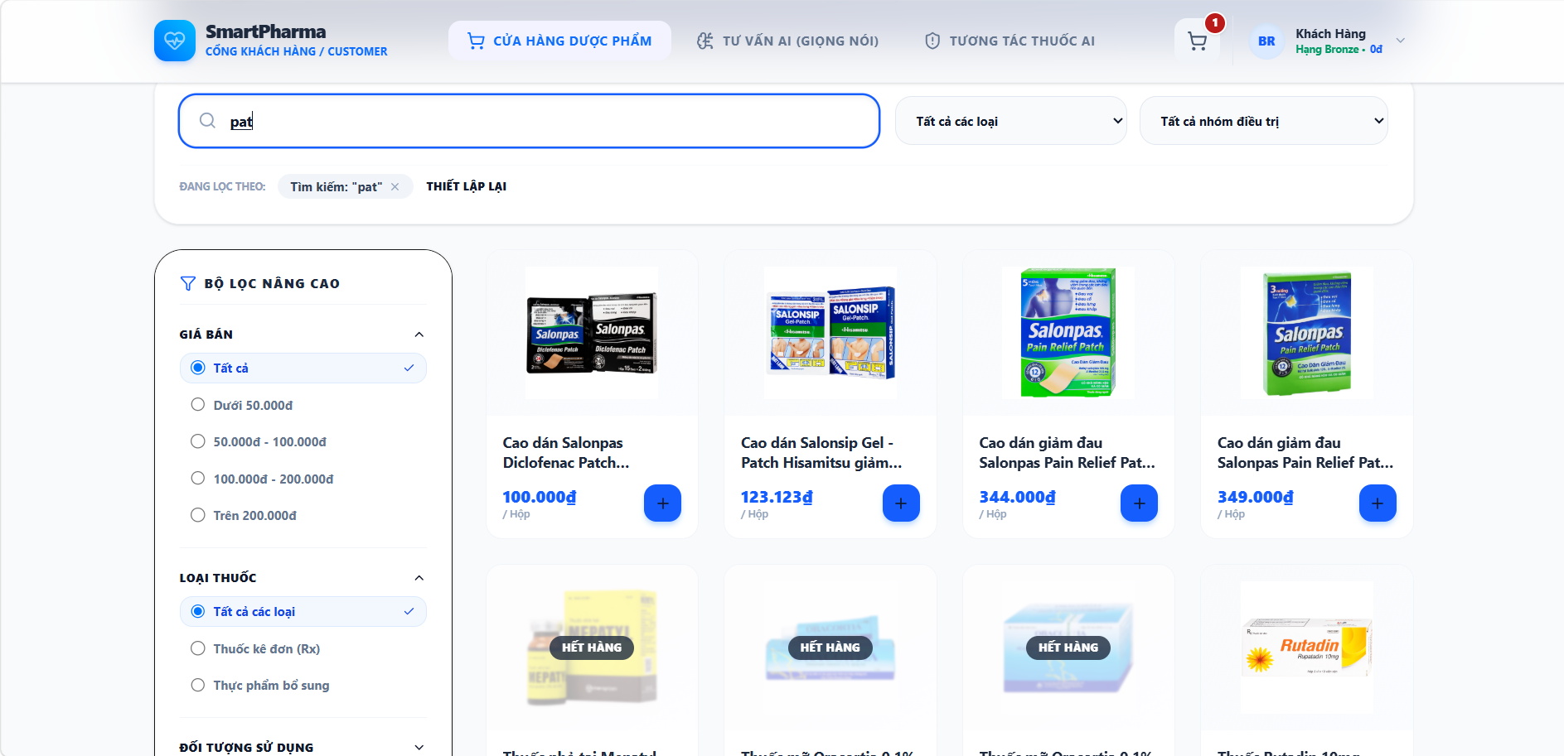
• Function Trigger:
• Navigation Path: Landing Page / Shop > Search Bar at top header (`/customer/shop`)
• Trigger Event / Frequency: User types in search box or presses Enter key.
• Function Description:
• Actors / Roles: Customer, Guest
• Purpose: Browse and search medicines by name, active ingredient, or medical indication.
• Interface Type: Full Web Page / Live Dropdown Search
• Screen Layout: N/A
• Function Details:
• Data:
- Read-only / Output: Product list grid, medicine thumbnail, name, active ingredient, retail unit price, OTC badge.
- Editable / Input: Search keyword, Category filter dropdown, OTC/Rx filter toggle.
• Validation:
- Search keyword is sanitized to prevent SQL injection or XSS scripting.
• Business Rule:
- N/A.
• Functionality:
- In Normal Cases: Customer enters keyword "Paracetamol" or selects "Pain Relief". System performs indexed full-text search, filters active SKUs, and updates product grid dynamically in < 500ms.
- In Abnormal Cases: If no products match query, system displays inline message MSG01 "No matching medicines found for '{keyword}'. Please try another search term."

3.3.2 Add to Cart (UC-09)
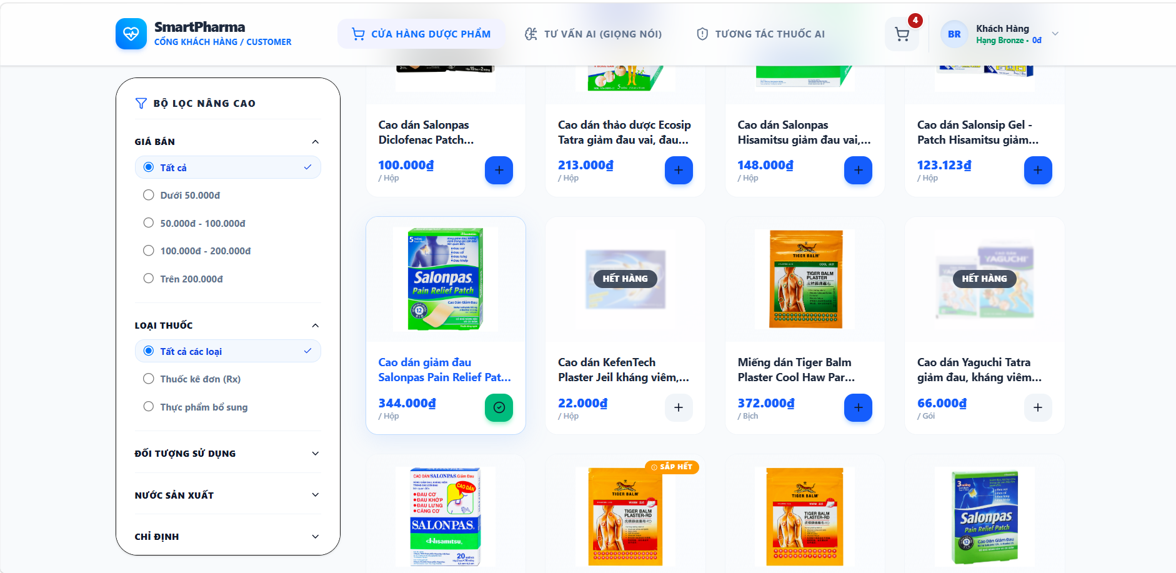
• Function Trigger:
• Navigation Path: Medicine Detail Screen / Catalog Card > Click 'Add to Cart' button
• Trigger Event / Frequency: On button click by Customer.
• Function Description:
• Actors / Roles: Customer
• Purpose: Adds desired medication quantity into personal shopping cart.
• Interface Type: Button Action / Floating Drawer
• Screen Layout: N/A
• Function Details:
• Data:
- Read-only / Output: Cart badge counter badge update, subtotal preview.
- Editable / Input: Selected Medicine ID, Quantity selector.
• Validation:
- Quantity must be a positive integer >= 1 and <= available branch stock quantity.
• Business Rule:
- BR-04: Rx medicines added to cart trigger a prescription upload warning flag.
• Functionality:
- In Normal Cases: Customer selects quantity (e.g. 2 boxes) and clicks 'Add to Cart'. System verifies stock availability, inserts/updates item in user's active Cart entity, updates header badge count, and shows toast MSG09.
- In Abnormal Cases: If requested quantity exceeds available stock, system blocks addition and displays warning toast "Requested quantity exceeds available stock limit."

3.3.3 Manage Personal Cart (UC-10)
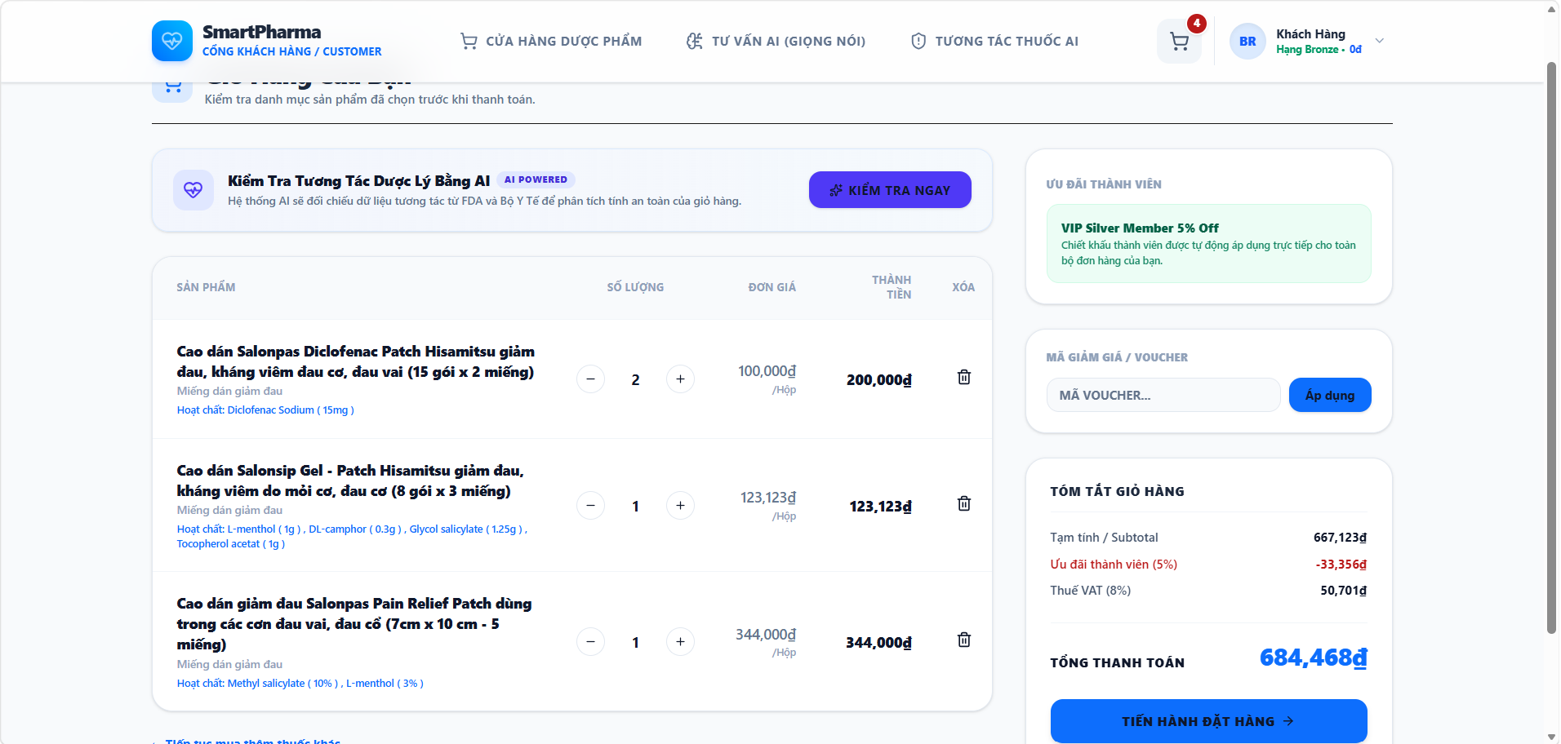
• Function Trigger:
• Navigation Path: Header > Click Cart Icon > Navigated to `/customer/cart`
• Trigger Event / Frequency: User navigates to Cart page.
• Function Description:
• Actors / Roles: Customer
• Purpose: Allows customers to view, adjust quantities, or remove items from online cart.
• Interface Type: Full Web Page Screen
• Screen Layout: N/A
• Function Details:
• Data:
- Read-only / Output: Line item details, unit price, quantity subtotal, estimated tax, total price.
- Editable / Input: Item quantity (+/- buttons), Remove item button, Voucher code input.
• Validation:
- Quantity changes must strictly be positive integers.
• Business Rule:
- N/A.
• Functionality:
- In Normal Cases: Customer modifies item quantities or clicks 'Remove'. System recalculates cart subtotal, updates Cart entity in database, and renders updated price summary.
- In Abnormal Cases: If cart becomes empty, system displays empty cart illustration with button "Continue Shopping".

3.3.4 Confirm Online Order (UC-11)
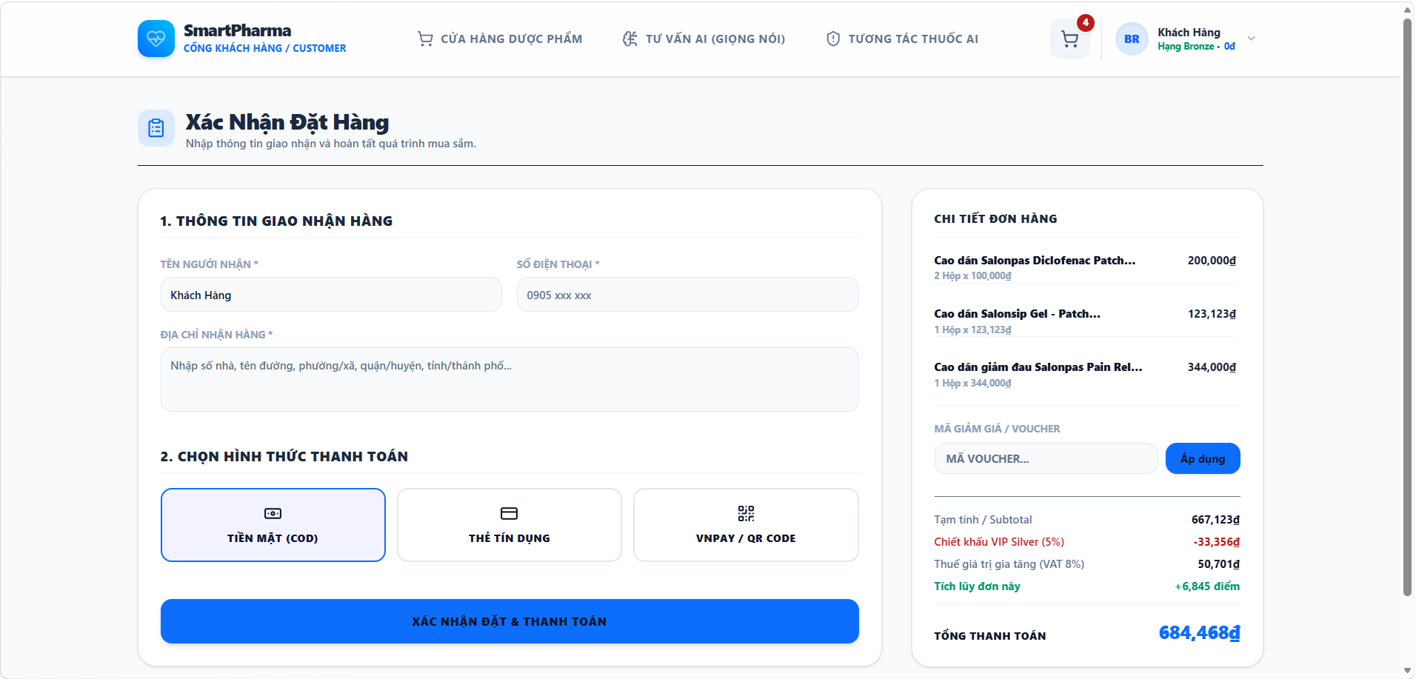
• Function Trigger:
• Navigation Path: Shopping Cart > Click 'Proceed to Checkout' > `/customer/checkout`
• Trigger Event / Frequency: Customer initiates order confirmation.
• Function Description:
• Actors / Roles: Customer
• Purpose: Fill delivery address, recipient contact details, and review order details before payment.
• Interface Type: Multi-step Form Screen
• Screen Layout: N/A
• Function Details:
• Data:
- Read-only / Output: Order summary list, shipping fee calculation, applied voucher discount.
- Editable / Input: Recipient Full Name, Phone Number, Delivery Address, Delivery Notes, Payment Method selection (VietQR / COD).
• Validation:
- Recipient Name, Phone Number, and Shipping Address are mandatory.
• Business Rule:
- BR-04: Orders containing Rx drugs must have an attached validated prescription record.
• Functionality:
- In Normal Cases: Customer enters valid shipping information, selects payment method, and clicks 'Place Order'. System creates pending Sales Order, locks item FEFO batches temporarily, and redirects to Payment screen.
- In Abnormal Cases: If required address fields are blank, system highlights fields in red with error MSG02 "The {field_name} field is required."

3.3.5 Pay Online Order (UC-12)
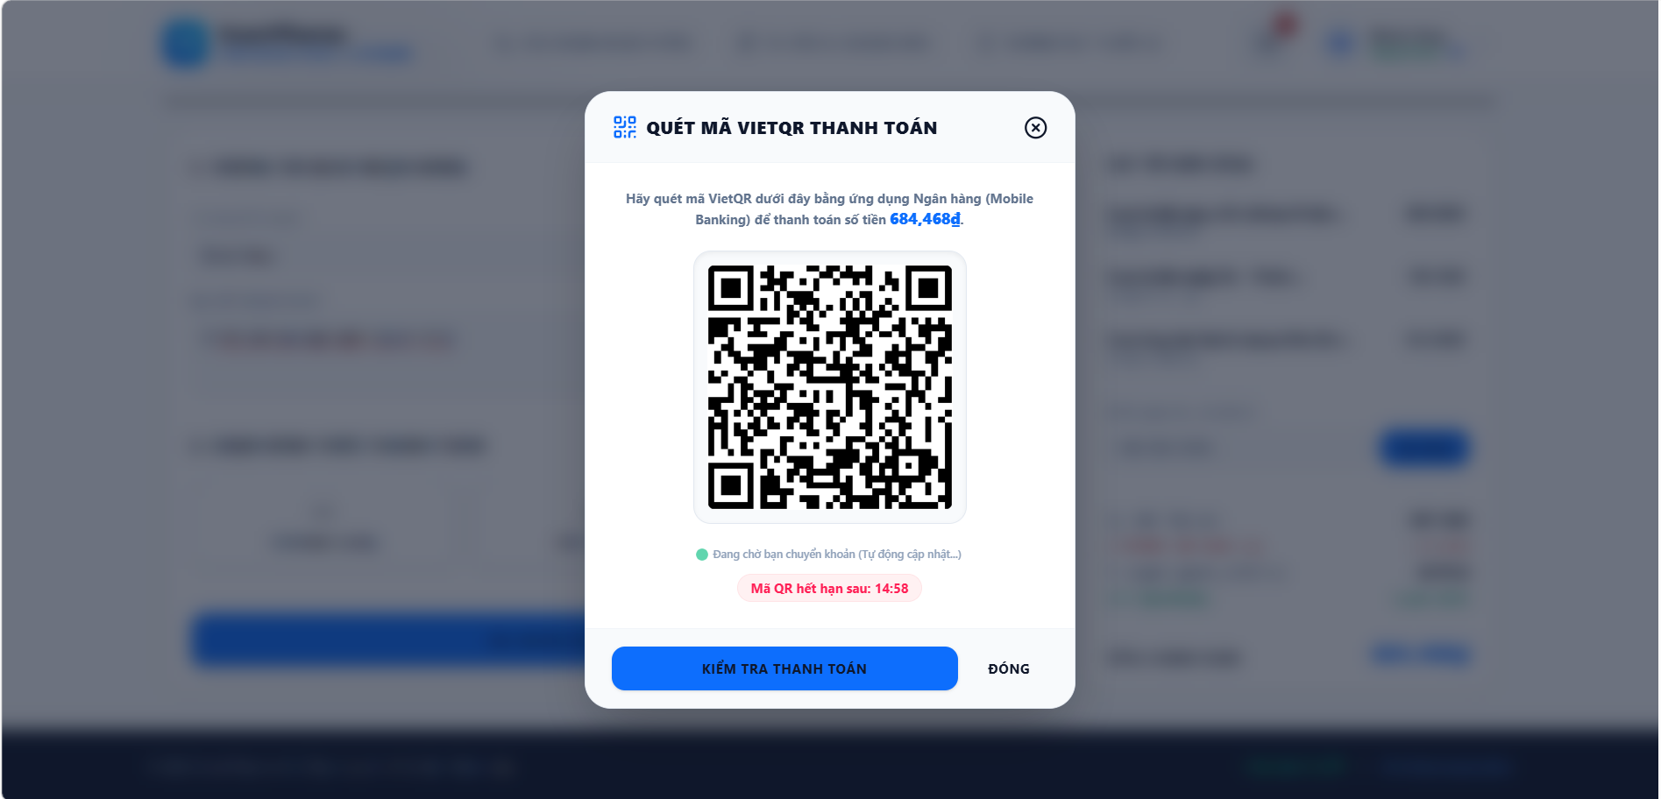
• Function Trigger:
• Navigation Path: Order Confirmation > Navigated to `/customer/payment?orderId=...`
• Trigger Event / Frequency: Customer proceeds to online payment.
• Function Description:
• Actors / Roles: Customer
• Purpose: Complete online payment via bank transfer using dynamic VietQR or select COD.
• Interface Type: Payment Gateway Widget / Screen
• Screen Layout: N/A
• Function Details:
• Data:
- Read-only / Output: Dynamic VietQR Code, Bank Account Number, Transfer Amount, Order Reference Code, Expiry Timer (15 min).
- Editable / Input: Payment Method Confirmation.
• Validation:
- Payment transaction signature must match payment gateway public key.
• Business Rule:
- BR-08: Deduct inventory based on atomic FEFO batch lock upon payment confirmation.
• Functionality:
- In Normal Cases: Customer scans VietQR using banking app. Payment gateway Webhook fires callback to system backend, system verifies payment signature, marks order status as `PAID`, deducts batch stock, and redirects to Order Confirmation page with success toast MSG14.
- In Abnormal Cases: If payment timer expires (15 min) without receiving webhook callback, order status changes to `CANCELLED_EXPIRED` and reserved FEFO stock locks are released.

3.3.6 View Order History (UC-13)
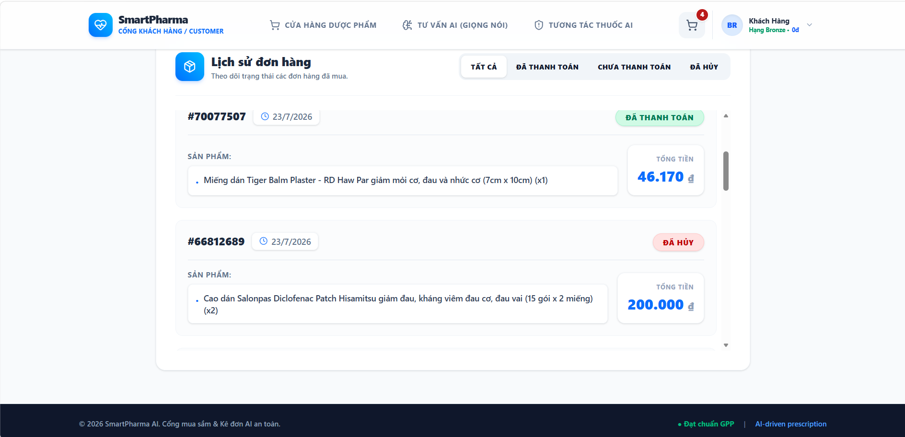
• Function Trigger:
• Navigation Path: Profile Menu > Click 'My Orders' > `/customer/orders`
• Trigger Event / Frequency: Customer opens order history.
• Function Description:
• Actors / Roles: Customer
• Purpose: View past purchase orders, delivery status timeline, invoice details, and re-order.
• Interface Type: Full Web Page Screen with Tabs
• Screen Layout: N/A
• Function Details:
• Data:
- Read-only / Output: Order ID, Order Date, Status Badge (Pending, Paid, Shipping, Completed, Cancelled), Total Amount, Item list.
- Editable / Input: Status Filter Tabs, Search Order Code, Cancel Order button.
• Validation:
- Order cancellation is allowed only for orders in `PENDING` or `PAID_UNSHIPPED` status.
• Business Rule:
- N/A.
• Functionality:
- In Normal Cases: Customer views list of past orders. Clicking an order expands full item breakdown, delivery tracking timeline, and downloadable PDF receipt link.
- In Abnormal Cases: If user attempts to cancel an order already in `SHIPPED` status, system disables cancel button and displays tooltip "Order is already in transit and cannot be cancelled."

3.3.7 View Customer Profile (UC-14)
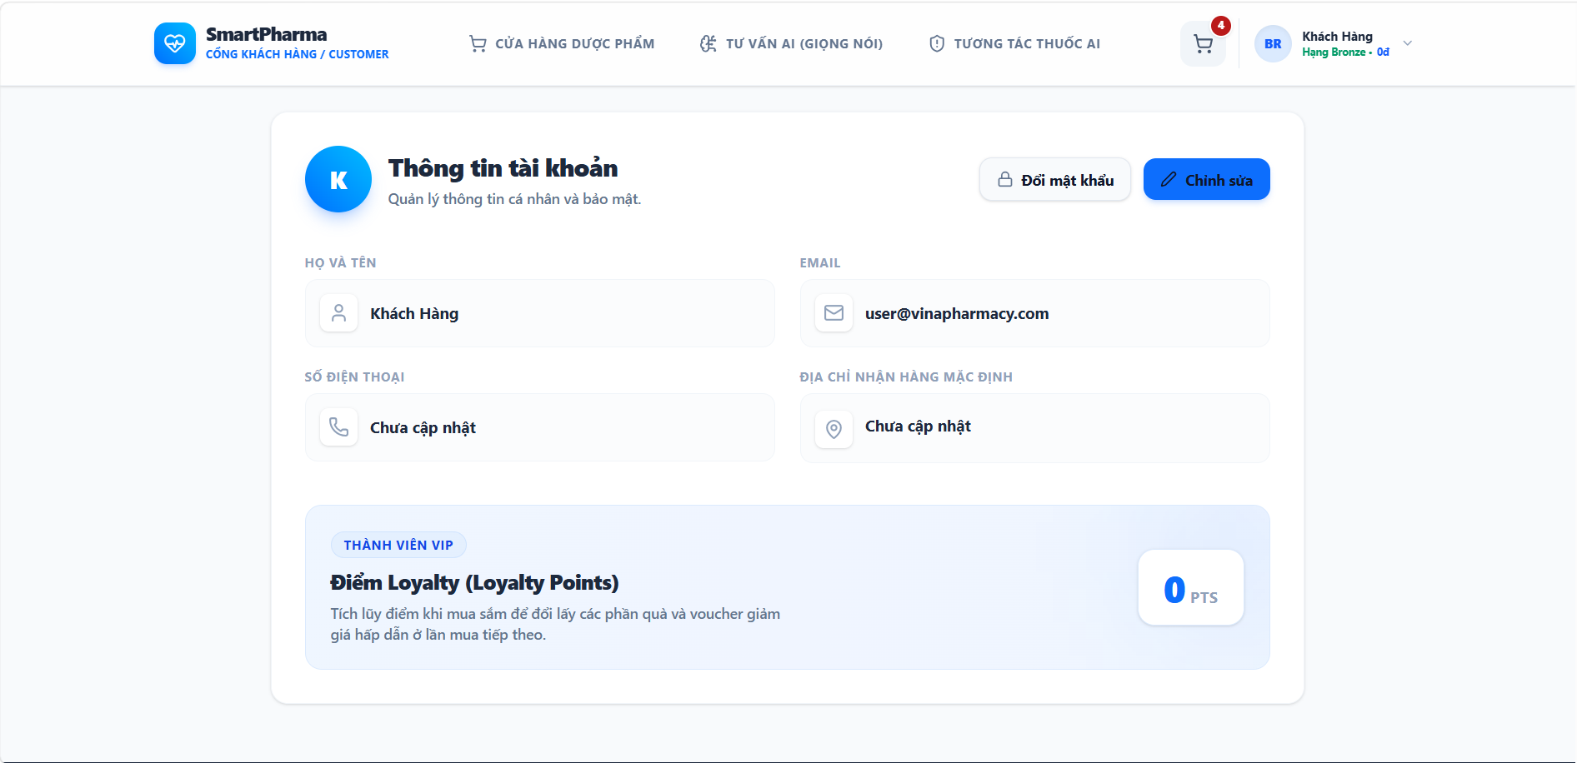
• Function Trigger:
• Navigation Path: Header User Avatar > Click 'Profile' > `/customer/profile`
• Trigger Event / Frequency: Customer opens profile settings.
• Function Description:
• Actors / Roles: Customer
• Purpose: View personal information, membership tier status (Gold, Silver, Bronze), and reward points balance.
• Interface Type: Full Web Page Screen
• Screen Layout: N/A
• Function Details:
• Data:
- Read-only / Output: Membership Tier Card, Accumulated Loyalty Points, Total Spent Amount, Member ID.
- Editable / Input: Full Name, Phone Number, Avatar Photo, Default Address.
• Validation:
- Profile update fields must satisfy standard formatting rules.
• Business Rule:
- BR-15: Customer loyalty points earned upon paid transactions and redeemable for vouchers.
• Functionality:
- In Normal Cases: Customer views membership details and updates profile information. System saves changes to User profile and displays toast "Profile updated successfully."
- In Abnormal Cases: If phone number format is invalid, system displays error MSG04 "Please enter a valid 10-digit phone number."

3.3.8 Consult AI via Text (UC-15)
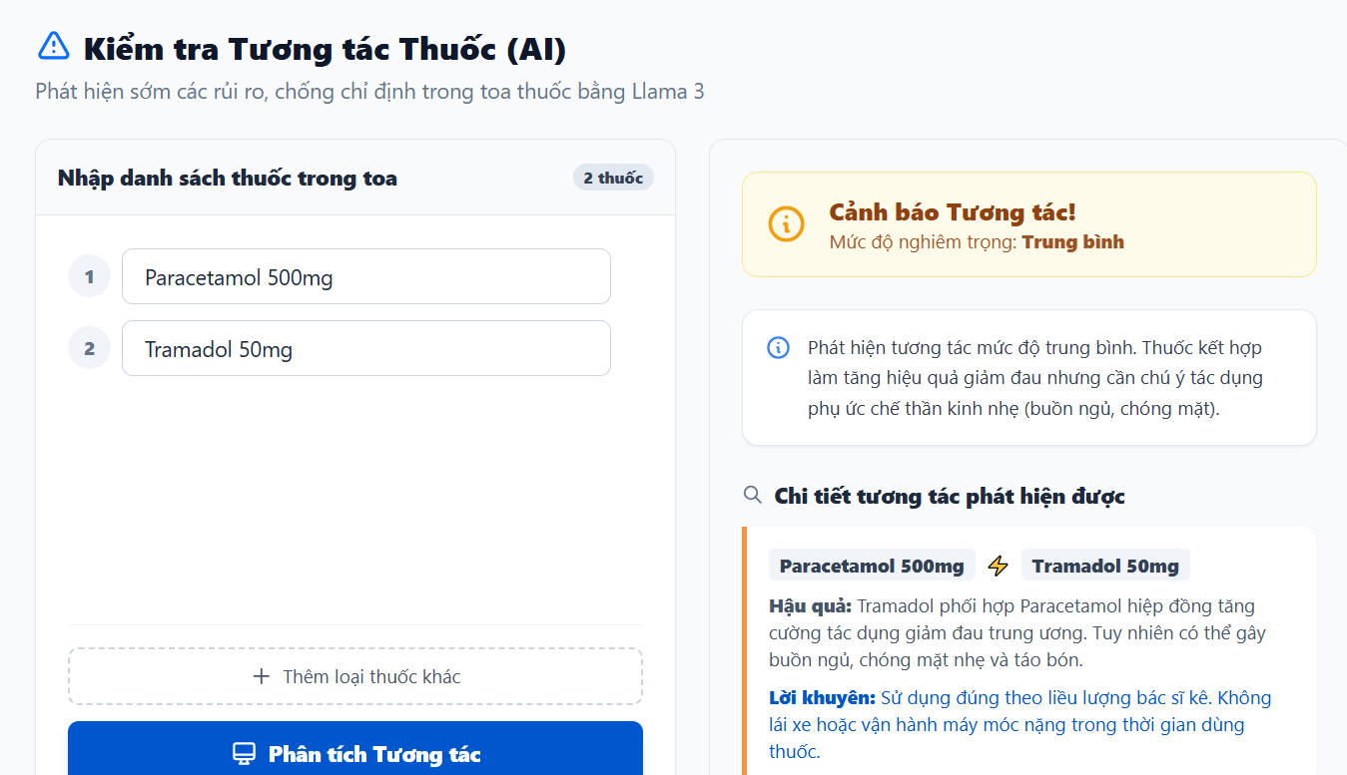
• Function Trigger:
• Navigation Path: Customer Portal Floating Widget / Banner > Click 'AI Health Assistant' (`/customer/ai-consult`)
• Trigger Event / Frequency: Customer submits symptom question in text box.
• Function Description:
• Actors / Roles: Customer
• Purpose: Text-based chatbot analyzing symptoms to suggest health advice and recommended OTC products.
• Interface Type: Interactive Chatbot Panel
• Screen Layout: N/A
• Function Details:
• Data:
- Read-only / Output: Chat response stream, recommended OTC product cards, active ingredient recommendations, medical disclaimer notice.
- Editable / Input: Natural language symptom query text.
• Validation:
- Text query must not be blank and must contain valid text characters.
• Business Rule:
- N/A (AI Health Consultation Advisory).
• Functionality:
- In Normal Cases: Customer types "I have a headache and mild fever". AI service processes NLP query, queries clinical knowledge database, streams medical consultation advice, and displays clickable product recommendation cards.
- In Abnormal Cases: If AI service encounters an API timeout, system falls back to standard message "Service temporarily busy. Please contact our pharmacist directly via hotline."

3.3.9 Consult AI via Voice (UC-16)
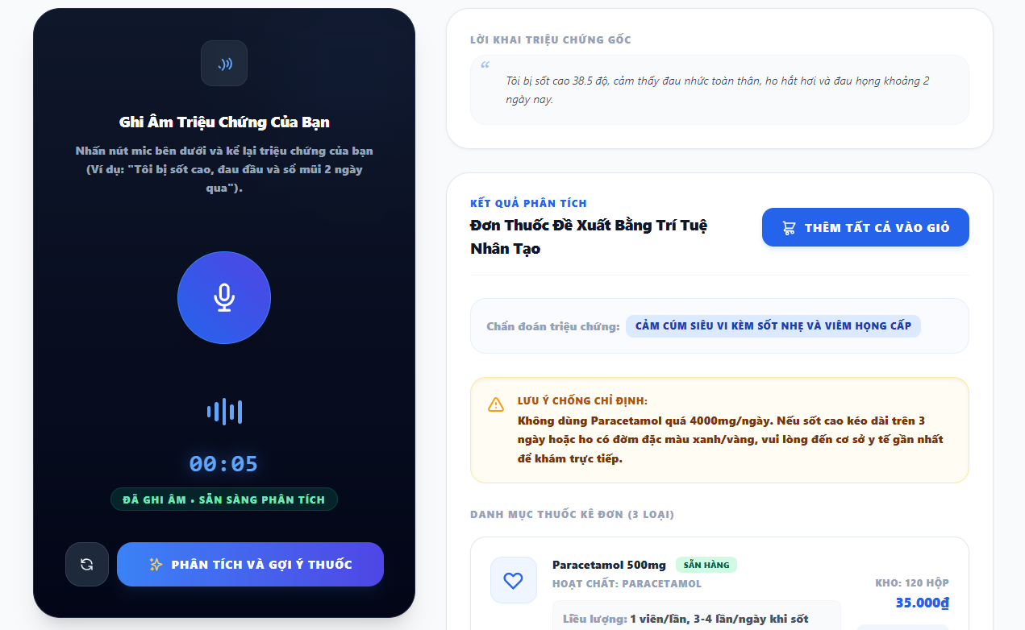
• Function Trigger:
• Navigation Path: AI Health Assistant Screen > Click Microphone Icon
• Trigger Event / Frequency: Customer presses record button to speak symptoms.
• Function Description:
• Actors / Roles: Customer
• Purpose: Voice-enabled AI assistant converting speech to text and analyzing health symptoms.
• Interface Type: Voice Recording Widget / Speech Interface
• Screen Layout: N/A
• Function Details:
• Data:
- Read-only / Output: Real-time audio wave visualization, transcribed text preview, AI health recommendations.
- Editable / Input: Voice Audio Stream input, Stop Recording button.
• Validation:
- Audio input duration must be between 2 seconds and 60 seconds.
• Business Rule:
- N/A.
• Functionality:
- In Normal Cases: Customer presses mic button, speaks symptoms, and stops recording. Backend Speech-to-Text engine transcribes audio into Vietnamese text, passes transcript to AI Consultation engine, and renders recommendations.
- In Abnormal Cases: If microphone permission is denied or audio is unintelligible, system prompts "Could not recognize audio. Please check microphone permissions or type your query."

3.4 Pharmacist POS Counter Terminal

3.4.1 Search Retail Medicines (UC-17)
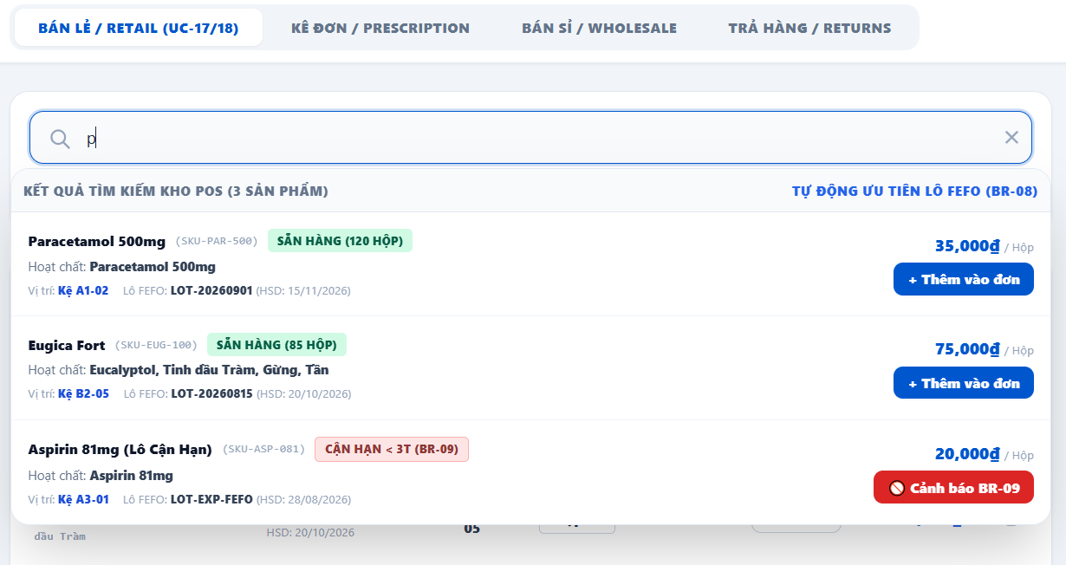

• Function Trigger:
• Navigation Path: Pharmacist Dashboard > POS Sales Terminal (`/pharmacist/sales`)
• Trigger Event / Frequency: Pharmacist types in POS search bar or scans barcode.
• Function Description:
• Actors / Roles: Pharmacist, Branch Manager
• Purpose: Fast search of retail medicines by name, active ingredient, or barcode at POS counter.
• Interface Type: POS Full Terminal Screen
• Screen Layout: N/A
• Function Details:
• Data:
- Read-only / Output: Medicine SKU, active ingredient, retail unit price, available FEFO batch quantity, stock location bin.
- Editable / Input: Search query / Barcode scanner input.
• Validation:
- Search must return results in < 200ms for fast counter operations.
• Business Rule:
- BR-08: Display available stock based strictly on non-expired FEFO batches.
• Functionality:
- In Normal Cases: Pharmacist scans product barcode or types drug name. POS screen instantly populates matching item with FEFO batch details and unit price.
- In Abnormal Cases: If item is out of stock at current branch, POS displays red tag "Out of Stock" and activates 'Suggest Substitute' button.

3.4.2 Add to Retail Cart (UC-18)
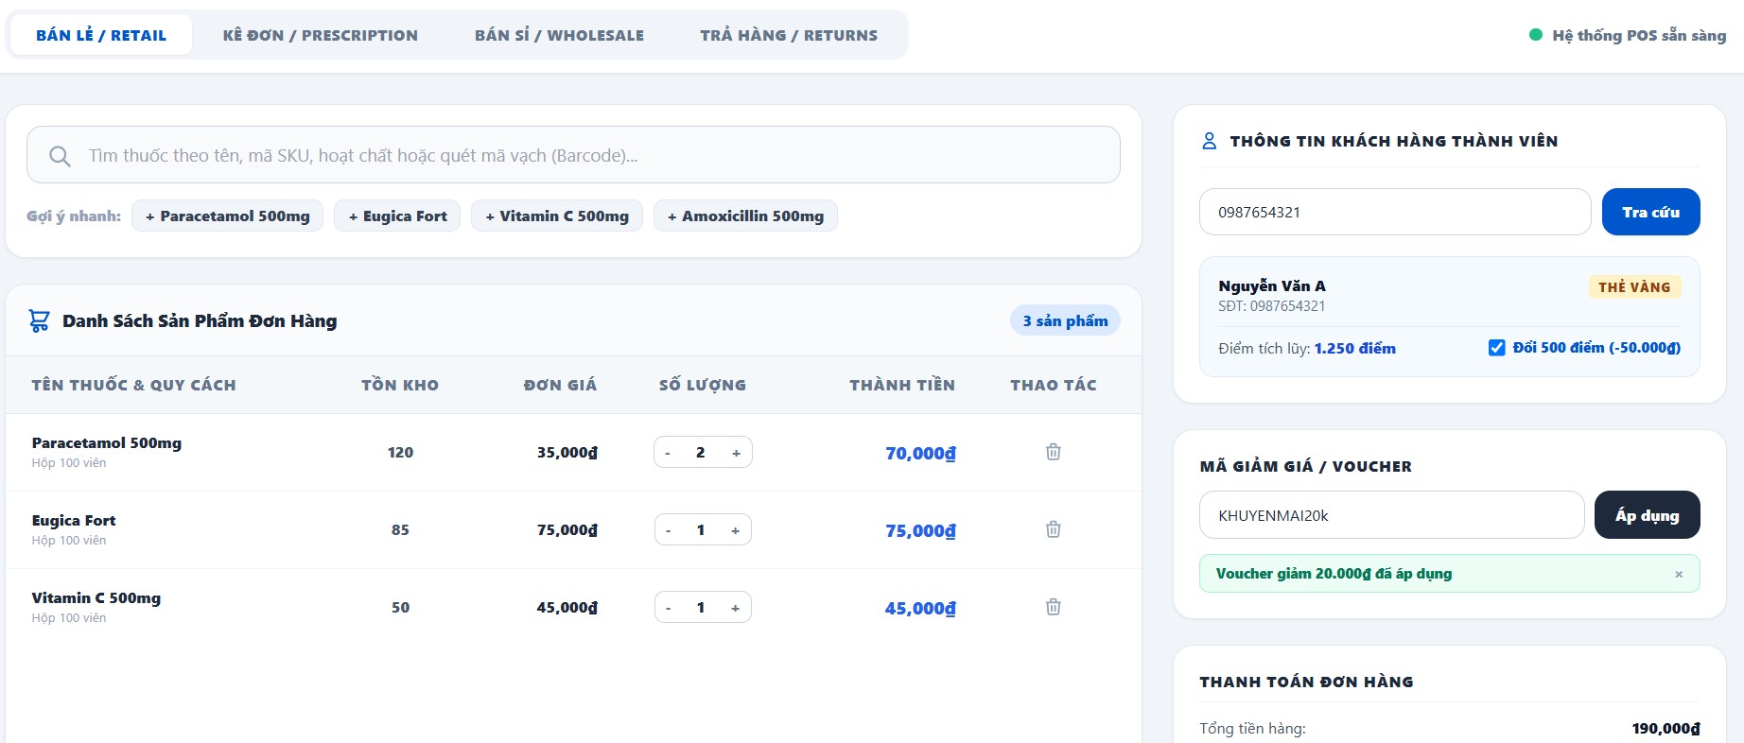
• Function Trigger:
• Navigation Path: POS Terminal Search Results > Click item or press Enter / Barcode Scan
• Trigger Event / Frequency: Item selected or scanned at POS counter.
• Function Description:
• Actors / Roles: Pharmacist
• Purpose: Appends selected medication item and default FEFO batch to active counter invoice cart.
• Interface Type: POS Cart Table Panel
• Screen Layout: N/A
• Function Details:
• Data:
- Read-only / Output: Item line total, FEFO Batch Number (`batchNo`), Expiry Date (`expDate`).
- Editable / Input: Unit selection (Box / Blister / Pill), Quantity integer.
• Validation:
- Quantity must not exceed physical branch stock for selected batch.
• Business Rule:
- BR-08: Auto-allocate nearest FEFO batch for selected line item.
• Functionality:
- In Normal Cases: Pharmacist adds item. POS automatically locks nearest FEFO batch, populates selling price based on unit type, and updates cart total.
- In Abnormal Cases: If batch expiry is < 3 months, system triggers Red Alert block (BR-09) preventing addition.

3.4.3 Edit Retail Cart (UC-19)
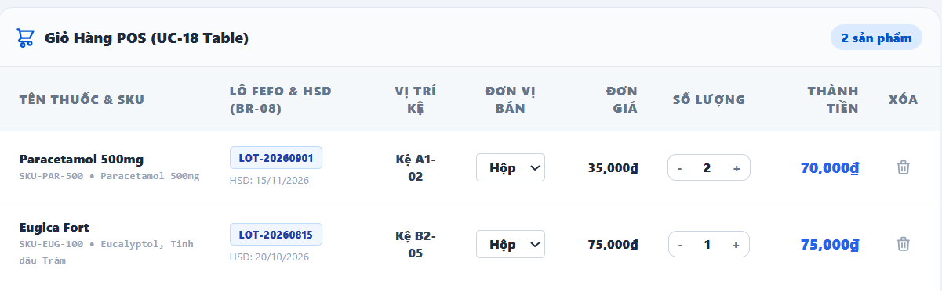
• Function Trigger:
• Navigation Path: POS Sales Terminal > Cart Item Row > Edit Quantity / Delete
• Trigger Event / Frequency: Pharmacist modifies line item in active POS cart.
• Function Description:
• Actors / Roles: Pharmacist
• Purpose: Adjust purchase quantities, change packaging units, or delete items from POS cart.
• Interface Type: POS Interactive Table
• Screen Layout: N/A
• Function Details:
• Data:
- Read-only / Output: Recalculated invoice subtotal, tax amount, discount subtotal.
- Editable / Input: Quantity input box, Unit Selector dropdown, Line discount input.
• Validation:
- Quantity must be >= 1 integer.
• Business Rule:
- N/A.
• Functionality:
- In Normal Cases: Pharmacist changes quantity from 1 to 3. POS updates batch reservation locks, recalculates line total and grand total instantly.
- In Abnormal Cases: If item is removed, batch reservation is immediately released back to branch stock pool.

3.4.4 Suggest Substitute Medicine (UC-20)
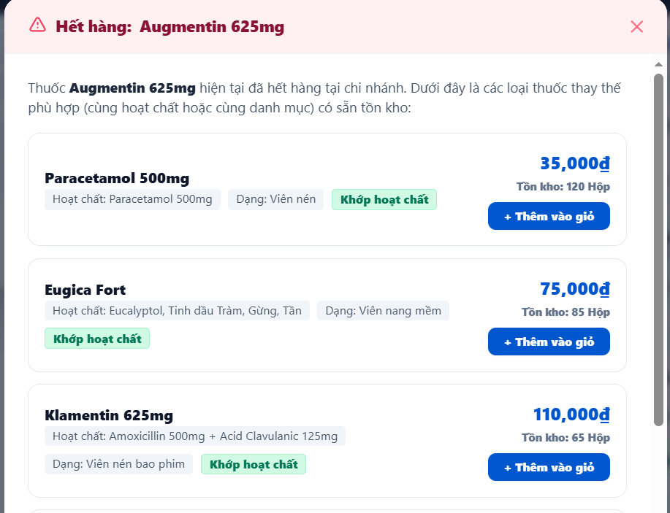
• Function Trigger:
• Navigation Path: POS Terminal > Item Out of Stock Alert > Click 'Suggest Substitute'
• Trigger Event / Frequency: On button click by pharmacist when requested medicine is unavailable.
• Function Description:
• Actors / Roles: Pharmacist
• Purpose: System automatically recommends equivalent substitute drugs matching active ingredient or therapeutic group.
• Interface Type: Modal Dialog
• Screen Layout: N/A
• Function Details:
• Data:
- Read-only / Output: Original requested drug name, list of substitute SKUs, matching active ingredient, dosage equivalence, price comparison, available branch stock.
- Editable / Input: Select substitute medicine button.
• Validation:
- Substitute items must match exact active ingredient strength or therapeutic category.
• Business Rule:
- N/A.
• Functionality:
- In Normal Cases: Requested drug is out of stock. Pharmacist opens modal, system displays 3 substitute medicines in stock with matching active ingredients. Pharmacist selects one to auto-fill POS cart.
- In Abnormal Cases: If no equivalent substitutes exist in branch inventory, modal displays "No in-stock substitute found for this active ingredient."

3.4.5 Apply Voucher and Points (UC-21)
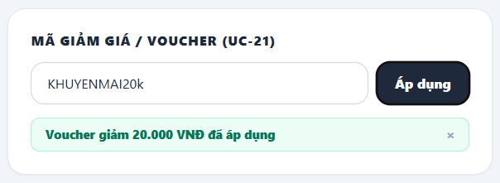
• Function Trigger:
• Navigation Path: POS Terminal > Customer Loyalty Section > Enter Phone Number / Voucher Code
• Trigger Event / Frequency: Pharmacist looks up customer phone number at counter.
• Function Description:
• Actors / Roles: Pharmacist
• Purpose: Look up customer profile to accumulate reward points or apply discount voucher codes to invoice.
• Interface Type: POS Widget Sidebar
• Screen Layout: N/A
• Function Details:
• Data:
- Read-only / Output: Customer Name, Tier Badge, Available Points Balance, Discount Amount.
- Editable / Input: Customer Phone Number, Redeem Points checkbox, Voucher Code string.
• Validation:
- Voucher code must be active, within valid date window, and satisfy minimum order value constraints.
• Business Rule:
- BR-15: Customer loyalty reward points calculated and redeemed based on Admin conversion rules.
• Functionality:
- In Normal Cases: Pharmacist enters customer phone number. Profile loads showing 500 points. Pharmacist applies 50,000 VND discount voucher. POS deducts discount from grand total and logs points accumulation for the order.
- In Abnormal Cases: If voucher code is expired or invalid, system displays error toast "Voucher code is invalid or expired."

3.4.6 Scan Prescription with AI (UC-22)
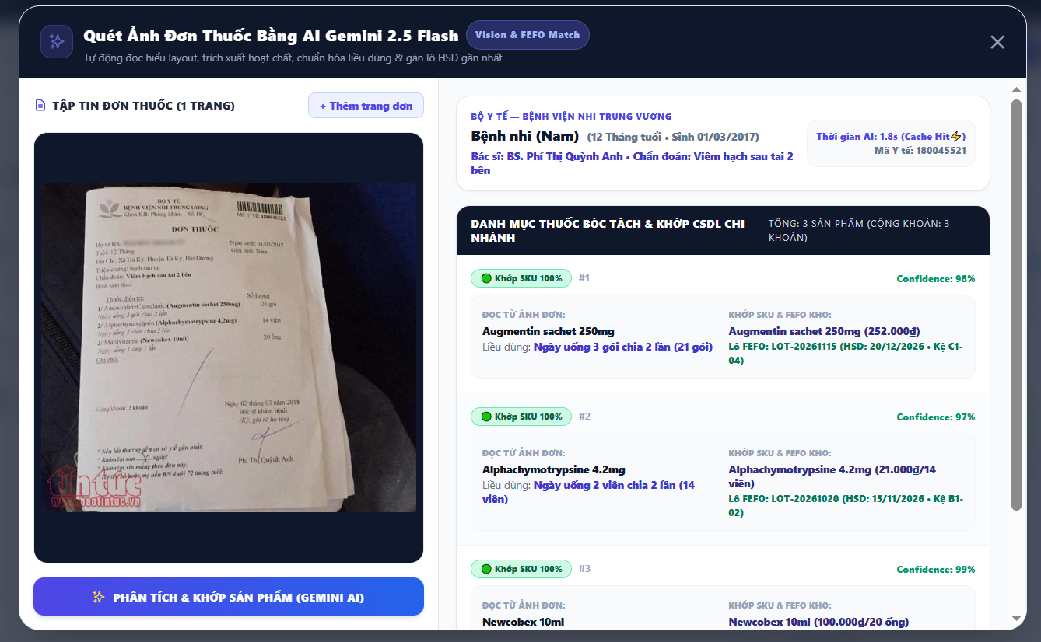
• Function Trigger:
• Navigation Path: POS Sales Terminal > Click 'Scan Prescription (AI)' button
• Trigger Event / Frequency: Pharmacist captures/uploads paper prescription image.
• Function Description:
• Actors / Roles: Pharmacist
• Purpose: AI Gemini 2.5 Flash OCR analyzes layout, extracts active ingredients/dosages, matches branch DB, and auto-fills POS cart with FEFO batches.
• Interface Type: Modal Upload / Camera Scanner Widget
• Screen Layout: N/A
• Function Details:
• Data:
- Read-only / Output: Original uploaded prescription image preview, extracted drug list, recognized dosages, matched branch SKUs, confidence score.
- Editable / Input: Upload Image File / Web Camera snapshot, Confirm Extracted Cart button.
• Validation:
- Uploaded file must be valid image format (JPEG, PNG, WEBP) under 10MB.
• Business Rule:
- BR-05: AI OCR extracts active ingredients and auto-selects available FEFO batches.
- BR-06: Pharmacist must review and manually confirm AI-suggested prescription cart items before payment.
• Functionality:
- In Normal Cases: Pharmacist uploads doctor prescription photo. AI OCR processes image in < 3s, extracts 4 prescribed drugs, merges duplicates, matches nearest branch FEFO batches, and populates POS cart for pharmacist verification.
- In Abnormal Cases: If image is blurry or illegible, AI displays low-confidence alert "Unclear handwriting detected. Please manually review extracted items."

3.4.7 Check Medicine Interactions (UC-23)
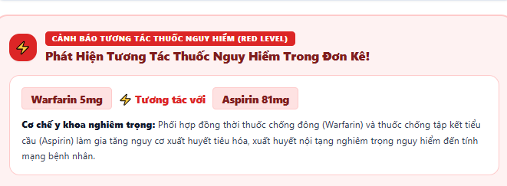
• Function Trigger:
• Navigation Path: POS Cart / Customer Cart > Click 'Check Drug Interactions' button
• Trigger Event / Frequency: Triggered manually or automatically prior to invoice confirmation.
• Function Description:
• Actors / Roles: Pharmacist, Customer
• Purpose: Verifies active ingredients of selected items in cart against clinical database for harmful contraindications or interaction warnings.
• Interface Type: Warning Alert Modal / Drawer
• Screen Layout: N/A
• Function Details:
• Data:
- Read-only / Output: Drug pair combination names, Severity Level Badge (Red: Severe, Yellow: Moderate, Blue: Info), Clinical interaction summary, Food/usage warning notes.
- Editable / Input: Acknowledge Warning checkbox, Override & Proceed button.
• Validation:
- Verification requires at least 2 distinct active ingredients in cart.
• Business Rule:
- BR-07: High-severity (Red Level) drug interaction warnings must be acknowledged by pharmacist before finalizing invoice.
• Functionality:
- In Normal Cases: Cart contains 3 medications. Pharmacist clicks check. System analyzes clinical database, detects no severe interactions, and displays green indicator "Safe Combination".
- In Abnormal Cases: System detects severe interaction between Warfarin and Aspirin (Risk of bleeding). Red Alert modal pops up requiring pharmacist signature/checkbox to acknowledge before checkout can proceed.

3.4.8 Confirm Retail Payment (UC-24)
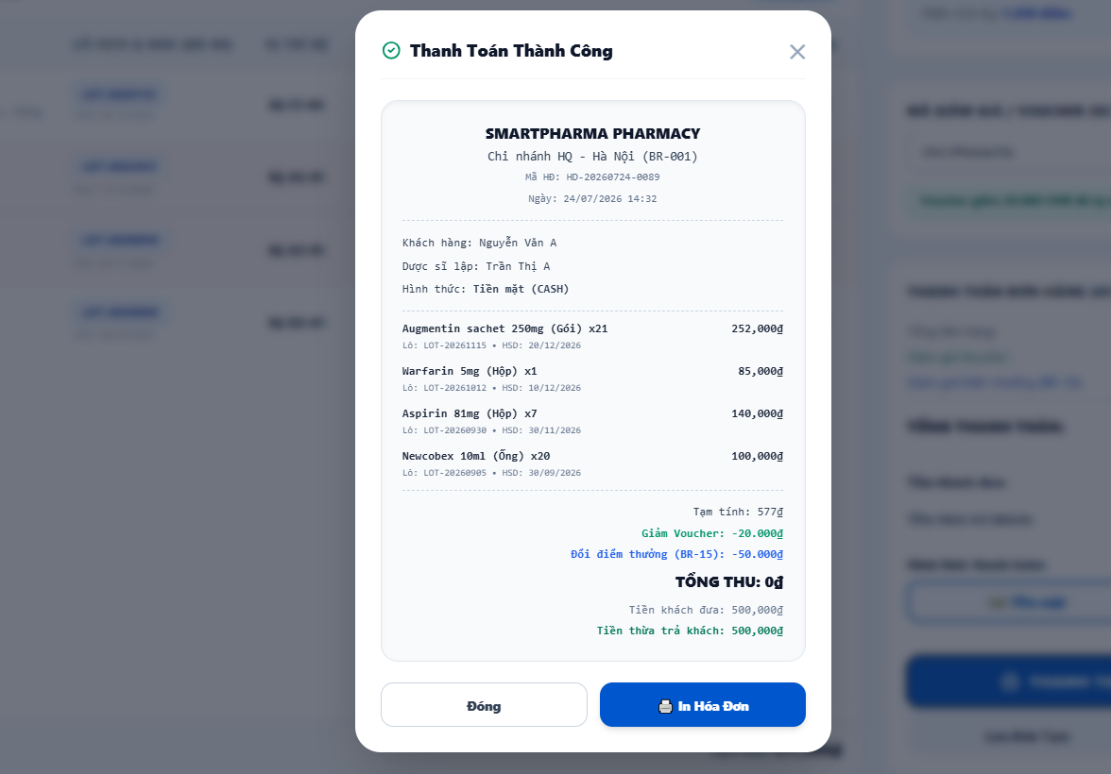
• Function Trigger:
• Navigation Path: POS Sales Terminal > Click 'Complete Payment' button
• Trigger Event / Frequency: Pharmacist finalizes transaction at counter.
• Function Description:
• Actors / Roles: Pharmacist
• Purpose: Confirm transaction via Cash or Bank Transfer, deduct branch FEFO stock, and print invoice.
• Interface Type: Payment Confirmation Modal
• Screen Layout: N/A
• Function Details:
• Data:
- Read-only / Output: Total Payable Amount, Change due calculation, Invoice Code (`INV-xxx`).
- Editable / Input: Payment Method (Cash / VietQR Bank Transfer), Cash Received input.
• Validation:
- Cash Received must be >= Total Payable Amount.
• Business Rule:
- BR-08: Deduct branch stock based strictly on FEFO batch locks.
- BR-12: Sales invoices must explicitly log batch number and expiry date for every line item.
• Functionality:
- In Normal Cases: Pharmacist selects Cash, enters customer cash amount. System calculates change, executes atomic SQL stock deduction from branch batches, marks order `COMPLETED`, and triggers receipt printer.
- In Abnormal Cases: If bank transfer fails or QR payment callback is not received, system holds transaction status as `PENDING_PAYMENT`.

3.4.9 Send E-Invoice via Email (UC-25)
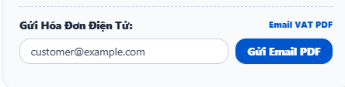
• Function Trigger:
• Navigation Path: POS Checkout Confirmation Modal > Check 'Send E-Invoice'
• Trigger Event / Frequency: Pharmacist enters customer email at payment completion.
• Function Description:
• Actors / Roles: Pharmacist
• Purpose: Sends digital electronic invoice (PDF) directly to customer's email address upon payment.
• Interface Type: Input Modal Popup
• Screen Layout: N/A
• Function Details:
• Data:
- Read-only / Output: E-Invoice Preview PDF, Sent Status Indicator.
- Editable / Input: Customer Email Address, Send Button.
• Validation:
- Email address must follow valid format.
• Business Rule:
- N/A.
• Functionality:
- In Normal Cases: Pharmacist inputs customer email `customer@example.com` and clicks send. System generates signed PDF e-invoice, dispatches email asynchronously via BullMQ, and displays success toast.
- In Abnormal Cases: If email server fails, system queues retry job and allows printing a physical receipt copy.

3.4.10 Create Wholesale Invoice (UC-26)
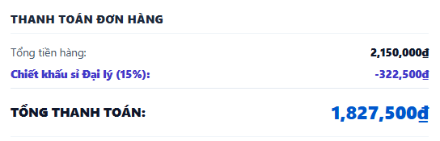
• Function Trigger:
• Navigation Path: POS Terminal > Toggle 'Wholesale Sale Mode' (`/pharmacist/sales?mode=wholesale`)
• Trigger Event / Frequency: Pharmacist selects wholesale order mode for agency partner.
• Function Description:
• Actors / Roles: Pharmacist, Branch Manager
• Purpose: Issue wholesale invoices for clinic/agency partners, applying tier discount pricing based on large volume purchases.
• Interface Type: POS Special Screen Mode
• Screen Layout: N/A
• Function Details:
• Data:
- Read-only / Output: Agency Partner Name, Tax ID, Wholesale Volume Tier Discount %, Subtotal.
- Editable / Input: Agency Partner Search/Selection, Bulk Box Quantities, Payment Terms.
• Validation:
- Wholesale mode requires minimum order quantity per item (e.g. >= 10 boxes).
• Business Rule:
- N/A.
• Functionality:
- In Normal Cases: Pharmacist selects registered agency partner, enters bulk order quantities. System applies wholesale tier discount, locks FEFO batches, issues wholesale tax invoice, and logs transaction.
- In Abnormal Cases: If agency tax ID is unverified, system blocks wholesale discount application until account profile is validated.

3.4.11 Search Return Invoice (UC-27)
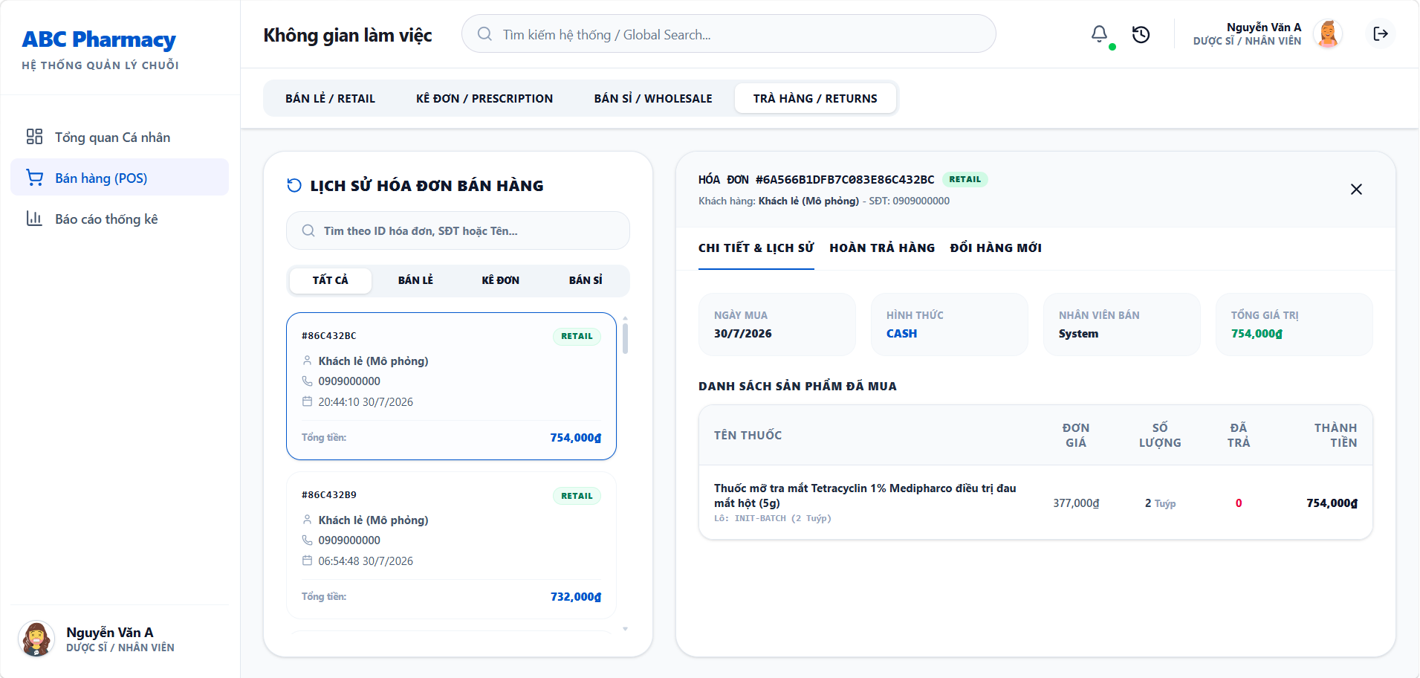
• Function Trigger:
• Navigation Path: POS Terminal > Menu > Select 'Return / Exchange' (`/pharmacist/returns`)
• Trigger Event / Frequency: Pharmacist enters invoice code or customer phone number to initiate return.
• Function Description:
• Actors / Roles: Pharmacist, Branch Manager
• Purpose: Search past retail invoices to verify purchase origin and item eligibility prior to executing returns.
• Interface Type: Full Web Page / Search Screen
• Screen Layout: N/A
• Function Details:
• Data:
- Read-only / Output: Invoice Date, Store Branch, Purchased Item List, Batch Numbers, Unit Selling Price, Return Eligibility Status.
- Editable / Input: Search Invoice Code / Customer Phone Number.
• Validation:
- Invoice search must match a valid completed transaction in the system.
• Business Rule:
- BR-13: Returns allowed within 7 days of purchase only upon verifying purchase origin.
• Functionality:
- In Normal Cases: Pharmacist inputs invoice code `INV-20260720-001`. System displays original receipt items, purchased batches, date, and marks eligible non-Rx items.
- In Abnormal Cases: If invoice is older than 7 days, system displays red badge "Return Period Expired (7 Days Exceeded)."

3.4.12 Create Return Slip (UC-28)
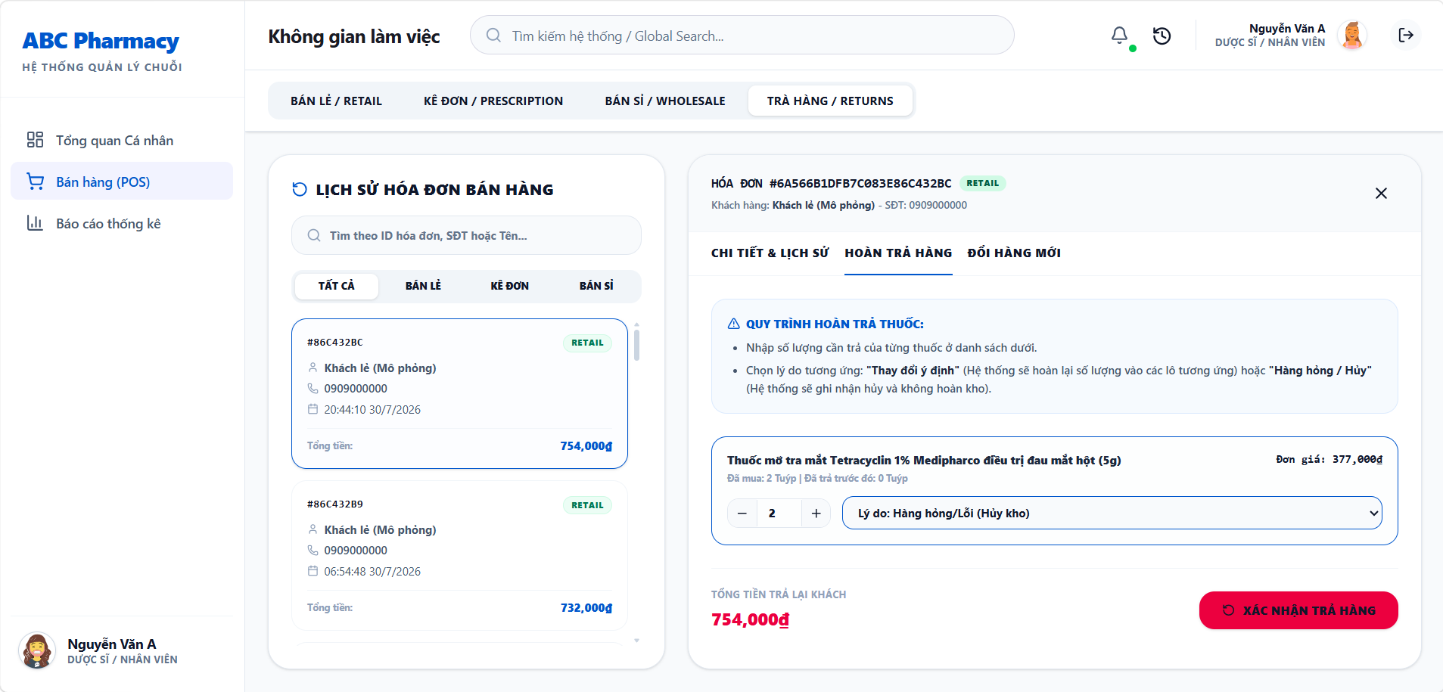
• Function Trigger:
• Navigation Path: Search Return Invoice Screen > Select Items > Click 'Create Return Slip'
• Trigger Event / Frequency: Pharmacist executes item return/refund.
• Function Description:
• Actors / Roles: Pharmacist, Branch Manager
• Purpose: Generates return slips recording reasons (defective goods, customer exchange), executes refunds, and restocks inventory.
• Interface Type: Form Modal Screen
• Screen Layout: N/A
• Function Details:
• Data:
- Read-only / Output: Return Slip Code, Refund Amount summary.
- Editable / Input: Returned Quantity per item, Return Reason dropdown (Defective, Wrong Item, Customer Change of Mind), Restock to Inventory checkbox.
• Validation:
- Returned quantity cannot exceed original purchased quantity on invoice.
• Business Rule:
- BR-14: Rx prescription drugs that have left counter cannot be restocked due to safety laws.
• Functionality:
- In Normal Cases: Pharmacist selects 1 returned OTC box, selects "Customer Change of Mind", clicks Confirm. System issues cash refund, creates Return Slip, and increments branch FEFO batch stock.
- In Abnormal Cases: If item is an Rx drug, system automatically unchecks "Restock to Inventory" and routes item to disposal queue (BR-14).

3.5 Central Warehouse & FEFO Inventory Management

3.5.1 View Medicine Catalog (UC-29)
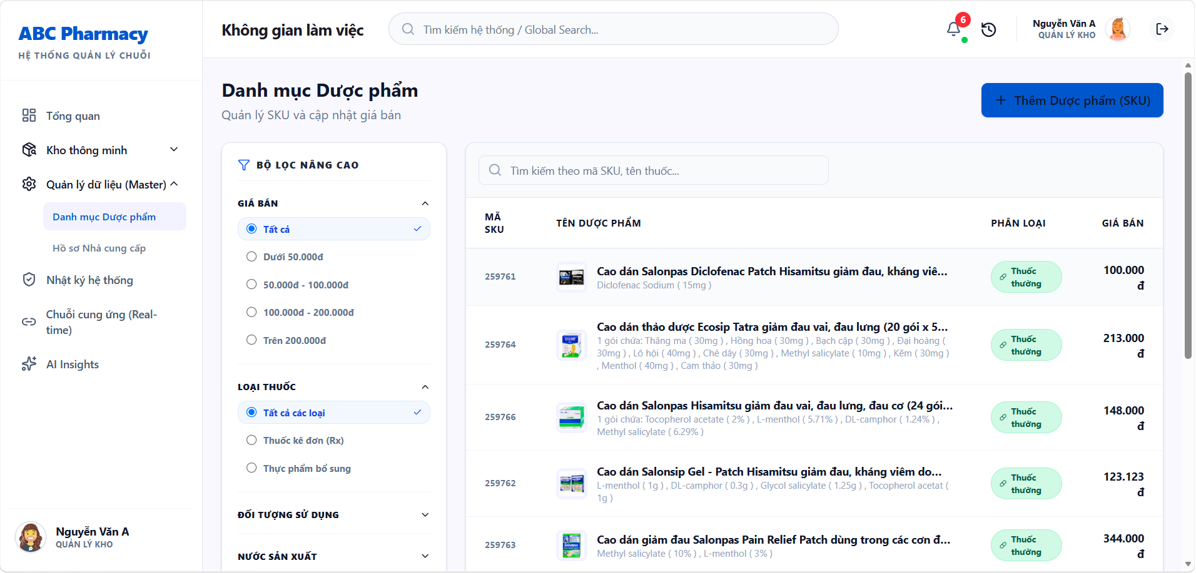
• Function Trigger:
• Navigation Path: Warehouse / Admin Dashboard > Master Data > `/warehouse/master-data/products`
• Trigger Event / Frequency: Inventory Manager or Admin opens medicine catalog.
• Function Description:
• Actors / Roles: Admin, Inventory Manager, Pharmacist
• Purpose: Displays complete list of master drug SKUs in system with active ingredients, therapeutic categories, packaging units, and base prices.
• Interface Type: Full Data Table Screen
• Screen Layout: N/A
• Function Details:
• Data:
- Read-only / Output: Medicine SKU Code, Brand Name, Active Ingredient, Category, Packaging Specifications, Unit Base Price, OTC/Rx Flag.
- Editable / Input: Search Bar, Category Filter, Sort options.
• Validation:
- Table supports server-side pagination (50 items/page).
• Business Rule:
- N/A.
• Functionality:
- In Normal Cases: User views master medicine list, filters by category "Antibiotics", and views full clinical details per SKU.
- In Abnormal Cases: If database connection times out, page displays error retry notification.

3.5.2 View Inventory by Batch (UC-30)
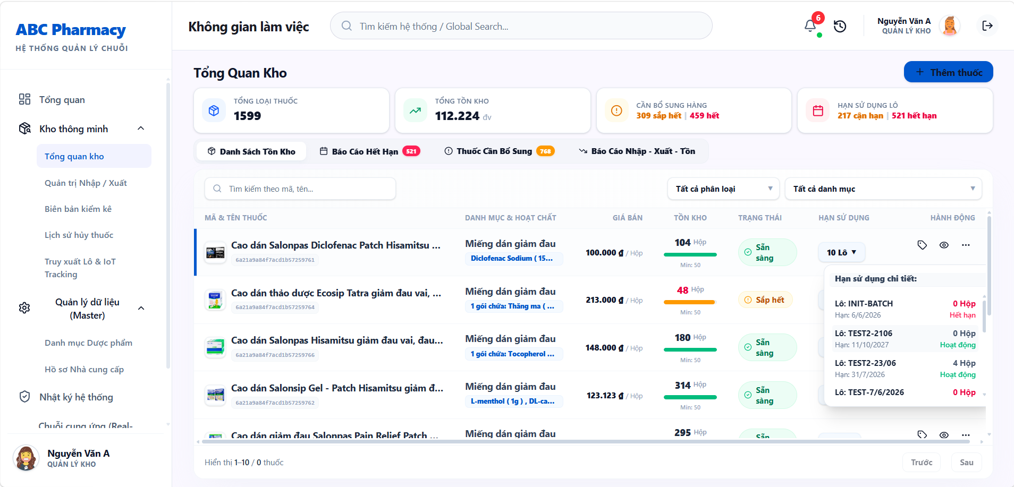
• Function Trigger:
• Navigation Path: Warehouse Dashboard > Inventory Control > `/warehouse/inventory/batches`
• Trigger Event / Frequency: Inventory Manager checks batch-level stock.
• Function Description:
• Actors / Roles: Inventory Manager, Admin
• Purpose: Displays actual stock details per product including Batch Number (`batchNo`), Expiration Date (`expDate`), and available stock quantity.
• Interface Type: Full Data Table Screen
• Screen Layout: N/A
• Function Details:
• Data:
- Read-only / Output: Product Name, Batch Number (`batchNo`), Expiry Date (`expDate`), Warehouse Location Bin, Available Quantity, Reserved Quantity, Expiry Risk Status Tag.
- Editable / Input: Search Batch No, Filter by Near-Expiry status, Store Location Selector.
• Validation:
- Search allows exact or partial batch number lookup.
• Business Rule:
- BR-08: Display batch stock sorted by FEFO (Earliest Expiry First).
• Functionality:
- In Normal Cases: Inventory Manager searches product "Amoxicillin". System displays all active physical batches sorted by earliest expiry date with location bin coordinates.
- In Abnormal Cases: Expired batches are highlighted in red background with status "EXPIRED - BLOCKED".

3.5.3 Create Goods Receipt (UC-31)
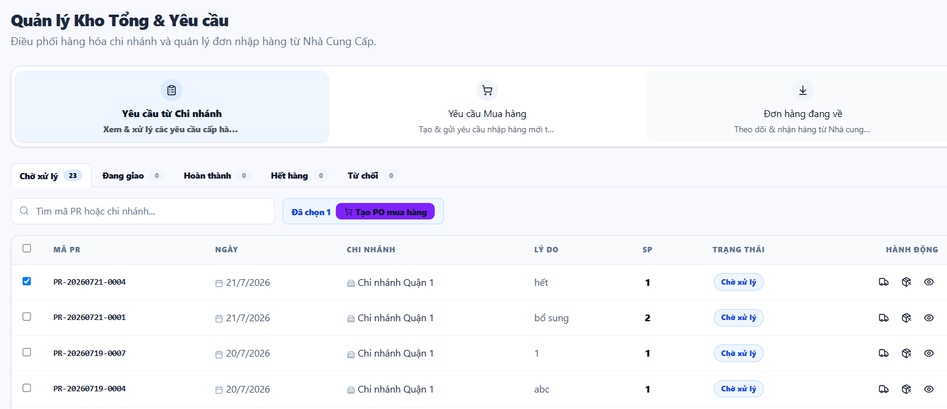
• Function Trigger:
• Navigation Path: Warehouse > Stock Import > Click 'Create Goods Receipt' (`/warehouse/inventory/requisitions`)
• Trigger Event / Frequency: Warehouse manager receives shipment from supplier based on approved PO.
• Function Description:
• Actors / Roles: Inventory Manager
• Purpose: Creates receiving document for goods delivered by supplier based on an approved Purchase Order (PO).
• Interface Type: Multi-step Form Screen
• Screen Layout: N/A
• Function Details:
• Data:
- Read-only / Output: PO Reference Number, Supplier Name, Expected SKUs and Quantities.
- Editable / Input: Received Quantities, Batch Numbers (`batchNo`), Expiration Dates (`expDate`), Manufacturing Dates, Unit Purchase Costs.
• Validation:
- Expiry date must be at least 12 months in the future for incoming supplier goods.
- Batch number is strictly required for every received line item.
• Business Rule:
- BR-18: GRN must undergo physical/AI inspection verification before central stock activation.
• Functionality:
- In Normal Cases: Manager selects approved PO #PO-2026-08, inputs actual received quantities, batch numbers, and expiry dates per item, and submits GRN for Admin approval.
- In Abnormal Cases: If received quantity exceeds approved PO quantity by > 10%, system triggers over-delivery warning requiring admin approval code.

3.5.4 Create Purchase Order (PO) (UC-32)
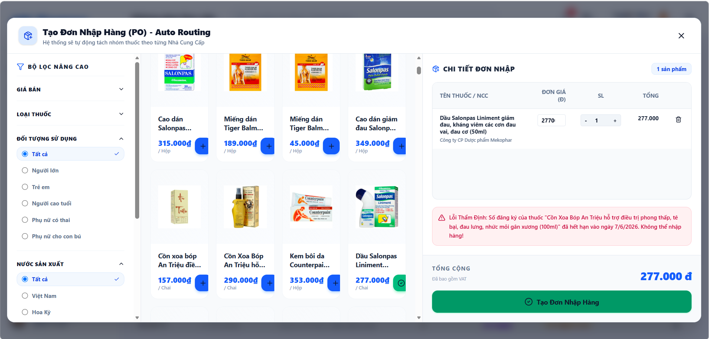
• Function Trigger:
• Navigation Path: Warehouse > Inventory > Click 'Create Purchase Order' (`/warehouse/inventory/po/create`)
• Trigger Event / Frequency: Inventory Manager creates new procurement order.
• Function Description:
• Actors / Roles: Inventory Manager
• Purpose: Create new Purchase Orders (PO) to submit to HQ Admin for approval before submitting to suppliers.
• Interface Type: Form Screen
• Screen Layout: N/A
• Function Details:
• Data:
- Read-only / Output: Supplier Contact Info, Calculated Order Total.
- Editable / Input: Supplier Selection dropdown, Item List, Order Quantities, Negotiated Unit Cost, Target Delivery Date.
• Validation:
- Item quantities must be positive integers > 0.
• Business Rule:
- BR-17: PO must receive explicit approval from HQ Admin before official transmission to suppliers.
• Functionality:
- In Normal Cases: Manager selects supplier, adds 5 medicine SKUs with desired replenishment quantities, clicks 'Submit for Approval'. System creates draft PO in `PENDING_APPROVAL` status and notifies Admin.
- In Abnormal Cases: If no supplier is selected, form submission is blocked with validation error MSG02.

3.5.5 Inspect Goods via AI (UC-33)
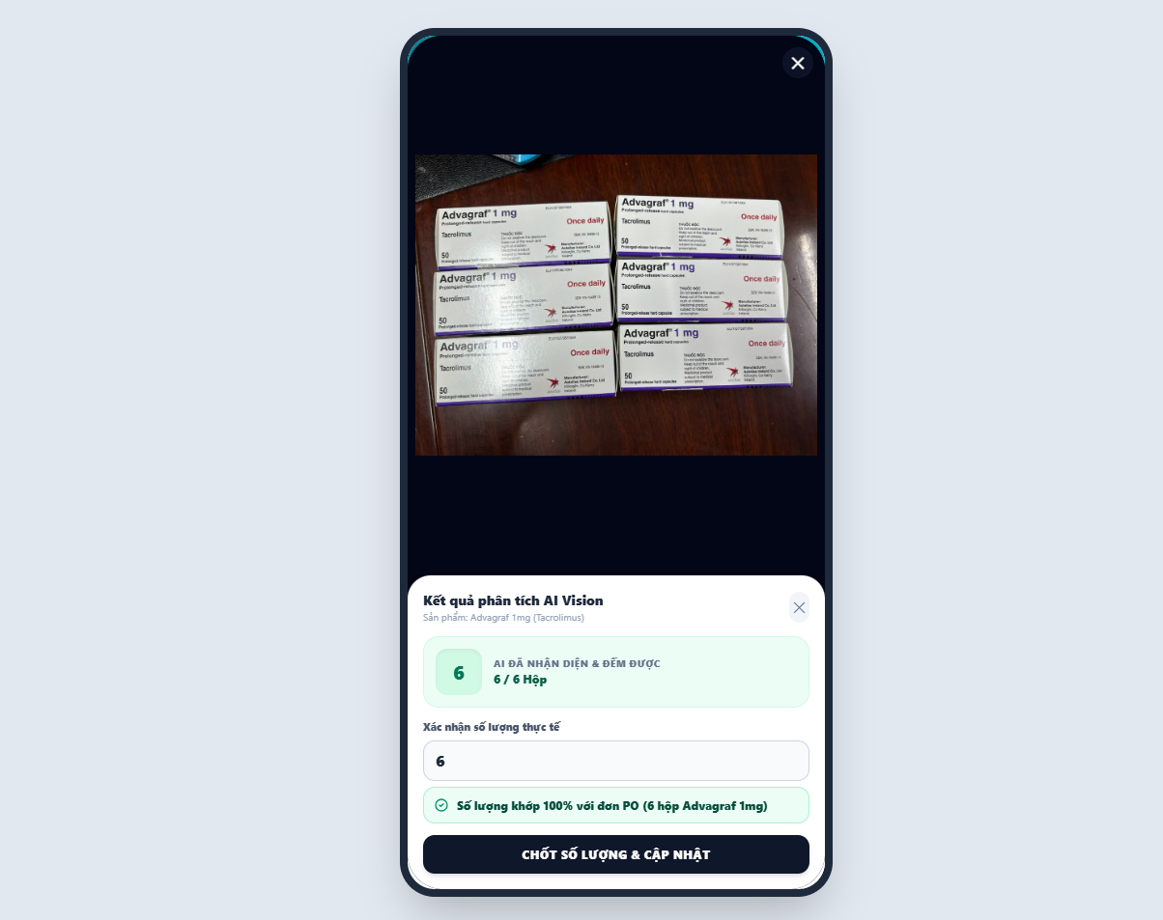
• Function Trigger:
• Navigation Path: GRN Creation Screen > Click 'Inspect Goods via AI' button
• Trigger Event / Frequency: Staff captures shipment package photos using mobile app / warehouse camera.
• Function Description:
• Actors / Roles: Inventory Manager
• Purpose: Capture images of shipment packages using mobile device; AI computer vision automatically counts actual medicine boxes in shipment to populate receipt.
• Interface Type: Camera Snapshot Widget / AI Processing Screen
• Screen Layout: N/A
• Function Details:
• Data:
- Read-only / Output: Uploaded Package Photo preview, AI Box Bounding Boxes, Detected Box Count, Audit Evidence Timestamp.
- Editable / Input: Capture Photo button, Confirm AI Count button.
• Validation:
- Image must contain clear lighting and visible box package contours.
• Business Rule:
- BR-18: AI camera inspection attaches visual evidence to GRN.
• Functionality:
- In Normal Cases: Staff takes photo of pallet with 100 medicine boxes. AI computer vision model analyzes image in < 2s, draws bounding boxes around 100 boxes, counts them automatically, and populates GRN quantity.
- In Abnormal Cases: If AI count differs from PO expected count (e.g. AI detects 95 boxes instead of 100), system flags discrepancy in orange for manual recount.

3.5.6 Alert Expiry Dates (UC-34)
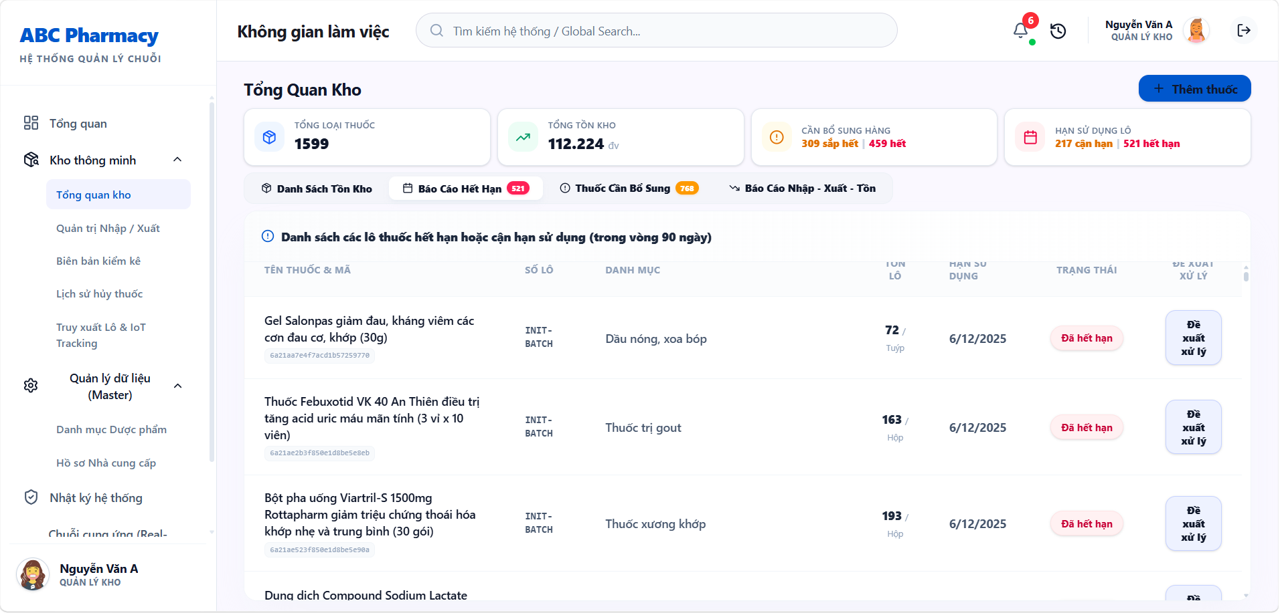
• Function Trigger:
• Navigation Path: Warehouse / Admin Dashboard > Click 'Expiry Alerts' (`/warehouse/inventory/expiry-alerts`)
• Trigger Event / Frequency: Automated daily background scan or manual navigation.
• Function Description:
• Actors / Roles: Inventory Manager, Admin
• Purpose: Reports detailed lists of near-expiry batches (under 6 months / 3 months) or expired items to plan for disposal/write-offs.
• Interface Type: Dashboard Report Screen
• Screen Layout: N/A
• Function Details:
• Data:
- Read-only / Output: Batch Number, SKU Name, Expiry Date, Days Remaining countdown, Stock Quantity, Warning Status (Red Alert < 3m, Yellow Alert < 6m).
- Editable / Input: Filter by Risk Category, Export Report button, Initiate Quarantine button.
• Validation:
- Date calculations evaluated against server current UTC time.
• Business Rule:
- BR-09: Red Alert batches (< 3m) automatically blocked from POS and quarantined.
- BR-10: Yellow Alert batches (< 6m) trigger promotional discount priority.
• Functionality:
- In Normal Cases: System displays interactive report table categorizing 5 Red Alert batches and 12 Yellow Alert batches. Manager clicks 'Quarantine' to lock Red Alert batches from sales.
- In Abnormal Cases: If no near-expiry batches exist, report displays green banner "All batches are within safe shelf-life limits."

3.5.7 Track Medicine Lot (UC-35)
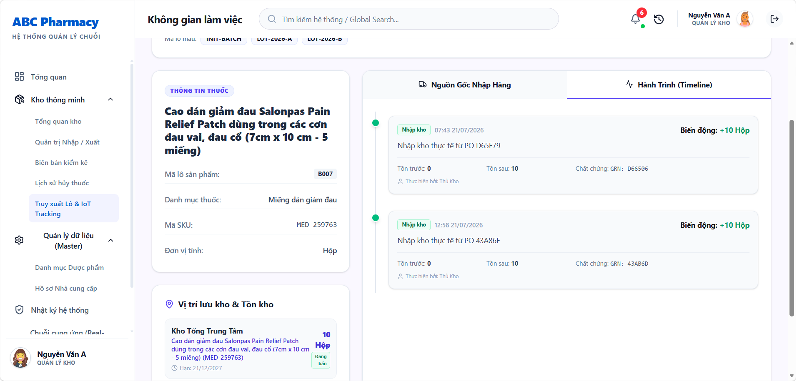
• Function Trigger:
• Navigation Path: Warehouse > Inventory > Lot Tracking (`/warehouse/lot-tracking`)
• Trigger Event / Frequency: Inventory Manager enters batch number to trace lot history.
• Function Description:
• Actors / Roles: Inventory Manager, Admin
• Purpose: Enter batch number (`batchNo`) to trace full supplier origin, PO, GRN, and display quantity fluctuation timeline for that batch.
• Interface Type: Full Audit Trail Screen
• Screen Layout: N/A
• Function Details:
• Data:
- Read-only / Output: Batch Metadata, Origin Supplier, Receiving GRN ID, Initial Quantity, Current Remaining Quantity, Complete Movement Timeline (GRN Inbound -> Branch Transfers -> Counter Sales -> Write-offs).
- Editable / Input: Batch Number Search Input.
• Validation:
- Batch number must exist in database.
• Business Rule:
- BR-12: Sales and movement transactions must log batch number for complete lot auditability.
• Functionality:
- In Normal Cases: Manager inputs batch `LOT-2026-99`. System displays full timeline showing GRN receipt of 1,000 units, transfer of 200 units to Branch A, sales of 150 units, leaving 650 units.
- In Abnormal Cases: If batch number is not found, system displays error "No lot record found matching batch number."

3.6 Branch Store Management

3.6.1 View Branch Stock (UC-36)
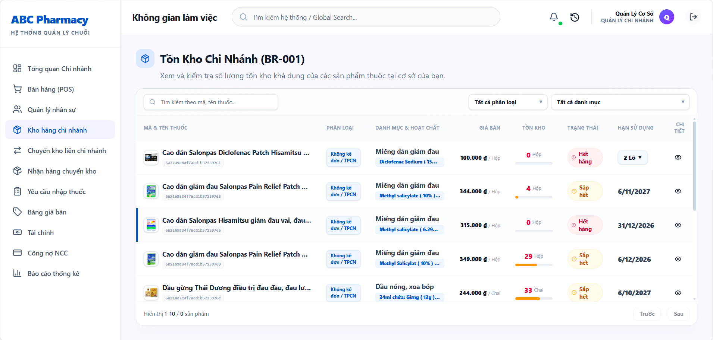
• Function Trigger:
• Navigation Path: Branch Dashboard > Stock Overview (`/branch/inventory`)
• Trigger Event / Frequency: Branch Manager views local store inventory.
• Function Description:
• Actors / Roles: Branch Manager
• Purpose: Quickly look up actual physical stock quantities and batch levels of medicines at the managed store branch.
• Interface Type: Data Table Screen
• Screen Layout: N/A
• Function Details:
• Data:
- Read-only / Output: Product Name, SKU, Category, Local Stock Quantity, Safety Stock Threshold, Expiry Warning Status.
- Editable / Input: Search Input, Low Stock Filter toggle.
• Validation:
- Displays data specific to the manager's assigned branch location.
• Business Rule:
- BR-16: Low stock status highlighted when local inventory drops below branch safety threshold.
• Functionality:
- In Normal Cases: Branch manager opens page. Table renders current branch stock. Items below safety stock threshold (e.g. < 10 boxes) are highlighted in yellow with button 'Request Requisition'.
- In Abnormal Cases: If branch connection is lost, page displays cached local stock data with offline warning tag.

3.6.2 Request Stock Requisition (UC-37)
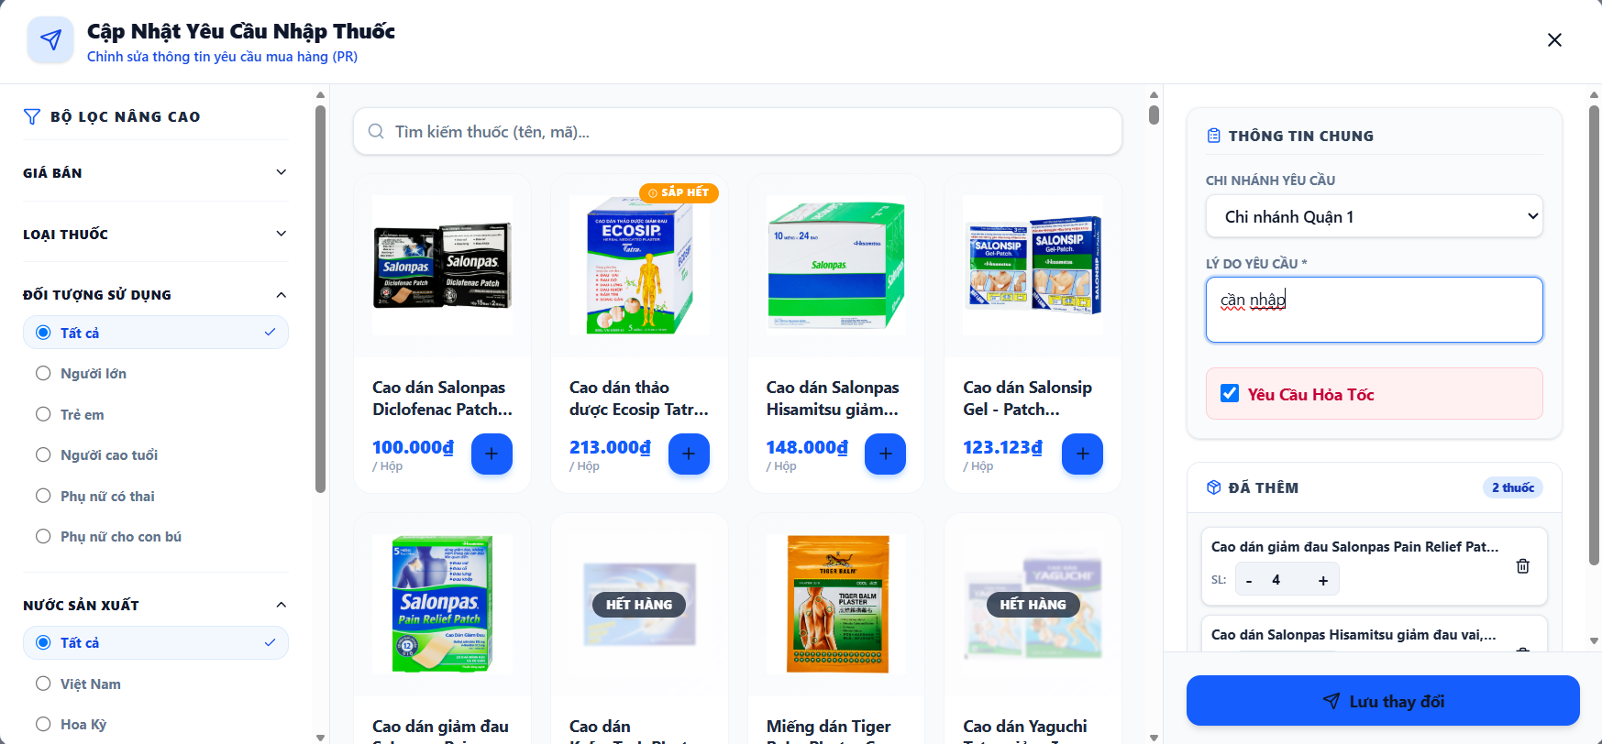
• Function Trigger:
• Navigation Path: Branch Inventory > Click 'Create Requisition (PR)' (`/branch/requisitions`)
• Trigger Event / Frequency: Branch Manager submits stock replenishment request to central warehouse.
• Function Description:
• Actors / Roles: Branch Manager
• Purpose: Create stock replenishment requests sent to central warehouse when branch counters experience shortages or out-of-stock items.
• Interface Type: Form Screen
• Screen Layout: N/A
• Function Details:
• Data:
- Read-only / Output: Branch Code, Current Stock Levels, Suggested Requisition Quantity.
- Editable / Input: Requested Item List, Requested Quantities, Priority Urgency dropdown (Normal / High / Critical Out-of-Stock), Notes.
• Validation:
- Requested quantities must be positive integers > 0.
• Business Rule:
- BR-16: Branch managers create PR when stock falls below safety thresholds.
• Functionality:
- In Normal Cases: Manager selects 3 low-stock items, enters requested quantities, selects "High Urgency", clicks Submit. System generates Requisition `PR-BR01-102` in `PENDING_HQ_APPROVAL` status and notifies Warehouse and Admin.
- In Abnormal Cases: If requested item list is empty, system blocks submission with MSG02.

3.6.3 Request Internal Transfer (UC-38)
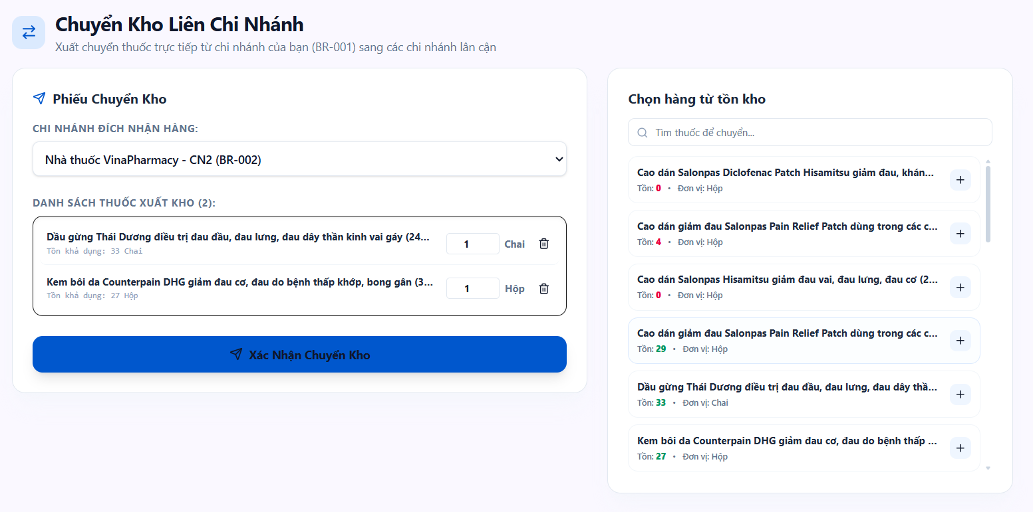
• Function Trigger:
• Navigation Path: Branch Inventory > Transfers > Click 'New Internal Transfer' (`/branch/receive-transfers`)
• Trigger Event / Frequency: Branch Manager creates inter-branch stock transfer slip.
• Function Description:
• Actors / Roles: Branch Manager
• Purpose: Create stock transfer slips to ship goods to neighboring branches to resolve cross-branch stock imbalances.
• Interface Type: Form Screen
• Screen Layout: N/A
• Function Details:
• Data:
- Read-only / Output: Origin Branch, Destination Branch Address, Available Local FEFO Batches.
- Editable / Input: Target Destination Branch dropdown, Transfer Items, FEFO Batch selection, Quantities.
• Validation:
- Destination branch cannot be the same as origin branch.
- Transfer quantity cannot exceed available origin branch stock.
• Business Rule:
- BR-19: Inter-branch transfers require confirmation from sending and receiving branch managers.
• Functionality:
- In Normal Cases: Manager at Branch A creates transfer slip for 20 boxes of Paracetamol to Branch B. System creates Transfer Record in `IN_TRANSIT` status, locks batch stock at Branch A, and alerts Branch B manager.
- In Abnormal Cases: If origin branch has insufficient batch stock, system blocks transfer creation.

3.6.4 Approve Stock Replenishment (UC-39)
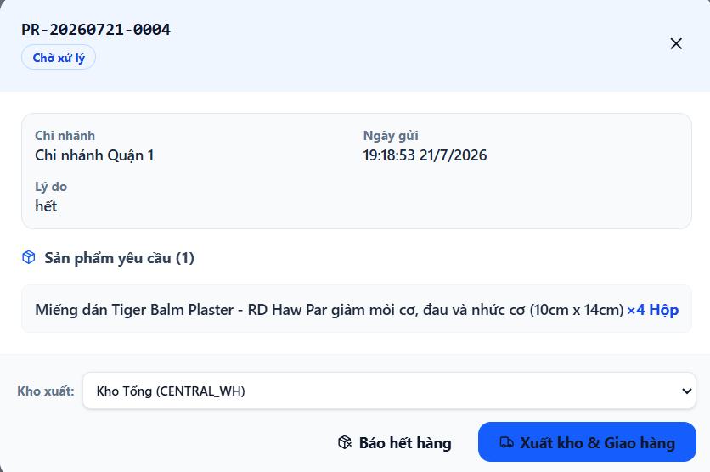
• Function Trigger:
• Navigation Path: Warehouse / Admin Dashboard > Requisitions > Select PR > Click 'Approve & Dispatch'
• Trigger Event / Frequency: Inventory Manager reviews branch PR request.
• Function Description:
• Actors / Roles: Inventory Manager
• Purpose: Review Requisition requests submitted by branches and approve dispatch of goods from central warehouse.
• Interface Type: Approval Details Screen
• Screen Layout: N/A
• Function Details:
• Data:
- Read-only / Output: PR Details, Requesting Branch, Item List, Requested Quantities vs Central Warehouse Available FEFO Batches.
- Editable / Input: Approved Quantities per line item, Warehouse FEFO Batch allocation selection, Approve button, Reject button + Rejection Reason.
• Validation:
- Approved quantity cannot exceed central warehouse available stock.
• Business Rule:
- BR-08: Central warehouse dispatches goods following strict FEFO batch allocation.
• Functionality:
- In Normal Cases: Inventory Manager reviews Branch A PR for 50 boxes, allocates central warehouse batch `LOT-CENTRAL-01`, clicks 'Approve'. System generates Dispatch Note, deducts central stock, and updates PR status to `DISPATCHED_IN_TRANSIT`.
- In Abnormal Cases: If central warehouse is also out of stock, manager enters rejection reason "Central warehouse out of stock; added to supplier PO" and clicks Reject.

3.6.5 Confirm Transfer Receipt (UC-40)
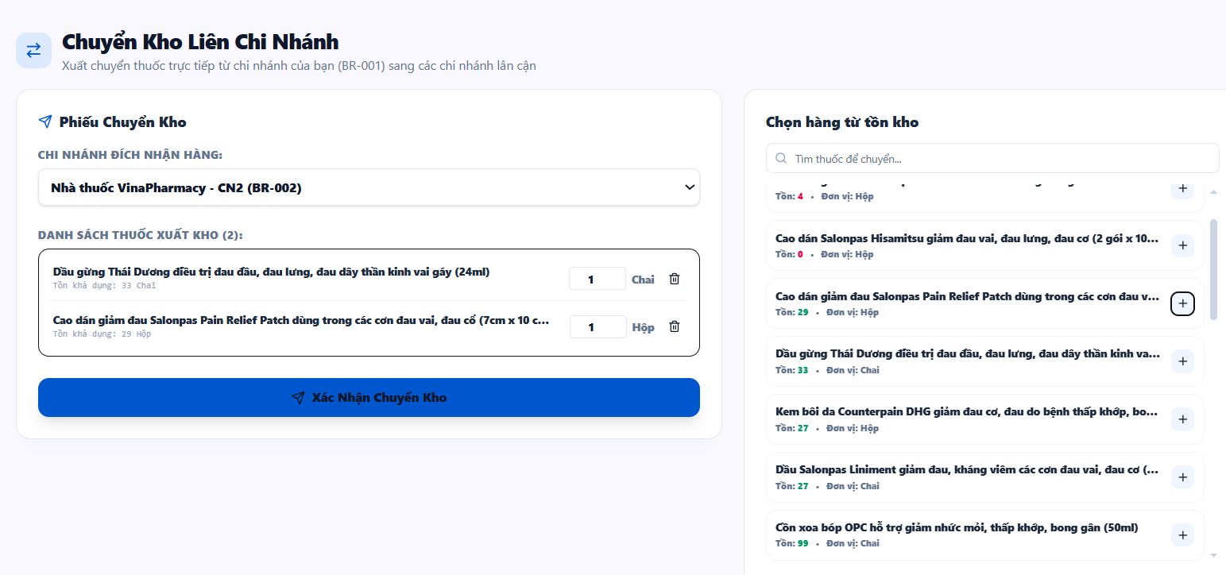
• Function Trigger:
• Navigation Path: Branch Transfers > Select Incoming Shipment > Click 'Confirm Goods Received' (`/branch/receive-transfers`)
• Trigger Event / Frequency: Branch Manager receives incoming stock shipment from warehouse or branch.
• Function Description:
• Actors / Roles: Branch Manager
• Purpose: Receive goods delivered from central warehouse, verify physical count, and click confirm to synchronize and update destination stock.
• Interface Type: Verification Confirmation Screen
• Screen Layout: N/A
• Function Details:
• Data:
- Read-only / Output: Dispatch Transfer Slip Code, Origin Warehouse/Branch, Expected Items and FEFO Batches.
- Editable / Input: Actual Received Quantities per item, Discrepancy Notes, Confirm Receipt button.
• Validation:
- Received quantity input must be non-negative integer.
• Business Rule:
- BR-19: Transfer receipt updates destination stock balances upon mutual confirmation.
• Functionality:
- In Normal Cases: Branch manager inspects delivered package of 50 boxes, verifies batch numbers match transfer slip, clicks 'Confirm Receipt'. System increments Branch B stock balance with received FEFO batches and marks transfer `COMPLETED`.
- In Abnormal Cases: If 2 boxes are missing (received 48 of 50), manager logs discrepancy 48 received, 2 missing, and submits partial receipt report.

3.7 HQ System Governance & Staff Management

3.7.1 View Staff List (UC-41)
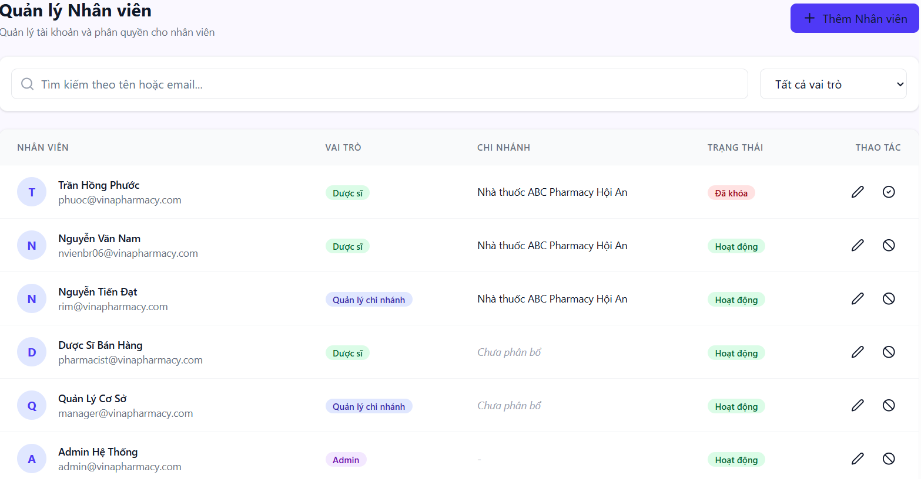
• Function Trigger:
• Navigation Path: Admin / Branch Dashboard > Staff Management (`/admin/employees`)
• Trigger Event / Frequency: Admin or Branch Manager opens staff directory.
• Function Description:
• Actors / Roles: Admin, Branch Manager
• Purpose: Displays a table listing all employees in the pharmacy chain with detailed information on role, work shift, branch, and activation status.
• Interface Type: Full Data Table Screen
• Screen Layout: N/A
• Function Details:
• Data:
- Read-only / Output: Staff ID, Full Name, Email, Phone Number, Role (Pharmacist, Inventory Manager, Branch Manager), Assigned Branch, Status (Active, Pending Approval, Deactivated).
- Editable / Input: Search Staff, Filter by Role/Branch, Status Filter.
• Validation:
- Branch Managers can only view staff assigned to their specific branch. Admins can view all chain staff.
• Business Rule:
- N/A.
• Functionality:
- In Normal Cases: Admin views complete employee directory across 10 branches, filters by role "Pharmacist", and checks active account statuses.
- In Abnormal Cases: If no staff match search query, table displays "No staff members found."

3.7.2 Create Staff Account (UC-42)
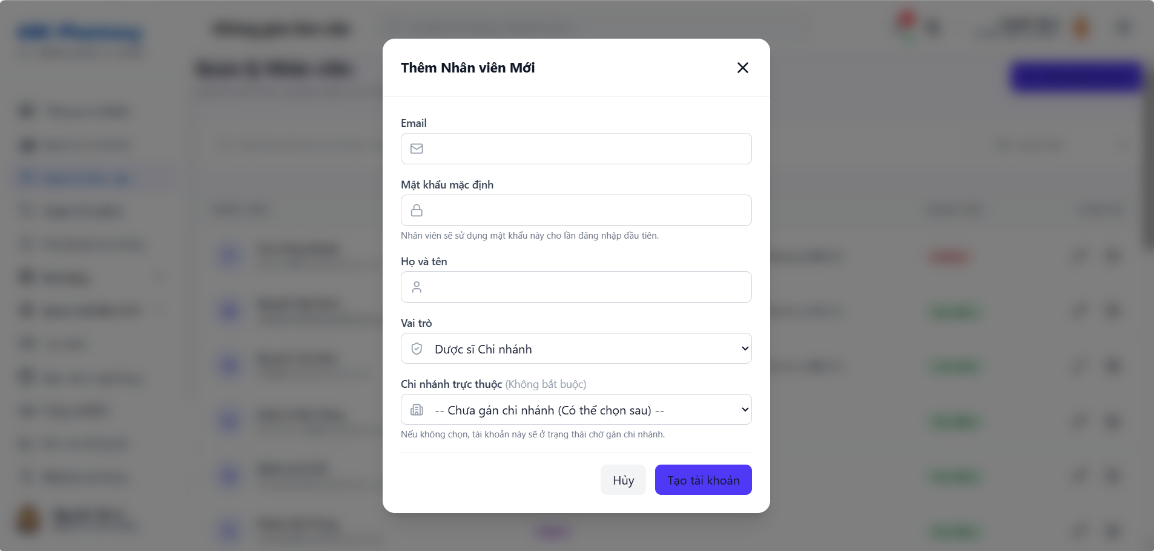
• Function Trigger:
• Navigation Path: Staff List Screen > Click 'Add New Staff' button
• Trigger Event / Frequency: Branch Manager or Admin creates staff account.
• Function Description:
• Actors / Roles: Branch Manager
• Purpose: Allows Branch Manager to create new accounts for pharmacists and counter staff members at their branch.
• Interface Type: Form Modal Screen
• Screen Layout: N/A
• Function Details:
• Data:
- Read-only / Output: Assigned Branch name.
- Editable / Input: Full Name, Work Email, Phone Number, Assigned Role (Pharmacist / Inventory Manager), Initial Password, Shift Schedule.
• Validation:
- Work email must be unique and follow valid format.
• Business Rule:
- BR-02: Staff accounts created by Branch Manager require Admin review/approval before activation.
• Functionality:
- In Normal Cases: Branch Manager fills new pharmacist details and submits. System creates account record in `PENDING_APPROVAL` status and dispatches email notification to HQ Admin.
- In Abnormal Cases: If email is already assigned to another user, system displays inline error "Email address already registered."

3.7.3 Approve Staff Account (UC-43)
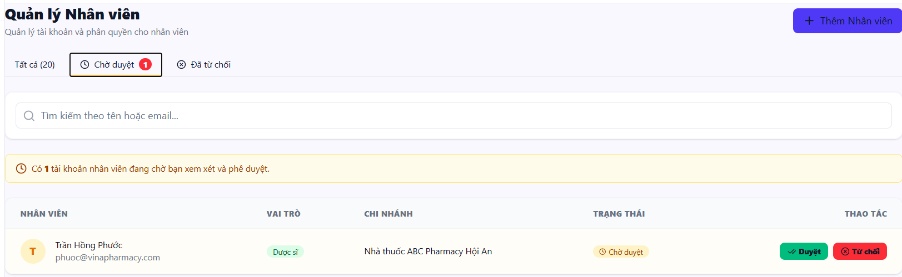
• Function Trigger:
• Navigation Path: Admin Dashboard > Approvals > Staff Requests > Click 'Approve Account'
• Trigger Event / Frequency: Admin reviews pending staff registration requests.
• Function Description:
• Actors / Roles: Admin, Branch Manager
• Purpose: Allows Admin or Branch Manager to review and approve newly registered staff accounts.
• Interface Type: Confirmation Modal / List
• Screen Layout: N/A
• Function Details:
• Data:
- Read-only / Output: Staff Name, Email, Assigned Branch, Role, Registration Timestamp.
- Editable / Input: Approve Button, Role Confirmation dropdown.
• Validation:
- Account must currently be in `PENDING_APPROVAL` status.
• Business Rule:
- BR-02: Account approval activates login permissions.
• Functionality:
- In Normal Cases: Admin reviews pending pharmacist account, clicks 'Approve'. System updates account status to `ACTIVE`, issues welcome email with login link, and logs approval in audit logs.
- In Abnormal Cases: If account is already active, approval button is disabled.

3.7.4 Reject Staff Account (UC-44)
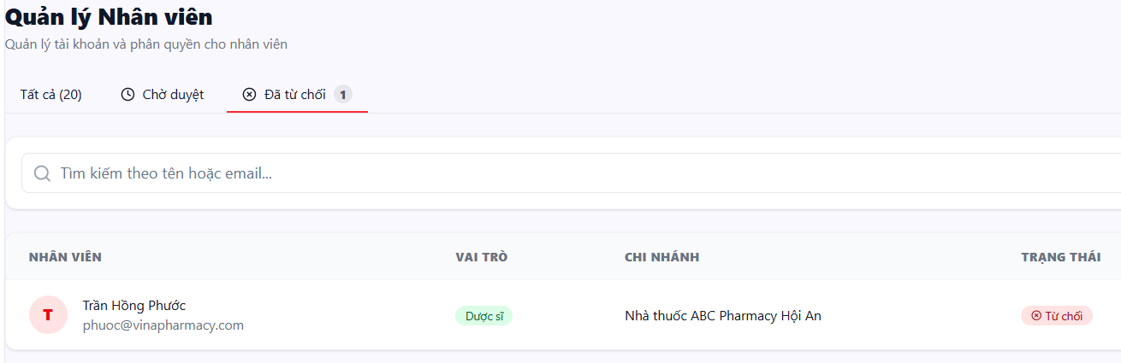
• Function Trigger:
• Navigation Path: Admin Dashboard > Approvals > Staff Requests > Click 'Reject Account'
• Trigger Event / Frequency: Admin rejects staff account creation request.
• Function Description:
• Actors / Roles: Admin, Branch Manager
• Purpose: Allows Admin or Branch Manager to reject new staff registration requests.
• Interface Type: Modal Screen with Textarea
• Screen Layout: N/A
• Function Details:
• Data:
- Read-only / Output: Staff Request Profile.
- Editable / Input: Rejection Reason textarea, Confirm Reject button.
• Validation:
- Rejection reason is required (minimum 10 characters).
• Business Rule:
- N/A.
• Functionality:
- In Normal Cases: Admin inputs reason "Invalid branch assignment credentials", clicks Confirm Reject. System updates status to `REJECTED`, sends notification email to requesting manager, and logs action.
- In Abnormal Cases: If rejection reason is blank, system displays validation error MSG02.

3.7.5 Create Branch (UC-45)
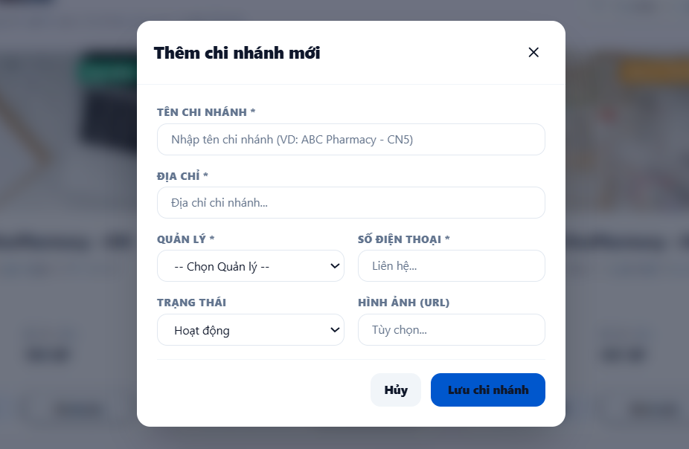
• Function Trigger:
• Navigation Path: Admin Dashboard > Branch Admin > Click 'Create Branch' (`/admin/branches`)
• Trigger Event / Frequency: HQ Admin provisions a new Branch Manager.
• Function Description:
• Actors / Roles: Admin
• Purpose: Allows HQ Admin to create new branch manager accounts and grant branch management permissions.
• Interface Type: Form Screen
• Screen Layout: N/A
• Function Details:
• Data:
- Read-only / Output: Available Store Branch List.
- Editable / Input: Manager Full Name, Work Email, Phone Number, Target Assigned Branch, Management Scope Permissions.
• Validation:
- Target branch must not already have an active primary Branch Manager assigned.
• Business Rule:
- N/A.
• Functionality:
- In Normal Cases: Admin enters manager details, assigns to "Da Nang Store Branch #2", submits. System creates active account with `BRANCH_MANAGER` role, sends temporary credentials via encrypted email, and assigns branch management scope.
- In Abnormal Cases: If selected branch already has an active manager, system prompts "Selected branch already has an assigned manager. Replace manager?"

3.7.6 Update Staff Role (UC-46)
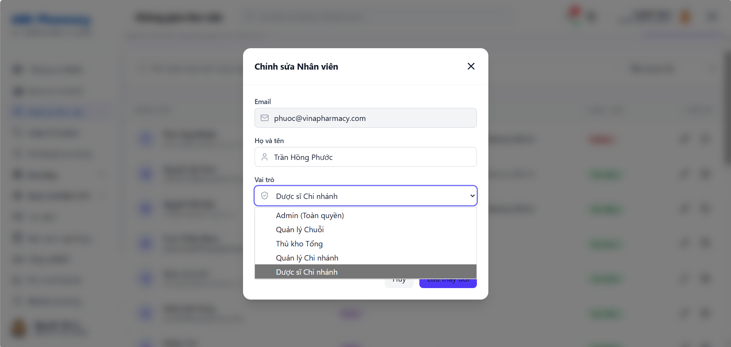
• Function Trigger:
• Navigation Path: Admin > Staff Management > Action Column > Click 'Edit Role / Branch'
• Trigger Event / Frequency: Admin modifies employee profile permissions.
• Function Description:
• Actors / Roles: Admin
• Purpose: Allows Admin to update staff profile, assign job roles, and reassign branch locations.
• Interface Type: Form Modal Screen
• Screen Layout: N/A
• Function Details:
• Data:
- Read-only / Output: Staff ID, Current Role, Current Branch.
- Editable / Input: Role dropdown (Pharmacist / Inventory Manager / Branch Manager), Reassigned Branch dropdown, Account Status toggle (Active / Suspended).
• Validation:
- Admin cannot modify their own super-admin role.
• Business Rule:
- BR-21: All role modifications recorded in system audit logs.
• Functionality:
- In Normal Cases: Admin changes staff member role from Pharmacist to Inventory Manager and assigns to Central Warehouse. System updates user role token claims and invalidates active session to enforce immediate permission reload.
- In Abnormal Cases: If Admin attempts to deactivate the last remaining Super Admin, system blocks action with alert "Cannot deactivate the primary system administrator."

3.7.7 Add Medicine (UC-47)
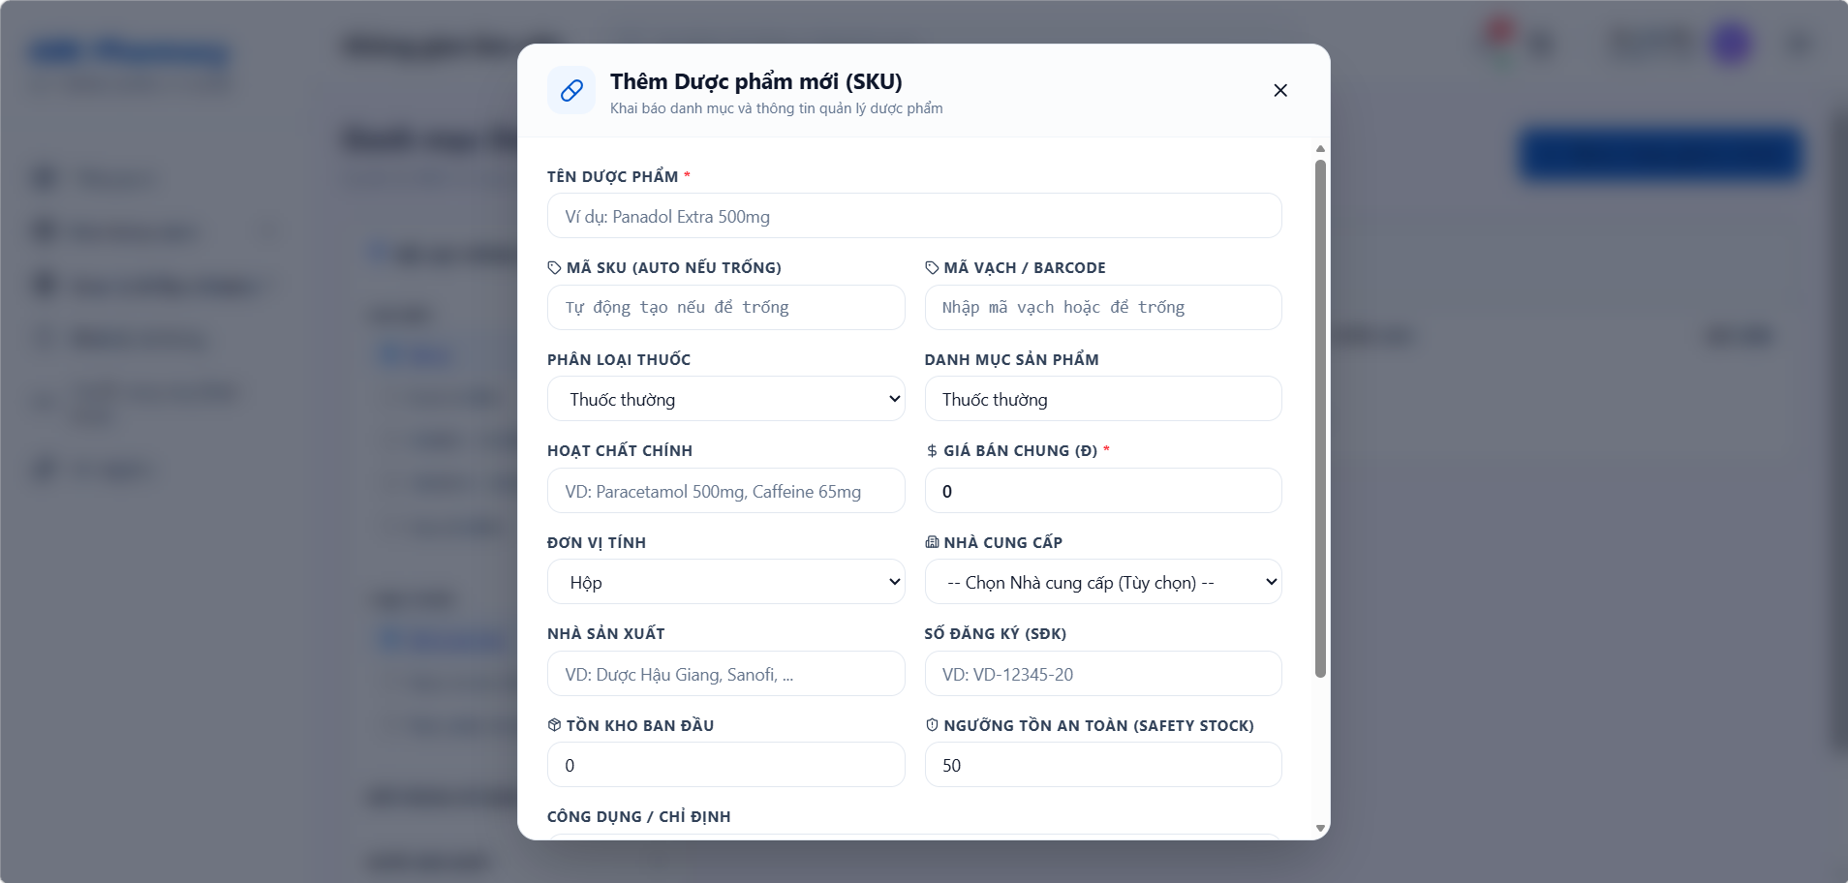
• Function Trigger:
• Navigation Path: Admin / Warehouse > Master Catalog > Click 'Add New Medicine' (`/warehouse/master-data/products`)
• Trigger Event / Frequency: Admin creates a new master drug SKU.
• Function Description:
• Actors / Roles: Admin
• Purpose: Create a new medicine and fill in identification attributes, packaging specifications, and usage instructions.
• Interface Type: Form Screen
• Screen Layout: N/A
• Function Details:
• Data:
- Read-only / Output: Generated SKU Code (`MED-xxxx`).
- Editable / Input: Brand Name, Generic Name, Active Ingredient, Concentration, Therapeutic Group, Dosage Form (Tablet / Capsule / Liquid), Unit Specifications (Box / Blister / Pill), Base Retail Price, OTC/Rx Flag, Manufacturer Name.
• Validation:
- SKU Brand Name and Active Ingredient are mandatory fields.
- Base Retail Price must be a positive number > 0.
• Business Rule:
- N/A.
• Functionality:
- In Normal Cases: Admin fills complete drug specification form and clicks Save. System creates new master Medicine entity in global catalog, generates SKU code, and renders product in catalog.
- In Abnormal Cases: If duplicate Brand Name + Concentration exists, system warns "A medicine SKU with this name and concentration already exists."

3.7.8 Update Medicine (UC-48)
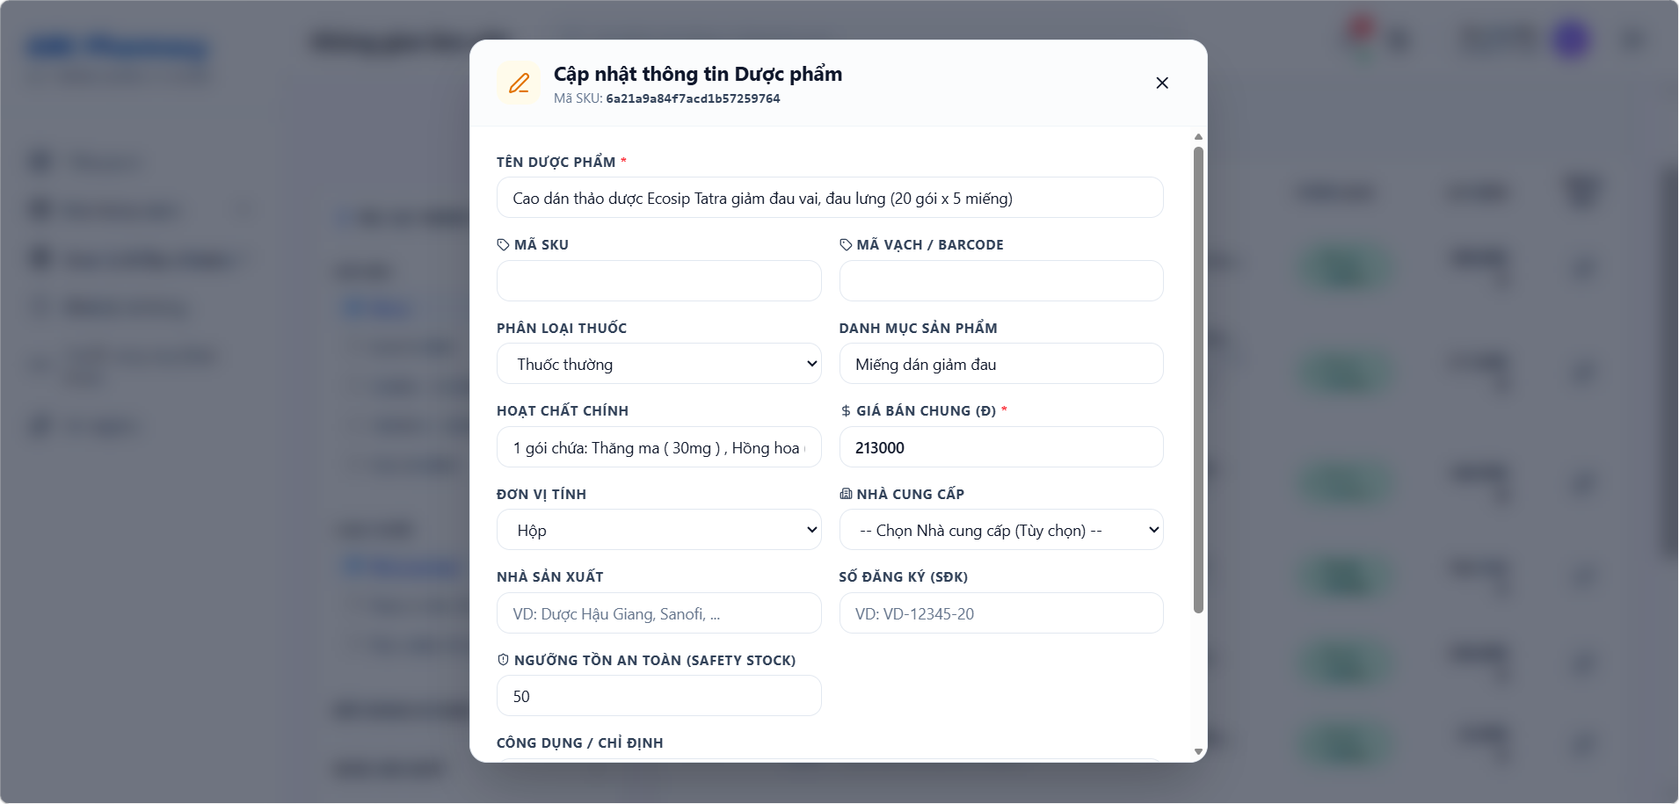
• Function Trigger:
• Navigation Path: Master Catalog > Click Edit Icon on Product Row
• Trigger Event / Frequency: Admin updates existing medicine details.
• Function Description:
• Actors / Roles: Admin
• Purpose: Edit medicine attributes, descriptions, images, or classification categories in the system catalog.
• Interface Type: Form Screen
• Screen Layout: N/A
• Function Details:
• Data:
- Read-only / Output: Medicine SKU Code, Historical Price Changes log.
- Editable / Input: Description, Packaging Units, Base Price, Prescription Flag, Product Image Upload.
• Validation:
- Base price changes require audit log reason.
• Business Rule:
- BR-21: Price modifications logged in audit records.
• Functionality:
- In Normal Cases: Admin updates base selling price from 50,000 VND to 55,000 VND, uploads new packaging photo, submits. System updates master record, invalidates API price cache, and logs price modification.
- In Abnormal Cases: If base price is entered as a negative value, system displays validation error MSG02.

3.7.9 View Supplier List (UC-49)
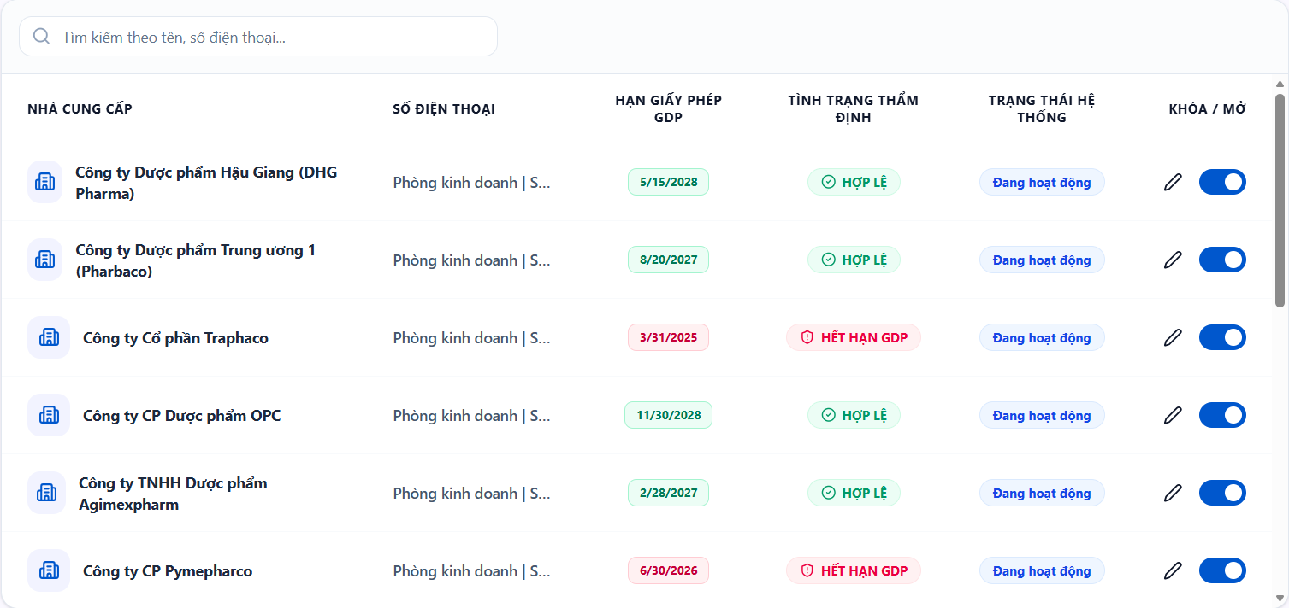
• Function Trigger:
• Navigation Path: Admin / Warehouse > Master Data > Suppliers (`/warehouse/master-data/suppliers`)
• Trigger Event / Frequency: Admin or Inventory Manager opens supplier directory.
• Function Description:
• Actors / Roles: Admin, Inventory Manager
• Purpose: Displays contact information, supplier code, and reliability rating of suppliers.
• Interface Type: Data Table Screen
• Screen Layout: N/A
• Function Details:
• Data:
- Read-only / Output: Supplier Code, Company Name, Tax ID, Phone Number, Email, GDP License Expiry Date, Credit Terms, Reliability Rating (1-5 Stars).
- Editable / Input: Search Supplier, Filter by GDP Expiry status.
• Validation:
- Displays active suppliers in system database.
• Business Rule:
- N/A.
• Functionality:
- In Normal Cases: User views list of 15 pharmaceutical suppliers, checks GDP license validity dates, and views credit terms.
- In Abnormal Cases: Suppliers with expired GDP licenses are highlighted with a red warning badge "GDP Expired."

3.7.10 Add Supplier (UC-50)
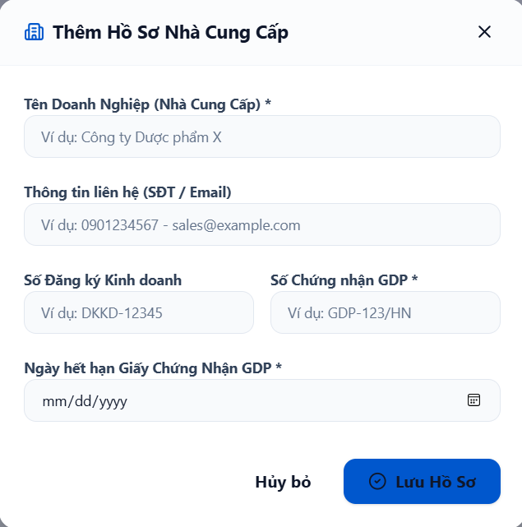
• Function Trigger:
• Navigation Path: Supplier List Screen > Click 'Register Supplier' button
• Trigger Event / Frequency: Admin registers new drug supplier.
• Function Description:
• Actors / Roles: Admin
• Purpose: Register new pharmaceutical supplier information and store legal profiles in the system.
• Interface Type: Form Modal Screen
• Screen Layout: N/A
• Function Details:
• Data:
- Read-only / Output: Generated Supplier Code (`SUP-xxx`).
- Editable / Input: Company Name, Tax Identification Number, Address, Contact Person, Email, Phone Number, GDP License Number, GDP License Expiry Date, Payment Credit Terms (e.g. Net 30 Days).
• Validation:
- Tax ID and Company Name are required and must be unique.
- GDP Expiry Date must be a future date.
• Business Rule:
- N/A.
• Functionality:
- In Normal Cases: Admin inputs supplier legal details and submits. System creates Supplier entity, generates supplier code, and saves profile for PO procurement.
- In Abnormal Cases: If Tax ID already exists in DB, system blocks creation with error "Tax ID is already registered to another supplier."

3.7.11 Update Supplier (UC-51)
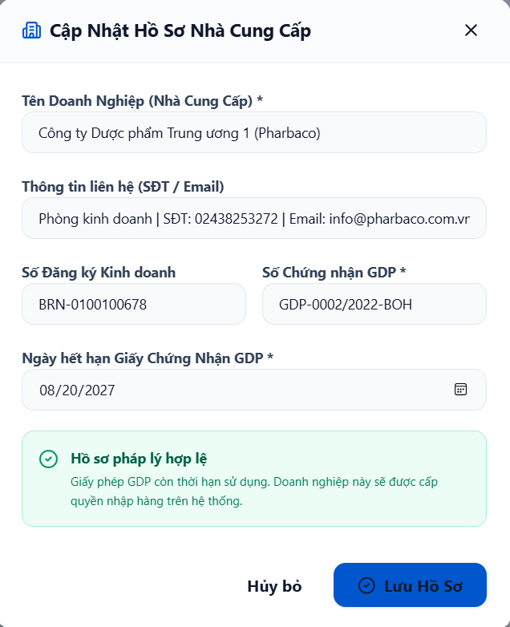
• Function Trigger:
• Navigation Path: Supplier List > Action Column > Click 'Edit Supplier'
• Trigger Event / Frequency: Admin updates supplier profile information.
• Function Description:
• Actors / Roles: Admin
• Purpose: Adjust contact information, GDP license expiration date, or supplier credit terms.
• Interface Type: Form Modal Screen
• Screen Layout: N/A
• Function Details:
• Data:
- Read-only / Output: Supplier Code, Historical PO Count.
- Editable / Input: Phone Number, Email, GDP License Expiry Date, Payment Terms, Active Status toggle.
• Validation:
- License expiration date must be valid date format.
• Business Rule:
- N/A.
• Functionality:
- In Normal Cases: Admin updates renewed GDP license expiry date to 2028-12-31 and updates phone number. System saves updated supplier profile.
- In Abnormal Cases: If supplier is marked Deactivated, system prevents selecting this supplier when creating new Purchase Orders.

3.8 Corporate Finance, Approvals & AI Analytics

3.8.1 View Revenue Dashboard (UC-52)
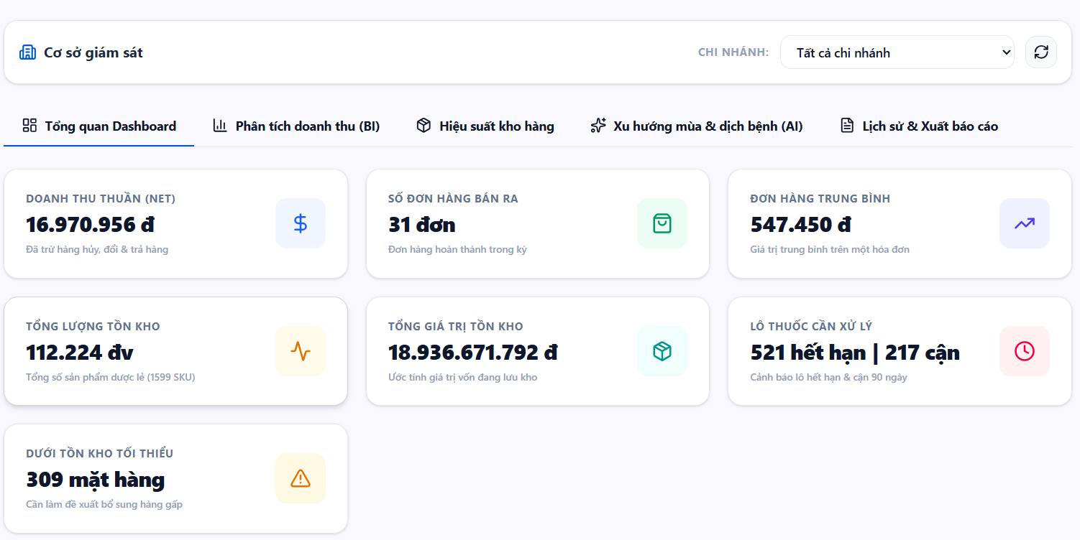
• Function Trigger:
• Navigation Path: Admin Dashboard > Analytics > Financial Revenue (`/admin/finance`)
• Trigger Event / Frequency: Admin views corporate revenue dashboard.
• Function Description:
• Actors / Roles: Admin
• Purpose: View revenue charts over time, transaction counts, total payables/receivables, and chain-wide operational performance.
• Interface Type: Executive BI Dashboard Screen
• Screen Layout: N/A
• Function Details:
• Data:
- Read-only / Output: Gross Revenue Widget, Net Profit Margin, Transaction Volume, Chain Cash Flow Chart, Accounts Payable to Suppliers, Accounts Receivable from Wholesale Partners.
- Editable / Input: Date Range Picker (Today / This Week / Month / Custom), Branch Selector Filter.
• Validation:
- Date range start date must be prior to end date.
• Business Rule:
- N/A.
• Functionality:
- In Normal Cases: Admin selects "Current Month" and "All Branches". Dashboard renders interactive revenue bar charts, profit margin pie charts, and sales growth breakdown.
- In Abnormal Cases: If financial service query fails, widget displays retry button "Failed to load financial metrics."

3.8.2 Compare Branch Performance (UC-53)
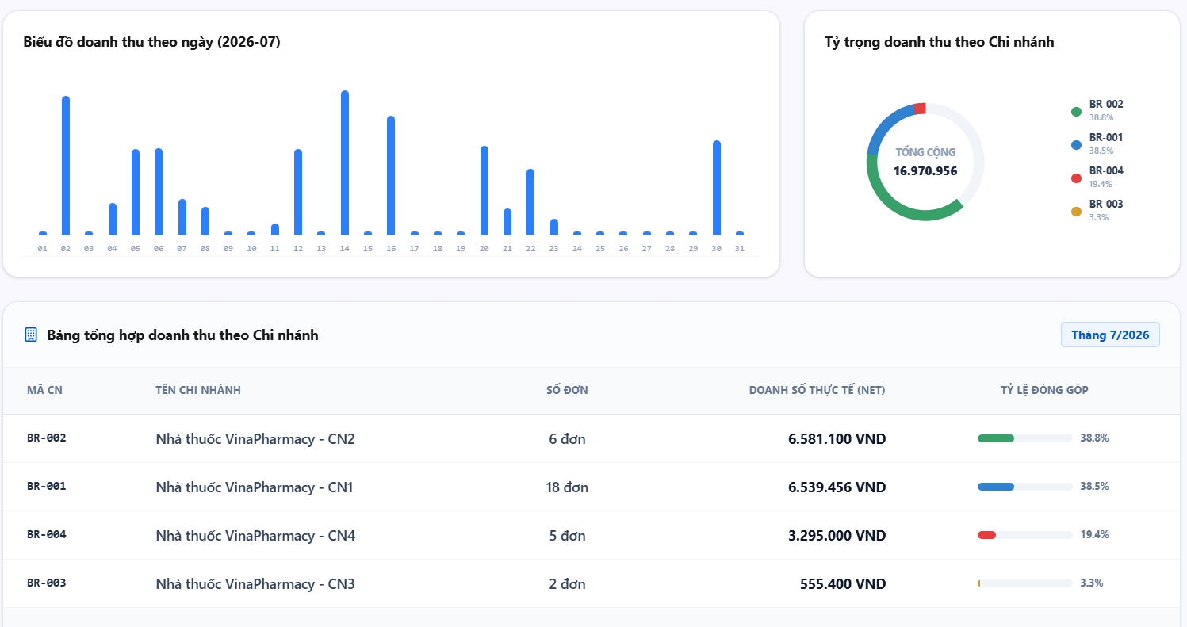
• Function Trigger:
• Navigation Path: Admin Dashboard > Analytics > Branch Performance (`/admin/ai-insights`)
• Trigger Event / Frequency: Admin opens branch comparative ranking analytics.
• Function Description:
• Actors / Roles: Admin
• Purpose: Display comparative ranking tables for sales volume, transaction counts, and growth rates across all branch locations.
• Interface Type: Analytics Comparison Screen
• Screen Layout: N/A
• Function Details:
• Data:
- Read-only / Output: Branch Ranking Table, Sales Revenue per Branch, Order Count per Branch, Average Ticket Size, Top Performing Branch Badge, Underperforming Alert Flag.
- Editable / Input: Sorting Criterion (Revenue / Orders / Growth %), Date Filter.
• Validation:
- Compares active stores in chain network.
• Business Rule:
- N/A.
• Functionality:
- In Normal Cases: Admin views table ranking 10 branches by revenue. System highlights top branch "Branch #1 - Da Nang Center" (120M VND) and flags lowest branch for operational review.
- In Abnormal Cases: If a newly opened branch has 0 sales, system displays "New Branch - No Data Yet".

3.8.3 Approve Purchase Order (PO) (UC-54)
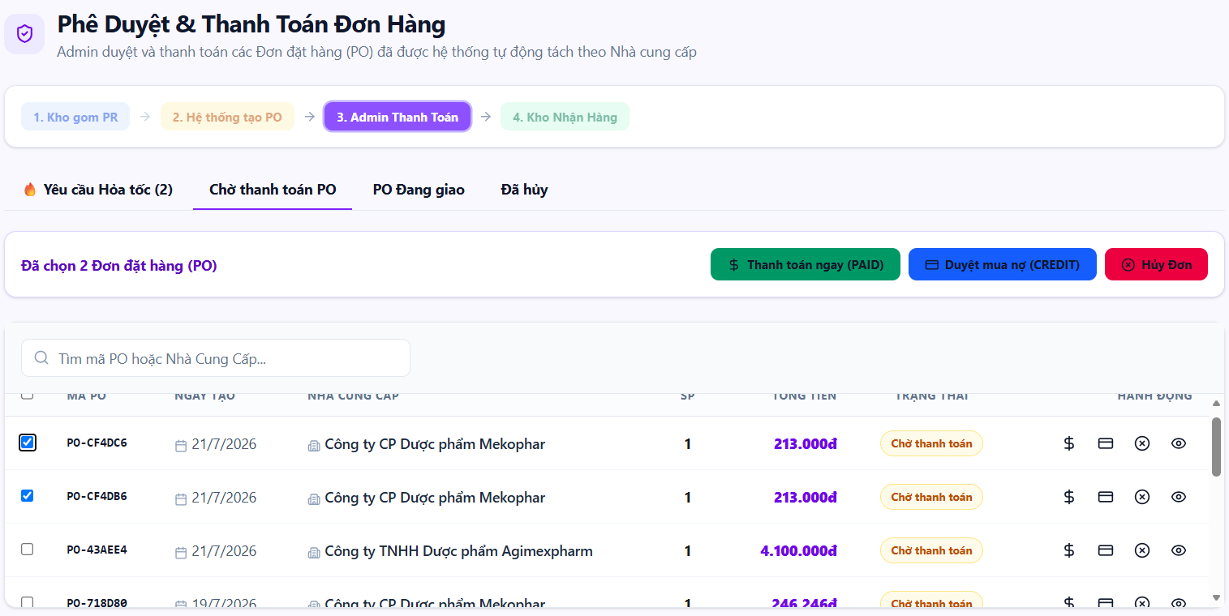
• Function Trigger:
• Navigation Path: Admin Dashboard > Approvals > Purchase Orders > Select PO (`/admin/approvals`)
• Trigger Event / Frequency: HQ Admin reviews pending supplier PO for approval.
• Function Description:
• Actors / Roles: Admin
• Purpose: Approve Purchase Orders (PO) sent to suppliers and configure payment methods.
• Interface Type: Approval Detail Screen
• Screen Layout: N/A
• Function Details:
• Data:
- Read-only / Output: PO Code, Supplier Name, Item List, Quantities, Unit Purchase Price, Calculated Total PO Cost.
- Editable / Input: Payment Method Selection (Bank Credit / Cash), Admin Approval Notes, Approve Button.
• Validation:
- PO must be in `PENDING_APPROVAL` status.
• Business Rule:
- BR-17: Purchase Orders submitted to suppliers must receive explicit approval from HQ Admin.
- BR-21: All PO approval actions logged in audit logs.
• Functionality:
- In Normal Cases: Admin reviews PO #PO-2026-88 total 150M VND, checks supplier credit terms, clicks 'Approve PO'. System updates PO status to `APPROVED_SENT_TO_SUPPLIER`, generates official PO PDF, and emails supplier.
- In Abnormal Cases: If PO total exceeds corporate credit limit, system displays warning prompt requiring secondary confirmation.

3.8.4 Reject Purchase Order (PO) (UC-55)
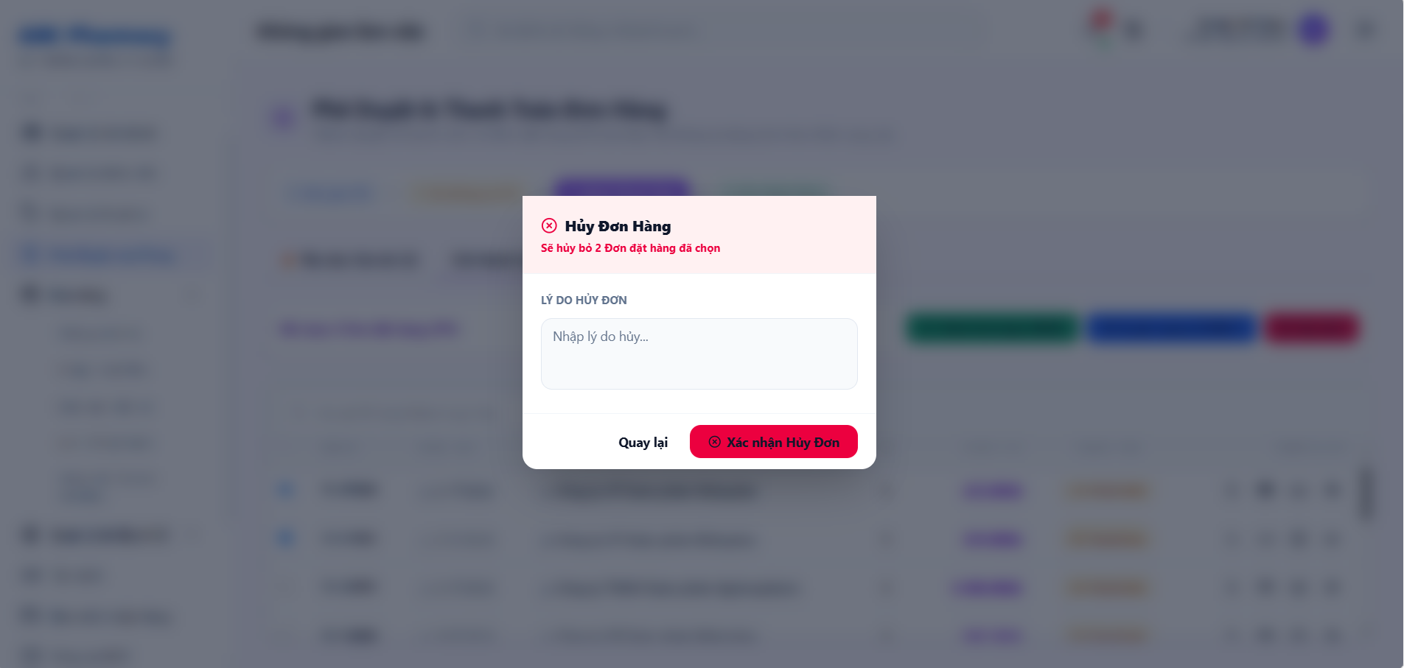
• Function Trigger:
• Navigation Path: Admin Dashboard > Approvals > Select PO > Click 'Reject PO'
• Trigger Event / Frequency: Admin rejects supplier PO submission.
• Function Description:
• Actors / Roles: Admin
• Purpose: Reject approval of purchase order PO and record rejection reasons.
• Interface Type: Modal Screen with Textarea
• Screen Layout: N/A
• Function Details:
• Data:
- Read-only / Output: Target PO Reference Summary.
- Editable / Input: Rejection Reason textarea (mandatory), Confirm Reject button.
• Validation:
- Rejection reason is strictly required (minimum 10 characters).
• Business Rule:
- N/A.
• Functionality:
- In Normal Cases: Admin inputs reason "Unit price for item X is higher than contracted rate; renegotiate with supplier", clicks Confirm Reject. System updates PO status to `REJECTED`, notifies Inventory Manager to edit PO.
- In Abnormal Cases: If rejection reason text is empty, system blocks rejection with error MSG02.

3.8.5 Approve Goods Receipt Note (GRN) (UC-56)
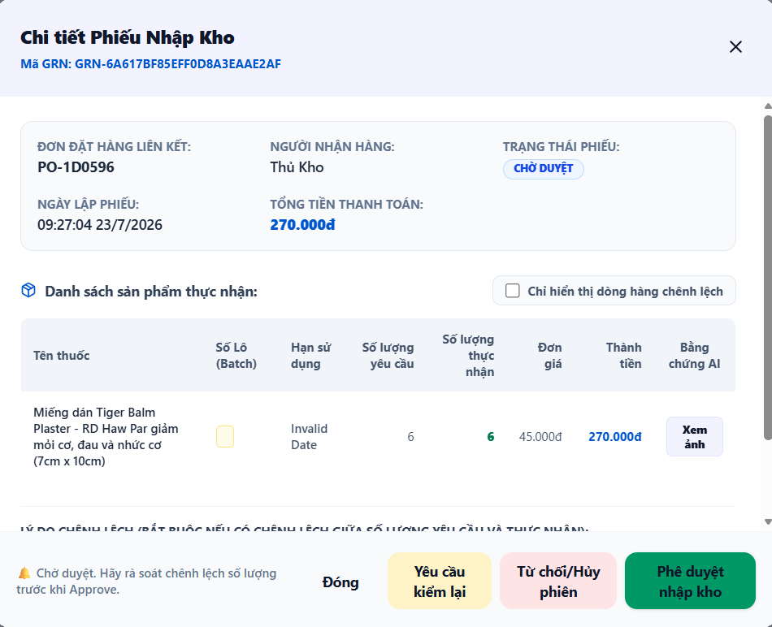
• Function Trigger:
• Navigation Path: Admin Dashboard > Approvals > GRN Receipts > Select GRN (`/admin/approvals`)
• Trigger Event / Frequency: HQ Admin signs off warehouse physical inspection GRN.
• Function Description:
• Actors / Roles: Admin
• Purpose: Sign and approve physical inspection receipt from warehouse manager to confirm official entry, increase total stock, and activate new batches.
• Interface Type: Approval Detail Screen
• Screen Layout: N/A
• Function Details:
• Data:
- Read-only / Output: GRN ID, Supplier Name, Physical Inspection Report, AI Camera Evidence Photo, Received FEFO Batches (`batchNo`, `expDate`), Total Inventory Valuation.
- Editable / Input: Approve GRN Button, Final Sign-off Notes.
• Validation:
- GRN must have passed physical or AI camera inspection.
• Business Rule:
- BR-18: GRN must pass inspection verification before central stock activation.
- BR-21: Action logged in system audit trail.
• Functionality:
- In Normal Cases: Admin inspects GRN data and AI box count evidence, clicks 'Approve GRN'. System signs receipt, officially updates central warehouse stock balances, activates new FEFO batches for dispatch, and updates PO to `FULFILLED`.
- In Abnormal Cases: If GRN contains unverified batch expiry dates, system blocks approval until warehouse manager corrects batch metadata.

3.8.6 Reject Goods Receipt Note (GRN) (UC-57)
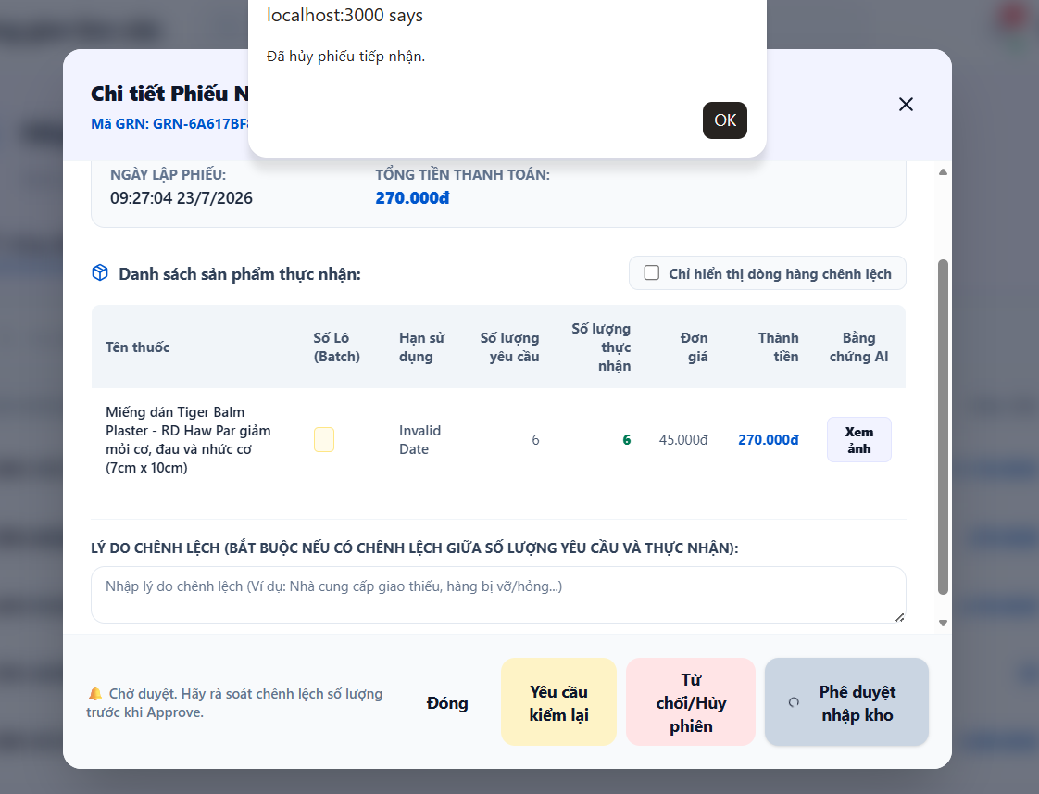
• Function Trigger:
• Navigation Path: Admin Dashboard > Approvals > Select GRN > Click 'Reject GRN'
• Trigger Event / Frequency: Admin rejects warehouse GRN entry.
• Function Description:
• Actors / Roles: Admin
• Purpose: Reject physical inspection receipt (GRN) from warehouse manager and record rejection reasons for re-verification.
• Interface Type: Modal Screen with Textarea
• Screen Layout: N/A
• Function Details:
• Data:
- Read-only / Output: Target GRN Details.
- Editable / Input: Rejection Reason textarea, Confirm Reject button.
• Validation:
- Rejection reason mandatory.
• Business Rule:
- N/A.
• Functionality:
- In Normal Cases: Admin enters reason "Batch numbers do not match physical supplier invoice; re-count required", clicks Confirm. System updates GRN status to `REJECTED_NEEDS_REVISION` and alerts warehouse manager.
- In Abnormal Cases: If rejection reason is blank, system displays error MSG02.

3.8.7 Manage Promotions (UC-58)
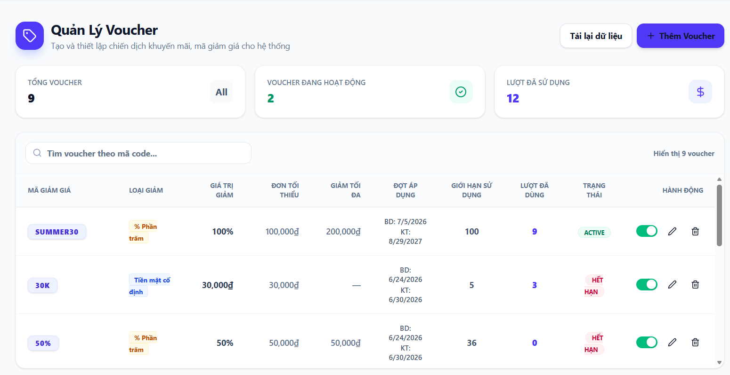
• Function Trigger:
• Navigation Path: Admin Dashboard > Marketing > Vouchers & Promotions (`/admin/vouchers`)
• Trigger Event / Frequency: Admin configures discount campaigns or flash sales.
• Function Description:
• Actors / Roles: Admin
• Purpose: Create percentage/cash discount voucher codes, set up Flash Sale events for designated time slots.
• Interface Type: Management Screen
• Screen Layout: N/A
• Function Details:
• Data:
- Read-only / Output: Active Promotion List, Redemption Usage Statistics, Remaining Voucher Quota.
- Editable / Input: Campaign Name, Voucher Code string, Discount Type (Percentage / Fixed Amount), Discount Value, Minimum Order Value, Start Date & End Date, Usage Limit Quota.
• Validation:
- Start Date must be prior to End Date. Discount value must be positive integer.
• Business Rule:
- BR-10: Priority promotional campaigns launched for Yellow Alert near-expiry batches.
• Functionality:
- In Normal Cases: Admin creates campaign "FLASH20", 20% off for near-expiry items, valid for 7 days with 500 redemptions. System activates voucher code for online cart and POS application.
- In Abnormal Cases: If voucher code string already exists, system displays error "Voucher code already active."

3.8.8 Manage Cash Flow (UC-59)
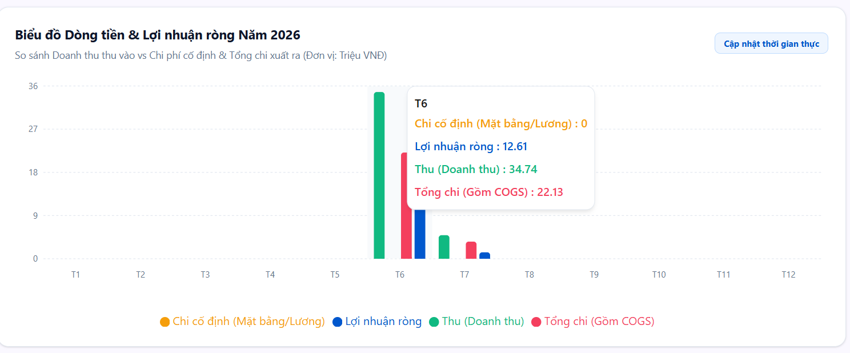
• Function Trigger:
• Navigation Path: Admin Dashboard > Finance > Cash Flow & Expenses (`/admin/finance`)
• Trigger Event / Frequency: Admin monitors corporate cash flow and logs fixed expenses.
• Function Description:
• Actors / Roles: Admin
• Purpose: View financial cash flow reports, enter fixed operational expenses (rent, salaries, utilities...) of branches.
• Interface Type: Financial Form & Ledger Screen
• Screen Layout: N/A
• Function Details:
• Data:
- Read-only / Output: Net Cash Flow Ledger, Operating Income vs Expenses Summary Chart, Net Profit.
- Editable / Input: Add Expense Item (Expense Category: Rent/Salary/Utility, Amount VND, Target Branch, Transaction Date, Receipt Attachment).
• Validation:
- Expense amount must be a positive number > 0.
• Business Rule:
- N/A.
• Functionality:
- In Normal Cases: Admin logs monthly branch store rent expense of 25,000,000 VND for Branch #1. System records ledger transaction, updates net cash flow calculations, and re-renders profit charts.
- In Abnormal Cases: If expense category is unselected, form submission is blocked.

3.8.9 Query Audit Logs (UC-60)
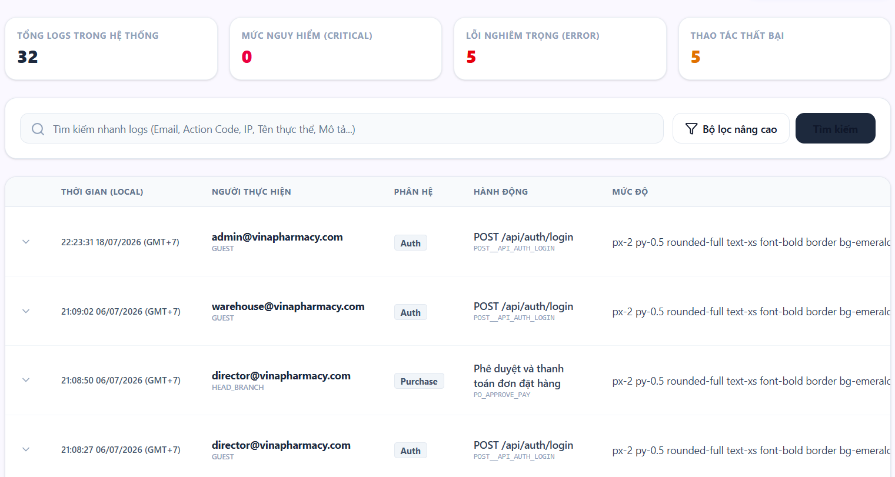
• Function Trigger:
• Navigation Path: Admin Dashboard > System Security > Audit Logs (`/admin/audit-logs`)
• Trigger Event / Frequency: Admin inspects system activity logs.
• Function Description:
• Actors / Roles: Admin
• Purpose: Retrieve audit log records tracking critical business operations performed by staff for security compliance.
• Interface Type: Audit Trail Screen
• Screen Layout: N/A
• Function Details:
• Data:
- Read-only / Output: Log ID, Timestamp, User Name & ID, User Role, Action Executed (e.g., `FEFO_OVERRIDE`, `PO_APPROVE`, `PRICE_UPDATE`), IP Address, Affected Entity ID, Changes Diff (Before/After values).
- Editable / Input: Filter by User, Date Range Picker, Action Code dropdown, Search Bar.
• Validation:
- Audit log records are immutable and read-only.
• Business Rule:
- BR-21: All critical actions must be recorded in immutable system audit logs.
• Functionality:
- In Normal Cases: Admin searches audit logs for action "PRICE_UPDATE" during the last 30 days. System returns paginated log entries showing exact before/after selling prices, user who executed change, timestamp, and IP address.
- In Abnormal Cases: If no logs match filter, table displays "No audit logs found for selected criteria."

3.8.10 Forecast Demand (UC-61)
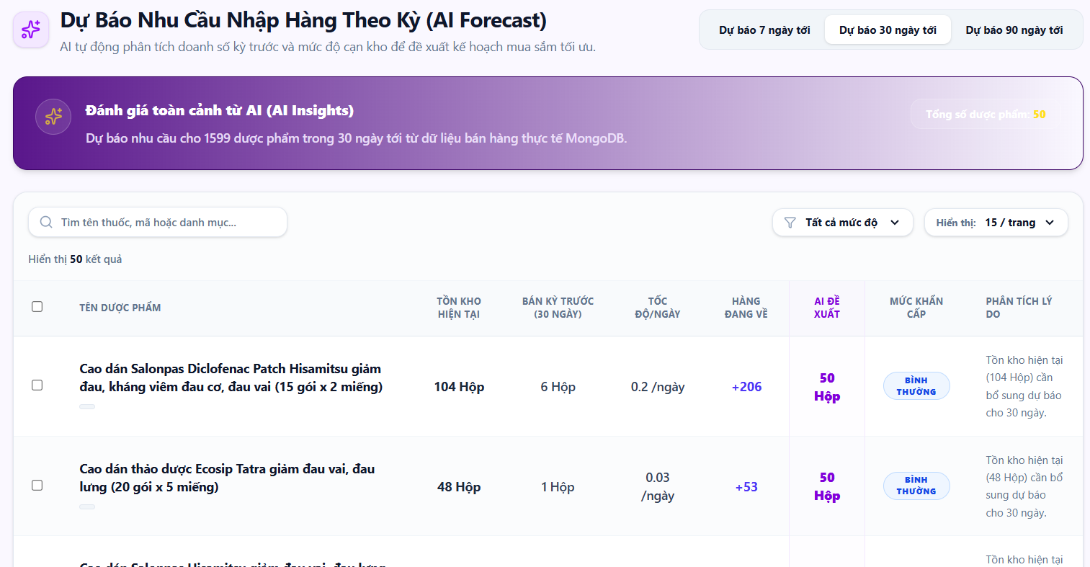
• Function Trigger:
• Navigation Path: Warehouse / Admin Dashboard > AI Analytics > Demand Forecast (`/warehouse/ai-forecast`)
• Trigger Event / Frequency: System runs scheduled forecast or user requests manual AI prediction.
• Function Description:
• Actors / Roles: Inventory Manager, Admin
• Purpose: System automatically analyzes sales volume and actual inventory levels to suggest replenishment order quantities from suppliers.
• Interface Type: AI Forecasting Dashboard Screen
• Screen Layout: N/A
• Function Details:
• Data:
- Read-only / Output: Predicted SKU Demand Curve (30-day projection), Current Warehouse Stock, Safety Stock Threshold, Calculated Economic Order Quantity (EOQ), Recommended Supplier PO List.
- Editable / Input: Forecast Horizon selector (14 Days / 30 Days / 90 Days), Target Safety Stock Days parameter.
• Validation:
- Model predictions require at least 30 days of historical sales data.
• Business Rule:
- BR-20: AI replenishment recommendations must be reviewed by Inventory Manager before converting to Purchase Orders.
• Functionality:
- In Normal Cases: Manager opens AI Forecast page. Predictive model analyzes 90-day sales velocity, projects 500 boxes of Paracetamol needed for next month, compares with 100 current stock, and recommends ordering 400 boxes (EOQ).
- In Abnormal Cases: If historical sales data is insufficient for a new drug SKU, system displays warning "Insufficient sales history; using default safety stock calculation."

3.8.11 Auto-Generate PO from AI Forecast (UC-62)
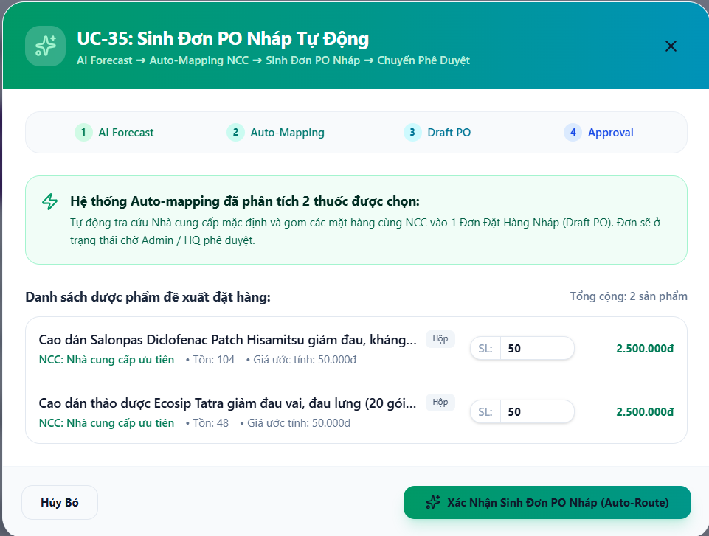
• Function Trigger:
• Navigation Path: AI Demand Forecast Dashboard > Select Recommended Items > Click 'Auto-Generate PO'
• Trigger Event / Frequency: On button click by Inventory Manager / Admin.
• Function Description:
• Actors / Roles: Inventory Manager, Admin
• Purpose: Allows converting AI Economic Order Quantity (EOQ) replenishment recommendations directly into an official Purchase Order (PO) with one click.
• Interface Type: Action Trigger / Form Preview Modal
• Screen Layout: N/A
• Function Details:
• Data:
- Read-only / Output: Generated Draft PO Summary, Auto-selected Preferred Supplier, EOQ Quantities, Estimated Procurement Cost.
- Editable / Input: Supplier selection override, Quantity adjustment, Confirm & Submit for Approval button.
• Validation:
- Generated PO items must have assigned active suppliers in master catalog.
• Business Rule:
- BR-17: PO must receive explicit approval from HQ Admin before transmission.
- BR-20: AI EOQ recommendations reviewed before PO conversion.
• Functionality:
- In Normal Cases: Manager reviews AI forecast recommendation for 400 boxes, clicks 'Auto-Generate PO'. System groups items by preferred supplier ID, creates draft PO #PO-2026-99 with EOQ quantities, and routes PO to Admin approval queue.
- In Abnormal Cases: If an AI recommended item has no registered supplier, system prompts "Please assign a supplier to item {SKU_name} before generating PO."

3.8.12 Detect Inventory Anomalies with AI (UC-63)
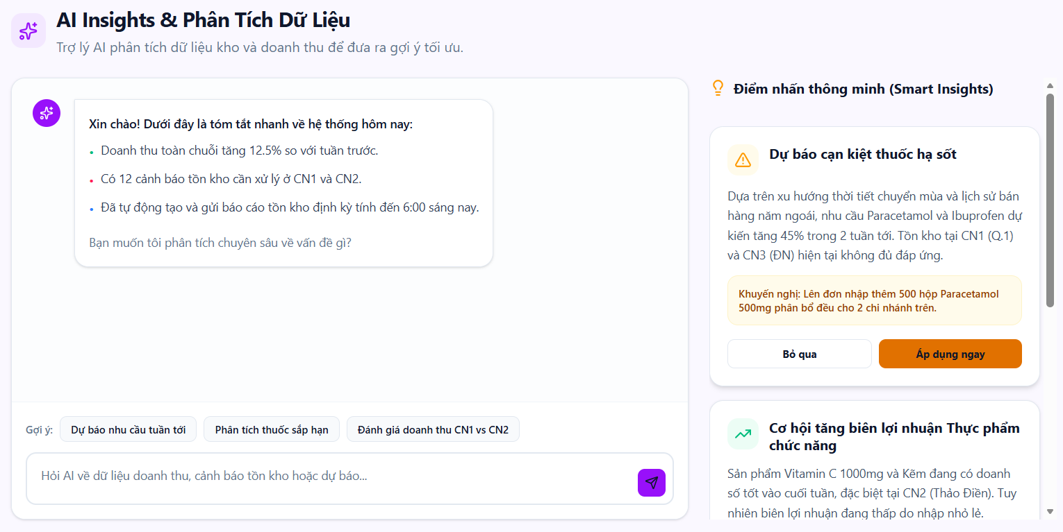
• Function Trigger:
• Navigation Path: Admin / Warehouse Dashboard > AI Analytics > Anomaly Detection (`/admin/ai-insights`)
• Trigger Event / Frequency: Automated background job or manual dashboard inspection.
• Function Description:
• Actors / Roles: Inventory Manager, Admin
• Purpose: AI system automatically detects and alerts unusual inventory fluctuations such as export spikes, critically low stock, or abnormal inventory adjustments.
• Interface Type: Executive Alert Dashboard Screen
• Screen Layout: N/A
• Function Details:
• Data:
- Read-only / Output: Anomaly Alert Cards, Affected SKU Name & Location, Expected Baseline Movement vs Abnormal Spike %, Suspected Root Cause (e.g. Unrecorded Wastage, Theft Risk, Sudden Outbreak Demand), Severity Flag.
- Editable / Input: Acknowledge Anomaly button, Initiate Audit Action button.
• Validation:
- Anomaly triggers when deviation exceeds 3 standard deviations from historical baseline.
• Business Rule:
- N/A.
• Functionality:
- In Normal Cases: AI anomaly detector scans stock movements, detects an abnormal write-off spike of 50 boxes at Branch #3 within 2 hours. Dashboard generates Red Anomaly Alert "Unusual Wastage Spike Detected at Branch #3" and notifies Admin.
- In Abnormal Cases: If no anomalies detected, dashboard displays "Inventory operations operating within normal statistical parameters."

3.8.13 Analyze Seasonal and Epidemic Trends (UC-64)
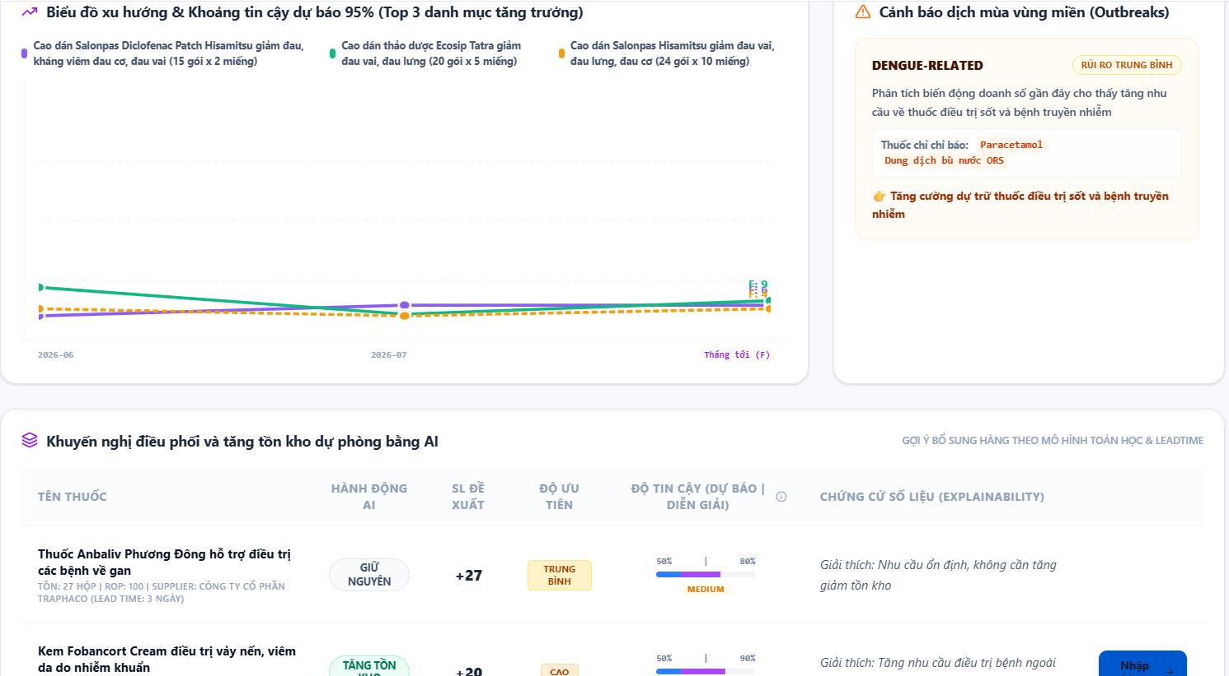
• Function Trigger:
• Navigation Path: Admin Dashboard > AI Analytics > Seasonal & Epidemic Insights (`/admin/ai-insights`)
• Trigger Event / Frequency: Admin opens strategic market intelligence dashboard.
• Function Description:
• Actors / Roles: Admin
• Purpose: Analyzes historical sales data across seasonal shifts and disease outbreaks to forecast medicine demand and optimize strategic stocking.
• Interface Type: Strategic BI Analytics Screen
• Screen Layout: N/A
• Function Details:
• Data:
- Read-only / Output: Seasonal Demand Heatmap, Epidemic Trend Category Correlation (e.g. Flu Remedies in Winter, Dengue Fever SKUs in Rainy Season), Strategic Stocking Recommendations list.
- Editable / Input: Disease Outbreak Filter, Weather Season Selector (Rainy / Dry / Winter), Forecast Target Region.
• Validation:
- Models incorporate external disease outbreak trend data.
• Business Rule:
- N/A.
• Functionality:
- In Normal Cases: Admin selects "Flu Season - Winter". System analyzes past 3-year historical sales, projects 150% demand increase in fever and cold medications, and displays recommended pre-stocking quantities for central warehouse.
- In Abnormal Cases: If no historical trend data exists for a category, system displays baseline generic demand projections.

3.8.14 Receive Notifications (UC-65)

• Function Trigger:
• Navigation Path: Top Right Header Bell Icon / Popup Toast Overlay (System-wide)
• Trigger Event / Frequency: Real-time Socket.io event push from backend server.
• Function Description:
• Actors / Roles: Customer, Pharmacist, Inventory Manager, Admin, Branch Manager
• Purpose: System pushes real-time socket notifications for near-expiry alerts, PO/GRN approval requests, or urgent branch replenishment requests.
• Interface Type: Notification Center Drawer / Toast Overlay
• Screen Layout: N/A
• Function Details:
• Data:
- Read-only / Output: Notification Title, Message Body, Timestamp, Category Icon (Alert, Approval, Order, Expiry), Unread Badge Count, Target Action Link URL.
- Editable / Input: Mark as Read button, Clear All button, Click Notification row (Navigates to URL).
• Validation:
- User must be logged in with active WebSocket connection room.
• Business Rule:
- N/A.
• Functionality:
- In Normal Cases: Branch Manager submits urgent PR. Backend emits WebSocket event `pr_created`. Admin's bell icon badge increments (+1), toast pops up "New Urgent PR #PR-102 submitted by Branch #1", clicking toast navigates directly to approval screen.
- In Abnormal Cases: If WebSocket drops connection, client falls back to 30-second HTTP polling to fetch unread notifications.

3.9 Extended Module Functional Requirements

3.9.1 Mobile Inbound Barcode Inspection (UC-66)
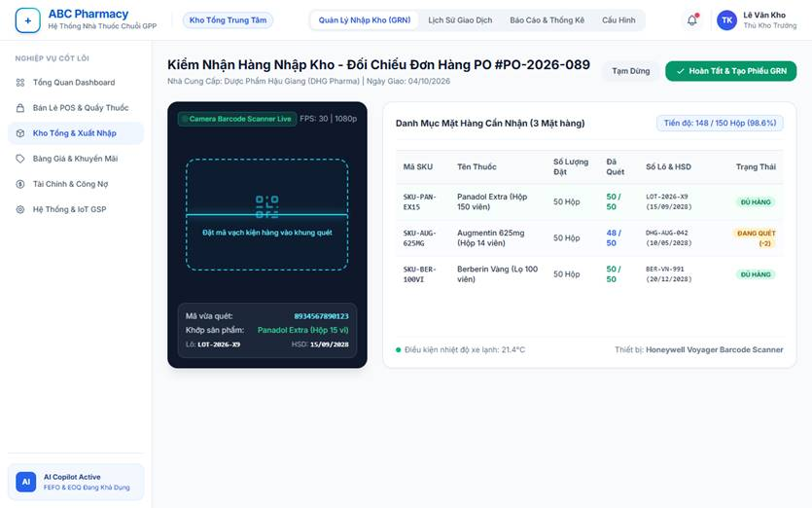
• Function Trigger:
• Navigation Path: Warehouse Mobile App > Inbound Management > Select Approved PO > Click 'Scan Barcode'
• Trigger Event / Frequency: Inventory Manager receives physical delivery from supplier at central warehouse dock.
• Function Description:
• Actors / Roles: Inventory Manager (Warehouse Staff)
• Purpose: Accelerates inbound goods inspection, eliminates manual transcription errors for lot numbers and expiry dates, and validates shipment contents against approved PO line items.
• Interface Type: Mobile Handheld Camera / Bluetooth Barcode Scanner Screen
• Screen Layout: Top camera viewfinder targeting 1D/2D barcodes; Bottom card displaying PO reference, scanned count vs ordered count, detected batch number, and verification status.
• Function Details:
• Data:
- Read-only / Output: PO Code, Supplier Name, SKU Code, Medicine Name, Expected Quantity, Current Scanned Count, Progress Bar, Batch Match Indicator (Green: Matched, Amber: Quantity Discrepancy, Red: Foreign SKU).
- Editable / Input: Barcode Scan Stream (Camera / Hardware Barcode Reader), Quantity per Master Carton, Batch Number (batchNo), Expiry Date (expDate), Manufacturing Date, Physical Package Condition Flag (Intact / Damaged).
• Validation:
- Scanned barcode must match an existing SKU within the selected Purchase Order.
- Expiration date (expDate) must satisfy the minimum required shelf life of at least 12 months from receipt date.
- Total scanned units cannot exceed 105% of PO authorized quantity without manager override.
• Business Rule:
- BR-18: Inbound shipments require verified barcode count verification before the Goods Receipt Note (GRN) can be submitted for Admin approval.
• Functionality:
- In Normal Cases: Warehouse staff scans master cartons. System beeps confirmation, increments verified quantity, automatically extracts embedded GS1 barcode attributes (lot and expiry), pre-populates GRN draft, and updates status to 'Inspected'.
- In Abnormal Cases: If an unscanned or foreign SKU barcode is detected, the device emits a warning sound and displays an inline red error: "Item not found in PO #PO-XXX. Please inspect invoice manually."

3.9.2 SKU & Barcode Management (UC-67)
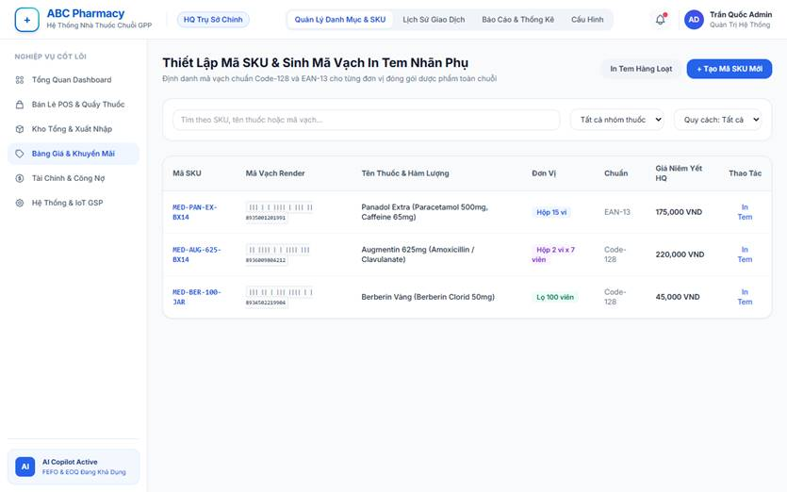
• Function Trigger:
• Navigation Path: Admin Dashboard > Master Data > Medicine Catalog > SKU & Barcode Settings (/admin/medicines/sku)
• Trigger Event / Frequency: Admin registers a new medicine packaging variant or generates printable barcode labels.
• Function Description:
• Actors / Roles: Admin
• Purpose: Establishes unique Stock Keeping Unit (SKU) identifiers across different packaging forms and generates standard Code-128 / EAN-13 barcodes for auxiliary labeling on imported pharmaceutical products.
• Interface Type: Desktop Web Management Table
• Screen Layout: Search and filter toolbar, SKU data table with barcode preview thumbnails, Batch Barcode Generator modal, Print Label dialog.
• Function Details:
• Data:
- Read-only / Output: Generated Barcode Image, SKU Code, Associated Medicine ID, Creation Timestamp, Barcode Standard (Code-128 / EAN-13).
- Editable / Input: Medicine Base Code, Packaging Specification (Pill / Blister / Box / Carton), Brand Prefix, Custom Manufacturer Barcode, Print Quantity, Label Size (35x22mm standard thermal).
• Validation:
- Generated SKU must be globally unique across all branches and central warehouse databases.
- Barcode numerical check digit must comply with standard GS1 checksum algorithms.
• Business Rule:
- Every distinct retail packaging specification for a given medicine must possess a unique SKU and Barcode to ensure accurate point-of-sale deduction.
• Functionality:
- In Normal Cases: Admin creates SKU for 'Augmentin 625mg - Box of 2 Blisters x 7 Tablets'. System assigns SKU MED-AUG625-BX14, renders Code-128 barcode, and allows one-click export to thermal label printer.
- In Abnormal Cases: If Admin inputs an existing barcode already mapped to another SKU, system rejects submission with MSG02: "Barcode duplicate detected. Already assigned to SKU #MED-XXX."

3.9.3 Medicine Categories & Active Ingredients (UC-68)
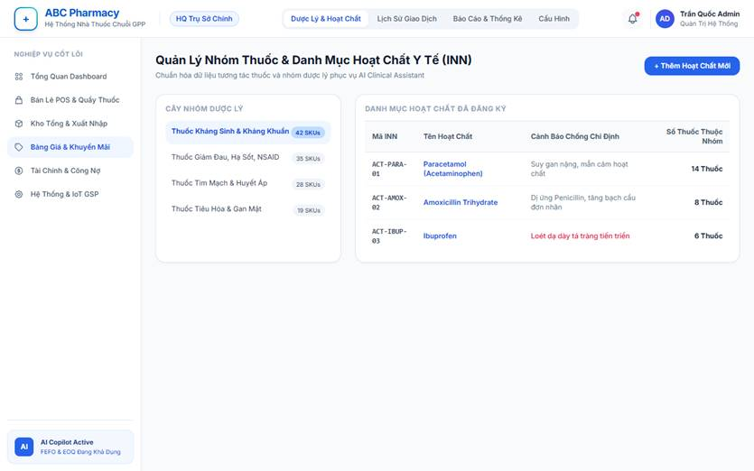
• Function Trigger:
• Navigation Path: Admin Dashboard > Master Data > Drug Classification (/admin/medicines/classification)
• Trigger Event / Frequency: Admin configures new therapeutic categories or maintains active pharmaceutical ingredients (API).
• Function Description:
• Actors / Roles: Admin
• Purpose: Organizes medicine catalog into hierarchical clinical categories and maintains standardized international non-proprietary active ingredients (INN) to feed the AI drug-drug interaction checker.
• Interface Type: Two-tab Desktop Web Screen (Tab 1: Therapeutic Categories, Tab 2: Active Ingredients)
• Screen Layout: Left pane displays Category Tree / Active Ingredient directory; Right pane displays detailed properties, associated medications, and clinical contraindication guidelines.
• Function Details:
• Data:
- Read-only / Output: Number of Associated Medicine SKUs, Interaction Severity Matrix, System Usage Count.
- Editable / Input: Category Name (EN/VI), Category Code, Parent Category, Active Ingredient Name (INN), Standard Dosage Unit, Chemical Formula, Black-box Warnings, High-risk Drug Flag.
• Validation:
- Active ingredient name must be non-empty and unique.
- Category tree cannot have circular parental dependencies.
• Business Rule:
- Whenever an active ingredient's contraindication profile is updated, system automatically refreshes the Qdrant medical vector index used by AI Clinical Assistant.
• Functionality:
- In Normal Cases: Admin adds active ingredient 'Ciprofloxacin', links contraindication with 'Antacids containing Magnesium/Aluminum'. System saves record and updates POS clinical warning engine immediately.
- In Abnormal Cases: If Admin attempts to delete a category that currently has active medicine SKUs assigned, system blocks action with warning: "Cannot remove category containing active products. Reassign SKUs first."

3.9.4 Multi-Level Unit of Measure Conversions (UC-69)
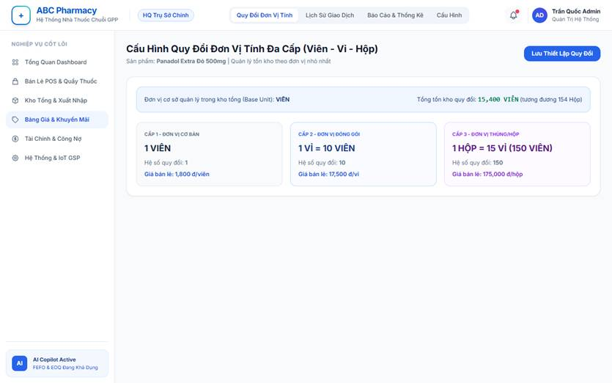
• Function Trigger:
• Navigation Path: Admin Dashboard > Master Data > Medicine Details > Unit Conversion Settings
• Trigger Event / Frequency: Admin configures wholesale and retail packaging tiers for a pharmaceutical product.
• Function Description:
• Actors / Roles: Admin
• Purpose: Defines conversion factors across multi-tier packaging units (e.g., 1 Box = 10 Blisters = 100 Tablets) so inventory balances remain mathematically sound whether receiving boxes or dispensing individual tablets.
• Interface Type: Tabular Configuration Screen
• Screen Layout: Base Unit definition card followed by hierarchical conversion rows with multiplication multipliers and retail pricing.
• Function Details:
• Data:
- Read-only / Output: Base Unit of Accounting (Smallest unit, e.g., Pill/Tablet), Current System Stock in Base Units.
- Editable / Input: Secondary Unit Name (e.g., Blister), Secondary Multiplier (e.g., 10), Tertiary Unit Name (e.g., Box), Tertiary Multiplier (e.g., 100), Unit Selling Price, Barcode per Unit.
• Validation:
- Conversion multipliers must be positive integers strictly greater than 1.
- Base unit cannot be altered once inventory transactions exist for the SKU.
• Business Rule:
- Central inventory always stores physical stock in the smallest base unit. Inbound and outbound movements in higher packaging units automatically multiply into base quantities.
• Functionality:
- In Normal Cases: Counter pharmacist sells 2 Blisters of Panadol (1 Blister = 10 Tablets). System deducts 20 base tablets from the nearest FEFO batch and decrements overall branch stock accordingly.
- In Abnormal Cases: If a user enters a non-integer or decimal multiplier (e.g., 0.5), system flags field in red: "Multiplier must be an integer greater than 1."

3.9.5 Branch Specific Price List Management (UC-70)
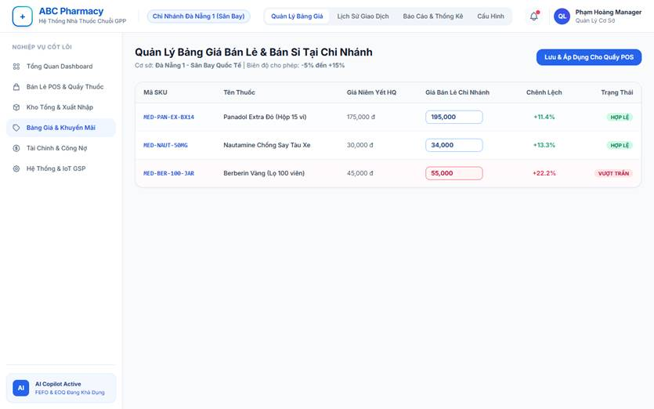
• Function Trigger:
• Navigation Path: Branch Manager Dashboard > Store Settings > Branch Price List (/branch/pricing)
• Trigger Event / Frequency: Branch Manager adjusts local retail or wholesale prices to reflect local operating overhead or competitive market conditions.
• Function Description:
• Actors / Roles: Branch Manager, Admin
• Purpose: Enables decentralized branch price customizations (e.g., tourist branches vs residential branches) while enforcing corporate profit margin floors and price ceilings established by HQ.
• Interface Type: Inline Editable Spreadsheet Grid
• Screen Layout: Medicine Search & Filter bar, Table displaying SKU, Medicine Name, HQ Global Price, Local Retail Price, Local Wholesale Price, Margin Variance %, Action Buttons.
• Function Details:
• Data:
- Read-only / Output: HQ Master Base Price, Allowed Price Range (Floor / Ceiling +/- 15%), Last Modified Date, Modified By.
- Editable / Input: Branch Retail Price, Branch Wholesale Tier Price, Effective Start Date, Price Adjustment Note.
• Validation:
- Branch price cannot fall below HQ Price Floor (Cost + 5%) or exceed HQ Price Ceiling (+15%).
• Business Rule:
- If a branch has not defined a custom price list (BranchPriceList = null), POS counter terminals automatically fall back to the corporate default (Medicine.basePrice).
• Functionality:
- In Normal Cases: Da Nang Airport Branch Manager sets retail price for travel sickness medication to 45,000 VND (HQ base 40,000 VND). System confirms price is within +15% ceiling, updates local POS cache, and logs change to audit log.
- In Abnormal Cases: Branch Manager inputs 55,000 VND (> 15% ceiling). System blocks save with error: "Specified price exceeds maximum authorized branch markup threshold of 15%."

3.9.6 Wholesale & Supplier Debt / Credit Limit Control (UC-71)
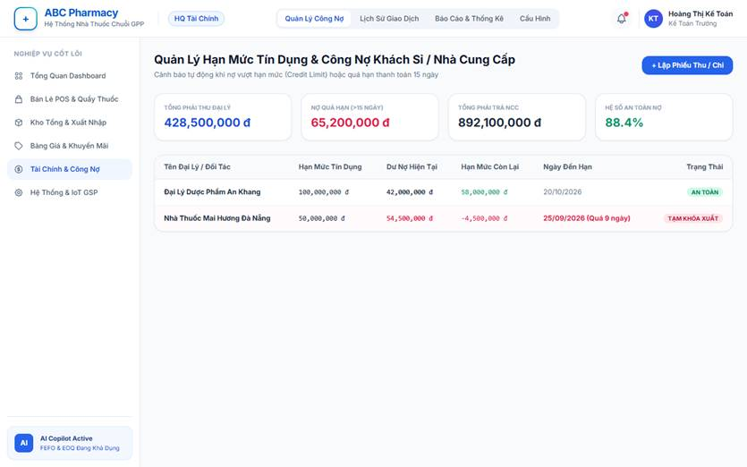
• Function Trigger:
• Navigation Path: Finance & Accounting > Debt & Credit Management (/admin/finance/credit-control)
• Trigger Event / Frequency: Pharmacist generates wholesale invoice or finance manager reconciles vendor accounts payable.
• Function Description:
• Actors / Roles: Admin, Branch Manager
• Purpose: Mitigates credit default risks by enforcing strict credit limits (creditLimit), tracking payment terms (paymentTermDays), and alerting on overdue accounts receivable from wholesale agency buyers.
• Interface Type: Analytical Debt Ledger & Account Review Screen
• Screen Layout: Summary KPI widgets (Total Receivables, Total Payables, Overdue Aging breakdown); Detailed partner debt table with color-coded risk flags.
• Function Details:
• Data:
- Read-only / Output: Current Debt Balance (currentDebt), Available Credit Buffer, Invoice Payment Due Date (dueDate), Debt Aging Category (Current, 1-30 Days Overdue, 31-60 Days, > 60 Days).
- Editable / Input: Partner Credit Limit (creditLimit), Approved Payment Terms in Days, Credit Freeze Override Checkbox, Payment Settlement Voucher amount.
• Validation:
- New wholesale orders on credit cannot exceed the agency's remaining available credit buffer (creditLimit - currentDebt).
• Business Rule:
- BR-22: System automatically suspends credit ordering privileges for wholesale accounts with invoices overdue past 15 days until outstanding balances are cleared.
• Functionality:
- In Normal Cases: Wholesale client with 100M VND credit limit and 40M VND existing debt places 30M VND order. Order is approved, new debt balance updates to 70M VND with 30-day payment countdown.
- In Abnormal Cases: Client attempts 70M VND order (exceeding limit by 10M VND). POS blocks invoice finalization: "Credit limit exceeded. Required down-payment: 10,000,000 VND to proceed."

3.9.7 Stocktake Session & Barcode Audit Count (UC-72)
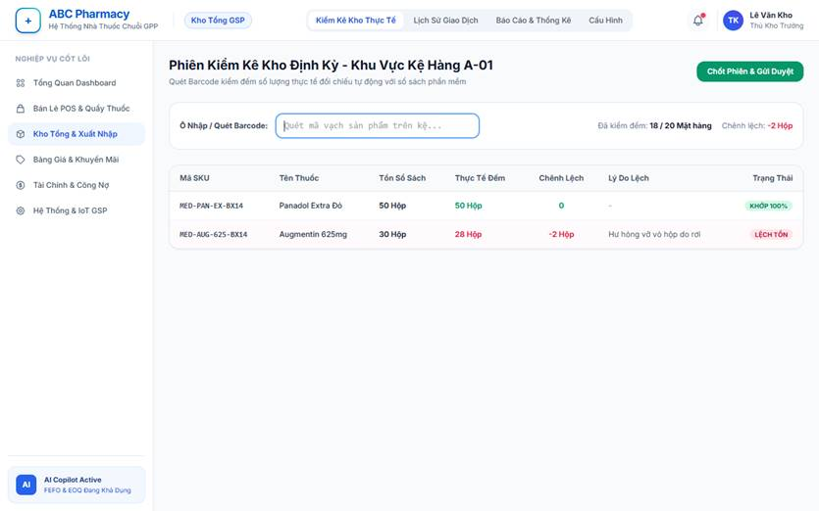
• Function Trigger:
• Navigation Path: Warehouse / Branch Portal > Inventory Control > Stocktake (/inventory/stocktake)
• Trigger Event / Frequency: Scheduled periodic rolling inventory audit (weekly or monthly per storage zone).
• Function Description:
• Actors / Roles: Inventory Manager, Branch Manager
• Purpose: Empowers warehouse and pharmacy storekeepers to perform blind or guided physical stock counts using barcode scanning, highlighting discrepancies against perpetual book inventory.
• Interface Type: Mobile / Tablet Stocktaking Application
• Screen Layout: Session Header (Zone/Rack selector, Auditor name); Barcode scanner input box; Real-time count list showing SKU, Expected, Counted, and Variance quantity.
• Function Details:
• Data:
- Read-only / Output: System Expected Stock Quantity, Count Variance (Units & Financial Value), Session Status (Draft, In Progress, Submitted, Reconciled).
• Data:
• Validation:
- Stocktake session must be frozen/locked before counting begins to prevent concurrent inventory updates.
• Business Rule:
- Storage zones undergoing physical stocktaking are temporarily locked from POS sales dispatch until the session is completed and unblocked.
• Functionality:
- In Normal Cases: Staff scans barcodes on Shelf B-02. System records 48 boxes counted against 50 expected (Variance: -2). Session calculates net shrinkage value and submits audit package to Branch Manager.
- In Abnormal Cases: If user scans a barcode registered to a different branch location, app notifies: "Barcode belongs to outside inventory scope. Item recorded as unassigned variance."

3.9.8 Stock Adjustment & Internal Disposal Slip (UC-73)
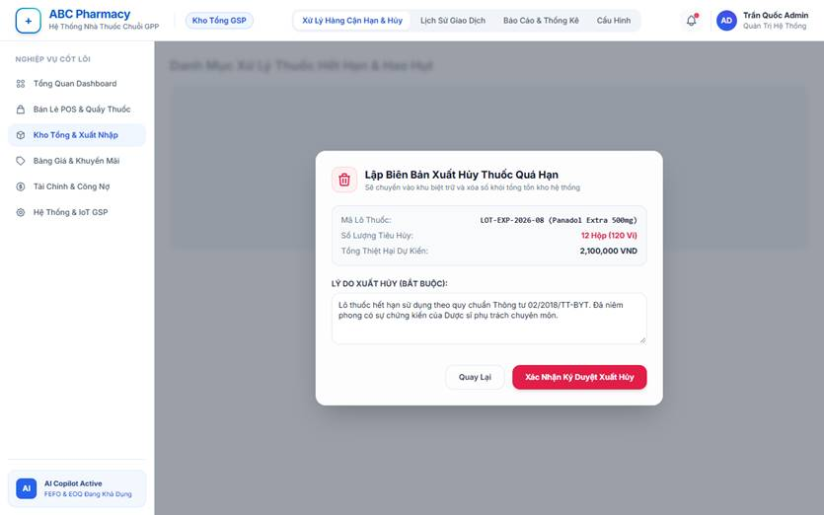
• Function Trigger:
• Navigation Path: Warehouse Dashboard > Stock Operations > Stock Adjustment & Disposal (/warehouse/adjustments)
• Trigger Event / Frequency: After stocktake reconciliation approval, or upon detecting broken, contaminated, or expired medicine batches.
• Function Description:
• Actors / Roles: Admin, Inventory Manager
• Purpose: Provides official GSP/GPP-compliant documentation to adjust inventory book quantities and record disposal of unmarketable pharmaceuticals.
• Interface Type: Two-pane Web Form with Electronic Signature Approval
• Screen Layout: Adjustment header (Reason, Reference Audit Session); Disposed Item Grid (SKU, Batch, ExpDate, Qty, Cost); Supporting photographic evidence upload box; Dual approval buttons.
• Function Details:
• Data:
- Read-only / Output: Adjustment Voucher Code, Discrepancy Value, Batch Expiration Date, Stock Before Adjustment, Stock After Adjustment.
- Editable / Input: Adjustment Type (Inventory Count Reconciliation / Damage Write-off / Expired Disposal), Batch Allocation, Reason Description, Uploaded Photographic Evidence, Digital Sign-off.
• Validation:
- Disposal slips for expired pharmaceuticals require attached photographic evidence showing batch numbers on outer packaging.
• Business Rule:
- BR-11: Expired medicine batches are immediately moved to Quarantine status upon identification and are only permanently deducted from inventory upon Admin signature on the Disposal Slip.
• Functionality:
- In Normal Cases: Inventory Manager logs 10 damaged ampoules, uploads photo of shattered packaging, and submits slip. Admin signs voucher digitally; system executes balance reduction and posts financial loss to inventory shrinkage ledger.
- In Abnormal Cases: If staff attempts to submit disposal slip without photographic attachment, system halts submission: "Mandatory photographic proof required for pharmaceutical write-offs."

3.9.9 IoT GSP Warehouse Environment Monitoring (UC-74)
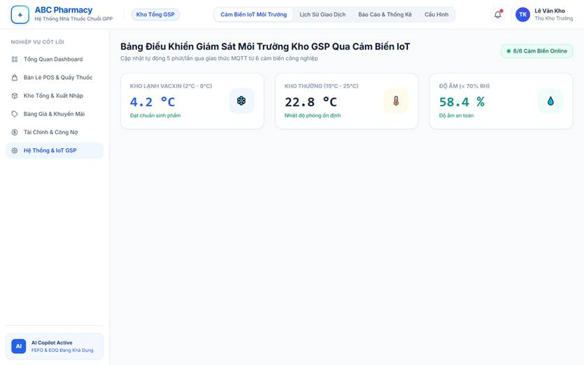
• Function Trigger:
• Navigation Path: Warehouse Dashboard > Environmental Telemetry (/warehouse/iot-monitor) or Automated Sensor Webhook Ingestion
• Trigger Event / Frequency: IoT hardware telemetry stream reporting temperature and humidity readings every 5 minutes.
• Function Description:
• Actors / Roles: Inventory Manager, Admin
• Purpose: Monitors storage conditions around the clock in compliance with Good Storage Practice (GSP) standards, triggering real-time alarm dispatches when cold-chain or warehouse room climates violate safety limits.
• Interface Type: Real-time IoT Dashboard & Incident Log
• Screen Layout: Gauge widgets for Cold Storage (2-8°C) and Ambient Warehouse (15-25°C, < 70% RH); 24-hour historical trend charts; Active Alert Feed.
• Function Details:
• Data:
- Read-only / Output: Current Temperature (°C), Current Relative Humidity (%RH), Sensor Hardware Battery Level, Network Status, GSP Compliance Score, Active Breach Duration.
- Editable / Input: Storage Zone Boundary Limits (Min/Max Temperature, Max Humidity), Escalation Notification Contacts, Sensor Calibration Offset, Incident Acknowledgment Note.
• Validation:
- Incoming sensor payloads must contain valid cryptographic device tokens.
• Business Rule:
- Continuous temperature breaches exceeding 15 consecutive minutes trigger automatic emergency SMS / WebSocket alerts to the Warehouse Manager and Admin.
• Functionality:
- In Normal Cases: Telemetry runs normally within GSP bounds (Ambient 22°C, 55% RH). System displays green indicator and appends hourly average data points to regulatory GSP compliance logs.
- In Abnormal Cases: Cold room refrigeration failure causes temperature to spike to 11.5°C (> 8°C limit). System triggers audio sirens on warehouse consoles, changes UI banner to flashing red, and dispatches high-priority alert notifications.

3.9.10 Cashier Shift Closing & Cash Drawer Balancing (UC-75)
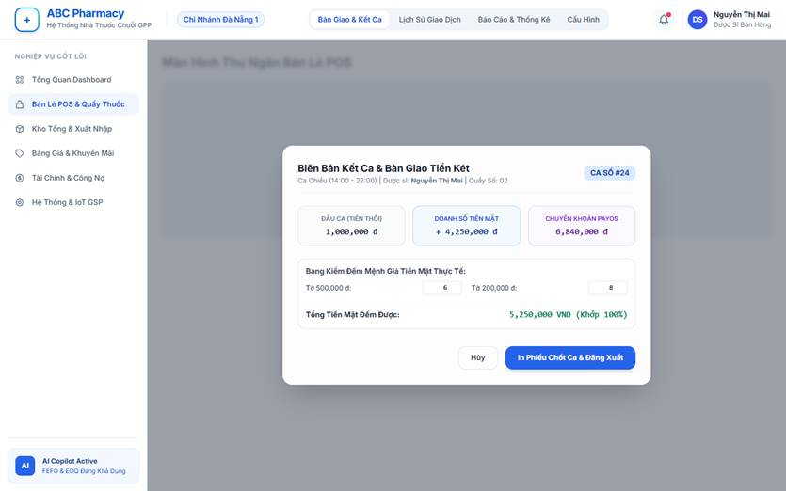
• Function Trigger:
• Navigation Path: POS Counter Terminal > Top Navigation Bar > Click 'Shift Closing & Cash Handover' (/pharmacist/shift-close)
• Trigger Event / Frequency: Counter Pharmacist concludes scheduled shift (Morning / Afternoon / Evening).
• Function Description:
• Actors / Roles: Pharmacist, Branch Manager
• Purpose: Ensures financial accountability at front counters by reconciling physical drawer cash against system recorded cash sales and PayOS digital transactions prior to shift handover.
• Interface Type: Modal Cash Balancing Window
• Screen Layout: Shift Summary widget (Float Amount, Net Sales, Returns); Currency Bill Counter Denomination Grid; Cash Variance Indicator; Handover Confirmation button.
• Function Details:
• Data:
- Read-only / Output: Opening Cash Float, Total Cash Sales, Total PayOS QR Payments, Total Customer Refunds, Expected Drawer Cash.
- Editable / Input: Physical Currency Denomination Count (Count of 500k, 200k, 100k, 50k, 20k, 10k, 5k bills), Actual Counted Cash, Discrepancy Note, Handover Recipient Staff ID.
• Validation:
- Pharmacist must input actual bill counts before the system reveals the final financial variance.
• Business Rule:
- Finalizing shift closing locks the current pharmacist's POS cashier terminal and mandates new credential login for the incoming shift cashier.
• Functionality:
- In Normal Cases: Pharmacist inputs bill counts matching the expected 4,500,000 VND. System verifies zero variance, prints physical Shift Closing Slip, and archives record for Branch Manager review.
- In Abnormal Cases: Counted cash is short by 50,000 VND. System prompts for mandatory explanation in 'Variance Reason' text field before permitting shift closure submission.

3.9.11 Branch Stock Requisition Quota Management (UC-76)
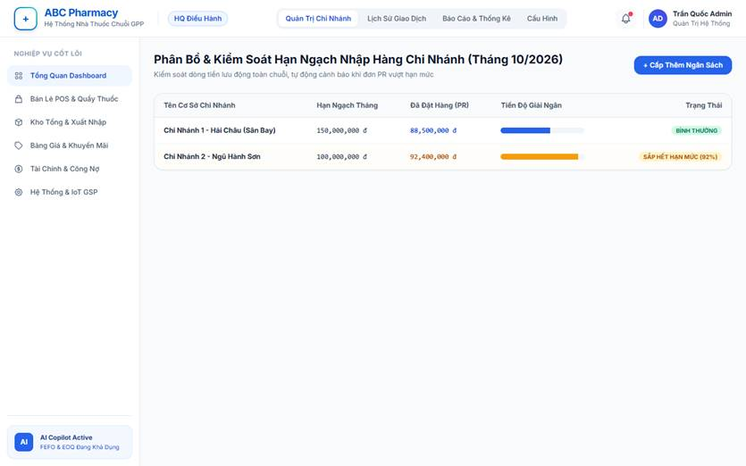
• Function Trigger:
• Navigation Path: Admin HQ Portal > Store Governance > Requisition Quota Allocation (/admin/branches/quotas)
• Trigger Event / Frequency: Monthly corporate working capital budget setting or ad-hoc quota adjustment.
• Function Description:
• Actors / Roles: Admin
• Purpose: Regulates inventory capital allocation across chain stores by imposing monthly procurement monetary quotas, preventing individual branch managers from placing excessive or speculative PR requests.
• Interface Type: Financial Control Table & Budget Progress Bar Screen
• Screen Layout: Branch list with allocated monthly quota, current PR expenditure, remaining spending allowance, and quota override controls.
• Function Details:
• Data:
- Read-only / Output: Total PR Value Submitted This Month, Approved PR Total, Remaining Branch Quota Allowance, Budget Utilization Percentage.
- Editable / Input: Monthly Branch Quota Cap (VND), Warning Threshold % (Default 80%), Quota Lock Toggle, Emergency Quota Add-on Amount.
• Validation:
- Quota cap must be a positive integer formatted in VND.
• Business Rule:
- BR-16: When a branch's pending PR pushes cumulative monthly spend beyond its allocated quota, the system flags the PR as 'Quota Exceeded' and requires explicit Admin C-suite financial sign-off.
• Functionality:
- In Normal Cases: Branch with 150M VND quota submits 30M VND PR (cumulative spend reaches 90M VND, 60% utilization). System approves submission without quota warnings.
- In Abnormal Cases: Branch with 10M VND remaining quota submits 25M VND PR. System blocks standard submission: "Purchase Requisition exceeds remaining monthly branch quota by 15,000,000 VND. Forwarded for Admin Special Review."

3.9.12 AI Smart Inter-Branch Stock Rebalancing (UC-77)
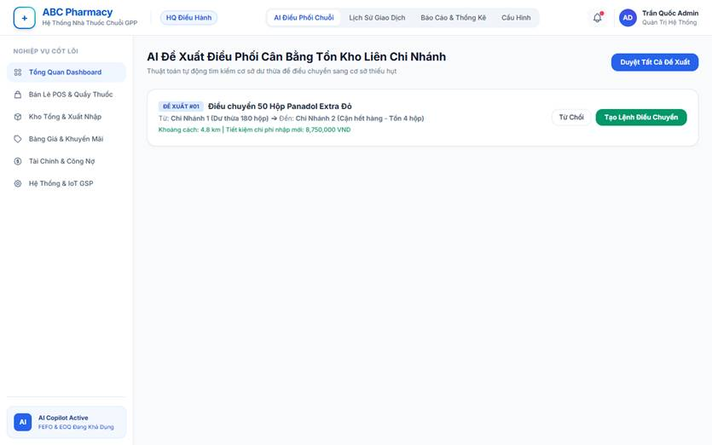
• Function Trigger:
• Navigation Path: Admin / Branch Dashboard > Inventory Analytics > AI Stock Rebalance (/admin/inventory/rebalance)
• Trigger Event / Frequency: Nightly AI cron calculation or manually triggered by Supply Chain Director.
• Function Description:
• Actors / Roles: Admin, Branch Manager
• Purpose: Optimizes working capital and mitigates expiration risks by using AI optimization models to identify slow-moving stock surpluses in one branch and recommending automated inter-branch transfers to stockout-risk branches nearby.
• Interface Type: Intelligent Recommendation Matrix Screen
• Screen Layout: Interactive map showing geographic transfer vectors; Recommended Transfer Pair table (Source Branch -> Destination Branch); Expected ROI and Waste Reduction metrics.
• Function Details:
• Data:
- Read-only / Output: Source Branch (Surplus), Target Branch (Deficit / High Velocity), Recommended Transfer Quantity, Distance Between Stores, Expiration Date of Transferred Batch, Estimated Waste Avoided.
- Editable / Input: Approve Recommendation checkbox, Modified Transfer Quantity, Generate Transfer Order button.
• Validation:
- Medicines selected for inter-branch transfer must have a valid shelf life of at least 6 months remaining.
• Business Rule:
- Transfer suggestions prioritize branch pairs within a 15km delivery radius to minimize internal logistics transit overhead.
• Functionality:
- In Normal Cases: AI detects Branch 1 has 180 boxes of Antihistamine with low 60-day turnover, while Branch 3 is 2 days from stockout. System suggests transferring 80 boxes. Manager clicks 'Approve', auto-creating an internal transfer requisition.
- In Abnormal Cases: If source branch manager rejects transfer citing impending local bulk reservation, system learns the context and recalculates optimal sourcing from the next best branch.

3.9.13 Controlled Substances Management (UC-78)
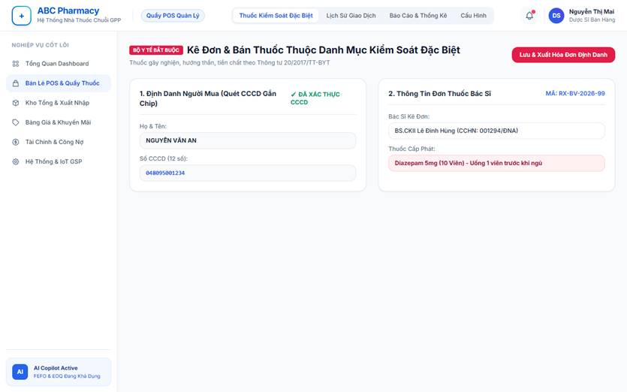
• Function Trigger:
• Navigation Path: POS Terminal / Warehouse Portal > Controlled Substances Module
• Trigger Event / Frequency: Receipt, transfer, or retail dispensing of narcotic, psychotropic, or precursor pharmaceuticals.
• Function Description:
• Actors / Roles: Admin, Pharmacist
• Purpose: Enforces statutory compliance with Ministry of Health regulations regarding controlled drugs, mandating strict prescription verification, customer national ID tracking, and specialized regulatory reporting.
• Interface Type: High-Security Dispensing Verification Screen
• Screen Layout: Prescription validation card; National ID (CCCD) scanner capture; Prescribing Doctor Credentials form; Dispensing quantity enforcement lock.
• Function Details:
• Data:
- Read-only / Output: Ministry of Health Controlled Drug Category, Special Registry Book Entry Number, Cumulative Daily Patient Purchase Count.
- Editable / Input: Patient Full Name, Citizen Identification Number (CCCD), Residential Address, Prescribing Doctor Name, Hospital/Clinic License Number, Uploaded Prescription Document Image.
• Validation:
- Citizen ID (CCCD) must be a valid 12-digit Vietnamese national identifier.
- Dispensed quantity cannot exceed the exact dosage prescribed on the medical doctor's original prescription.
• Business Rule:
- BR-23: Controlled substances are strictly prohibited from online checkout/e-commerce delivery and require in-person counter dispensing with pharmacist double-verification.
• Functionality:
- In Normal Cases: Pharmacist dispenses codeine-containing medication, scans customer CCCD, records doctor's hospital details, and confirms dispensing. System logs record into the immutable Controlled Substances Logbook.
- In Abnormal Cases: If user attempts to complete checkout without inputting customer CCCD number, checkout button remains disabled with warning: "National ID identification is legally mandatory for controlled pharmaceutical dispensing."

3.9.14 Digital Health Passport & Medication Reminder (UC-79)
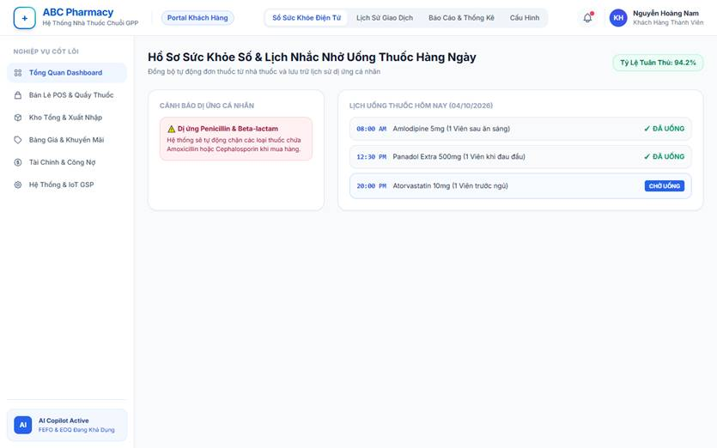
• Function Trigger:
• Navigation Path: Customer Mobile App > Health Profile > Medication Reminders (/app/health-passport)
• Trigger Event / Frequency: Customer creates a health habit schedule or system automatically syncs prescription dosage instructions following counter checkout.
• Function Description:
• Actors / Roles: Customer, Pharmacist
• Purpose: Enhances patient therapeutic adherence and safety by maintaining a digital health passport (chronic conditions, allergies) and delivering timely push reminders for scheduled doses.
• Interface Type: Flutter Mobile App Interface
• Screen Layout: Daily timeline cards (Morning, Afternoon, Evening, Bedtime); Health Passport Summary tag cloud (Allergies, Chronic Diseases); Adherence streak score.
• Function Details:
• Data:
- Read-only / Output: Pharmacist Dispensing Notes, Drug Dosage Instructions, Allergy Interaction Warnings, Monthly Adherence Compliance Rate.
- Editable / Input: Drug Allergy Tags (e.g., Penicillin, Aspirin), Underlying Chronic Conditions (Hypertension, Diabetes), Notification Time Alarms, 'Dose Taken' Confirmation checkbox.
• Validation:
- Reminder alarm times must not conflict for identical medication doses.
• Business Rule:
- When a pharmacist completes POS prescription checkout, prescription instructions automatically synchronize into the customer's linked mobile app profile.
• Functionality:
- In Normal Cases: At 08:00 AM, customer receives push alert: "Time to take 1 tablet of Amoxicillin 500mg after breakfast." Customer taps 'Taken', updating their personal compliance chart.
- In Abnormal Cases: Customer attempts to add an OTC medicine to online cart containing active ingredient matching their profile's documented allergy: app presents immediate red alert: "Warning: Product contains substance matching your recorded Penicillin allergy."

3.9.15 Database Backup & Disaster Recovery (UC-80)
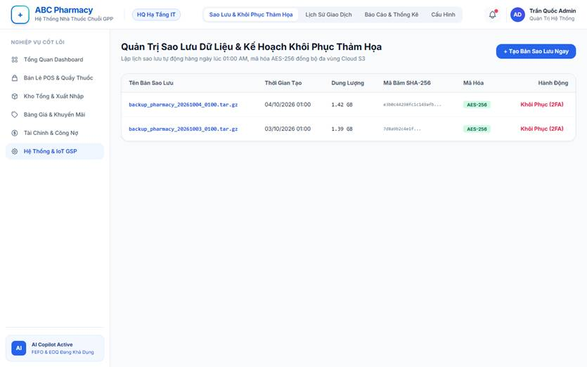
• Function Trigger:
• Navigation Path: Admin IT Console > System Infrastructure > Backup & Recovery (/admin/system/backup)
• Trigger Event / Frequency: Nightly scheduled automated cron job at 01:00 AM, or manual execution by IT Administrator prior to major deployment.
• Function Description:
• Actors / Roles: Admin (IT Administrator)
• Purpose: Safeguards transactional, inventory, and clinical data integrity through encrypted snapshot archives and provides verified disaster restoration workflows.
• Interface Type: Administrative Operations Console
• Screen Layout: Storage Capacity gauges; Archive Log Table (Timestamp, Size, Hash, Status); 'Create Manual Backup Now' button; 2FA-secured 'Restore Snapshot' modal.
• Function Details:
• Data:
- Read-only / Output: Archive File Name, Snapshot Size (MB), SHA-256 Checksum Hash, AES-256 Encryption Verification Status, Local & Offsite Cloud Mirror Sync Status.
• Data:
• Validation:
• Data:
• Business Rule:
- Backup archives are automatically encrypted using AES-256 before storage and mirrored to geographically separate secondary cloud storage to ensure zero data loss.
• Functionality:
- In Normal Cases: Admin clicks 'Create Manual Backup'. System executes database snapshot, compresses and encrypts output file, verifies SHA-256 integrity, mirrors to cloud storage, and logs success to audit trail.
- In Abnormal Cases: If storage disk free space is below 15%, backup operation halts immediately with critical alert: "Backup aborted due to insufficient disk storage buffer."

4.2 Quality Attributes

4.2.1 Usability
- Training Time:
- Counter Pharmacists / POS Cashiers (< 30 minutes).
- Warehouse Storekeepers / Inventory Managers (< 1 hour).
- Admin / Branch Managers (< 1 hour).
- Task Completion Speed:
- Standard counter sales operations (POS checkouts, prescription scanning, invoice generation) must take under 1 minute or fewer than 4 clicks.
- Branch stock requisition submission and inventory count entry must be completed within 3 minutes.
- Layout & Language:
- High contrast visual warning flags (Red Alert for batches < 3 months expiry, Yellow Alert for < 6 months, Red Warnings for severe drug-drug interactions).
- Integrated Vietnamese Medical NLP for symptom-based medicine search and localized UI terms.

4.2.2 Reliability
- Availability:
99.9% uptime (24/7 continuous operational availability for online store portal and counter POS terminals), permitting scheduled off-peak maintenance.
- Error Handling:
Standardized user-friendly error displays and background retry queue mechanisms (BullMQ/Redis) for payment webhooks and email dispatch to prevent transaction data loss.
- Data Integrity:
Strict ACID compliance for database transactions (Sales Orders, Counter Invoices, FEFO Batch allocations) to prevent concurrent double-deductions and overselling.
- Bug SLA:
- Critical bugs (POS checkout failure, inventory deduction calculation error) resolved within 4 hours.
- Significant bugs resolved within 48 hours.
- Minor UI bugs resolved in the next sprint cycle.

4.2.3 Performance
- Response Time:
- Redis Cache Hits: < 10ms response time.
- Standard API Transactions (Medicine Search, Cart Update, Order Status): < 2 seconds under normal conditions.
- Heavy Processing Tasks (AI Prescription OCR extraction, AI Demand Forecasting): < 5 seconds.
- Capacity:
Capable of supporting up to 500 concurrent active users including counter pharmacists, warehouse staff, branch managers, and online customers.
- Throughput:
Capable of processing up to 10,000 transactions and inventory batch movements per day across all store branches.
- Resource Efficiency:
Optimized database indexing and memory usage to ensure stable CPU (< 60%) and RAM utilization on standard server environments even during peak retail hours.

4.3 Security
- Authentication:
Secure JWT-based authentication system with multi-role access support (Admin, Branch Manager, Inventory Manager, Pharmacist, Customer) enforcing strict Role-Based Access Control (RBAC).
- Data Protection:
Passwords must be hashed using strong encryption (bcrypt/Argon2), and TLS 1.3 / SSL protocols must be enforced to secure sensitive data transmissions (patient prescriptions, payment callbacks, profile info).
- Access Control:
Enforce strict API endpoint permissions preventing unauthorized cross-branch data access or administrative action execution.

4.4 Maintainability
- Code Modularity:
The system follows a modular software architecture with clear separation of concerns (Auth module, POS module, Inventory FEFO module, AI OCR service module), simplifying future feature extensions.
- Testing:
Critical business functions such as FEFO batch allocation, POS order checkout, and GRN stock receiving include automated unit and integration tests to ensure system stability.
- Documentation:
Maintain comprehensive technical documentation, including OpenAPI/Swagger specs, background worker integration manuals, and user operational guides for each role.

5. Requirement Appendix

5.1 Business Rules
ID | Rule Definition
BR-01 | User registration requires email verification via a 6-digit OTP code before activating a customer account.
BR-02 | Newly registered staff accounts (Pharmacists, Inventory Managers, Branch Managers) must be approved by HQ Admin or Branch Manager prior to initial login.
BR-03 | User passwords must satisfy security complexity requirements (minimum 8 characters, containing uppercase, lowercase, numeric, and special characters).
BR-04 | Prescription-only medications (Rx) cannot be dispensed or checked out without an uploaded doctor prescription or validated prescription record.
BR-05 | AI OCR prescription scanning must extract active ingredients, dosage specifications, and auto-select available branch items following FEFO logic.
BR-06 | Pharmacists must review and manually confirm AI-suggested prescription cart items before completing counter retail checkout.
BR-07 | High-severity drug interaction warnings (Red Level) flagged by the system must be acknowledged and resolved by the pharmacist before invoice finalization.
BR-08 | All medicine dispatches (online orders, counter sales, inter-branch transfers) must strictly follow First-Expired, First-Out (FEFO) batch allocation.
BR-09 | Medicine batches with expiration dates under 3 months (Red Alert) must be automatically blocked from POS checkout and placed in quarantine status.
BR-10 | Medicine batches with expiration dates between 3 and 6 months (Yellow Alert) must trigger system alerts and prioritize promotional discount campaigns.
BR-11 | Expired pharmaceutical products cannot be sold under any circumstances and must be documented via an official Expired Drug Disposal Record.
BR-12 | Sales invoices (counter and online) must explicitly log the batch number (batchNo) and expiry date (expDate) for every line item.
BR-13 | Product returns and exchanges are permitted within 7 days of purchase only upon verifying purchase origin via valid invoice code or customer phone number.
BR-14 | Dispensed prescription medicines (Rx) that have left the store counter cannot be restocked or returned due to pharmaceutical safety regulations.
BR-15 | Customer loyalty reward points are accumulated upon paid transactions and can be redeemed for discount vouchers based on rates configured by Admin.
BR-16 | Branch Managers may create stock Purchase Requisitions (PR) only when local inventory drops below pre-configured branch safety thresholds.
BR-17 | Purchase Orders (PO) submitted to suppliers must receive explicit approval from HQ Admin before official transmission.
BR-18 | Goods Receipt Notes (GRN) generated upon receiving supplier shipments must pass physical or AI camera inspection verification before central stock activation.
BR-19 | Inter-branch inventory transfers require confirmation from both sending and receiving branch managers to update destination stock balances.
BR-20 | AI-generated Economic Order Quantity (EOQ) replenishment recommendations must be reviewed by the Inventory Manager prior to converting into Purchase Orders.
BR-21 | All critical business actions (inventory manual overrides, retail price adjustments, role assignments, PO approvals) must be recorded in immutable system audit logs.

5.2 Common Requirements
# | Requirement | Description
1 | Users must be authenticated (verified login) with valid JWT tokens before placing online orders, accessing staff dashboards, or viewing personal profiles. | Ensures system access control, protects sensitive medical profile data, and prevents unauthorized transaction requests.
2 | System data entities (Medicines, Suppliers, Invoices, Purchase Orders, FEFO Batches) must use soft-delete mechanisms (deletedAt) instead of permanent database purging. | Preserves historical financial auditability, inventory movement logs, and GSP/GDP regulatory compliance reporting integrity.
3 | All list views (Medicine Catalog, Order History, Inventory Batch Logs, System Audit Records) must implement server-side pagination (default 10, 20, or 50 items per page). | Reduces database query execution overhead, optimizes network payload transfers, and maintains fast UI rendering response times (< 500ms).
4 | All monetary values (Medicine Prices, Invoice Totals, Supplier Debt, Cash Flow Reports) must be rounded to whole integers and formatted in Vietnamese Dong (VND) with thousands separators (e.g. 150,000 VND). | Guarantees financial consistency and readability across retail POS counter screens, customer receipts, and accounting reports.
5 | All system timestamps (Transaction Creation, Batch Expiry Dates, GRN Receiving Time, Audit Logs) must be stored in UTC format in the database and displayed in GMT+7 (Indochina Time). | Prevents batch expiration calculation discrepancies and ensures accurate time tracking across multi-branch locations.
6 | Scanned doctor prescription images, patient medical notes, and AI OCR consultation logs must be encrypted in transit (HTTPS/TLS 1.3) and at rest (AES-256). | Protects sensitive patient health information (PHI) and complies with medical data security regulations.
7 | Customer-facing web portals and staff POS counter terminals must adapt responsively to Desktop, Tablet, and Mobile screen resolutions. | Ensures seamless operational experience for pharmacists on counter touchscreens and customers shopping on mobile devices.
8 | Every inventory modification, stock write-off, price adjustment, and PO approval must record the User ID, Timestamp, IP Address, and Action Code into an immutable Audit Log. | Provides full operational accountability, fraud prevention, and complete audit traceability for pharmacy retail compliance.
9 | External API integrations (Payment Webhooks, Google Gemini AI OCR, Speech-to-Text) must enforce timeout thresholds (max 5s) and graceful error fallback messages. | Prevents external service outages from locking counter POS checkout processes or bringing down the core web application.
10 | Central warehouse stock updates and FEFO batch changes must immediately invalidate Redis cache keys and broadcast WebSocket events to connected branch clients. | Guarantees real-time inventory consistency and prevents double-selling out-of-stock medicine items across online and offline channels.

5.3 Application Messages List
# | Message code | Message Type | Context | Content
1 | MSG01 | In line | There is no medicine search result found | No matching medicines found for "{keyword}". Please try another search term.
2 | MSG02 | In red, under the text box | Input-required fields are left empty | The {field_name} field is required.
3 | MSG03 | In red, under the text box | Input value length exceeds maximum length | Exceed maximum length of {max_length} characters.
4 | MSG04 | In red, under the text box | Invalid phone number format entered | Please enter a valid 10-digit phone number.
5 | MSG05 | In line | Username or password is incorrect upon signing in | Incorrect email or password. Please check your credentials and try again.
6 | MSG06 | Toast message | Account registration completed successfully | Registration successful! A verification email has been sent to {email}.
7 | MSG07 | Toast message | Email verification OTP confirmed | Email verified successfully. You can now log in to your account.
8 | MSG08 | Toast message | Password reset link dispatched via email | A password reset link has been sent to {email}.
9 | MSG09 | Toast message | Item added to online shopping cart | {medicine_name} has been added to your shopping cart.
10 | MSG10 | Toast message | Shopping cart item quantity updated | Updated item quantity in cart successfully.
11 | MSG11 | Modal popup | Prescription upload required for Rx medicine | This medicine requires a valid prescription. Please upload your doctor's prescription image to proceed.
12 | MSG12 | Toast message | AI OCR prescription scan completed | Prescription analyzed successfully! Extracted {item_count} items and auto-selected matching FEFO store batches.
13 | MSG13 | Alert dialog | High-severity drug interaction detected | Warning: Severe interaction detected between {medicine_A} and {medicine_B}. Please consult a pharmacist before proceeding.
14 | MSG14 | Toast message | Online customer order placed successfully | Order #{order_code} placed successfully! Thank you for shopping with us.
15 | MSG15 | Toast message | Order cancellation request submitted | Order cancellation request submitted for order #{order_code}.
16 | MSG16 | Toast message | Counter retail POS sale completed and receipt printed | Transaction completed successfully. Invoice #{invoice_code} generated.
17 | MSG17 | Toast message | Out-of-stock medicine substituted at POS | Replaced out-of-stock item with substitute medicine {medicine_name}.
18 | MSG18 | Modal popup | Expired or near-expiry batch blocked from POS | Batch #{batch_no} is expired (or < 3 months expiry) and blocked from sale. Item moved to quarantine.
19 | MSG19 | Toast message | Requisition PR request submitted to HQ | Purchase Requisition #{pr_code} submitted to HQ successfully.
20 | MSG20 | Toast message | Purchase Order (PO) approved by HQ Admin | Purchase Order #{po_code} approved successfully.
21 | MSG21 | Toast message | Goods Receipt Note (GRN) created and stock updated | GRN #{grn_code} created successfully. Central stock updated with new FEFO batches.
22 | MSG22 | Toast message | Inventory physical audit count report submitted | Inventory count report submitted for verification.
23 | MSG23 | Toast message | Staff registration account approved by Admin | Staff account for {staff_name} approved successfully.
24 | MSG24 | Toast message | Master medicine product catalog updated | Medicine product catalog updated successfully.
25 | MSG25 | Alert dialog | Network connection lost or server error | System connection error. Please check your internet connection and try again.

