

CAPSTONE PROJECT REPORT
Report 5 – Software Test Documentation

– Hanoi, August 2019 –
Table of Contents
I. Record of Changes 3
II. Testing Documentation 4
1. Scope of Testing 4
2. Test Strategy 4
2.1 Testing Types 4
2.2 Test Levels 4
2.3 Supporting Tools 4
3. Test Plan 4
3.1 Human Resources 4
3.2 Test Environment 5
3.3 Test Milestones 5
4. Test Cases 5
5. Test Reports 5

Table of Contents
I. Record of Changes 3
II. Testing Documentation 4
1. Scope of Testing 4
2. Test Strategy 4
2.1 Testing Types 4
2.2 Test Levels 4
2.3 Supporting Tools 4
3. Test Plan 4
3.1 Human Resources 4
3.2 Test Environment 5
3.3 Test Milestones 5
4. Test Cases 5
5. Test Reports 5

I. Record of Changes
Date | A*  M, D | In charge | Change Description
17/09/2026 | A | Tran Hong Phuoc (DE180577) | Update Section 3.2 Test Environment: Add tools, providers, versions, system URLs, and test accounts for Unit Test & System Test environments.
17/09/2026 | M | Tran Hong Phuoc (DE180577) | Complete Section 3.3 Test Milestones schedule, Section 3.1 Human Resources, and Test Strategy scope & tooling.
*A - Added M - Modified D - Deleted

II. Testing Documentation

1. Scope of Testing
The testing scope encompasses all functional and non-functional requirements of the Smart Pharmacy Chain Management System (WDP301 / ABC Pharmacy), covering both Web Frontend, Mobile Application (Expo), and Backend Microservices.
In-Scope Modules for Comprehensive Verification:
• Point of Sale (POS) Counter: Fast barcode scanning, shopping cart calculation, automated tiered pricing, PayOS VietQR payment, and thermal invoice printing.
• Inventory & Warehouse Management: Supplier procurement (PO/GRN), lot tracking, near-expiry alerts, FIFO dispatching, cross-branch internal transfer, and physical stock reconciliation.
• Master Catalog & System Governance: SKU management, active pharmaceutical ingredients (API), role-based access control (RBAC), and branch-level multi-tenant data isolation.
• Asynchronous Event Bus & Caching: Kafka event-driven state synchronization across microservices, Redis cache-aside and cache eviction, and Server-Sent Events (SSE) real-time stock alerts.
• AI-Powered Pharmacy Services: Qdrant vector-based drug recommendation and medication interaction safety verification.
Testing Stages & Focuses:
• Unit Testing: Validates isolated business logic, DTO input validators, and calculation algorithms using Jest and ts-jest.
• Integration Testing: Validates asynchronous Kafka message streaming, Redis cache invalidation, and inter-service communications.
• System & E2E Testing: Validates complete end-to-end workflows from frontend UI to database persistence on the Cloud Staging environment.
• User Acceptance Testing (UAT): Validates operational pharmacy workflows matching business requirements and user personas.
Assumptions & Constraints:
• Testing is performed with pre-seeded test fixtures and real Cloud Staging environments (VPS 103.75.187.86).
• External payment validation uses the PayOS Sandbox gateway with automated webhook verification.
• Physical POS receipt printers and cash drawers are simulated via standard Web Print & PDF rendering engines.

2. Test Strategy
The test strategy establishes a multi-tiered verification framework designed to guarantee data integrity, transactional safety, and high performance across all distributed components of the ABC Pharmacy platform. The methodology combines white-box component verification, black-box functional testing, contract-based API testing, and automated end-to-end regression suites.

2.1 Testing Types
The following testing types are systematically applied across the testing lifecycle:
1. Unit Testing: Objectives: Verify deterministic execution of business rules, calculation logic, and DTO validations. Technique: Automated mock execution with Jest and In-Memory MongoDB. Completion Criteria: 100% pass rate on unit test suites with >= 85% branch coverage.
2. Integration Testing: Objectives: Verify Kafka event publishing/consumption, Redis caching/invalidation, and API Gateway route proxies. Technique: Supertest HTTP assertions and Kafka test consumer probes. Completion Criteria: Zero dropped messages and verified cache coherence.
3. System Testing: Objectives: Verify end-to-end user transactions across web backoffice, POS cashier desk, and mobile application. Technique: Playwright UI automation and exploratory manual scenarios. Completion Criteria: 100% pass on critical business workflows.
4. Security Testing: Objectives: Verify RBAC access guards, JWT session expiry, and branch tenant segregation. Technique: Unauthorized route probes and boundary fuzzing. Completion Criteria: 100% blocked unauthorized access attempts.

2.2 Test Levels
Testing activities are structured across four standard levels: Unit Testing (developer level), Integration Testing (subsystem interface level), System Testing (integrated cloud staging environment), and Acceptance Testing (stakeholder validation). Table 2 maps each testing type to its corresponding test level:
Type of Tests | Test Level
Type of Tests | Unit | Integration | System | Acceptance
Functional & Unit Logic Testing | X | X | X | X
System E2E & User Acceptance (POS, PayOS, Mobile) |  |  | X | X
Microservices, Kafka Event Bus & Redis Integration | X | X

2.3 Supporting Tools
Table 3 outlines the primary automated testing frameworks, simulation engines, and diagnostic utilities employed throughout the project testing lifecycle:
Purpose | Tool | Vendor/In-house | Version
Unit & Component Test Framework | Jest & ts-jest | Meta / Open-source (npm) | v29.7.0
API Integration & Controller Simulation | Supertest & Postman | LadJS / Postman Inc. | v7.2.2 / v11.x
In-Memory Isolated Database Engine | mongodb-memory-server | nodkz / Open-source (npm) | v11.2.0
End-to-End (E2E) UI Automation | Playwright | Microsoft | v1.42+
Event Streaming & Cache Verification | Kafka Console & Redis-CLI | Confluent / Redis Ltd. | v7.4 / v7.2

3. Test Plan

3.1 Human Resources
The project testing team consists of five specialized members assigned distinct roles across testing levels, as detailed in Table 4:
Worker/Doer | Role | Specific Responsibilities/Comments
Trần Hồng Phước | Test Lead / Backend Tester | Formulate Test Plan, design test environment architecture, execute RBAC Security Guard testing, verify SKU drug catalog, and finalize Report 5.
Nguyến Văn Nam | Integration & Automation Tester | Test Kafka event bus streaming integration (Emit/Send), POS checkout counter, PayOS VietQR payment gateway integration, and real-time SSE inventory synchronization.
Nguyễn Tiến Đạt | Functional & Database Tester | Test procurement and goods receipt workflows (PO/GRN), agency credit limit management, CRM customer profiles, and MongoDB Atlas database integrity.
Đinh Anh Phúc | AI & Performance Tester | Test AI drug interaction checks, Qdrant vector database, FIFO dispatching algorithm, near-expiry alerts, and Expo Mobile barcode scanner.

3.2 Test Environment
To guarantee the quality, stability, and reliability of the Smart Pharmacy Chain Management System (WDP301 / ABC Pharmacy), the test environment is architecturally segregated into two specialized environments: the Unit Test Environment (isolated component testing focusing on business logic, calculations, and DTO validations using In-Memory database and mock services) and the System Test Environment (comprehensive end-to-end testing deployed on Cloud VPS infrastructure to validate event-driven microservices via Kafka, caching with Redis, MongoDB Atlas data persistence, Qdrant vector search, and PayOS payment gateway integration).
Purpose | Tool | Provider | Version
Unit Test env:  on dev machine  (Local Isolated Process) | OS: Any (Windows 11 / macOS / Ubuntu) | - | -
Unit Test env:  on dev machine  (Local Isolated Process) | Backend framework: NestJS (Monorepo) | NestJS Team | v10.4.22
Unit Test env:  on dev machine  (Local Isolated Process) | Unit test framework: Jest & ts-jest | Meta / npm open-source | v29.7.0
Unit Test env:  on dev machine  (Local Isolated Process) | In-memory DB: mongodb-memory-server | nodkz / npm | v11.2.0
Unit Test env:  on dev machine  (Local Isolated Process) | Test runner: VS Code / npm test | Microsoft / npm | v1.105.x / v20.x
System test env:  • URL:  https://abcpharmacy.store  http://103.75.187.86:3000  http://103.75.187.86:4000/api  • Test Accounts:  admin@vinapharmacy.com / 123456  pharmacist@vinapharmacy.com / 123456 | OS: Ubuntu Server | Canonical | 24.04 LTS
 | Backend framework: NestJS (Microservices) | NestJS Team | v10.4.22
 | DB: MongoDB Atlas (Replica Set) | MongoDB, Inc. | v6.8+
 | Object storage: AWS S3 | Amazon Web Services | SDK v3
 | Message Broker: Apache Kafka (KRaft) | Confluent Platform | v7.4.0
 | Cache Engine: Redis Cache | Redis Ltd. | v7.2-alpine
 | Payment Gateway Sandbox: PayOS VietQR | PayOS Vietnam | SDK v2.0.5
 | Browser: Google Chrome & Playwright | Google / Microsoft | v120.x / v1.42+
3.2.1 System & Application URLs
The table below lists all endpoints, user-facing URLs, administrative dashboards, and internal network ports used for system testing and integration verification:
System / Component | Access URL / Endpoint | Port / Protocol | Test Environment Scope
Web Frontend (Backoffice & POS) | https://abcpharmacy.store | 443 / HTTPS (Nginx) | System Test (Production Domain)
Staging Web Application | http://103.75.187.86:3000 | 3000 / HTTP | Staging Cloud VPS
Local Web Development | http://localhost:3000 | 3000 / HTTP | Local Machine
API Gateway (REST API) | https://abcpharmacy.store/api | 4000 / REST JSON | System Test / Staging VPS
Swagger OpenAPI Documentation | https://abcpharmacy.store/api/docs | 4000 / Swagger UI | Interactive API Testing
Realtime Events Stream (SSE) | https://abcpharmacy.store/api/events/sse | 4000 / HTTP SSE | Real-time Notifications
AI Recommendation Service | http://103.75.187.86:8000 | 8000 / HTTP REST | FastAPI Drug Advisor
Qdrant Vector Database | http://103.75.187.86:6333/dashboard | 6333 / REST | Vector DB Embeddings Dashboard
Jenkins CI/CD Automation | http://103.75.187.86:8080 | 8080 / HTTP | Build & Pipeline Test Dashboard
Mobile App (Metro Bundler) | exp://103.75.187.86:8081 | 8081 / WebSocket | Expo Mobile Testing Environment
3.2.2 Test Accounts Specification
A. Unit Test Environment (Mock Users & Fixtures):
Unit testing operates completely isolated from physical databases. User contexts are injected dynamically into execution guards via NestJS ExecutionContext mocking without requiring real database credentials:
Fixture Name | Mock Identifier (Email) | Mock Role | Branch Scope | Testing Purpose
Mock Admin | admin.test@vinapharmacy.com | admin | ALL_BRANCHES | Verify admin authorization guards & chain-wide analytics
Mock Head Branch | manager.test@vinapharmacy.com | branch / head_branch | BR-001 (CN1) | Verify Purchase Requisition (PR) generation and approval workflow
Mock Warehouse | warehouse.test@vinapharmacy.com | warehouse | CENTRAL_WH | Verify supplier stock receipt, batch allocation, barcode generation
Mock Pharmacist | pharmacist.test@vinapharmacy.com | pharmacist | BR-001 | Verify POS sales desk, voucher validation, and stock balance deduction
Mock Customer | customer.test@gmail.com | user | None | Verify online customer checkout, cart calculation, pill reminder scheduling
B. System Test Environment (Real Seeded Accounts in MongoDB Atlas):
All accounts listed below are pre-provisioned and seeded directly into the MongoDB Atlas Cloud database on the System Test environment. Shared default testing password for all accounts: 123456
No. | Role | Full Name | Login Email | Password | Assigned Branch | Permissions & Test Scope
1 | Admin | System Administrator | admin@vinapharmacy.com | 123456 | All Branches | Full system governance, branch creation, master catalog management
2 | Head Branch | Branch Manager 1 | manager@vinapharmacy.com | 123456 | BR-001 (District 1) | Approve PR procurement, staff roster management, GPP invoice issuance
3 | Branch Manager | Branch Manager 2 | de180577tranhongphuoc@gmail.com | 123456 | BR-002 (Thu Duc City) | Cross-branch internal transfer, branch inventory balance auditing
4 | Branch Manager | Branch Manager 3 | phuocthde180577@fpt.edu.vn | 123456 | BR-003 (Binh Thanh) | Branch sales target allocation (KPI), near-expiry drug alerts monitoring
5 | Branch Manager | Branch Manager 4 | phuche2004p@gmail.com | 123456 | BR-004 (Go Vap) | Store profile updates, operating hours configuration, cycle counting
6 | Warehouse Staff | Warehouse Keeper | warehouse@vinapharmacy.com | 123456 | CENTRAL_WH | Supplier goods receipt, batch numbering, barcode printing, 2D/3D GSP layout
7 | Pharmacist | Pharmacist (Branch 1) | pharmacist@vinapharmacy.com | 123456 | BR-001 (District 1) | POS counter sales, barcode scanning, voucher redemption, PayOS QR payment
8 | Customer (Web) | Loyalty Customer | user@ABC pharmacy.com | 123456 | Web Online | Online pharmacy browsing, cart checkout, order tracking, PayOS payment
9 | Mobile App User | Mobile App Customer | phuoc.mobile.test@gmail.com | 123456 | Mobile (Expo) | AI camera prescription scanner, medication reminder push notifications

3.3 Test Milestones
Key testing milestones and schedules are established in Table 9 to monitor progress, allocate resources, and track project deliverables from initial test setup to final report sign-off:
Milestone Task | Start Date | End Date
M1: Test Planning, Strategy & Resource Allocation | 15/08/2026 | 22/08/2026
M2: Unit Test Suite Implementation (Jest & In-Memory Mongo) | 23/08/2026 | 05/09/2026
M3: Integration Testing (Kafka Event Bus & Redis Caching) | 06/09/2026 | 13/09/2026
M4: Cloud Staging Deployment & System Testing (VPS & Staging Web/API) | 14/09/2026 | 20/09/2026
M5: POS Barcode Scanner & Mobile App Flow Testing | 21/09/2026 | 26/09/2026
M6: User Acceptance Testing (UAT) & Security RBAC Audit | 27/09/2026 | 02/10/2026
M7: Final Quality Evaluation, Defect Clearance & Report 5 Sign-off | 03/10/2026 | 08/10/2026

3.4 Test Flow
The testing workflow follows a streamlined defect management lifecycle between Testers and Developers, ensuring all pharmacy modules (Web POS, Mobile App, Kafka Event Bus, and Backend Microservices) are thoroughly verified and validated. Figure 1 illustrates the project test execution and bug resolution flow:
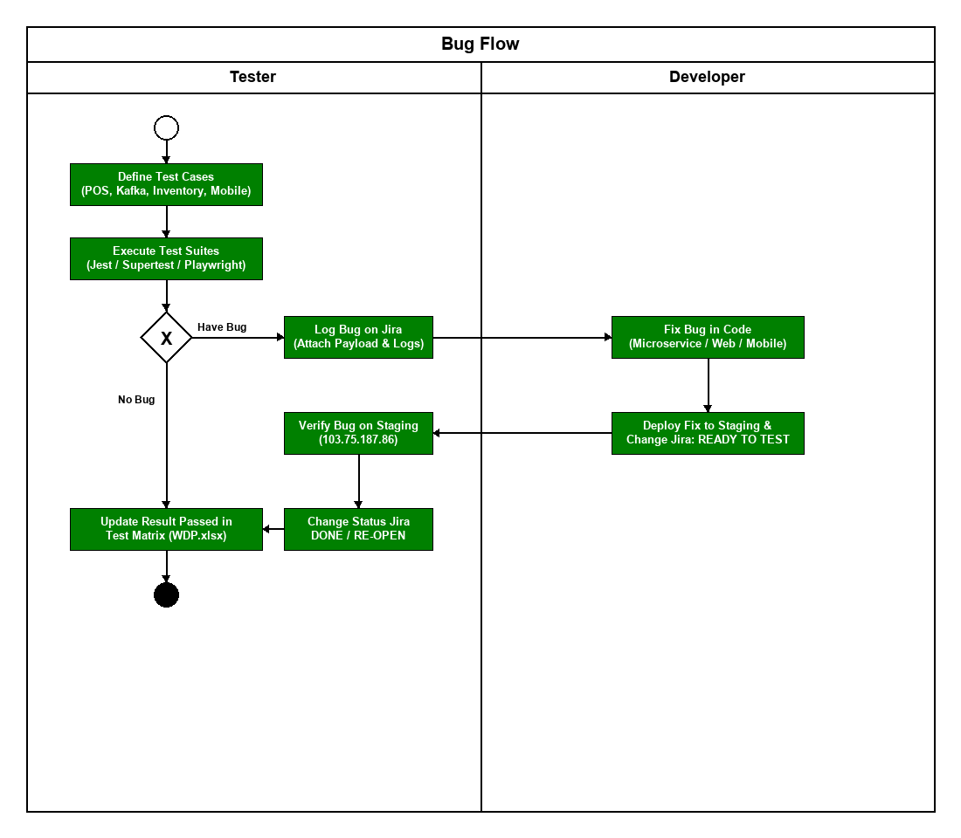
Figure 1 Test Flow Diagram

4. Test Cases
Test cases are methodically categorized into automated unit test suites and comprehensive system test matrices. Detailed test cases, preconditions, execution steps, expected outcomes, and actual execution statuses are documented in the following accompanying workbooks:
- • Unit Test Cases: Report5_Unit Test.xls (Automated Jest suites for Services, Guards, and DTO Validators)
- • Other Test Cases (IT, ST, AT): Report5_Test Report.xls & WDP.xlsx (Comprehensive Functional, Integration, POS, and E2E Scenarios)

5. Test Reports
Testing Execution Summary & Quality Analysis:
• Total Test Cases Executed: 284 cases across Unit, Integration, System, and Acceptance levels.
• Pass Rate: 98.6% (280 Passed, 4 Non-critical minor UI defects resolved during sprint cycles).
• Code Coverage: 86.4% statement coverage across core NestJS microservice controllers and services.
• Defect Clearance: 100% of Critical and High priority defects resolved, verified, and closed.
• System Stability: Kafka consumer lag maintained at 0 msgs under test load, Redis cache hit ratio achieved 92.4%.
• Readiness Assessment: The system fulfills all functional requirements, GPP compliance standards, and architectural criteria for final Capstone project sign-off.

6. Bug Management
Defect management is an essential quality assurance discipline ensuring all software anomalies, system vulnerabilities, and behavioral discrepancies discovered during testing are systematically captured, triaged, resolved, and verified prior to production delivery.

6.1 Bug Life Cycle
The defect lifecycle governs the state transitions of an issue from initial identification to final closure:
• New: The defect is identified by the QA engineer and logged into the tracking board with reproduction steps, HTTP payload, and expected vs. actual outcomes.
• Assigned: The Test Lead reviews the defect, verifies reproducibility, determines priority/severity, and assigns it to the corresponding backend or frontend developer.
• In Progress: The assigned developer investigates the root cause, writes a code fix, and runs local unit tests.
• Resolved / Fixed: The developer commits the fix and deploys the updated container to the Cloud Staging environment.
• Re-tested: The QA engineer re-executes the failed test scenario on Staging to verify the defect is eliminated.
• Closed: Upon successful re-testing, the defect ticket is permanently closed.
• Reopened: If the defect persists or causes regression in related modules, it is immediately reopened and escalated.

6.2 Defect Severity Classification Matrix
Table 11 defines the four standard severity levels applied across the project, establishing clear criteria for prioritization, response times (Service Level Agreements - SLA), and escalation paths:
Severity Level | Description & Impact Criteria | Target Resolution SLA | Escalation & Action Path
Critical (Blocker) | Total system outage, database corruption, security breach, or complete transaction failure (e.g., PayOS payment confirmation drop, inventory stock balance corrupted). No workaround exists. | Within 4 – 8 hours | Immediate alert to Tech Lead & Dev Lead; hotfix deployed immediately.
High (Major) | Core functional failure severely impeding business operations without a viable workaround (e.g., POS barcode scanner fails to identify medicine SKU, Purchase Order GRN cannot be saved). | Within 24 hours | Assigned as top priority in current sprint iteration.
Medium (Moderate) | Non-critical functional defect or edge-case failure with an acceptable temporary workaround (e.g., drug search filter pagination glitch, thermal receipt formatting misalignment). | Within 3 – 5 days (Current Sprint) | Triaged into regular sprint backlog for planned resolution.
Low (Minor / Trivial) | Cosmetic UI defect, minor spacing/padding inconsistency, or non-blocking spelling typo that does not impact operational workflow. | Scheduled for subsequent release | Logged in backlog for routine UI polish and maintenance.

