Submission Class Diagram
Shelton Tool-Hire Review Portal Domain Model
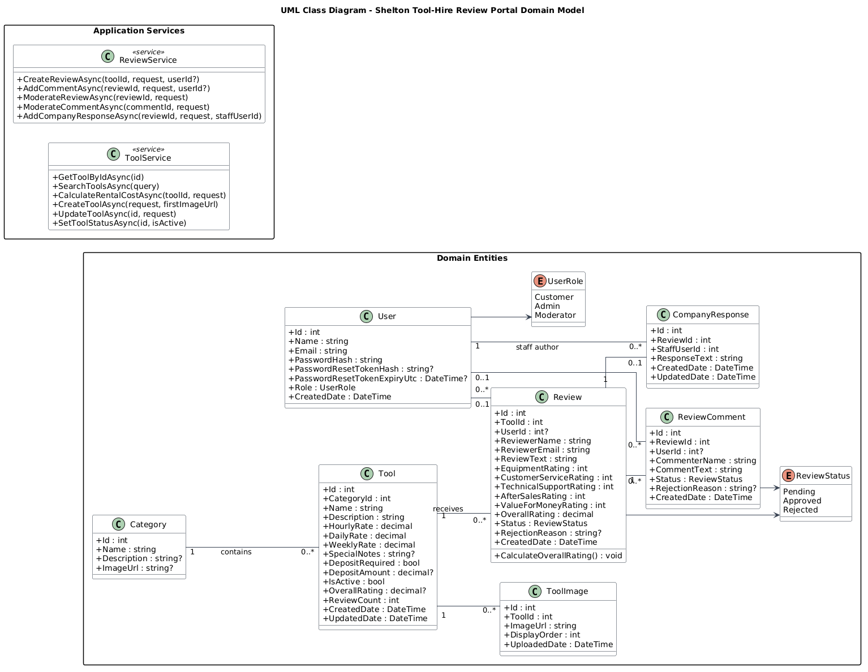
Figure 1. Corrected UML class diagram for submission.

Lecturer Feedback Alignment
The diagram has been corrected so the domain model does not assign application-service responsibilities to entity classes.
Feedback issue | Submission correction
CalculateRentalCost was shown as a Tool operation. | Removed from Tool. Rental estimation is shown in ToolService.CalculateRentalCostAsync(...), using Tool.HourlyRate, Tool.DailyRate and Tool.WeeklyRate.
Updating rental cost was ambiguous. | Represented as updating Tool pricing fields through ToolService.UpdateToolAsync(...) and UpdateToolRequest, not as updating a calculated rental-cost value.
Guest review/comment submission was not reflected correctly. | Review.UserId and ReviewComment.UserId are optional (int?) because guests can submit using name/email while registered customers can be linked to User.
Staff review actions were mixed with customer behaviour. | ReviewService contains moderation operations; Admin and Moderator perform approval/rejection in the use case/activity diagrams, while entities store the resulting status.
Company response permission needed clarity. | CompanyResponse is linked to a staff User; accepted roles are Admin or Moderator, consistent with the implemented policy.

Submission files
- Word document: Docs/Report/Submission_Class_Diagram.docx
- PlantUML source: Docs/Report/UML/07_Submission_Class_Diagram.puml
- Rendered diagram image: Docs/Report/UML/07_Submission_Class_Diagram.png

