**User Manual**

The aim of the game is to gather as many resources (ore, food and energy) as possible before the game ends. This is done by purchasing roboticons and placing them on tiles that the player owns. Tiles that contain roboticons will produce resources during the production phase. The quantity that the tiles produce corresponds to the level of the roboticon that they contain.

**Game Structure**

Phase 1 - Tile acquisition phase, each player must select a tile and claim it.

Phase 2 - Roboticon purchase phase, roboticons can be purchased from the market.

Phase 3 - Roboticons deployment/customisation phase, roboticons can be deployed on tiles and upgraded.

Phase 4 - Production phase, tiles containing roboticons will produce resources.

Phase 5 - Market phase, resources can be bought from/sold to the market.

9

12

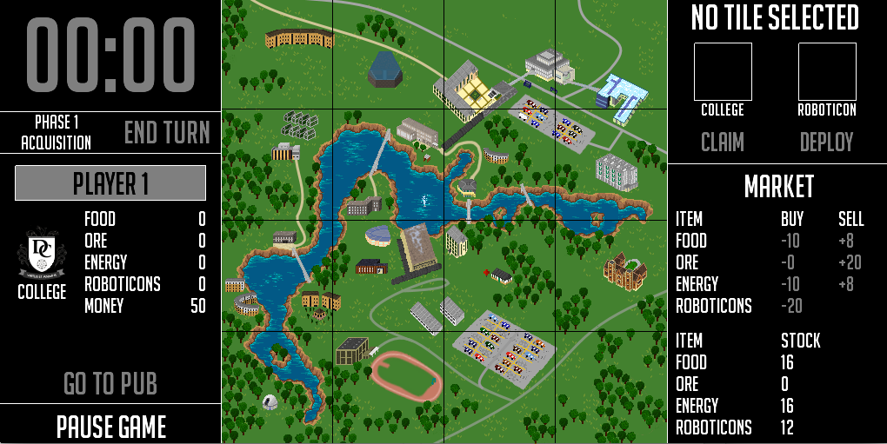

5

14

13

10

11

3

8

7

6

2

1

4

1. Press this button to end the turn and switch to the other player. Shows the inventory of the current player.
2. Shows the college symbol of the current player.
3. Press to pause the current state of the game.
4. Shows the current stock of each resource within the market.
5. Shows the buy and sell prices of the resources in the market. Click the number under the buy/sell column in order to buy/sell the chosen resource. Red font signifies that the player can’t afford the resource, green font signifies that they can.
6. Press this button to deploy a roboticon within the selected tile, this button will change to ‘upgrade if there is a roboticon present within the tile.
7. Shows the current roboticon stored on the tile, if there is one.
8. Press this button to claim an unowned tile during phase 1.
9. The college symbol corresponding to the player that owns the selected tile.
10. The game map, owned tiles are highlighted in the colour corresponding to the college of the player that owns them.
11. Shows the current time left in the turn.
12. Go to pub is activated during the phase 5 when the market is active providing you have at least 10 money.
13. This is the name of the player who’s turn it currently is.