Results:

1. Methodology  
     
   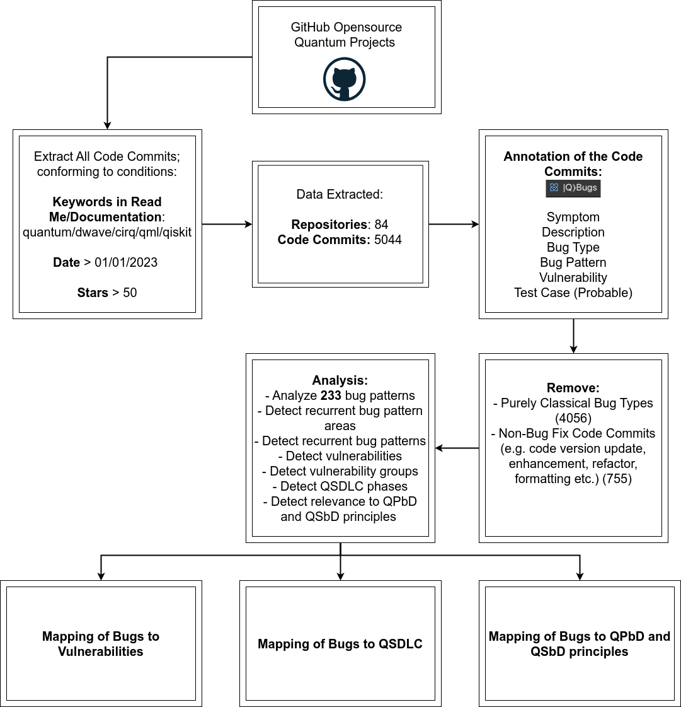
2. State of extracted data from GITHUB opensource quantum projects. Pure Classical components in projects as compared to quantum/hybrid components

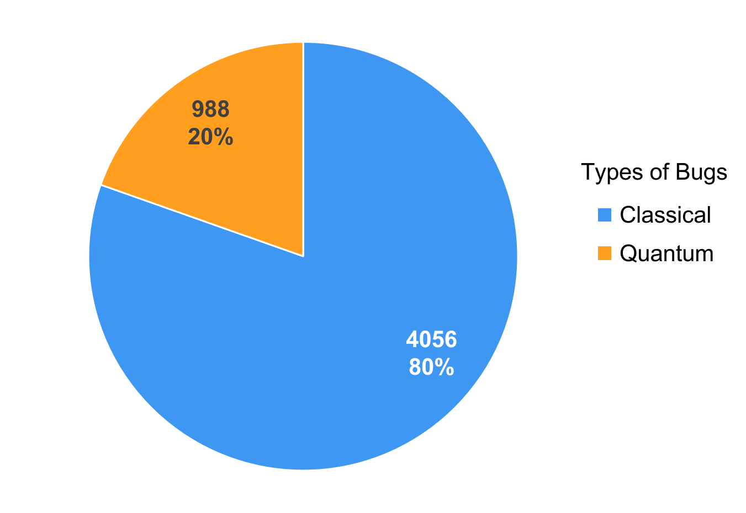

1. Areas of Code Commits after removing purely classical components  
   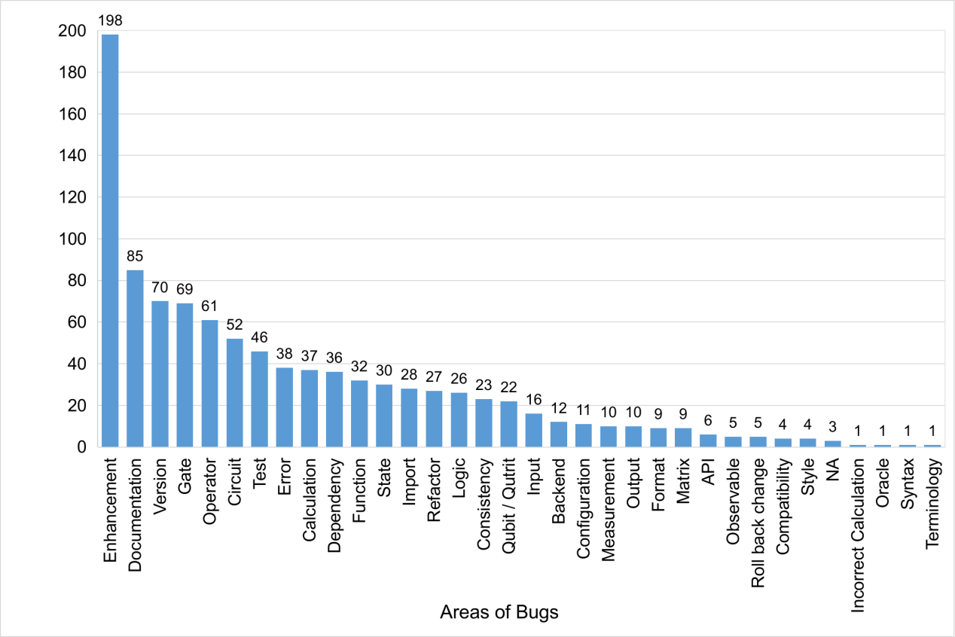
2. After removing all code commits not related to any fix, e.g. enhancement, refactor, formatting etc.(non bug fix)  
   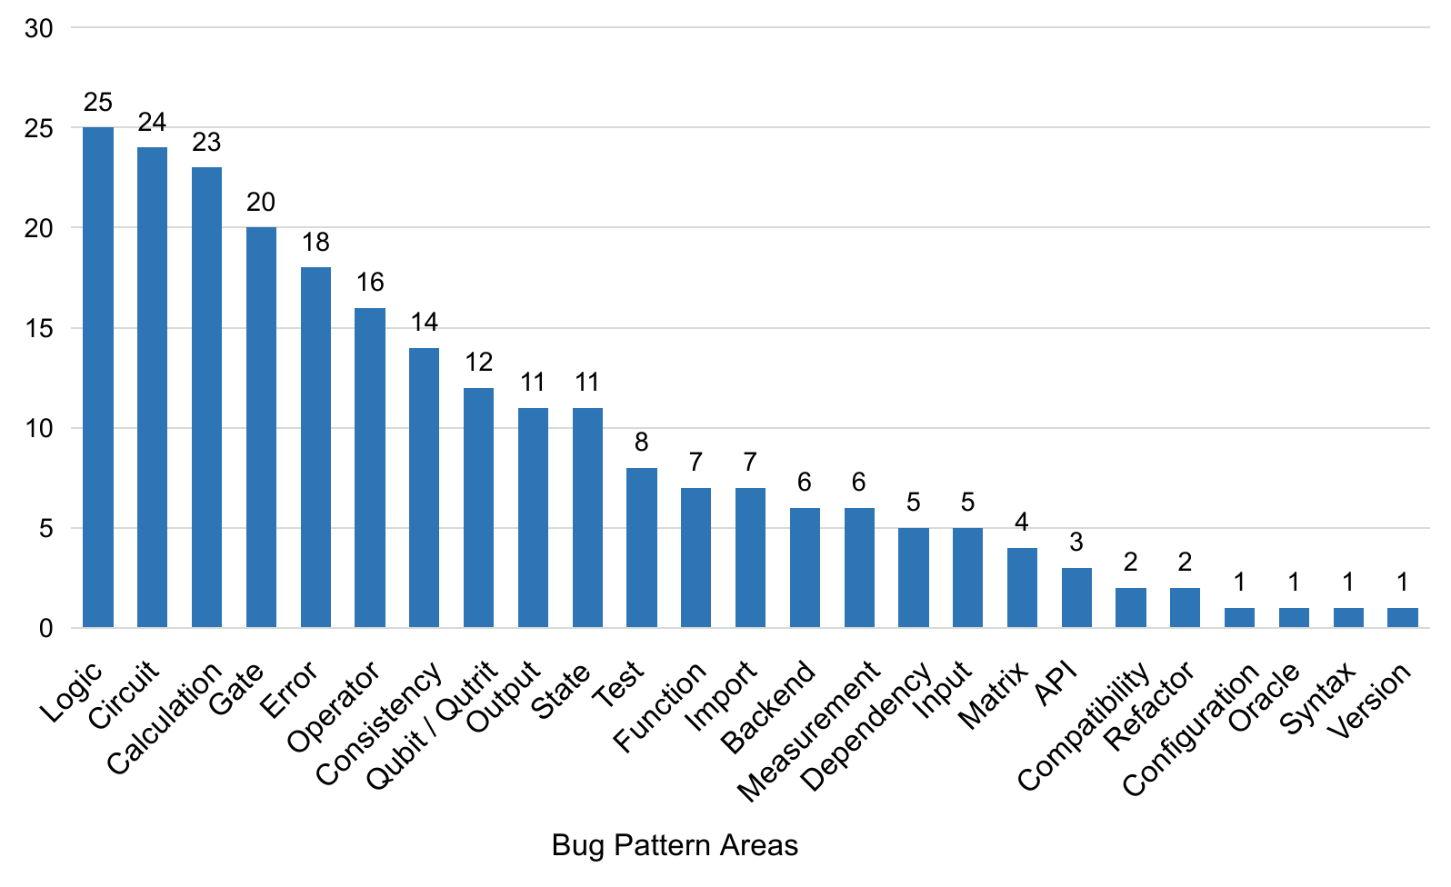
3. The specific bug patterns are varied, and thus they were generalized further into more homogeneous groups which resemble better to their actual nature.   
   The **distribution of bug patterns** can be represented through this word cloud.  
     
   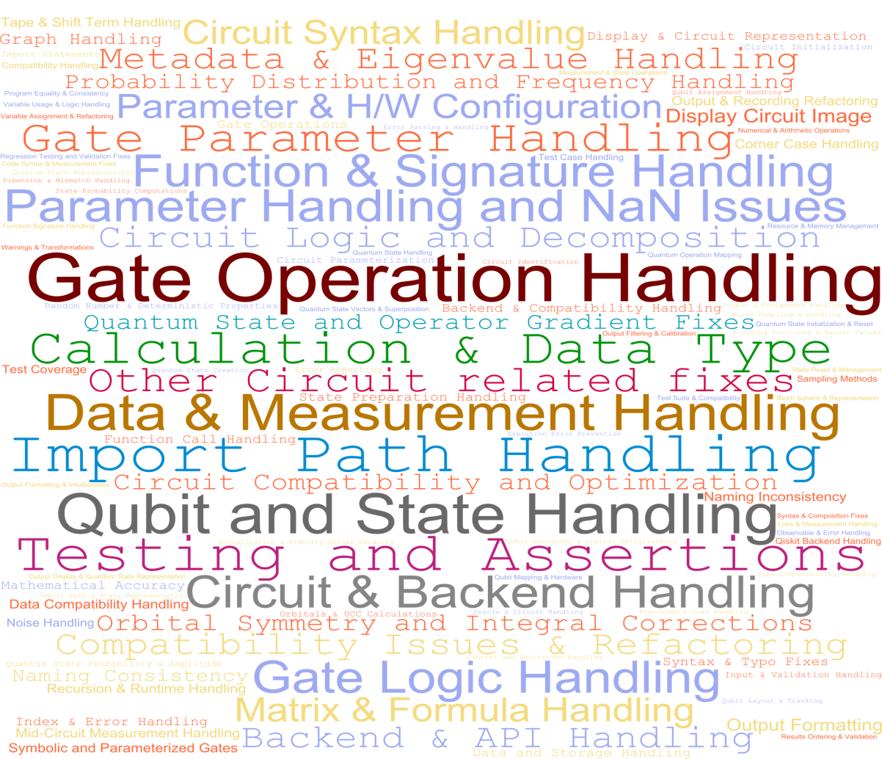
4. Sankey diagram for **mapping between** **Bug Areas to Types of Vulnerabilities**.  
     
   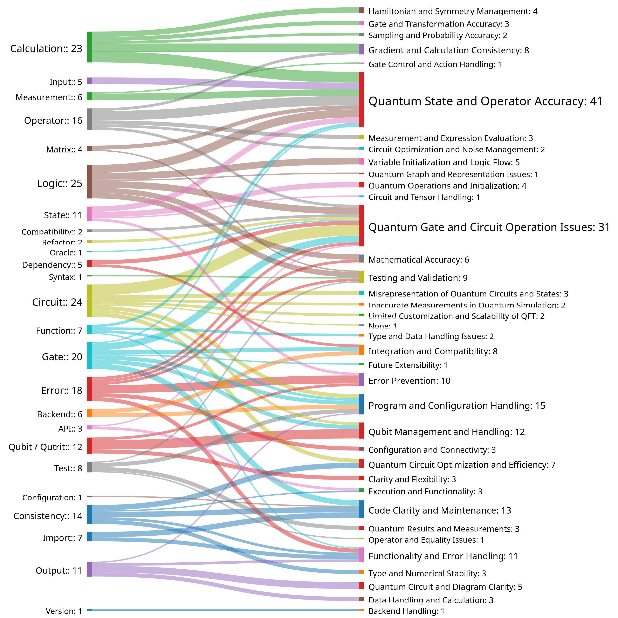
5. Sankey diagram for **mapping between** **Bug Areas to QSLC Phases** to which these bugs are related to/ or where they originate.  
   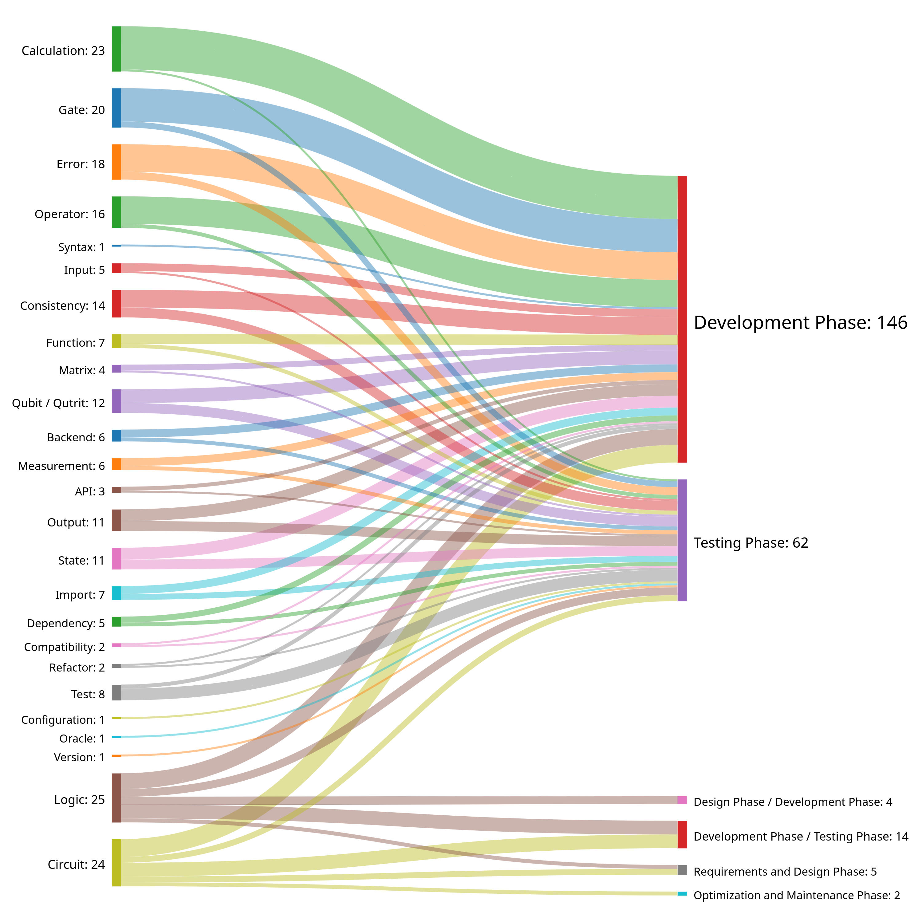
6. Heatmap to explain the relationship between Bug Areas and QPbD  
     
   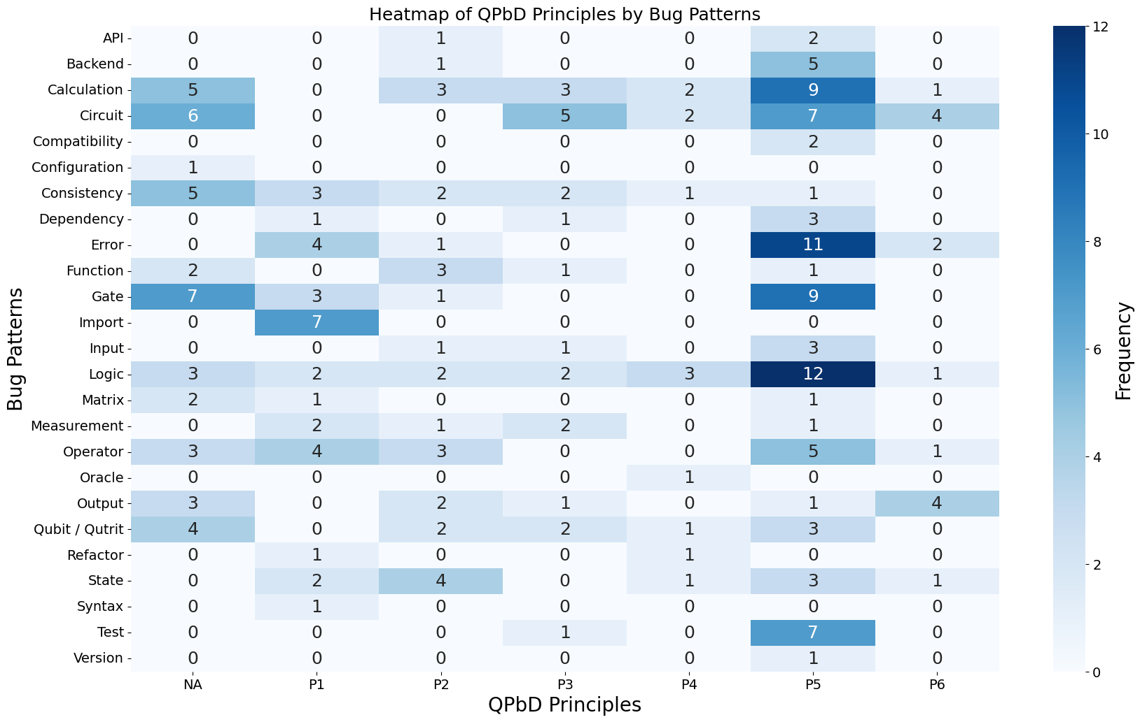
7. Heatmap to explain the relationship between Bug Areas and QSbD  
     
   