Lab 9 Deploy PRTG Network Monitoring System
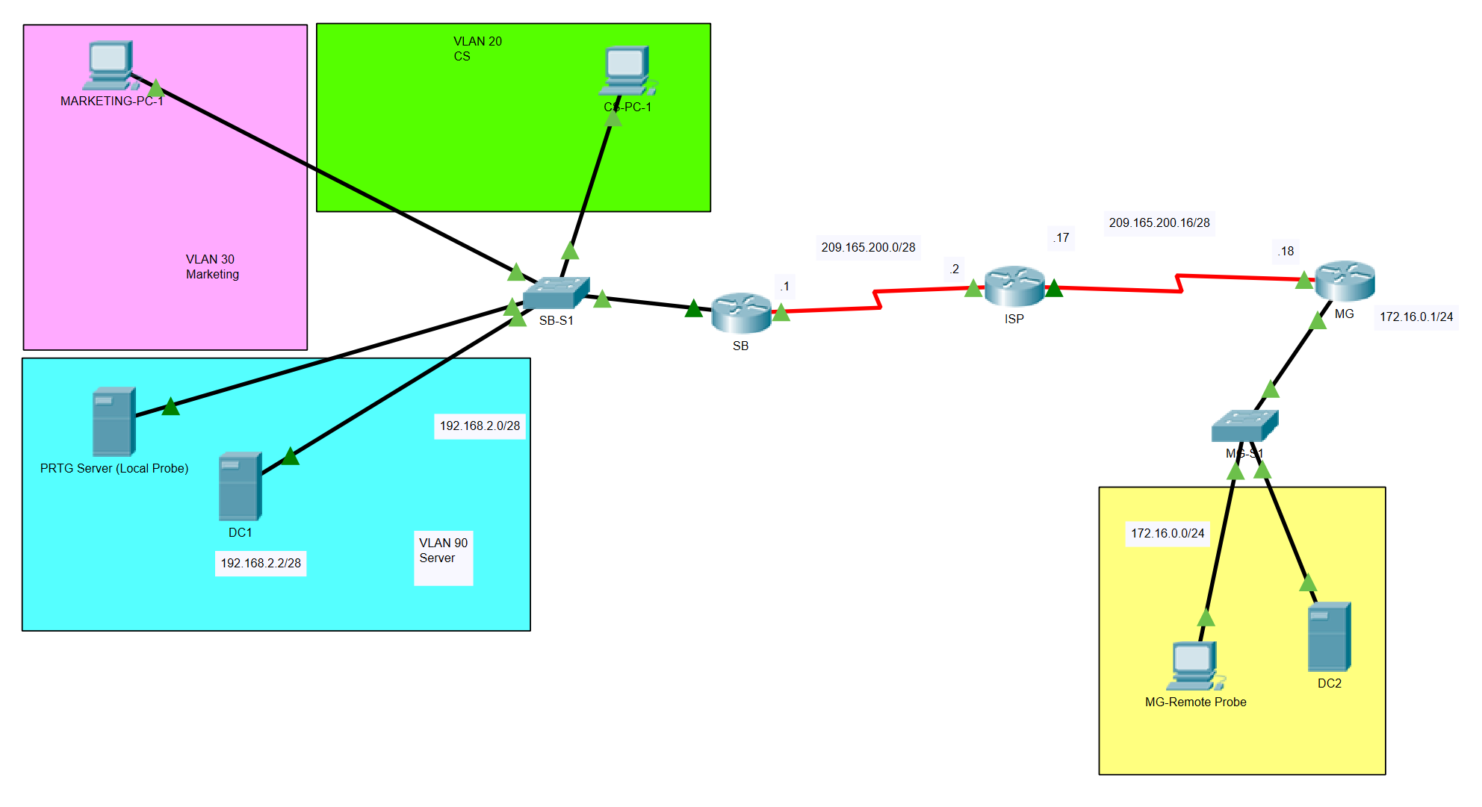
In this lab, you are going to deploy PRTG server (local probe) on SB-FS2 server and a PRTG remote probe on MG site. Maximum two students can be teamed to do this lab.
Two domain controllers DC1 and DC2 are going to be installed on site SB and site MG respectively. The following subtasks need to be completed:
- Install PRTG on SB-FS2.
- Configure Core Probe & Create Remote Probe Installer
- Install Remote Probe on MG site
- Add Sensors on Core Probe & Remote Probe

Starting Requirements:
Restore the network environment as in Lab 5 - VPN IPSec Over GRE Tunnel & Lab 8.6 – Install and configure File Server Resource Manager. Make sure the following requirements are met:
- End devices on SB site can ping to the MG site end devices via the IPSec GRE tunnel between the SB router and the MG router.
- Three servers which include DC1, DC2, and SB-FS2 are all installed and configured.

Lab 9.1 Install PRTG on SB-FS2.
Follow the tutorial video 9.1 – install PRTG to download the PRTG setup program from Connect and install SB-FS2 server as a PRTG server.

Lab 9.2 Configure Core Probe & Create Remote Probe Installer
- Refer to the document of Week 9 Teaching Lab CN-5.2.2.6 - Configuring SNMP and complete the following targets:
- Configure SNMP manager on the PRTG server.
- Configure SNMP agents on SB router and SB-S1 switch, which report to the core probe on the PRTG server.
- Complete the following targets by referring to the document of Week 9 Teaching Lab CN-8.1.2.6- Configuring Syslog and NTP:
- Configure SB router as the NTP master server.
- Configure SB-S1 switch, MG router, and MG-S1 as the NTP clients.
- Configure the PRTG server on SB-FS2 as the syslog server to receive syslog messages from SB router and SB-S1 switch.
- Refer to the tutorial video 9.2 - Configure Core Probe & Create Remote Probe Installer to create a remote probe installer generated by the PRTG server on SB-FS2.

Lab 9.3 Install Remote Probe on MG site
- Refer to the tutorial video 9.3 - Install Remote Probe on DC2 to install DC2 as a remote probe PC which reports to the PRTG server on SB-FS2.
- Refer to the document of Week 9 Teaching Lab CN-5.2.2.6 - Configuring SNMP and complete the following targets:
- Configure SNMP manager on Remote probe PC from MG site.
- Configure SNMP agents on MG router and MG-S1 switch, which report to the remote probe PC from MG site.
- Complete the following targets by referring to the document of Week 9 Teaching Lab CN-8.1.2.6- Configuring Syslog and NTP:
- Configure the PRTG remote probe on DC2 as the syslog server to receive syslog messages from MG router and MG-S1 switch.

Lab 9.4 Add Sensors on Core Probe and Remote Probe
- Complete the following tasks by referring to the tutorial video 9.4 – Add sensors:
- Add SNMP bandwidth and Ping sensors for SB router and SB-S1 switch on the PRTG server from SB-FS2.
- Add SNMP bandwidth and Ping sensors for MG router and MG-S1 switch on the PRTG remote probe on DC2.

Ending Requirements:
- Demonstrate the following to the teacher and get marked off:
- PRTG server is installed on SB-FS2 with required SNMP sensors and syslog sensors configured.
- PRTG remote probe is installed on DC2 with required SNMP sensors and syslog sensors configured.
- Take screenshots according to the teacher’s requirements and paste them on the AT4 Part 2 template.
- Obtain sign-off from the teacher.

