Music Streaming App

Introduction
Project Name: Music Streaming App
Goal: To design and develop a modern music streaming application that allows users to explore, play, and organize their favorite songs easily.
Role: UX/UI Designer and Developer Tools Used: Figma, Adobe XD,MSWord.
Team Members:
• Madhumathi S
• Jothiga S
• Kaviya K
• Sethuraman A
• Santhosh P
Problem Statement
Many users face challenges finding a seamless and personalized music experience. Existing platforms can be cluttered, slow, or lack tailored recommendations. This project aims to create a clean, intuitive, and user-friendly app that provides smooth playback, smart suggestions, and easy playlist management.
Target Audience / Personas
The app targets music enthusiasts of all age groups who listen to songs regularly through smartphones or desktops. Their main needs include: - Easy navigation and song discovery
Personalized playlists based on mood or genre
-Offline music playback and minimal ads Pain Points:
-Too many ads interrupting the experience
– Difficult navigation in existing apps
- Lack of customization and offline features
User Research
Research Methods: Online surveys, user interviews, and competitive analysis of apps like Spotify, Apple Music, and YouTube Music. Key Insights:
- 75% of users prefer minimalistic UI and fast streaming.
- Personalized recommendations significantly increase engagement.
– Offline playback is one of the most requested features.
Findings:
A user-friendly interface with smart recommendations and flexible controls enhances the overall listening experience.

Information Architecture
The app structure includes:
1. Home – Display featured playlists, trending songs, and recommendations.
2. Search – Explore songs, artists, and genres.
3. Library – Access saved songs, albums, and playlists.
4. Player – Control playback, lyrics, and song queue.
5. Profile – Manage account, settings, and preferences.
User Flow / Journey
1. User opens the app and logs in.
2. Browses the Home screen for recommendations or uses the Search option.
3. Selects a song or playlist to play.
4. Adds songs to a personal playlist or marks as favorite.
5. Adjusts playback controls and views lyrics.
6. Logs out or continues listening in background mode.

UI Design
The final UI design uses:
- Primary Colors: Deep Purple and White for an elegant modern look
- Typography: Poppins and Inter for readability
- Components: Cards, tabs, sliders, and icons for music playback and browsing.
Prototype & Interactions
Interactive navigation prototypes were created in Figma to simulate app and playback transitions. Micro-interactions such as play/pause animations, swipe gestures, and enhance the overall
user experience. 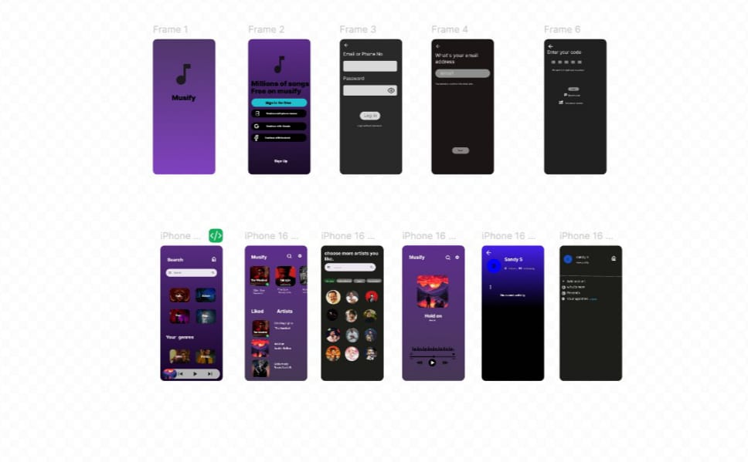
Conclusion
The Music Streaming App successfully delivers a personalized and user-centered approach to enjoying music anytime, anywhere. It combines simplicity, speed, and smart features to improve user satisfaction and engagement.

Thank you!

