**Attenuator Module V1 for the PAM**

* Frequency: 0.1-20GHz
* Attenuation: 5-BIT, max: 31 dB
* Impedance: 50Ω

**Ein Bild, das Text, Diagramm, Reihe, Plan enthält.
Schematic**

Inputs:

* RFin: Radio signal input
* +5V: positive supply voltage (+5V@4.5mA)
* -5V: negative supply voltage (-5V@5.5mA)
* CLK: Clock Signal
* DATA: serial bit-pattern for attenuator
* LE: Letch Enable
* GND

Outputs:

* RFout: Radio signal output

Ein Bild, das Text, Screenshot, Schrift, Zahl enthält.
**Components** -*All Case Codes are metric*

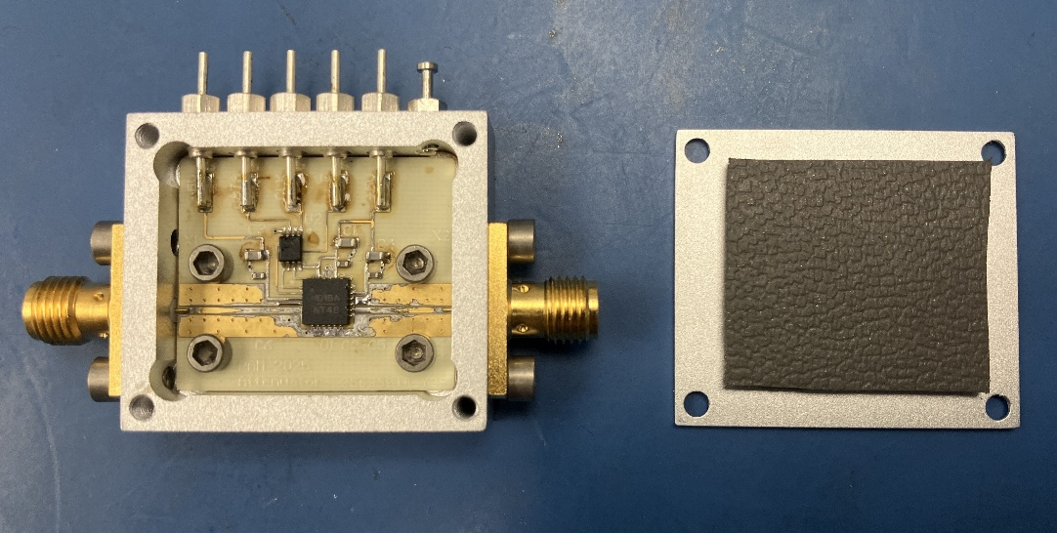2 – SMA 2Hole (142-1701-201) [X1, X2]  
5 – Feed through cap 4-40UNC-2A (B3C153B) [X3-7]  
1 – Turret Terminal 2-56 UNC – 2A (1595-2)   
1 – variable attenuator (HMC1018ALP4E) [U1]  
3 – 100pF 1005 (GRM1555C2A101FA01D) [C2,C5,C6]  
3 – 1000pF 1608 (GCM1885C1H102FA16D) [C1,C3,C4]  
1 – Non-Inv. buffer VSSOP-8 (SN74LVC3G17DCUR) [U2]  
   
1 – RO4350 PCB  
1 – Box   
1 – Lid  
4 – Screws 3-48 UNC - 2B x 3/16 (92196A091)  
4 – Screws 2-56 UNC - 2B x 1/8 (21202)  
4 – Screws 2-56 UNC - 2B x 5/32 (91771A884)  
1 – RF-absorber PSA 0.08’’, ca. 20 x 24 mm (MR42-0008-20)

**Footprint**

Footprint of attenuator module (left) compared to footprint of commercially available evaluation board with the same attenuator (right).

Ein Bild, das Elektronik, Schaltung, Elektronisches Bauteil, Elektrisches Bauelement enthält.

**S-parameters**

S-parameter measurement with the VNA (N5230C) of attenuator module v1 (red) in comparison to attenuator evaluation board (gray).

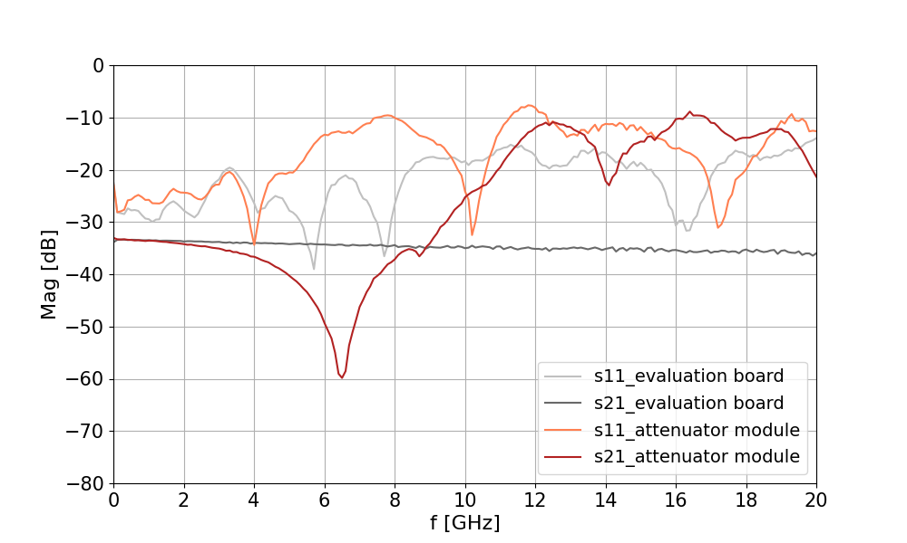

**Troubleshooting**

* Attenuator replacement had no effect, ruling out a **faulty component**.
* Evaluation board performed well, confirming the **attenuator model** is not the issue.
* Switching off the **power supply** had no impact on the irregularity of the modules S21 trace. The S21 trace of the evaluation board looked smooth even with the power switched off.
* Amplifier and detector modules performed correctly, despite using the same **CPW and SMA transitions**.
* HFSS simulations indicated that **trace-to-attenuator transitions** should not significantly degrade performance.
* Two key differences found between the **footprints** of the attenuator module and evaluation board:
  1. **Ground plane** in the module is narrowed over a longer distance.
  2. **Ground pads** on the evaluation board are directly connected to the central ground pad, allowing RF energy to escape from the trace.