**Detector Module for the PAM**

* Frequency: 0.5-20GHz
* Impedance: 50Ω

**Ein Bild, das Text, Diagramm, Reihe, parallel enthält.
Schematic**

Inputs:

* RFin: Radio signal input
* +5V: positive supply voltage (+5V@1.6mA)
* GND

Outputs:

* Det: Output for power measurement

Ein Bild, das Text, Screenshot, Rechteck, Zahl enthält.
**Components** -*All Case Codes are metric*

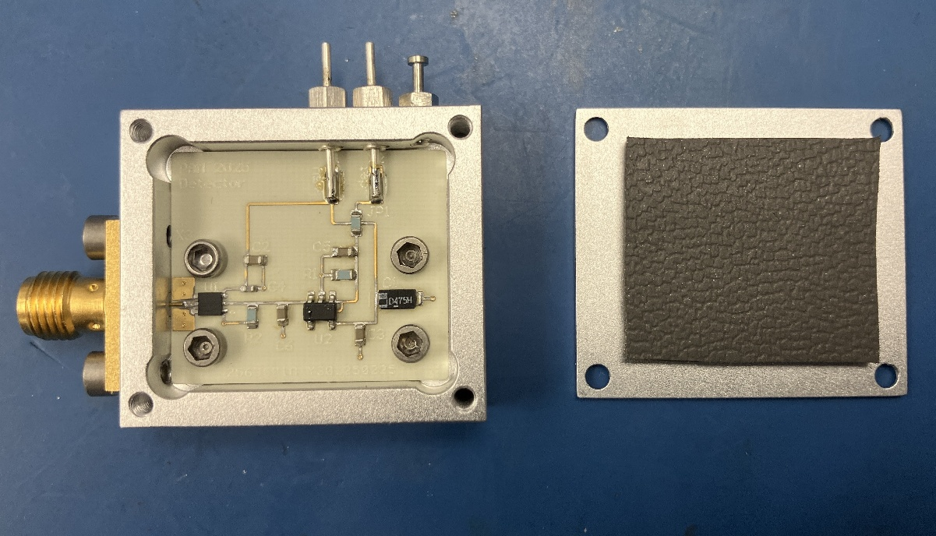1 – SMA 2Hole (142-1701-201) [X3]  
2 – Feed through cap: 4-40UNC-2A (B3C153B) [X1,X2]  
1 – Turret Terminal 2-56 UNC – 2A (1595-2)  
1 – detector LFCSP-6 (ADL6010ACPZN-R2) [U1]  
1 – op amp SOT-23-5 (AD8065ARTZ-REEL7) [U2]  
1 – 100pF 1005 (GRM1555C2A101FA01D) [C4]  
1 – 4.7uF 3216 (TH3A475K020C5000) [C1]  
4 – 100nF 1608 (GCM188R71C104KA37J) [C2-3,C5-6]  
1 – 0Ω 1608 (MCT06030Z0000ZP500) [JP1]  
1 – 1kΩ 1608 (MCT06030C1001FPW00) [R1, R2]  
   
1 – RO4350 PCB   
1 – Box   
1 – Lid  
2 – Screws 3-48 UNC - 2B x 3/16 (92196A091)  
4 – Screws 2-56 UNC - 2B x 1/8 (21202)  
4 – Screws 2-56 UNC - 2B x 5/32 (91771A884)  
1 – RF-absorber PSA 0.08’’, ca. 20 x 24 mm (MR42-0008-20)

**Footprint**

**Ein Bild, das Text, Screenshot, Diagramm, Schrift enthält.
**

**S-parameter**

S-parameter measurement with the VNA (N5230C) of detector module 1.  
 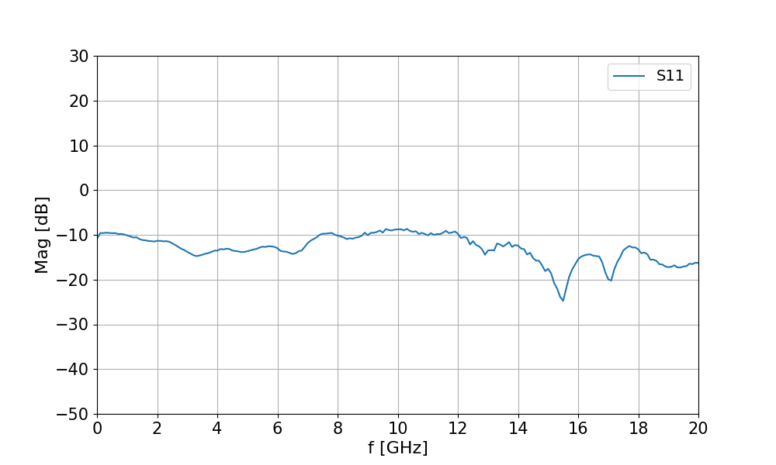

**Voltage-to-power Curve**

A signal generator (E4420B) was used to apply an RF input with a fixed frequency and varying power levels. It was connected with a 14 inch long SMA cable (AFX-CA-141-14 AtlanTec RF) to the detector module 1. The power was increased stepwise and the corresponding output voltages were measured using a multimeter. A power supply provided the +5 V supply voltage for the detector module.  
  
**Ein Bild, das Text, Reihe, Diagramm, parallel enthält.
**