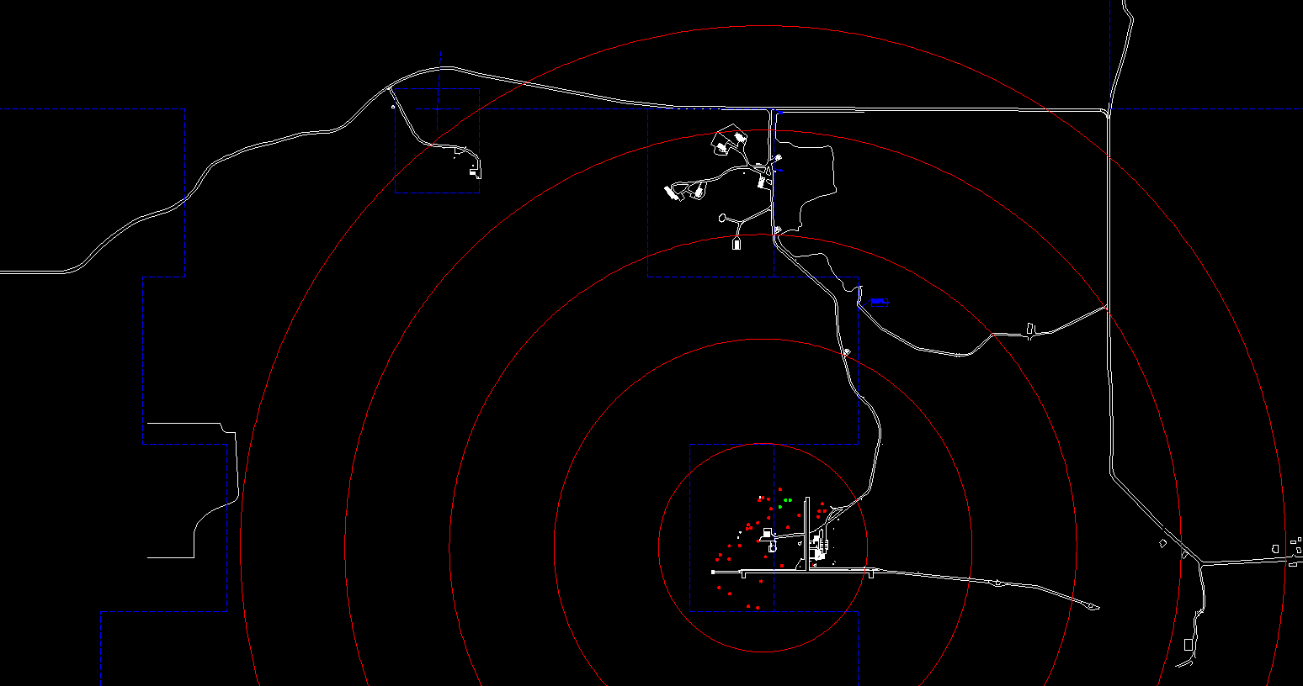

1250 m

1000 m

750 m

500 m

250 m