Tapered Microstrip Balun for ATA Feed Development
ATA Memo 35

G. Engargiola
November 26, 2001

Abstract
The ATA log-periodic antenna feed produces balanced signals at its terminals, which are closely followed by MMIC amplifiers. For each polarization channel, a balun must either precede a single unbalanced amplifier or follow two amplifiers, which independently amplify the out-of-phase signals from the terminal pair. This memo discusses a tapered line balun with a 50 Ω unbalanced output which also has a favorable geometry for use in the cryogenic ATA feed.

Introduction
The current design of the ATA feed is a non-planar log-periodic antenna with a 20° opening angle. Between the arms of the antenna is located a square pyramidal metallic shield with a 10° opening angle, which serves as a vacuum container for a cryogenic amplifier. The self-similar geometry of the antenna/shield combination produces a radiation pattern and impedance which vary insignificantly over a log period in frequency. A connection from the balanced leads of the antenna to the electronics interior to the shield can be made in two ways. (1) Each antenna arm can be connected via an unbalanced transmission line to an independent unbalanced amplifier input. Opposite antenna arms produce anti-symmetric signals, hence their amplified outputs can be combined with a 180° hybrid; a scheme for this connection is described in a separate memo. (2) Alternatively, the balanced terminals of the antenna can be connected via a balun to a single amplifier. The balun must be appropriately broadband, matching the terminal impedance of the antenna to the amplifier input, and compatible with the long narrow geometry of the shield at the location of the antenna terminals. The design for such a balun is presented in this memo (shown in Figure 1).

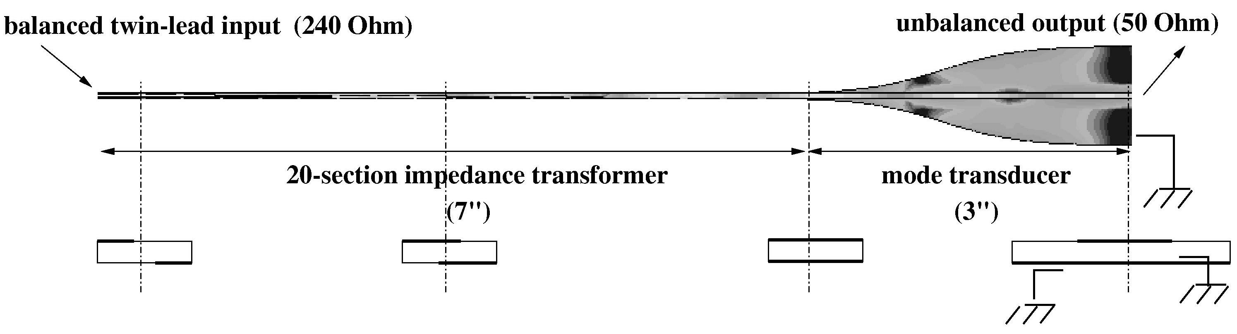
Figure 1: Drawing of the balun. The lower set of figures shows the cross-section at different places along the line.

Basic design and modeling
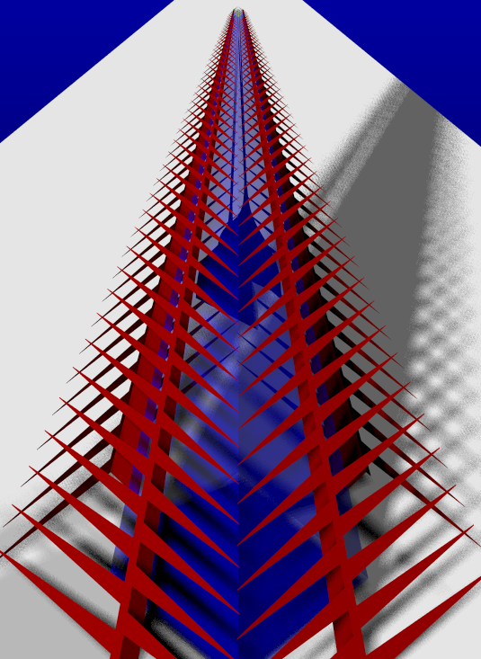
Simply put, a balun is a reciprocal transducer, converting the odd signal mode at the antenna terminals to the sum of an odd and even mode at the terminals of an unbalanced (grounded) transmission line structure. In effect, it passes microwave energy while blocking net RF current flow between the two ports. Space constraints in the pyramidal shield and the need for wide bandwidth make a tapered-line design ideal – ferrite core baluns are too bulky and narrowband.
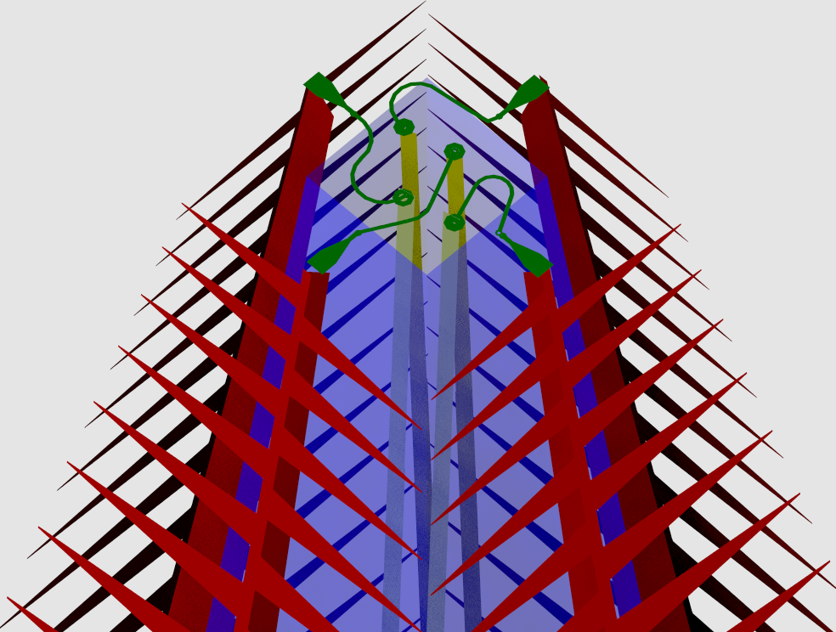
Figure 2: Feed with baluns and feeder tip, zooming out to view the upper third of the full-size feed. The inner pyramid is the semi-transparent blue in this figure.

The opening of the pyramidal shield is 0.150″ × 0.150″ at the feed terminals, which are separated by 0.300″. Moreover, since two orthogonal non-planar log-periodic (LP) antennas surround the pyramidal shield for dual polarization, the balanced ports of two baluns must be brought to the narrow tip of the shield without inducing significant cross-polarization coupling. For this reason, the shield volume must be partitioned by a metallic septum, so that the baluns do not capacitively couple. Figure 1 shows the balun and Figure 2 shows the tip of the dual polarization feed structures, zooming out to show the entire feed structure.

The shield volume is partitioned diagonally so that the balanced port of each balun can be located to give maximum separation from the surrounding grounded metal walls, which limits the highest practical impedance one can achieve with a twin-lead type transmission line. The balanced port of each balun must have the same impedance as the antenna terminals (240 Ω). This can be conveniently achieved within the available space constraints by fabricating offset 0.010″ microstrip lines separated by 0.050″ on opposite sides of 0.015″ thick Cuflon. The balun leads are approximately 0.050″ equidistant from the septum and pyramidal shield walls.

The twin-lead input of the balun must also be a 240/50 Ω transformer section. The input of the balun transducer section, described in the next paragraph, is a broadside-coupled pair of 0.060” lines. For reasons of space economy it is most conveniently mated to the 240 Ω twin lead input by asymmetrically tapering top and bottom conductors (Fig. 3a) so that the outer diameter of the pair remain constant (0.060″). The cross section of the balun is shown in Figure 1 as the lower set of figures. An IE3D simulation gives the impedance of this transmission line structure as a function of a single linear parameter X (see Figures 3a and 4). Figure 4 also shows the impedance along the line (Z). The impedance steps yield a 20-section 240/50 Ω transformer of minimum length with a 25 dB return loss (Klopfenstein taper). The number of steps limits the upper frequency cutoff (> 10 GHz) and the total length determines the low frequency cutoff (< 1 GHz). Full wave simulations predict a return loss of better than 25 dB and less than 0.3 – 0.4 dB of insertion loss (Fig 3b).
Z

Figure 3a: Matching transformer section of the balun showing the offset.
X
0.060″

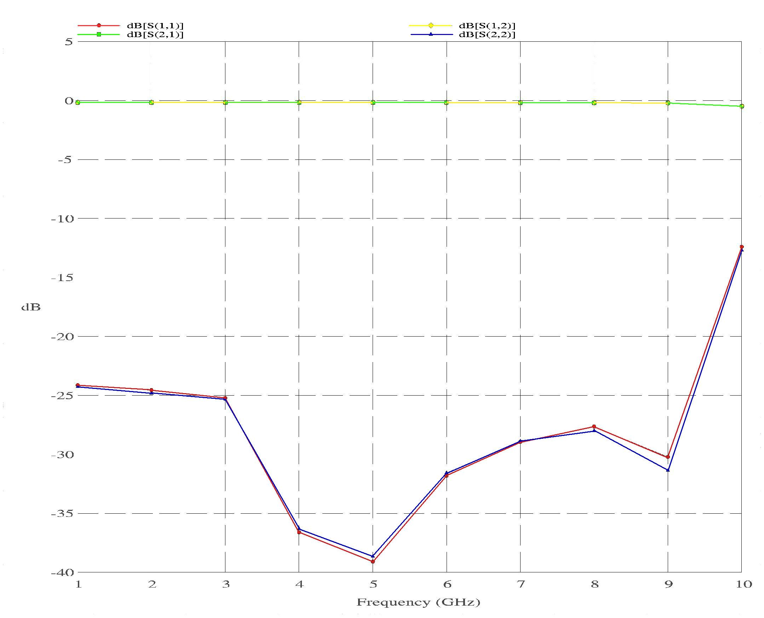
Figure 3b: Full wave simulation of the transformer section of the balun. Shown are S₁₁, S₂₁, S₁₂ and S₂₂.
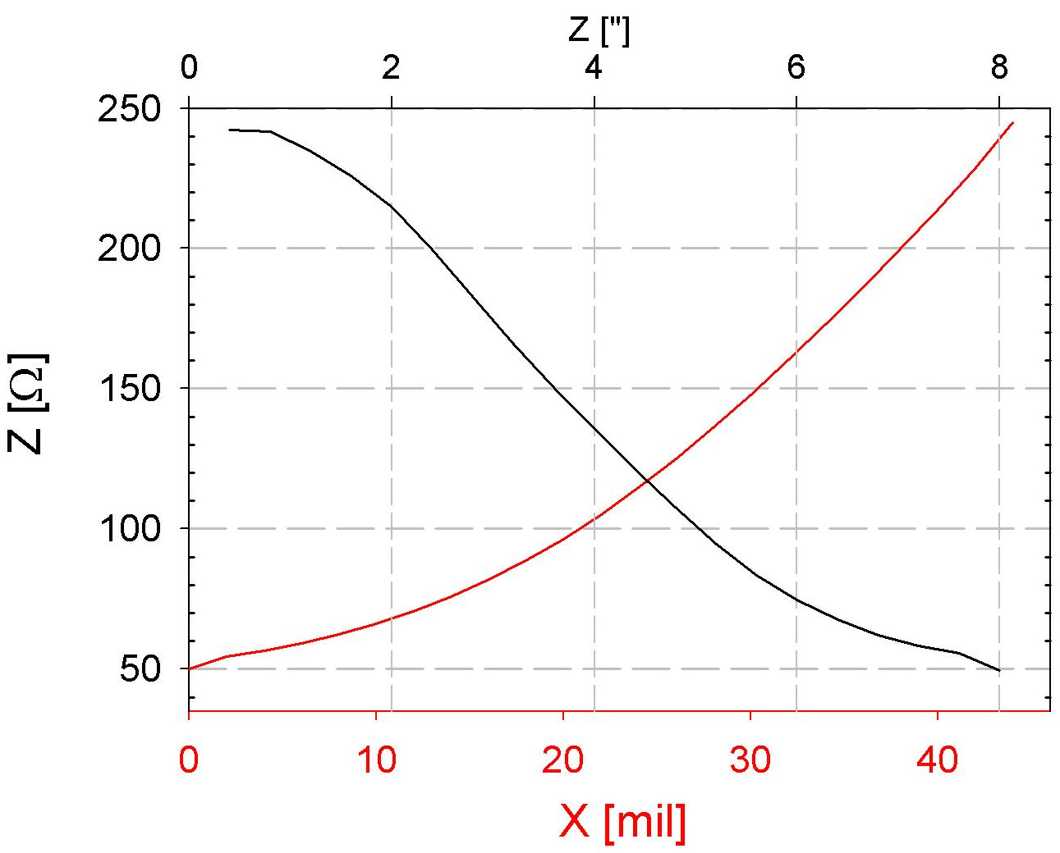
Figure 4: (Red) Impedance as a function of X, the inner line separation, with the outer line separation of 0.060″ and Cuflon thickness of 0.015″. (Black) Impedance along the line Z.

The transducer section (Fig. 5a) consists of a 0.060” wide line broadside coupled through the Cuflon substrate to a line of the same width at the balanced port which flares out exponentially. At the unbalanced port, the balun transducer is effectively a microstrip line, where the bottom conductor becomes the ground plane (it is attached to case ground along the end). The length of the transducer and speed of the taper of the bottom conductor line determine the passband of the transducer section, which has been optimized for 1 - 10 GHz. Full wave simulations predict a return loss of less than 20 dB and an insertion loss of less than 0.2 – 0.3 dB (Fig 5b).

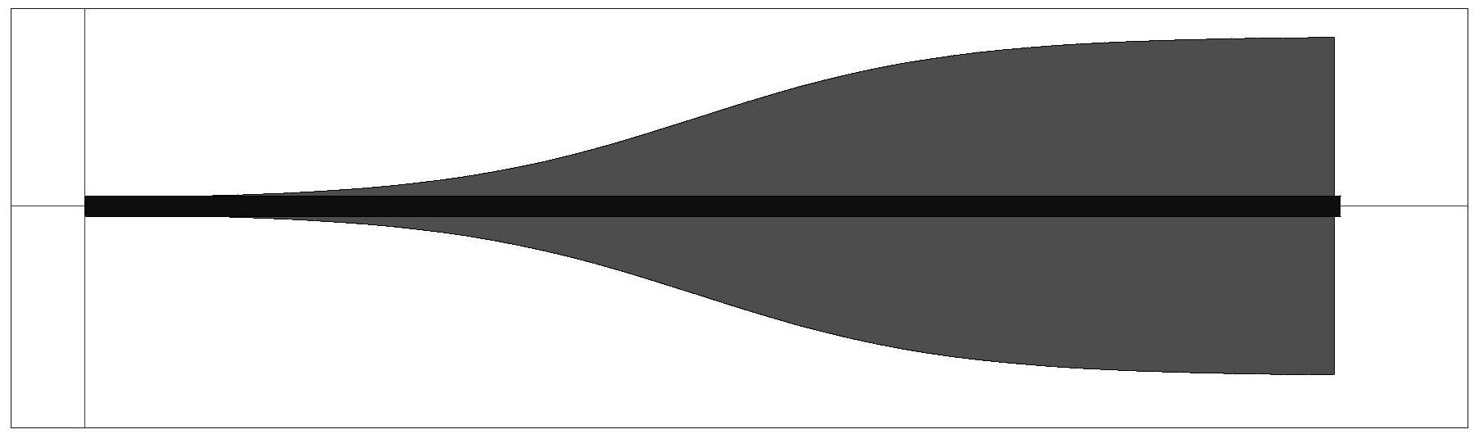
Figure 5a: Transducer section and unbalanced “microstrip” end of the balun.

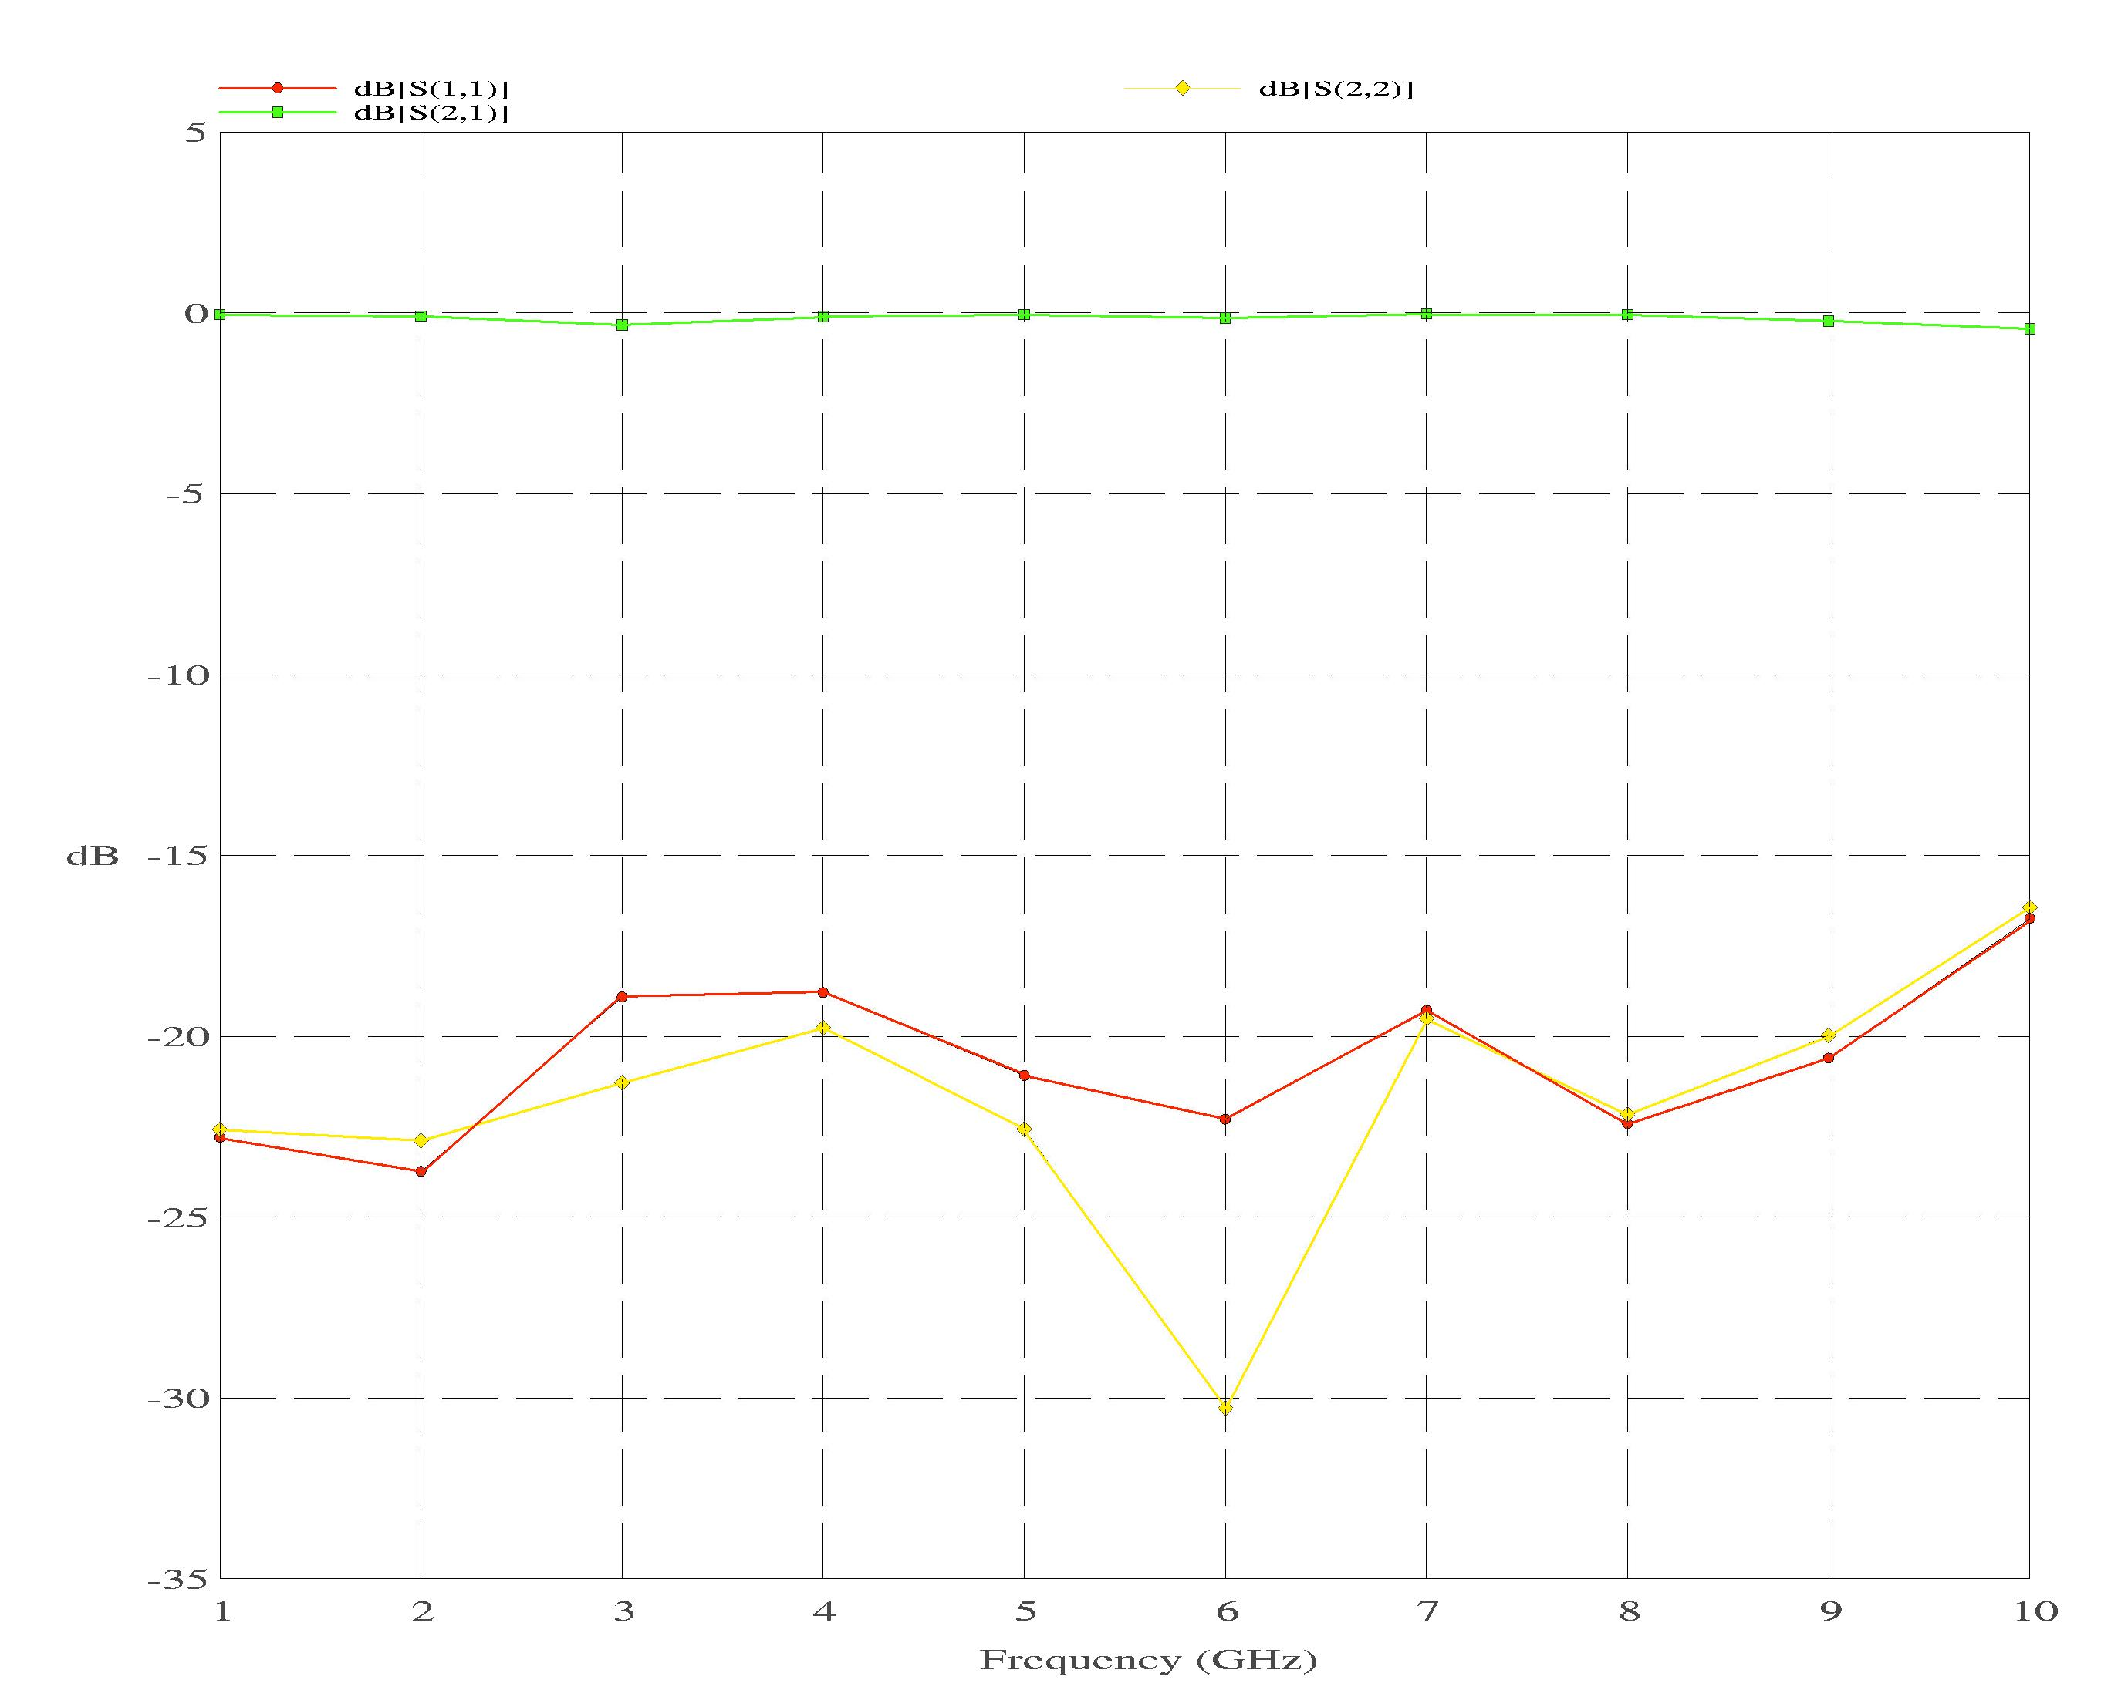

Figure 5b: Full wave simulation of the transducer section of the balun. Shown are S₁₁, S₂₁ and S₂₂.

Test Results
As shown in Figure 1, this taper-line balun has two sections: the balanced line portion which matches the antenna impedance to ~50 Ω and a portion which actually performs the mode transduction. One method to confirm the proper function of this balun design is to connect two baluns end-to-end at the balanced port (see Figure 6a). Clearly, the center of this circuit arrangement is a balanced twin lead, while the ends, which are microstrip-to-coax transitions, are unbalanced.

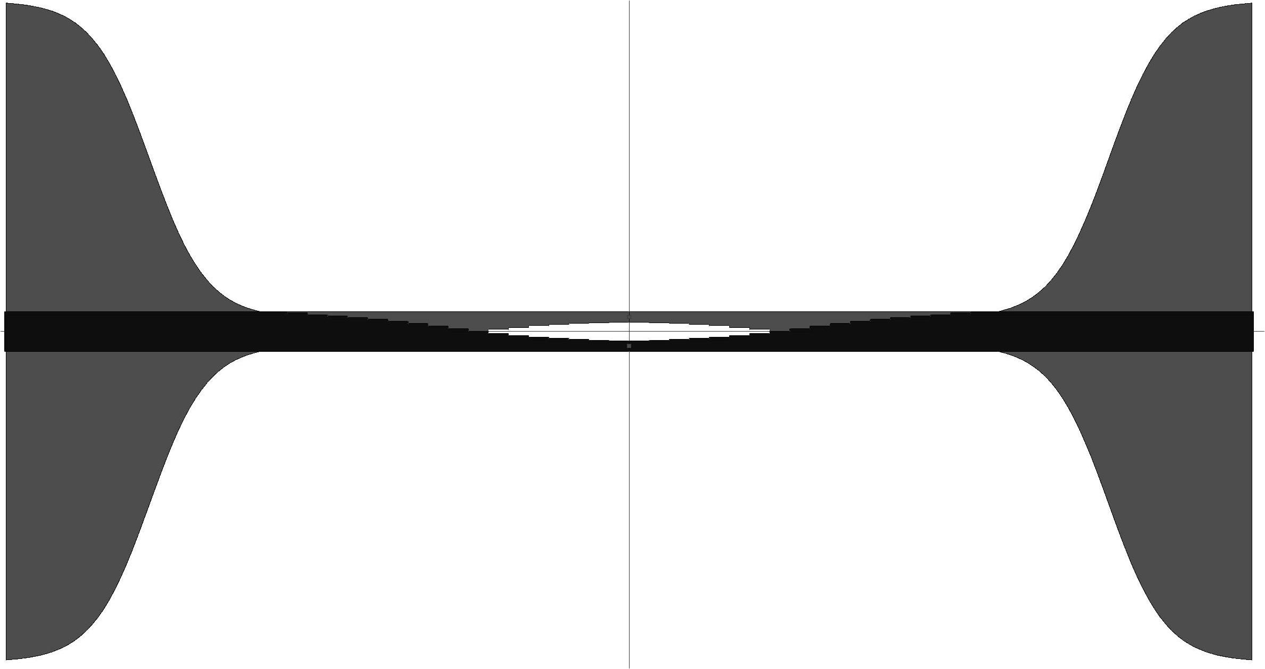
(a)
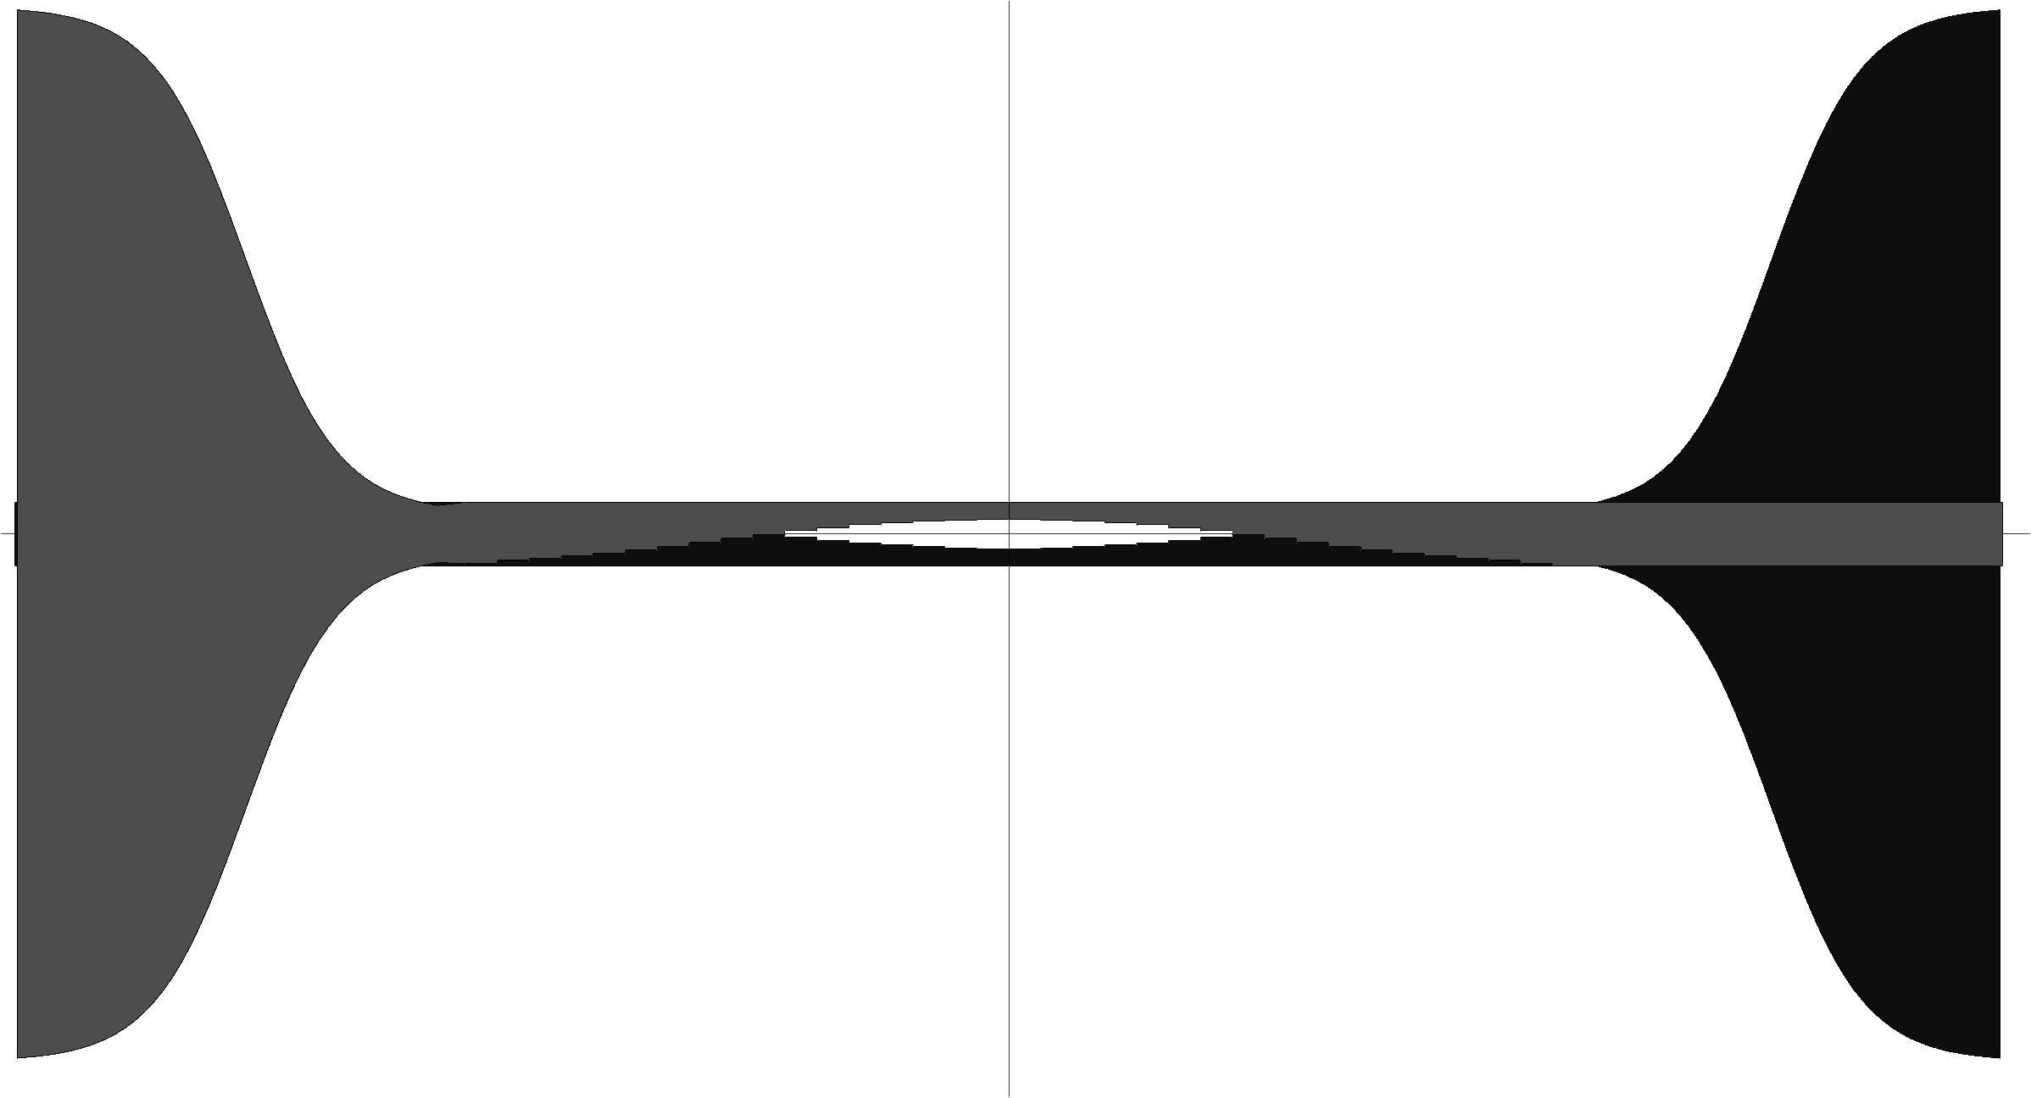
Figure 6: (a) End-to-end connection of the balun. (b) Cross-connected balun.
(b)

Figure 7 shows the transmission properties of this circuit at room temperature are |S₂₁| < 1 dB for frequencies spanning 1 to 7 GHz and |S₂₁| < 2 dB from about 7-11 GHz. This is greater than the net insertion loss of 0.4 – 0.7 dB predicted by simulations. The discrepancy at least partially arises from the omission of a correction for the effects of dielectric surface roughness which can as much as double the loss expected from a perfectly smooth PC board. The return loss |S₁₁| is 15 – 20 dB across the same band (Figure 7). To check the phase performance of the balun circuit, a second circuit is made by connecting two baluns end-to-end as before but with the twin leads cross-connected (see Figure 6b). Since the balun transforms a balanced signal in the E-plane to an unbalanced signal in the H-plane, a comparison of the two back-to-back balun pairs should exhibit a 180° phase difference over the passband. Figure 8 shows that this is indeed the case from 1 - 10 GHz. The phase error slowly increases from less than 1° at 1 GHz to approximately 13° at 10 GHz.
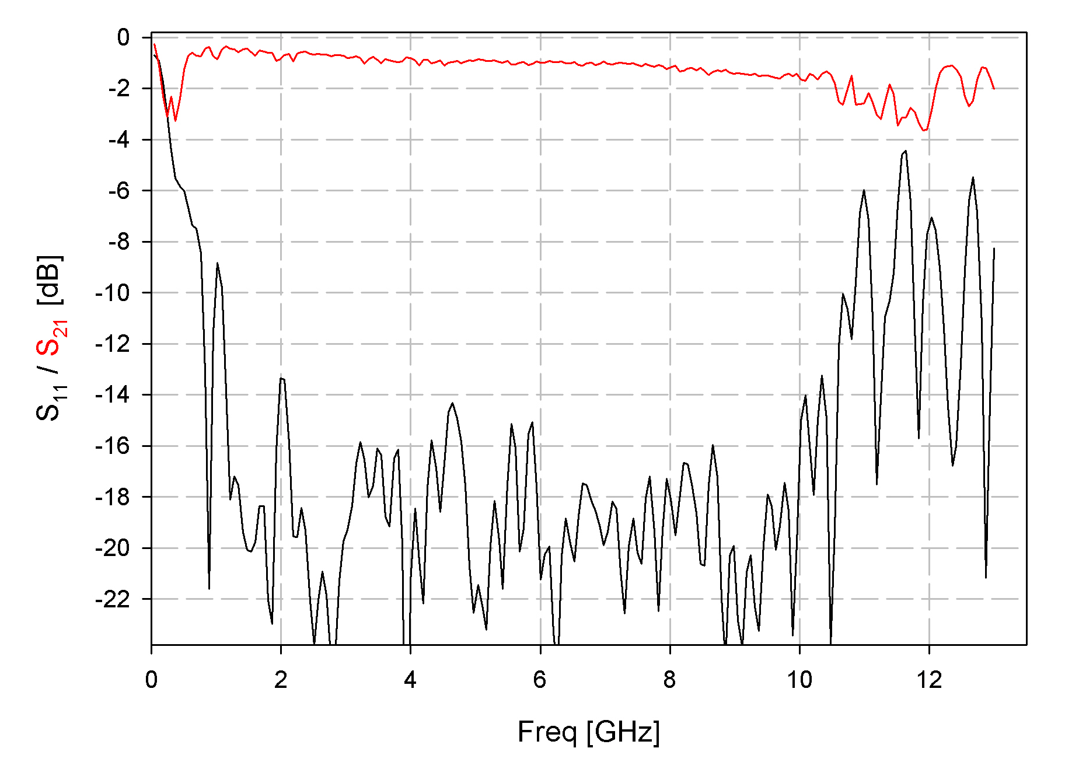
Figure 7: Measured performance of end-to-end balun. Note that S₂₁ includes only one length of balun, while S₁₁ is the full end-to-end setup.

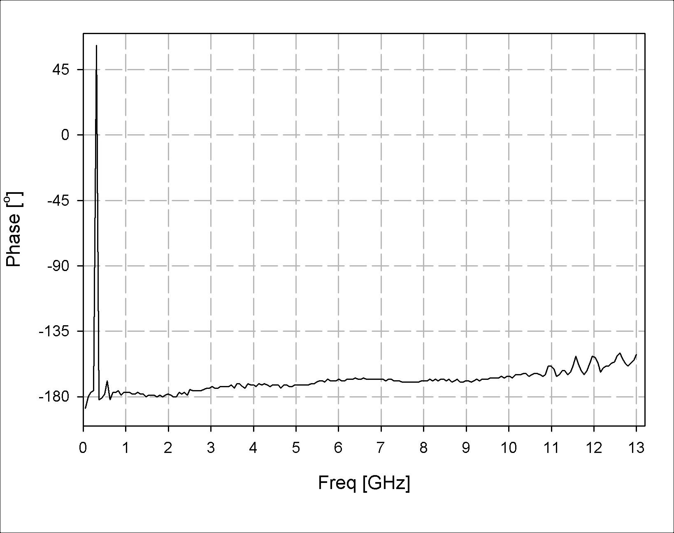
Figure 8:

Figure 8: Relative phase between the balun arrangements shown in Figure 6.

Discussion
The results quoted in the previous section were for balun pairs mounted in an open test fixture. For the balun to function properly, it must work in a pyramidal shield. The effects of nearby conducting walls are two-fold: (1) they lower the characteristic impedance of both balanced and unbalance transmission lines, making them more lossy; and (2) they provide a conduction path for in-phase signals (the even mode) along the twin leads. At the tip of the pyramidal shield, the impedance of the balanced transmission line mode (odd mode) and the even mode are 240 Ω and 120 Ω respectively. Because the shield flares out at a 5 degree half-angle, the impedance of the even mode continuously increases from 120 Ω at the balanced port to 1 kΩ at the unbalanced port according to full wave simulations of the balun/shield combination; hence the ratio of odd/even mode impedances is nearly 20:1. It is expected that with a good impedance match to the balun at both ports the even mode excitation should be negligible. In any case, this balun fabricated for Cuflon is certainly adequate for range testing the ATA feed antenna patterns. Use of this balun in a cryogenic front end requires scaling it to alumina, which means reducing its length by more than a factor of 2, and making sure significant excitation of the even mode does not occur, which can raise the sidelobe patterns and make the beam profile asymmetric. Table I presents the design boundary conditions of the alumina based circuit.
Table I: 0.010″ Alumina balun design.
Twin lead port | Throat  (broadside coupled pair) | Unbalanced port
Lead dia = 0.0011″ | Lead width = 0.0168″ | Gnd plane width = 0.200″
Lead sep. = 0.0168″ | Lead sep. = 0.020″ | μ-strip width = 0.010″
Width of shield = 0.150″ | Width of shield = 0.484″ | Width of shield = 0.708″
Lead-shield sep. ~ 0.045″ | Lead-shield sep. ~ 0.163″ | μ-strip-shield sep. ~ 0.245″
Zo = 240 Ω | Zo = 50 Ω
Ze > 350 Ω  (lead-wall impedance) | Ze > 270 Ω  (lead-wall impedance)
One way to attenuate the even mode in a cryogenic balun is to attach a resistive card vane to the inside of the shield, perpendicular to the cooled circuit board (see Figure 9). Care must be taken not to attenuate the odd mode in locations where the fringe fields between balanced leads are high. To avoid this, the vane should probably have maximum extent at the balun "neck" (the transducer input) where 0.060″ lines are broadside coupled and fringe fields are at minimum strength.
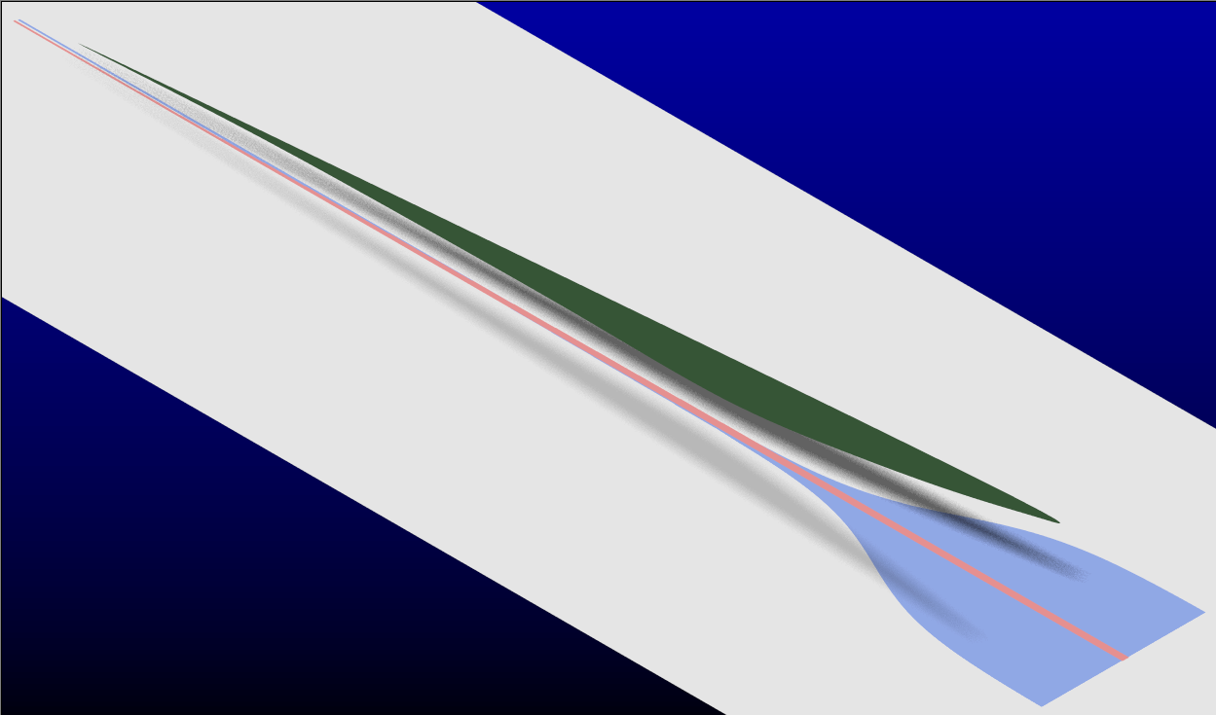
Figure 9: Rendering of the resistive card (green) over the balun (blue/red).

IE3D is a electromagnetic modeling package from Zeland Software.

