A Note on Baluns

S. Weinreb, May 31, 2001

Most papers on baluns report the insertion loss measured in a back-to-back configuration. However, another vital characteristic, the common-mode rejection is usually not reported. Referring to Figure 2, the common mode rejection is the ratio of voltages produced between 1 and 1’ at the unbalanced port for excitation between 2 and 2’ to the voltage produced by a voltage between 2 or 2’ and ground. The lack of balance at terminals 2 and 2’ is also produced by a difference in the impedances Z1 and Z2 shown in the figure. Note that if either Z1 or Z2 is low and the other is high the back to back insertion loss will be low but will increase if the balanced terminals are flipped.

A second problem with most analyses or measurements of baluns is that the location of grounded metallic conductors near the balun is not specified. The purpose of the balun is to isolate two terminals with respect to ground and this isolation depends on the location of grounded conductors even in the case that the conductors are at equal distances from the balanced terminals. This is illustrated in the case shown in Figure 1 where the balance is dependant upon the size of the grounded housing for the parallel plate lines. If the housing or any other grounded conductor did not extend to the balanced right-hand side of the structure the balance is very good.

It is instructive to consider a simple unbalanced transmission line, coaxial or microstrip, as a balun. It will give low insertion loss in a back-to-back to configuration. If the back-to-back connections are flipped it will also give low insertion loss if no ground conductors are considered. However, if the generator and load have a common ground connection the flipped insertion loss will be very high.

Figures 1 is copied from Figure 11.9 of RF and Microwave Coupled-Line Circuits by Mongia, Bahl, and Bhartia. This reference contains more information about the balun shown in the figure and has many other examples of baluns.

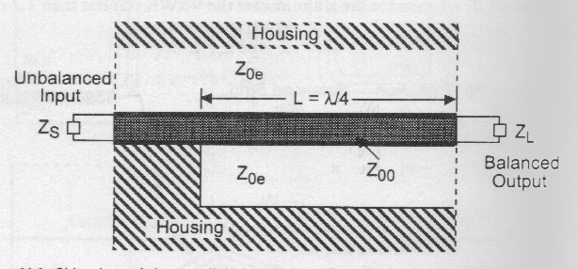

Figure 1 – Cross section view of parallel-plate balun in a metal housing.
The characteristic impedance between the parallel plates is Zoo and the characteristic impedance between the plates in the housing is Zoe. The balun works well only if Zoe >> Zoo; i.e. the housing is large compared with the spacing between plates.

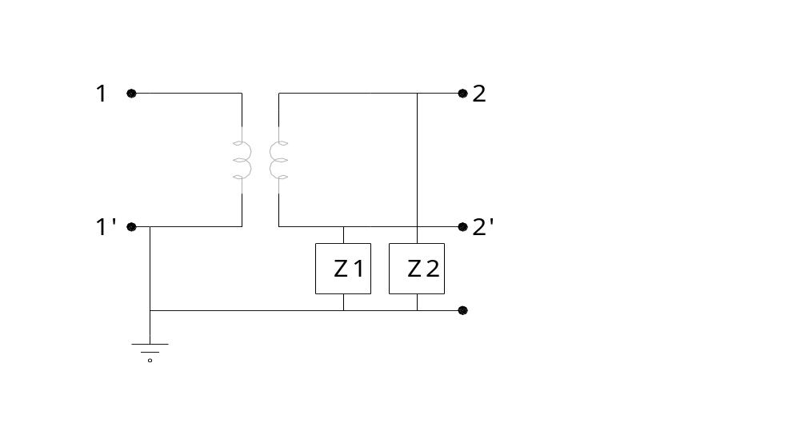Figure 2 – Equivalent circuit of a balun. In the ideal case Z1 and Z2 are open circuits. In many real baluns, Z1 and Z2 are reactive but are not equal. Note that if Z1 is small and Z2 is large a back to back test of the balun will give low insertion loss and reflections but the common-mode rejection is poor. The equivalent circuit of some baluns includes a grounded center tap on the balanced secondary of the transformer.

