Tapered Microstrip Balun for Integrating a Non-Planar Log Periodic Antenna

with an LNA

G. Engargiola

Radio Astronomy Lab

University of California, Berkeley

Abstract

Many antennas generate balanced signals across their terminal pairs, requiring the inclusion of a balun between the terminals and an unbalanced amplifier. For good sensitivity, the amplifiers should be as near to the terminals as feasible. This memo describes a tapered microstrip balun with a 210 Ω balanced port and a 50 Ω unbalanced port, which has favorable geometry and RF performance for integrating a low noise amplifier with a non-planar log periodic antenna developed at the University of California’s Radio Astronomy Lab.

Introduction

Two non-planar LP antennas can be combined to produce an RF feed with dual polarization and low cross polarization coupling. The resulting four-arm structure has a pyramidal shape, which can couple to orthogonal modes of linear polarization. The main radiation lobe is circular down to the 15 dB power contour and radiates in the direction of the antenna apex. We fabricated such an antenna with a 20° opening angle between opposite arms, achieving a forward gain of 12 dB and cross polarization coupling of ~ –25 dB.^{1,2} Fixed between the arms of this antenna is a grounded pyramidal metallic shield with a 10° opening angle, which provides an isolated space for two low noise amplifiers (LNAs), one per polarization channel. To improve the noise performance, this shield may also house a compact cryogenic refrigerator to cool the amplifiers.

Connecting the balanced leads of this antenna to an unbalanced LNA (or transmission line) requires designing a broadband balun which matches the 210 ohm terminal impedance of the antenna to the 50 ohm amplifier input and which can be threaded through the narrow geometry of the shield near the antenna terminals. A design for such a balun is presented in this note.

Basic Design and Modeling

Simply stated, a balun is a reciprocal transducer, converting the odd signal mode at the antenna terminals to the sum of an odd and even mode at the terminals of an unbalanced (grounded) transmission line structure.³ In effect, it passes microwave energy while blocking net RF current flow between the two ports. Space constraints in a narrow pyramidal shield and the need for wide bandwidth make a tapered microstrip design ideal. Gans et al ⁴ demonstrated one of the first examples of a tapered microstrip balun. This is an evolvement of an early broadband balun realized in coaxial line by Duncan & Minerva ⁵.

Figure 1 shows the balun we designed, and Figure 2 shows the tip of the dual polarization feed structure with the baluns connected – the inset shows the entire feed for reference. To achieve good performance at 10 GHz, the log periodic antenna must be truncated at the high frequency end by no more than 0.850” below the vanishing point of the self-similar antenna/shield structure were it continued to arbitrarily high frequency. At this displacement, the opening of the pyramidal shield is 0.150″ × 0.150″ and the antenna terminals are separated by 0.300″. Moreover, since the antenna has two polarization channels, the balanced ports of two baluns must be brought to the narrow end of the shield without inducing significant cross-polarization coupling. For this reason, the shield volume is partitioned by a metallic septum, so that the baluns do not capacitively couple.

The shield volume is partitioned diagonally so that the balanced port of each balun can be located to give maximum separation from the surrounding grounded metal walls, which limits the highest practical impedance one can achieve with a twin-lead. The balanced port of each balun must have the same impedance as the antenna terminals (210 Ω). This can be conveniently achieved within the available space constraints by fabricating offset 0.010″ microstrip lines separated by 0.050″ on opposite sides of 0.015″ thick Cuflon. The balun leads are approximately 0.050″ equidistant from the septum and pyramidal shield walls. Cuflon ⁶ was chosen over Duroid 5880 ⁷ circuit board material because the combined ohmic and dielectric losses are nearly a third less over the band.

The twin-lead input of the balun is a 210/50 Ω impedance transformer . The input of the balun transducer section, described in the next paragraph, is a broadside-coupled pair of 0.060” lines. For reasons of space economy it is most conveniently mated to the twin lead input by asymmetrically tapering top and bottom conductors (Fig. 3a) so that the outer diameter of the pair remain constant (0.060″). The cross section of the balun is shown in Figure 1 as the lower set of figures. Simulation with IE3D⁸ gives the impedance of this transmission line structure as a function of a single linear parameter X (see Figures 3a and 4). Figure 4 also shows the impedance along the line (Z). The impedance steps yield a 20-section 210/50 Ω transformer of minimum length with a 25 dB return loss (Klopfenstein taper⁹). The number of sections limits the high frequency limit (> 10 GHz), and the total length determines the low frequency cutoff (< 1 GHz). Full wave simulations predict a return loss of better than 25 dB and less than 0.2 – 0.4 dB of insertion loss (Fig 3b).

The transducer section (Fig. 5a) consists of a 0.060” wide line broadside coupled through the substrate to a line of the same width at the balanced port which flares out quasi-exponentially. At the unbalanced port, the balun transducer is effectively a microstrip line, where the bottom conductor becomes the ground plane (it is attached to case ground along the end). The length of the transducer and speed of the taper of the bottom conductor line determine the passband of the transducer section, which has been optimized for 1 - 10 GHz. Full wave simulations predict a return loss of less than 20 dB and an insertion loss of less than 0.2 – 0.3 dB (Fig 5b).

Test Results

As shown in Figure 1, this taper-line balun has two sections: the balanced line portion which matches the antenna impedance to ~50 Ω and a portion which actually performs the mode transduction. One method to confirm the proper function of this balun design is to connect two baluns end-to-end at the balanced port (Figure 6a). This requires fabricating a balun similar to the first but with the conducting features reflected about the midline. S-parameter measurements can then be performed with an Agilent 8722ES spectrum analyzer.

Figure 7 shows that the transmission properties of this circuit at room temperature are |S₂₁| < 1 dB for frequencies spanning 1 to 7 GHz and |S₂₁| < 2 dB from about 7-11 GHz. This is somewhat greater than the net insertion loss of 0.8 – 1.4 dB predicted by doubling the simulated losses. The discrepancy at least partially arises from the omission of a correction to the method of moment simulation results for the effects of dielectric surface roughness. The return loss |S₁₁| is 15 – 20 dB across the same band.

To check the phase performance of the balun , we made a second circuit configuration by connecting two baluns end-to-end as before but with the twin leads cross-connected (Figure 6b) i.e one of the baluns is flipped 180° about its midline. Since the balun transforms a balanced signal in the H-plane to an unbalanced signal in the E-plane, a comparison of the two back-to-back balun configurations should exhibit a 180° phase difference. A thru calibration is performed with the network analyzer attached to the first end-to-end balun circuit configuration, after which the phase of the second configuration is measured. Figure 8 shows that from 1 - 10 GHz the measured phase difference between the two back-to-back configurations is 180°±2°.

Discussion

The results quoted in the previous section apply to balun pairs mounted in an open test fixture. For this balun to properly link a LNA with our LP antenna, it must operate in a metal pyramidal shield. The effects of nearby conducting walls are two-fold: (1) they lower the characteristic impedance of both balanced and unbalance transmission lines (2) they provide a conduction path for in-phase signals (the even mode) along the twin leads. Care must be taken to avoid significant excitation of the even mode, which can raise sidelobe patterns and reduce the forward gain. It is expected that with a good impedance AND field match to the balun at both ports (with careful design of the RF transitions) the even mode excitation should be negligible. Indeed, placing our end to end balun test fixture in a long metal box approximately 1” x 1” in cross section increases measured loss by less than 0.05 dB – this seems to indicate minimal coupling to the even mode by the unbalanced ports. Nevertheless, special care must be taken against misalignment of the balun in narrow asymmetric metal enclosures which can lead to the excitation of common modes or to high-Q cavity modes.

One way to attenuate any possible unwanted modes on an enclosed cryogenic balun is to attach a resistive card vane to the inside of the radiation shield, perpendicular to the plane of the balun along the midline (Figure 8). Care must be taken not to attenuate the odd mode in locations where the fringe fields between balanced leads are high. To avoid this, the vane should probably have maximum extent at the balun "neck" (the transducer input) where balanced lines are broadside coupled and fringe fields are at minimum strength.

Use of a tapered microstrip balun in a narrow cryostat requires scaling the design to quartz (ε = 3.8 – 4.5) or alumina (ε = 9.6), which can reduce its length by more than a factor of 3. By making the tapered microstrip balun as short as possible, one can minimize the noise contribution due to ohmic loss. This is especially important when designing a low noise log periodic frontend, where it is desirable to locate cooled GaAs or InP MMIC amplifiers as close as possible to the antenna terminals. In the Cuflon balun (ε = 2.1), the twin-lead impedance matching section and the balun transducer were optimized as separate circuits, resulting in a total circuit length of ~10”. By closely integrating the impedance matching and mode filtering function, it is possible to design a 500 MHz – 11.2 GHz balun on a 0.020”quartz substrate which is 3.6” in length (Figure 8). In this case, the impedance match is 210/100 Ω -- the unbalanced end is directly wirebonded to a MMIC amplifier at 77 K. Simulations show the VSWR is < 1.2.

Conclusion

A wideband microstrip balun has been developed which can be used in low noise cryogenic applications. Its narrow geometry and low loss make it ideal for attaching an unbalanced amplifier module to a non-planar log periodic antenna. When the balun is placed in a conducting enclosure, excitation of unwanted modes of transmission can be minimized by careful field and impedance matching of balun ports and by inclusion of a resistive vane in proximity to the balun.

Acknowledgements

The author wishes to thank W. J. Welch and D DeBoer for helpful discussions.

References

¹ G. Engargiola,.2003, “Non-planar log-periodic feed for integration with a cryogenic
microwave amplifier,” IEEE Symposium Digest, “New Frontiers in Antennas and Propagation for a Wireless World,” June 16-21, San Antonio, TX

² U.S. Patent Application., Pub.no. US2003/00116181, “Log Periodic Antenna,” Gregory Engargiola, Pub. Date: Jan 23, 2003

³ Stephan Maas, “The RF and Microwave Circuit Design Cookbook,” Boston London: Artech House, c1998

⁴ M. Gans et al., “Frequency Independent Baluns,” Proc. IEEE, p647, June 1965

⁵ J. W. Duncan & V. P. Minerva, “100:1 Bandwidth Balun Transformer,” Proc. IRE, p156, February 1960.

⁶ Cuflon, Polyfon Co., Norwalk, CT 06851

⁷ Duroid 5880, Rogers Corp., Chandler, AZ 85226

⁸ IE3D ver. 9.0, Zeland Software, Inc., Fremont, CA 94538

⁹ R. W. Klopfenstein, Proc. IRE, January 1956, pp 31 - 35
Figure Caption

Figure 1: Drawing of the balun. The lower set of figures shows the cross-section at different places along the line.

Figure 2: Feed with baluns and feeder tip; inset shows the upper third of the full-size feed. The inner pyramidal shield is semi-transparent.

Figure 3a: Matching transformer section of the balun showing the offset X.

Figure 3b: Full wave simulation of the transformer section of the balun. Shown are S₁₁, S₂₁, S₁₂ and S₂₂.

Figure 4: (Red) Impedance as a function of X, the inner line separation, with the outer line separation of 0.060″ and Cuflon thickness of 0.015″. (Black) Impedance along the line Z.

Figure 5a: Transducer section and unbalanced “microstrip” end of the balun.

Figure 5b: Full wave simulation of the transducer section of the balun. Shown are S₁₁, S₂₁ and S₂₂.

Figure 6: (a) End-to-end connection of the balun. (b) Cross-connected balun.
Figure 7: Measured performance of end-to-end balun. Note that S₂₁ includes only one length of balun, while S₁₁ is the full end-to-end setup.

Figure 8: Relative phase between the balun arrangements shown in Figure 6.

Figure 9: Rendering of a resistive card vane (green) over balun (blue/red) for attenuating unwanted modes within a conducting enclosure.

Figure 10 A tapered microstrip balun fabricated on 0.020” quartz. Suitable for use in a cryogenic frontend i.e cooled to same temperature as an InP or GaAs MMIC amplifier. Antenna arms are assumed outside the cryostat, at 295 K. This quartz balun is ~1/3 the length of the Cuflon balun we fabricated and tested.

Figure 1 – G. Engargiola, Review of Scientific Instruments

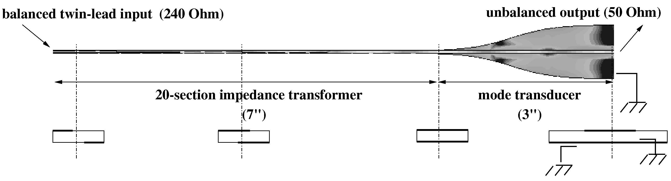

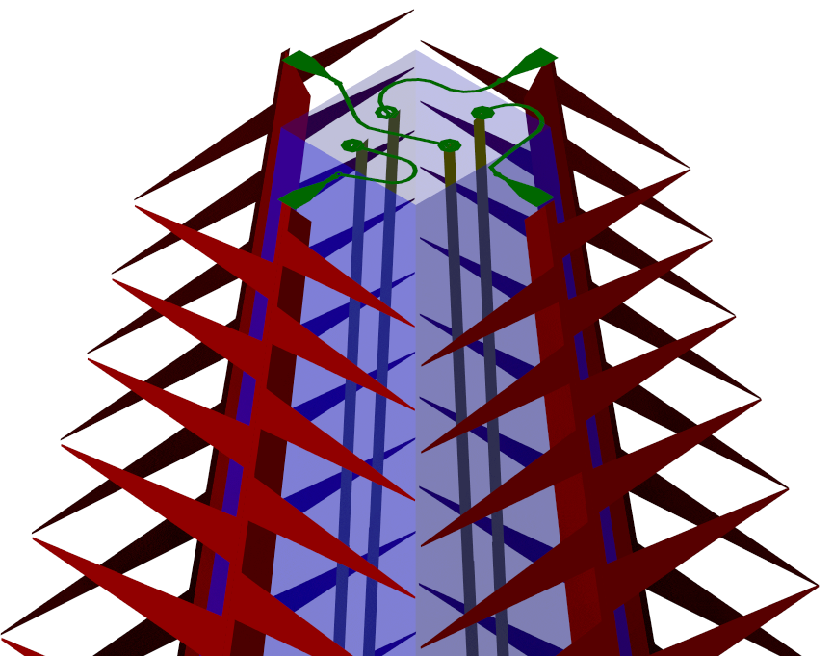
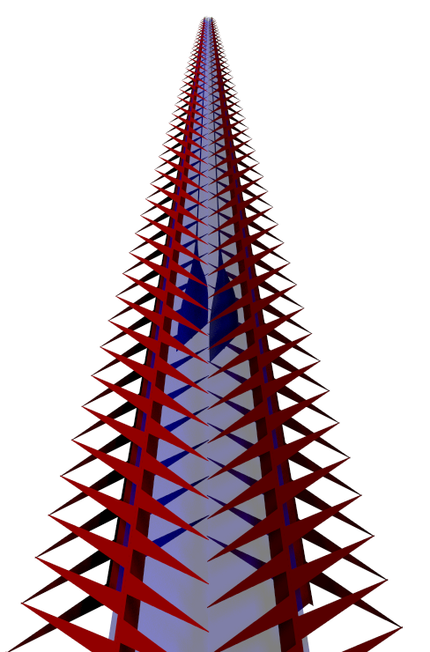

Figure 2 – G. Engargiola, Review of Scientific Instruments

X
midline
Figure 3a – G. Engargiola, Review of Scientific Instruments

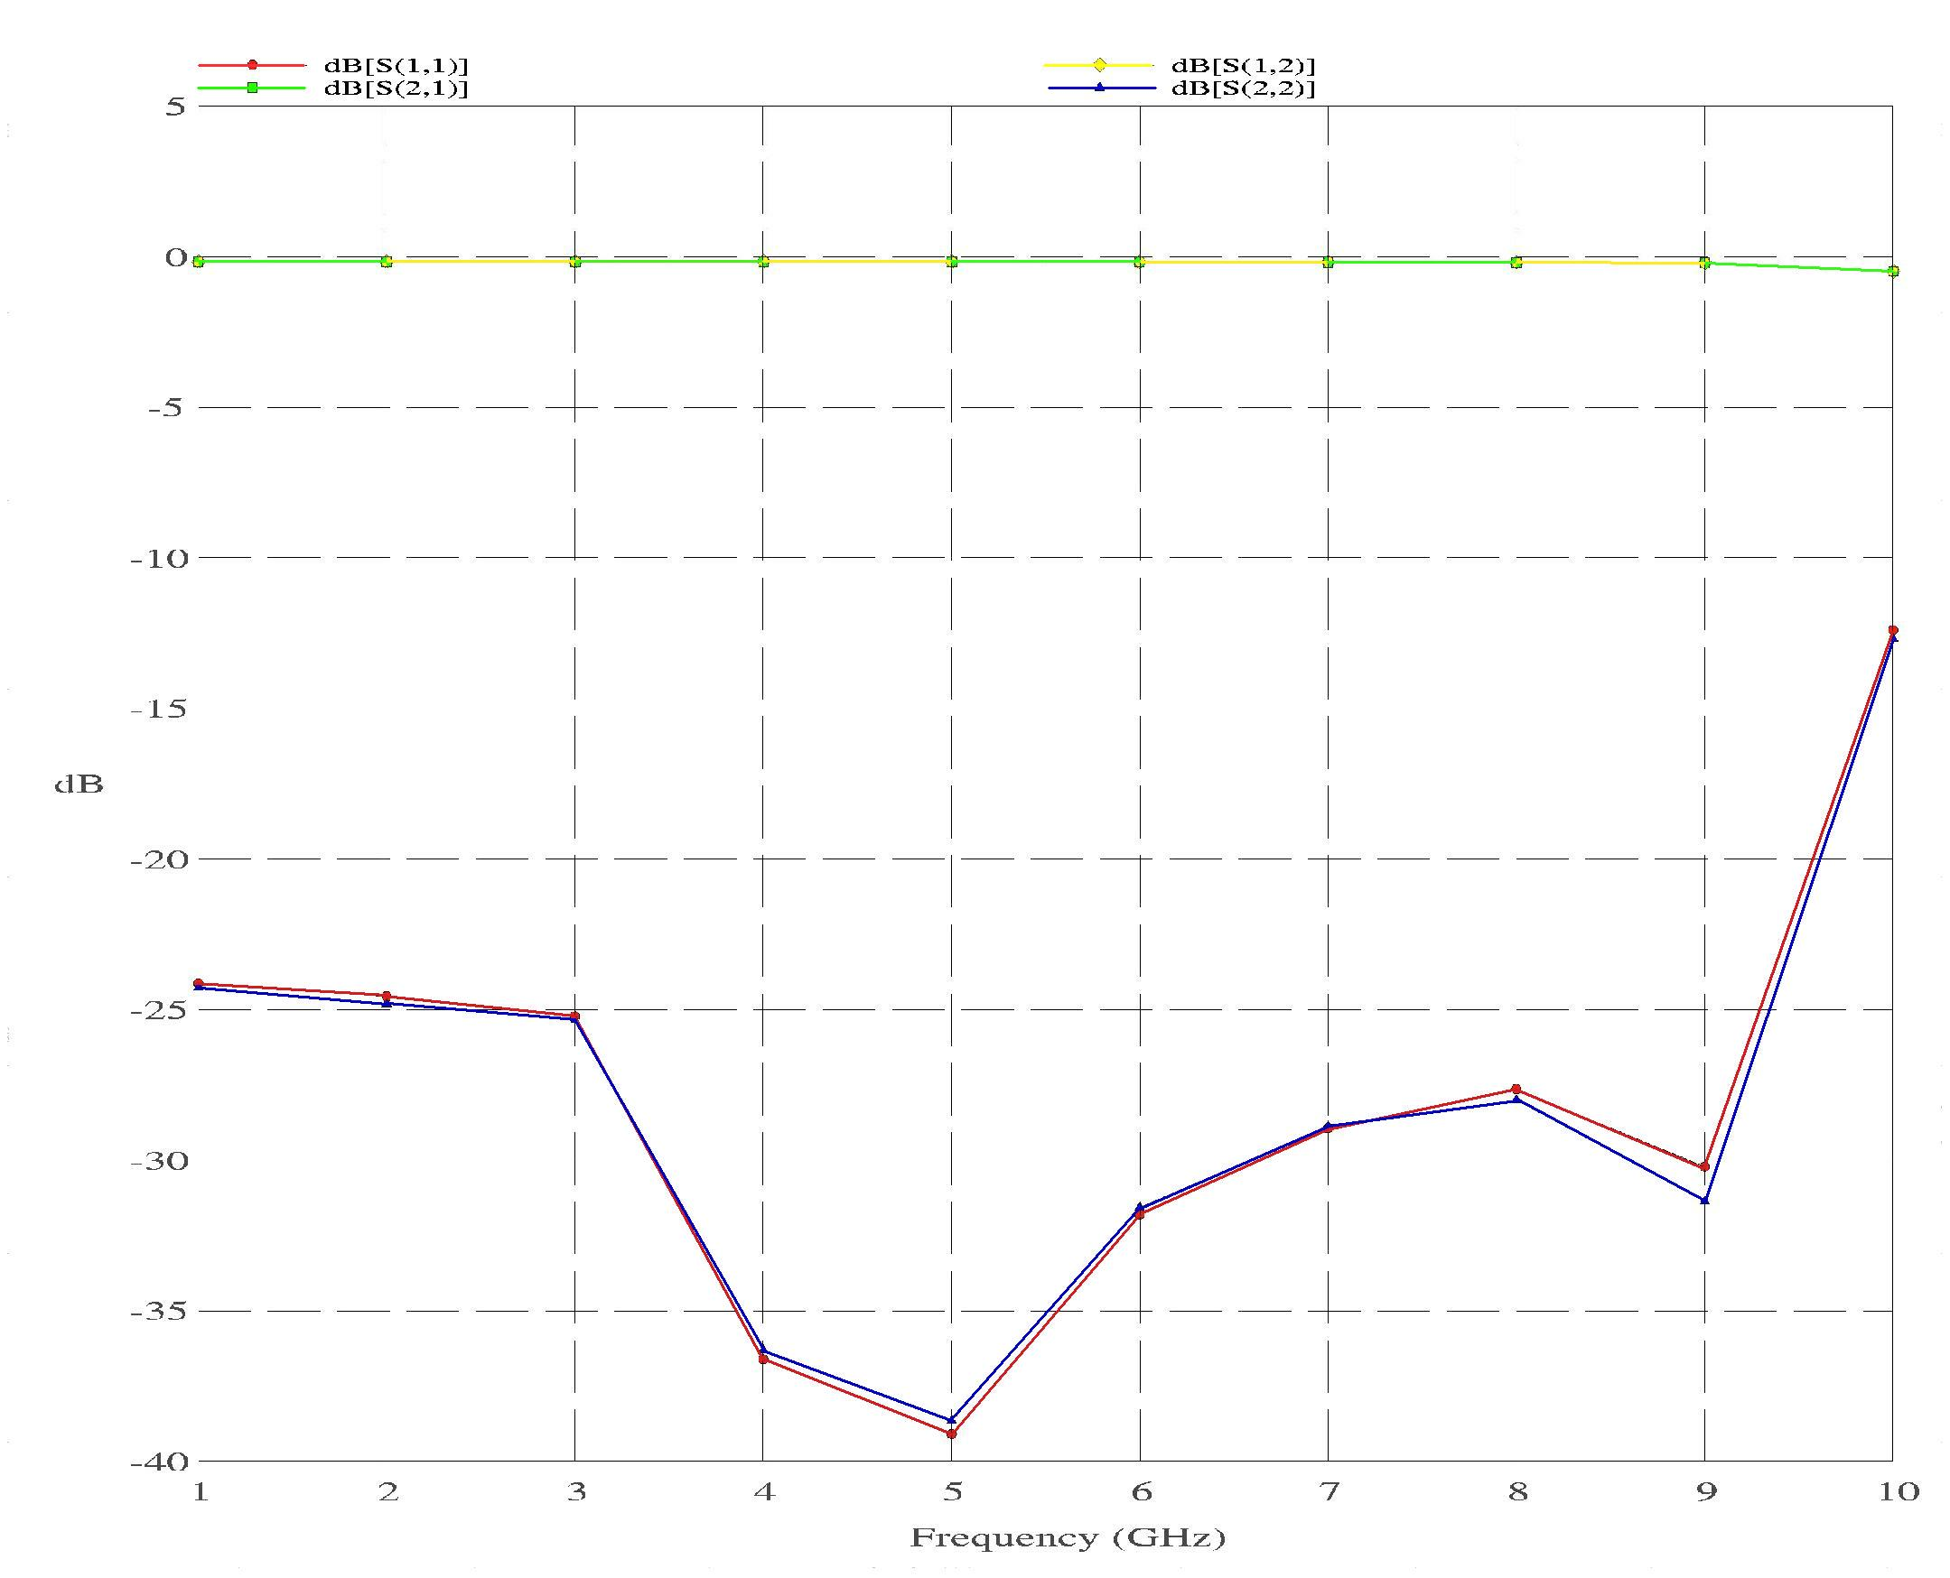
Figure 3b – G. Engargiola, Review of Scientific Instruments

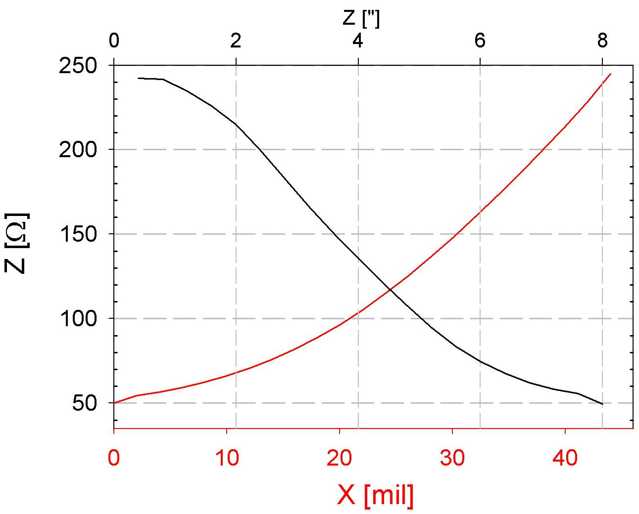

Figure 4 – G. Engargiola, Review of Scientific Instruments
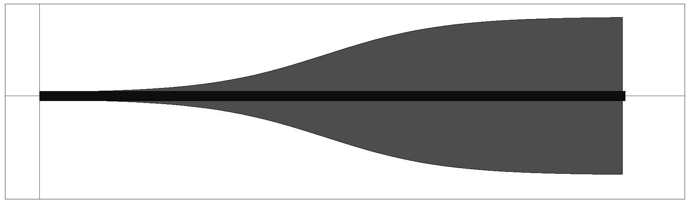

Figure 5a & 5b – G. Engargiola, Review of Scientific Instruments

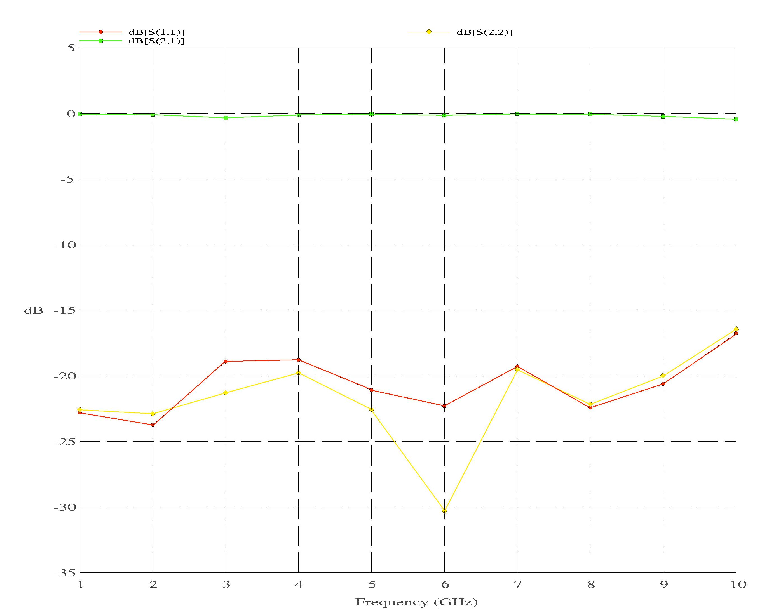

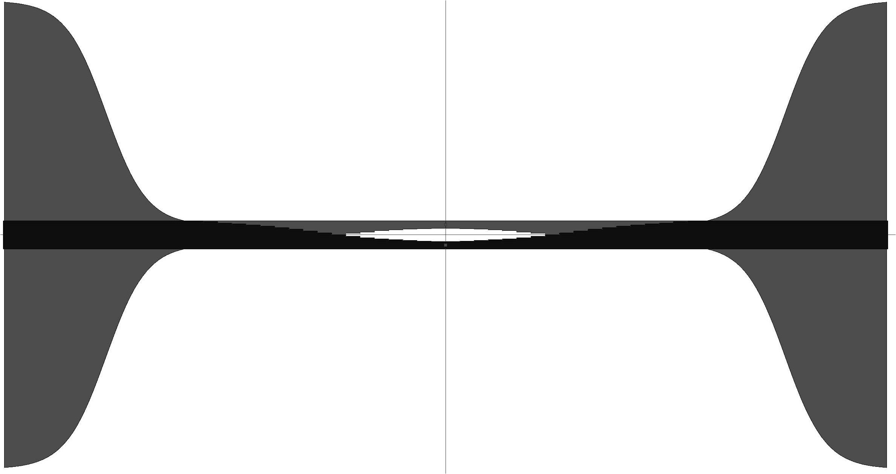
(a)
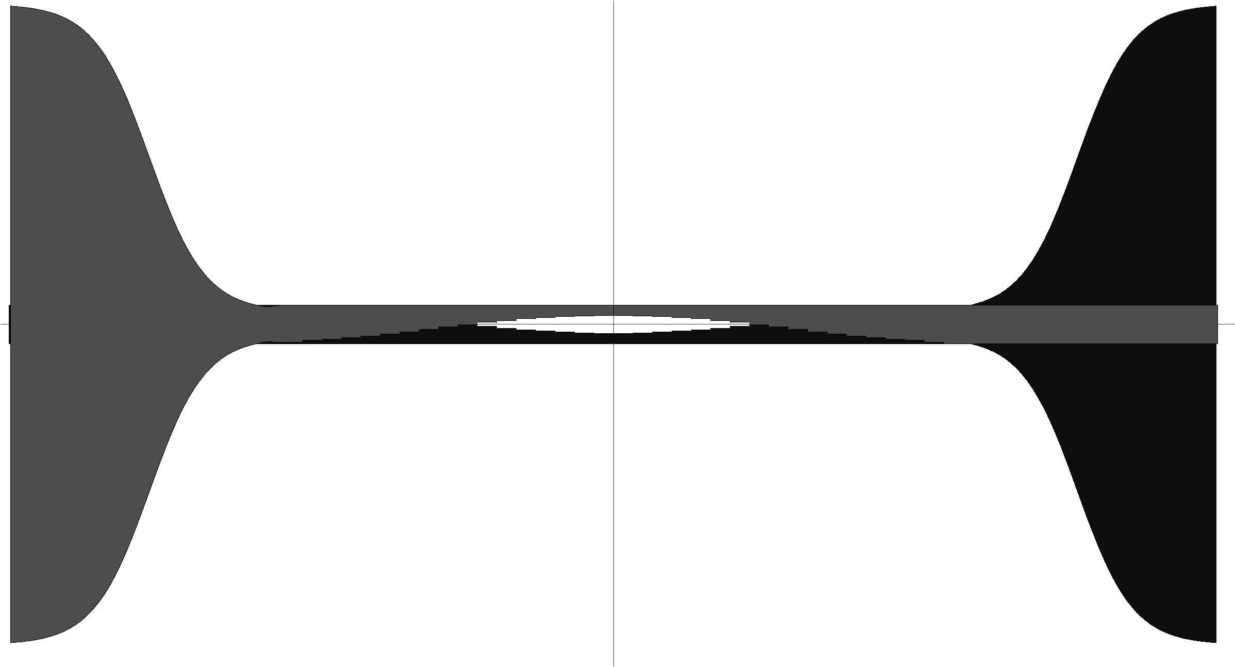
Figure 6: (a) & (b) – G. Engargiola, Review of Scientific Instruments
(b)

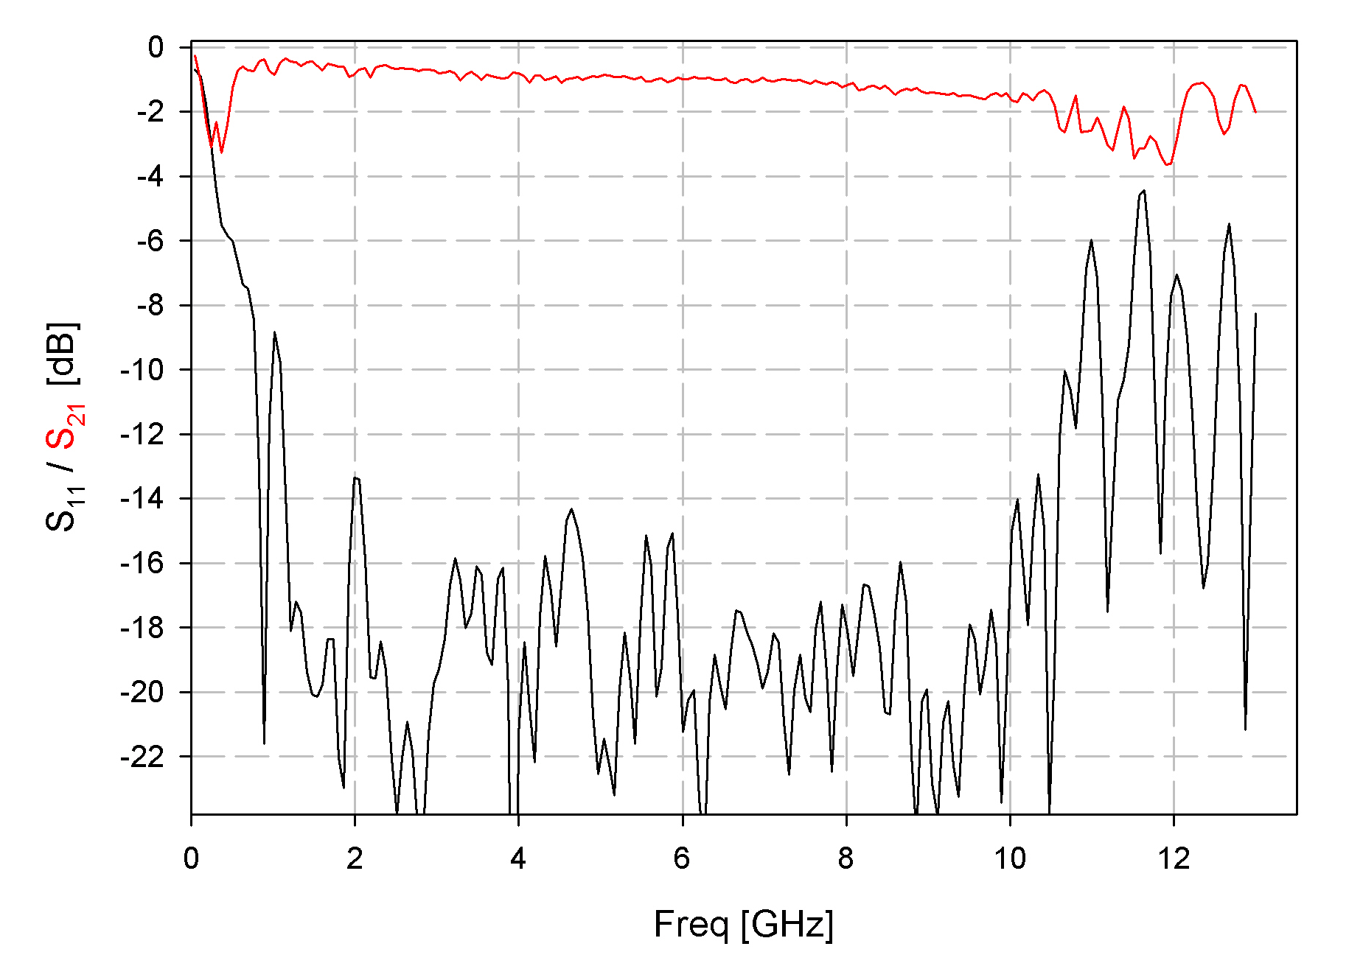

Figure 7– G. Engargiola, Review of Scientific Instruments

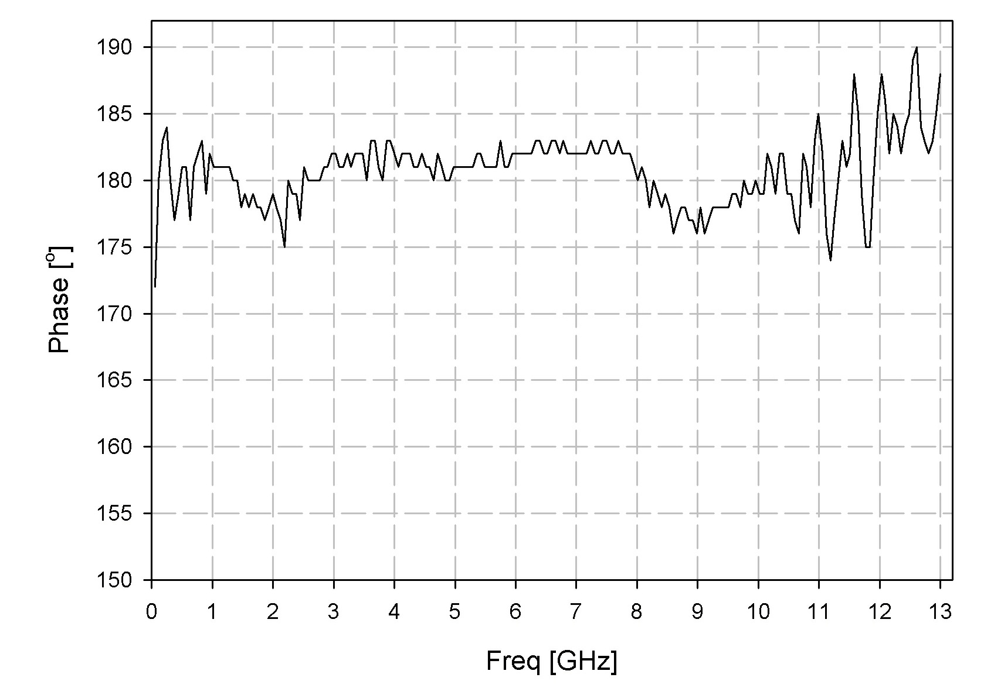

Figure 8 – G. Engargiola, Review of Scientific Instruments

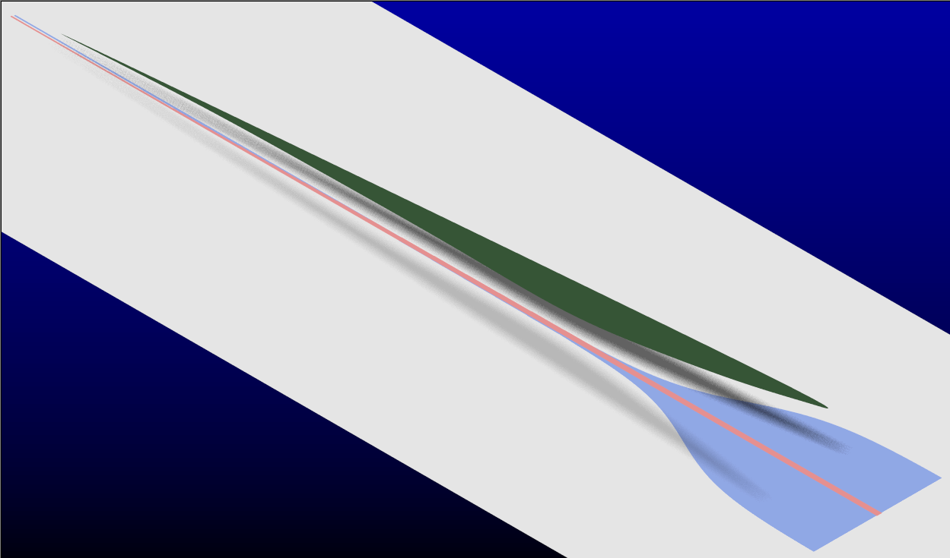

Figure 9, G. Engargiola, Review of Scientific Instruments

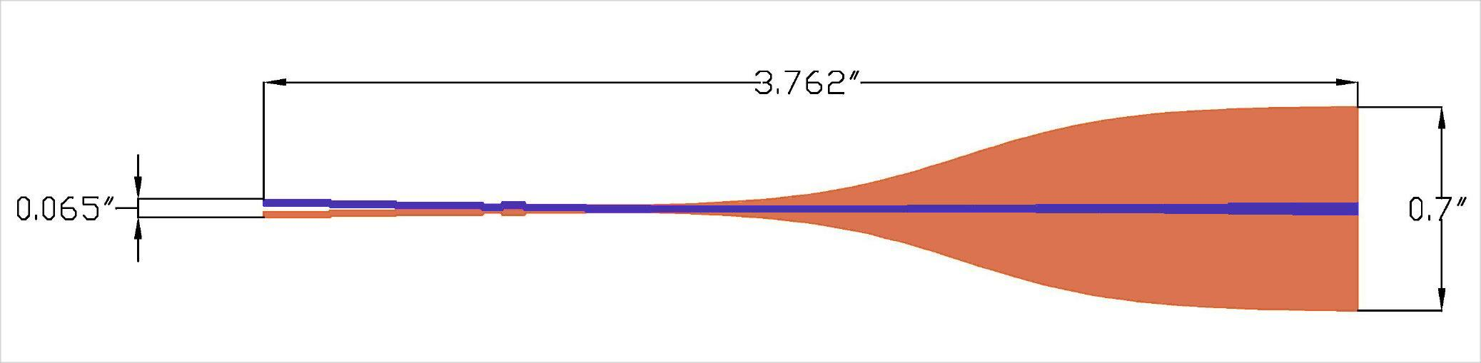

Figure 10 - G. Engargiola, Review of Scientific Instruments

