Attenuator Module V2 for the PAM
- Frequency: 0.1-20GHz
- Attenuation: 5-BIT, max: 31 dB
- Impedance: 50Ω

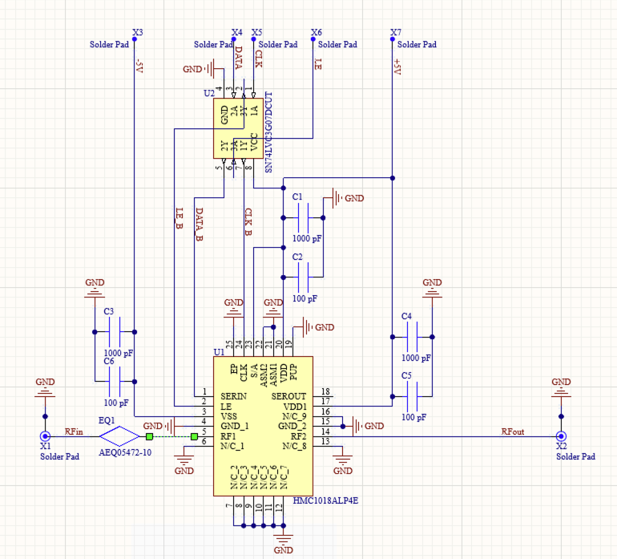
Schematic
Inputs:
- RFin: Radio signal input
- +5V: positive supply voltage (+5V@4.5mA)
- -5V: negative supply voltage (-5V@5.5mA)
- CLK: Clock Signal
- DATA: serial bit-pattern for attenuator
- LE: Letch Enable
- GND
Outputs:
- RFout: Radio signal output

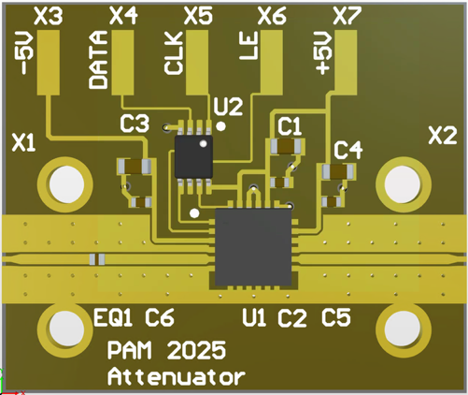
Components - All Case Codes are metric
2 – SMA 2Hole (142-1701-201) [X1, X2]
5 – Feed through cap 4-40UNC-2A (B3C153B) [X3-7]
1 – Turret Terminal 2-56 UNC – 2A (1595-2)
1 – variable attenuator (HMC1018ALP4E) [U1]
3 – 100pF 1005 (GRM1555C2A101FA01D) [C2,C5,C6]
3 – 1000pF 1608 (GCM1885C1H102FA16D) [C1,C3,C4]
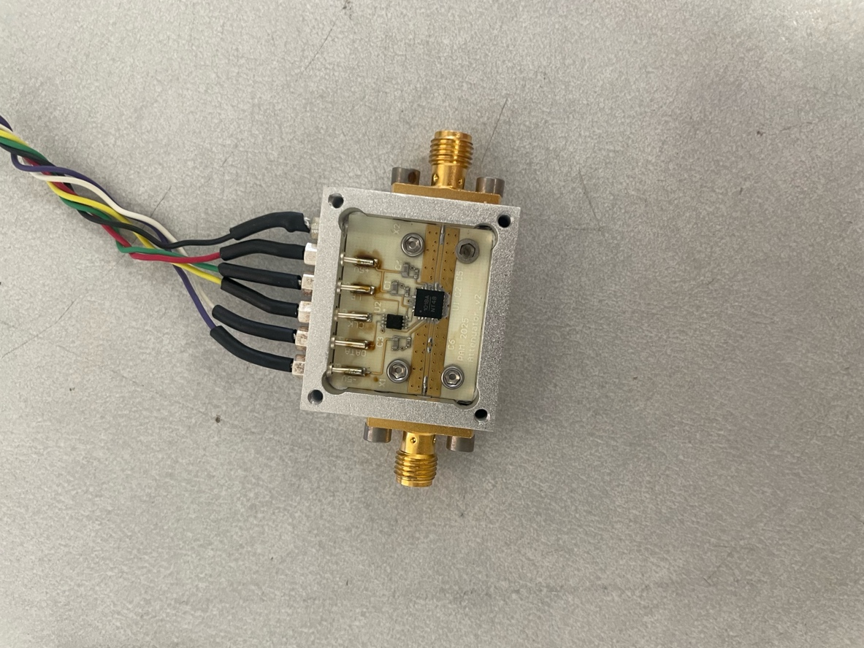
1 – 3.5dV equalizer 0605 (AEQ05472-T) [EQ1]
1 – Non-Inv. buffer VSSOP-8 (SN74LVC3G17DCUR) [U2]
1 – RO4350 PCB
1 – Box
1 – Lid
4 – Screws 3-48 UNC - 2B x 3/16 (92196A091)
4 – Screws 2-56 UNC - 2B x 1/8 (21202)
4 – Screws 2-56 UNC - 2B x 5/32 (91771A884)
1 – RF-absorber PSA 0.08’’, ca. 20 x 24 mm (MR42-0008-20)
Footprint
Ground pins surrounding the RF input and RF output are connected to the central ground pad.
