Detector Module for the PAM
- Frequency: 0.5-20GHz
- Impedance: 50Ω

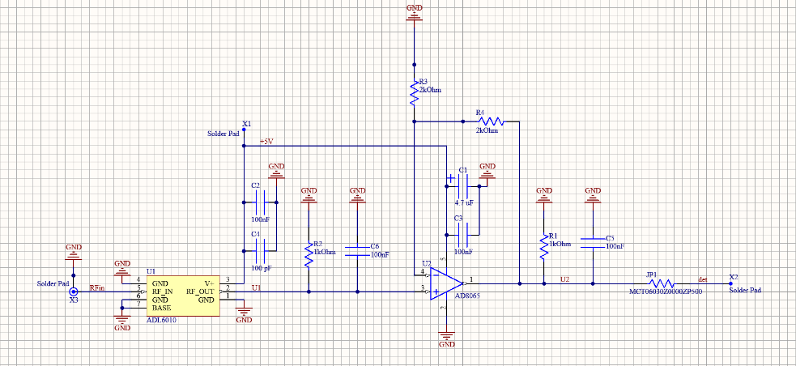
Schematic
Inputs:
- RFin: Radio signal input
- +5V: positive supply voltage (+5V@1.6mA)
- GND
Outputs:
- Det: Output for power measurement

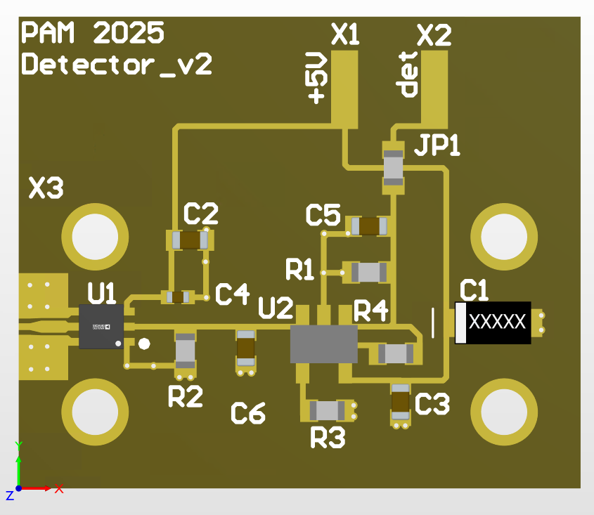
Components - All Case Codes are metric
1 – SMA 2Hole (142-1701-201) [X3]
2 – Feed through cap: 4-40UNC-2A (B3C153B) [X1,X2]
1 – Turret Terminal 2-56 UNC – 2A (1595-2)
1 – detector LFCSP-6 (ADL6010ACPZN-R2) [U1]
1 – op amp SOT-23-5 (AD8065ARTZ-REEL7) [U2]
1 – 100pF 1005 (GRM1555C2A101FA01D) [C4]
1 – 4.7uF 3216 (TH3A475K020C5000) [C1]
4 – 100nF 1608 (GCM188R71C104KA37J) [C2-3,C5-6]
1 – 0Ω 1608 (MCT06030Z0000ZP500) [JP1]
1 – 1MΩ 1608 (MCT06030C1004FPW) [R1]
1 – 2kΩ 1608 (MCT06030C2001FP500) [R2]
1 – 1.6kΩ 1608 (MCT06030C1601FP500) [R4]
1 – 402Ω 1608 (MCT06030C4020FP500) [R3]
1 – RO4350 PCB
1 – Box
1 – Lid
2 – Screws 3-48 UNC - 2B x 3/16 (92196A091)
4 – Screws 2-56 UNC - 2B x 1/8 (21202)
4 – Screws 2-56 UNC - 2B x 5/32 (91771A884)
1 – RF-absorber PSA 0.08’’, ca. 20 x 24 mm (MR42-0008-20)

Footprint
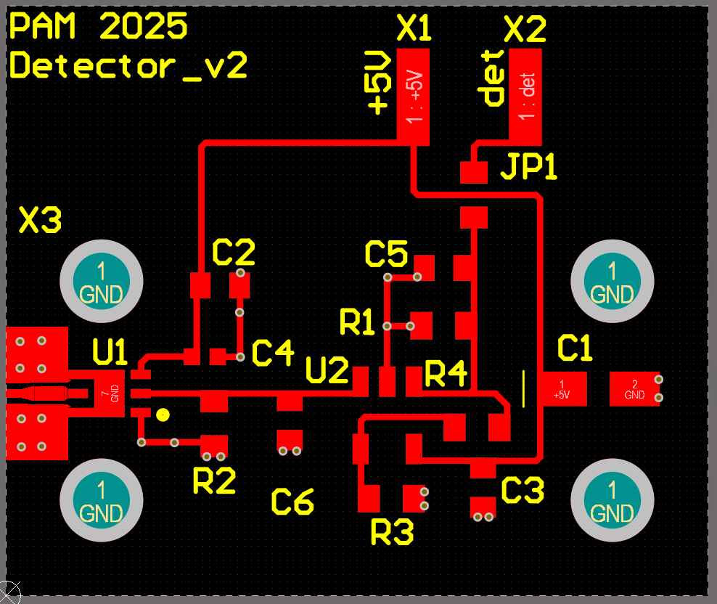

S-parameter
S-parameter measurement with the VNA (N5230C) of detector module v1.
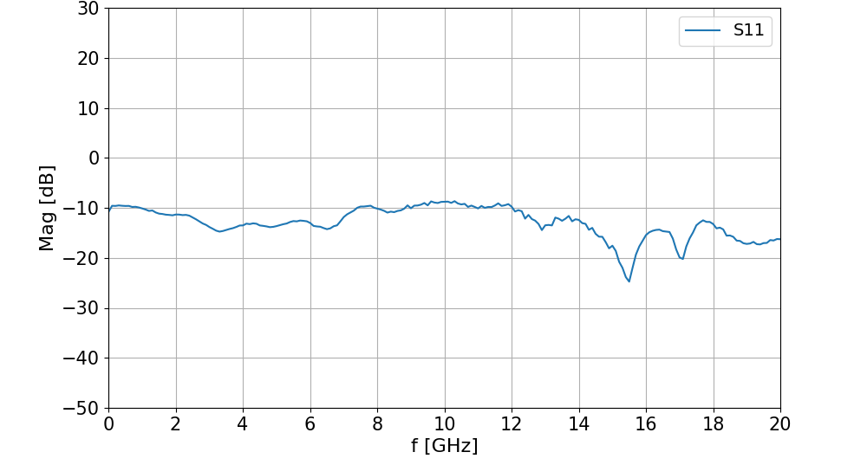

Voltage-to-power Curve
A signal generator (E4420B) was used to apply an RF input with a fixed frequency and varying power levels. It was connected with a 14 inch long SMA cable (AFX-CA-141-14 AtlanTec RF) to the detector module v1. The power was increased stepwise and the corresponding output voltages were measured using a multimeter. A power supply provided the +5 V supply voltage for the detector module.
