The Post-Amplifier Module (PAM)

David DeBoer
April 29, 2002

0 – Introduction
The post-amplifier module, or PAM, is a temperature-regulated module that sits within the feed pyramid and accepts dual-polarization radiation from the LNA’s and transmits the entire dual-pol RF band (0.5–11.2 GHz) back to the converter room via analog optical fiber. It also houses the necessary control components to regulate temperature and voltage. This report summarizes the specifications for the PAM.

1 – The Pyramidal Housing
The feed pyramid in which the PAM will be housed is roughly 1.2-m with a 5° half-angle. This makes the rear opening roughly 8.5″ wide. The front portion of the pyramid is the dewar itself followed by a hollow portion divided down the middle by a septum to duct airflow in and out. The cryogenics is also housed in this area. Figure 1 shows the interior of the pyramidal housing. The top figure shows the PAM on the back of the housing, while the lower figure shows it inside the housing. Both have about the same volume.
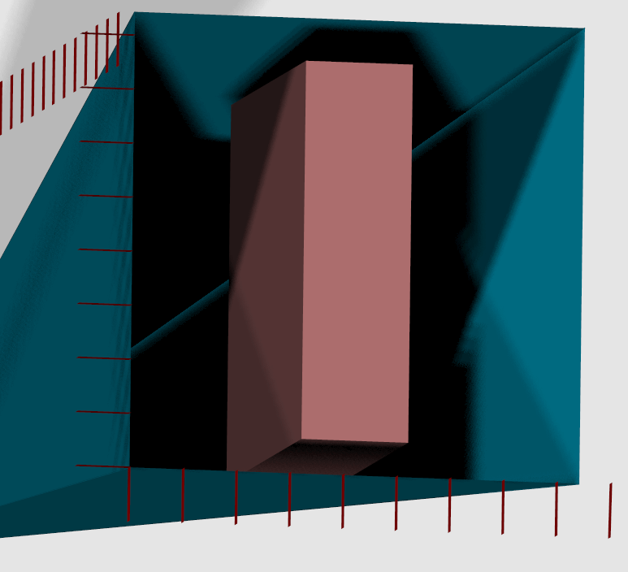
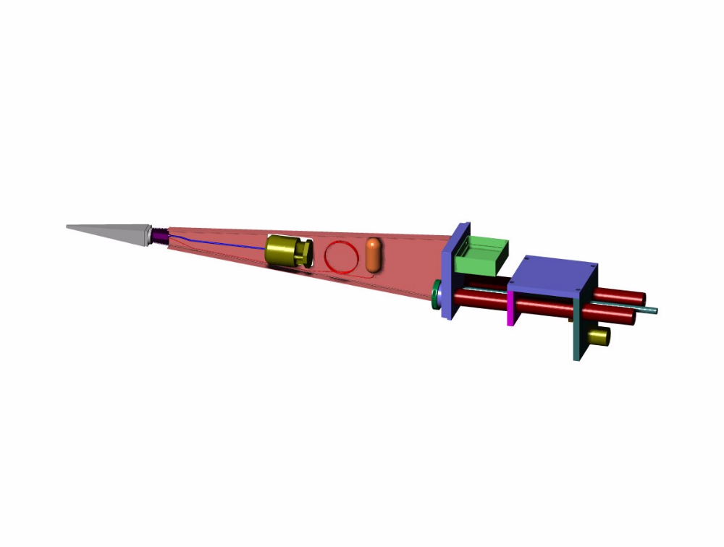
Figure 1: Views of the pyramid enclosure. (Top) Cutaway showing the dewar, heat exchanger, compressor, reservoir, along with an electronics box and focus drive. (Left) End view (with 1″ ruler) and a 7″×7″×2″ box.

2 – LNA and Cable
The LNA that drives the PAM is under development at JPL and is a fairly flat 32-dB gain block contributing 12–20 K across the extended ~11 GHz bandwidth. A fall-back design would utilize a 25-dB LNA, if reduced gain is necessary in the space-constrained dewar. Figure 2a shows the assumed gain/noise temperature profile of the LNA for the 32-dB and 25-dB amps. The 25-dB noise temperature is assumed to be the same as for the 32-dB case.
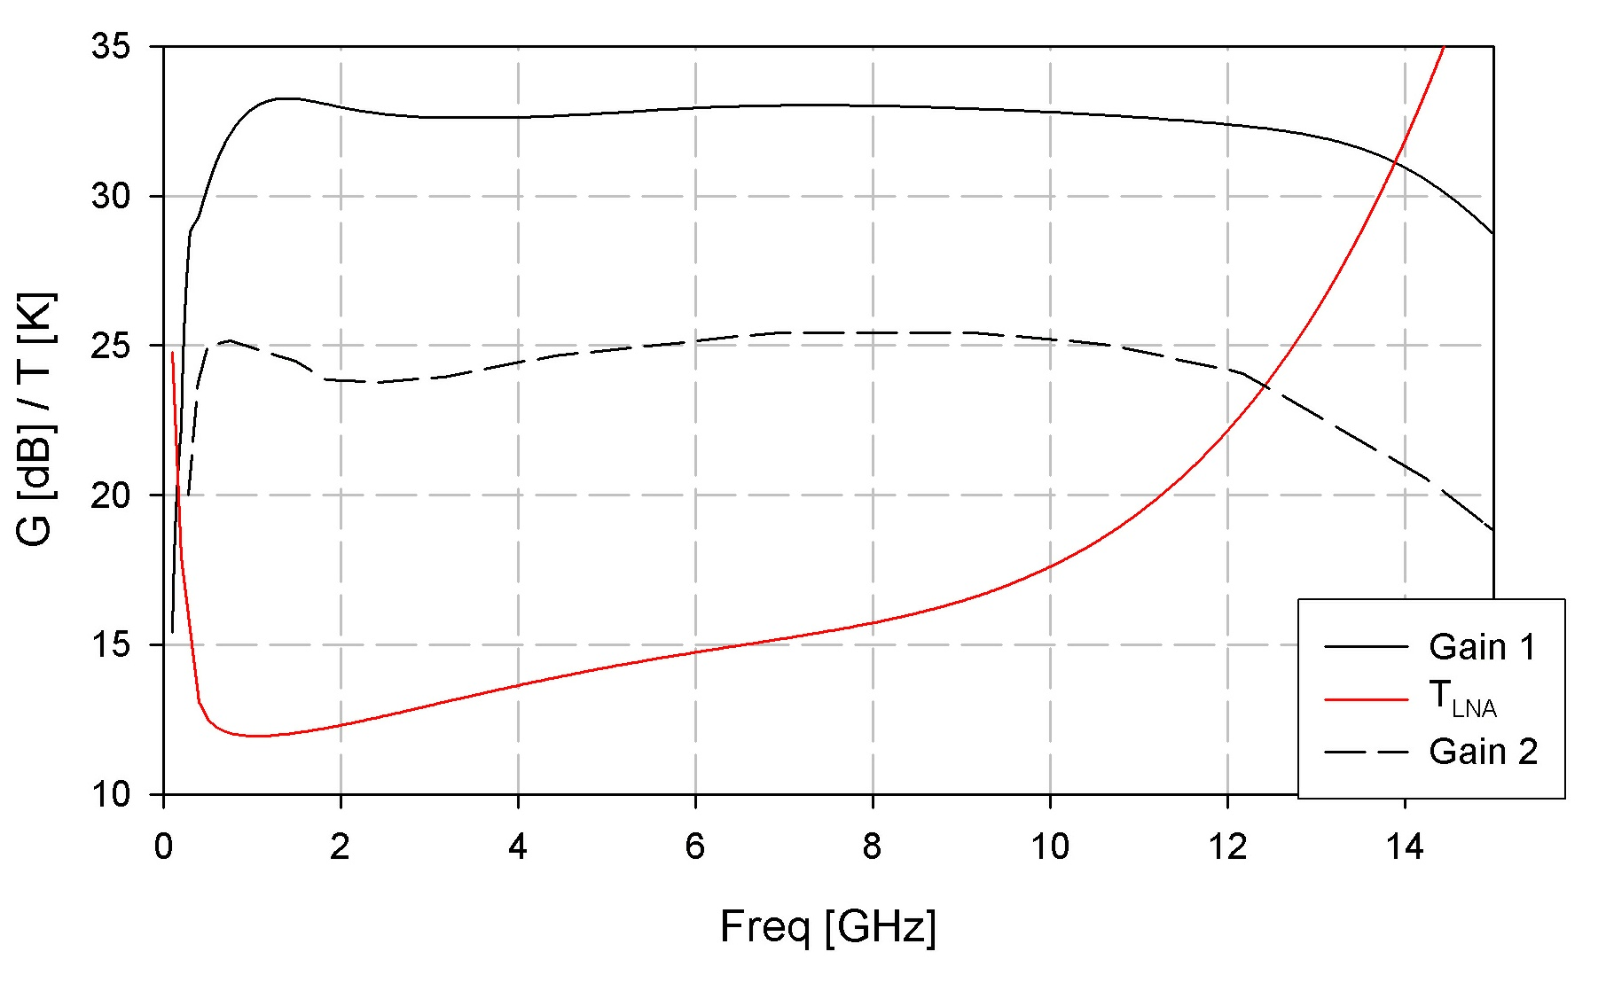
Figure 2a: LNA gain and noise temperature.
Approximately 1-meter of cable will transport the signal to the PAM. Measurements of a length of 0.141″ semi-rigid cable with SMA connectors found in the lab yield the assumed cable loss shown in Figure 2b. A lower loss cable with better thermal characteristics will likely be used, however there will be board and other losses.
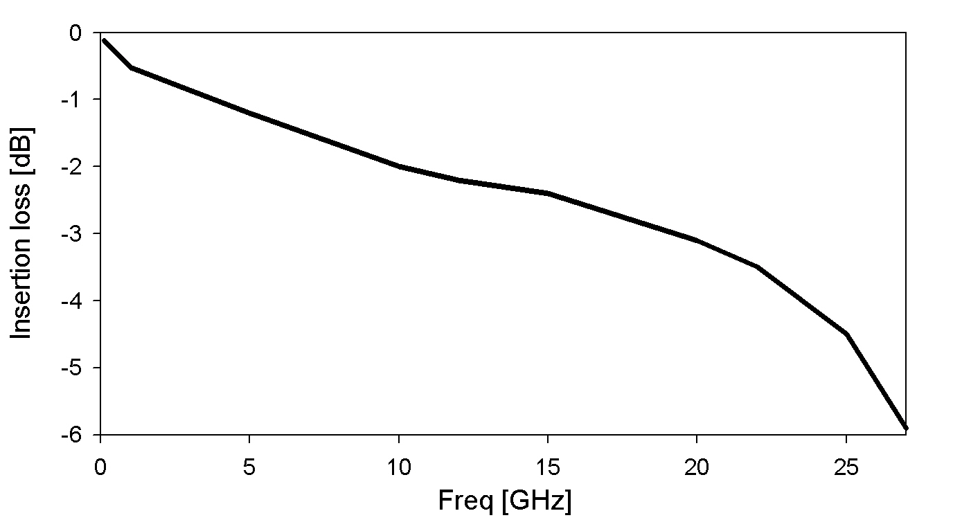
Figure 2b: Cable loss in 0.141″ semi-rigid from the dewar to PAM.

3 – PAM Stages
The PAM will consist of the following cascaded stages:
- gain stage #1 (1×NBB-300, RF Nitro)
- equalizer #1 (Thornton for 3 NBB-300)
- high-pass filter (Thornton)
- variable attenuator #1 (1×HMC424LP3, Hittite)
- gain stage #2 (3×NBB-300, RF Nitro)
- variable attenuator #2 (1×HMC424LP3, with additional 8 dB attenuation, Hittite)
- gain stage#3 (2×NBB-300, RF Nitro)
- equalizer #2 (Thornton for 3 NBB-300)
- fiber-optic transmitter (FLD5F10NP, Fujistu)

3.1 – Gain and Equalizer
The gain element is taken to be an RF Nitro NBB-300 wideband amplifier, and the specs were taken from their web-site (www.rfnitro.com). A constant noise figure of 5.1 dB was assumed (which is their quoted 3 GHz value, and the only value quoted). S₂₁ for the NBB-300 (and NBB-310) is shown in Figure 3.1, and the NBB-300 values are used as the gain. The blue line is the gain after equalization, a resonant circuit designed by Welch. Three NBB-300 units were mounted and tested by Thornton and the gain is shown in Figure 3.1. He also designed an equalizer for the actual performance, which is also shown.
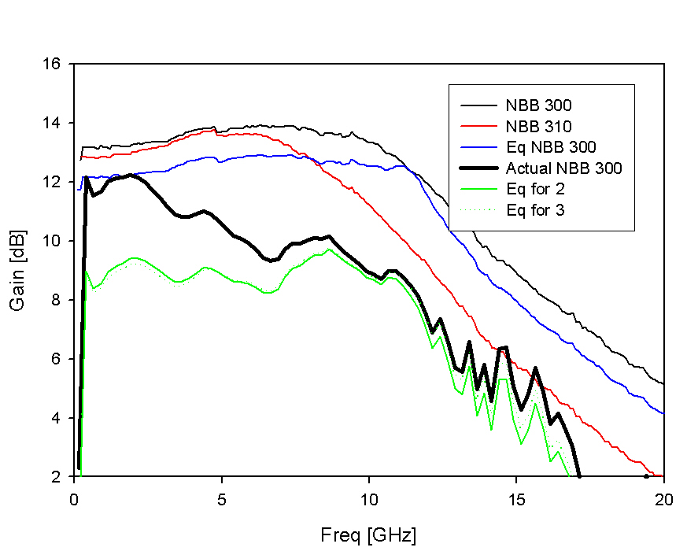
Figure 3.1: Gain of the RF-Nitro GaAs amplifiers, including equalization of the NBB-300. The heavy line is the actual performance and the green line shows the equalization.

3.2 – High-Pass Filter
The high-pass filter is inserted early to filter out the strong low-frequency signals, and is a 7 pole filter with a 3-dB cut-off frequency of 0.3 GHz designed by Thornton. The insertion loss is shown in Figure 3.2.
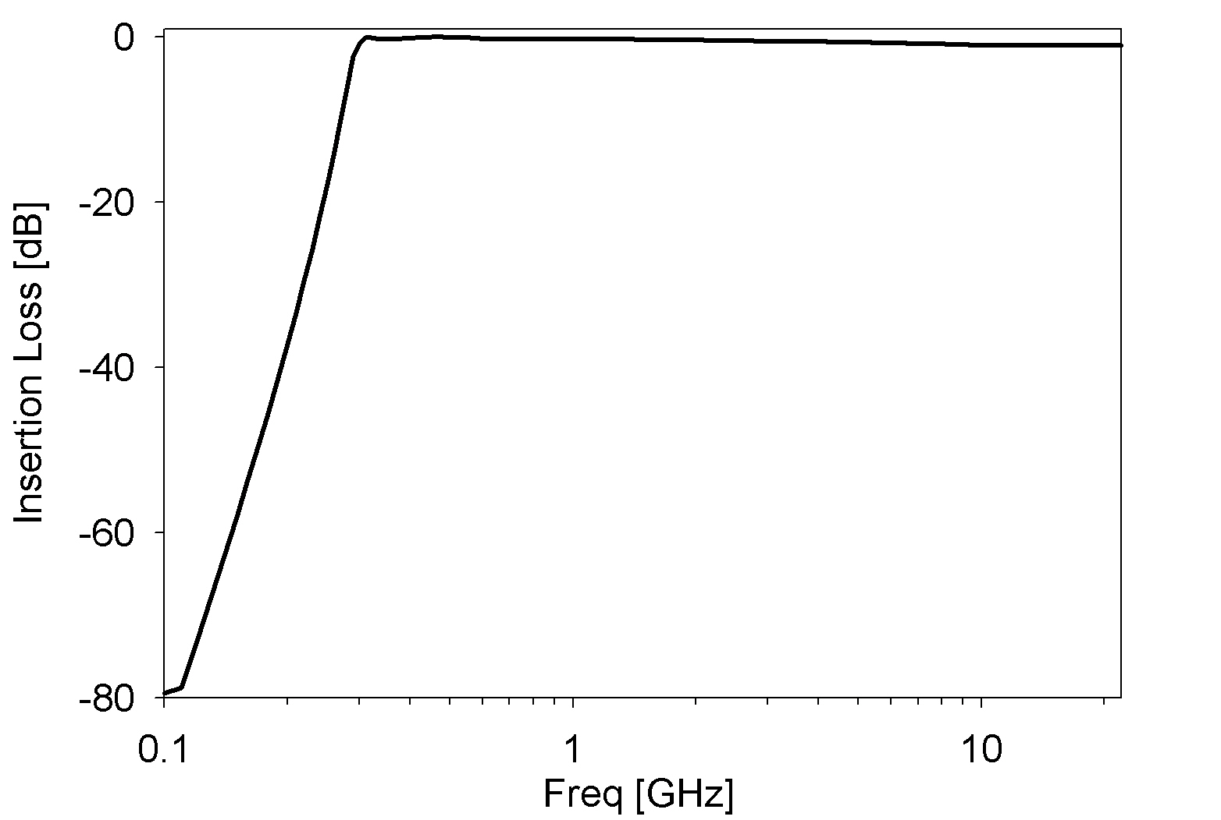
Figure 3.2: Insertion loss of high-pass filter.

3.3 – Variable Attenuator
The variable attenuator will be two cascaded Hittite HMC424LP3 6-bit 0.5dB step attenuators. The nominal insertion loss of one unit is 3 dB (see Figure 3.3, read from data sheet graph). The total additional attenuation that can be switched is then about 64 dB.

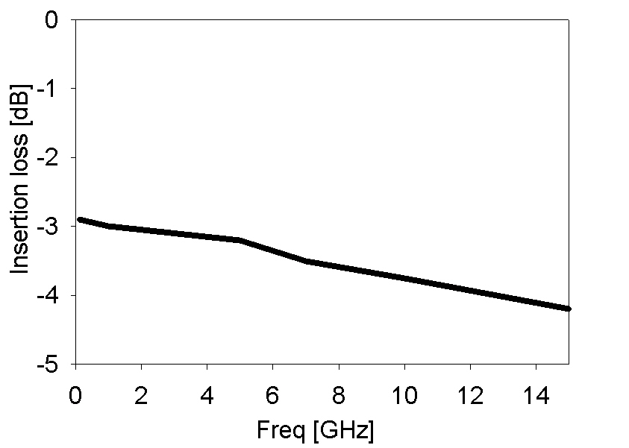
Figure 3.3: Insertion loss of the Hittite variable attenuators.

3.4 – Fiber-Optic Transmitter
The fiber-optic link is a Fujitsu FLD5F10NP, with an assumed constant 42 dB noise figure. The drive power to the fiber TX should be about -11.5 dBm. The gain is shown in Figure 3.4.
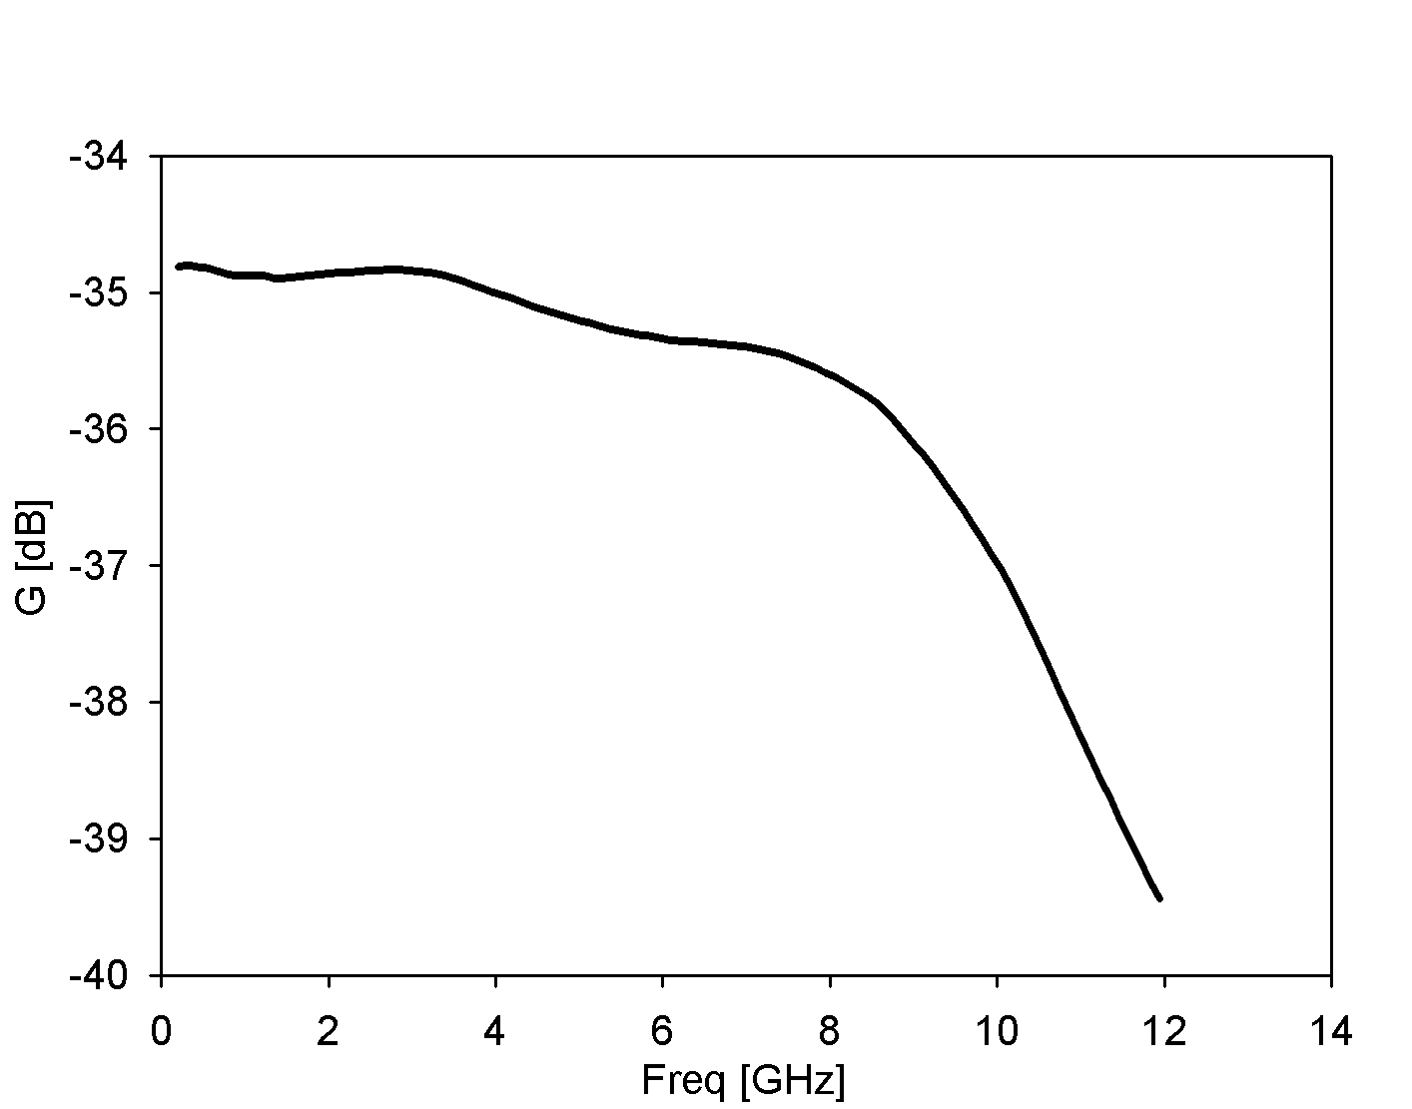
Figure 3.4: Insertion loss of the fiber-optic link.

4 – Signal Path through the PAM
The signal path analysis will assume that the LNA is the 32-dB block, and then the ramifications of utilizing the 25-dB block will be discussed. In addition, a zenith view with moderate relative humidity (35%) will be used as the baseline. The implications of different external factors (elevation and RH) will then be discussed. The next section will discuss strong sources in the beam (RFI and the sun).

4.1 – Blank sky power
The power incident onto the PAM and the system temperature at the input to the PAM are shown in Figure 4.1a. This assumes that the FOV is a blank, moderate humidity level sky looking at zenith. The integrated power incident on the PAM is -48.7 dBm.
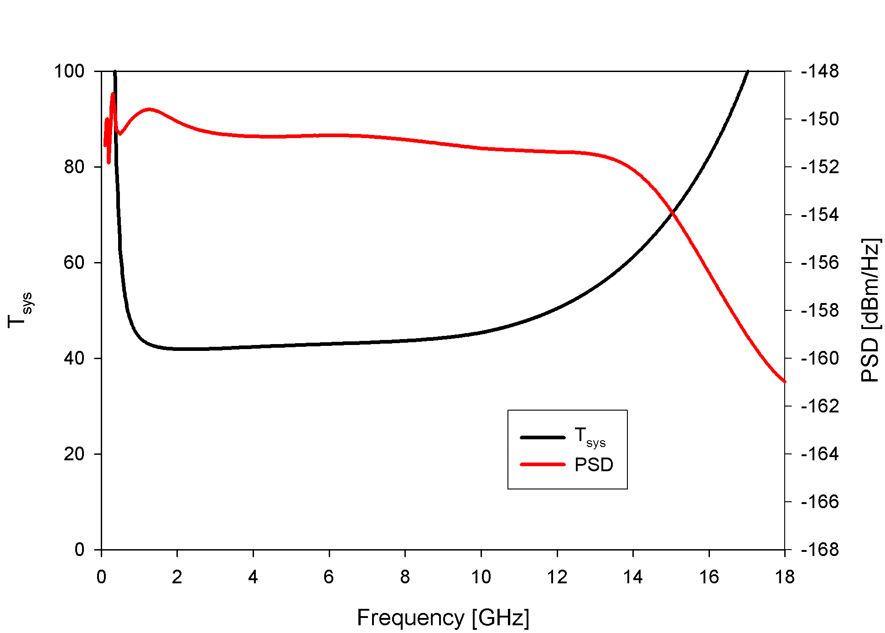
Figure 4.1a: Power and T_{sys} on input to the PAM.
The power incident onto the second gain stage (2×NBB-300) and the system temperature at that point are shown in Figure 4.1b. The integrated power at that point is -47.2 dBm.
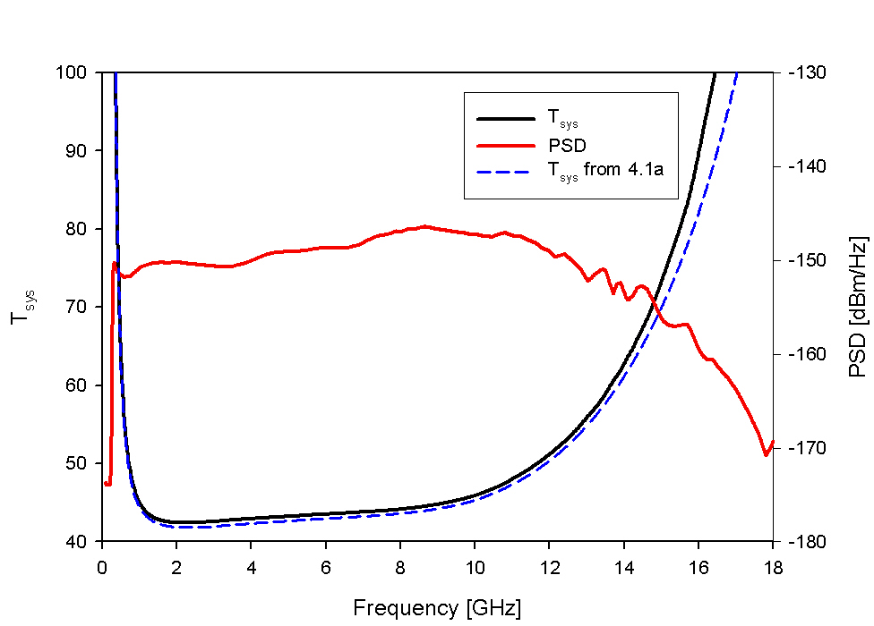
Figure 4.1b: Power and T_{sys} on input to the second PAM gain stage.
The power into the fiber-optic link is shown in Figure 4.1c. The integrated power onto the fiber-optic link is -11.5. The maximum power is on the output of the third gain stage, where it is -5.5 dBm.
Figure 4.1c: Power and T_{sys} on input to the fiber-optic link.

The consequences of using the 25-dB LNA instead of the 32-dB LNA are shown in Figure 4.1d. The additional attenuation on the second variable attenuator is then 0 dB (rather than 8 dB) and the integrated power is -11.1 dBm. Figure 4.1d shows the additional system temperature due to the PAM (including the fiber-optic link) using the 32-dB gain LNA (blue), the 25-dB LNA (red) as well as the additional contribution with the 32-dB LNA excluding the f/o link (black). Obviously, if use of the 25-dB LNA necessitates a better first stage in the PAM.

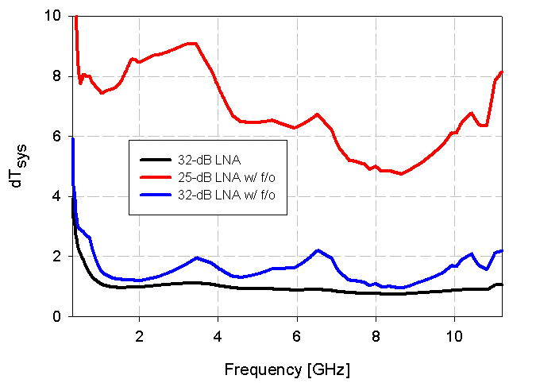
Figure 4.1d: Additional system temperature due to the PAM, with and without the f/o transmitter for the 32-dB LNA case and with the f/o for the 25-dB case.
If the telescope is viewing the horizon and the relative humidity is 65%, the integrated power onto the f/o transmitter is -11.1 dBm (with the same attenuation settings). Figure 4.1e shows the power and system temperature on input to the RF converter board (RFCB) for the two different sky views. More equalization will be applied in the RFCB.
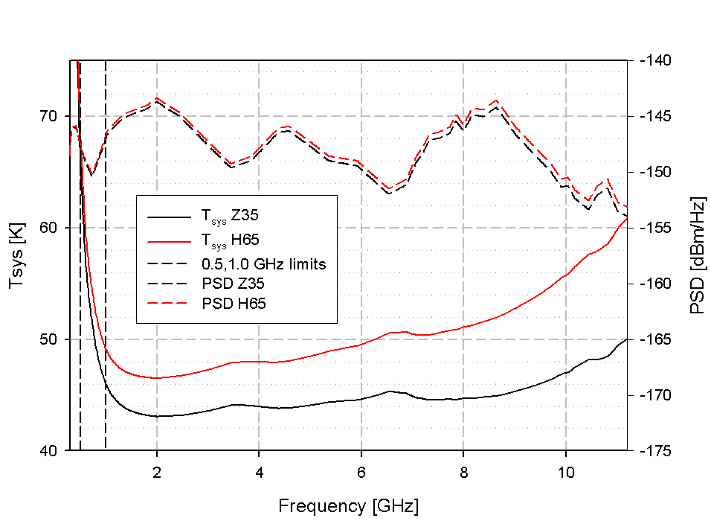
Figure 4.1e: T_{sys} and PSD incident onto the RFCB for zenith and RH=35% (Z35) and elevation 15° and RH=65% (H65).

4.2 – RFI
RFI appropriate for low-frequency interference, GPS, Iridium, satellite radio and C-band satellites appropriate for a 0 dBi side-lobe have been injected into the system. Figure 4.2 shows the output of the third gain stage (the point with the greatest RF power). The integrated power at that point is -1.0 dBm and the power incident onto the f/o transmitter is -8.7 dBm. Adding another 2.5 dB or so of attenuation may be the standard mode of operation and is reflected in the values given at the beginning of section 3.
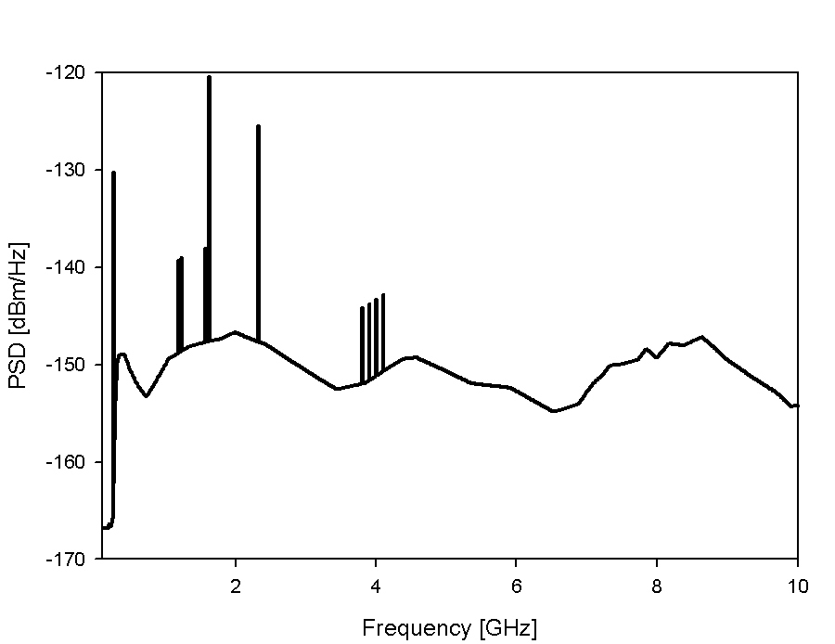
Figure 4.2: PSD incident onto the RFCB with RFI, with the additional 2.5 dB.
4.3 – Solar Observations
If people chose to view the sun, additional attenuation will need to be switched in. Based on DeBoer and Bower 2001, the active sun will increase T_{sys} by about 50 dB and the quiet sun by about 25 dB. The possibility of viewing the sun is the motivating factor in moving the first variable attenuator up the chain. To accommodate the quiet sun, the first variable attenuator should switch in 26 dB of extra attenuation. The highest power level is then at the output of the third gain stage at about -4 dBm.

The active sun is a bit more problematic. By switching in 45 dB of attenuation at the first variable attenuator the proceeding elements are within normal operating limits. However, the first gain stage in the PAM is essentially at the 1-dB compression point (+12 dBm on output). This level of solar flux is expected to occur for about 2 minutes per year and it is not clear that extraordinary measures should be taken to account for this instance, other than the fact that we don’t want anything to blow up. Figure 4.3 shows the power at the maximum point for the active sun (after the first PAM gain stage) and the quiet sun (after the third gain stage).

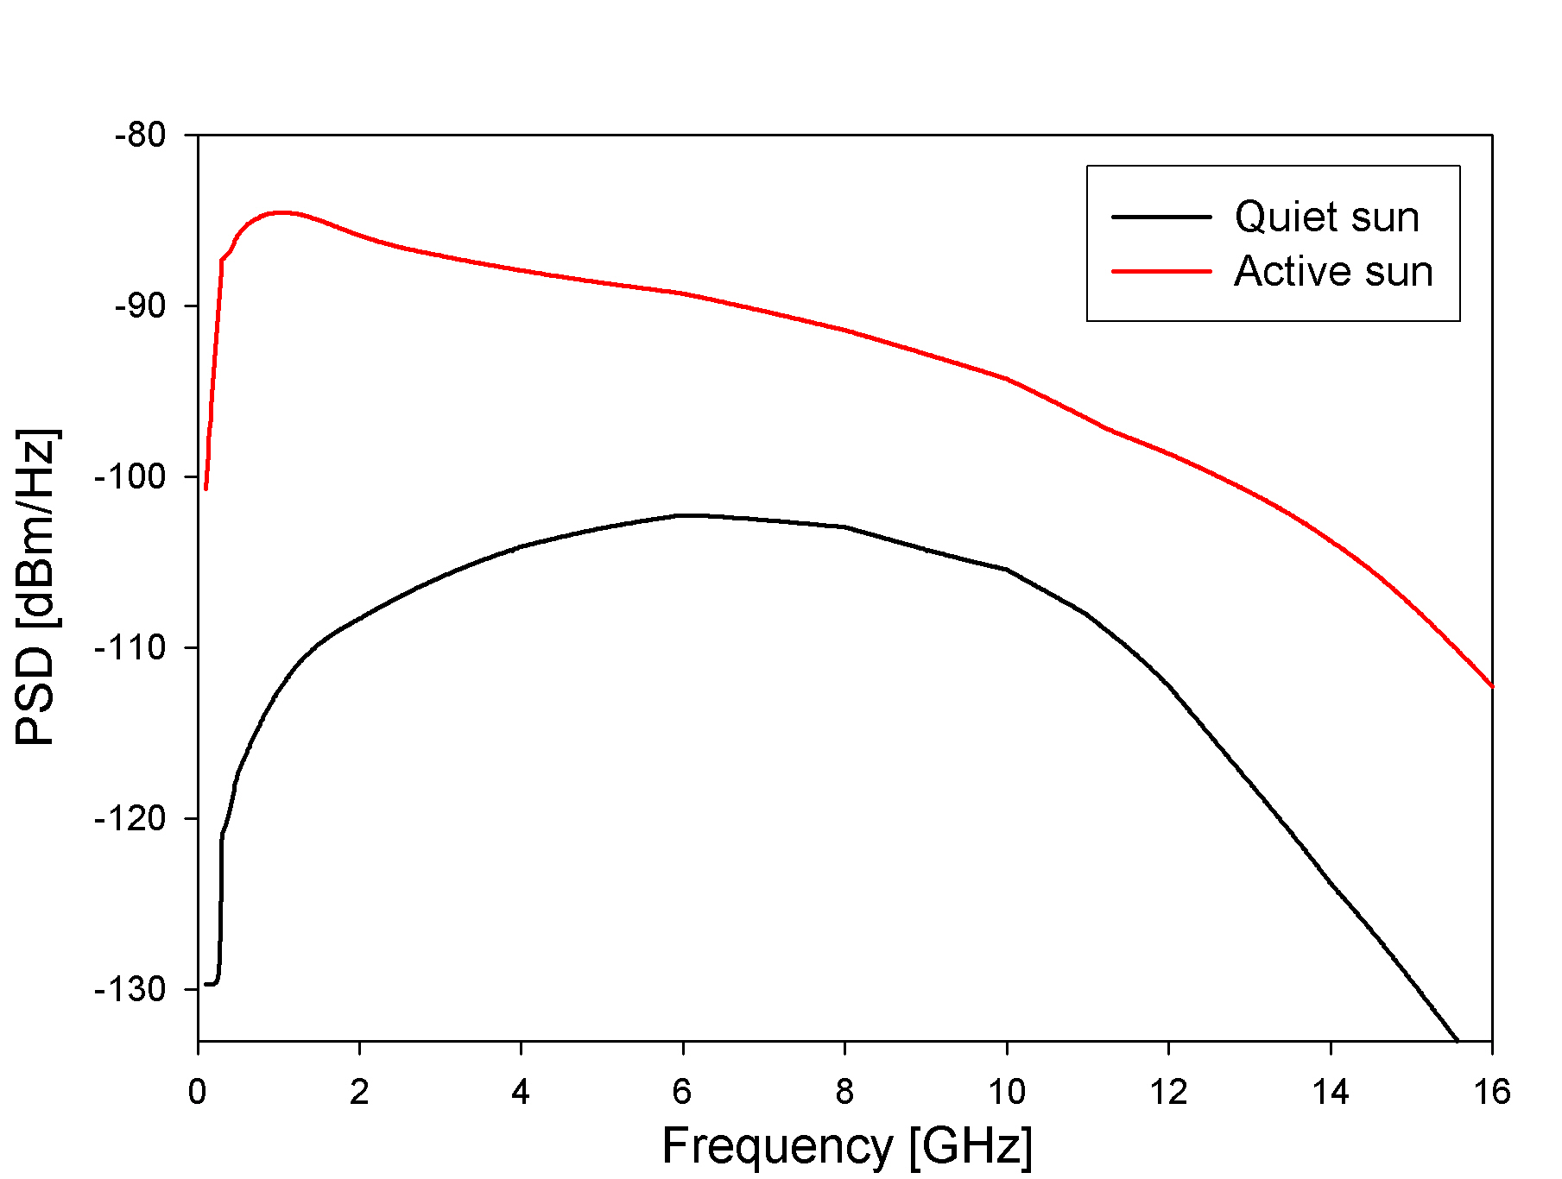
Figure 4.3: Power looking at the active sun (red, after the first gain block) and the quiet sun (black, after third gain block).

5 – PAM Control
The PAM will interface with a PIC chip that resides in the front-end which also interfaces to the LNA and cryogenics (Figure 5.0). A serial interface connects the PIC with a processor located on the alidade that provides the interface back to the control room, as well as local computational power. The primary control points in the PAM are temperature and RF power.
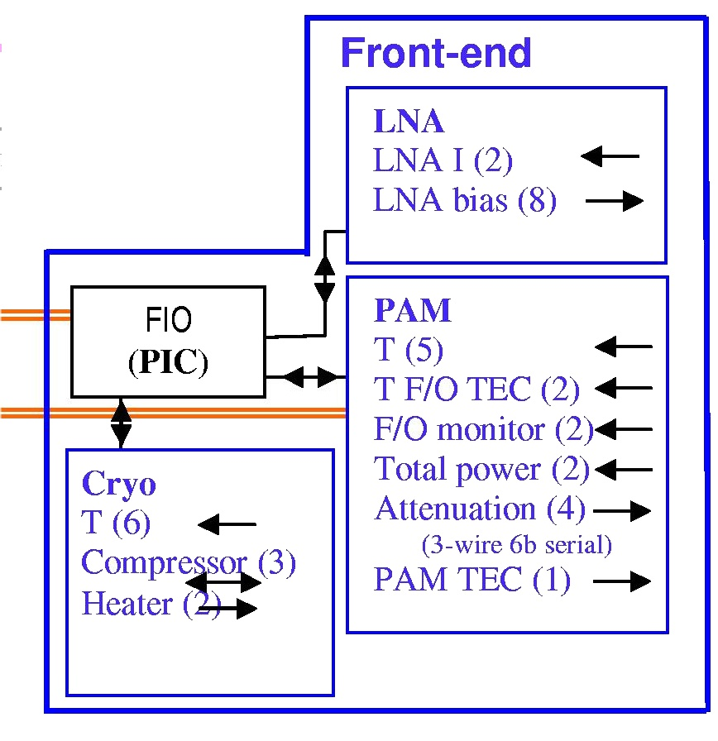
Figure 5.0: Control points in the front-end.
Monitor
Command

5.1 – Temperature
In order to achieve high-gain stability, thermal regulation for the PAM is required. System-wide, the goal for the beam gain stability over one hour is 3% and the requirement is10%. The channel-to-channel relative stability goal is 1% in voltage over about 1000 sec. These values imply gain stability at the PAM of about 1% (goal) and 3% (requirement). Table I lists the thermal coefficient for the components of the PAM. These values imply thermal stability of -0.04 dB/K.

Component | Thermal coefficient [dB/K] | Total [dB/K]
Amplifier | -0.0015 | -0.0075
Passive | -0.01 (complete guess) | -0.01
Variable attenuator | -0.004 | -0.008
Fiber-optic transmitter | -0.01 | -0.01
 |  | ~ -0.04

Temperature is monitored at several points throughout the PAM (nominally at 5 different points) and read by the PIC microcontroller. The programmable microcontroller may relay either (1) the samples, (2) statistical information, or (3) status back to the control system, depending on the desired mode. The PAM thermoelectric cooler (TEC) will use the feedback locally to control the temperature. The f/o transmitter will also include another TEC, which will likely remain set at a fixed point using independent thermal monitors (2).

5.2 – RF Power
A total power detector before the f/o link will monitor the input power to the link via an a/d on the FIO PIC. The RF power is controlled by setting the variable attenuators, which are to be Hittite HMC424LP3 variable attenuators (www.hittite.com). It will be driven by the front-end PIC controller via a bit register using three lines and 6-bits. The tables below provide information on the Hittite from the data sheet.

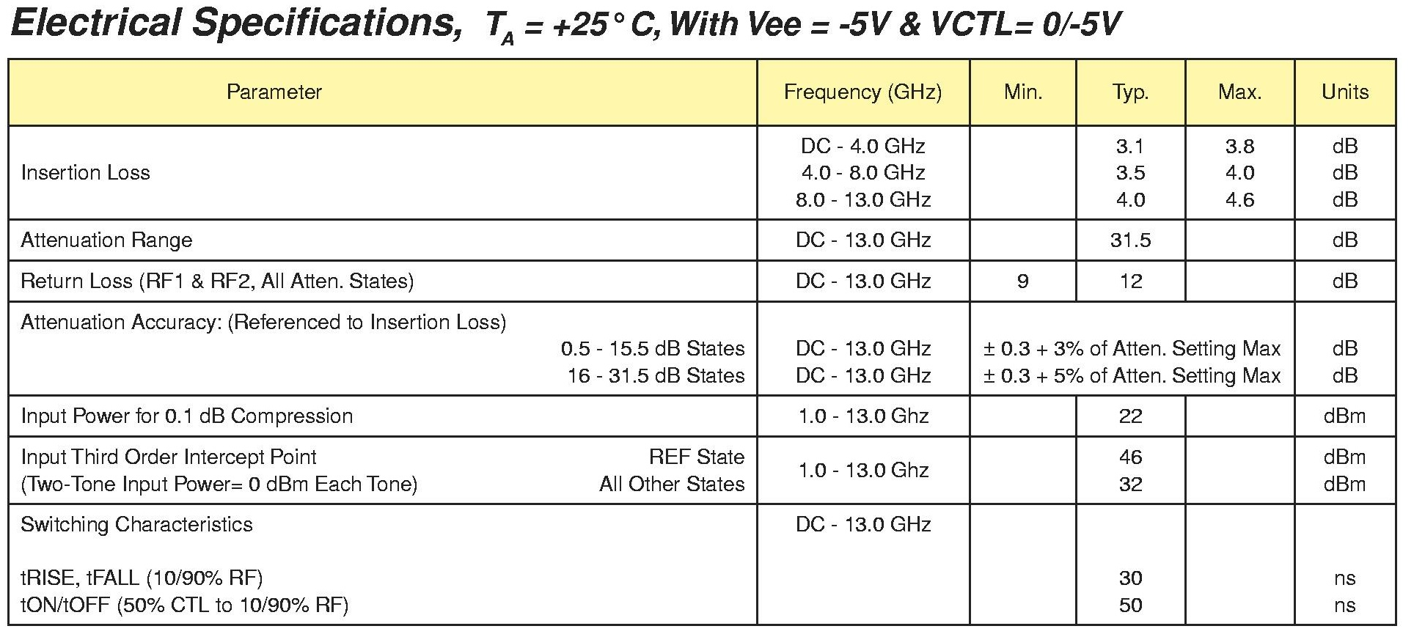

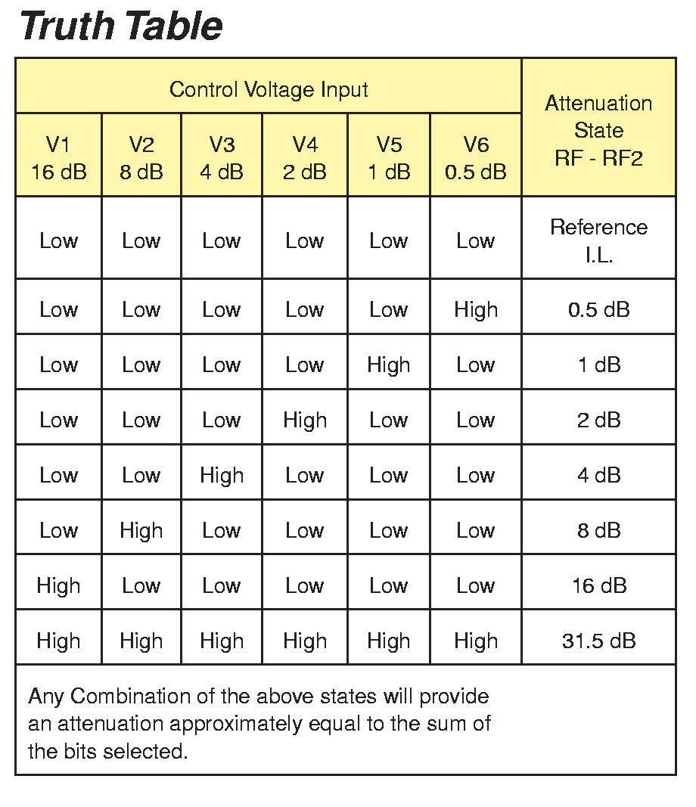
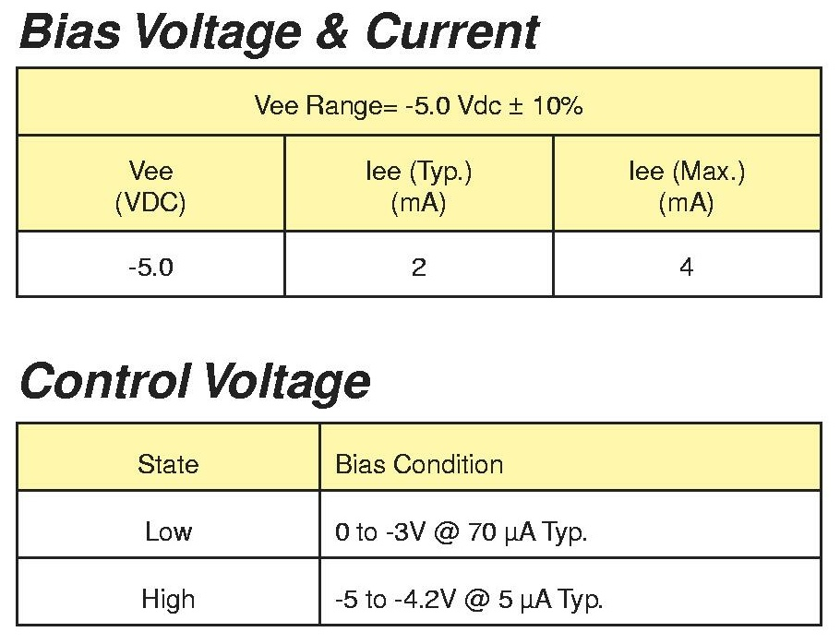

The variable attenuator is controlled via one serial line from the FIO PIC, which loads a FIFO serial bit register

5.3 – Fiber-optic link
In addition to the total power monitoring, it is anticipated that the f/o link current will be monitored as well to assess the state of the link and to aid in diagnosing. It will be sampled by an a/d on the FIO PIC.

5.4 – DC Power

Component | Qty | Voltage [V] | Nom current [mA]
PIC | 1 | 5
RF Nitro NBB-300 (regulated) | 12 | 3.9 | 50 | at chip
RF Nitro NBB-300 (regulated) | 12 | 12 |  | provided
Hittite var att HMC424LP3 (regulated) | 4 | -5 | 2 | bias
Hittite var att HMC424LP3 (regulated) | 4 | 0 – -3 | 0.070 | low
Hittite var att HMC424LP3 (regulated) | 4 | -5 – -4.2 | 0.005 | high
shift register | 2
Fujitsu f/o link FLD5F10NP (regulated) | 2 | -0.8 |  | bias

