To Play Video
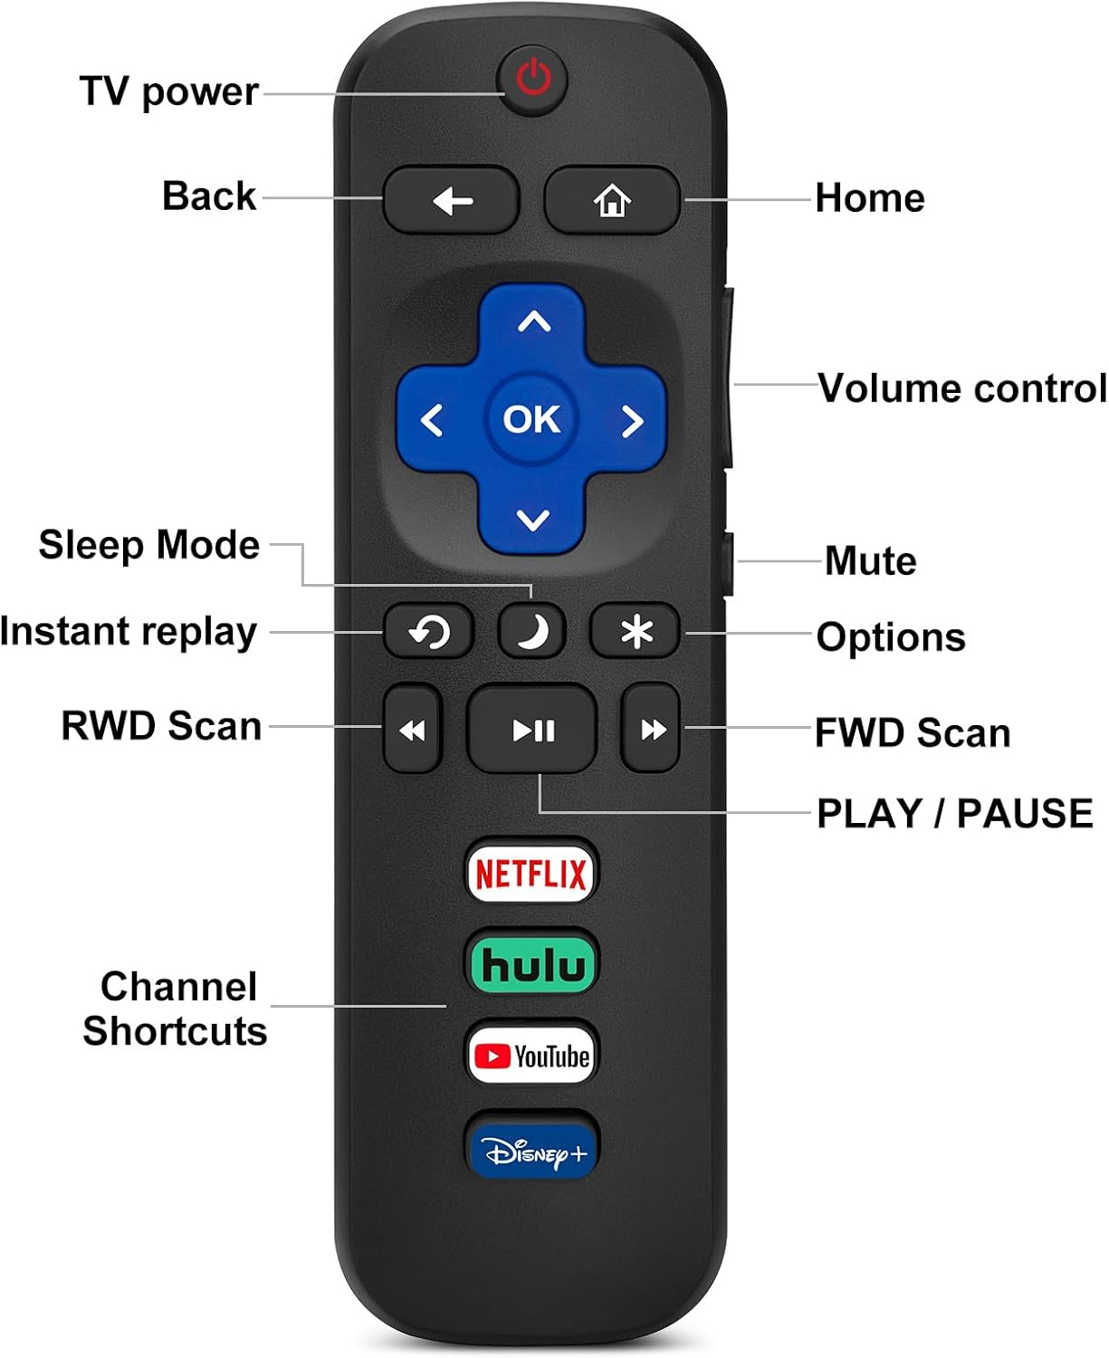
If TV is off:
- Press Power Button
Once TV is on:
- Click right to Jellyfin and press OK

- Click on HCRO and press OK
- Select desired video and press OK

When finished, please leave TV on for next person.

If you run into any issues feel free to ask a staff member.



