# Ve370 Introduction to Computer Organization

Homework 5

杨毅文 519370910053

# Assigned: November 4, 2021

**Due: 2:00pm on November 11, 2021 Submit a PDF file on Canvas**

1. (15 points) If we change load/store instructions to use a register (without an offset) as the base address, these instructions no longer need to use the ALU. As a result, the MEM and EX stages can be overlapped and the pipeline has only four stages.
   1. How will the reduction in pipeline depth affect the clock cycle time? (5 points)

The change will not affect the single clock cycle time if the critical path in MEM EX merged stage is not the longest among all stages, but if they are the longest, than the clock cycle time will be extended.

* 1. How might this change improve the performance of the pipeline? (5 points)

Since the stage number changes from five to four, then the total execution clock cycles will drop from IC + 4 to IC + 3.

* 1. How might this change degrade the performance of the pipeline? (5 points)

There is no offset for the instruction will cause that we perhaps need to add the address using one extra instruction, which will extend the total clock cycles by one.

1. (25 points) One of the solutions to control hazard is to always stall the instruction following the branch or jump instruction by inserting nop instructions. Using the following diagram as a reference:

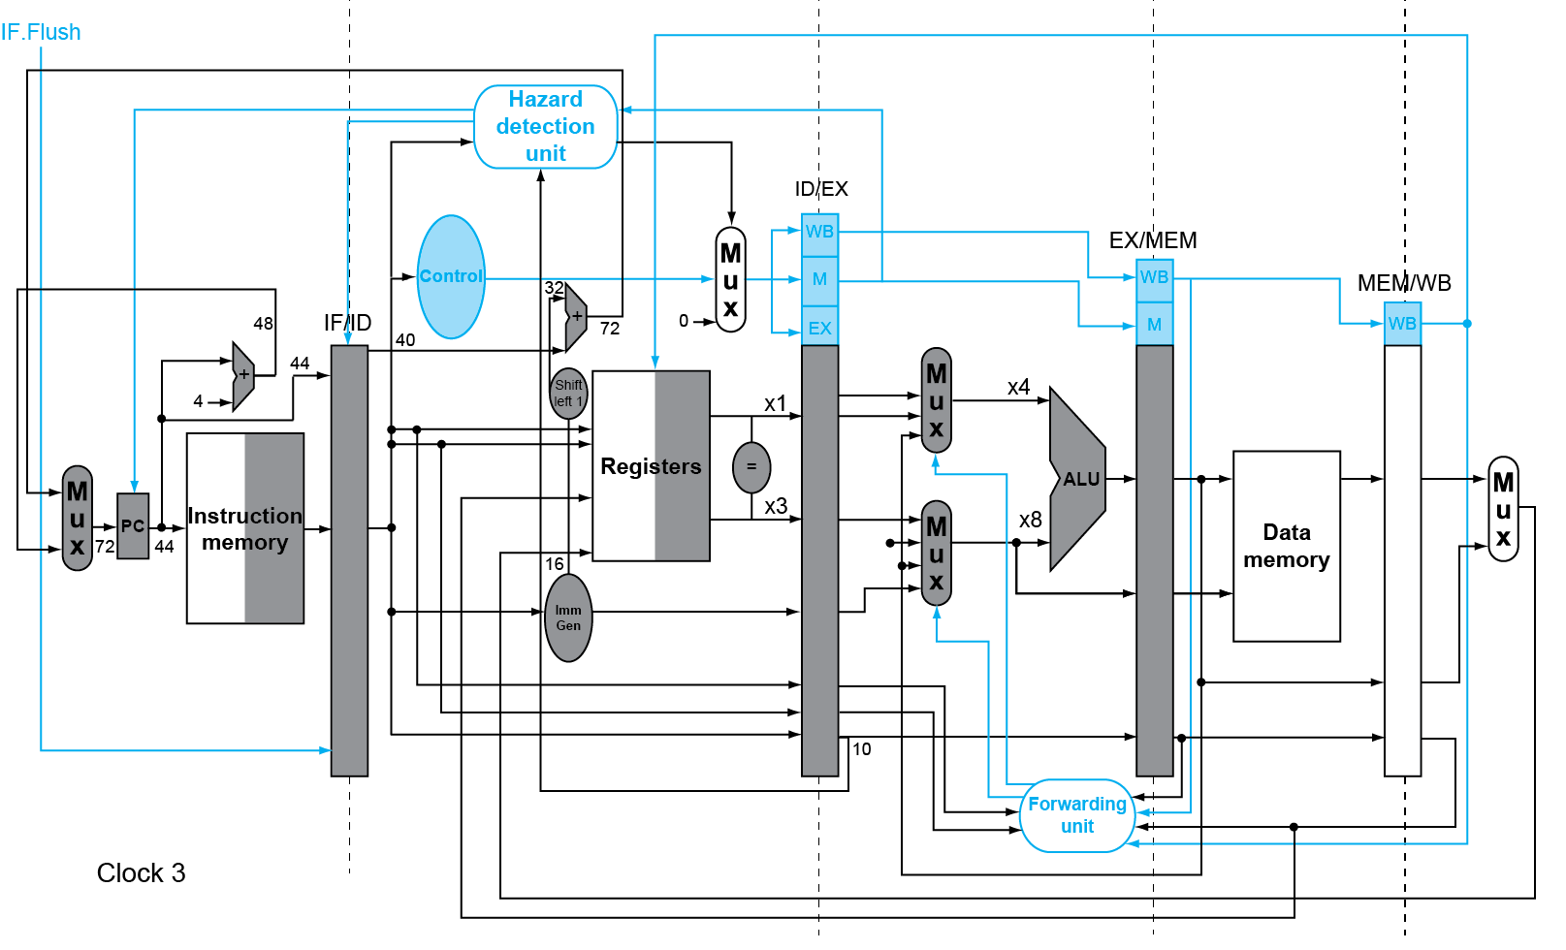

* 1. How many nop should be inserted after each beq instruction? (5 points)

One

* 1. How can this stall be implemented in hardware rather than in software? Hint: nop instruction is realized as addi x0, x0, 0. (10 points)

The stall can be implemented using IF.FLUSH that flushes the next instruction into addi x0, x0, 0 if the branch condition is satisfied.

* 1. If the above pipeline is modified to support jal instruction, which would be the earliest stage the jump instruction is identified and jump target is calculated? In that case, how many stalls would have to be inserted? How would the clock cycle time be affected? (10 points)

The jump instruction should be identified and calculated in the ID stage and one stall should be inserted. The clock cycle time will not be affected since jump instructions do not add more modules onto the critical path in ID stage.

1. (20 points) Consider the following loop.

LOOP: lw x10, 0(x13)

lw x11, 8(x13) add x12, x10, x11 addi x13, x13, 16 bne x12, x0, LOOP

Assume that perfect branch prediction is used (no stalls due to control hazards), that there are no delay slots, that the pipeline has full forwarding support, and that branches are resolved in the EX (as opposed to the ID) stage. Show a pipeline execution (multicycle) diagram for the first two iterations of this loop. Hint: unfold the loop first. Hint : you may use Excel to show the execution diagram.

|  |  |  |  |  |  |  |  |  |  |  |  |  |  |  |  |  |
| --- | --- | --- | --- | --- | --- | --- | --- | --- | --- | --- | --- | --- | --- | --- | --- | --- |
|  | 0 | 1 | 2 | 3 | 4 | 5 | 6 | 7 | 8 | 9 | 10 | 11 | 12 | 13 | 14 | 15 |
| lw x10 0 x13 | IF | ID | EX | MEM | WB |  | IF | ID | EX | MEM | WB |  | IF | ID | EX | MEM |
| lw x11 8 x13 |  | IF | ID | EX | MEM | WB |  | IF | ID | EX | MEM | WB |  | IF | ID | EX |
| add x12 x10 x11 |  |  | IF | ID | - | EX | MEM | WB |  | IF | ID | - | EX | MEM | WB |  |
| addi x13 x13 16 |  |  |  | IF | - | ID | EX | MEM | WB |  | IF | - | ID | EX | MEM | WB |
| bne x12 x0 -16 <LOOP> |  |  |  |  |  | IF | ID | EX | MEM | WB |  | IF | ID | EX | MEM | WB |

1. (20 points) The importance of having a good branch predictor depends on how often conditional branches are executed. Together with branch predictor accuracy, this will determine how much time is spent flushing due to mispredicted branches. In this exercise, assume that the breakdown of dynamic instructions into various instruction categories is as follows:

|  |  |  |  |  |
| --- | --- | --- | --- | --- |
| R-type | branch | jal | lw | sw |
| 40% | 25% | 5% | 25% | 5% |

Also, assume the following branch predictor accuracies:

|  |  |  |
| --- | --- | --- |
| Always-Taken | Always-Not-Taken | 2-Bit |
| 45% | 55% | 85% |

* 1. Stall cycles due to mispredicted branches and jumps increase the CPI. What is the extra CPI due to jumps? What is the extra CPI due to mispredicted branches with the always-taken predictor? Assume that branch outcomes are determined in the ID stage and that there are no data hazards, and that no delay slots are used. (10 points)

Extra CPI due to jumps: 5%

Extra CPI due to branches: 25% $×$ (1 - 45%) = 13.75%

* 1. Repeat (1) for the 2-bit predictor. (10 points)

Extra CPI due to jumps: 5%

Extra CPI due to branches: 25% $×$ (1 - 85%) = 3.75%

1. (20 points) This exercise examines the accuracy of various branch predictors for the following repeating pattern (e.g., in a loop) of branch outcomes: T, NT, T, T, NT. (T: taken, NT: not taken)
   1. What is the accuracy of always-taken and always-not-taken predictors for this sequence of branch outcomes? (5 points)

Always taken: 60%

Always not taken: 40%

* 1. What is the accuracy of the 2-bit predictor if this pattern is repeated forever? (5 points)

60%

* 1. Design a predictor that would achieve a perfect accuracy if this pattern is repeated forever. You predictor should be a sequential circuit with one output that provides a prediction (1 for taken, 0 for not taken) and no inputs other than the clock and the control signal that indicates that the instruction is a conditional branch. (10 points)

A 5-bit ring shift register with initial value 10110, MSB being the output and shift left every time.