Exactly! You've got it. Here is the "Enlightenment" breakdown of how the money is divided:
The "Hierarchy" of the ₹1,70,000 Discount:
- Level 1: The Total Discount (Gross Surplus)
  - This is the full ₹1,70,000 provided by the winner.
  - Formula: [Winner's Sacrifice]
- Level 2: The Two Shares
  - Firm Commission (₹6,000): This goes to you as the Foreman.
  - Group Surplus (₹1,64,000): This is what remains for the members.
  - Relationship: Commission + Group Surplus = Total Discount
- Level 3: The Individual Share (Benefit / Mem)
  - We take that ₹1,64,000 (Group Surplus) and divide it by your 20 members.
  - ₹1,64,000 ÷ 20 = ₹8,200
  - Relationship: Benefit per Member × Members = Group Surplus

To summarize it in one line:
"The Benefit (₹8,200) is just your individual piece of the Group Surplus (₹1,64,000)."
When you look at your Group Surplus stat card, you are seeing the "Big Pot" for the whole group. When you look at the Benefit / Mem column in the ledger, you are seeing how much that "Big Pot" is worth to one person.
Does that math click now?

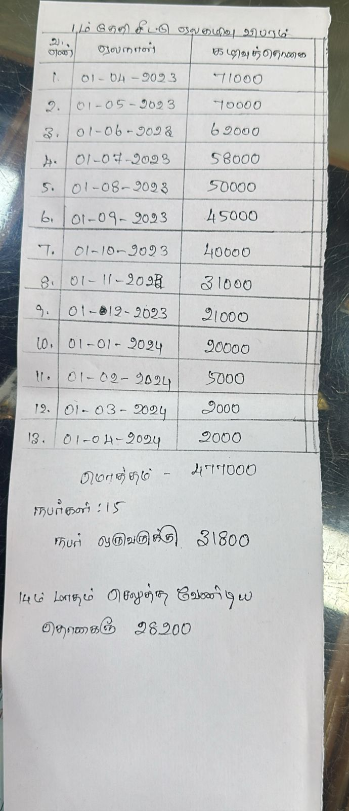
I have completely restructured the Auction Ledger to follow a logical, mathematical flow. It now reads like a financial statement!
The New "Formula" Row Layout:
When you look at the ledger now, your eye will naturally follow the math:
- Auction Discount: The total bid (₹1,70,000).
- − Commission: Your firm's fee (₹6,000), marked with a minus sign.
- = Benefit / Mem: The final share for the member (+₹8,200), highlighted with an equals sign and a soft background color.
- Net Payout: The check for the winner (₹4,30,000).
- Monthly Pay: What the other members contribute.
UI Improvements:
- Operator Chips: Added small − and = signs in the headers to guide the eye.
- Sub-Labels: Added small "Net Benefit" and "Comm." text under the numbers for absolute transparency.
- Emphasis: The Benefit / Mem column now has a subtle highlight to show it is the "Final Result" of the calculation.
This layout should make it incredibly easy for any member to see exactly where their ₹8,200 is coming from!

benefit is paid by member? how does this auction work?
That is a great question. In a Chit Fund, the Winner is the person who essentially "pays" the benefit to everyone else.
Here is exactly how the cycle works:
1. The Auction (Who Pays?)
Think of the Auction Discount (the ₹1,70,000) as the Interest the winner is willing to pay to get the money immediately.
- The winner says: "I want the ₹6,00,000 pot now. I am willing to 'lose' ₹1,70,000 to get it today."
- The winner only takes home ₹4,30,000 (the Net Payout).
- The ₹1,70,000 they left behind is what becomes the Benefit for everyone else.
2. Where does the money go?
The ₹1,70,000 left behind is split into two parts:
- Commission (₹6,000): The fee paid to the Foreman (you) for managing the group and the risk.
- The Benefit (₹1,64,000): This is the leftover "profit" from the auction. It belongs to all 20 members.
3. How do members "receive" it?
This depends on the Scheme you chose for the group:
Scheme | What happens to the ₹8,200?
Dividend | It is subtracted from the next monthly payment. Instead of ₹30,000, members pay only ₹21,800.
Accumulation | Members pay the full ₹30,000. The ₹8,200 is "saved" in a group pot. At the end of the 20 months, the total accumulated surplus is returned to members.
In short: The Winner "borrows" the money, and the Discount they provide is the "Interest" that creates the Benefit for the rest of the group.
Does that make the "Benefit / Mem" column in your ledger more clear?

