CS 255 System Design Document Template

DriverPass System Design Document
S.Gofo 8.15.2026

UML Diagrams

UML Use Case Diagram
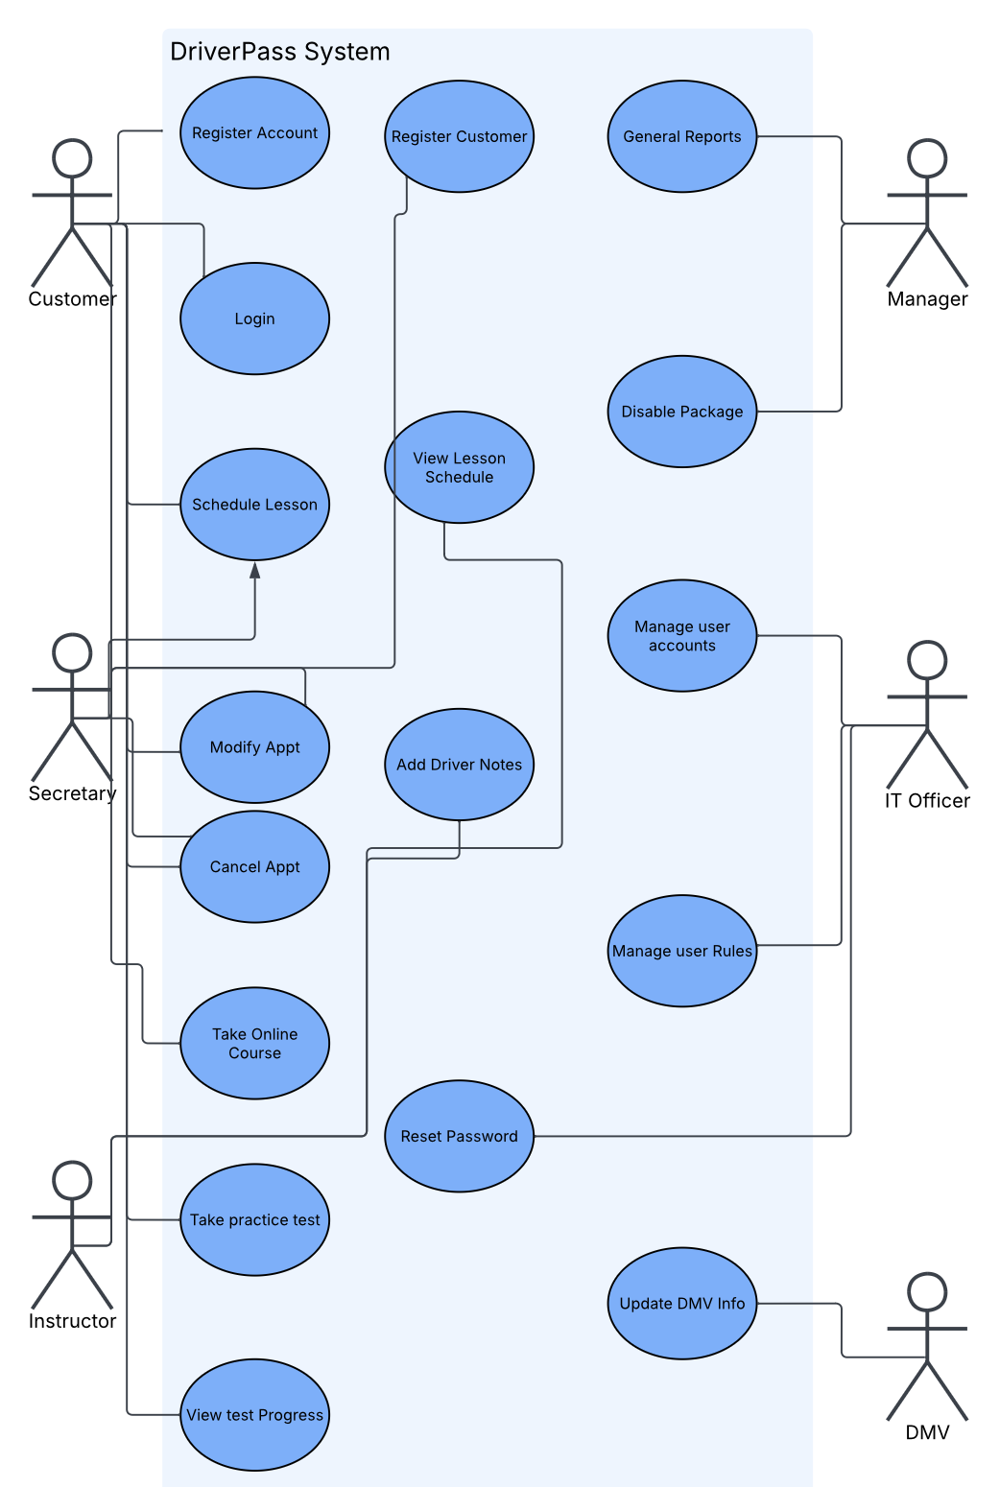

UML Activity Diagrams
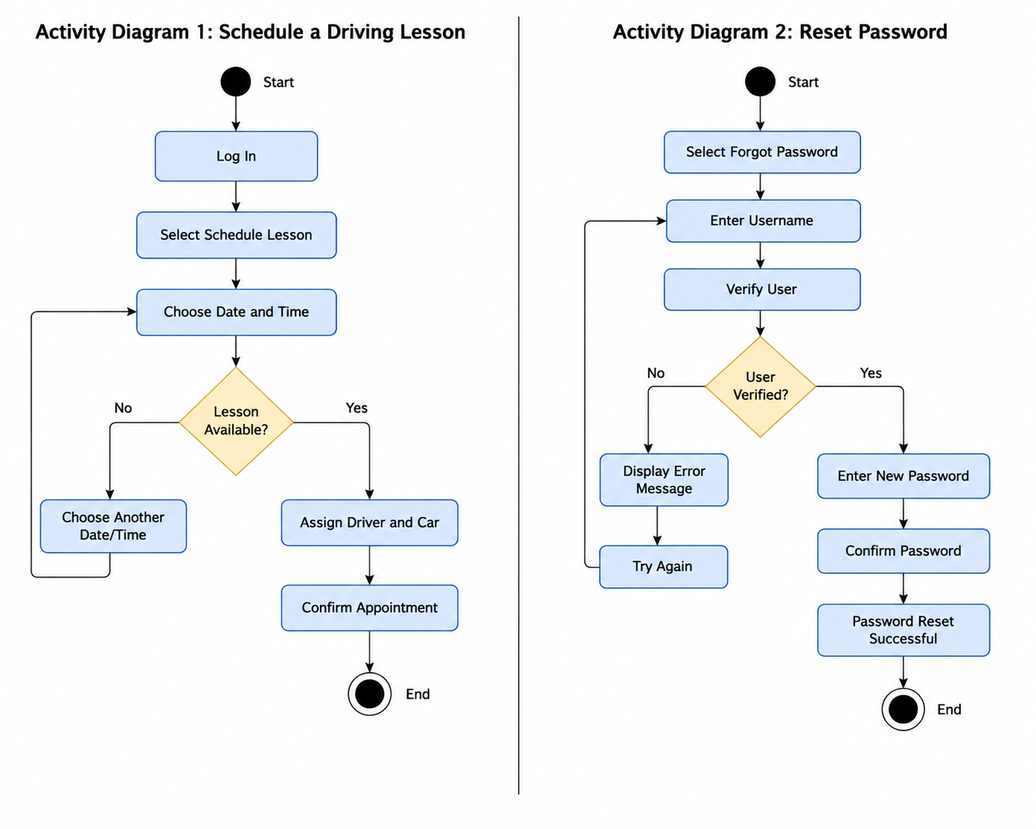

UML Sequence Diagram & Class Diagram

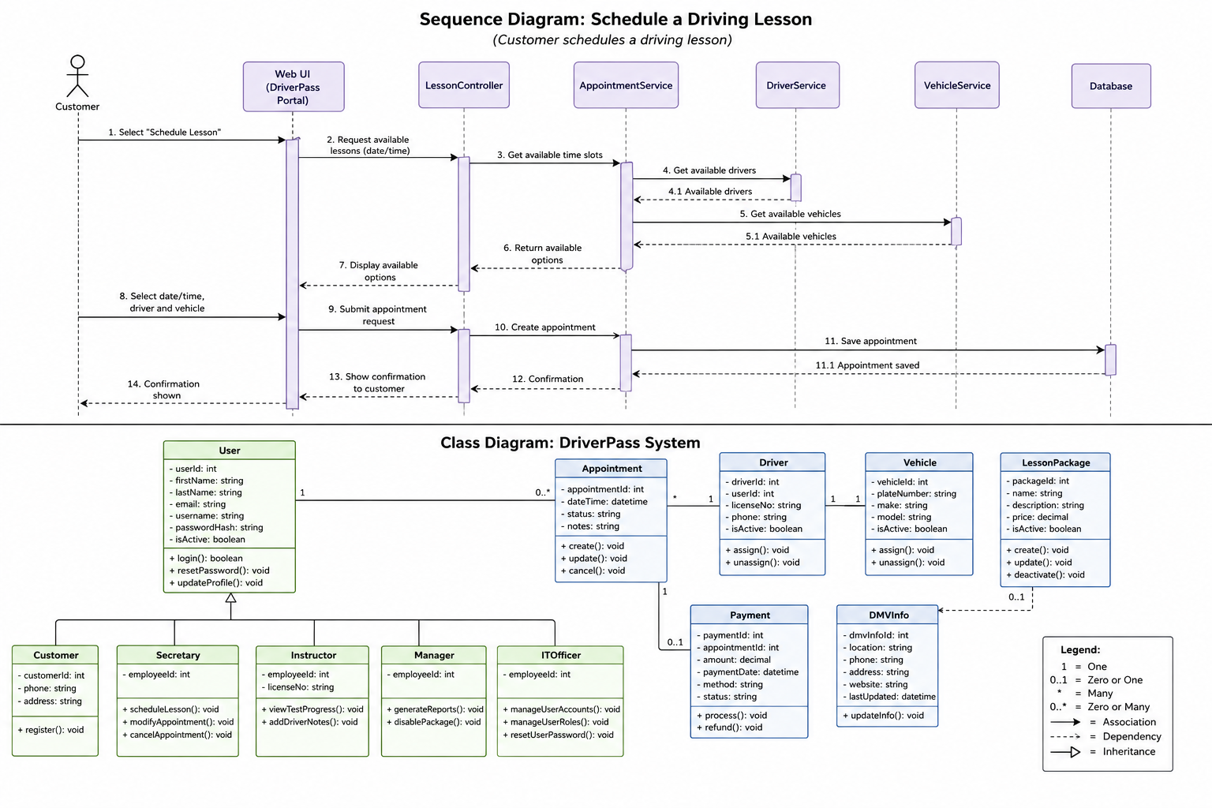

Technical Requirements
The DriverPass system will require the following technical components to support the functions described in the interview and UML diagrams.
Hardware
• Internet connected computers for DriverPass staff to manage customers, appointments, reports, and user accounts.
• Customer access from standard computers, tablets, or mobile devices.
• Cloud hosted server resources so DriverPass does not need to maintain its own server hardware.
Software
• A web based DriverPass application that runs through a modern web browser.
• A centralized database for customer records, appointments, packages, test progress, driver notes, and account information.
• Report export capability so business information can be downloaded and worked with in Excel.
• Account management features for password resets, blocking access, and assigning different user roles and permissions.
Tools and Integration
• A connection to the DMV so DriverPass can receive updated rules, policies, and sample test questions and be notified when changes are available.
• Activity tracking so DriverPass can identify who created, changed, or canceled an appointment and produce activity reports when needed.
• Secure login and access controls so customers and employees only see the functions appropriate for their role.
Infrastructure
• Cloud based hosting to support access from different locations while reducing the need for DriverPass to manage backups and server security.
• Reliable internet access is required for creating or changing system data. Reports and selected information may be downloaded for offline review.
• The system should allow DriverPass to disable existing training packages and support future development to add or remove packages and features.
AI Acknowledgment
Generative AI was used to help organize the project requirements, draft written content, and plan the UML diagrams.

