**Hossam adel fathy ahmed** 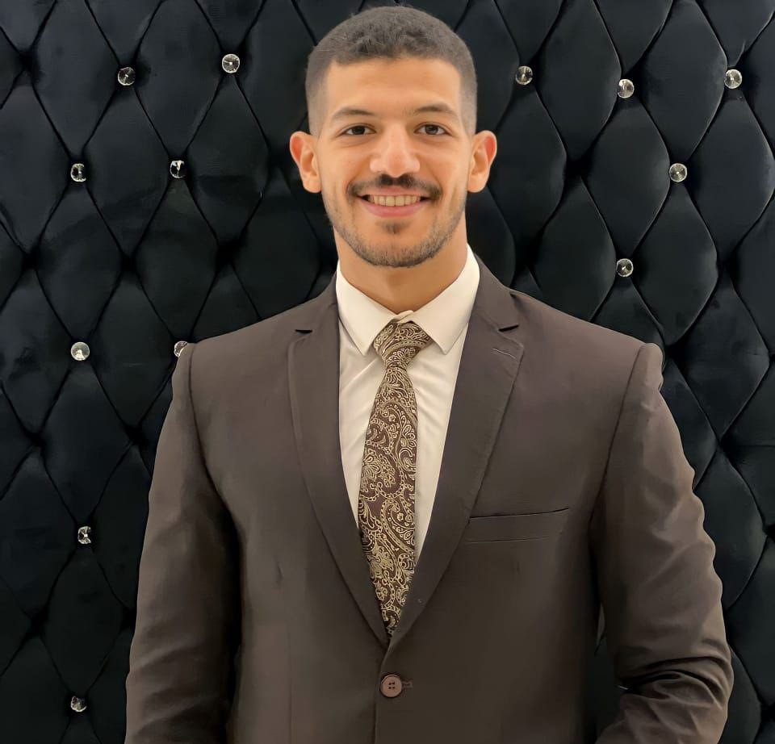

Seeking a challenging position in a reputable company where my work

experience, auditing background, and interpersonal skills are well developed **aljumhuriih Street, Taif Petroleum Tower**

**Assuit Egypt**

**+201060472853**

**h010604728@Gmail.com**

# EXPERIENCE

-**Restaurant cashier**

**-Accountant in a clothing store**

-

# EDUCATION

**faculty of Commerce,** Assiut University

2018- 2022

**High School,** Secondary Jamal Al-Ataifi for boys, Abu Tig

2016 - 2018

# COURSES

**English** — Assiut University

JAN 2020

**ICDL** — Assiut University

APRIL 2020

**Office ---youtube**

# SKILLS

Interpersonal Skills. Problem Solving.

Customer Service Skills. Teamwork Skills.

Communication Skills. Negotiation Skills.

Leadership. Management skills.

# PERSONAL INFORMATION

Gender: Male Nationality: Egyptian Date of birth: 1/2000

Place of birth: Assuit Marital status: Single

# LANGUAGES

Arabic: Mother Tongue English: Good