From Appliance to Value – Circular Economy Evidence Report
This report demonstrates, using diagrams and financial evidence, why treating end-of-life appliances as waste underestimates their real economic value. Appliances manufactured around 2010 contain significant recoverable metals.

Example: 2010 Fridge (~100 kg)
Copper, despite being a small fraction of total weight, represents the largest share of recoverable value.
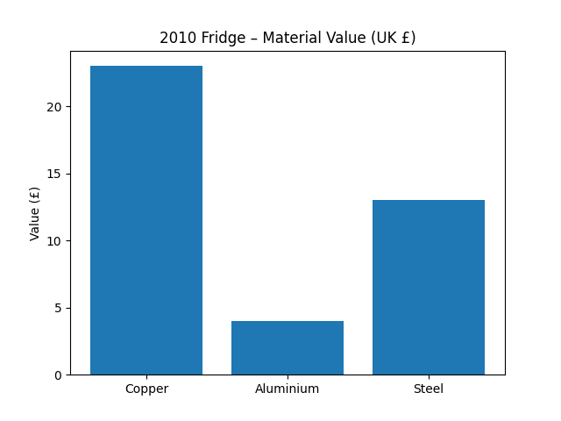
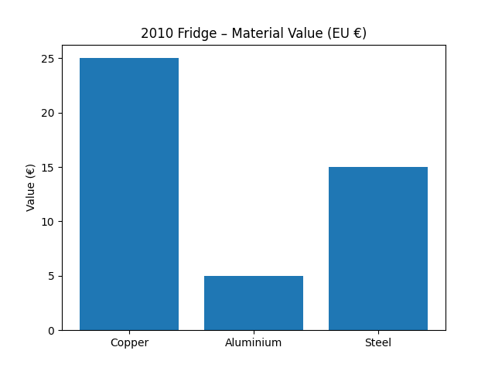
Key insight: Separating non-ferrous metals prior to recycling can double or triple the financial return compared with whole-appliance disposal.

Circular Economy Impact
• Reduces demand for virgin metal extraction
• Saves 70–90% of energy versus primary metal production
• Retains economic value within local communities
• Supports EU and UK waste and resource efficiency targets

