From Appliance to Value – Circular Economy Evidence Report
This report provides quantitative and visual evidence showing that end-of-life household appliances retain significant recoverable value. Treating appliances purely as waste results in avoidable economic loss and reduced circular-economy performance.

Recoverable Value Across Appliance Types
The charts below show typical recoverable material value for common 2010-era appliances when basic-to-advanced separation is applied.
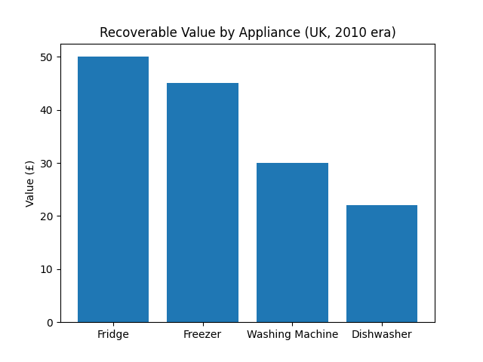
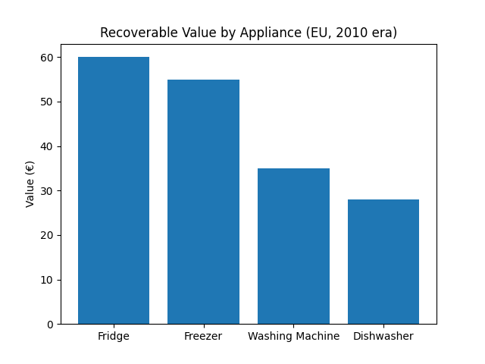
Key insight: Refrigeration appliances consistently hold the highest recoverable value due to copper-rich compressors, while washing machines and dishwashers still offer meaningful returns through motors, wiring, and steel drums.

Implications for Circular Economy Performance
• Improved material recovery rates
• Reduced dependency on virgin copper and aluminium
• Lower energy demand across the materials supply chain
• Increased local economic retention

