Workshop #2: Exceptions

**Learning Outcomes:**

Upon successful completion of this workshop, you will have demonstrated the abilities to:

* Practice handling errors in your program.
* Describe to your instructor what you have learned in completing this workshop.

**Requirements:**

**Part1: [5 points]**

Write a Java program to accept a number and print out it. If the number is below 1 then a message “the number is invalid” is printed out. Using do..while to input again, try-catch block to handle errors.

The user interface may be:

Enter the number: - 2

The number is invalid”

Enter the number: world

The number is invalid”

Enter the number: 2

The number is 2

**Step by step workshop instructions:**

* Create a new project named “workshop2”
* In the project, create a new file named “Part1.java”
* In the method main, you type:

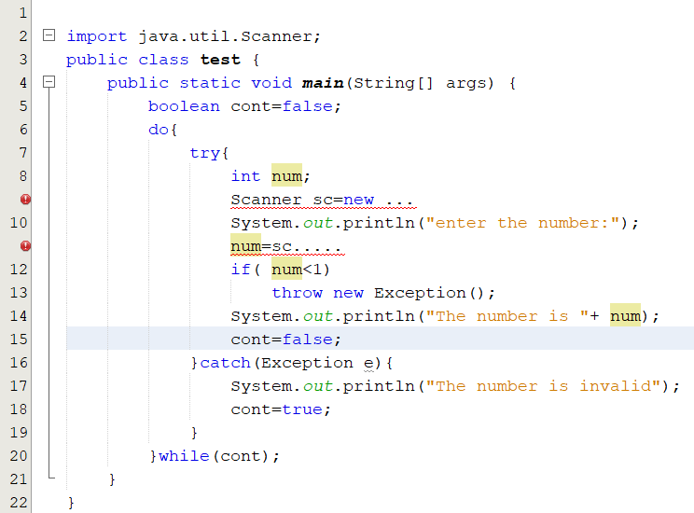

**Part 2: [5 points]**

Write a Java program to accept a string and print out it. If the string does not match SExxx(x is digit) then a message “the string is invalid” is printed out. Using do..while to input again.

***Hint: In library class String, you should use the method matches() to do this, use try-catch block and use throws to handle errors.***

The user interface may be:

Input the string 1: I love u  
the string is invalid

Input the string 1: SE123  
the string is SE123

**Step by step workshop instructions:**

Background:In this workshop, you will use the pattern string( also called regular expression, see more [What is a Regular Expression? - Definition from Techopedia](https://www.techopedia.com/definition/25843/regular-expression#:~:text=-%20Definition%20from%20Techopedia%20Definition%20-%20What%20does,and%20concise%20means%20to%20match%20strings%20of%20text.)). You should read the document to complete the exercise.

**Task 1: use try-catch**

* In the project “Workshop2”, create a new file named “Part2.java”
* In the method main, you type:

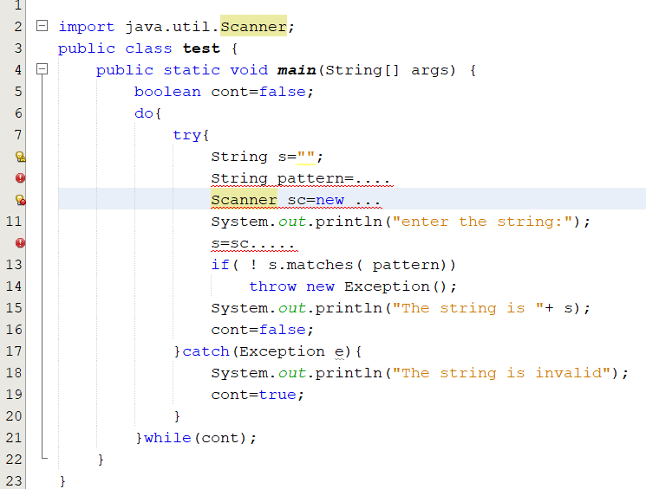

At the row 9, use rules of the regular expression to create a pattern string “SExxx”, x is digit

**Task 2: use throws keyword**

* create a new file named “Part2_2.java”
* in the method main, type:

