Workshop #6: **Collection framework**

**Learning Outcomes:**

Upon successful completion of this workshop, you will have demonstrated the abilities to:

* Practice the ArrayList class.
* Practice some basic functions : add, update, remove, display, search,… in the list
* Describe to your instructor what you have learned in completing this workshop.

**Total:** [10 points]

In this demonstration, ArrayList is used to store a list of students. Student details include: Code, name, mark. A menu is supported for user choosing one operation at a time:

(1) Add new student

(2) Search a student based on his/her code

(3) Update name and mark of a student based on his/her code

(4) Remove a student based on his/her code

(5) List all students.

Constraints:

Student code must be in format <S000>, 0 is a digit.

Student name can not be blank

Mark: 0..10

Design:

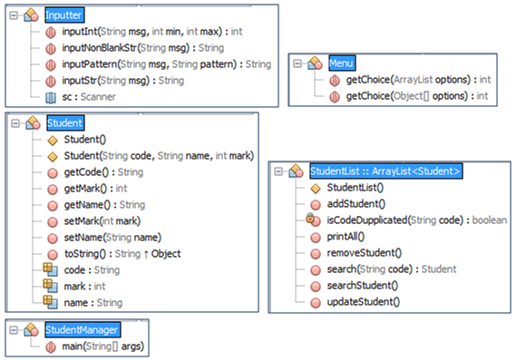

Implement:

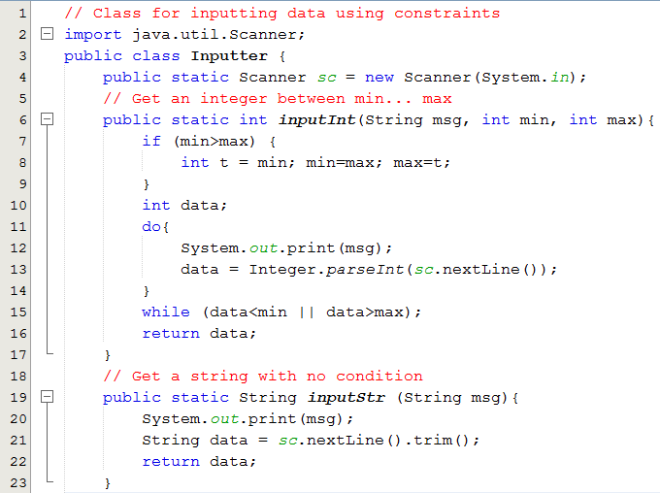

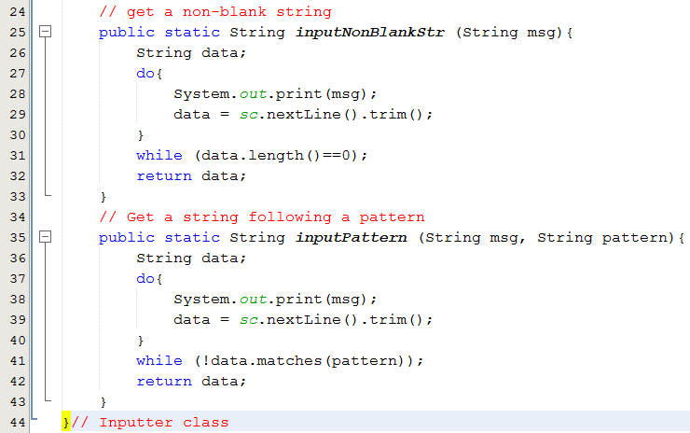

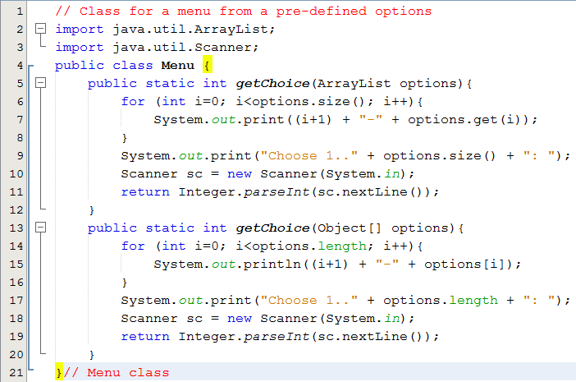

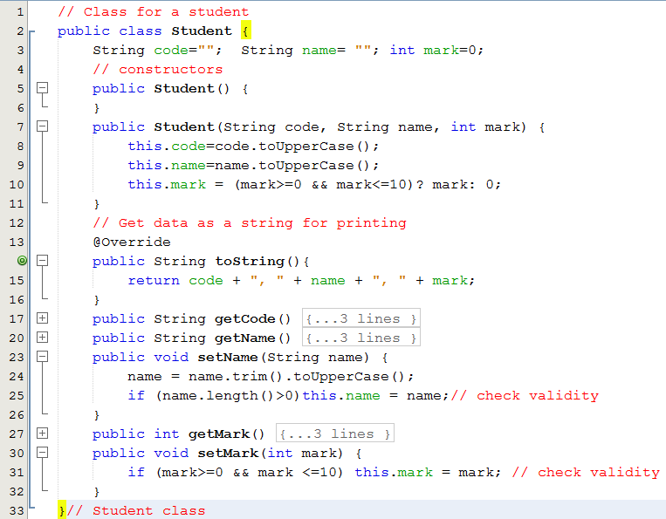

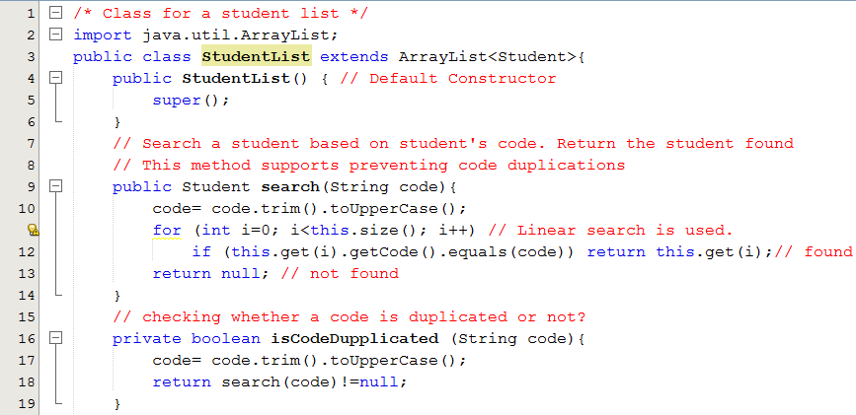

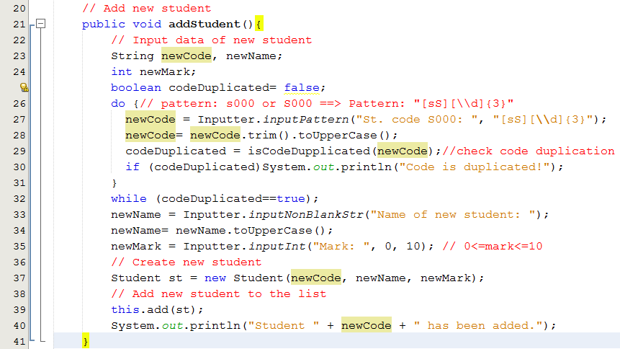

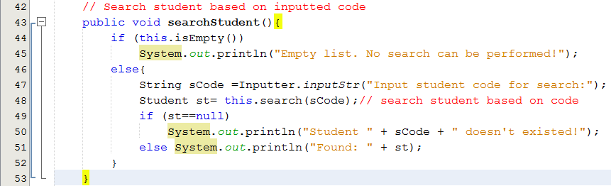

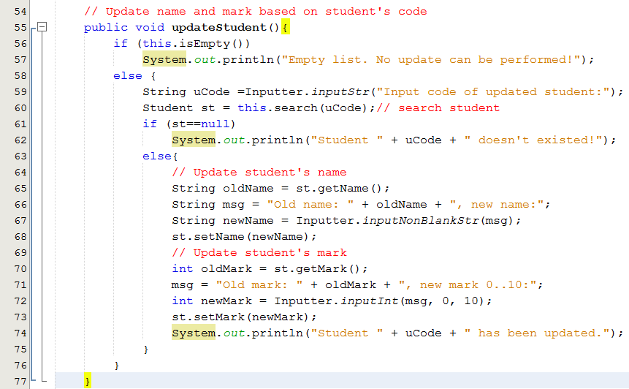

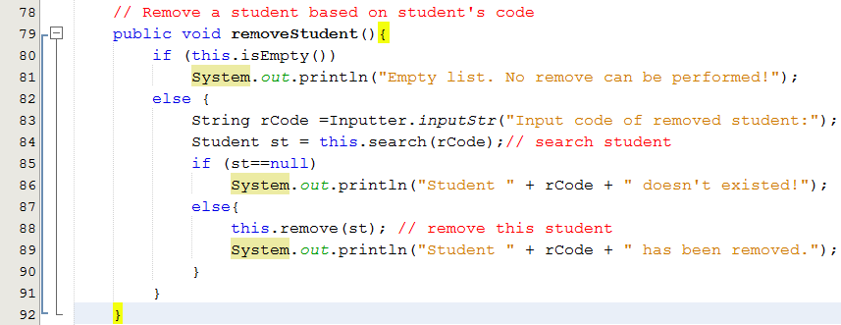

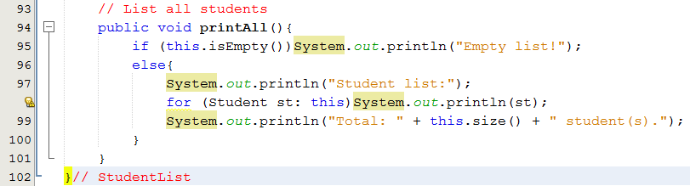

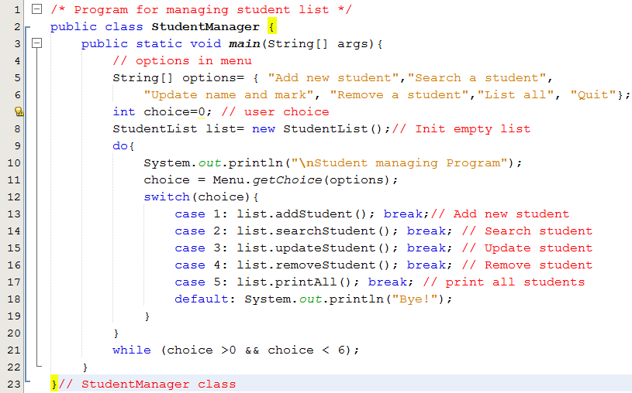

**Test cases**

Run the program, the following menu allows user to choose one operation at a time:

Student managing Program

1-Add new student

2-Search a student

3-Update name and mark

4-Remove a student

5-List all

6-Quit

Choose 1..6:

|  |  |  |
| --- | --- | --- |
| **Test case** | **Option** | **Input and Result** |
| 1 | 2 | No input,  Output: Message: Empty list. No search can be performed! |
| 2 | 3 | No input,  Output: Message: Empty list. No update can be performed! |
| 3 | 4 | No input.  Output: Message: Empty list. No remove can be performed! |
| 4 | 5 | No input.  Output: Message: Empty list! |
| 5 | 1 | Input code : ABC/ A1234/ S12345/S001.  Input name: blank/ James  Input mark: -2/12/7  Message: Student S001 has been added. |
| 6 | 2 | Add: S008, Jack, 5 |
| 7 | 3 | Add: s004,monica, 8 |
| 8 | 5 | Output:  Student list:  S001, JAMES, 7  S008, JACK, 5  S004, MONICA, 8  Total: 3 student(s). |
| 9 | 2 | Input student code for search: Input S123  Output: Student S123 doesn't exist! |
| 10 | 2 | Input student code for search: Input s008  Output: Found: S008, JACK, 5 |
| 11 | 3 | Input code of updated student: Input S123  Output: Student S123 doesn't exist! |
| 12 | 3 | Input code of updated student: Input s008  Old name: JACK, new name: input bill  Old mark: 5, new mark 0..10: input 10  Output: Student s008 has been updated. |
| 13 | 5 | Output:  Student list:  S001, JAMES, 7  S008, BILL, 10  S004, MONICA, 8  Total: 3 student(s). |
| 14 | 4 | Input code of removed student: Input s123  Output: Student s123 doesn't exist! |
| 15 | 4 | Input code of removed student: Input s008  Output: Student s008 has been removed. |
| 16 | 5 | Output:  Student list:  S001, JAMES, 7  S004, MONICA, 8  Total: 2 student(s). |