ARCHITECTURE COMPARISON & GAP ANALYSIS
Sonata Sarthi Hierarchical Consumer vs. Uber QueryGPT
Text-to-SQL Reference Architecture Study
Prepared for: Sonata Sarthi Engineering Team
Reference Files: consumers.py · uber_case_study.txt
Version 1.0

Table of Contents
- Executive Summary
- 1. High-Level Comparison Matrix
- 2. What We Have Achieved — Current Architectural Strengths
- 3. Pipeline Comparison
- 4. Gap Analysis
- 5. Target Architecture Blueprint
- 6. Actionable Step-by-Step Upgrade Plan
- 7. Summary Recommendation

Executive Summary
This document presents a comprehensive comparative analysis of the existing Sonata Sarthi Hierarchical Consumer implementation (consumers.py) against the enterprise QueryGPT Text-to-SQL architecture developed by Uber.
The current implementation has already established a solid, production-grade foundation with a 3-level hierarchical routing engine, hybrid vector/keyword search, a locally persistent ChromaDB auto-sync layer, and multi-model LLM gateway support. To reach Uber-grade accuracy, scale, and resilience across large enterprise schemas, four architectural capability areas remain to be built: Prompt Enhancement, Dynamic Column Pruning, Vectorized Few-Shot SQL Examples, and a Recursive SQL Validation & Self-Correction Loop.
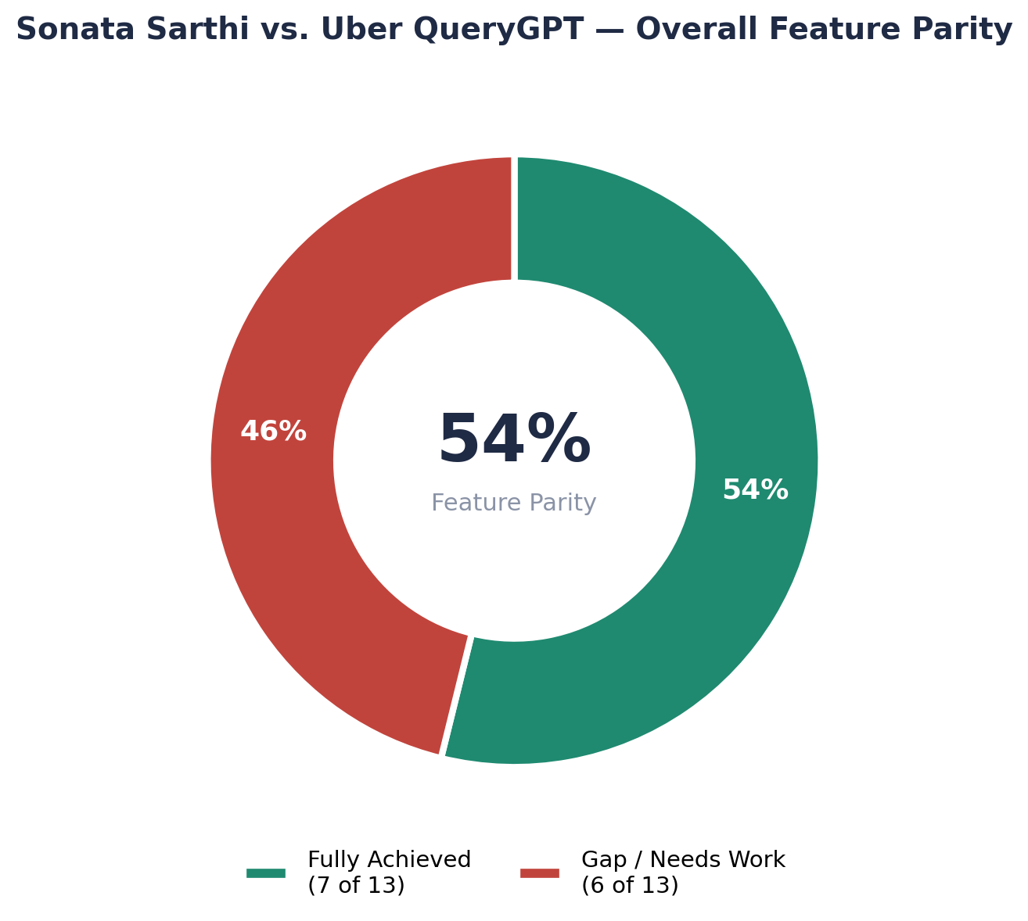
Figure 1 — Overall feature parity between the current implementation and the Uber QueryGPT reference (13 capability areas assessed).
Bottom line: 7 of 13 architectural capabilities are already at full parity with Uber QueryGPT. The remaining 6 are concentrated almost entirely in the SQL-generation quality layer — prompt shaping, schema trimming, few-shot grounding, and post-generation validation — rather than in retrieval or infrastructure, which are already strong.

1. High-Level Comparison Matrix
The table below maps every major architectural capability in Uber's QueryGPT case study to its corresponding implementation (or absence) in consumers.py.
Architectural Feature | Uber QueryGPT Architecture | Sonata Sarthi consumers.py | Status
Domain / Workspace Routing | Workspaces (Mobility, Ads, Core Services) | 3-Level Hierarchy (Category → Subcategory → Table) via TreeNode & DatabaseSearchTree | Fully Achieved
Domain Classification Strategy | Intent / Workspace Routing Engine | Hybrid: Keyword Matching + ChromaDB Cosine Similarity + LLM Fallback | Fully Achieved
Schema Knowledge Base | Vector DB for Schemas & Metadata | ChromaDB Persistent Store (sarthi_table_schemas) with Auto-Sync on Connect | Fully Achieved
Specialized Domain Prompts | Workspace-specific Prompts | DB-backed Subcategory Prompts (Chatbot_Sa_SubcategoryPrompts) | Fully Achieved
Multi-Engine / LLM Abstraction | Multi-model routing | Pluggable Engine Architecture (Gemma Gateway, Groq Llama 3.3 70B, Vertex AI) | Fully Achieved
Performance & Caching | Low latency query engine | Class-level In-Memory Cache + Redis MD5 Response Cache + WebSocket Streaming | Fully Achieved
Visualization & Charting | Integrated BI reporting | GraphConsumerSplDwsfCall Plotly Chart Generator (Bar, Pie, Line, Scatter) | Fully Achieved
Prompt Enhancement / Expansion | Dedicated Prompt Expander Agent enriches vague queries | Raw user query passed directly to classifiers | Needs Implementation
Column Pruning / Filtering | Filters 50–200+ columns to top relevant columns | Passes full table schema string / static schemas to LLM | Needs Implementation
Few-Shot SQL Example RAG | Vector retrieval of past verified SQL by question similarity | Static Query_Patterns string loaded from subcategory DB table | Needs Upgrade
SQL Validation & Self-Correction | Recursive Validator Agent (syntax, table/column, join checks) | Basic SELECT/EXEC string check; try-except on direct execution | Needs Implementation
Business Rule / Glossary RAG | Separate vector store for business metric definitions | Embedded inside raw subcategory prompt strings | Needs Upgrade
Feedback Loop & Indexing | Continuous indexing of approved queries into vector store | Saves history to Chatbot_Sa_ChatHistory (no automated re-indexing) | Needs Implementation

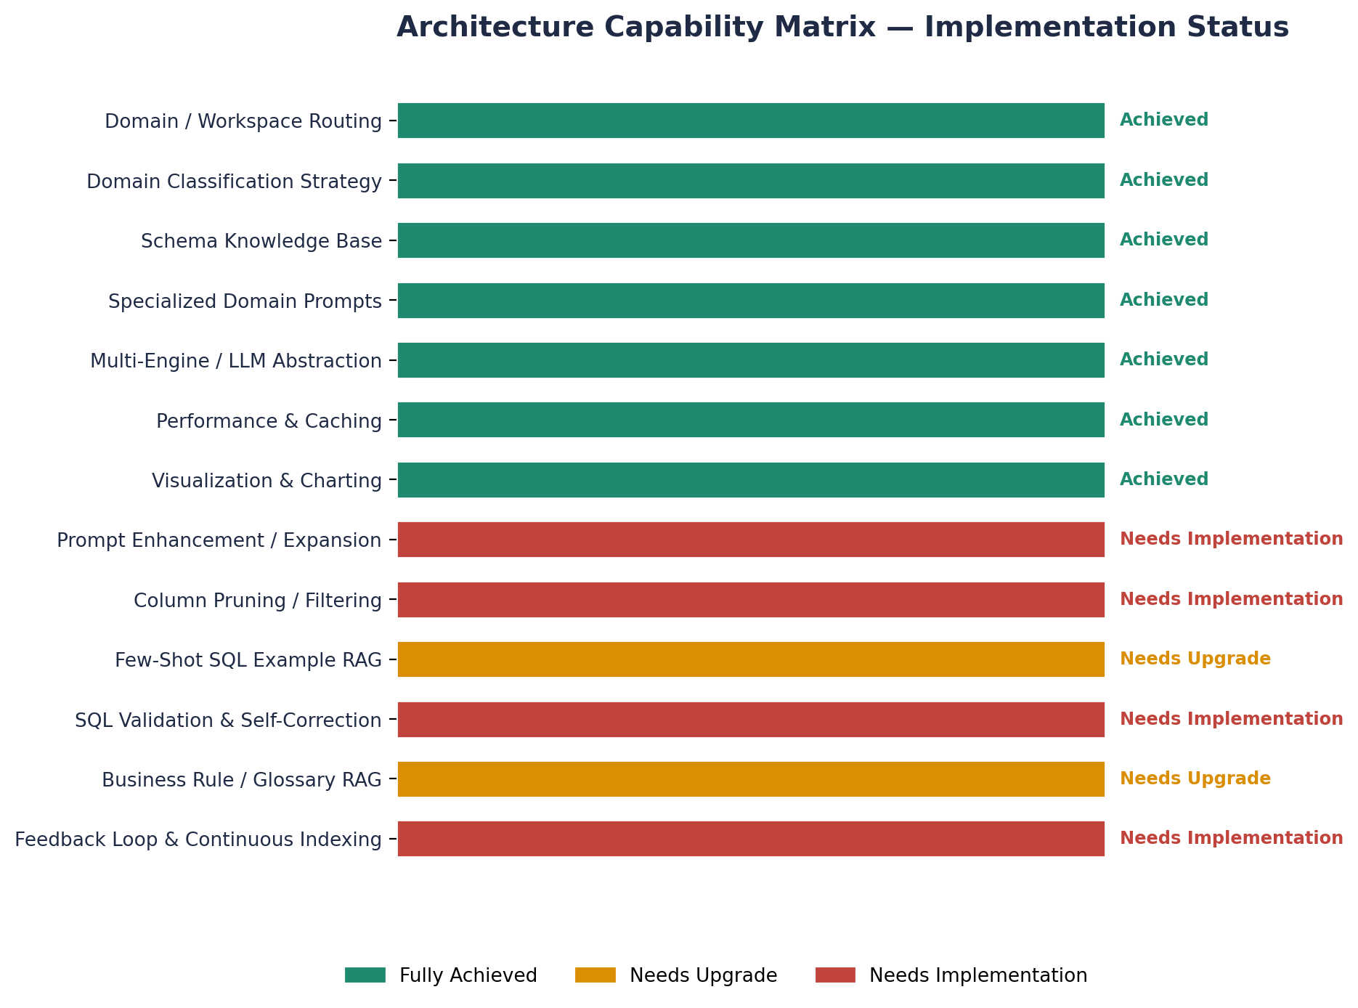
Figure 2 — Capability-by-capability implementation status across the full comparison matrix.

2. What We Have Achieved — Current Architectural Strengths
consumers.py already incorporates several sophisticated design patterns that match core principles of Uber QueryGPT.

2.1 Three-Level Hierarchical Search Tree
Components: TreeNode, DatabaseSearchTree
Prevents dumping the entire database schema into the LLM. Queries are scoped hierarchically:
- Level 1 — Category: identifies the primary business vertical (e.g., Sonata Premier League, Hierarchy, User/Staff details).
- Level 2 — Subcategory: narrows to the target functional area (e.g., geo-hierarchy, geo-hierarchy-head).
- Level 3 — Table & Query Generation: selects relevant table groups and loads specialized T-SQL prompts.

2.2 Hybrid Tri-Layer Classification Engine
Components: classify_category_hybrid, classify_subcategory_hybrid
High-speed, cost-efficient routing using three sequential evaluation stages:
- Fast keyword matching — sub-millisecond lookup via SQL-loaded dictionaries (category_keywords_db, subcategory_keywords_db).
- Vector similarity search (ChromaDB) — cosine similarity matching over embedded category and subcategory text.
- LLM fallback — generative classification for complex, unstructured, or ambiguous queries.

2.3 Persistent ChromaDB Vector Store with Auto-Sync
Components: sync_chroma_db_from_database, retrieve_top_k_schemas_chroma
On WebSocket connection startup, the consumer automatically syncs SQL Server schema definitions into local ChromaDB persistent collections (sarthi_categories, sarthi_subcategories, sarthi_table_schemas). During query processing, top-K table schemas are dynamically retrieved via vector search and injected into the LLM prompt.

2.4 Dynamic Database-Driven Prompt Management
Component: get_subcategory_prompt
Specialized subcategory prompts, table candidate lists, query patterns, and schema definitions are maintained in SQL Server (Chatbot_Sa_SubcategoryPrompts) and cached in memory, eliminating hardcoded prompts and allowing dynamic system tuning.

2.5 Enterprise Optimization & Multi-Model Support
Pluggable AI models (GatewayModel, GroqModel, GenerativeModel), Redis cache (rcache), and progress streaming:
- Seamless switching between Google Vertex AI, Groq (Llama 3.3 70B), and a custom Gemma API Gateway.
- Instant Redis caching with MD5-hashed keys to serve repeated queries without LLM overhead.
- Real-time WebSocket progress notifications to the frontend during classification steps.

3. Pipeline Comparison
The current linear pipeline handles classification and retrieval well, but skips four stages that Uber's architecture treats as first-class: prompt enrichment, column pruning, few-shot SQL grounding, and validated self-correction.
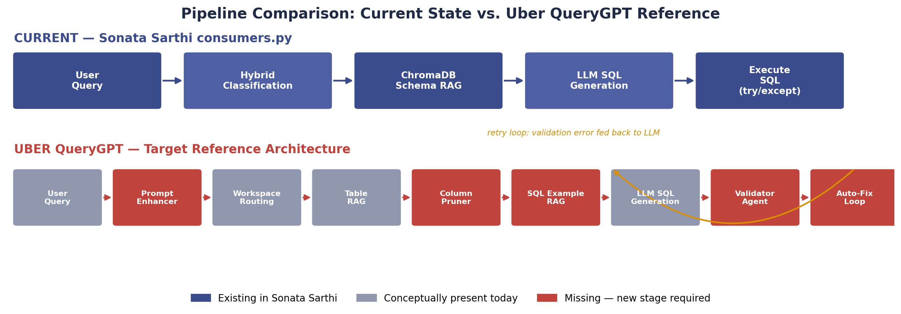
Figure 3 — Stage-by-stage comparison of the current pipeline against the Uber QueryGPT reference pipeline.

4. Gap Analysis
Comparing consumers.py with Uber's QueryGPT study reveals five key architectural gaps that impact accuracy on complex enterprise queries.

Gap 1 — Prompt Enhancement / Expansion Agent
Uber's paradigm: users often enter incomplete queries (e.g. "patna collection july"). A Prompt Enhancer Agent runs before classification/retrieval to expand short inputs into fully disambiguated natural language prompts (metrics, date ranges, aggregation granularities).
Current state: the raw user string is passed directly into keyword/vector matching. Short or vague inputs can cause classification misfires or incomplete SQL generation.
Needed: a pre-classification Prompt Expander Agent that converts shorthand questions into structured, explicit user intents.

Gap 2 — Dynamic Column Pruning / Filtering
Uber's paradigm: enterprise tables frequently contain 50–200+ columns. Sending all column definitions to the LLM pollutes the context window, increases token cost, and induces hallucination. A Column Pruner selects only the top ~10–15 relevant columns before SQL generation.
Current state: full table schemas are retrieved from ChromaDB, or static schema blocks are injected wholesale — wide tables such as Day_Wise_Summarised_Final_Geography_Hierarchy send the model dozens of unused columns.
Needed: a column-filtering pass (vector similarity or LLM selection) that trims schema metadata to query-relevant columns before final prompt assembly.

Gap 3 — Vectorized Few-Shot SQL Example Library
Uber's paradigm: thousands of previously authored, validated SQL queries are vectorized. For a given question, QueryGPT retrieves the top 3–7 most similar past SQL queries as few-shot examples, teaching the LLM exact join conditions and business logic.
Current state: query patterns are stored as static text blocks in Chatbot_Sa_SubcategoryPrompts — there is no dynamic similarity search against a granular vector collection of SQL query pairs.
Needed: a sarthi_sql_examples ChromaDB collection for dynamic few-shot retrieval based on question similarity.

Gap 4 — Recursive SQL Validation & Self-Correction Agent
Uber's paradigm: generated SQL passes through a Validator Agent before execution, checking syntax correctness, table/column existence against metadata, and proper join keys and aggregation functions. On failure, the error is fed back to the LLM in a recursive correction loop (up to N retries).
Current state: the consumer only checks whether the query starts with SELECT/EXEC. If SQL Server throws an execution error (e.g. Invalid column name 'RiskScore'), the exception is caught and an error message is returned to the user.
Needed: a dedicated SQL Validator & Auto-Correction Loop that catches database errors, feeds the stack trace back into the LLM, and auto-corrects the query before responding.

Gap 5 — Automated Feedback Loop & Continuous RAG Indexing
Uber's paradigm: successful, user-approved queries and edits are continuously indexed into the vector store, creating a self-improving flywheel.
Current state: chat history is saved to dbo.Chatbot_Sa_ChatHistory, but there is no automated mechanism to vectorize successful queries back into ChromaDB.
Needed: a background process or feedback hook to index verified queries from Chatbot_Sa_ChatHistory into the sarthi_sql_examples vector collection.

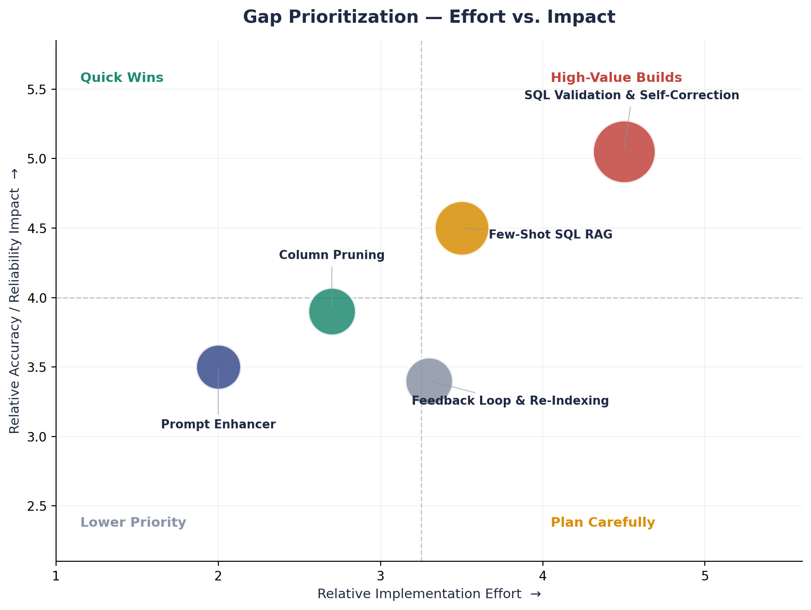
Figure 4 — Gap prioritization by relative implementation effort vs. expected accuracy/reliability impact.

5. Target Architecture Blueprint
To evolve HierarchicalSearchConsumer into an Uber-grade Text-to-SQL system, the proposed end-to-end multi-agent execution pipeline adds three new ChromaDB collections and four new processing stages around the existing classification and generation core.
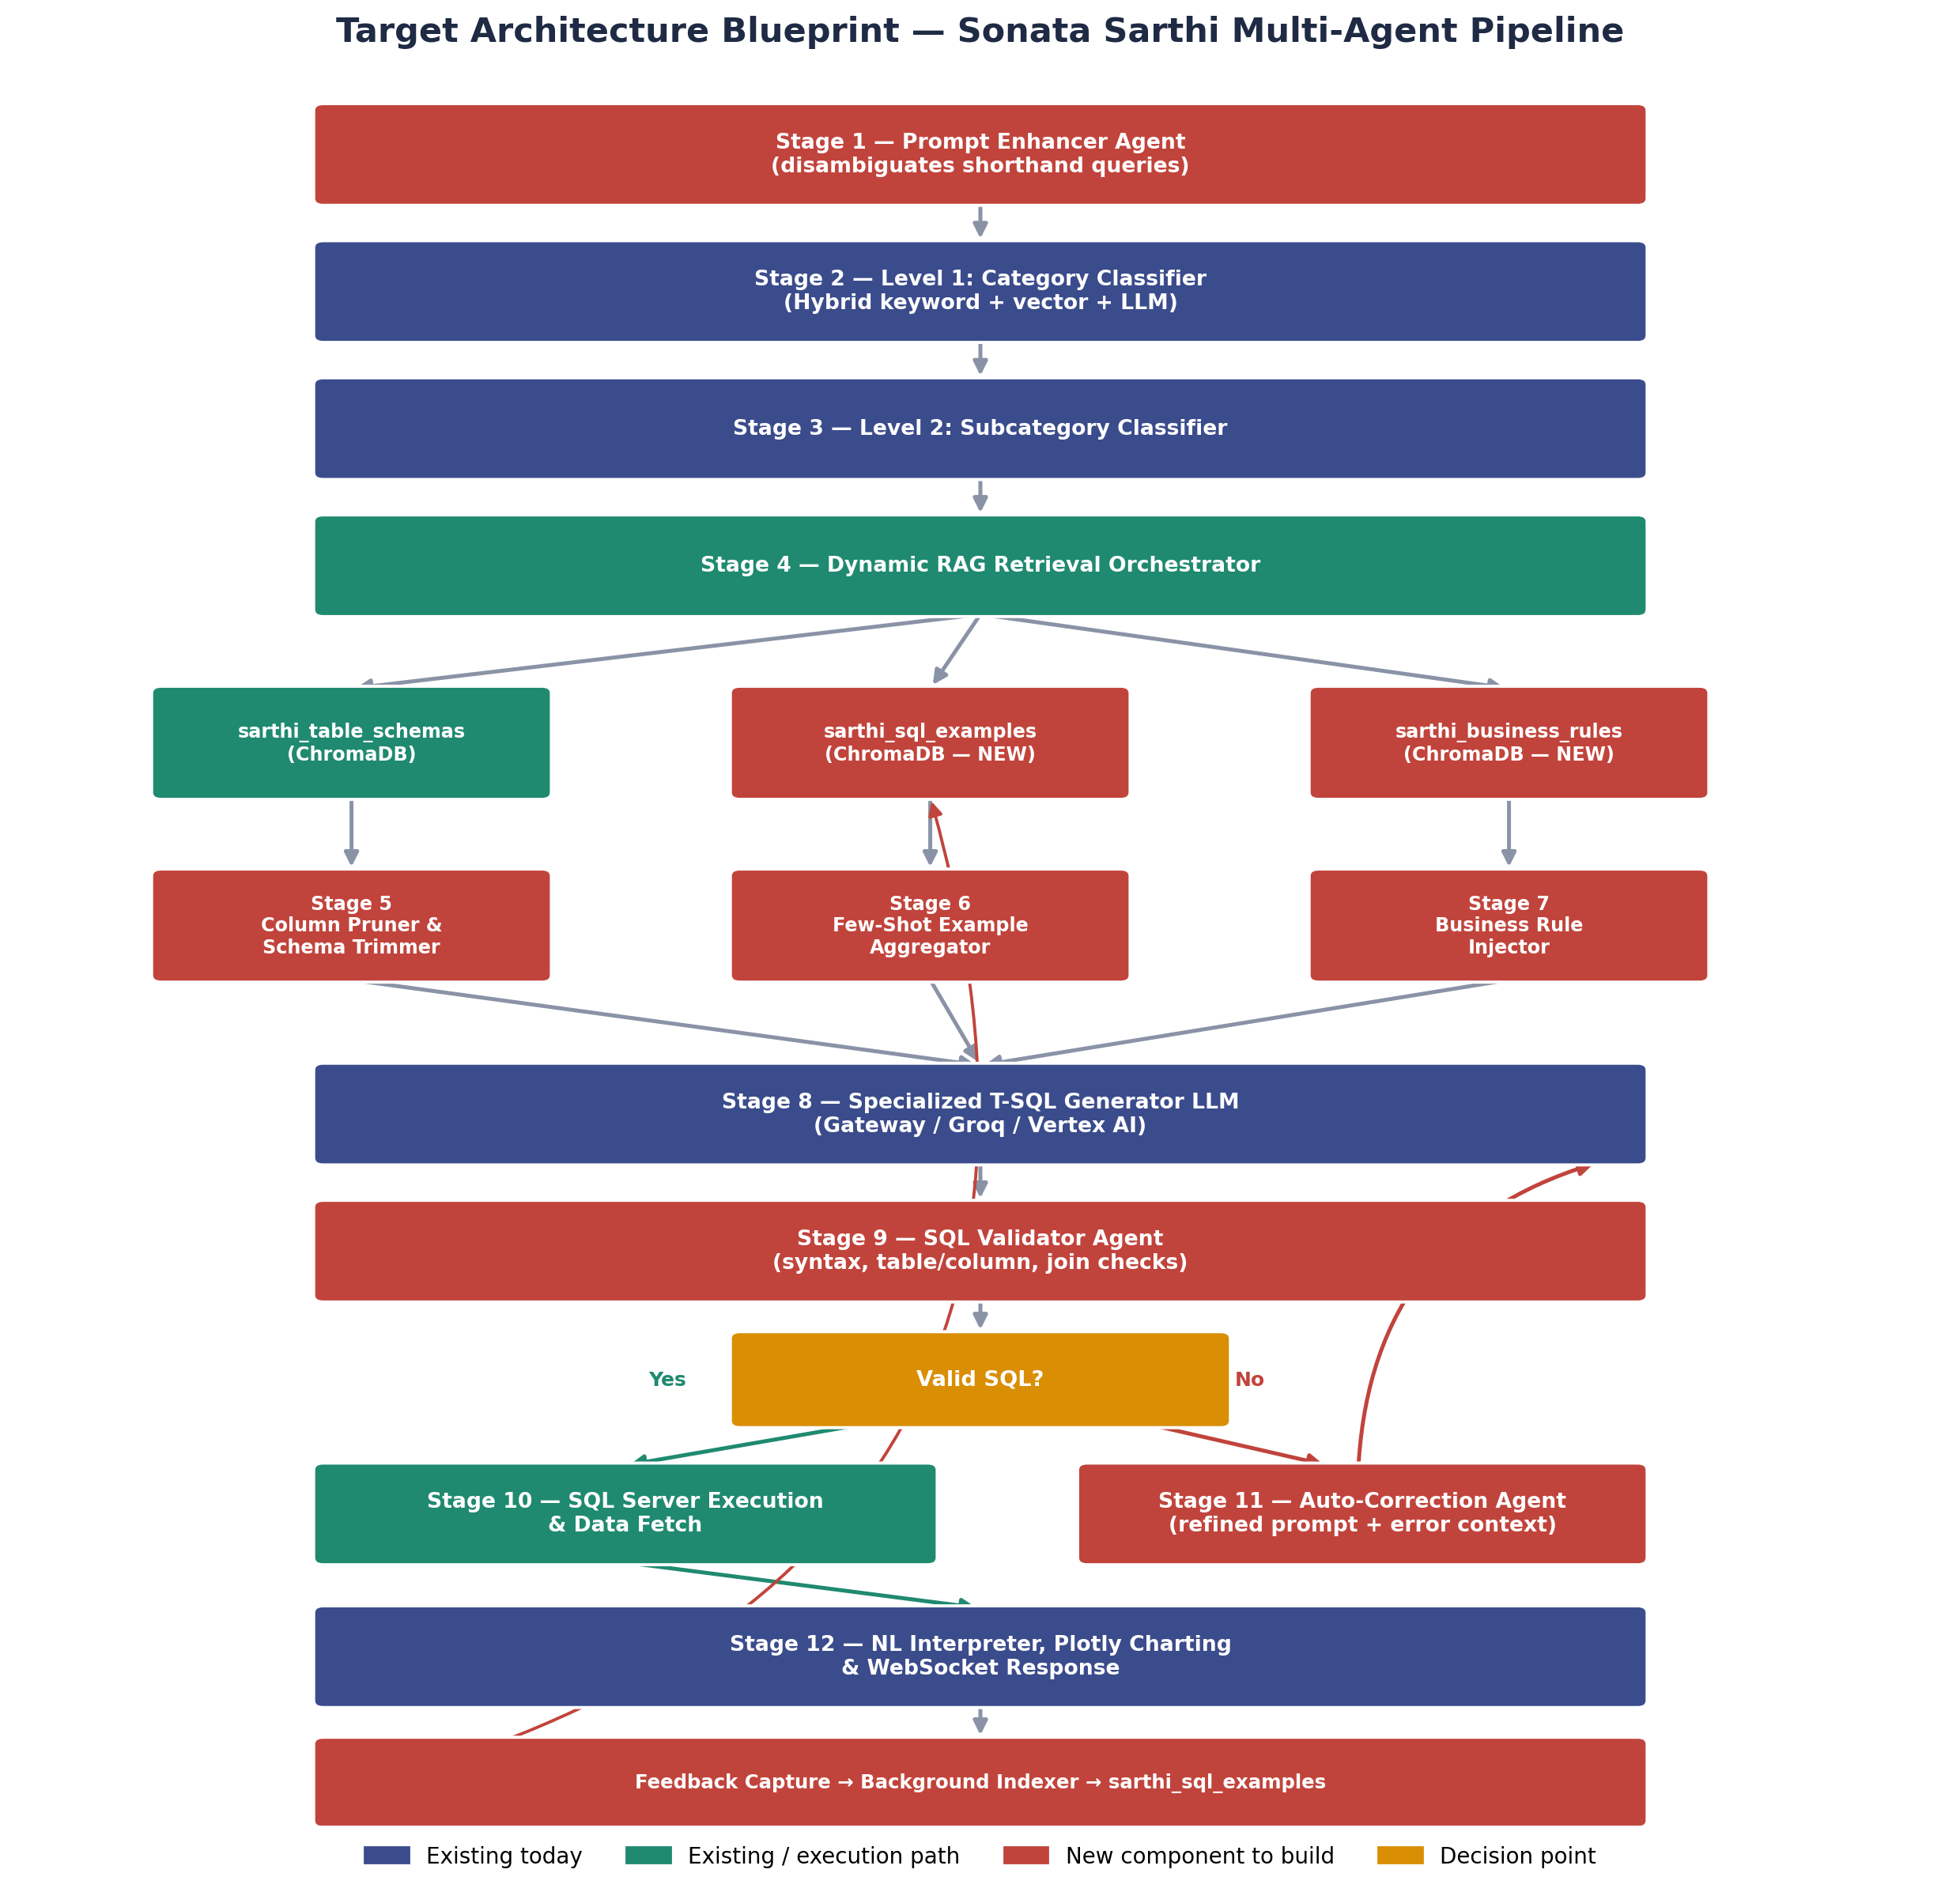
Figure 5 — Full 12-stage target pipeline, including the RAG branch (schemas / SQL examples / business rules) and the validate → auto-correct retry loop.

6. Actionable Step-by-Step Upgrade Plan
These changes are designed to be implemented inside consumers.py without breaking existing WebSocket contracts.
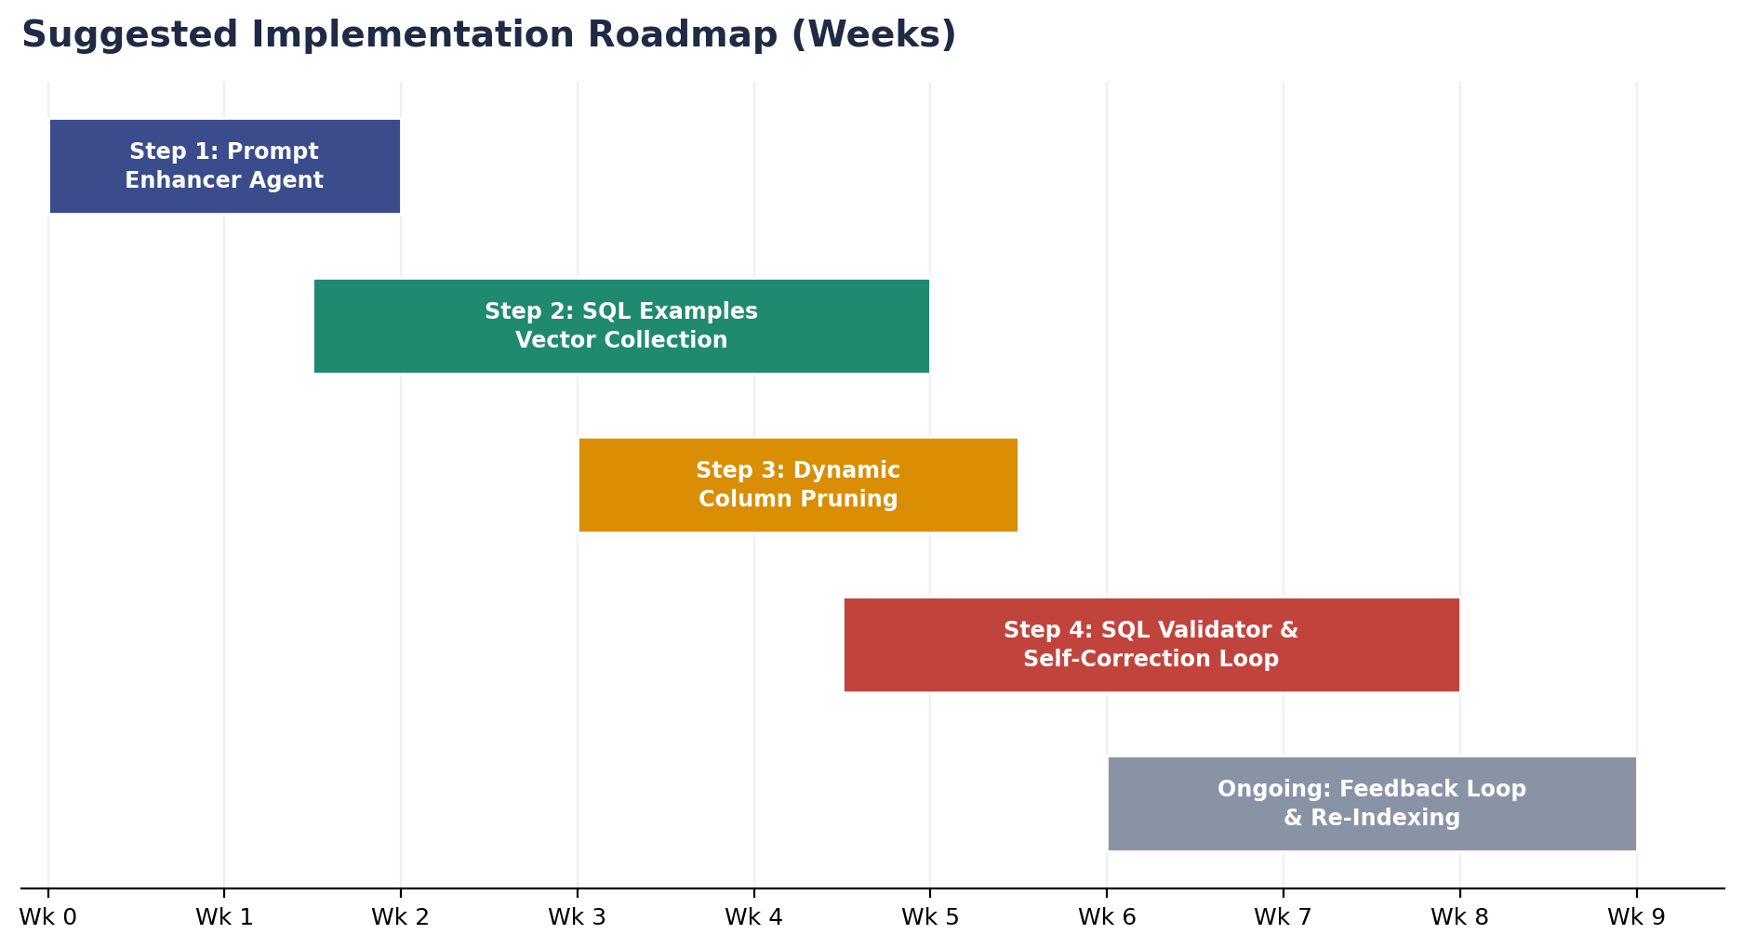
Figure 6 — Suggested phased rollout across the four build steps, with continuous feedback indexing running in parallel.

Step 1 — Implement PromptEnhancer Method
- Add a fast LLM utility method enrich_user_prompt(raw_query, conversation_history) to HierarchicalSearchConsumer.
- Expand shorthand abbreviations (e.g. bro, npa, pos, dpd) into formal technical queries before Level 1 classification.

Step 2 — Build the sarthi_sql_examples ChromaDB Collection
- Add a new collection sarthi_sql_examples inside sync_chroma_db_from_database().
- Store sample natural language questions alongside their benchmark T-SQL queries.
- Implement retrieve_top_k_sql_examples(query, subcategory, k=3) to inject dynamic few-shot examples into Level 3 query generation.

Step 3 — Implement Dynamic Column Pruning
- Add prune_schema_columns(schema_text, user_query, max_columns=15) to inspect table schema definitions and keep only columns semantically relevant to the user query.

Step 4 — Implement the validate_and_correct_sql Self-Correction Loop
Wrap SQL Server execution in a retry loop (max 2–3 iterations):
def execute_with_self_correction(self, initial_query, context_message):
current_query = initial_query
for attempt in range(3):
try:
# Attempt database execution
db_results = pd.read_sql_query(text(current_query), self.engine)
return db_results, current_query, None
except Exception as sql_err:
# Feed exact error trace back into LLM for auto-fix
correction_prompt = f"""
The following T-SQL query failed on SQL Server:
```sql
{current_query}
```
Error Message: {str(sql_err)}
User Question: {context_message}
Please correct the T-SQL query to fix the error. Return ONLY the valid SQL query.
"""
current_query = self.query_model.generate_content([correction_prompt]).text
raise Exception("Max self-correction retries exceeded.")

7. Summary Recommendation
The existing HierarchicalSearchConsumer architecture has already mastered the hardest part of RAG: hierarchical domain isolation and vector routing.
By adding Prompt Enhancement, Column Pruning, Vectorized Few-Shot SQL RAG, and Recursive Auto-Correction, the Sonata Sarthi engine will achieve 1:1 architectural feature parity with Uber QueryGPT — cutting query failure rates and eliminating SQL syntax and column hallucinations across complex backend schemas.
Recommended sequencing: start with the Prompt Enhancer and Column Pruner (lowest effort, immediate accuracy gains), then build the SQL Example RAG collection, and finish with the Validator / Auto-Correction loop, which delivers the largest reliability improvement but depends on the other three being in place first.

