

QUEUE MANAGEMENT APPLICATION DOCUMENTATION

(ASSIGNMENT 2)

Student Name: Cristea Tudor

Group: 30423

CONTENT

1. ASSIGNMENT OBJECTIVE ………………………………………………………... 3
2. PROBLEM ANALYSIS, MODELING, SCENARIOS, USE CASES …………...….. 3
3. DESIGN AND IMPLEMENTATION ……………………………………………..… 4
4. RESULTS ……………………………………………………………………………. 7
5. CONCLUSIONS …………………………………………………………………….. 8
6. BIBLIOGRAPHY ……………………………………………………………….…… 8
7. ASSIGNMENT OBJECTIVE

The objective of this assignment is to design and implement a queue management application with a dedicated graphical interface through which the user can enter the number of clients, the number of queues, the maximum simulation time, the minimum arrival time, the maximum arrival time, the minimum service time and the maximum service time and start the simulation using these pieces of data. The progress, as well as the results of the simulation, are displayed in real-time by the interface and are also saved in a text file for later use.

The sub-objectives are the following:

* + - * Design and implement the *Client* class, *Server* class, *Scheduler* class, *SimulationManager* class, *Strategy* interface and *SelectionPolicy* enum
* Design and implement the two strategies in which the clients are assigned to a certain queue (shortest queue strategy and shortest time strategy)
* Ensuring the thread-safety of the classes
* Design and implement the Graphical User Interface (GUI)
* Design and implement the controller that links the models to the views (the interface)
* Testing and Debugging possible errors and/or edge-cases

1. PROBLEM ANALYSIS, MODELING, SCENARIOS, USE CASES

The use case diagram is depicted in Figure 1.

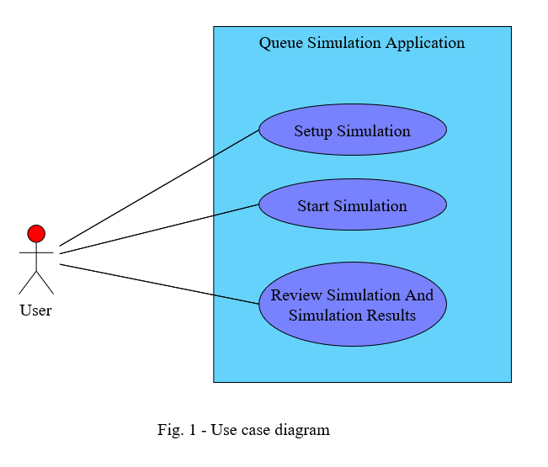

**Use case: Setup Simulation/Start Simulation/Review Simulation**

**Primary actor: User**

**Success Scenario Steps:**

1. The user enters all the necessary parameters in order to start the simulation (number of clients, number of queues, queue size, maximum simulation time, minimum arrival time maximum arrival time, minimum service time, maximum service time)
2. The user presses the “*Start Simulation*” button
3. The application validates the data which was entered
4. The simulation starts and progresses in real-time (second by second)
5. The simulation time is reached or there are no clients left in the waiting queue nor in one of the active queues
6. The simulation stops and the results are displayed on the screen in a separate window
7. The user can close the result window and the simulation window and thus, return to the setup window from which another simulation with new or existing data can be started

**Alternative Scenarios:**

1. The user enters anything other than a strictly positive number in one of the text fields and presses the “*Start Simulation*” button
   * + The application informs the user that the text he entered is invalid
     + The simulation cannot be started until all data is valid
     + The scenario returns to step 1
2. The user leaves one of the text fields empty

* The application informs the user that there is at least one empty text field
* The simulation cannot be started until all text fields are filled (correctly)
* The scenario returns to step 1

1. DESIGN AND IMPLEMENTATION

The package diagram is depicted in Figure 2. I decided to group my classes based on their functionality, and thus, adopted the MVC (Models, Views, Controllers) pattern for developing this application. This way, the application has a high coherence.

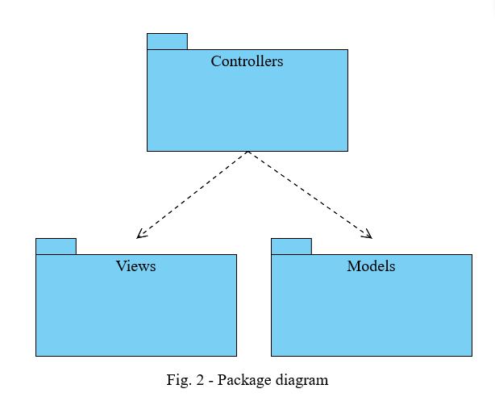

The *Client* class diagram is depicted in Figure 3. Each client will have a unique id, an arrival time (this is supposed to replicate the scenario in which clients request a server in real-time, at various time stamps) and a service time, which represents the time it takes for the server to fulfill the client’s request.

The *Server* class diagram is depicted in Figure 3. Each server contains a *BlockingQueue* of clients, as well as a waiting period which will be declared as an *AtomicInteger* in order to ensure the thread-safety of the *run()* method, where this waiting period will be primarily used. The *run()* method, for each thread of the *Server* class will run as long as the *volatile boolean* variable *go* is set to true. The first client of the queue is taken and the thread will “sleep” for a number of seconds equal to the amount of the service time of that particular client. After the thread “wakes up” again, the client will be removed from the queue and the waiting period will be decreased by an amount equal to the service time of the removed client.

The *Scheduler* class diagram is depicted in Figure 3. The scheduler is responsible with creating and starting the servers, operations which are performed in the constructor of this class. The *changeStrategy()* method takes the enum as a parameter and changes the strategy accordingly. Therefore, the *dispatchClient()* method adds the client to one of the servers depending on the strategy type.

The *Strategy* interface is depicted in Figure 3. It is a functional interface, since it only contains the *addClient()* abstract method, is implemented by two classes: the *ShortestQueueStrategy* class and the *ShortestTimeStrategy* class. Each of them, implement the *addClient()* method according to their name. The former will place the client into the server with the least number of clients and the latter will place the client into the server with the smallest waiting period.

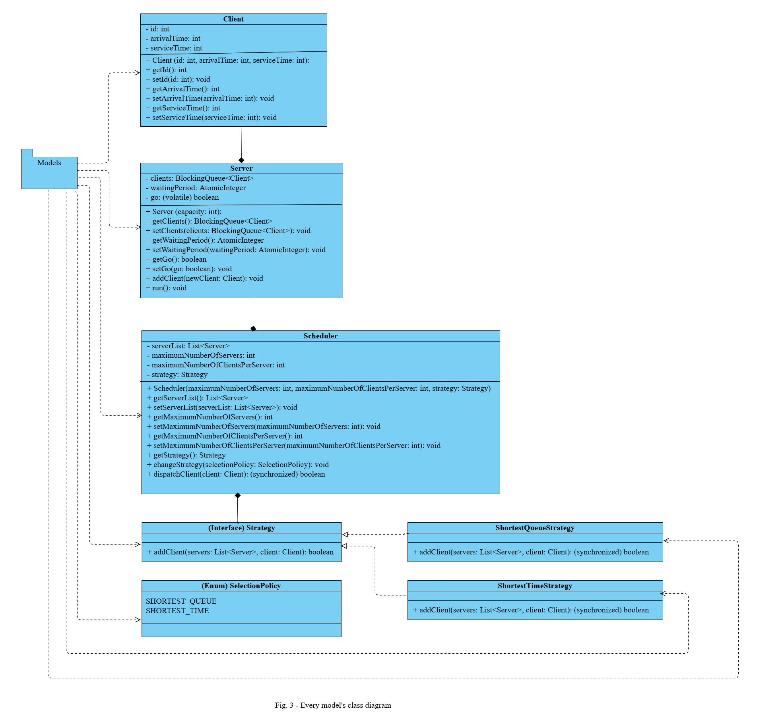The *SelectionPolicy* enum is depicted in Figure 3. It is only used to help with the selection of the type of strategy that needs to be applied when assigning clients to servers.

The *MainController* class diagram is depicted in Figure 4. The *validateInput()* method is responsible with validating the strings of text that are entered by the user in the text fields of the GUI. If these strings are either empty or do not represent strictly positive numbers, then the user will be notified of their mistakes and the simulation will not start. The *validateInput2()* method is responsible with verifying the fact that the minimum times are smaller or equal to their respective maximum times.

The *SimulationManager* class diagram is depicted in Figure 4. This represents the main thread of the application. The *generateRandomClients()* method, as the name suggests, will generate clients with random arrival times and service times, both of which are situated in a certain intervals. The list of generated clients is then sorted by their arrival times, since all of the them are created at the beginning of the simulation. Thus, they will be assigned one of the servers at the appropriate moment of the simulation, or later if all of the servers are full. However, even if they are assigned a certain server, each client will still wait its turn, until the server can process them (they reach the front of the queue). The *run()* method is responsible with many things that happen throughout the simulation. Firstly, it creates the log text file in which each step of the simulation as well as the results of the simulation are saved for later use. Secondly, it is responsible with the entire simulation, meaning that it dispatches clients to servers, displays the evolution of the simulation time, server queues and waiting queue, in real time, through the GUI. Additionally, it keeps track of all queues (including the waiting one) and stops the simulation prematurely if there are no more clients in any queue. At the end of the simulation, it stops all servers and displays, using a separate window, the results of the simulation including the average waiting time, average service time and peak hour.

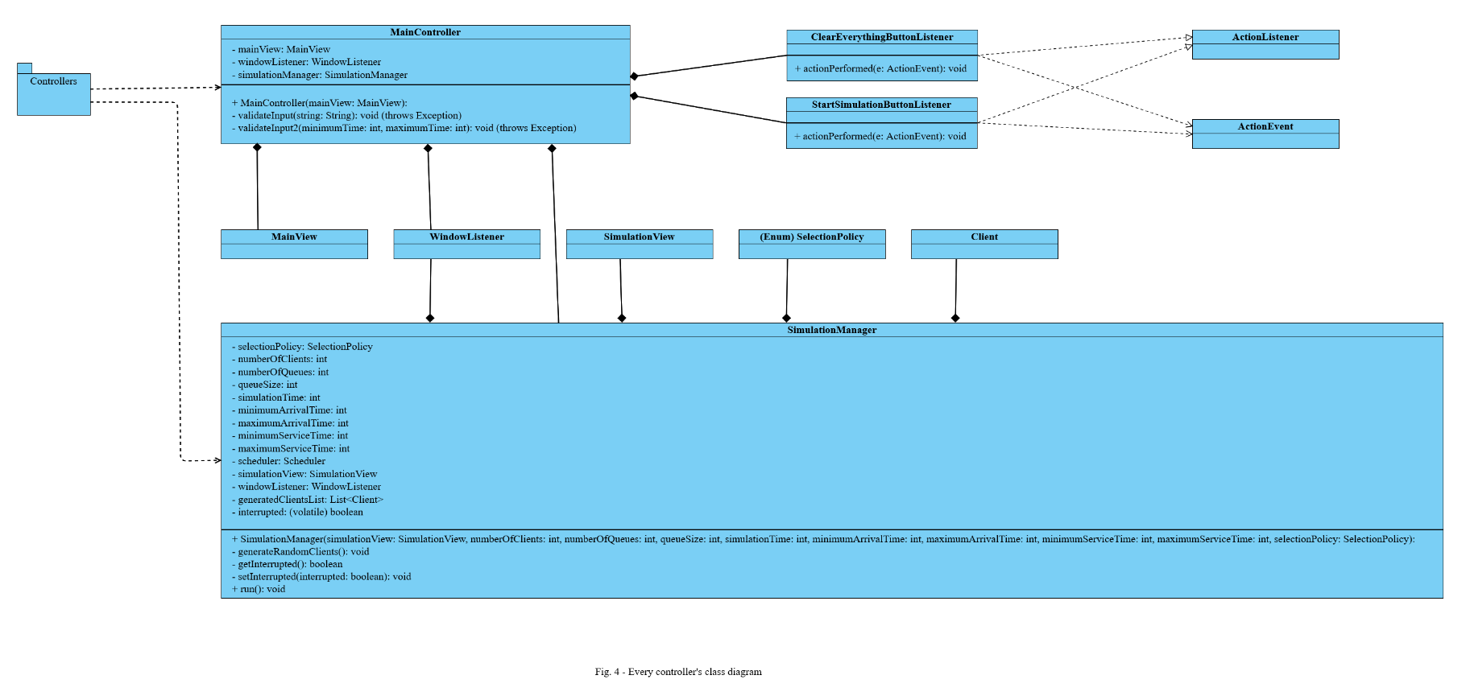

The *MainView* class diagram is depicted in Figure 5. It contains text fields and a combo box for the setup elements of the simulation, as well as two buttons: one for clearing every text field and another for launching the simulation. Supposing that the data entered is valid, a second window appears in which the real-time evolution of the queues can be observed, while the initial window will become inactive (non-interactable).

The *SimulationView* class diagram is depicted in Figure 5. It contains real-time information about certain aspects of the simulation including the current time, the list of waiting clients and the lists of clients for each server. The simulation will stop either when the current time will reach the maximum simulation time (which was chosen during the setup phase of the application) or when all queues (including the waiting queue) are empty. After the simulation is done, a third window will appear containing the results of the simulation. If, however, the user decides to stop the simulation abruptly by closing the simulation window, then the application will not compute and display any results, and all servers including the simulation manager will be halted. The user will have to wait for about a second until he can modify the parameters of the simulation and start a new one.

The *ResultsView* class diagram is depicted in Figure 5. It includes the concrete values of the average waiting time, average service time and peak hour (the busiest hour). This data might be useful to the user. Once the results window and the simulation window are both closed, the user can, once again, modify the parameters of the simulation and start a new one. Here is how I interpreted and computed these results:

* **average waiting time**: the sum of the waiting times of the clients that were in the “waiting queue” at some point during the simulation divided by their number added with the sum of the waiting times of the clients that have been assigned a server but have not been served yet divided by the number of servers; the latter sum is computed for every unit of time (in this case, every second) of the simulation and thus, at the end, these averages are summed up and divided by the total time of the simulation
* **average service time**: the sum of the service times of the clients that were served completely (their service time reached zero) or partially (the simulation ended while they were being served) divided by the total number of clients of the simulation
* 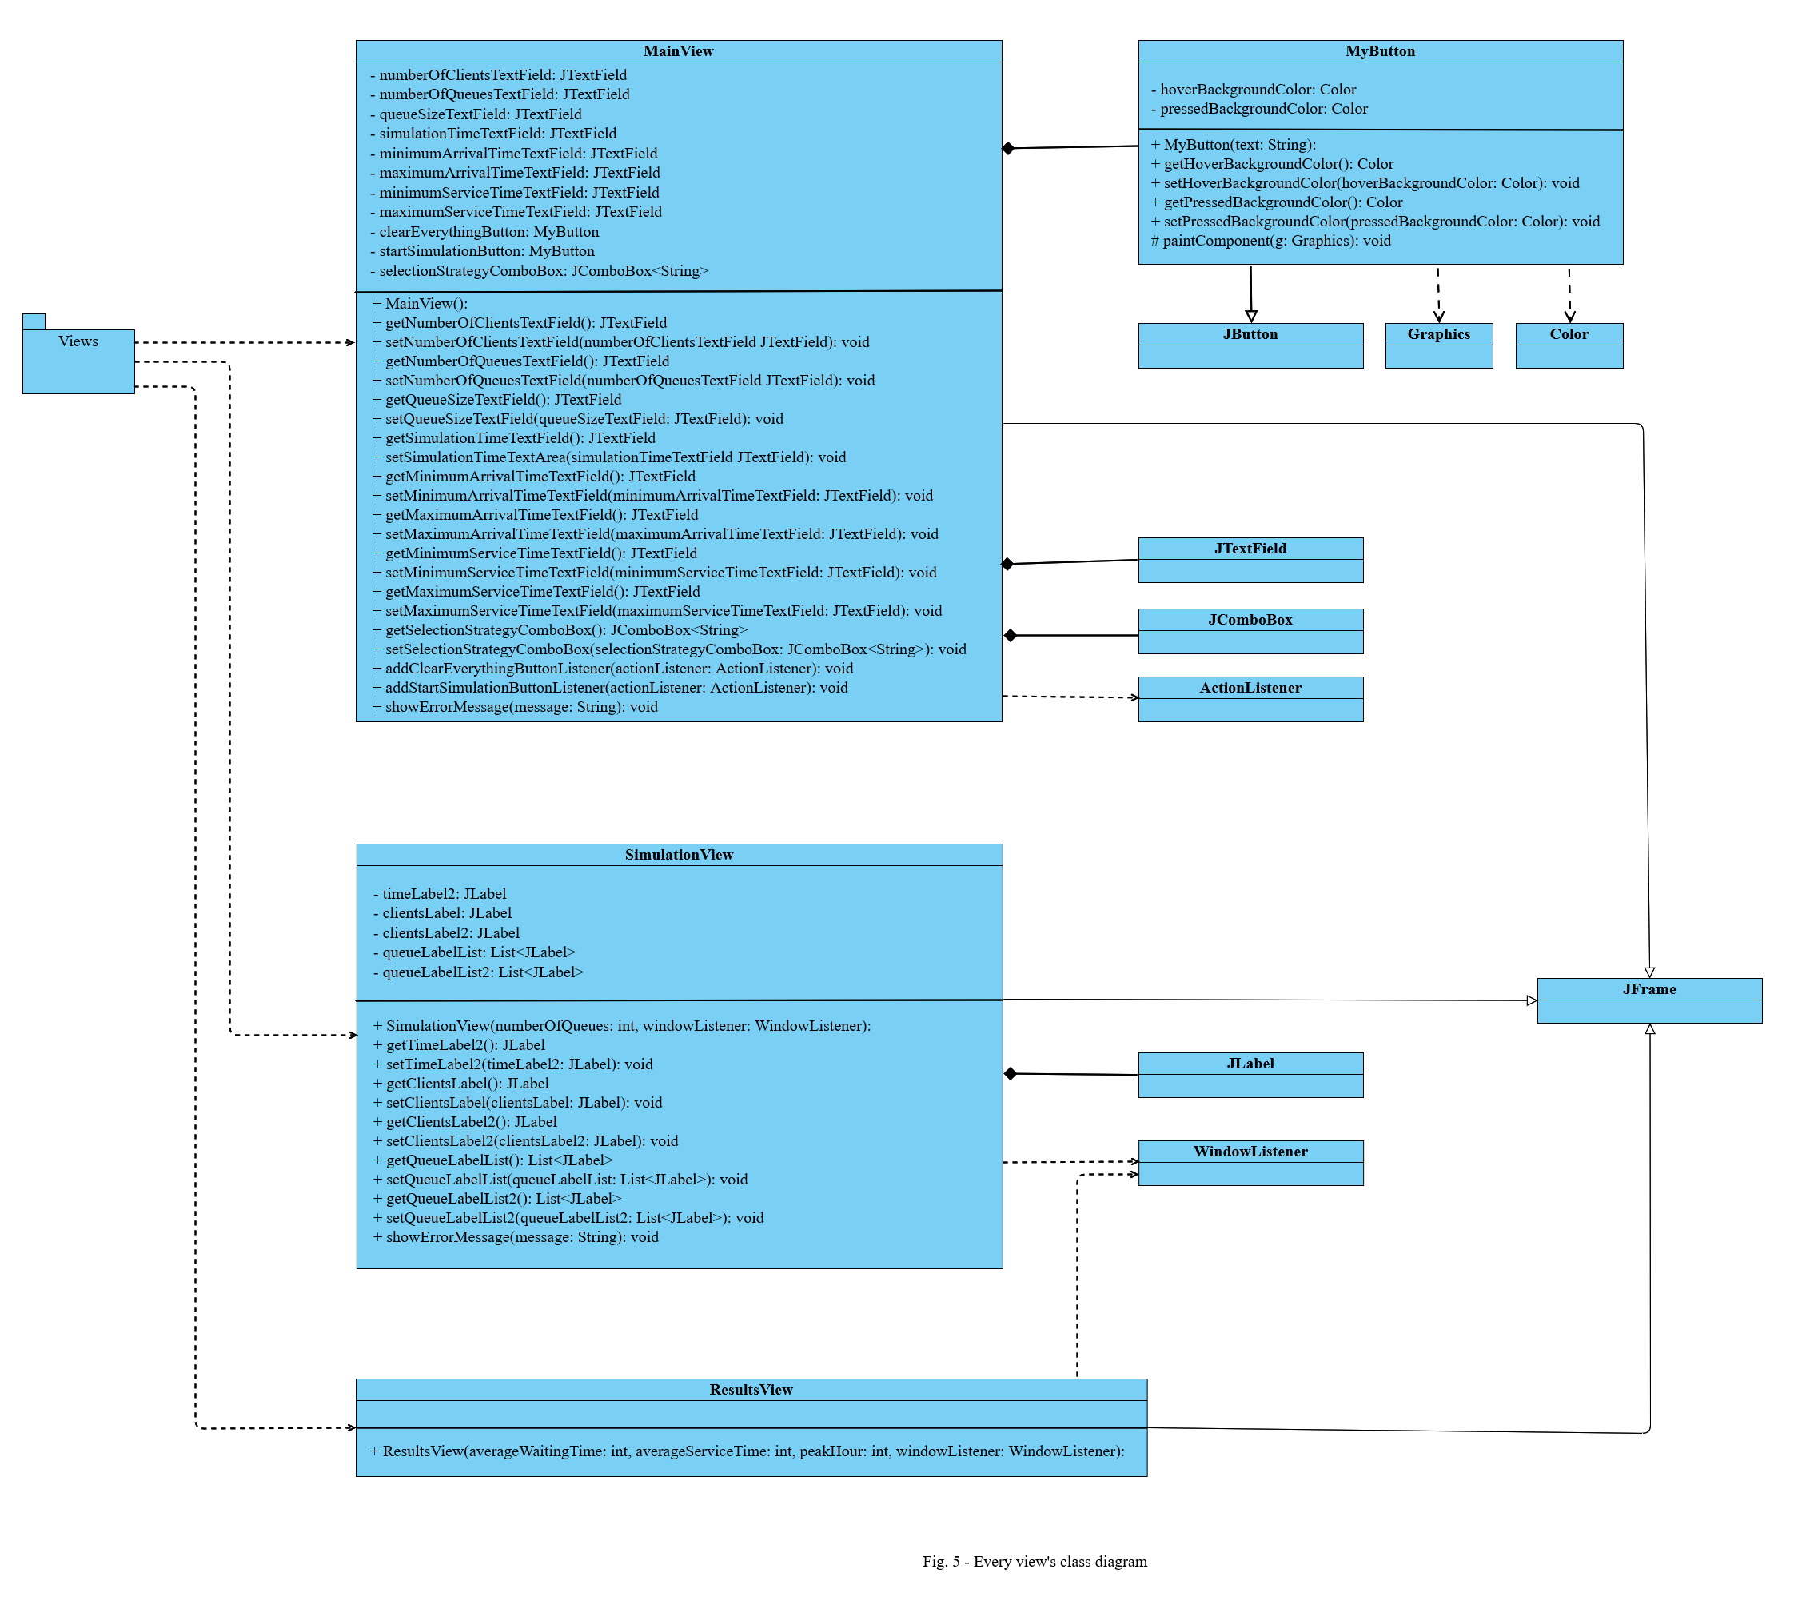**peak hour**: the unit of time (in this case, the second) in which the number of clients in every server, as well as in the waiting queue was maximum

1. RESULTS

The application was tested using the three tests provided in the assignment documentation. The results were stored in separate log text files. No apparent issues were observed throughout the testing phase.

1. CONCLUSIONS

In conclusion, a queue simulation application is very useful to people which are interested to implement some sort of queueing system, which can range from a server-based website to a physical store. It can give the user an idea on what the problems and the limitations of such a system might be. Using the results provided by the application, the user can take further action based on these numbers.

Working on this assignment, personally I have learned how to implement thread-safe classes and thread-safe methods (using the “*synchronized*” keyword and the “*volatile*” keyword). Additionally, I have learned how to work with threads (implement their *run()* method, instantiate them, start them, make them wait) and how to implement an application from a concurrent point of view as opposed to a sequential point of view (which was the primary case up until now).

Obviously, the application can be developed further with additional features, such as:

* letting the user choose a different size for each queue
* implementing a functionality such that the clients are randomly generated and added to the simulation in real-time (to make it more realistic and unpredictable)
* making the application able to add or remove queues based on the workload of the simulation

1. BIBLIOGRAPHY

* [online.visual-paradigm.com](https://online.visual-paradigm.com) (for diagrams)
* *Fundamental Programming Techniques* course lecture slides and laboratory slides
* [stackoverflow.com](https://stackoverflow.com)
* [chat.openai.com/chat](https://chat.openai.com/chat)
* [geeksforgeeks.org/](http://www.geeksforgeeks.org/)
* [youtube.com](https://www.youtube.com) (for tutorials)