Milestone 2: Web Application Entity Design

Ahmed Salem

Chengjiu Hong

Darel Ogbonna

Robin Ma

<https://github.com/SFSU-CSC-667/term-project-spring-2017-card>

Table of Content

Entity Diagram 3

Description of Each Entity 4

**a) Entity Diagram**

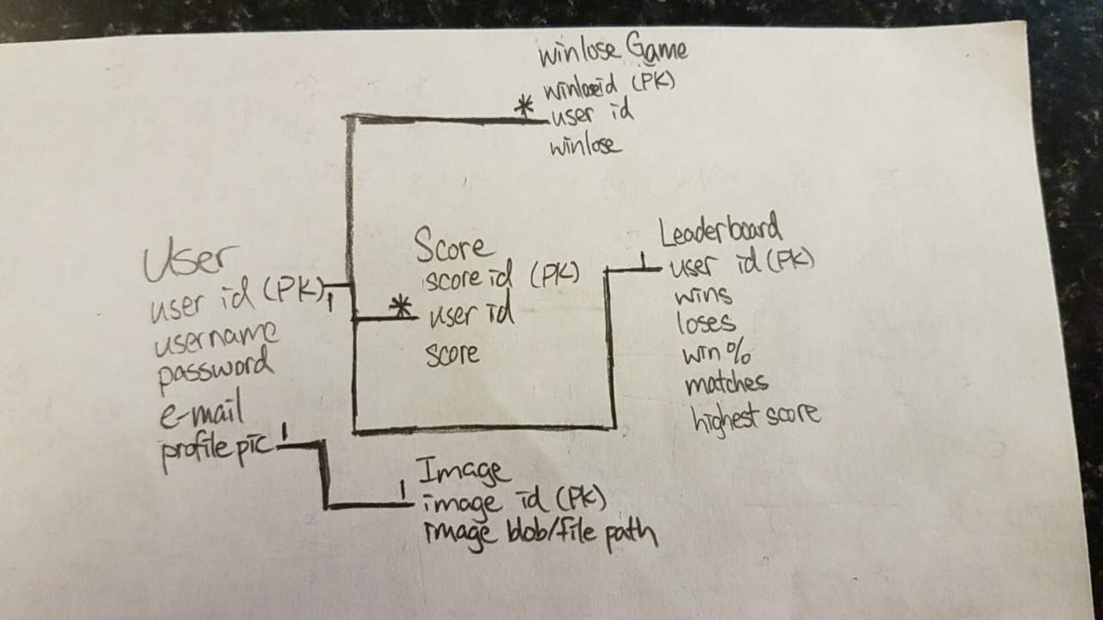

**b) Description of Each Entity**

1. User:

* Each user could play multiple different game
* Each user could win or lose multiple different games

1. Image

* An image object also needs to be stored in the database, could be a blob or file path
* one to one relationship to user table profile pic

1. Score

* Keep tracks of each user's score by games id
* User table is a one to many relationships with Scores table

1. WinLose

* Keep tracks of each user's win and lose
* User table is a one to many relationship with WinLose table

1. Leaderboard

* Populated by the information within Score table and WinLose table
* Consist of the calculation from the information within Score table and WinLose table