Pokr

Term Project

CSC 867/667

San Francisco State University

Specification Document

Chandra Pradyumna Adusumilli

Rex Lam

Repo: https://github.com/SFSU-CSC-667/term-project-spring-2017-pokr

Contents

Register 3

Verification 4

Login 4

Forgot Password 5

Reset Password 5

Edit Account Settings 6

Edit Password 6

Lobby 7

Game 7

Chat 8

## Register

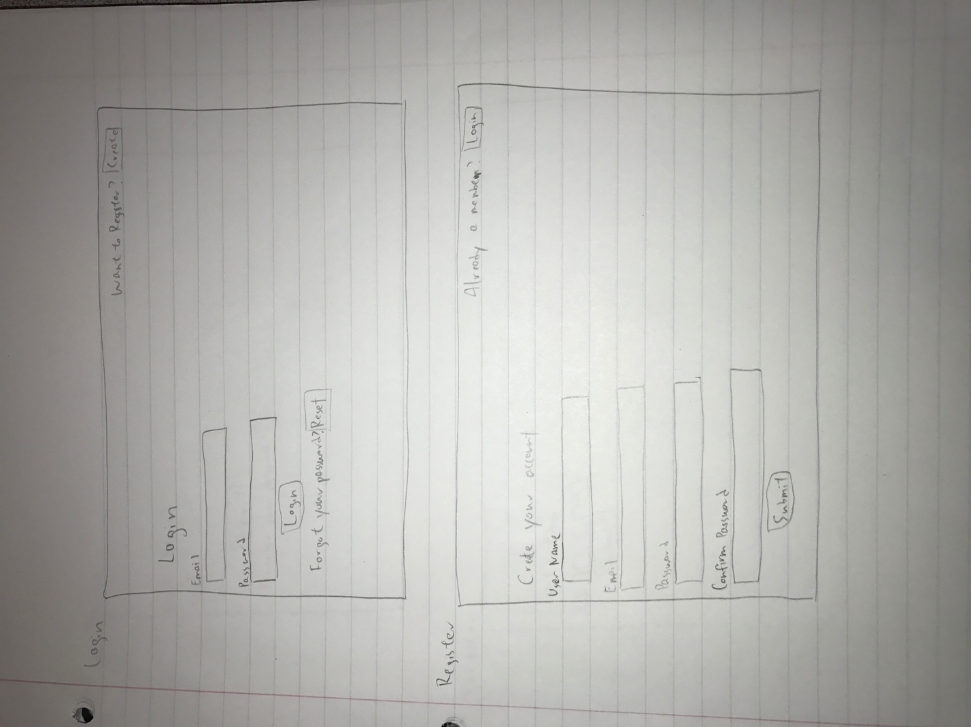

A user will be able to register an account with Pokr.

User will enter the following details

* Username
* Name
* Email
* Password
* Confirm Password

After clicking the submit button the user will receive verification email with a six digit verification code to the address he has given and user will be redirected to Verification Screen.

The system prompts the user if email address or username is already in use.

The user can go to the login screen by clicking the login button.

## Verification

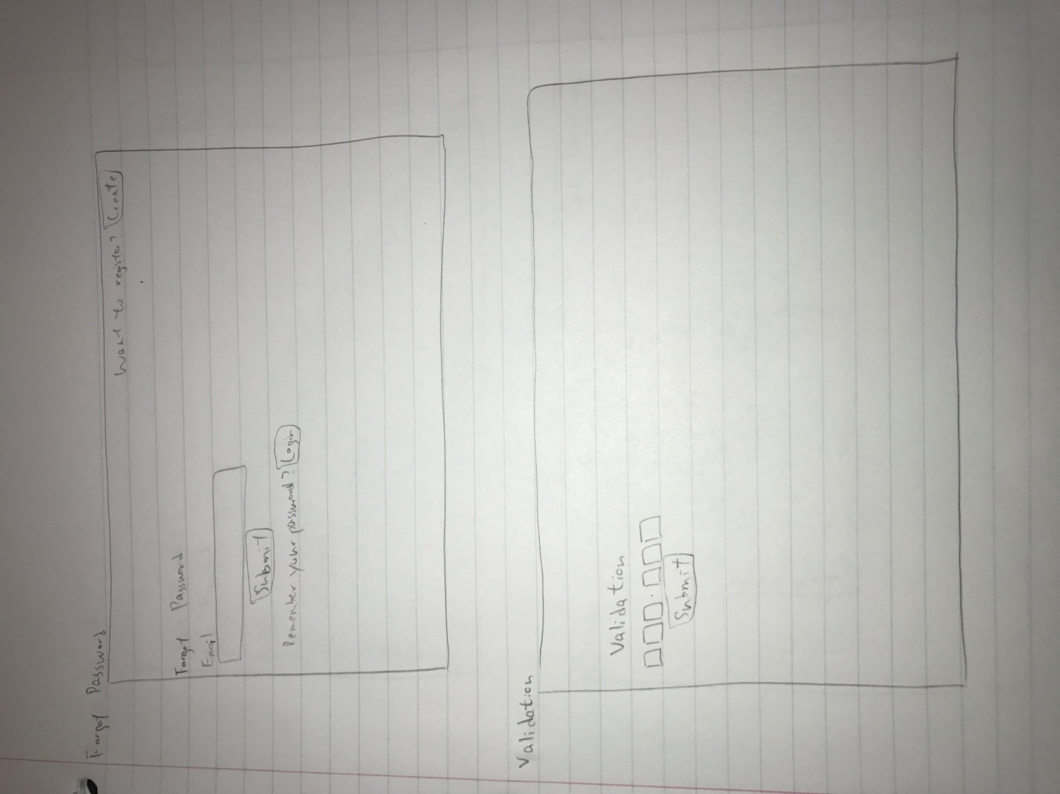

User has to enter verification code he received and click on submit. If successfully user will be redirected to login else the system will prompt the user to enter correct code.

## Login



User has to enter his username/email and password and click on login.

* If correct user logs in and verified, he goes to the lobby screen
* If correct user logs in and unverified, he goes to the verification screen
* If username/email is not present in data the user will be prompted stating the same
* If password is incorrect user will be prompted stating the same

The user can go the forgot password screen by click forgot password button

The user can go to the register screen by clicking the register button

## Forgot Password



The user enters his email address and clicks on submit

If present a reset link is sent to it else the user will be prompted stating invalid email address.

## Reset Password

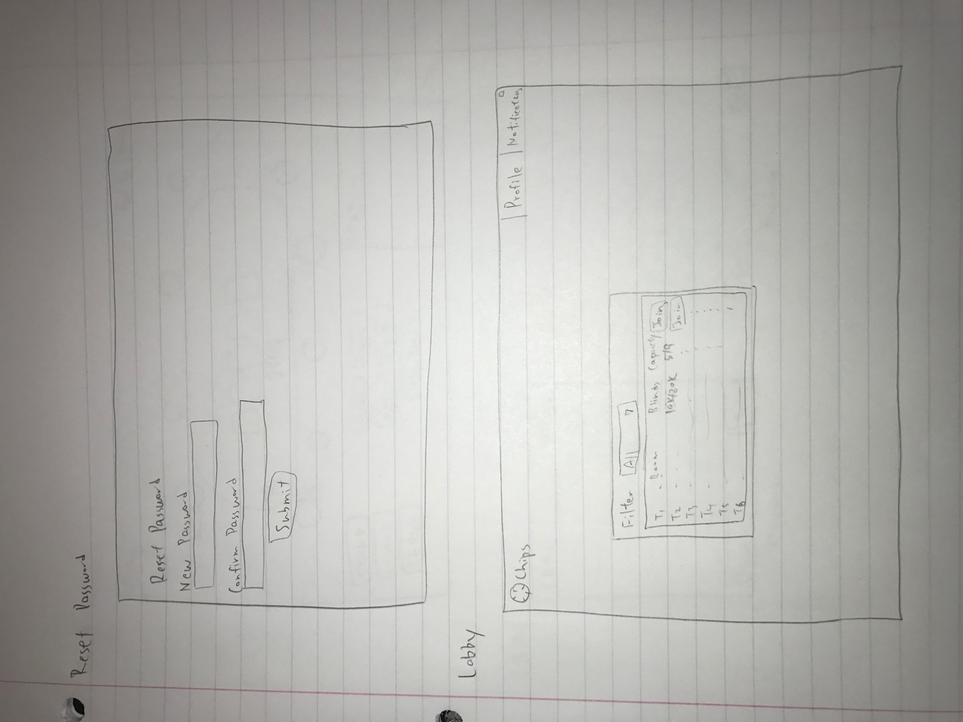

The user has to enter password and confirm it. The user’s password is changed and redirected to login.

## Edit Account Settings

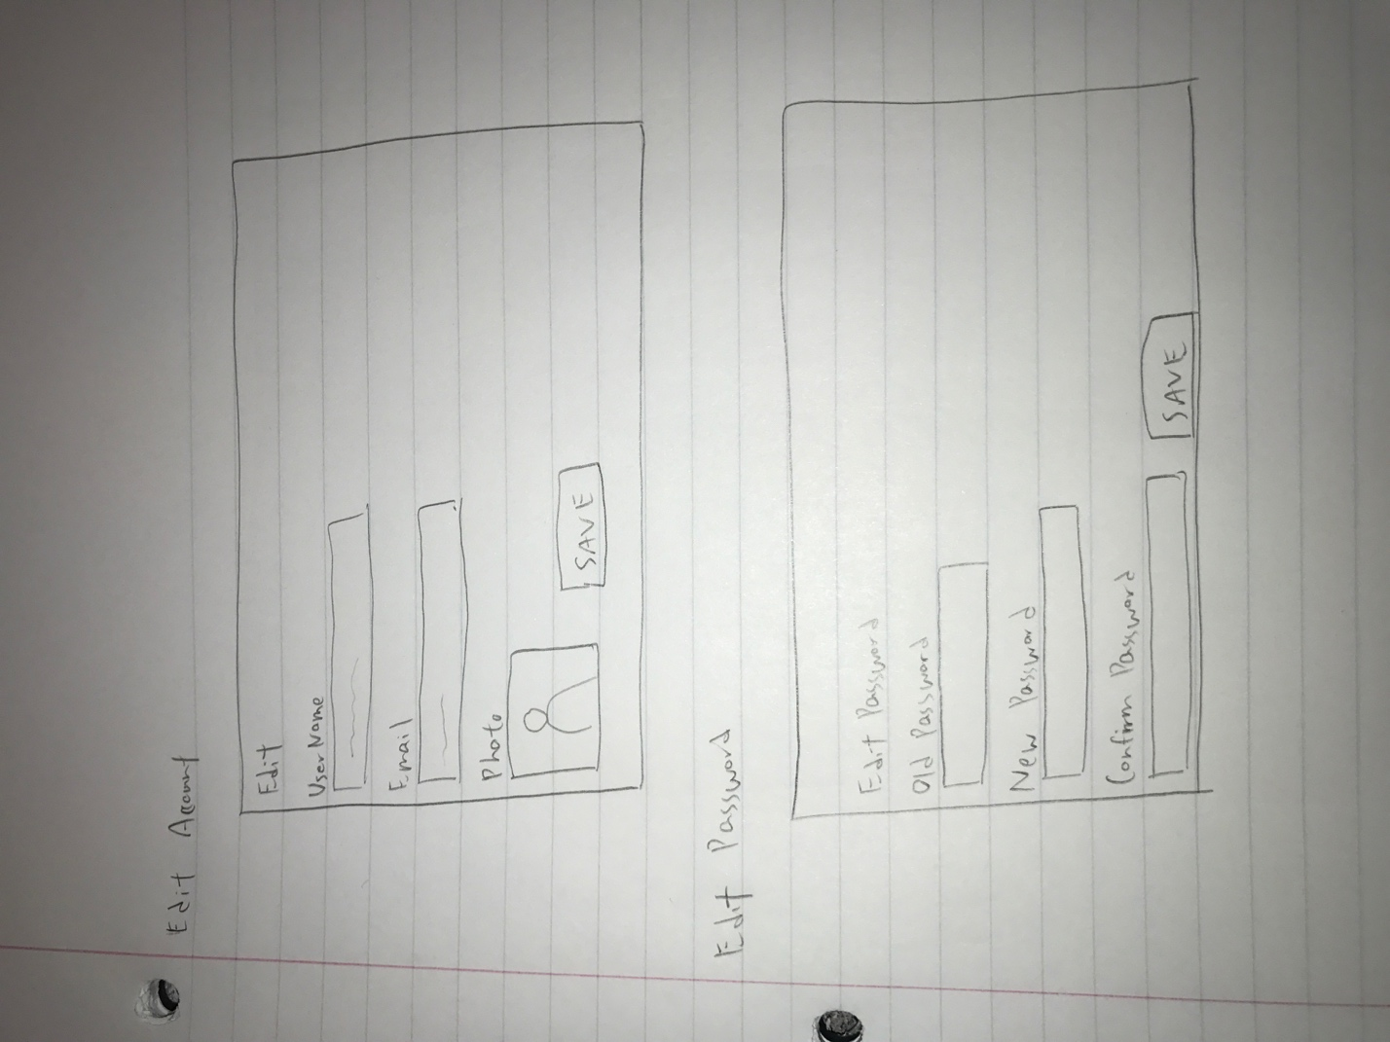

The user can edit Username, name, email or account picture and save the changes.

## Edit Password

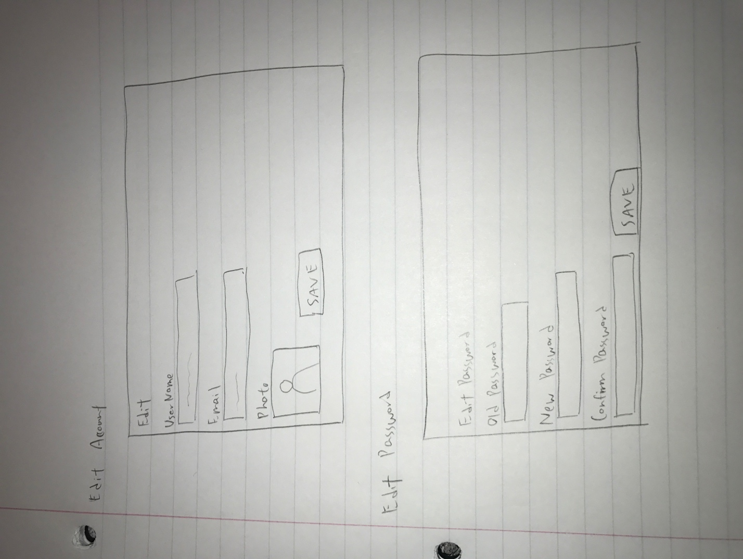

User enters current password, new password and confirms it. Save button changes the current password to the new one.

## Lobby



List of tables, their blinds and their status is displayed.

User can filter between the tables based on blinds.

User can click on join button next to the table to join it.

## Game

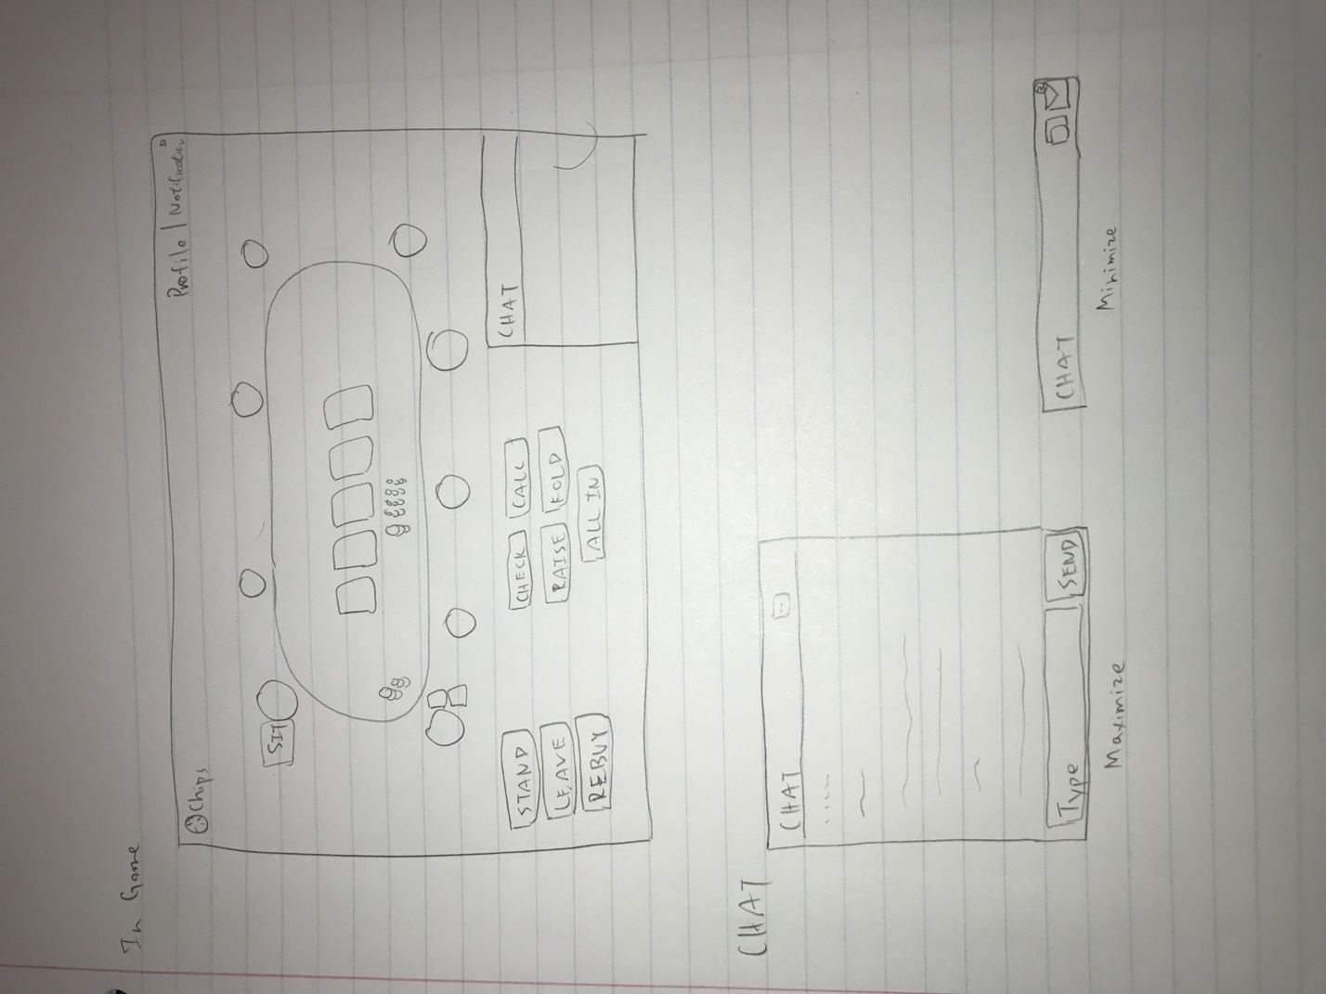

User when enter will be displayed currently running game.

Table functionalities:

* Sit
* Stand
* Leave
* Rebuy

User can decide on the amount of chips he can buy in after he clicks on sit

Game functionalities:

* Check
* Call
* Raise
* Fold
* All in

## Chat



User can minimize or maximize the chat

When minimized user can’t type into it. He gets notification when there are new messages

User can enter a message and press enter to submit the message in the chat when maximized.