Pokr

Term Project

CSC 867/667

San Francisco State University

Database Design Document

Chandra Pradyumna Adusumilli

Rex Lam

Repo: https://github.com/SFSU-CSC-667/term-project-spring-2017-pokr

Contents

Design Diagram 3

Users 3

UserChips 4

Rewards 5

Passwords 6

Sessions 6

Cards 7

Chips 8

Tables 9

TableUsers 10

Chats 11

Games 11

GameUsers 12

GameCards 13

UserCards 14

UserPlays 14

GamePots 15

PotUsers 16

## 

## Design Diagram

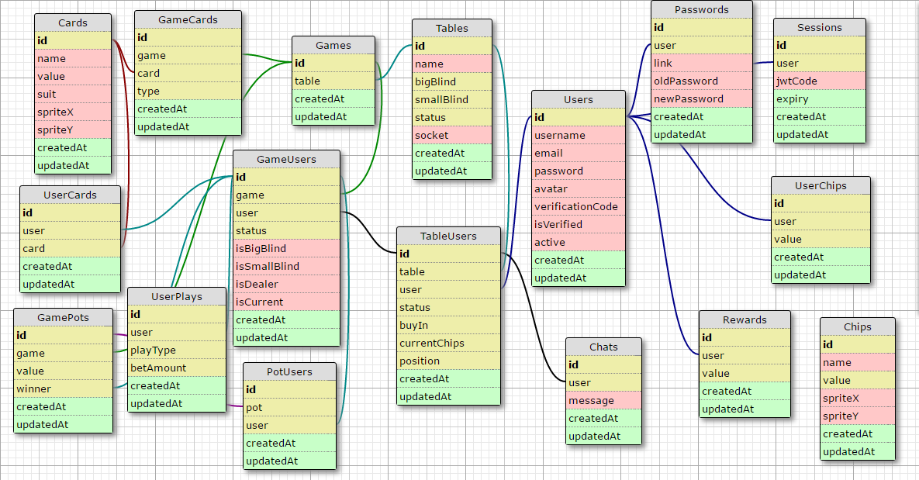

## Users

Holds all the information related to user. Facilitates login, registration.

**Columns:**

**id:** Primary Key, Integer, Auto-Increment

**username:** varchar(50), unique, not null

The username of the user with which they login. It has to be created when registering. It cannot be altered later on.

**name:** varchar(50), not null

The name of the user. It is generated when registering. Can be edited through settings page

**email:** varchar(50), unique, not null

The email of the user. It is generated when registering. Any alerts and messages like verification codes and password reset links are sent to this email. It can be editing from settings page.

**password:** varchar(100), not null

The password for login. It is created when registering. It can be reset from forgot password page or settings page.

**avatar:** varchar(100)

The path for user’s avatar image. It can be changed from account settings page.

**verificationCode:** varchar(100)

The six digit verification code sent to the user’s email after registration.

**isVerified:** Boolean, default->false

Flag to check if a user is verified

**active:** Boolean, default->true

Flag to check is a user is active

**createdAt:** timestamp with timezone

The timestamp when the record is first created.

**updatedAt:** timestamp with timezone

The timestamp when the record is last updated.

## UserChips

Holds the amount of chips with each user.

**Columns:**

**id:** Primary Key, Integer, Auto-Increment

**user:** integer, foreign key relation to ‘Users->id’

The corresponding user of the record

**value:** Integer, default value->0

The amount of chips with the user.

**createdAt:** timestamp with timezone

The timestamp when the record is first created.

**updatedAt:** timestamp with timezone

The timestamp when the record is last updated.

## Rewards

Holds the free daily reward data

**Columns:**

**id:** Primary Key, Integer, Auto-Increment

**user:** integer, foreign key relation to ‘Users->id’

The corresponding user of the record

**value:** Integer, default value->0

The amount of chips with the user.

**createdAt:** timestamp with timezone

The timestamp when the record is first created.

**updatedAt:** timestamp with timezone

The timestamp when the record is last updated.

## Passwords

Holds the data when a user changed his password

**Columns:**

**id:** Primary Key, Integer, Auto-Increment

**user:** integer, foreign key relation to ‘Users->id’

The corresponding user of the record.

**link:** varchar(100)

The link sent to the user’s email when he clicks on forgot password.

**oldPassword:** varchar(100)

The user’s old password

**newPassword:** varchar(100)

The user’s new password

**createdAt:** timestamp with timezone

The timestamp when the record is first created.

**updatedAt:** timestamp with timezone

The timestamp when the record is last updated.

## Sessions

Holds when each user logged in and details of the token

**Columns:**

**id:** Primary Key, Integer, Auto-Increment

**user:** integer, foreign key relation to ‘Users->id’

The corresponding user of the record.

**jwtCode:** varchar(100), not null

The token generated when the user logs in.

**expiry:** timestamp with timezone

The time when the token becomes invalid.

**createdAt:** timestamp with timezone

The timestamp when the record is first created.

**updatedAt:** timestamp with timezone

The timestamp when the record is last updated.

## Cards

Holds the data of the different cards, their image

**Columns:**

**id:** Primary Key, Integer, Auto-Increment

**name:** varchar(20)

The name of the card for example “Jack of Spades”

**value:** varchar(10)

The value of card for example “Ace”

**suit:** varchar(10)

The name of suit for example “Diamond”

**spriteX:** varchar(10)

The left position of the card on the image sprite

**spriteY:** varchar(10)

The top position of the card on the image sprite

**createdAt:** timestamp with timezone

The timestamp when the record is first created.

**updatedAt:** timestamp with timezone

The timestamp when the record is last updated.

## Chips

Holds the data of the different chips, their image

**Columns:**

**id:** Primary Key, Integer, Auto-Increment

**name:** varchar(20)

The name of the chip for example “Red”

**value:** integer

The value of the chip for example “100”

**spriteX:** varchar(10)

The left position of the chip on the image sprite

**spriteY:** varchar(10)

The top position of the chip on the image sprite

**createdAt:** timestamp with timezone

The timestamp when the record is first created.

**updatedAt:** timestamp with timezone

The timestamp when the record is last updated.

## Tables

The details of different tables available.

**Columns:**

**id:** Primary Key, Integer, Auto-Increment

**name:** varchar(20)

The display name of the table

**bigBlind:** integer

The big blind of the table for example “10”

**smallBlind:** integer

The small blind of the table for example “5”

**status:** integer

The status of the table for example “1”->the table is full

**socket:** varchar(50)

The details of the socket for the table

**createdAt:** timestamp with timezone

The timestamp when the record is first created.

**updatedAt:** timestamp with timezone

The timestamp when the record is last updated.

## TableUsers

The list of users connected to the table

**Columns:**

**id:** Primary Key, Integer, Auto-Increment

**table:** integer, foreign key to “Tables->id”

Corresponding table for the record

**user:** integer, foreign key to “Users->id”

Corresponding user for the record

**status:** integer, default value->0

The status of the user for example “1”->playing the current hand

**buyIn:** integer, default value->0

The buy in amount the user purchased to sit on the table

**currentChips:** integer, default value->0

The current chips the user has on the table

**position:** integer, default value->0

The position of the user on the table

**createdAt:** timestamp with timezone

The timestamp when the record is first created.

**updatedAt:** timestamp with timezone

The timestamp when the record is last updated.

## Chats

Holds the messages of the chat in the table

**Columns:**

**id:** Primary Key, Integer, Auto-Increment

**user:** integer, foreign key to “TableUsers->id”

The user who sent the message

**message:** text

The body of the message

**createdAt:** timestamp with timezone

The timestamp when the record is first created.

**updatedAt:** timestamp with timezone

The timestamp when the record is last updated.

## Games

Each hand/game on the table

**Columns:**

**id:** Primary Key, Integer, Auto-Increment

**table:** integer, foreign key to “Tables->id”

The table where the current game is running

**createdAt:** timestamp with timezone

The timestamp when the record is first created.

**updatedAt:** timestamp with timezone

The timestamp when the record is last updated.

## GameUsers

The players of the current hand

**Columns:**

**id:** Primary Key, Integer, Auto-Increment

**game:** integer, foreign key to “Games->id”

The corresponding game

**user:** integer, foreign key to “TableUsers->id”

The user playing the hand

**status:** integer, default value->1

The current status of the user for example “1->playing”,”2->folded”

**isBigBlind:** Boolean, default value->false

Flag to check if the user is big blind for the game

**isSmallBlind:** Boolean, default value->false

Flag to check if the user is small blind for the game

**isDealer:** Boolean, default value->false

Flag to check if the user is dealer for the game

**isCurrent:** Boolean, default value-> false

Flag to check the turn of the user

**createdAt:** timestamp with timezone

The timestamp when the record is first created.

**updatedAt:** timestamp with timezone

The timestamp when the record is last updated.

## GameCards

The details of the cards on the table

**Columns:**

**id:** Primary Key, Integer, Auto-Increment

**game:** integer, foreign key to “Games->id”

The reference to the current game

**card:** integer, foreign key to “Cards->id”

The reference to the cards

**type:** integer, default value ->1

The type of the card for example “1-> flop”, “2->turn”, “3->river”

**createdAt:** timestamp with timezone

The timestamp when the record is first created.

**updatedAt:** timestamp with timezone

The timestamp when the record is last updated.

## UserCards

The details of the cards each user received for the game

**Columns:**

**id:** Primary Key, Integer, Auto-Increment

**user:** integer, foreign key to “GameUsers->id”

Reference to the user of the cards

**card:** integer, foreign key to “Cards->id”

Reference to the cards

**createdAt:** timestamp with timezone

The timestamp when the record is first created.

**updatedAt:** timestamp with timezone

The timestamp when the record is last updated.

## UserPlays

Details of each move the player makes

**Columns:**

**id:** Primary Key, Integer, Auto-Increment

**user:** integer, foreign key to “GameUsers->id”

Reference to user making the play

**playType:** integer, default value->1

The type of play made by the player, for example “1->check”

**betAmount:** integer, default value->0

The amount of chips the user bet during this play

**createdAt:** timestamp with timezone

The timestamp when the record is first created.

**updatedAt:** timestamp with timezone

The timestamp when the record is last updated.

## GamePots

The pots for each game. Can be the main pot or the side pots

**Columns:**

**id:** Primary Key, Integer, Auto-Increment

**game:** integer, foreign key to “Games->id”

The reference to the game

**value:** integer, default value->0

The value of the pot

**winner:** integer, foreign key to “GameUsers->id”

The reference to the winner of the current pot

**createdAt:** timestamp with timezone

The timestamp when the record is first created.

**updatedAt:** timestamp with timezone

The timestamp when the record is last updated.

## PotUsers

Details of the users in the pot

**Columns:**

**id:** Primary Key, Integer, Auto-Increment

**pot:** integer, foreign key to “GamePots->id”

The reference to the pot

**user:** integer, foreign key to “GameUsers->id”

The reference to the users in the pot

**createdAt:** timestamp with timezone

The timestamp when the record is first created.

**updatedAt:** timestamp with timezone

The timestamp when the record is last updated.