Milestone 2: Web Application Entity Design

Team Members:
Mon-Shih Chuang
Kaluo Xie
Jeremy Tan
Brian Marcial

https://github.com/SFSU-CSC-667/term-project-spring-2017-supermario

Table of Contents:
- Entity Diagrams
- SQL

Milestone 2: Web Application Entity Design

Entity Diagrams:

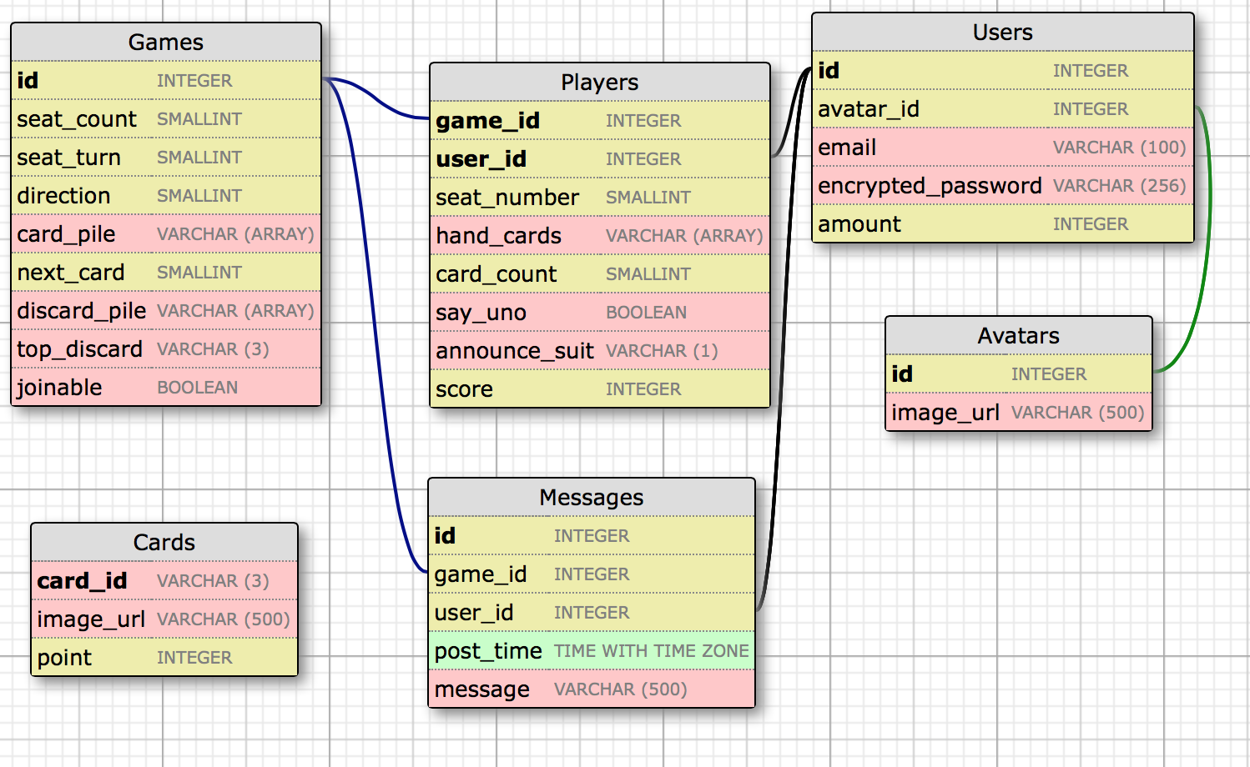
- Games – Holds the number of players in a game. If the game is full with the maximum number of players, other players will not be able to join, but if it is not full, then other players can join. It will also hold each players turn, and the direction of each players turn along with a deck of cards.
- Players – Will hold players' id number and the game id number to keep track of the games being played. It will also contain the number of cards a player holds, when a player announces “UNO” and a final score when the game ends.
- Messages – Contains the game and user id's and messages of each chat room along with a time stamp.
- Users – Will have personal avatar id's for the users, email and encrypted password of each user.
- Avatars – Contains the id of the avatar as well as the image url.
- Cards – Will have each card's unique id, it's image url and each point of the card.

Milestone 2: Web Application Entity Design

SQL:

CREATE TABLE IF NOT EXISTS Users (
id SERIAL PRIMARY KEY,
avatar_id SMALLINT REFERENCES Avatars(id),
encrypted_password VARCHAR(256) NOT NULL,
email VARCHAR(100) UNIQUE NOT NULL,
amount INTEGER DEFAULT 0
);

CREATE TABLE IF NOT EXISTS Games (
id SERIAL PRIMARY KEY,
seat_count SMALLINT DEFAULT 0,
seat_turn SMALLINT,
direction SMALLINT,
card_pile VARCHAR ARRAY,
next_card SMALLINT,
discard_pile VARCHAR ARRAY,
top_discard VARCHAR(3),
joinable BOOLEAN DEFAULT TRUE
);

CREATE TABLE IF NOT EXISTS Messages (
id SERIAL PRIMARY KEY,
game_id INTEGER REFERENCES Games(id) ON DELETE CASCADE,
user_id INTEGER REFERENCES Users(id),
post_time TIME WITH TIME ZONE,
message VARCHAR(500)
);

CREATE TABLE IF NOT EXISTS Cards (
card_id VARCHAR(3) PRIMARY KEY,
image_url VARCHAR(500),
point INTEGER NOT NULL
);

CREATE TABLE IF NOT EXISTS Players (
game_id INTEGER REFERENCES Games(id) ON DELETE CASCADE,
user_id INTEGER REFERENCES Users(id),
seat_number SMALLINT NOT NULL,
hand_cards VARCHAR ARRAY,
card_count SMALLINT DEFAULT 0,
say_uno BOOLEAN DEFAULT FALSE,
announce_suit VARCHAR(1) DEFAULT NULL,
score INTEGER DEFAULT 0,
PRIMARY KEY (game_id, user_id)
);

CREATE TABLE IF NOT EXISTS Avatars (
id SERIAL PRIMARY KEY,
image_url VARCHAR(500)
);

