**CSC 667 Milestone 2: Web Application Entity Design**

**Due Date:** 3/18/2017

**Team:** GottaHackEmAll

**Team Members:** Zach Watkins, Logan Figgins, Derek Florimonte, Frank Koutulas

**Project GitHub: (Please See Email About Our GitHub Account Issue)**

**Table of Contents:**

1. Entity Diagram
2. User Entity
3. Player Entity
4. Game Entity
5. Card Entity
6. Image Table Entity
7. UserStats
8. Connections?
9. **Entity Diagram**

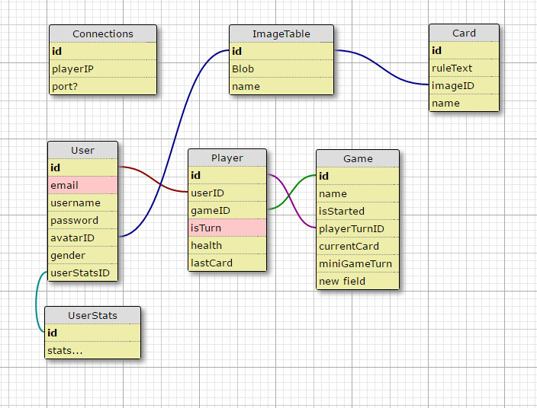

Figure 1: Diagram Outlining Database Architecture

1. User Entity

The user entity contains all information stored in the database about who the user actually is. It contains information provided by the user during account creation. The entity also contains the foreign key called avatar ID, which points to an image with that id contained in the Image. User entites also make use of the foreign key userStatsID or order to simplify storing and retrieving game a user’s game statistics. The complete list of stats to be recorded by server is still being discussed.

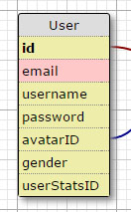

Figure 2: User Entity Table

1. Player Entity

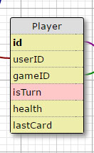

The player entity table contains information about the player while in a game. Player has information such as the last card they played which can be useful for checking information about damage dealt or health healed. There is a check for when it is the current player’s turn. There is a health integer which will keep track of the player’s health throughout the game while it is played. Game ID will keep track of which game the player currently resides in. User ID will keep track of the player’s that are currently in the game.

Figure 3: Player Entity

1. Game Entity

A game entity stores the ID and names of all games currently active on the server. Each game has a human readable name that will be displayed for users searching for a lobby to join. The game also contains information on if that game has been started or if it currently still accepting more players. The current card is recorded as well has which player’s turn it is. This ensures that if a player disconnects to the game it is possible to rejoin and preserve game state.

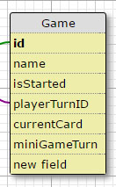

Figure 4: Game Entity

1. Card Entity

The card entities are immutable. Each card has an id, test regarding the rules of the card, and a foreign ImageID key. The card also will have human readable name.

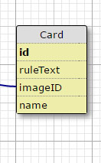

Figure 5: Card Entity

1. Image Table Entity

The image table contains an primary key ID as well a Binary Large Object containing the stored images. The image will also have a human readable name.

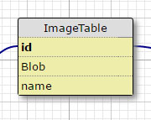

Figure 6: Image Table

1. User Stats

The user stats table will contain information relating to the player’s overall progress and game statistics. These stats have not been decided fully yet and are still a work in progress but, would include stats such as Player XP, Player Total Win / Loss Ratio, Wins, Losses, etc.

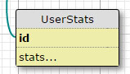

Figure 7: User Stats

1. Connections?

The connections entity table is mainly here as a placeholder until we learn more about how the game server for the game is going to function exactly.

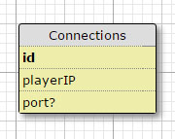

Figure 8: Connections